Evaluation of Terraform Security Scanners and Policy-as-Code Gates for AWS Infrastructure-as-Code Misconfiguration Detection
Vishvaksen Machana
x25173421
MSc in Cloud Computing
National College of Ireland

Abstract
Static scanners and policy gates are deployed on infrastructure pipelines to detect cloud misconfigurations before they go into production, but no study has been published that explains what they miss when it comes to Terraform code. Current assessments are based on the number of alerts raised, not defects missed, as there are no defects you don't know about that can affect an evaluation. Therefore, the accuracy reported depends on the design of the studies not on the instrument. This proposal outlines a labeled, secure / insecure Terraform module corpus, to which manual review, static scanning, and a policy gate are applied using the same inputs across the four AWS misconfiguration categories. The precision, recall, F1 and false-negative rates are also reported for each stage and each category, as well as the scan time per stage and remediation effort per stage. The labels and corpus have been published, thus the measurement is repeatable and not to be trusted.
Keywords: infrastructure as code, Terraform security, policy as code, misconfiguration detection, labelled benchmark

Introduction
More and more cloud infrastructure is now announced, not set up manually. Infrastructure as code (IaC) is a way to describe the infrastructure (servers, storage, permissions and so forth) as text files, which are version-controlled and automatically deployed, and Terraform is the most popular tool to deploy IaC on Amazon Web Services (AWS). While the practice eliminates manual error in provisioning, it also guarantees that if an attribute gets typed wrong, it always will be.
The errors committed are typical and significant. They index 371,981 HCL repositories, and of the 62,406 repositories scanned, they find 32,603 repositories storing public addresses, 8,217 repositories with compute instances storing public addresses, and 392 identity policies with unrestricted admin privilege. The least observed policy group of the three main providers is encryption at rest, according to Verdet et al. (2025). Public storage, over-permissive access, unencrypted data and weak logging are therefore not theoretical, but are forms that are seen in use at scale with successful application of the code.
It is difficult that is applied successfully. Drosos et al. (2024) examine 360 IaC faults and conclude that misconfiguration is the second most common symptom (27%), where the characteristic is that the fault is silent: the deployment returns a success code, but leaves the system in an unintended state. The example is a module that finishes properly, producing a file with a password that is accessible to everyone. This type of defect cannot be detected through a check of successful deployment, since it has been successful.
There are two defenses to it, both of which are implemented prior to the code. A static scanner like Checkov or tfsec is used to scan the configuration and report violations of the rules. A policy-as-code gate, usually Open Policy Agent (OPA), with rules written in Rego, further prevents the pipeline from passing when the rule(s) fail. Both defenses are in widespread use, as found by Foalem et al. (2026) who found that OPA accounted for 62% of policy files in 399 repositories, with 65.4% of those repositories stating that they use OPA for security governance.
This is why the question of the study is: What percentage of the labelled AWS misconfigurations will be identified by Terraform security scanners and an enforced policy-as-code gate?
It is unknown what the effectiveness of either is. Teams use these tools with the assumption that when an alert is raised, it is a defect that has been caught, but a scanner can only report what its rules define – and no published Terraform study has measured what a scanner doesn't. The evidence contradicts each other: Verdet et al. (2025) cite precision of 0.97 for Checkov, while Singh et al. (2024) say 0.643 for the same tool. That gap is not Checkov's, but the methods used to measure it in each study, one by adjudicating on disputed cases, and the other by counting raw output as opposed to uncurated code. If there is no set of flaws in the corpus that is already established, then neither figure can be compared to the other.
There are four objectives to this question. The first builds a labelled set of secure and insecure Terraform modules in four categories of AWS misconfigurations. The second is the detection accuracy with manual review, static scanning and an enforced policy gate against those labels. The third assesses the amount of scan time and remediation required for each stage. The fourth reports accuracy per category, which is a more revealing indicator of accuracy because they won't get averaged out of the total.
This proposed solution is a benchmark, not another tool comparison. All common AWS resources are written in pairs – with a secure and insecure version respectively – and the same set of resources is passed through the three stages, with a different set of labels scoring each one. The defects are known in advance and the number of false negatives can be counted, thus for the first time, the recall and F1 will be computable on Terraform.
In Section 2, the authors examine the frequency of such misconfigurations, why they haven't been tested, what previous evaluations had measured, what they hadn't measured and why the lack of labelled Terraform ground truth leaves it unconfirmed. The corpus, the enforcement stages, the measures and statistical treatment, the ethical position and the schedule are mentioned in section 3.

Literature Review

Misconfiguration in Infrastructure as Code
By tackling IaC defects, we're setting the scale of the problem and why it's still not addressed with traditional tests. Drosos et al. (2024) report on 360 faults in IoT-A ecosystems and highlight misconfiguration, which is the second most common symptom, with 27% of the faults running and reporting success. Buhler et al. (2025) provide the matching prevalence data for Terraform, with 62,406 projects, which have 1,773,991 resources and are known to have tens of thousands of violations across the categories explored here.
The two complement each other, but both do not answer the question. Drosos et al. make the point that it is impossible to test for something silently, and so there is nothing to be observed by the post-deployment test, but their corpus is Ansible, Puppet and Chef, and they test none of those. Buhler et al. do have Terraform, but they don't publish any ground-truth labels, so all their counts come from the scanner. Together they set the frequency of the firing of a scanner on a real Terraform, but not its frequency of correctness.

Evaluating Scanners and Enforcement Gates
To benchmark this study, Verdet et al. (2025) scan 812 open-source Terraform projects with both Checkov and tfsec, and, over the 121 policies that both tools detect, they report 326 of 3,026 shared checks returning contradictory verdicts on the same code. For Checkov, precision and recall are 0.97 and 0.73 on an adjudicating 97 case sample, while for tfsec they are 0.26 and 0.35, respectively. This measure is only applicable in cases of disagreement, and thus reveals the more common of the two accurate tools in the conflict, but cannot claim their accuracy for a known set of compositions; it fails to identify defects they have in common.
This is narrowed down by Minna, Massacci and Tuma (2025). After running each one on 7973 Helm templates, they only have 9 policies in common, and they generate between 8 and 46 alerts per artefact on the same input templates, a gap that is due to the rule catalogues, not the code and further manual validation of their results yields virtually no false positives, which takes the question of false positives to the next level, and one of false negatives. The closest to the current design are Singh et al. (2024) who tested four scanners with 1000 Terraform files and measured a precision of 64.3% for Checkov. As can be seen by the fact that the two are in agreement on the tools ordered, but disagree by more than thirty percent on the same tool, the reported accuracy is an artefact of the evaluation design, set against Verdet et al. Singh et al. boldly include only positives – there is no recall, no F1, no category labels.
There is a methodology that could solve this problem, but not in HCL. Rahman et al. (2023) create a 240-manifest Kubernetes oracle in eleven categories, with a precision of 0.64 and recall of 0.73 for one scanner, and a precision and recall of 0.0 on three categories altogether. Opdebeck, Zerouali and De Roover (2023) hand-label 243 weaknesses across more than 15,000 Ansible scripts, uncovering more than 55% of smells to be data-flow indirection weaknesses. Saavedra and Ferreira (2022) label 214 smells across three languages and gain 28 percentage points of precision, since they had no option on but rebuilding their oracles, as the previous data sets were no longer retrievable. They are led to believe that rule engineering can achieve significant benefits, whereas Opdebeeck et al. believe that the residual error is flow dependent and can not be achieved by rule engineering.
There has been much less research on enforcement than there has been on detection. Although policy-as-code is widely adopted in practice, it is an observational study by Foalem et al. (2026) and it does not measure on gate. Only Nogueira and Resende (2026) have made one measurement—reusing one OPA layer for continuous-integration validation and admission control and reporting—with them claiming that they blocked all of the bypass scenarios they evaluated. It's a flawless figure, at least in comparison to Rahman et al., because the policies have been written together and the test scenarios are written for Kubernetes, not Terraform. The reviewed studies are compared with this proposal in Table 1. No Terraform row has labelled ground truth, no recall of enforcement stages are reported and no comparison of enforcement stages.
Table 1 Reviewed studies contrasted with the proposed benchmark
Study | IaC technology | Strength | Limitation | Labelled ground truth | Metrics reported | Enforcement stages
Verdet et al. (2025) | Terraform | 812 projects; conflicts adjudicated | Accuracy only on disputed cases | No | Precision, recall on disputed subsample | None
Minna et al. (2025) | Helm / Kubernetes | Seven analysers, 4,961 templates | False negatives unexamined | No | Alert counts; manual false-positive check | None
Singh et al. (2024) | Terraform | Four scanners; closest design | Positives only; no recall or F1 | No | True and false positives; precision | None
Buhler et al. (2025) | Terraform | 62,406 projects at scale | Unlabelled scanner output | No | Raw violation counts | None
Rahman et al. (2023) | Kubernetes | 240-manifest labelled oracle | Kubernetes, not HCL; no gate | Yes; 11 categories | Precision, recall per category | None
Nogueira and Resende (2026) | Kubernetes | Only measured gate | Policies and tests self-authored | Self-authored | Block rate | Continuous integration and admission
This proposal | Terraform | Labelled pairs, four AWS categories | Synthetic modules, one provider | Yes; category and severity | Precision, recall, F1 and false-negative rate | Manual review, scanning, enforced gate

Why This Research Is Necessary
There are three things settled and a fourth thing not settled. Prevalence is determined by Buhler et al. (2025) and Verdet et al. (2025). The only defence that remains is pre-deployment detection and this is what Drosos et al. (2024) corrects. The disagreements among the tools are resolved by Verdet et al. (2025) and Minna et al. (2025).
The missing element is what hasn't been resolved. There are no published study reports of recall or F1 for Terraform scanners against labelled ground truths. Singh et al. record only the positive cases; Verdet et al. have only adjudicated cases on which they get the recall. Rahman et al. (2023) have applied the oracle-based approach to the Kubernetes project and to Ansible (Opdebeeck et al., 2023; Saavedra and Ferreira, 2022) but not to HCL, since the module, variable and remote-state indirection are different enough that it cannot be assumed that they can be transferred.
What this means for a team is that they will not be able to determine if there are any misconfigurations that remain after putting in place controls, or if they should put in place a gate to see the impact.

Research Niche
There is no existing study that compares Terraform scanner recall against known defects, manual review, static scanning and an enforced gate against the same inputs, and provides accuracy per misconfiguration category. None of the three reviewed studies passes all three: Singh et al. (2024) is a comparison of tools without any false negatives; Rahman et al. (2023) is a labeling effort for each category, but only on Kubernetes; and Nogueira and Resende (2026) is a measurement effort on a gate but on self-authored policies.
The baseline is Verdet et al. (2025). Their design is in essence as a tool to measure what developers do, so there's no concept of scanner accuracy and their recall figure is limited to disputed cases. This lack is the issue addressed here. The objective of measurement in this study is not the scanners, but rather the scanners' effect on the target.The scanners' precision and recall measures remain in this study because they are the object of measurement, not the means of it.
The contribution is a labeled secure and insecure corpus of AWS Terraform modules, and the first assessment of the number of static scanning and enforced gate failures on it. There are three expectations that are recorded as thresholds, meaning that at least one of them could be contradicted by a measurement: At least one tool records recall below 0.5 on at least one category; Enforced gate removes more residual risk than static scanning; No stage detects all categories. The standard is detailed in Section 3. Deferred to future work are other providers, runtime detection and machine-learning detectors.

Research Method & Specification
A benchmark experiment answers this question. A labelled corpus is constructed, then passed through three enforcement stages while an independent set of labels scores each one. Figure 1 shows the arrangement.
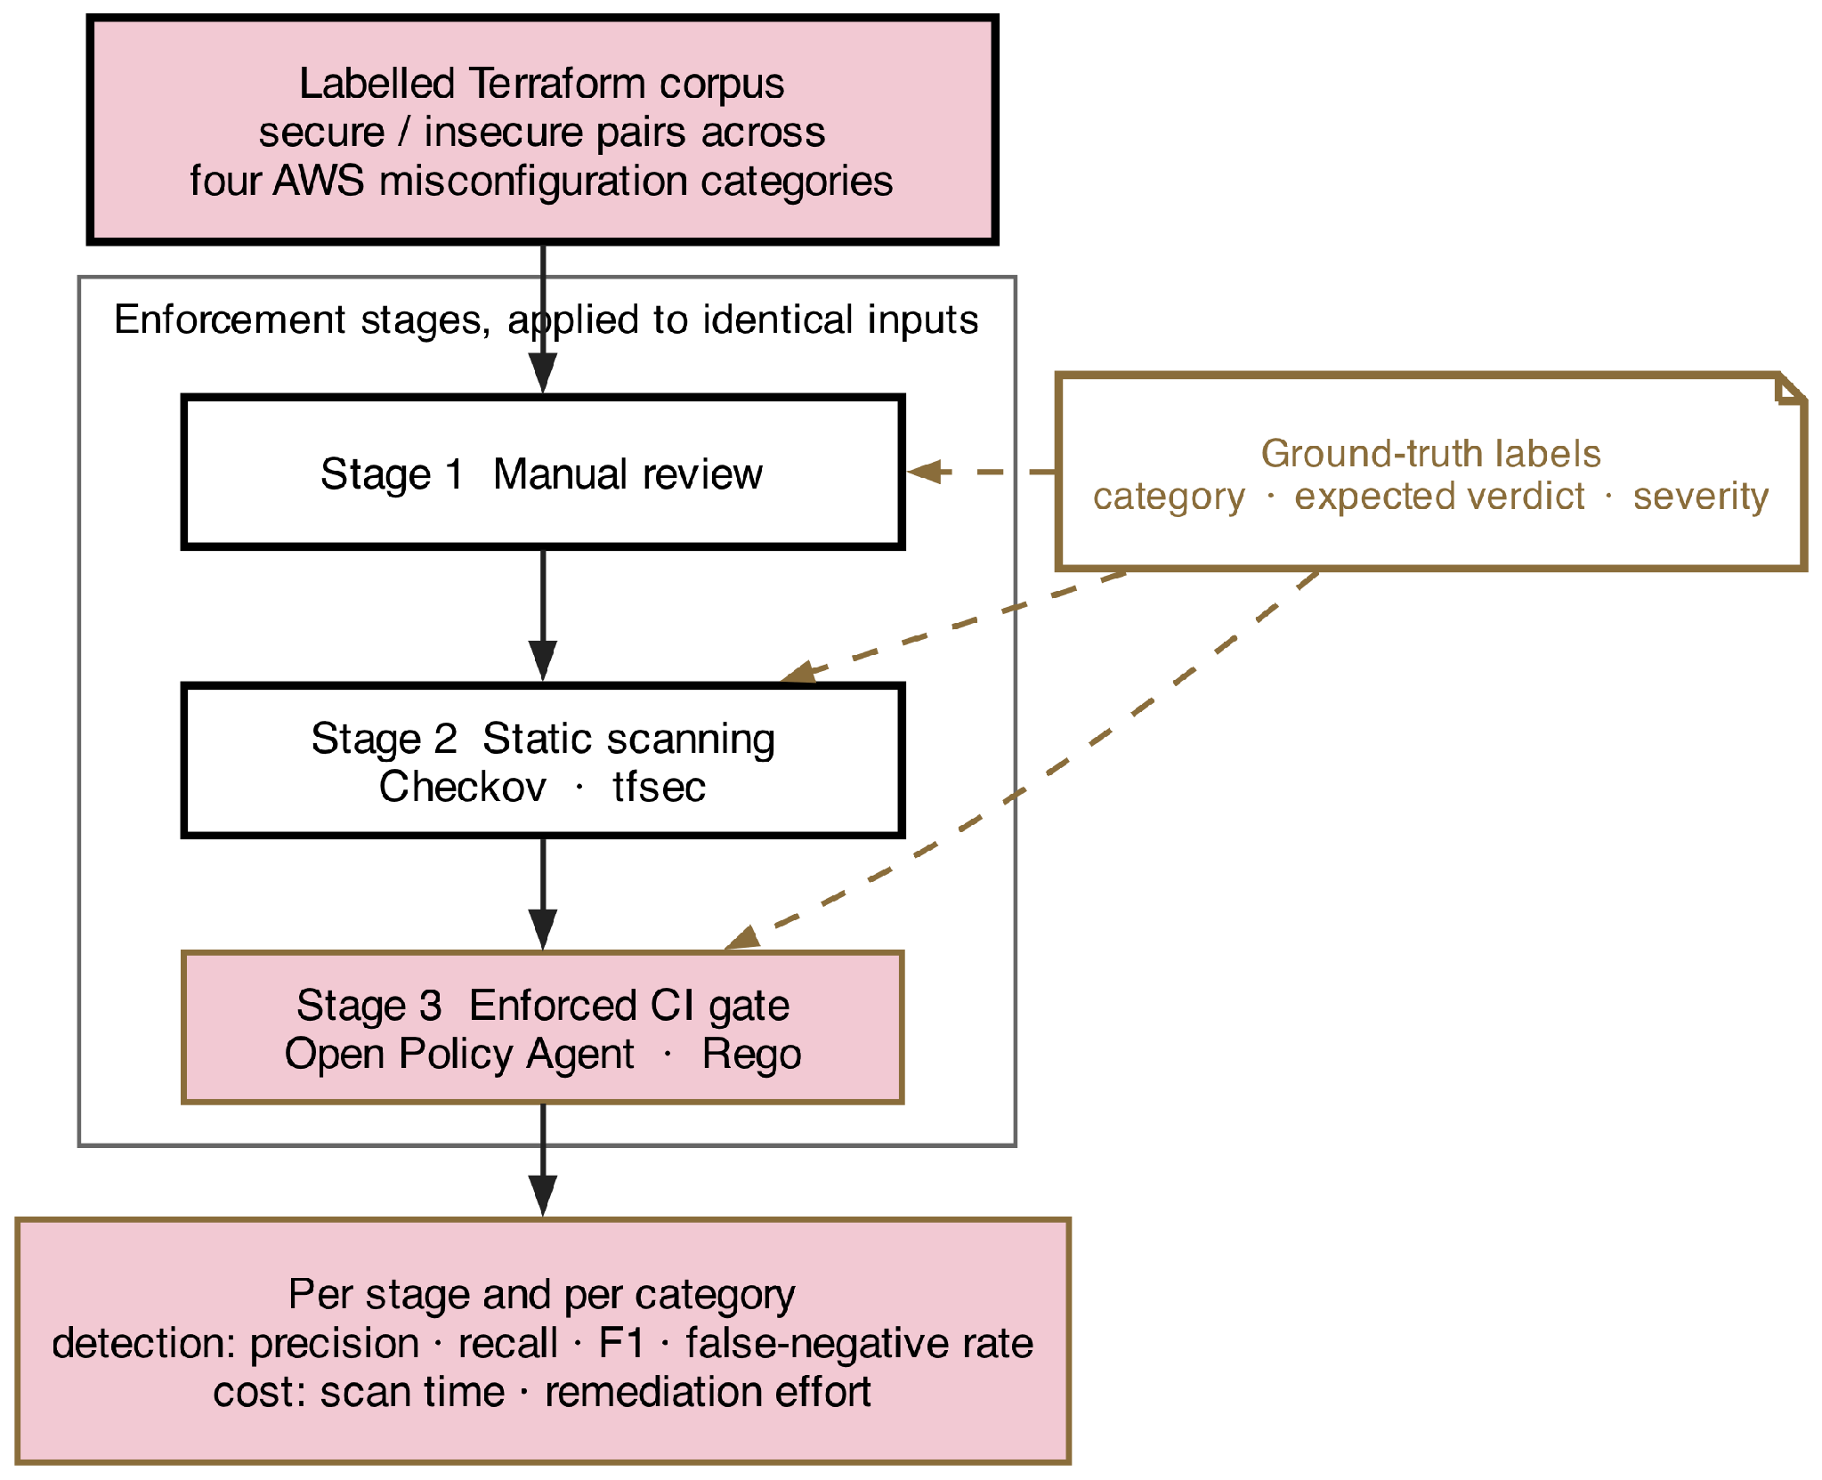
Figure 1 Benchmark setup: labelled corpus, enforcement stages and scoring

Research Method
The independent variable is the stage to which the enforcement is applied: Manual review, using a documented checklist; Static scanning using Checkov and tfsec; Continuous-integration gate enforced using OPA, with policies defined in Rego. Misconfiguration category is one of four conditioning factors found at scale by both Buhler et al. (2025) and Verdet et al. (2025) in applied Terraform.
The construction of the instrument (the corpus) is specified, not assumed, as the corpus is the instrument. In each category, we have two versions of common AWS resources, one secure and one insecure, differing only on the attribute that has the defect. Each module is marked with Category, Expected Verdict and a Severity based on the providers published guidance. There are, say, 60 modules per category, with 60% defective and hence 120 defective modules are recalled. With this number, a paired comparison would resolve a difference of 0.15 in recall between two stages, with 80% power and an alpha of 0.05, which is the same as the 240-manifest oracle of Rahman et al. (2023) and the 243-case oracle of Opdebeeck et al. (2023). Labels are prepared prior to the operation of any tool, and a 20% subsample is independently labelled by a second reviewer to allow for assessment of inter reviewer agreement.
The dependent variables are precision, recall, F1 and false-negative rate – stage and category, severity coverage, scan time per module and remediation effort – the number of lines difference in the version-control diff between an insecure module and its secure pair. The result is reported on the same terms as Verdet et al. (2025) so that it can be read and compared with theirs.
The corpus, the resource types, the tool versions (which are fixed and reported) and the machine on which the scans are executed are kept constant, as are the rule sets, which remain at their shipped default. There are two confounds that need to be dealt with. Each pair is obtained by mutating one of the attributes of the secure variant, and if it is not the attribute defined as the defect, then a detection of the secure variant is not due to the misconfiguration. Individually, a tool that is optimized on the corpus it is evaluated with would appear to be pleased with itself, so the policies of the OPA are defined not in terms of the modules, but in terms of the category definitions.
The independent second labelling and the release of the corpus are the controls on that – the labels are written in-house by the researcher and a mislabel is a measurement error. The external validity is limited with synthetic modules of one provider. For changed lines, effort for remediation will closely approximate but not match developer time.

Research Resources
The experiment depends on Terraform and the Checkov and tfsec scanners, which are open source and freely available, along with OPA with Rego policies, and a continuous-integration runner to run the gate. Pinned versions of tools are reported and there is no such thing as an unpinned version for a tool, due to the fact that rule catalogues vary between releases and an unpinned version would render the measurement repeatable.
The labelled corpus used for the test is the one presented above and created for this study. There is no production configuration, no personal data and no third party repository content, and no participants participate. Modules are validated by the Terraform parser, which means that all cases are syntactically deployable with no impact to real infrastructure. All AWS interactions needed for validation remain under the free-tier limits in the researcher's account.
The corpus, its labels, the policy definitions and the evaluation scripts are published on publication, the direct result of the non-retrievability which propelled Saavedra and Ferreira (2022) to start building their oracles again from scratch.

Evaluation
The answer to questions one and two is provided by comparing the result of detection over the three stages on identical inputs. Objective three is achieved by recording the scan time and remediation effort for each accuracy measurement, while objective four is achieved by reporting each measure per category, as Rahman et al. (2023) demonstrate that a decent overall score does not mean that a tool has no accuracy in a given category.
The null and the alternative to the hypothesis are stated in each comparison prior to making any measurement. For detection accuracy, H0 asserts presence of no differences between the three stages of enforcement, and H1 makes the assertion of at least one difference between the three stages of enforcement. H0: There is no difference in recall between the four categories within a stage; H1: At least one difference in recall between the four categories within a stage. H0: Remediation effort is equal across stages; H1: Remediation effort is not equal across stages. None is one-sided as enforcement is assumed to help, but the only measured gate reports perfect accuracy on self-authored tests.
The selection of test is not done before but after a normality assessment. When the distributions are normal, one-way analysis of variance is used to compare the three stages, using eta-squared as the effect size; when they are not, the one-way analysis of variance is replaced by the Kruskal-Wallis test, with the use of epsilon-squared as the effect size. The category-level rates are compared using McNemar's test as each stage has the same modules to assess. Each difference reported has a 95% confidence interval.
Every one of the hypotheses is drawn from one labelled corpus, and tests are performed with an alpha value of 0.05 and Holm-Bonferroni adjustment. The smallest difference that is of interest is pre-determined at 0.05 recall and the rule of what it means is written down before the tool is executed.

Ethical Considerations of the Research
There are no participants and no personal data is used at any point. There is no production configuration and no third-party repository content – the entire corpus is written specifically for the purpose of this study, rendering consent and data-protection considerations beyond the scope of this study.
The corpus is by its very nature a collection of insecure cloud configuration examples, and so is by nature dual use. The categories are already known in the providers' own documentation, and the tools under test will detect them; removing them will result in a similar non-retrievability as in Saavedra and Ferreira (2022), where they had to re-create their own oracles. It is explicitly stated that the modules are for evaluation of the detectors only and should not be deployed. No live infrastructure is applied to.
This is an issue of reporting integrity, since the study compares named tools for which the maintainer(s) can be determined. They are not tailored to the benefit of any particular tool, but are used at their shipped default settings; the version of each tool is reported because the rules can change from release to release; and the results are reported by category and not as a single rank, as it would be tempting to reach a verdict your evidence does not support. If a tool does not include a category at all, it is not a defect claim, just a coverage boundary.

Project Plan
Figure 2 sets out the twelve-week schedule. The first week provisions the sandbox and pins tool versions, after which corpus construction runs from week two as four parallel category tracks that finish together, since a partial corpus cannot be evaluated.
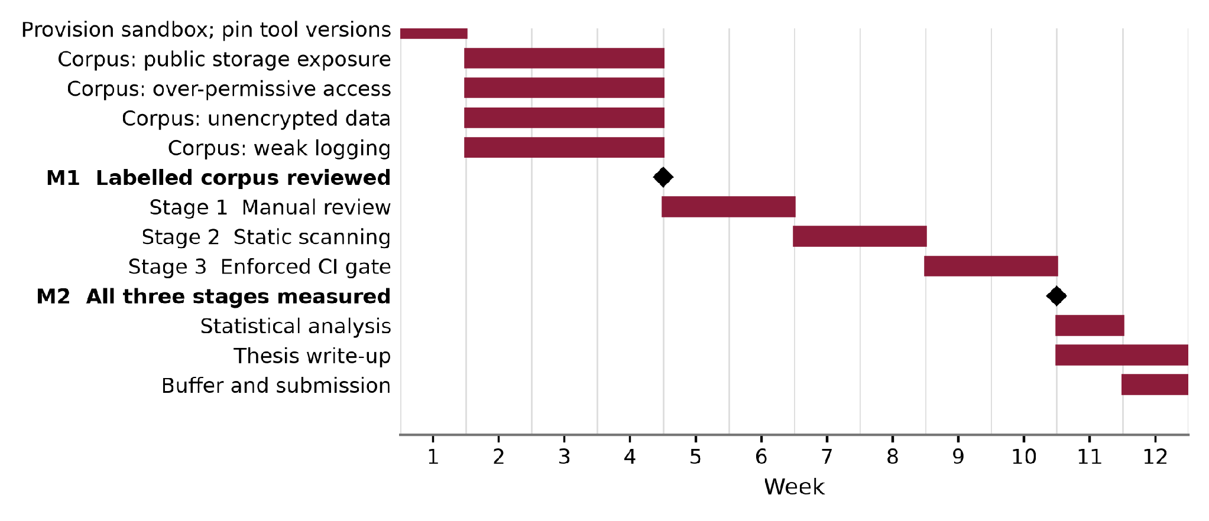
Figure 2 Twelve-week project plan
The four tracks converge at week five on a labelled corpus with an independently reviewed sample, the precondition for every measurement that follows. The three enforcement stages are scheduled one after another, weeks five to eleven, but each runs over the same unmodified corpus so the verdicts stay paired. Statistical analysis and the write-up occupy week eleven, week twelve is contingency, and the principal risk is labelling proving slower than planned, which the parallel tracks absorb.

References
Buhler, C., Spielmann, D., Meier, R. and Salvaneschi, G. (2025) 'TerraDS: a dataset for Terraform HCL programs', in Proceedings of the 2025 IEEE/ACM 22nd International Conference on Mining Software Repositories. Ottawa: IEEE, pp. 654-658. doi: 10.1109/MSR66628.2025.00101. [Conference - CORE Ranking A (ICORE2026)]
Drosos, G.-P., Sotiropoulos, T., Alexopoulos, G., Mitropoulos, D. and Su, Z. (2024) 'When your infrastructure is a buggy program: understanding faults in infrastructure as code ecosystems', Proceedings of the ACM on Programming Languages, 8(OOPSLA2), pp. 2490-2520. doi: 10.1145/3689799. [Conference - CORE Ranking A (ICORE2026, OOPSLA)]
Foalem, P.L., Da Silva, L., Khomh, F. and Merlo, E. (2026) 'An empirical study of Policy-as-Code adoption in open-source software projects', Journal of Systems and Software, 242, 113028. doi: 10.1016/j.jss.2026.113028. [Journal - JCR Impact Factor 3.8 (2024), Q2]
Minna, F., Massacci, F. and Tuma, K. (2025) 'Analyzing and mitigating (with LLMs) the security misconfigurations of Helm charts from Artifact Hub', Empirical Software Engineering, 30(5), 132. doi: 10.1007/s10664-025-10688-0. [Journal - JCR Impact Factor 3.4 (2024), Q2]
Nogueira, L. and Resende, A. (2026) 'Reusing policy-as-code across CI/CD and Kubernetes admission control: an empirical assessment of governance consistency', Computers, 15(7), 453. doi: 10.3390/computers15070453. [Journal - JCR Impact Factor 5.2 (2024), Q2]
Opdebeeck, R., Zerouali, A. and De Roover, C. (2023) 'Control and data flow in security smell detection for infrastructure as code: is it worth the effort?', in Proceedings of the 2023 IEEE/ACM 20th International Conference on Mining Software Repositories. Melbourne: IEEE, pp. 534-545. doi: 10.1109/MSR59073.2023.00079. [Conference - CORE Ranking A (ICORE2026)]
Rahman, A., Shamim, S.I., Bose, D.B. and Pandita, R. (2023) 'Security misconfigurations in open source Kubernetes manifests: an empirical study', ACM Transactions on Software Engineering and Methodology, 32(4), pp. 1-36. doi: 10.1145/3579639. [Journal - JCR Impact Factor 6.9 (2024), Q1]
Saavedra, N. and Ferreira, J.F. (2022) 'GLITCH: automated polyglot security smell detection in infrastructure as code', in Proceedings of the 37th IEEE/ACM International Conference on Automated Software Engineering. New York: ACM, pp. 1-12. doi: 10.1145/3551349.3556945. [Conference - CORE Ranking A* (ICORE2026)]
Singh, R., Yeboah-Ofori, A., Kumar, S. and Ganiyu, A. (2024) 'Fortifying cloud DevSecOps security using Terraform infrastructure as code analysis tools', in Proceedings of the 2024 International Conference on Electrical and Computer Engineering Researches. Gaborone: IEEE, pp. 1-6. doi: 10.1109/ICECER62944.2024.10920371. [Conference - not listed in the CORE rankings database]
Verdet, A., Hamdaqa, M., Da Silva, L. and Khomh, F. (2025) 'Assessing the adoption of security policies by developers in Terraform across different cloud providers', Empirical Software Engineering, 30(3), 74. doi: 10.1007/s10664-024-10610-0. [Journal - JCR Impact Factor 3.4 (2024), Q2]

