Reliability and Recovery of Amazon SQS Messaging under Injected Consumer and Downstream Failures
Anjaneya Reddy Gurram
24288853
MSc in Cloud Computing
National College of Ireland

Abstract
Managed message queues are deployed in cloud-native systems specifically to absorb disruption, yet the configuration guidance available for Amazon Simple Queue Service derives almost entirely from steady-state performance analysis in which consumers do not fail. The settings that govern behaviour during failure, namely visibility timeout, retry limit and dead-letter queue threshold, therefore remain uncharacterised in the regime they exist to serve. This proposal specifies a controlled two-arm experiment in which functionally equivalent order-processing services, one synchronous and one queue-decoupled, are subjected to programmatically injected consumer and downstream failures under normal and burst load. Message loss, duplicate processing, dead-letter capture and recovery time are measured across configurations, alongside throughput and latency retained from prior work to preserve direct comparability. The expected contribution is a parameter-level account of the trade-off between reliability, recovery and cost in queue-mediated serverless workloads.
Keywords: Amazon SQS, message reliability, fault injection, serverless computing, recovery time

Introduction
Cloud-native applications routinely decouple producer and consumer services with a managed message queue so that downstream work can proceed asynchronously. Amazon Simple Queue Service (SQS) is the most widely deployed managed instance of this pattern within Amazon Web Services (AWS). The value of such a queue is not throughput alone; it is the capacity to absorb disruption, holding messages while a consumer restarts or a datastore recovers. Cabane and Farias (2024) show that adopting event-driven communication materially changes system performance characteristics, and Bosilia et al. (2026) report that it also changes resilience and robustness relative to synchronous designs. The mechanisms through which SQS delivers that absorption are configurable: the visibility timeout that hides a message while it is being processed, the retry limit that governs how often redelivery is attempted, and the dead-letter queue (DLQ) that captures messages which repeatedly fail.
Configuration guidance for these mechanisms, however, is derived from steady-state analysis. Kyrychenko et al. (2025b) model an SQS-backed serverless pipeline using classical queueing theory and load-test a prototype over 500,000 records, concluding that batch size and message visibility time are the dominant factors and that proper configurations increase throughput without loss of reliability. That conclusion rests on an assumption rather than a measurement: the study states that the queue guarantees no message loss, attributing the property to a third party, and infers preserved reliability from throughput results. Reliability is therefore treated as a service guarantee rather than an observed outcome. The difficulty is that visibility timeout, retry limit and DLQ threshold have no behavioural consequence while every message is processed on first delivery. They acquire consequence only when processing fails, which is precisely the regime a steady-state queueing model excludes by construction.
The methods required to examine that regime are established. Al-Said Ahmad et al. (2024) inject delay into cloud-native applications and observe that availability defects emerge abruptly at particular delay values, while Yang et al. (2024) derive a resilience index from systematic failure injection across microservice systems. Neither reports message-level outcomes, and neither treats queue configuration as an experimental variable. Reliability under failure and configuration under load have thus been studied separately, leaving the parameters that connect them unmeasured.
Research Question. The above research problem motivates the following research question: How does Amazon SQS configuration affect message reliability and recovery under injected consumer and downstream failures?
Four objectives address this question. The first quantifies how visibility timeout, retry limit and DLQ threshold affect message loss and duplicate processing under injected failure. The second measures recovery time to steady state as a function of the same parameters. The third determines whether the reliability implied by steady-state configuration guidance persists once failures occur. The fourth characterises the trade-off between reliability, recovery and the latency and cost incurred to achieve them.
The work contributes a parameter-level characterisation of SQS reliability and recovery under controlled failure, expressed in metrics that permit direct comparison with existing steady-state results. Practitioners gain an evidence base for selecting visibility timeout, retry and DLQ settings rather than accepting defaults. The research community gains a reusable fault-injection harness and a measured trade-off surface against which analytical queueing models can be validated.
Section 2 reviews the configuration and resilience literature, contrasts the approaches taken and identifies the research niche. Section 3 specifies the experimental method, the resources and test data required, the evaluation and analysis plan including the hypotheses to be tested, the ethical considerations arising, and the twelve-week project plan.

Literature Review

Configuration of Queue-Based Serverless Systems
The two available studies of SQS configuration originate from the same group and optimise different constructs. Kyrychenko et al. (2025b) hold the workload fixed at 500,000 records and search for the parameter combination maximising throughput, reporting batch size and visibility timeout as dominant. Kyrychenko et al. (2025a) instead target scaling responsiveness, applying semi-Markov prediction over workloads exceeding one million records and reporting a 21.3 per cent throughput increase together with a reduction in cold starts. The two therefore operationalise success differently, as steady throughput in the former and elastic responsiveness in the latter, yet neither operationalises reliability as a measured quantity. The former asserts it; the latter does not address it. For a question concerned with message loss and duplication under failure, both leave the dependent variable undefined.
The methodological divide is equally instructive. Kyrychenko et al. (2025b) derive guidance analytically from M/M/1 and M/M/k models, gaining generality at the cost of a state space containing no representation of a failed consumer. Cabane and Farias (2024) take the opposite approach, measuring event-driven performance empirically and finding effects that analytical treatment had not anticipated, but confine observation to normal operation. Analytical tractability and empirical fidelity are thus traded against one another, and neither trade reaches the failure regime in which the parameters of this research question operate.
Configuration is therefore well established as decisive for queue performance and poorly established as a determinant of reliability. What the resilience literature does measure is considered next.

Resilience Measurement and Fault Injection
Fault injection is a mature instrument, but its outputs are pitched above the message. Al-Said Ahmad et al. (2024) inject network delay into containerised and serverless applications across varying user loads, reporting throughput and latency. Yang et al. (2024) inject failures across three microservice systems and rank monitoring metrics by their contribution to service degradation, producing a single resilience index. The former varies one fault dimension and reads system-level performance; the latter aggregates many metrics into a scalar. Neither yields message loss, duplicate-processing rate or dead-letter capture, which are the constructs through which a queue's reliability is expressed, and so neither can attribute an outcome to a queue setting.
Considered together, two findings bound the problem. Bosilia et al. (2026) construct functionally equivalent monolithic and event-driven implementations of an order process and compare resilience and robustness under failure, establishing that asynchronous communication alters both. Al-Said Ahmad et al. (2024) establish that failure effects are load-dependent rather than uniform. Architecture and load condition therefore both matter. What remains unresolved is which configuration produces the resilience that Bosilia et al. observe, because their comparison holds queue settings fixed while varying the architecture around them.
That distinction defines the position of this study relative to the two closest prior works, which fail to reach it from opposite directions. Bosilia et al. (2026) vary architectural style under failure but hold queue configuration fixed, so resilience is attributed to the architecture rather than to any setting within it. Kyrychenko et al. (2025b) vary precisely those settings, but only in the steady state, where they have no behavioural consequence. One varies the wrong factor under the right conditions; the other varies the right factor under the wrong conditions. This proposal holds the asynchronous architecture constant and varies its configuration under injected failure, so that a measured outcome can be attributed to a setting. The synchronous arm is a control against which queue-mediated behaviour is referenced, not the object of comparison. The distinction matters because architectural style is chosen once, whereas visibility timeout, retry limit and DLQ threshold are tuned continuously by whoever operates the system.
Fault injection is thus available and validated but has not been directed at queue configuration parameters. Table 1 summarises how the reviewed studies differ from the present proposal.
Table 1 Comparison of reviewed studies with the present proposal
Study | Approach | Evaluation methodology | Limitations | How this proposal differs
Kyrychenko et al. (2025b) | Tune visibility timeout, delivery delay and batch size for throughput | M/M/1 and M/M/k models; 500,000-record workload | Asserts reliability as service-guaranteed and infers it from throughput; no failure induced | Induces failure and measures loss, duplication, DLQ capture and recovery time
Kyrychenko et al. (2025a) | Serverless queue framework with predictive scaling | Load testing over one million records; throughput and cold starts | Optimises scaling under load, not behaviour under consumer failure | Failure is the treatment rather than a disturbance
Bosilia et al. (2026) | Monolithic versus event-driven architecture | Two equivalent order-process systems under failure | Compares architectural styles; queue configuration held fixed | Varies configuration within the asynchronous architecture
Al-Said Ahmad et al. (2024) | Chaos engineering under varying user load | Delay injection; throughput and latency | Injects delay only; no message-level reliability metrics | Injects consumer and downstream faults; measures message-level outcomes
Yang et al. (2024) | Resilience profiling by degradation dissemination | Fault injection with metric ranking across three systems | Produces an aggregate index, not parameter-level guidance | Produces a parameter-to-outcome trade-off surface
Cabane and Farias (2024) | Impact of event-driven architecture on performance | Exploratory empirical comparison | Measures performance under normal operation only | Measures reliability and recovery under injected failure

Research Niche
A shared blind spot runs through the configuration literature. Kyrychenko et al. (2025b) and Kyrychenko et al. (2025a) both model the queue as a system in equilibrium, and the analytical formalism they employ has no state for a consumer that accepts a message and then fails. The parameters under investigation are inert in that formalism: a visibility timeout expires only when processing does not complete, a retry limit is consulted only after a failure, and a dead-letter threshold is reached only after repeated failures. This is not an omission that a longer experiment would remedy; it is a structural limit on what steady-state models can express.
Kyrychenko et al. (2025b) optimise Amazon SQS visibility timeout, delivery delay and batch size for throughput and latency while presuming steady-state operation with healthy consumers, which is the one regime in which the mechanisms they tune are never exercised for the purpose they exist to serve. This study measures message loss, duplicate processing, dead-letter capture and recovery time under injected consumer and downstream failures, retaining their throughput and latency metrics so that behaviour under failure can be compared directly against the steady-state case they characterise. A targeted search of the peer-reviewed literature located no empirical study treating visibility timeout, retry limit or dead-letter threshold as experimental variables, which corroborates the structural argument without substituting for it.
The expected contribution is a measured trade-off surface relating three configurable SQS parameters to four reliability and recovery outcomes under defined failure modes. Anticipated findings are that the long visibility timeouts favoured for throughput extend recovery time after failure, and that permissive retry limits reduce dead-letter capture at the cost of increased duplicate processing; both would qualify existing guidance rather than contradict it. Practitioners benefit directly, gaining measured grounds for configuration decisions currently made by default or convention. The research community gains a comparable baseline for failure-regime measurement of managed queues, together with a harness reusable for first-in-first-out queues, alternative brokers and multi-region failure modes, which are deferred here as future work.

Research Method & Specification
The research question is addressed by controlled experiment. Two functionally equivalent order-processing services are constructed: an arm in which a producer invokes its consumer synchronously and directly, and an arm in which producer and consumer are decoupled by an SQS Standard queue with an attached dead-letter queue. Failures are injected programmatically into both arms while the queue configuration of the second is varied systematically. Figure 1 shows the arrangement.
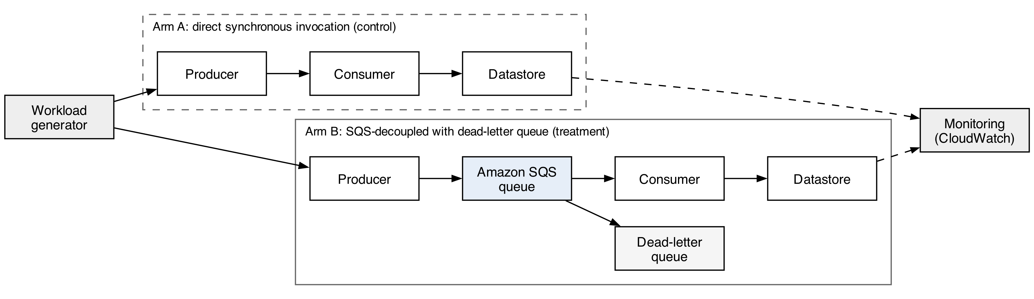
Figure 1 Experimental setup: control and treatment arms

Research Method
The independent variables are the visibility timeout, the retry limit expressed as a maximum receive count, the dead-letter queue threshold and the batch size, together with two factors that condition their effect: load, at normal and burst levels, and failure type. Four failure types are injected, namely consumer process termination, unhandled function error, datastore write rejection and datastore timeout. The dependent variables are the message-loss rate, the duplicate-processing rate, the dead-letter capture rate, the successful-processing rate and the recovery time, defined as the interval from cessation of failure until queue depth returns to its pre-failure level. Throughput and latency are additionally recorded because they are the metrics reported by Kyrychenko et al. (2025b), and retaining them is what permits results to be placed alongside theirs.
Region, account, queue type, message payload, workload generator and consumer resource allocation are held constant across all runs. Two confounds require explicit treatment. First, SQS Standard queues provide at-least-once delivery, so a non-zero duplicate rate arises independently of any injected failure; the no-fault control establishes this floor and reported duplicate rates are expressed relative to it. Second, provider-side performance varies over time, which Eismann et al. (2022) show can exceed the effect under measurement in serverless settings; run order is randomised across configurations and each configuration is repeated so that temporal drift is distributed rather than confounded with treatment.
Three threats to validity are acknowledged. Internally, injected failures are synthetic and may not reproduce the timing characteristics of organic failures, which is mitigated by injecting at several points in the processing path rather than at a single boundary. Externally, findings are obtained from one account, one region and one queue type, and generalisation beyond that configuration is not claimed. In construct terms, recovery time operationalises recovery as backlog clearance, which does not capture consumer-side state repair; this limit is stated rather than assumed away.

Research Resources
The experiment requires Amazon SQS Standard queues, AWS Lambda for the consumer functions, Amazon DynamoDB as the datastore and Amazon CloudWatch for metric collection. Infrastructure is defined as code so that each configuration is provisioned and destroyed reproducibly, which also bounds cost. Fault injection is implemented within the consumer and datastore-access paths under control of an environment-driven switch, avoiding dependence on a managed chaos service. Test data consists of synthetic order transactions generated for the study; no personal, private or third-party data is used and no human participants are involved. The work is scoped to remain within free-tier and low-cost service limits.

Evaluation
The research question is answered by comparing dependent-variable distributions across configurations under matched failure and load conditions. The first two objectives are addressed directly by those comparisons. The third is addressed by testing whether the configuration that maximises throughput in the absence of failure also minimises loss and recovery time in its presence; a negative result would establish that steady-state guidance does not transfer. The fourth is addressed by expressing measured reliability against the added latency and invocation cost each configuration incurs.
Each comparative objective is expressed as a hypothesis pair. For the first, the null hypothesis states that visibility-timeout setting has no effect on message-loss rate under injected consumer failure, against the alternative that at least one setting differs. For the second, the null hypothesis states that retry limit has no effect on recovery time, against the alternative that at least one differs. For the third, the null hypothesis states that the throughput-optimal configuration does not differ from alternatives in loss or recovery time, against the alternative that it does. All are non-directional and two-tailed tests are used accordingly, because existing guidance offers no measured basis for predicting a direction.
Distributional assumptions are tested before a test is selected. Where normality holds, one-way analysis of variance is applied with eta-squared reported as effect size; where it does not, which Eismann et al. (2022) indicate is likely for latency and recovery measures, the Kruskal-Wallis test is applied with epsilon-squared. The significance level is 0.05. Because several hypotheses are tested on the same collected data, the Holm-Bonferroni correction is applied across the family. Repetition counts are fixed in advance from a pilot run so that the smallest effect of practical interest is detectable, and interpretation rules are recorded before collection begins: a result is reported as evidence against a null hypothesis only if it is both statistically significant after correction and associated with a non-negligible effect size.

Ethical Considerations of the Research
No human participants are involved and no personal or third-party data is processed. All transactions are synthetic and generated for the study, so consent and data protection obligations do not arise. Three further considerations do. Deliberately inducing failure and generating load against a commercial provider must remain within its acceptable-use terms, and the experiment is confined to resources within the researcher's own account and to load levels well below any threshold at which other tenants could be affected. The experiment consumes billable compute and therefore carries a financial and environmental cost; run counts are justified by the pilot rather than maximised, and the resulting energy footprint is acknowledged as a cost incurred for knowledge. Research integrity requires that the analysis plan be fixed before collection, that all runs including anomalous and failed ones be reported, and that the single-account and single-region scope be stated wherever findings are summarised, since overstating external validity would mislead practitioners making configuration decisions. Should the experiment reveal undocumented provider behaviour, it will be reported to the provider before publication. Configurations, code and collected data will be released so that claims can be independently checked.

Project Plan
The project is planned across twelve weeks, shown in Figure 2. Rig construction and instrumentation occupy the first two weeks and conclude with a validated environment. Baseline measurement follows, establishing the duplicate-delivery floor against which later results are expressed. Three fault-injection campaigns then proceed sequentially, each pairing a failure type with the parameter most relevant to it, followed by burst-load replication. Analysis occupies weeks nine and ten and write-up week eleven, with week twelve retained as buffer. Each phase depends on completion of the preceding milestone, and the buffer absorbs overrun in the experimental campaigns, which carry the greatest schedule risk because they depend on provider behaviour outside the researcher's control.
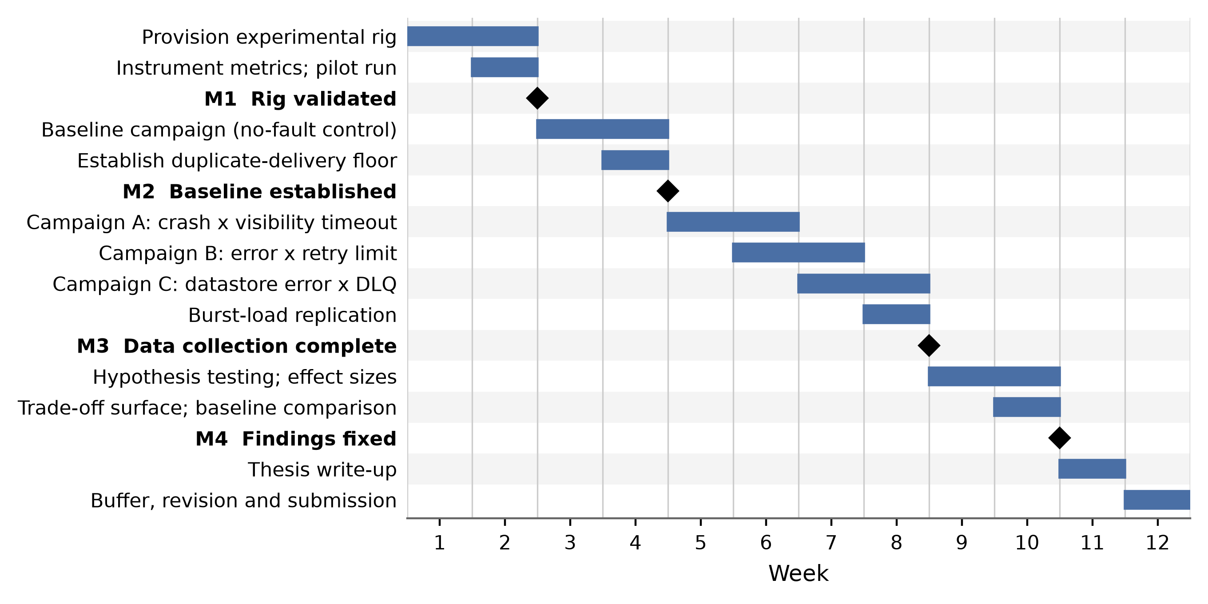
Figure 2 Twelve-week project plan

References
Al-Said Ahmad, A., Al-Qora'n, L.F. and Zayed, A. (2024) 'Exploring the impact of chaos engineering with various user loads on cloud native applications: an exploratory empirical study', Computing, 106(7), pp. 2389-2425. doi: 10.1007/s00607-024-01292-z. [Journal - JCR Impact Factor 2.8 (2024)]
Bosilia, N., Weinberger, G. and Haindl, P. (2026) 'Assessing the impact of asynchronous communication on resilience and robustness: a comparative study of microservice and monolithic architectures', in Software Architecture. ECSA 2025 Tracks and Workshops, Lecture Notes in Computer Science 15982. Cham: Springer, pp. 171-186. doi: 10.1007/978-3-032-04403-7_16. [Conference - CORE Ranking B (ICORE2026)]
Cabane, H. and Farias, K. (2024) 'On the impact of event-driven architecture on performance: an exploratory study', Future Generation Computer Systems, 153, pp. 52-69. doi: 10.1016/j.future.2023.10.021. [Journal - JCR Impact Factor 5.9, Q1; SJR 1.551]
Eismann, S., Costa, D.E., Liao, L., Bezemer, C.-P., Shang, W., van Hoorn, A. and Kounev, S. (2022) 'A case study on the stability of performance tests for serverless applications', Journal of Systems and Software, 189, 111294. doi: 10.1016/j.jss.2022.111294. [Journal - JCR Impact Factor 3.8, Q1]
Kyrychenko, O., Ostapov, S. and Kyrychenko, O. (2025a) 'Design of a framework for serverless distributed data processing using queues', Eastern-European Journal of Enterprise Technologies, 4(9(136)), pp. 19-25. doi: 10.15587/1729-4061.2025.335723. [Journal - Scopus-indexed, CiteScore 2, SJR Q3; no JCR Impact Factor; Google Scholar citations: 2 (accessed 26 July 2026)]
Kyrychenko, O.O., Ostapov, S.E. and Kyrychenko, O.L. (2025b) 'Optimization of SQS configurations for efficient batch data processing', WSEAS Transactions on Systems, 24, pp. 36-43. doi: 10.37394/23202.2025.24.4. [Journal - Scopus-indexed, SJR 0.179, Q4; no JCR Impact Factor; Google Scholar citations: 2 (accessed 26 July 2026)]
Yang, T., Lee, C., Shen, J., Su, Y., Feng, C., Yang, Y. and Lyu, M.R. (2024) 'MicroRes: versatile resilience profiling in microservices via degradation dissemination indexing', in Proceedings of the 33rd ACM SIGSOFT International Symposium on Software Testing and Analysis (ISSTA 2024). New York: ACM, pp. 325-337. doi: 10.1145/3650212.3652131. [Conference - CORE Ranking A (ICORE2026)]

