SIGNATURE VERIFICATION
ASWINCHANDER, VARUNSHIVAKUMAR, TARUN
B.TECH COMPUTER SCIENCE ENGINEERING, VELLORE INSTITUR OF TECHNOLOG
CHENNAI
aswinchander.n2019@vitstudent.ac.in
varun.shivakumar2019@vitstudent.ac.in
tarun.r2019@vitstudent.ac.in

Abstract— Signatures are the most often utilised mechanism for identifying people whose identities have been retrieved from prior signatures.The main point is that in a bank, signatures are extremely crucial since money withdrawals are dependent on them. Signature verification is required for personal identity.one of the most widely utilised biometric approaches
The signature verification procedure is based on human scrutiny of one known sample in many business circumstances, such as check payment.There are no ideal methods in place at banks to verify whether a signature on a check is genuine or not. This may result in bank fraud.The number of incidents of signature forgery in banks is on the rise these days.The project will assist in determining if a signature is genuine or not.
Online and offline verification are the two methods of verification available. Basically, in this Project we are going to implement How to find a signature is original or fake.
Firstly, we will train the system by using a database of signatures.This database of signatures is previously authorized by the system.This system will analyse all signatures and will make a reference signature will be used for other signature verification.There are many parameters (like Euclidean Distance) in the feature space between the claimed signature and to be examined signature as a measure.
If the absolute difference between the parameters of original signature and the verification signature is greater than a pre-defined threshold then the signature is identified as forgery

- Introduction
. Basically, we'll put it into action. In this assignment, you'll learn how to tell if a signature is real or not. To begin, we'll teach the technique using a signature database. This signature database has already been authorised by the system. This system will evaluate all signatures and establish a reference signature that will be used to validate the validity of other signatures. In the feature space between the claimed signature and the signature under investigation, numerous parameters (such as Euclidean Distance) exist as a measure. If the absolute discrepancy between the parameters of the original signature and the verification signature is more than a pre-defined threshold, the signature is considered forged.
- Literature survey
Researchers have employed a variety of technologies, including neural networks, to do parallel processing and signature verification, and they are constantly presenting new concepts, ideas, and methods.
There are several more methods for evaluating random forgeries, such as histograms and 2D transformations.
Measurements taken when tracing the signature and hence the location of feature points on the signature's skeleton.
Because the issue is attempting to breed a form rather than a temporal pattern, this result implies that the dynamics aren't stable enough to be employed for signature verification.
Only static photos of signatures will be verified here.
- Proposed work
The User ID is entered to start the signature verification mechanism. The user must enter his or her ID into the system. The system will determine whether or not the user ID is registered. If the user ID has not yet been registered, the user must provide five signatures for training purposes. The user will be requested to sign for testing if the user ID has been registered. The input training signatures and input testing signatures will then go through the Pre-processing step. The input training signature will be recorded as a reference signature in the database, while the input testing signature will be saved as a sample signature and moved on to the Verification step. The sample signature is verified in the Verification step. Below diagram shows the Process flow:
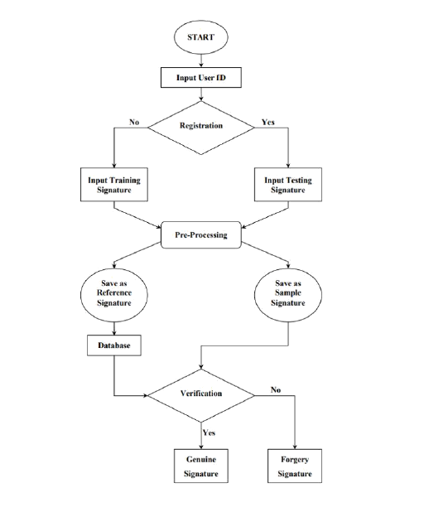

Harware:A laptop with i5 processor.Software:Google collab.
This research will aid in the identification of genuine and forged signatures.
IV.CONCLUSION
The quantity, amount, and kind of data used in the training phase determine the training. Our test set is considerably smaller than that of standard machine learning datasets.Because a signature is the result of human effort, errors are common, even when the signature is drawn by the same individual.A single verification failure might occur during the test process if a mistake is made. A error during the training phase, on the other hand, might result in a reduction in verification accuracy.
References
- International Journal of Innovative Research in Computer Science & Technology (IJIRCST) ISSN: 2347-5552, Volume-3, Issue-3, May- 2015
- Signature verification & recognition meera v. Kanawade1 & katariya s. S2.
- Online handwritten signature verification system based on DWT features extraction and neural network classification Maged M.M. Fahmy *.
- Handwritten Signature Verification using Deep Learning Eman Alajrami1 , Belal A. M. Ashqar2 , Bassem S. Abu-Nasser2 , Ahmed J. Khalil2 , Musleh M. Musleh2 , Alaa M. Barhoom2 , Samy S. Abu-Naser

