Requirements Table
Lab 1: Requirements Engineering & UML Use-Case Modelling
Problem Statement #03 – Campus Placement & Internship Pipeline
Name: TARUN GOWDA P
SRN: PES1UG24AM303
Req ID | Type | Description | Priority | Acceptance Criteria | Rationale
FR-001 | Functional | The system shall parse uploaded student resumes (PDF format), extract skill tags, and match profiles against active company eligibility rules. | High | Pass: Ineligible applicants are filtered out with clear discrepancy reasons. Fail: Applicant with active backlog bypasses eligibility filter. | Automates initial screening and prevents ineligible applicants from consuming recruiter review time.
FR-002 | Functional | The system shall apply configurable multi-tier CGPA cutoffs and active-backlog rules defined per company drive to automatically determine student eligibility. | High | Pass: A student below the specified CGPA tier for a drive is automatically marked “Not Eligible” with the specific rule violated shown. Fail: A student below the cutoff appears in the eligible applicant list. | Prevents placement officers from manually cross-checking eligibility for hundreds of applicants per drive, reducing human error.
FR-003 | Functional | The system shall allow the Placement Officer to create multi-round interview schedules, assign time slots to shortlisted candidates, and maintain a live queue status (Waiting / In-Progress / Completed) for each round. | High | Pass: When a round is closed, every candidate shows an updated status and no two candidates are double-booked in the same slot with the same interviewer. Fail: Two candidates are assigned an overlapping slot with the same interviewer. | Coordinating multi-round interviews manually across large batches is error-prone; automated queueing prevents clashes and delays.
FR-004 | Functional | The system shall generate a digital offer letter for candidates who clear all interview rounds, capture the candidate’s accept/decline response, and lock the applicant’s status once a response is recorded. | Medium | Pass: An offer letter PDF is generated within 5 seconds of Placement Officer approval, and the candidate’s response updates the record instantly. Fail: A candidate is able to submit more than one accept/decline response for the same offer. | Formalizes the offer stage and prevents duplicate or delayed responses that could hold up drive-closure reporting.
FR-005 | Functional | The system shall allow Student Applicants to view real-time application status (Applied / Shortlisted / Interview Scheduled / Offered / Rejected) for each drive and shall trigger an automated email/SMS notification whenever status changes. | Medium | Pass: A status change made by the officer is reflected on the student’s dashboard and triggers a notification within 1 minute. Fail: Status changes without any notification being sent or logged. | Keeps students informed without requiring the placement cell to manually communicate every update, reducing helpdesk queries.
NFR-001 | Nonfunctional | The system shall encrypt all student academic records and offer documents at rest using AES-256. | High | Pass: Benchmarking tests confirm target latency and security standards under simulated peak load. | Protects sensitive academic and offer data from unauthorized access or breach, in line with data-privacy expectations.
NFR-002 | Nonfunctional | The system shall support at least 2,000 concurrent student users browsing and applying to drives during peak placement season, maintaining a page response time under 3 seconds at the 95th percentile. | High | Pass: Load testing with 2,000 concurrent simulated users shows a 95th-percentile response time ≤ 3s with 0 failed requests. Fail: Response time exceeds 3s for more than 5% of requests under the same load. | Placement drives open application windows to entire batches simultaneously, causing sudden traffic spikes; the platform must stay responsive to avoid missed deadlines.

UML Use-Case Diagram
Lab 1: Requirements Engineering & UML Use-Case Modelling
Problem Statement #03 – Campus Placement & Internship Pipeline
Name: TARUN GOWDA P
SRN: PES1UG24AM303
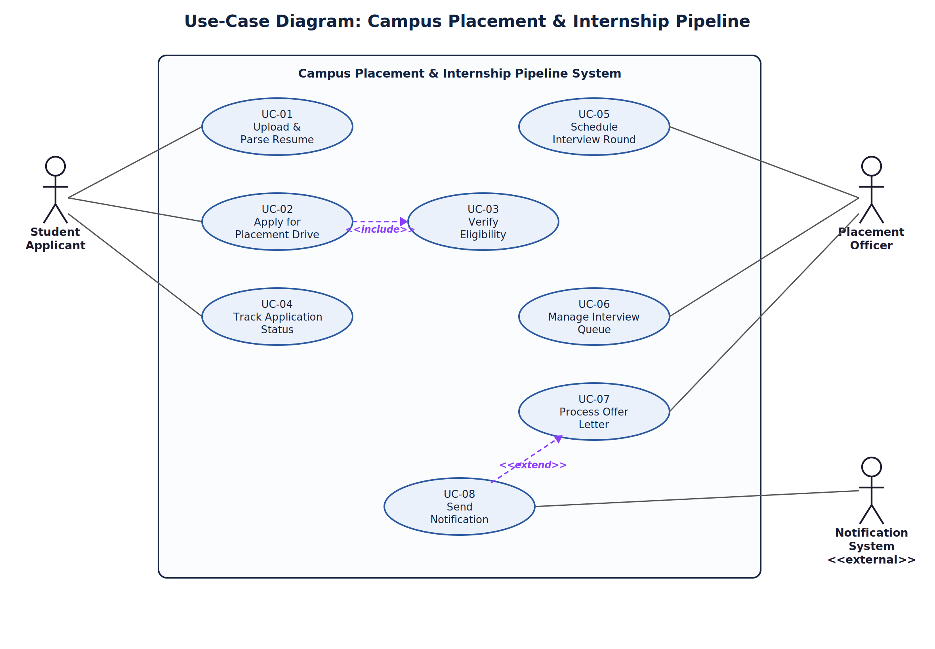

Use-Case Flow Specification
Lab 1: Requirements Engineering & UML Use-Case Modelling
Problem Statement #03 – Campus Placement & Internship Pipeline
Name: TARUN GOWDA P
SRN: PES1UG24AM303
Use Case ID | UC-02
Use Case Name | Apply for Placement Drive
Actor(s) | Student Applicant (primary); System (Verify Eligibility, included)
Preconditions | 1) The Student Applicant has a registered account and has already uploaded a resume (UC-01 – Upload & Parse Resume completed). 2) The target placement drive is published and currently open for applications.
Postconditions | Success: An application record is created with status “Applied” and the student is notified. Failure: No application record is created; a “Not Eligible” result with reason is logged against the student and drive.

Main Success Scenario
1. Student Applicant selects an active placement drive from the dashboard.
2. System displays the drive details, including eligibility criteria (CGPA cutoff tier, backlog policy) and the application deadline.
3. Student Applicant clicks “Apply.”
4. System retrieves the student’s academic record (CGPA, active backlog count) and previously parsed resume skill tags.
5. System invokes the «include» use case Verify Eligibility (UC-03) to check the student against the drive’s multi-tier CGPA and backlog rules.
6. Verify Eligibility confirms the student meets all eligibility criteria for the drive.
7. System creates an application record with status “Applied” and timestamps the submission.
8. System sends a confirmation notification to the student (via UC-08 – Send Notification).
9. Use case ends successfully.

Alternate Flow – 5a. Student Does Not Meet Eligibility Criteria
• 5a1. Verify Eligibility determines that the student’s CGPA or active-backlog count violates the drive’s eligibility rule.
• 5a2. System displays a “Not Eligible” message along with the specific discrepancy reason (e.g., “CGPA below Tier-2 cutoff of 7.5”).
• 5a3. System logs the rejected attempt for audit purposes but does not create an application record.
• 5a4. Use case ends; the application is not submitted.

