HandsMen Threads: Elevating the Art of Sophistication in Men's Fashion

Submitted By:
Name: Tummala Taruni
Roll No.: 238W1A0560
College Email: 238w1a0560@vrsec.ac.in

PROJECT OVERVIEW
HandsMen Threads is a dynamic organization in the fashion industry that specializes in premium men's bespoke tailoring and personalized styling. The objective of this Salesforce project is to develop a centralized platform for managing business data and improving customer relationships.
The Salesforce application is designed to maintain customer, product, order, inventory, and marketing campaign information in a structured manner. The system also provides a foundation for implementing automation such as automated order confirmations, dynamic loyalty management, proactive stock alerts, and scheduled bulk order processing.
The project focuses on maintaining data integrity through the Salesforce user interface and improving overall business efficiency through Salesforce automation and development features.

PROJECT OBJECTIVES
The main objectives of the HandsMen Threads Salesforce project are as follows:

Centralized Data Management
The project aims to provide a centralized platform for storing and managing business information. Instead of maintaining information across separate systems, customer, product, order, inventory, and marketing data can be organized within Salesforce.

Data Integrity
Maintaining accurate and consistent data is an important requirement of the project. Salesforce configuration features are used to ensure that users enter valid and appropriate information through the user interface.

Customer Management
The system provides a structured approach to maintaining customer information. Customer data can subsequently be used for order processing, customer communication, and loyalty management.

Order Management
The project provides a dedicated object for maintaining order information. Unique order numbers are automatically generated using Salesforce Auto Number functionality.

Inventory Management
The Inventory object provides a dedicated structure for storing stock-related information. This information can subsequently be used to monitor stock levels and trigger alerts when inventory falls below the required threshold.

Marketing Management
The Marketing Campaign object provides a structured way of maintaining campaign-related information.

Business Process Automation
The project aims to automate repetitive business activities such as order confirmation emails, loyalty updates, stock alerts, and bulk order processing.
These objectives establish the foundation for the Salesforce implementation described in the subsequent sections.

Data Model Design

The data model for the HandsMen Threads Salesforce project was designed to organize the core business information of the organization. It includes custom objects for managing customers, products, orders, inventory, and marketing activities. The model provides the foundation for maintaining data consistency and supporting the required business processes.
The standard Salesforce objects do not provide all the business-specific structures required by HandsMen Threads. Therefore, custom objects were created to represent the organization's specific business entities.
Five custom objects were identified for the project:
- HandsMen Customer
- HandsMen Product
- HandsMen Order
- Inventory
- Marketing Campaign
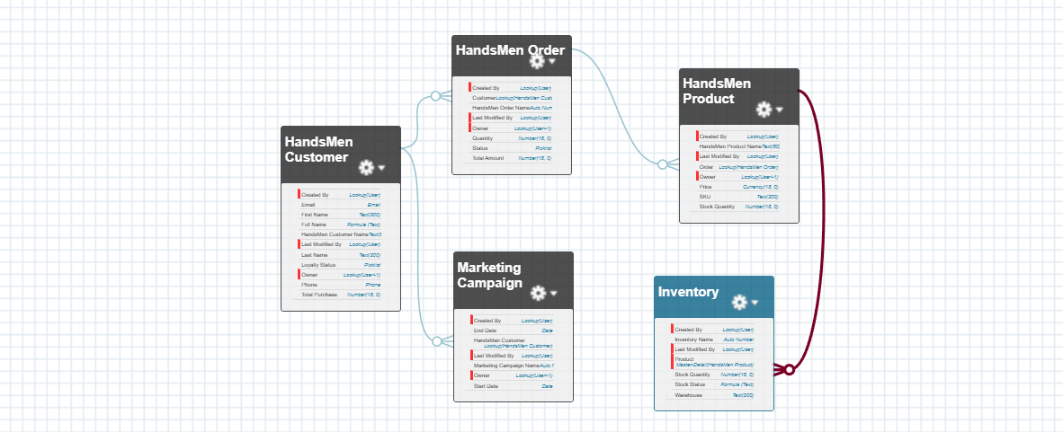
Object – HandsMen Customer
Description
The HandsMen Customer object is designed to maintain customer information in a structured manner. It acts as the main customer record used by order management and customer-related processes, including the loyalty program.

Object Creation Procedure
- Open Setup using the Gear icon.
- Select Object Manager.
- Click Create → Custom Object.
- Enter the required object details.
- Enable Allow Reports and Allow Search.
- Click Save.

Property | Configuration
Label | HandsMen Customer
Plural Label | HandsMen Customer
Record Name | HandsMen Customer Name
Data Type | Text
Allow Reports | Enabled
Allow Search | Enabled

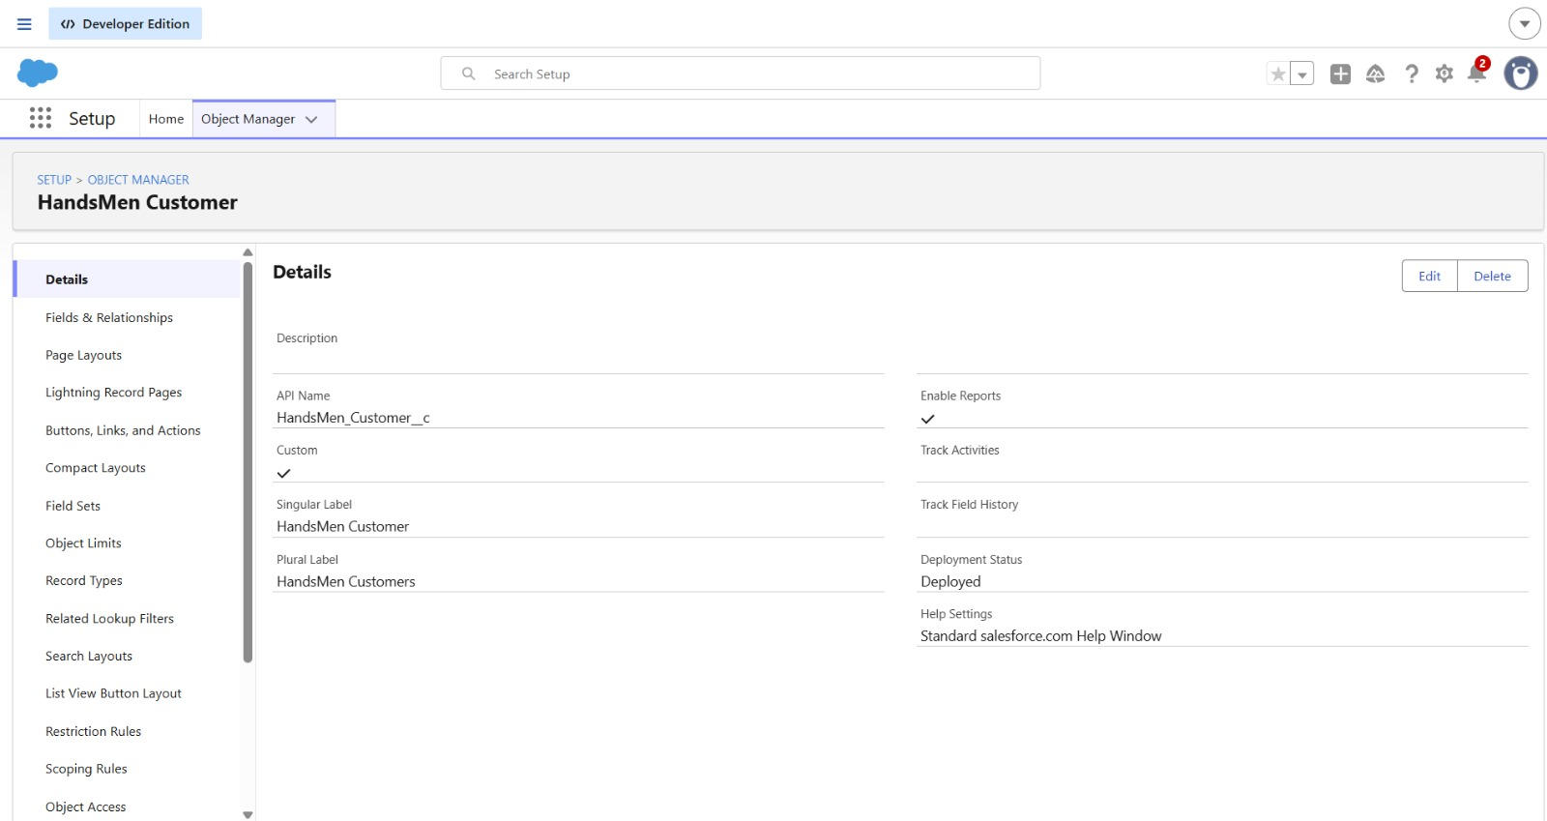

Object – HandsMen Product
The HandsMen Product object represents the products maintained by the organization. It provides the product information required for order and inventory-related operations.

Configuration
The object was configured with:
- Object Label: HandsMen Product
- Record Name: HandsMen Product Name
- Record Name Type: Text
- Reports: Enabled
- Search: Enabled

Purpose
The HandsMen Product custom object was created to maintain information about products offered by HandsMen Threads.
Product information is important for the organization's order and inventory processes. The object provides a dedicated location for maintaining product records.
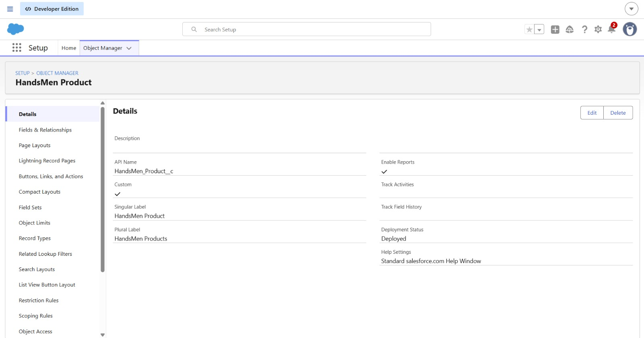
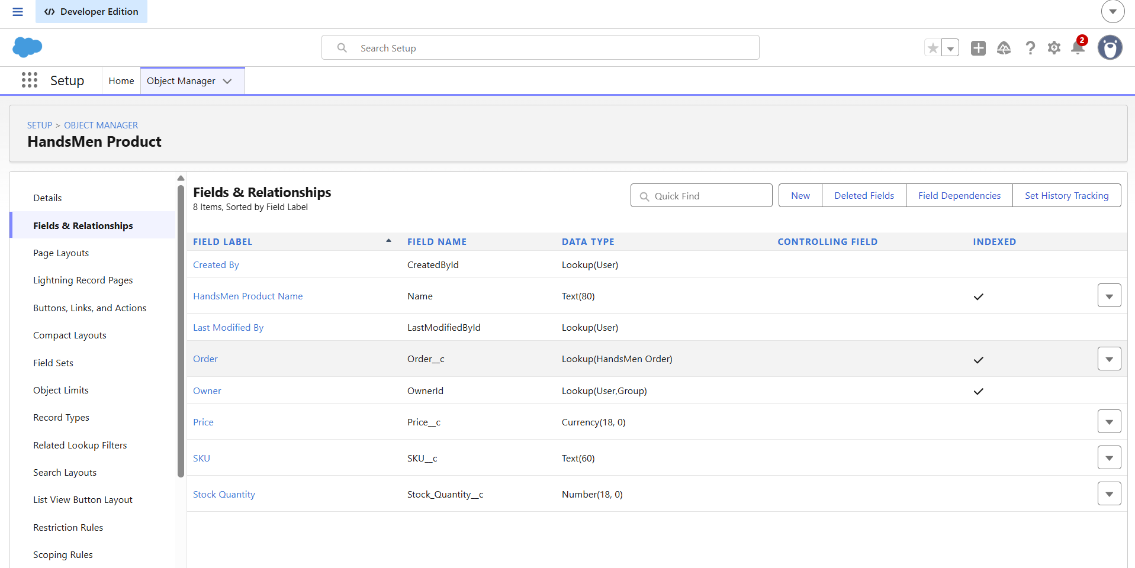
Object – HandsMen Order
The HandsMen Order object was introduced to manage customer orders. Since every order requires a unique identifier, an Auto Number field was selected for the record name.
The numbering format was configured as O-{0000}, beginning from 001.

Configuration
- Object Label: HandsMen Order
- Record Name: HandsMen OrderNumber
- Record Name Type: Auto Number
- Number Format: O-{0000}
- Starting Number: 001
- Reports: Enabled
- Search: Enabled
This object forms an important part of the automated order confirmation and order-related inventory processes.
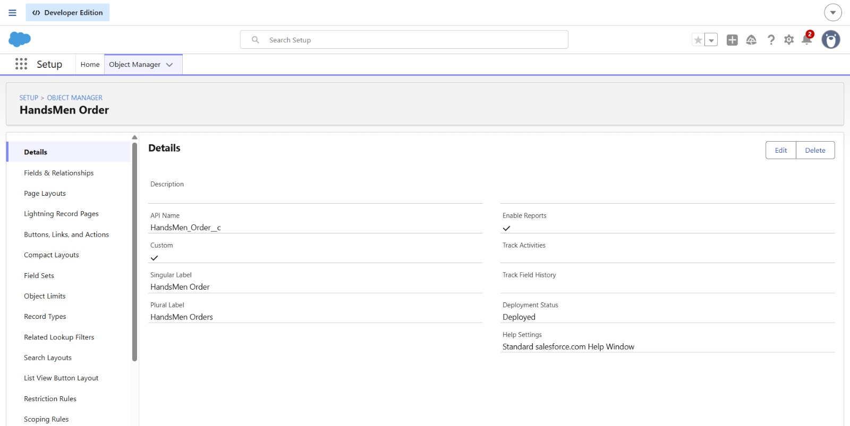
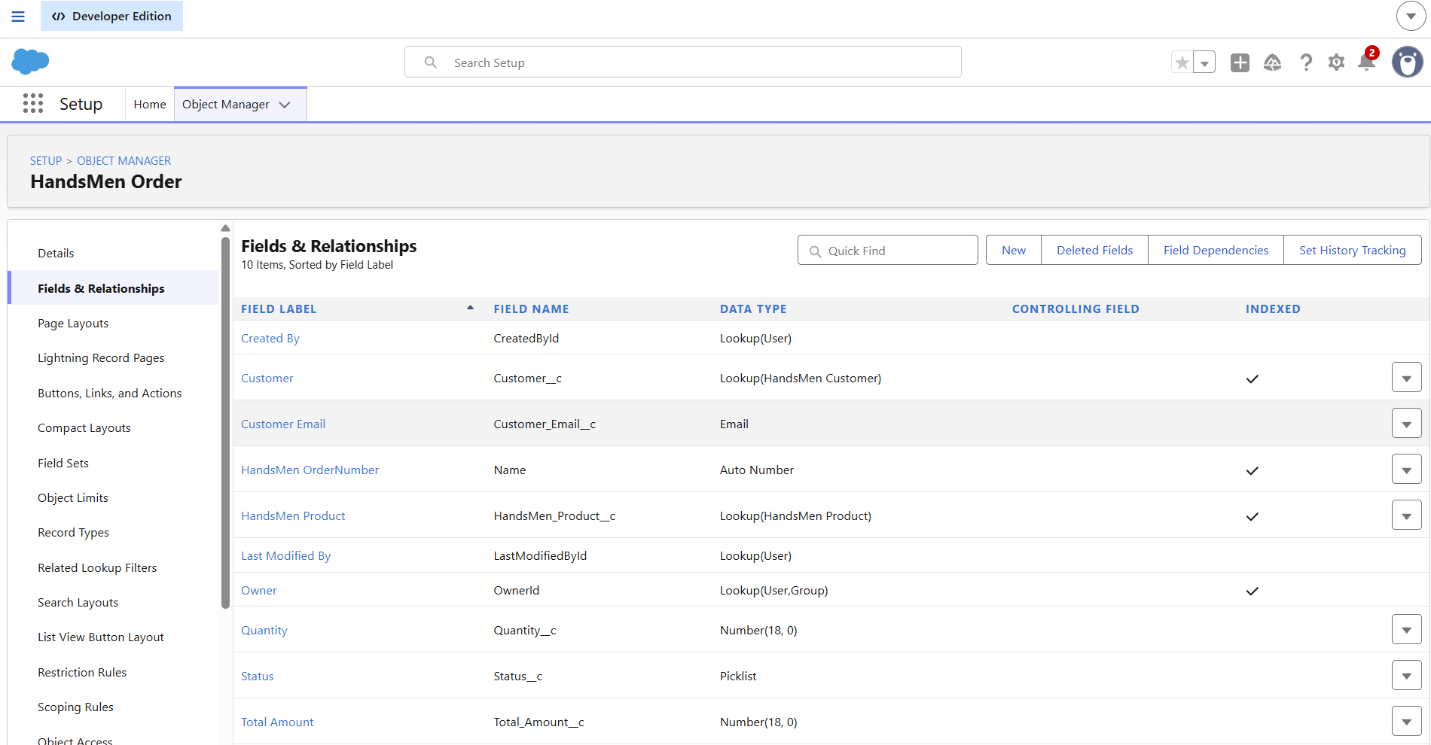
Object – Inventory
The Inventory object was created to maintain stock-related records. It supports the project's proactive stock alert requirement by providing a dedicated location for inventory information.
The record identifier was configured using Auto Number with the format I-{0000}, starting from 001.

Configuration
- Object Label: Inventory
- Record Name: Inventory Number
- Record Name Type: Auto Number
- Number Format: I-{0000}
- Starting Number: 001
- Reports: Enabled
- Search: Enabled
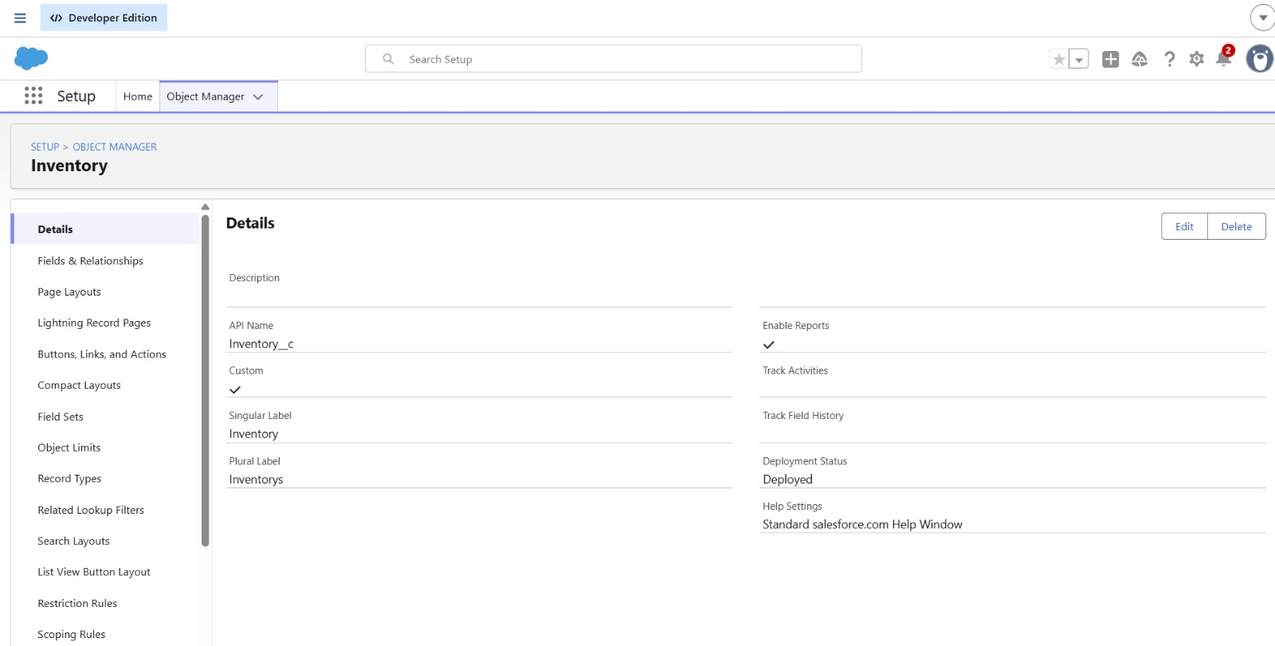
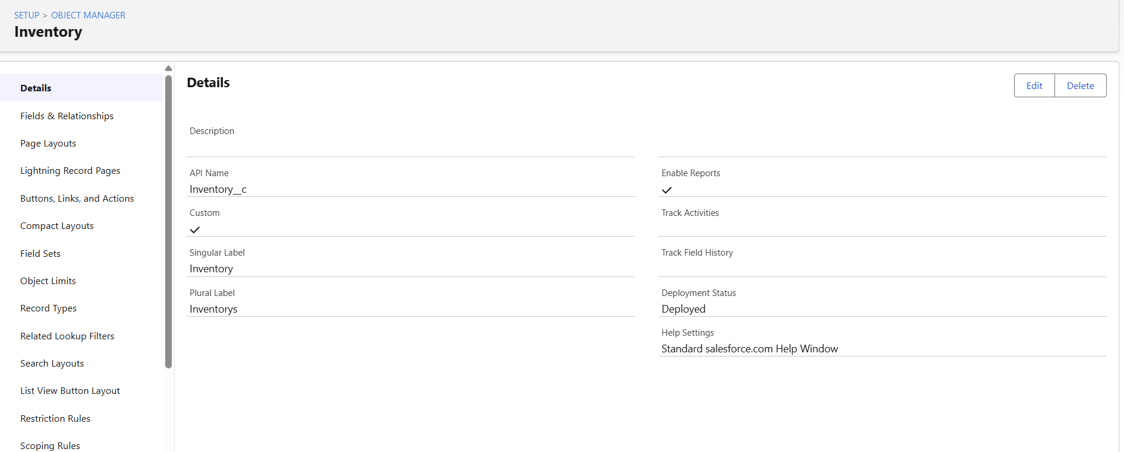
Object – Marketing Campaign
The Marketing Campaign object was created to organize campaign-related information within Salesforce. It supports the marketing activities included in the HandsMen Threads system.
The campaign records use an automatically generated identifier with the format MC-{0000}, starting from 001.

Configuration
- Object Label: Marketing Campaign
- Record Name: Marketing Campaign Number
- Record Name Type: Auto Number
- Number Format: MC-{0000}
- Starting Number: 001
- Reports: Enabled
- Search: Enabled
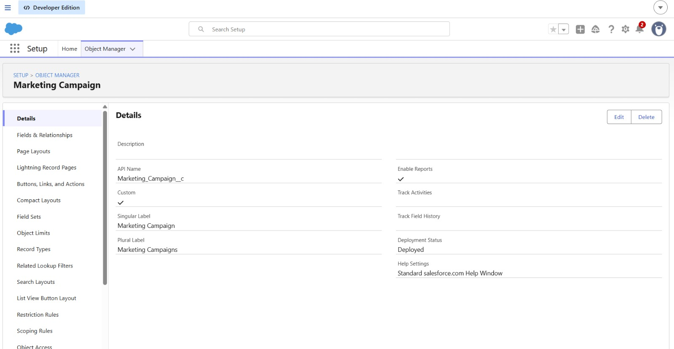
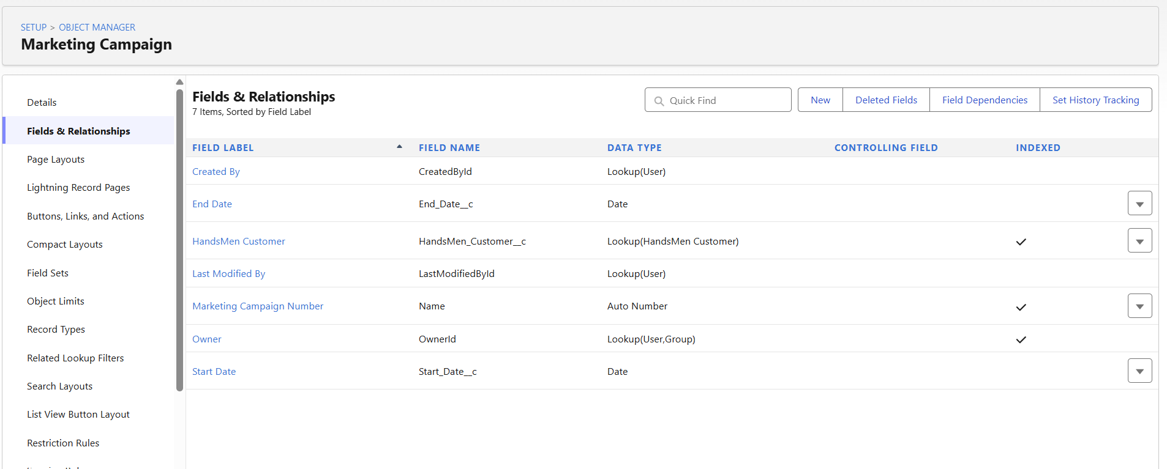
Data Management – Tabs
After creating the required custom objects, custom tabs were created to make these objects accessible from the Salesforce interface. The HandsMen Customer tab was created first, followed by tabs for the remaining custom objects.

Creating a Custom Tabs
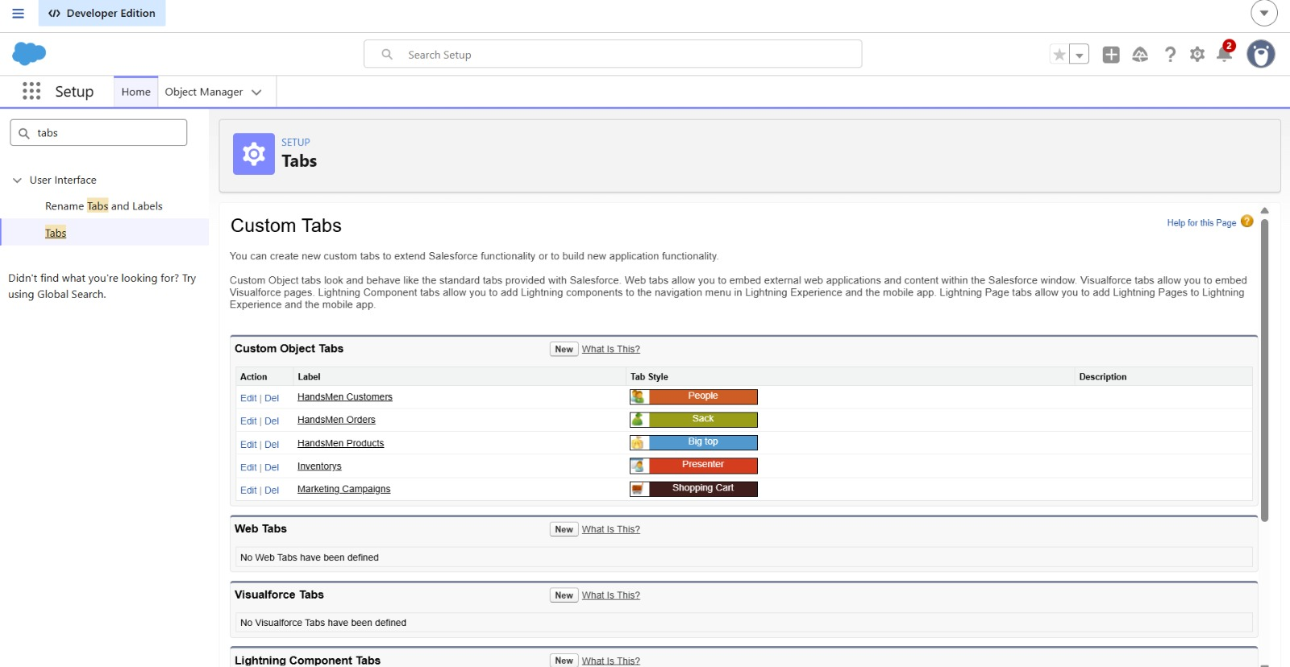

Tab—HandsMen Customer
- Navigate to Setup.
- Enter Tabs in the Quick Find search bar.
- Select Tabs under User Interface.
- In the Custom Object Tabs section, click New.
- Select HandsMen Customer as the object.
- Choose a suitable Tab Style.
- Click Next.
- Keep the Add to Profiles settings as default and click Next.
- Keep the Add to Custom Apps settings as default.
- Click Save.
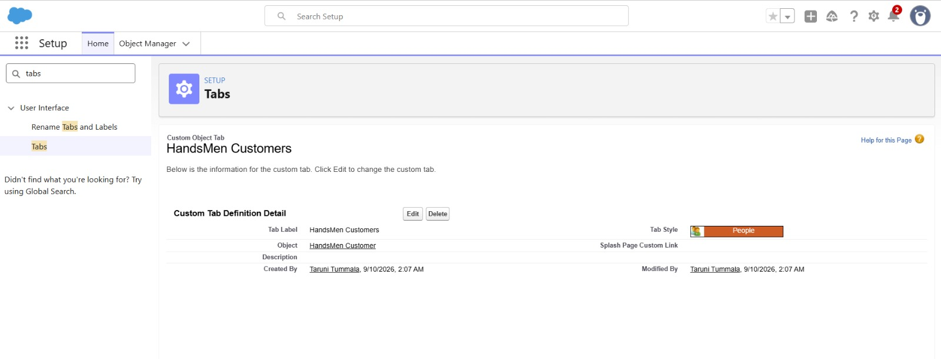

Creating Tabs for the Remaining Objects
The same procedure was followed to create custom tabs for the other objects created in the HandsMen Threads application:
- HandsMen Product
- HandsMen Order
- Inventory
- Marketing Campaign
Tab – HandsMen Product
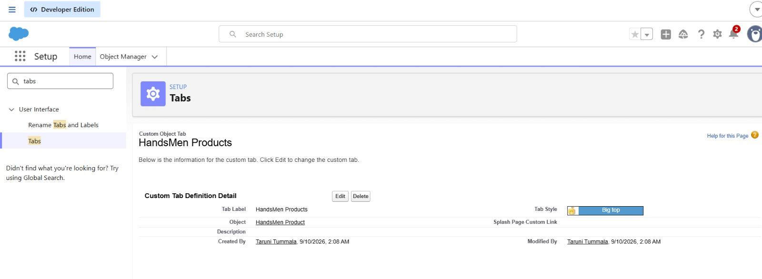
Tab – HandsMen Order
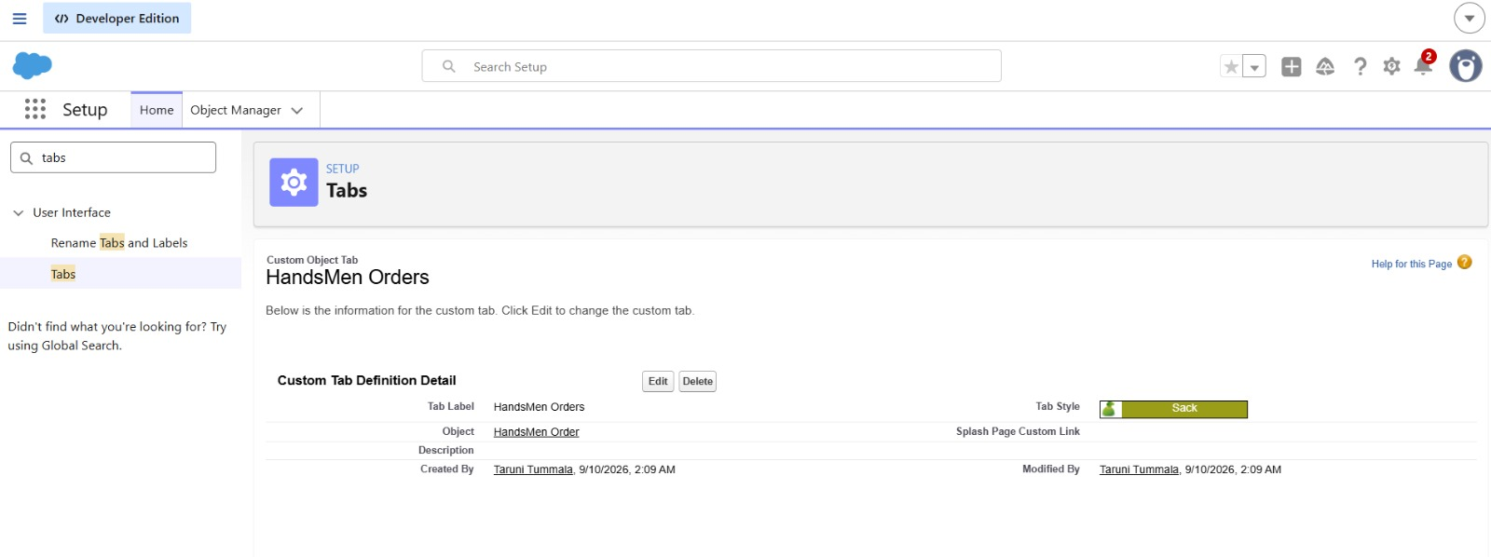
Tab – Inventory
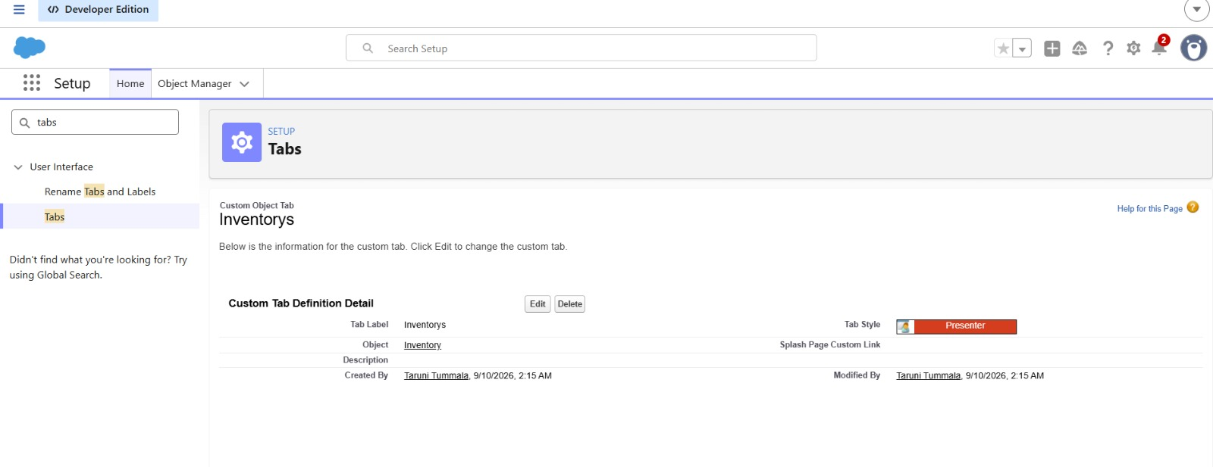
Tab – Marketing Campaign
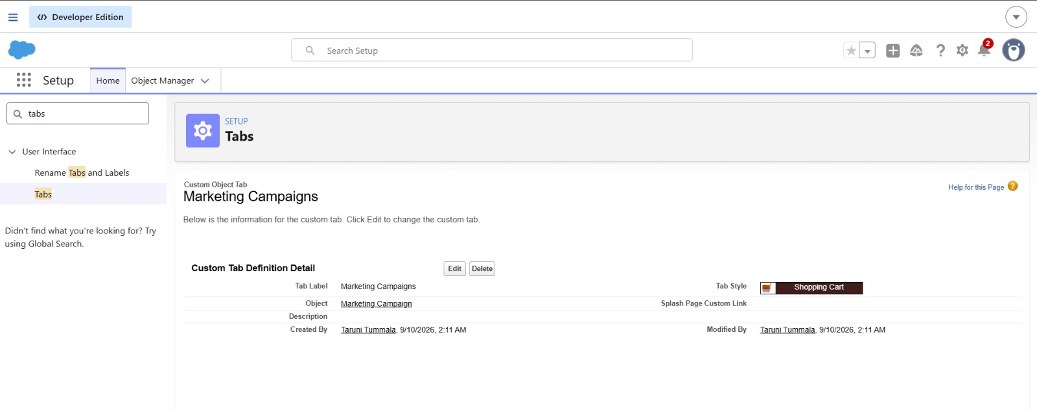
Data Management – App Manager
HandsMen Threads Lightning App
To bring the different components of the HandsMen Threads Salesforce project into one working interface, a dedicated Lightning Application named HandsMen Threads was configured. The application provides access to the custom objects and standard Salesforce features required for managing the organization's data.

Application Setup
The HandsMen Threads Lightning App was created using Setup → App Manager → New Lightning App.
The application details were configured as follows:
- App Name: HandsMen Threads
- Developer Name: Automatically populated
- Description: Give a meaningful description
- Image: Optional
- Primary Color: Default
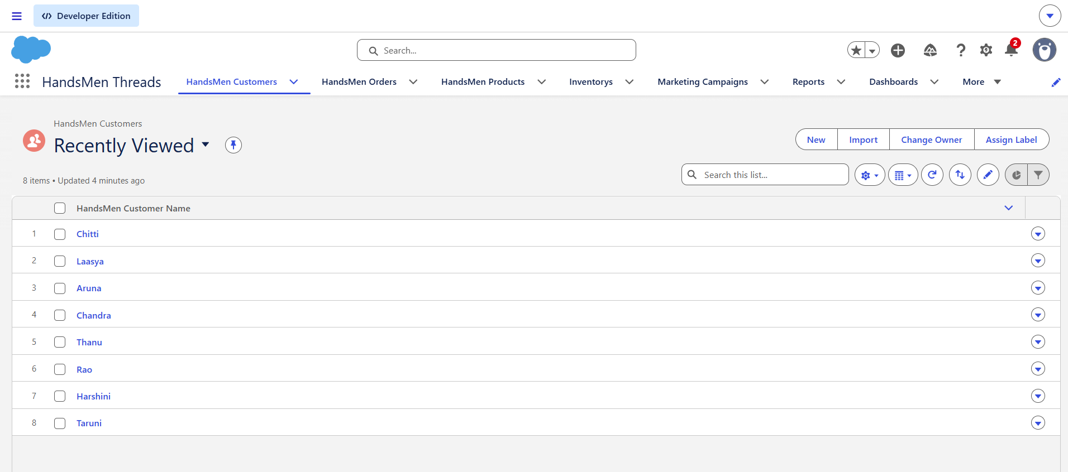

Navigation Items
The required custom objects and Salesforce features were added to the application's navigation menu:
- HandsMen Customers
- HandsMen Orders
- HandsMen Products
- Inventorys
- Marketing Campaigns
- Accounts
- Contacts
- Reports
- Dashboards
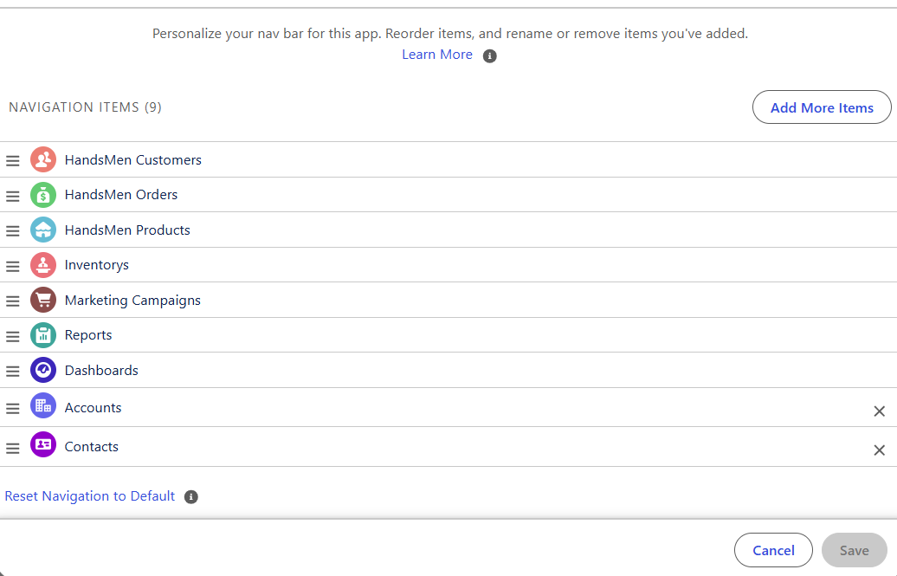

Add User Profiles
- Search for System Administrator in the profile search bar.
- Select the System Administrator profile.
- Use the arrow button to add the profile.
- Click Save & Finish.
Data Management – Fields

1. HandsMen Customer

Field – Email
The Email field is created in the HandsMen Customer object to store customer email information.
Steps:
- Go to Setup → Object Manager.
- Search for and open HandsMen Customer.
- Select Fields & Relationships → New.
- Select Email as the data type and click Next.
- Enter Email as the Field Label.
- The Field Name is automatically generated.
- Click Next → Next → Save and New.
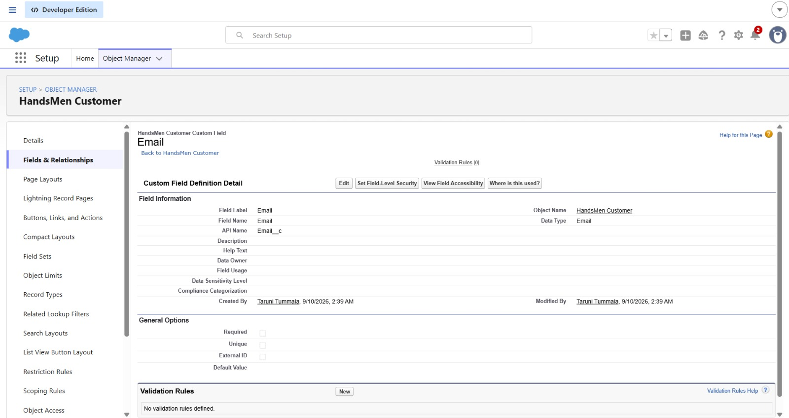

Field – Phone
The Phone field is created to maintain the customer's contact number.
Steps:
- Open HandsMen Customer → Fields & Relationships → New.
- Select Phone as the data type.
- Enter Phone as the Field Label.
- Click Next → Next → Save and New.
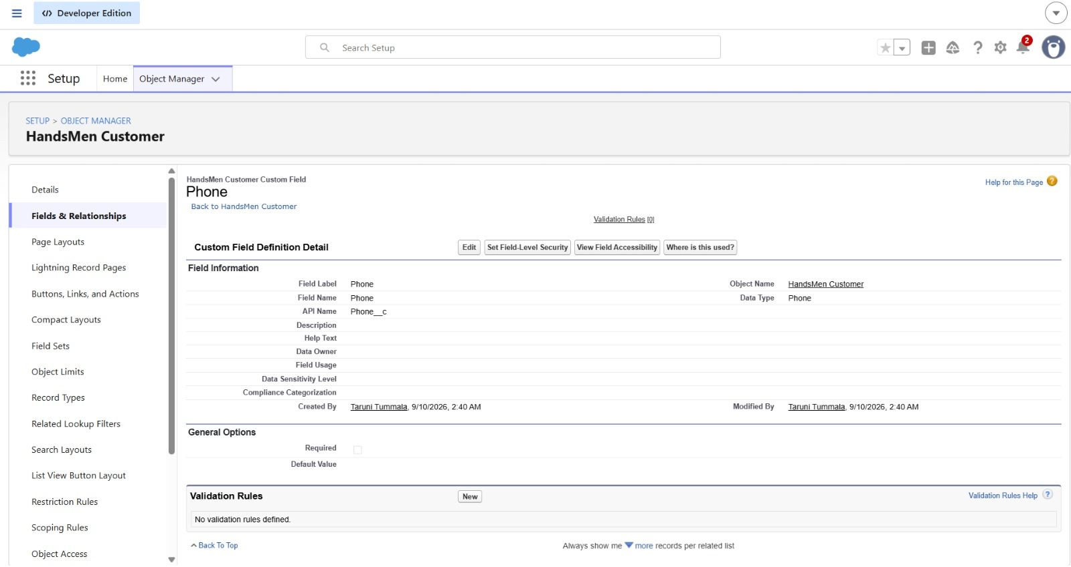

Field – Loyalty Status
The Loyalty Status field is created as a Picklist to maintain the loyalty category of customers.
Values:
- Gold
- Silver
- Bronze
Steps:
- Open HandsMen Customer → Fields & Relationships → New.
- Select Picklist as the data type.
- Enter Loyalty Status as the Field Label.
- Select Enter values, with each value separated by a new line.
- Enter the three loyalty values.
- Click Next → Next → Next → Save and New.
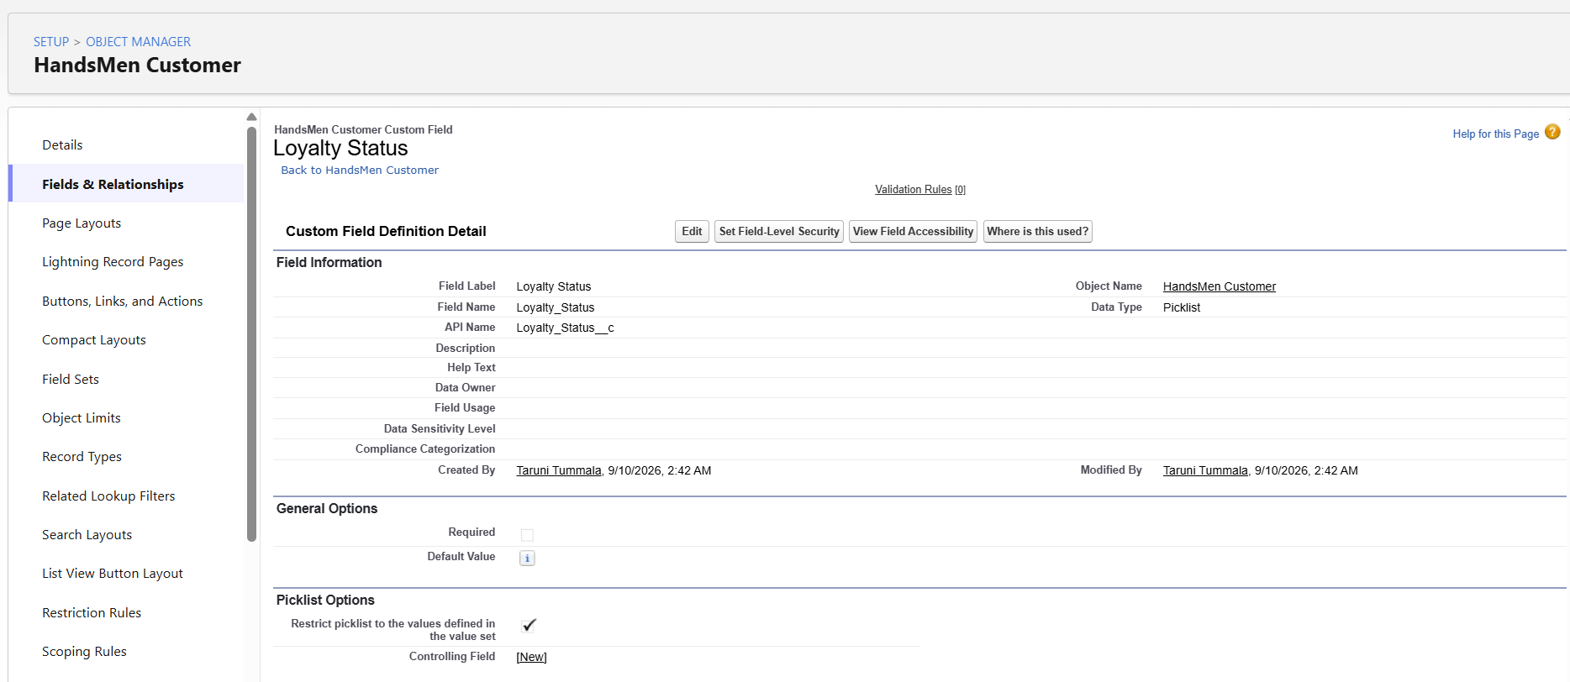
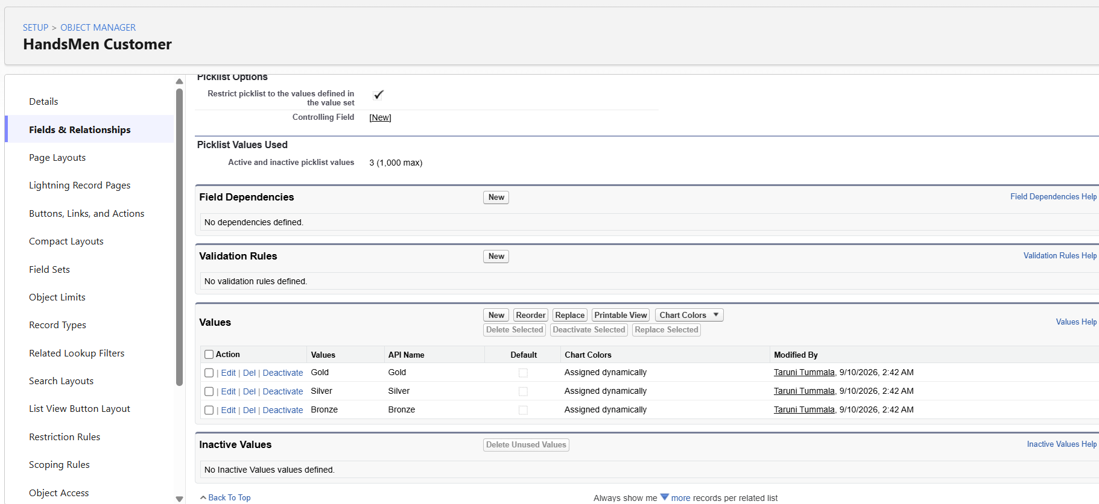
Field – Total Purchases
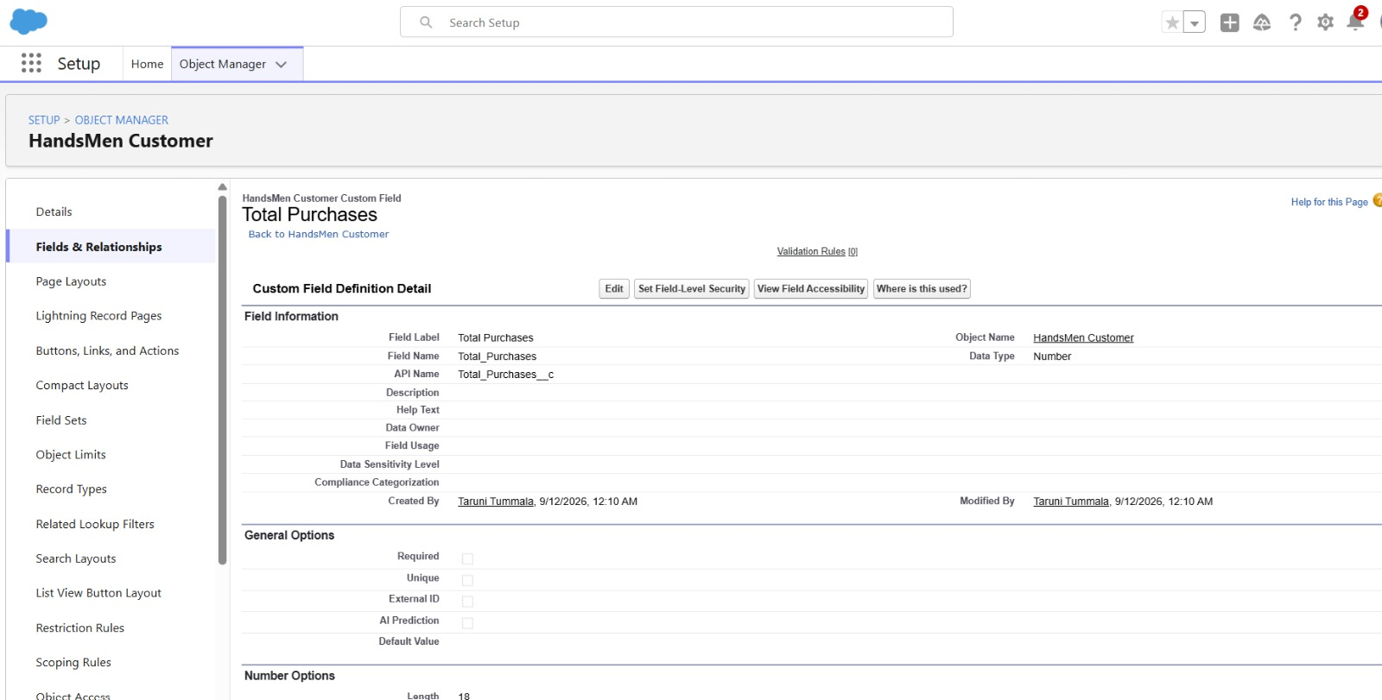
2. HandsMen Product
Field | Type
Name | Record Name
SKU | Text
Price | Currency
Stock Quantity | Number
Field – SKU
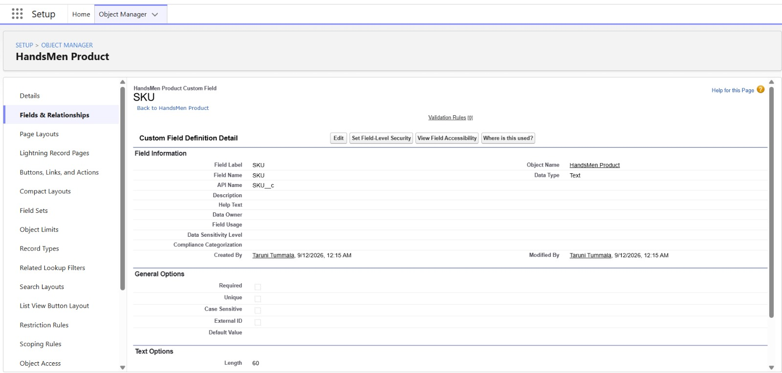
Field – Price
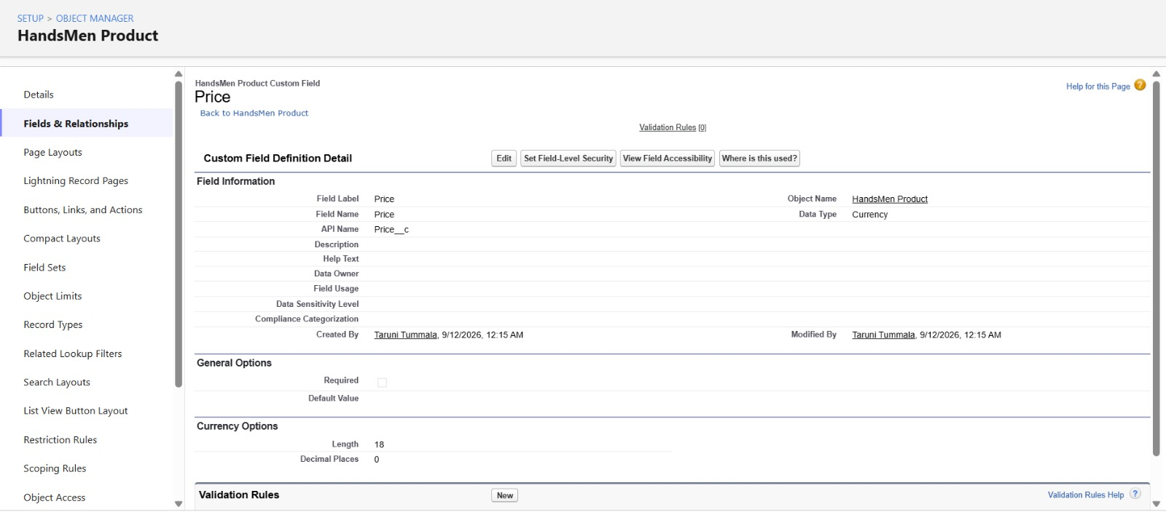
Field – Stock Quantity
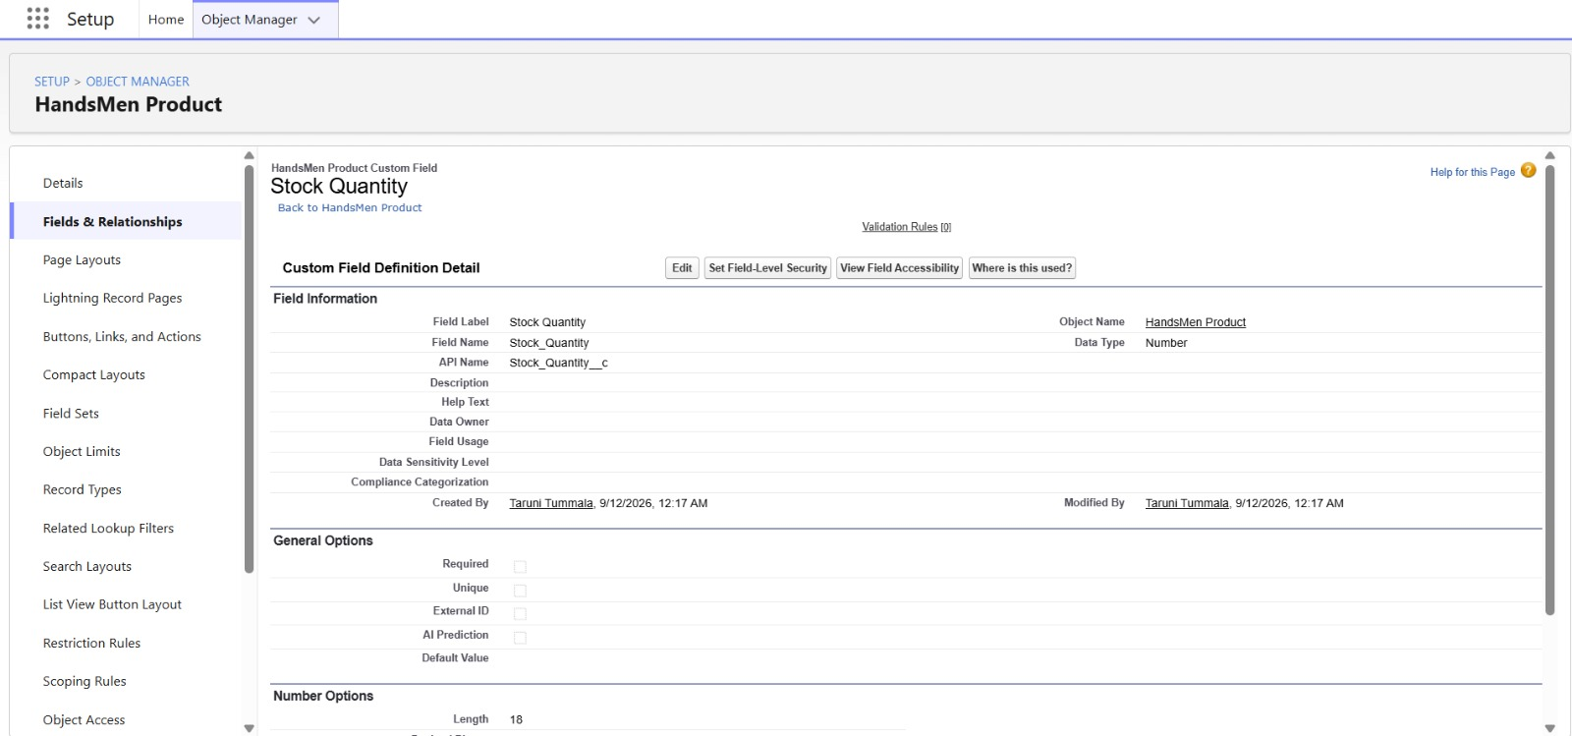
3. HandsMen Order
The HandsMen Order object was configured to capture information required for managing customer orders.
The fields created include:
- Status – maintains the current order state.
- Quantity – records the ordered quantity.
- Total Amount – stores the order amount
Field – Status
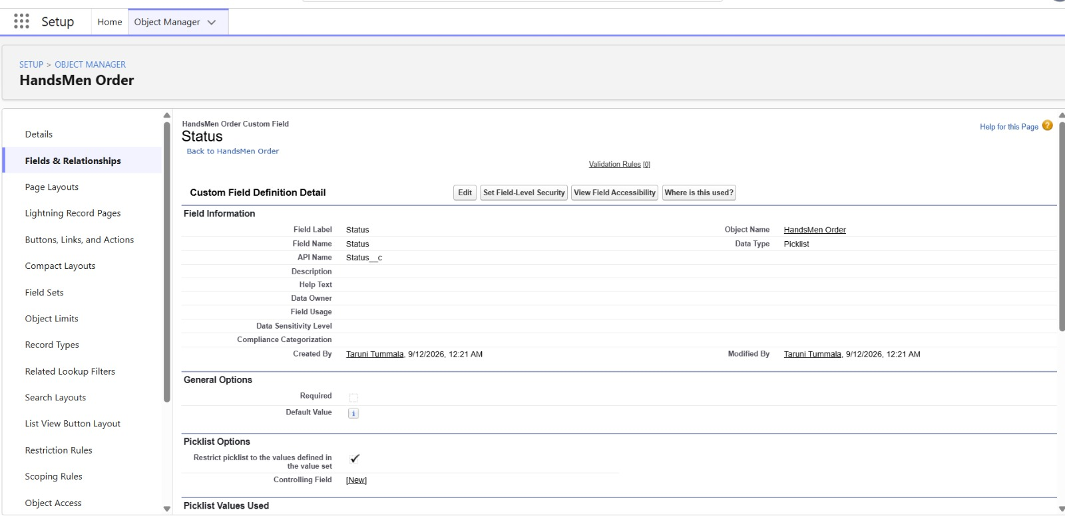
Field – Quantity
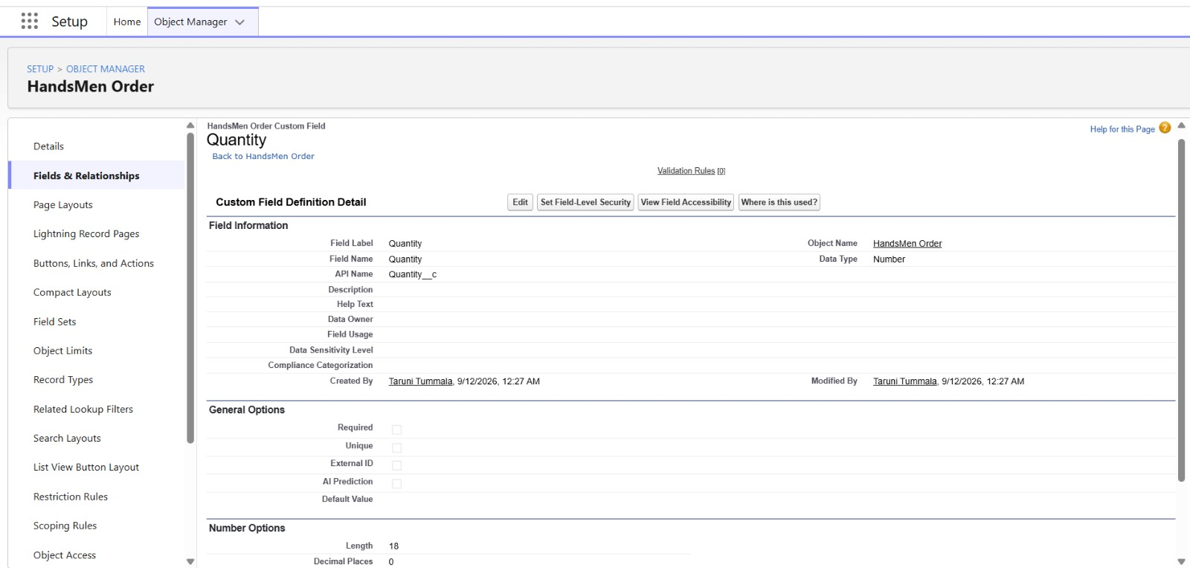

Field – Total Amount
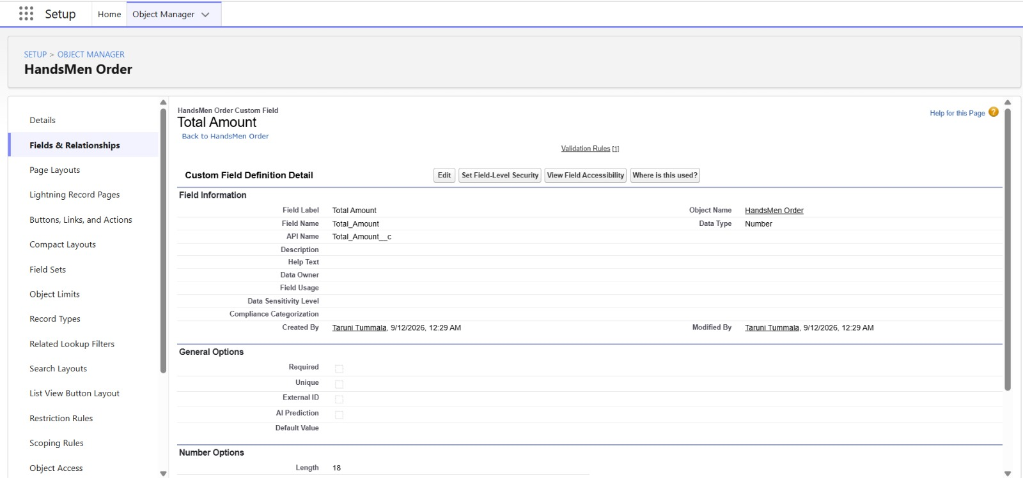
4. Inventory
The Inventory object was configured to maintain stock-related information.
The fields include:
- Warehouse – identifies the warehouse information.
- Stock Quantity – records the available stock.
- Stock Status – determines the current stock condition through a formula.
Field – Warehouse
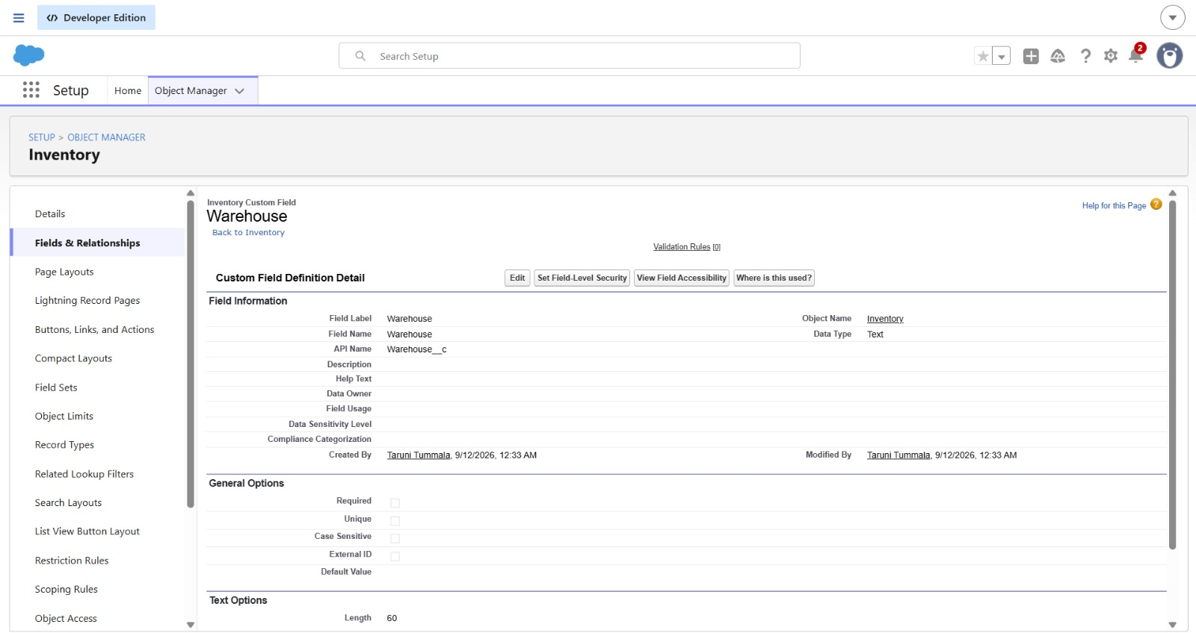

Field – Stock Quantity
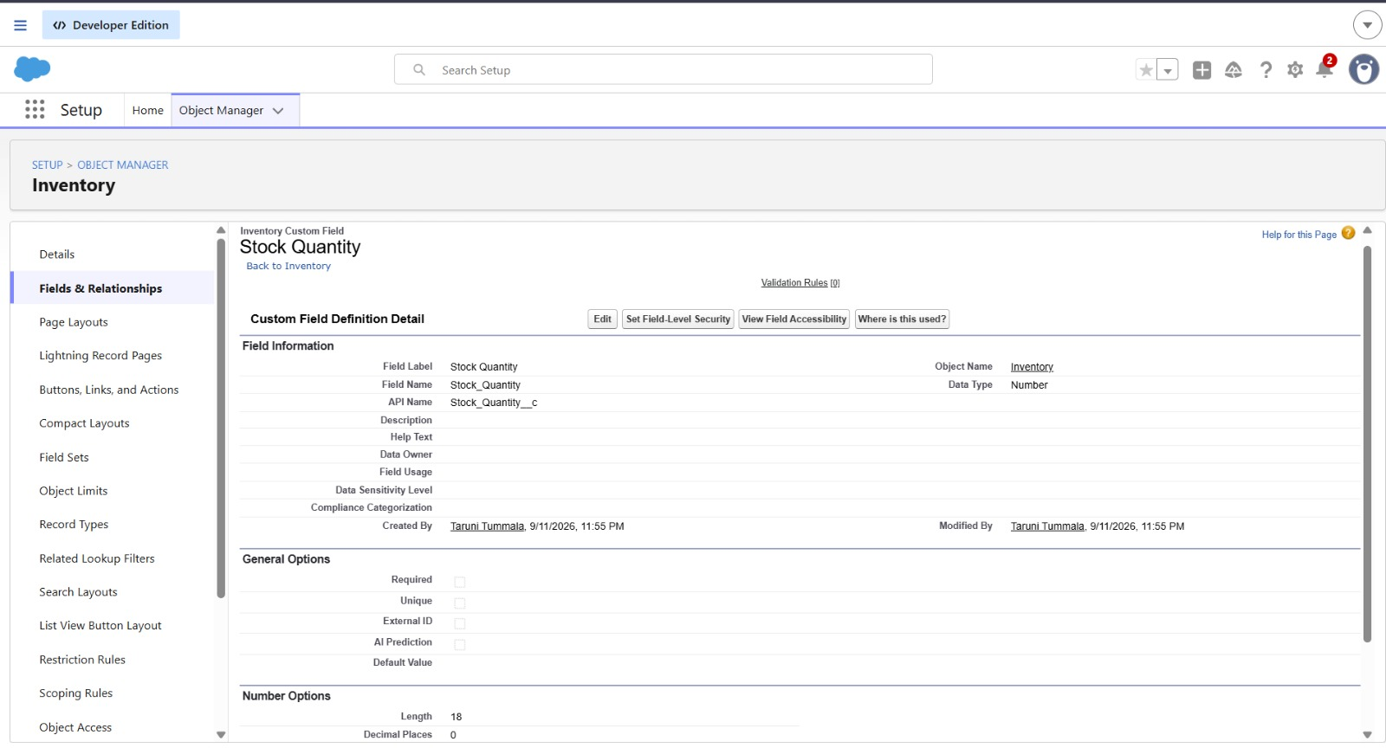
5. Marketing Campaign
The Marketing Campaign object was configured with fields required to maintain campaign details.
The campaign information includes:
- Start Date
- End Date
Field – Start Date
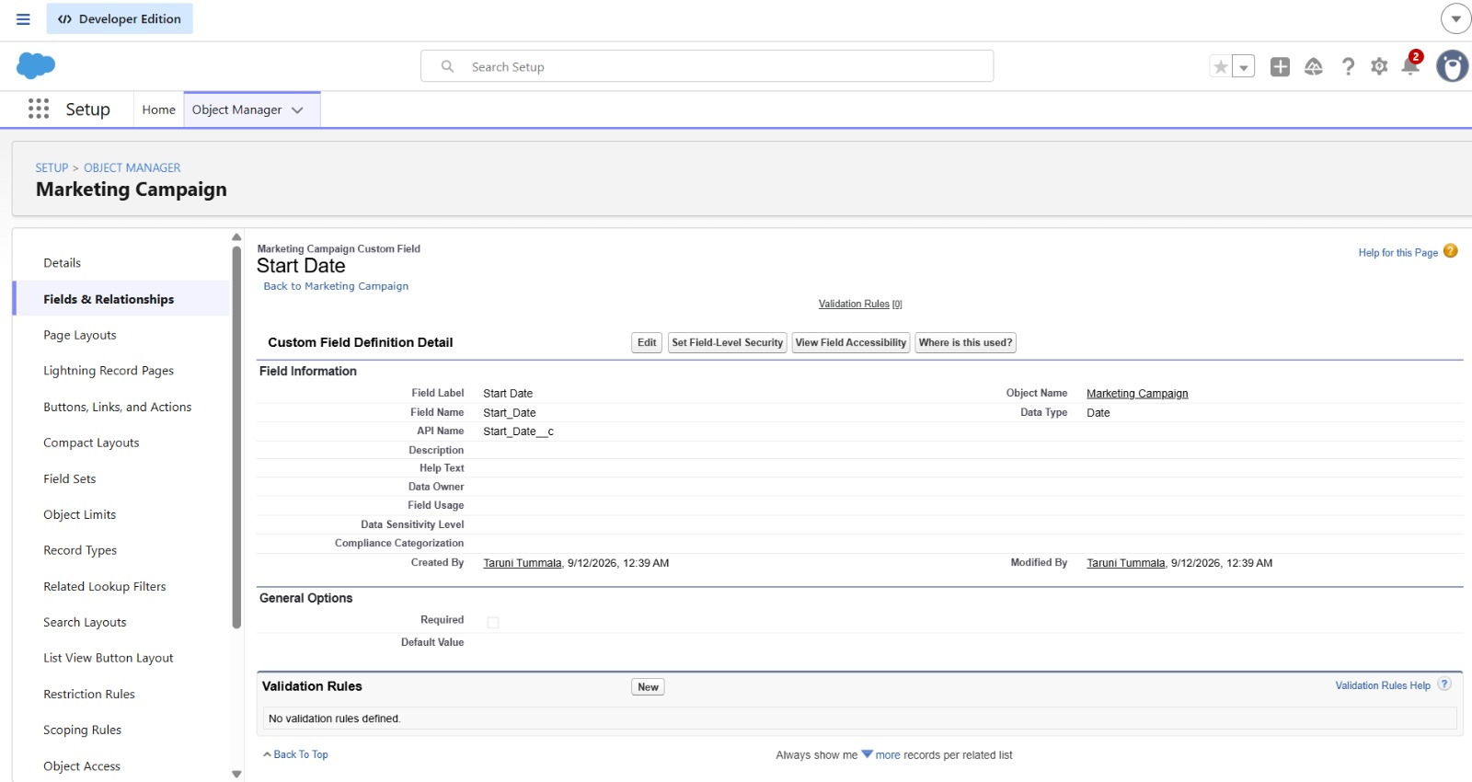
Field – End Date
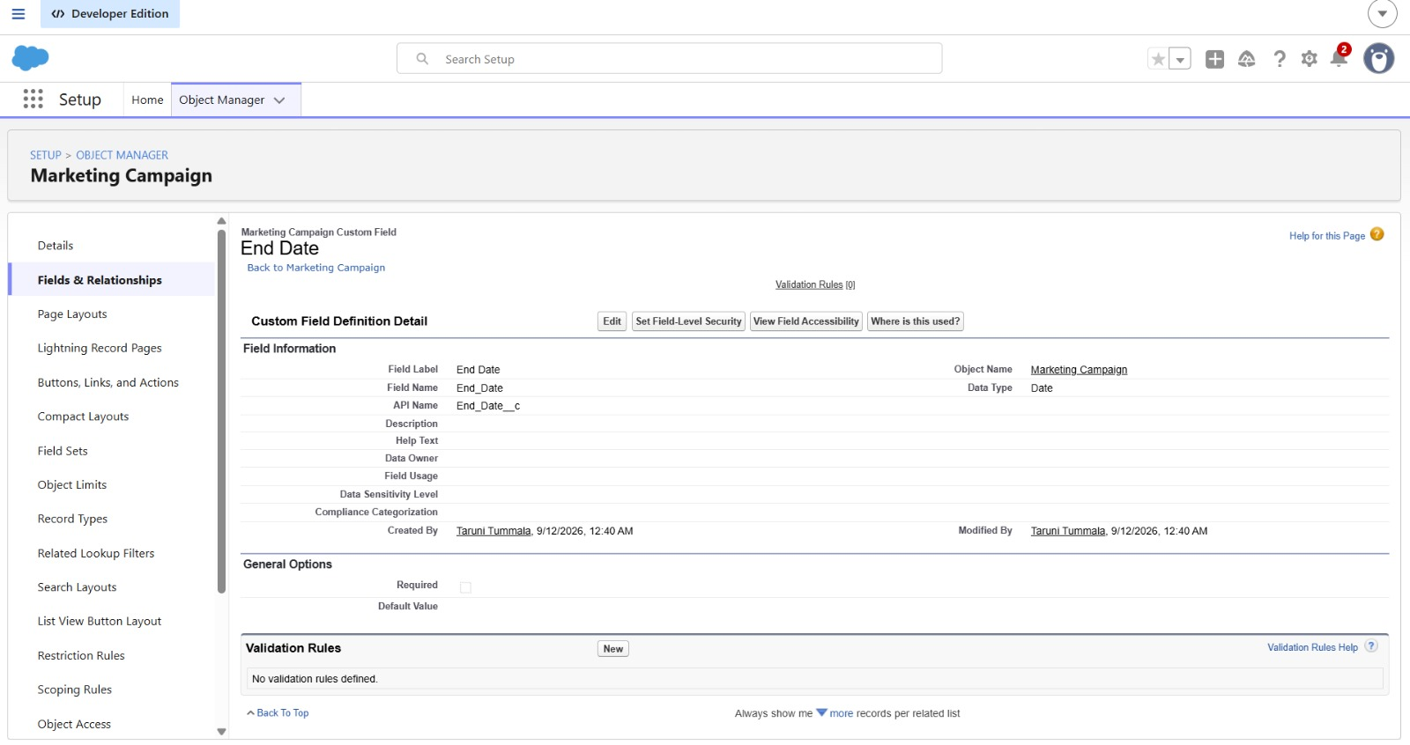
Data Management – Relationships
Relationships were created between the custom objects to connect the related records in the HandsMen Threads Salesforce application.

1. Lookup Relationship – Marketing Campaign and HandsMen Customer
A Lookup Relationship was created between the Marketing Campaign and HandsMen Customer objects to associate marketing campaign records with customer records.

Steps
- Go to Setup → Object Manager.
- Open Marketing Campaign.
- Select Fields & Relationships → New.
- Select Lookup Relationship as the data type and click Next.
- For Related To, select HandsMen Customer.
- Set the Field Label as HandsMen Customer.
- Click Next → Next → Save.
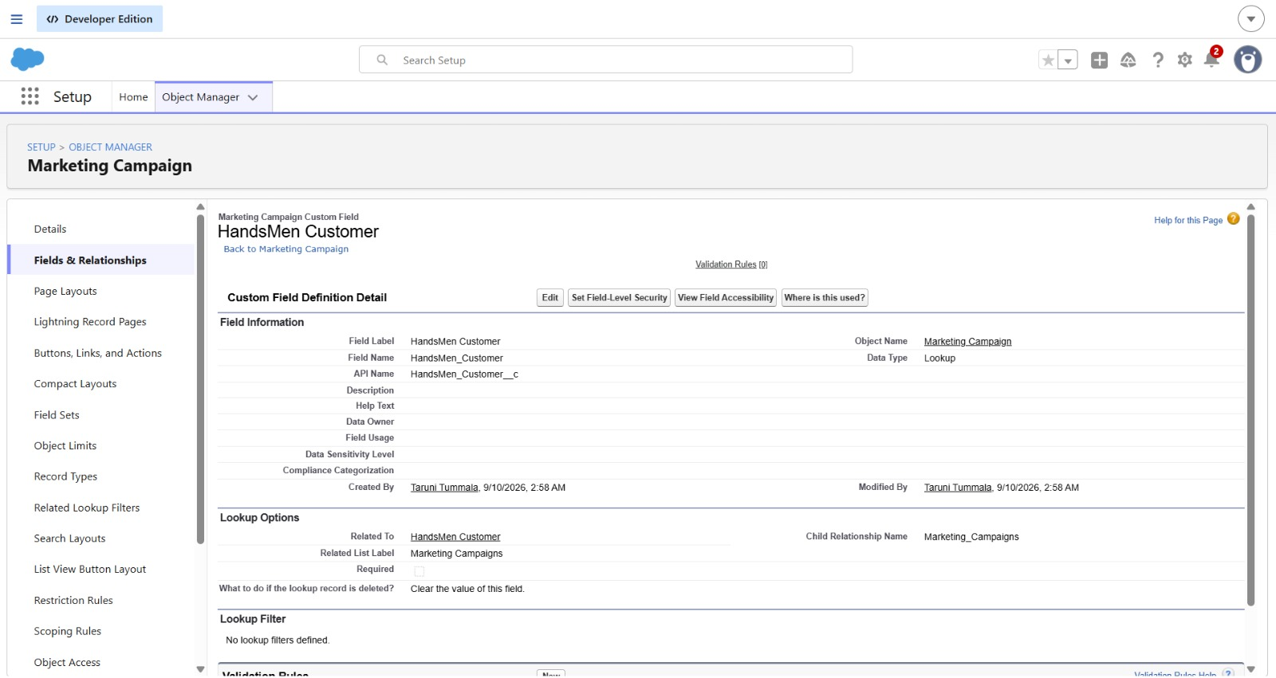

2. Lookup Relationship – HandsMen Product and HandsMen Order
A Lookup Relationship was created between the HandsMen Product and HandsMen Order objects to associate products with their corresponding orders.

Steps
- Go to Setup → Object Manager.
- Open HandsMen Product.
- Select Fields & Relationships → New.
- Select Lookup Relationship and click Next.
- For Related To, select HandsMen Order.
- Set the Field Label as Order.
- Click Next → Next → Save.

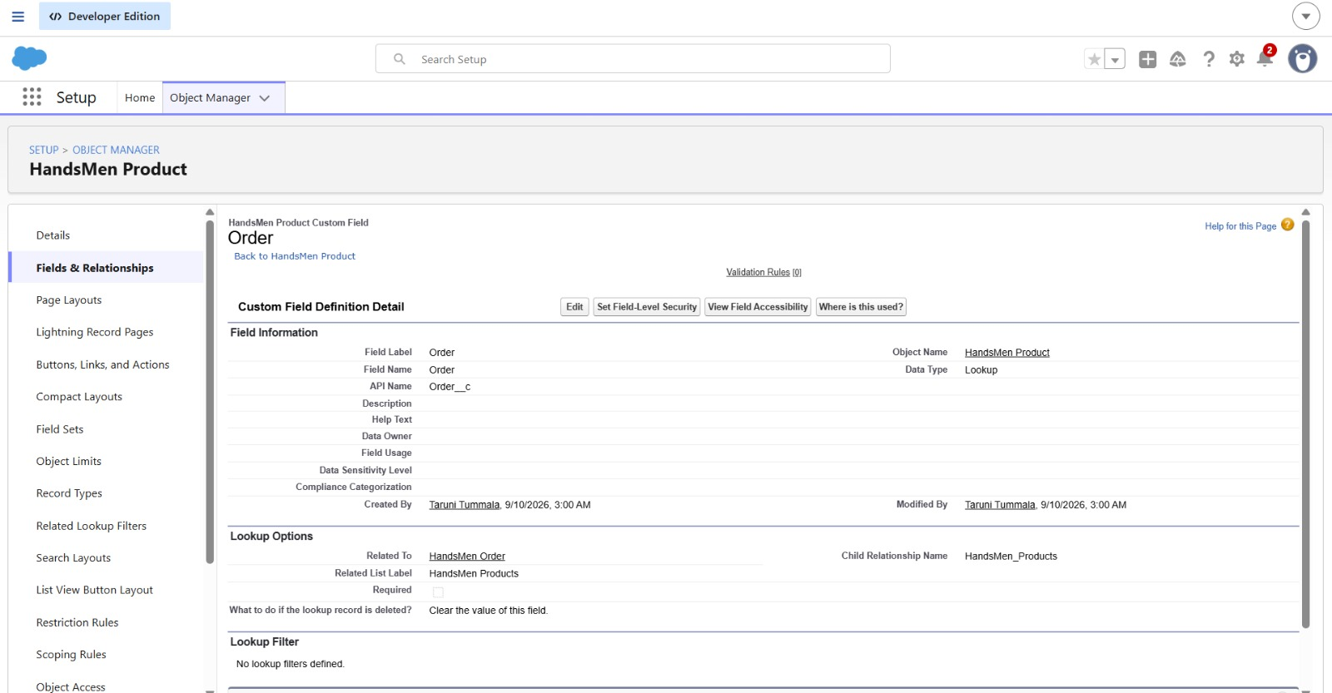
3. Lookup Relationship – HandsMen Order and HandsMen Customer
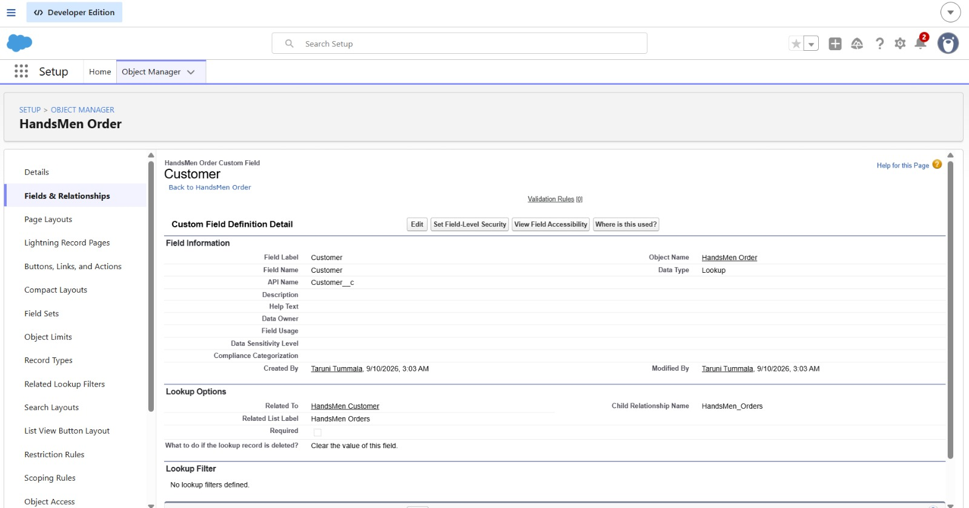
4. Master-Detail Relationship – Inventory and HandsMen Product
A Master-Detail Relationship was created between the Inventory and HandsMen Product objects to establish a dependent relationship between inventory records and products.

Steps
- Go to Setup → Object Manager.
- Open Inventory.
- Select Fields & Relationships → New.
- Select Master-Detail Relationship and click Next.
- For Related To, select HandsMen Product.
- Set the Field Label as Product.
- Click Next → Next → Save.

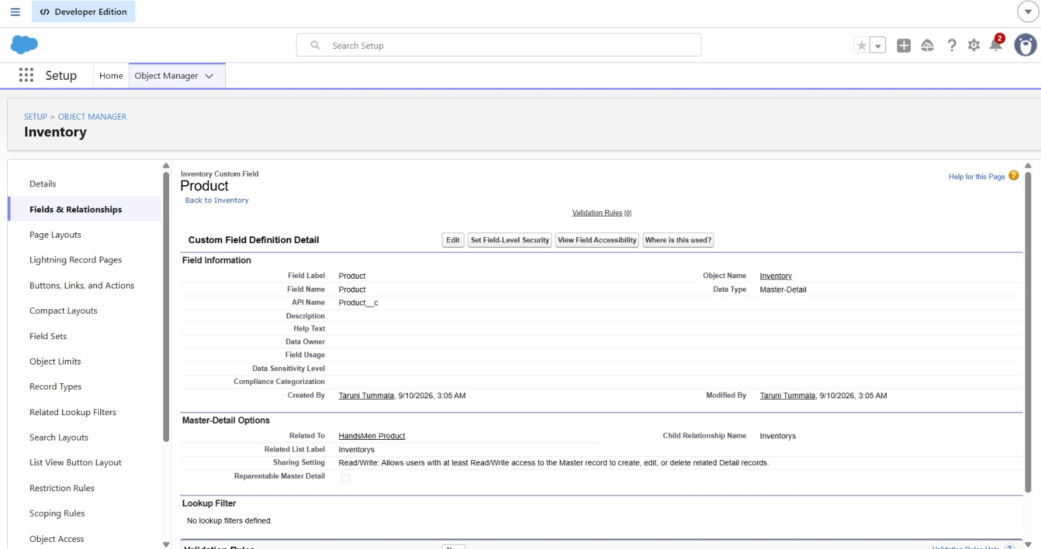

HandsMen Customerr
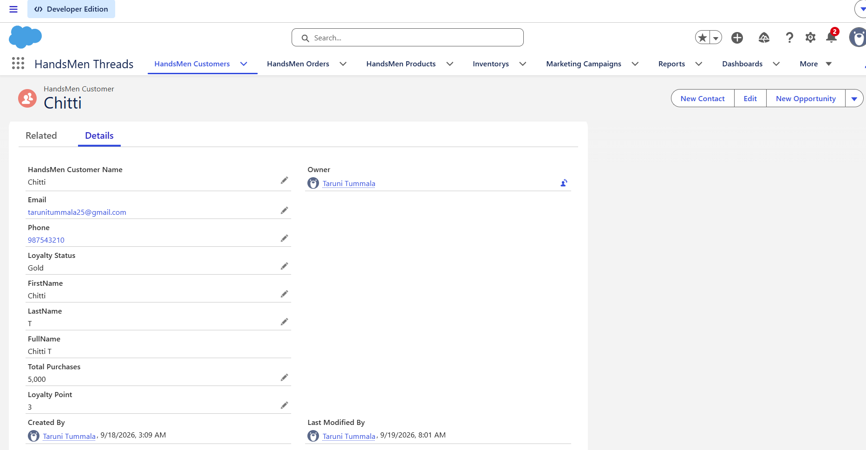

HandsMen Order
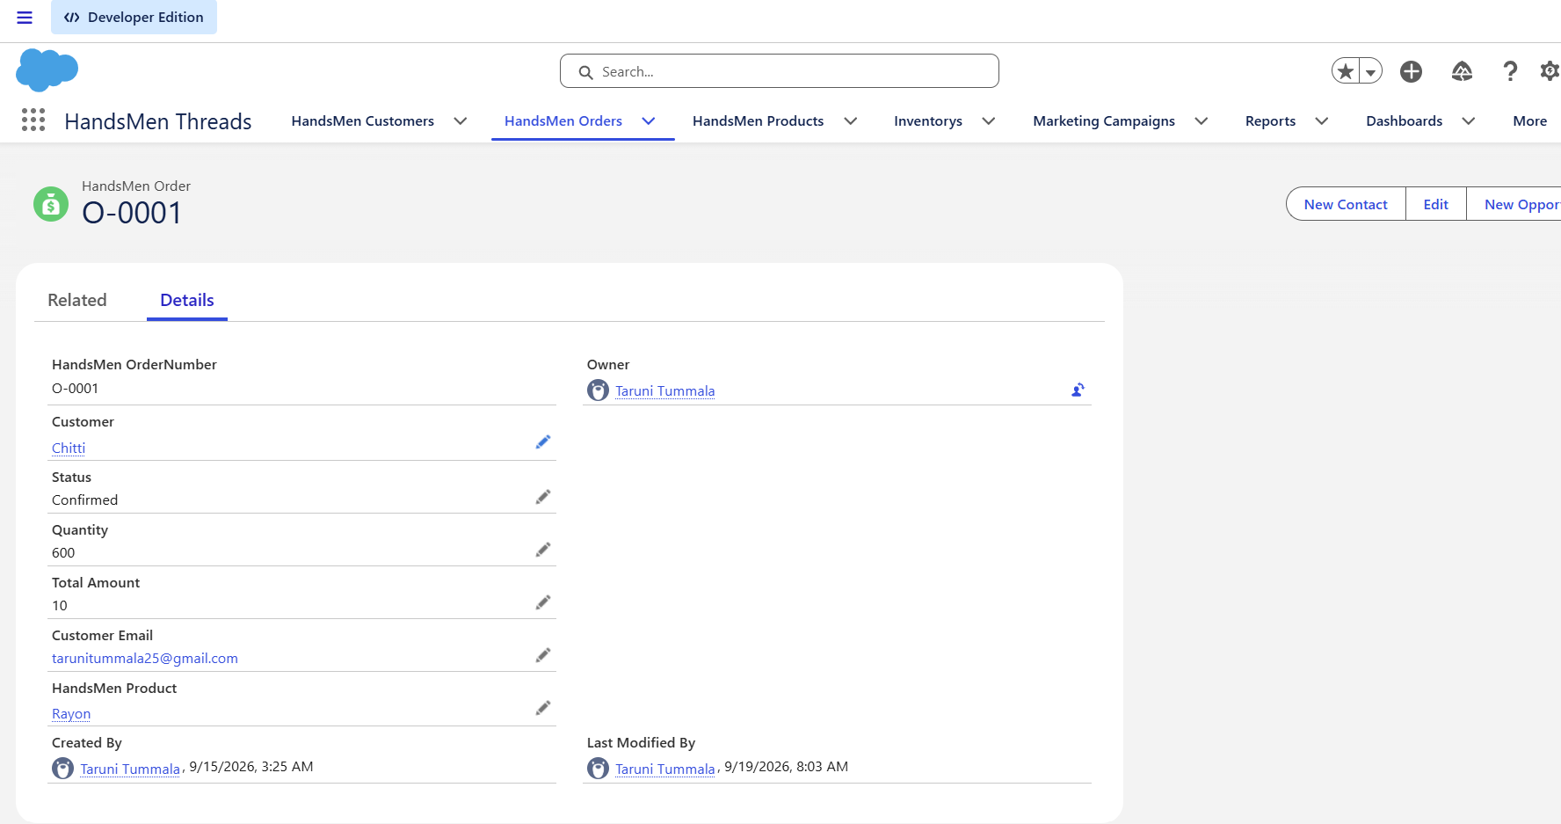
HandsMen Product
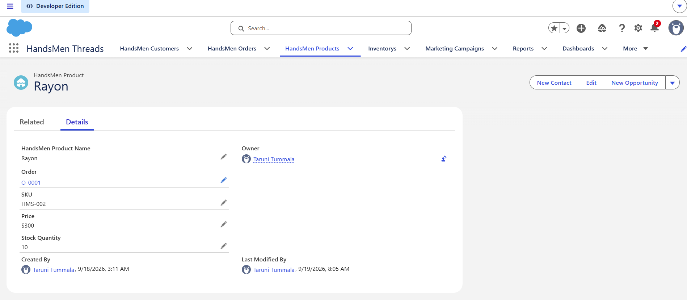
Inventory
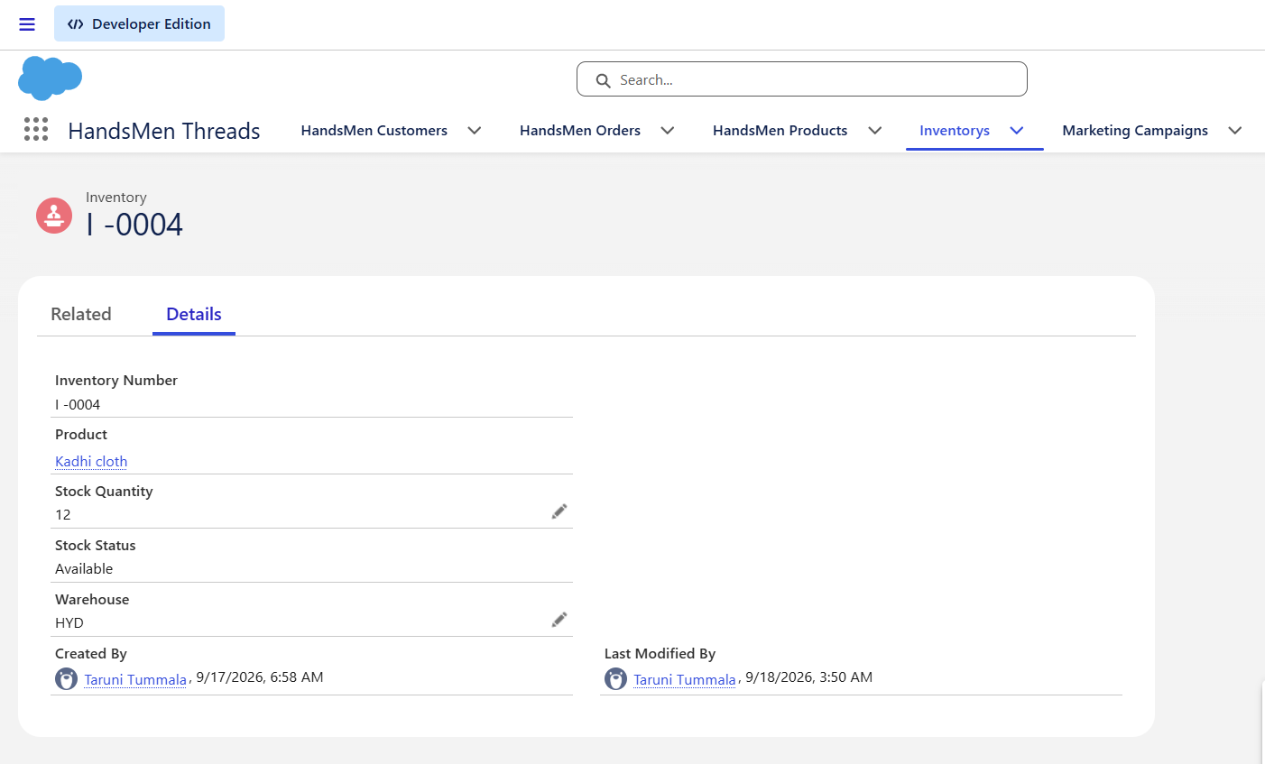
Marketing Campaign
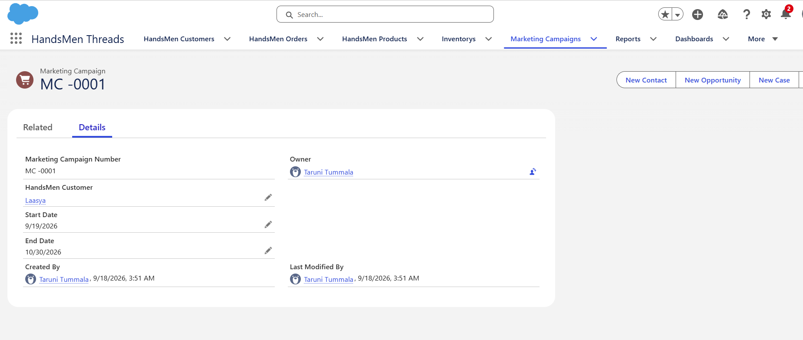
Formula Fields
Formula fields were created in Salesforce to automatically calculate or derive values from existing field information. These fields reduce the need for manual updates and support the business requirements of the HandsMen Threads application.

1. Full Name Formula Field
The Full Name formula field was created in the HandsMen Customer object to combine the customer's first name and last name into a single value.

Steps:
- Go to Setup → Object Manager.
- Open HandsMen Customer.
- Select Fields & Relationships → New.
- Select Formula as the field type.
- Click Next.
- Enter Full Name as the Field Label.
- Select Text as the Formula Return Type.
- Enter the required formula to combine the first and last name.
- Click Next → Next → Save.

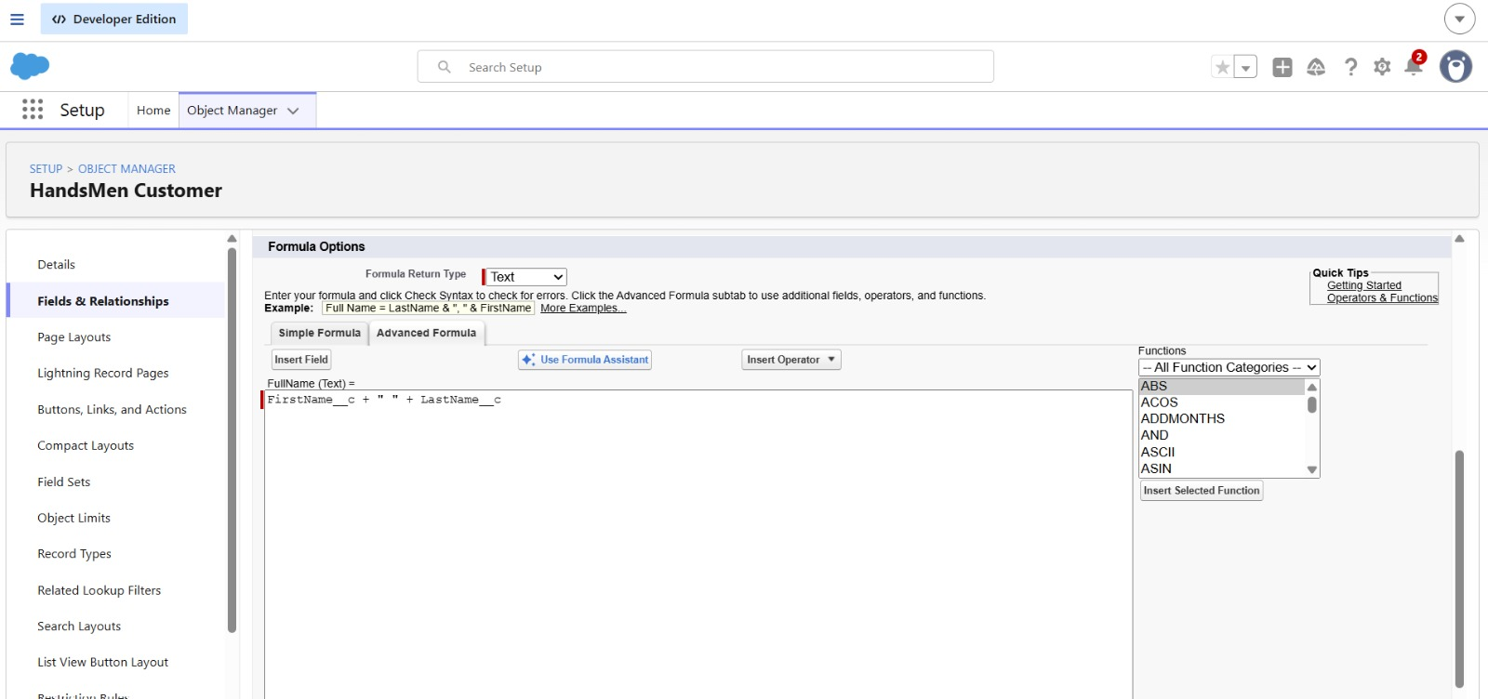
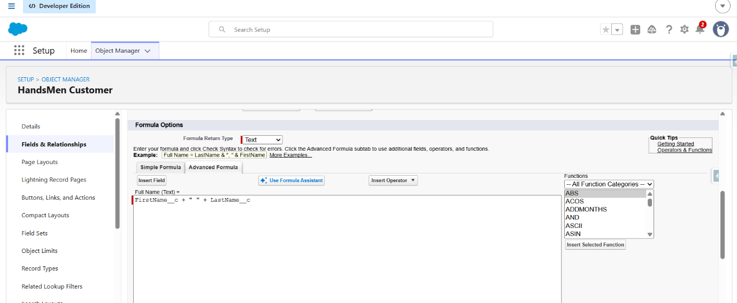

2. Stock Status Formula Field
The Stock Status formula field was created in the Inventory object to automatically determine the stock condition based on the available stock quantity.

Steps
- Go to Setup → Object Manager.
- Open Inventory.
- Select Fields & Relationships → New.
- Select Formula as the field type.
- Click Next.
- Enter Stock Status as the Field Label.
- Select Text as the Formula Return Type.
- Enter the required stock-status formula.
- Click Next → Next → Save.
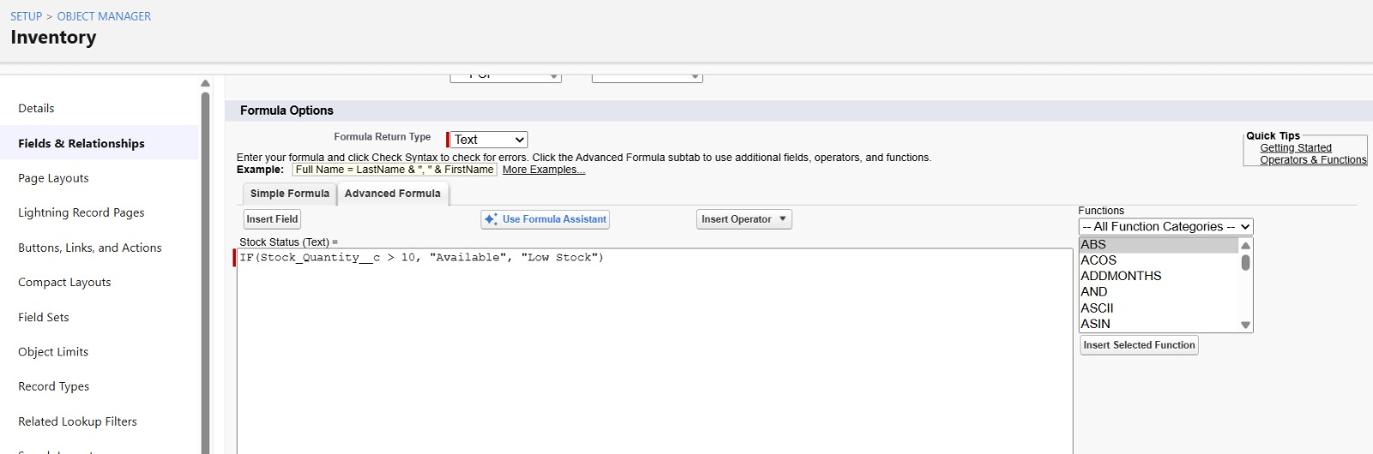
Data Configuration – Validation Rules
Validation rules were created to ensure that incorrect or invalid data is not entered into the HandsMen Threads Salesforce objects. The rules validate important field values before a record can be saved.

Creating Validation Rules

1. Validation Rule – Total Amount
The validation rule was created for the Total Amount field in the HandsMen Order object to prevent an invalid or zero order amount from being entered.
Steps:
- Go to Setup → Object Manager.
- Search for and open HandsMen Order.
- Select Validation Rules → New.
- Enter the Rule Name as Total Amount.
- Enter the Error Condition Formula:
Total_Amount__c <= 0
- Enter the Error Message as: Please Enter Correct Amount
- Select Field as the Error Location.
- Select Total Amount as the field.
- Click Save.
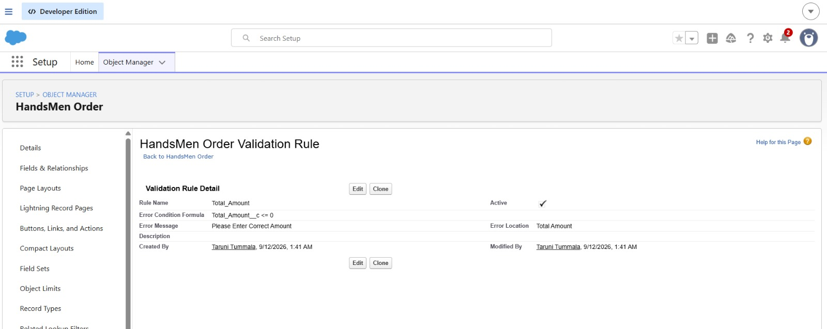
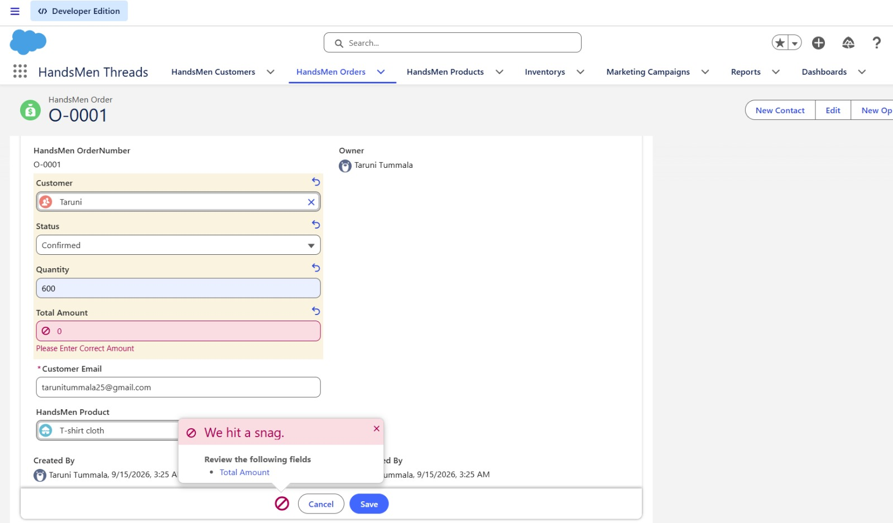

2. Validation Rule – Stock Quantity
A validation rule was created for the Inventory object to ensure that the inventory count is not entered as a negative value.
Rule Name: Stock Quantity
Error Condition Formula: Stock_Quantity__c <= 0
Error Message: the inventory count is never less than zero.
Error Location: Top of Page

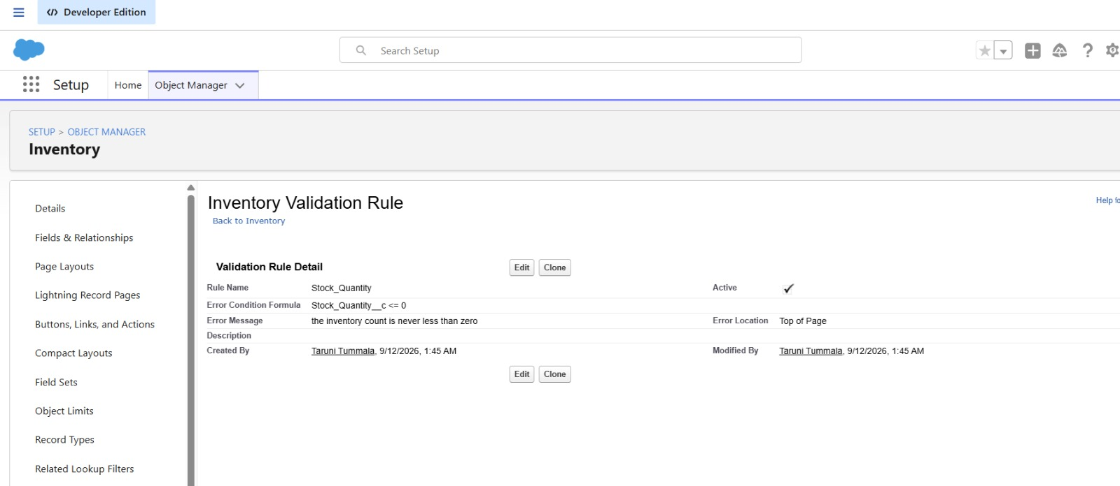
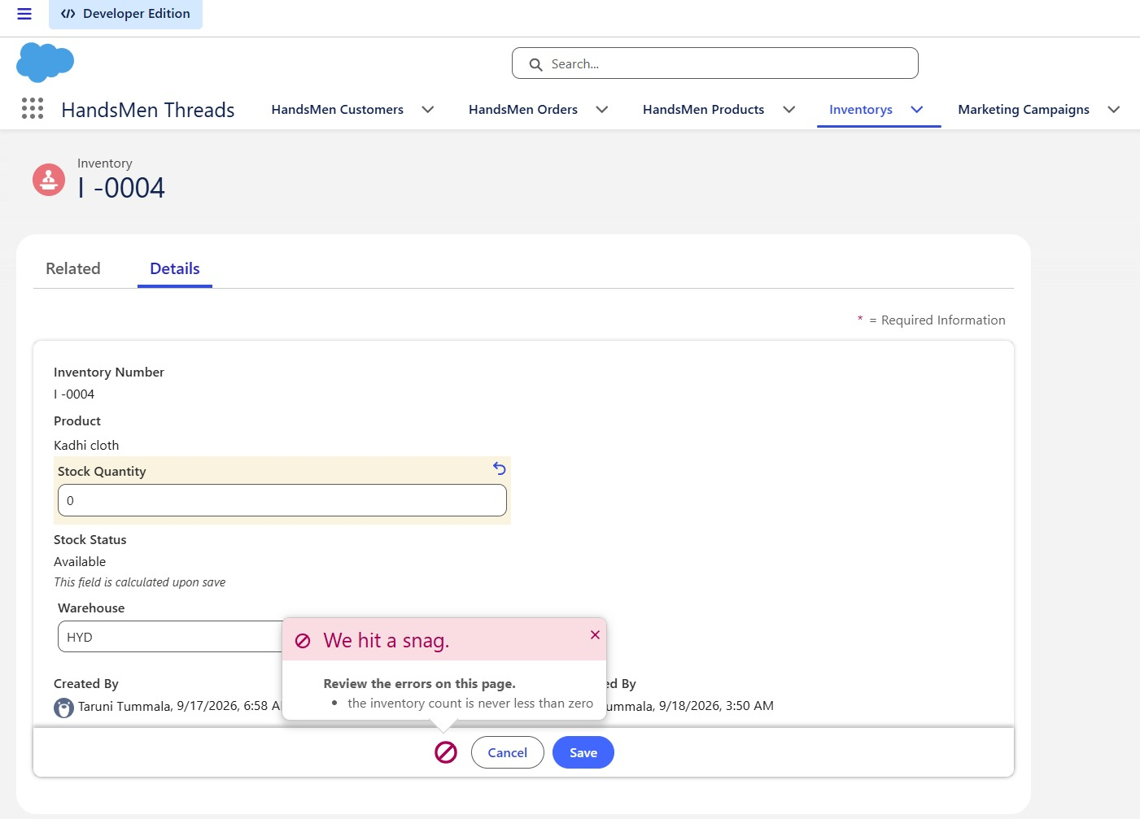

3. Validation Rule – Email
A validation rule was created for the HandsMen Customer object to check whether the entered email follows the specified Gmail format.
Rule Name: Email
Error Condition Formula: NOT CONTAINS(Email, "@gmail.com")
Error Message: Please fill Correct Gmail
Error Location: Top of Page

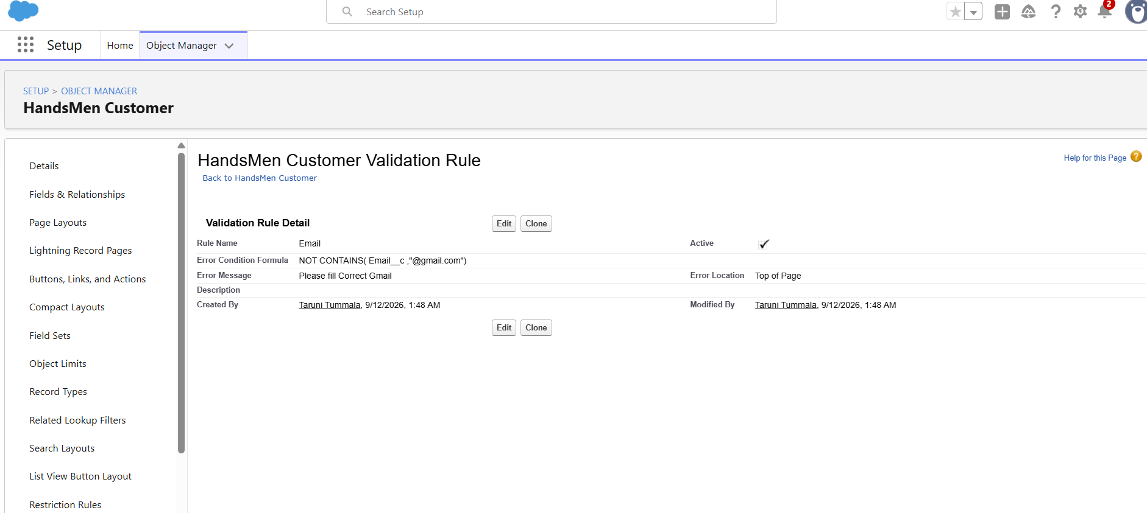
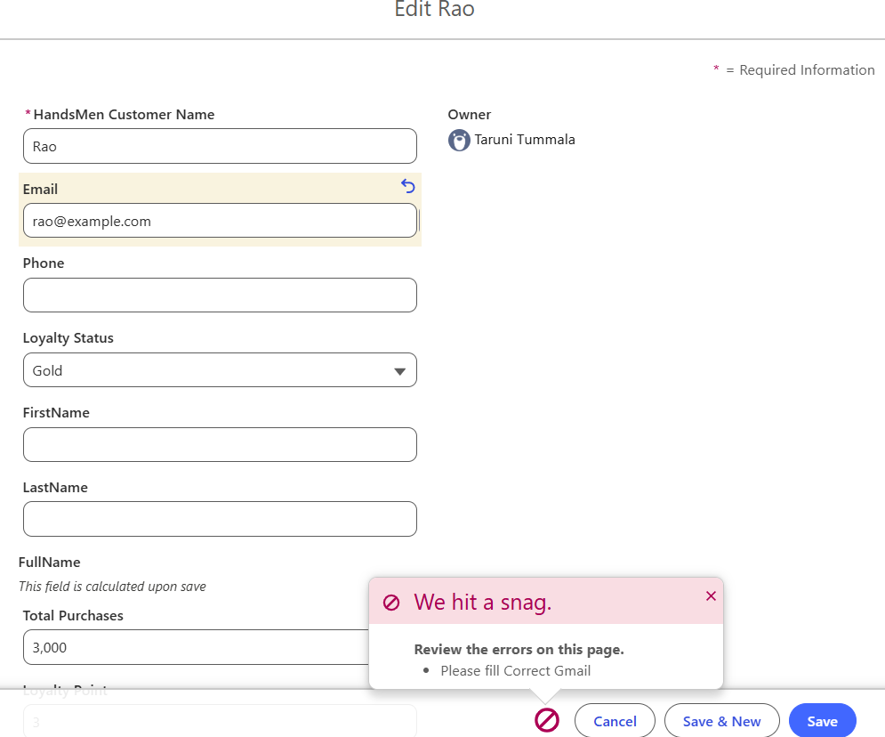
Data Security – Profiles

Creating a Profile
A profile was created to define the access permissions required for the HandsMen Threads application. The profile was cloned from the Standard User profile and named Platform 1.

Steps
- Go to Setup.
- Type Profiles in the Quick Find box.
- Select Profiles.
- Clone the Standard User profile.
- Enter Platform 1 as the profile name.
- Click Save.
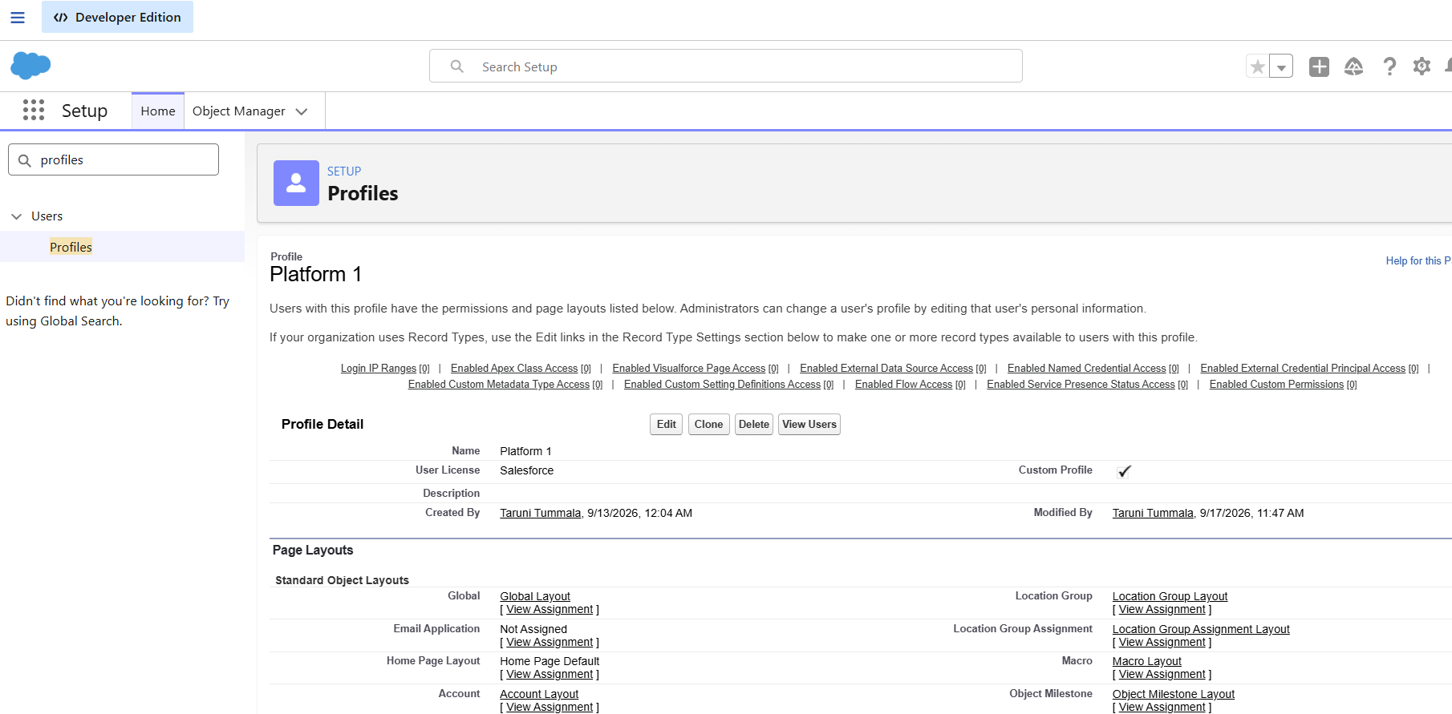

Configuring Object Permissions
After creating the profile, the required permissions were configured for the custom objects used in the HandsMen Threads application.
- Open the Platform 1 profile.
- Click Edit.
- Scroll to Custom Object Permissions.
- Provide the required access permissions for the HandsMen Product and Inventory objects.
- Scroll down and click Save.
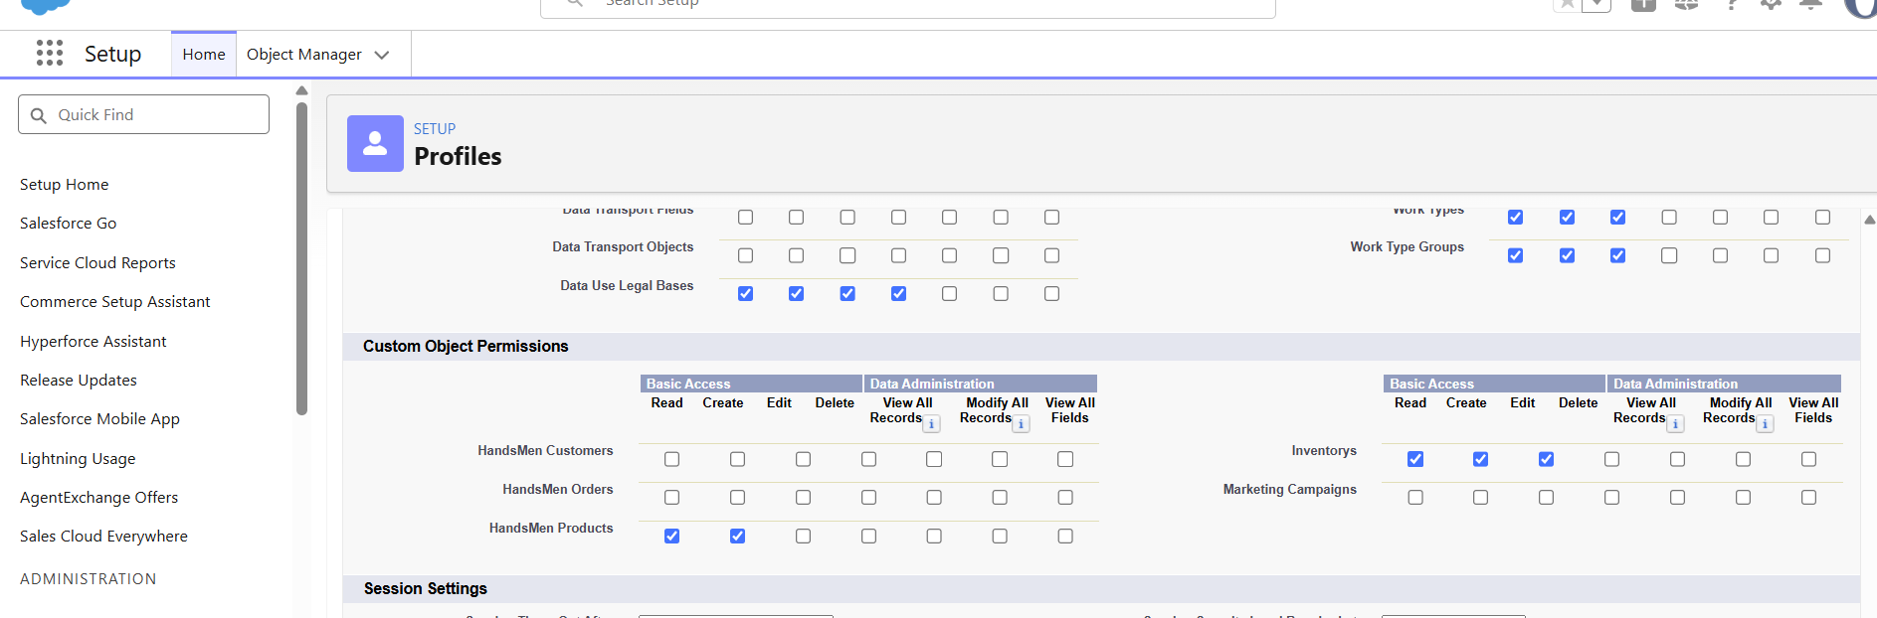
Data Security – Roles

Creating Roles
Roles were created to define the reporting hierarchy for the HandsMen Threads Salesforce application.
- Go to Setup → Roles.
- Click Expand All and select Add Role under the required parent role.
- Enter the role name and select the appropriate Reports To role.
- Click Save.
The following roles were created:
- Sales
- Inventory
- Marketing

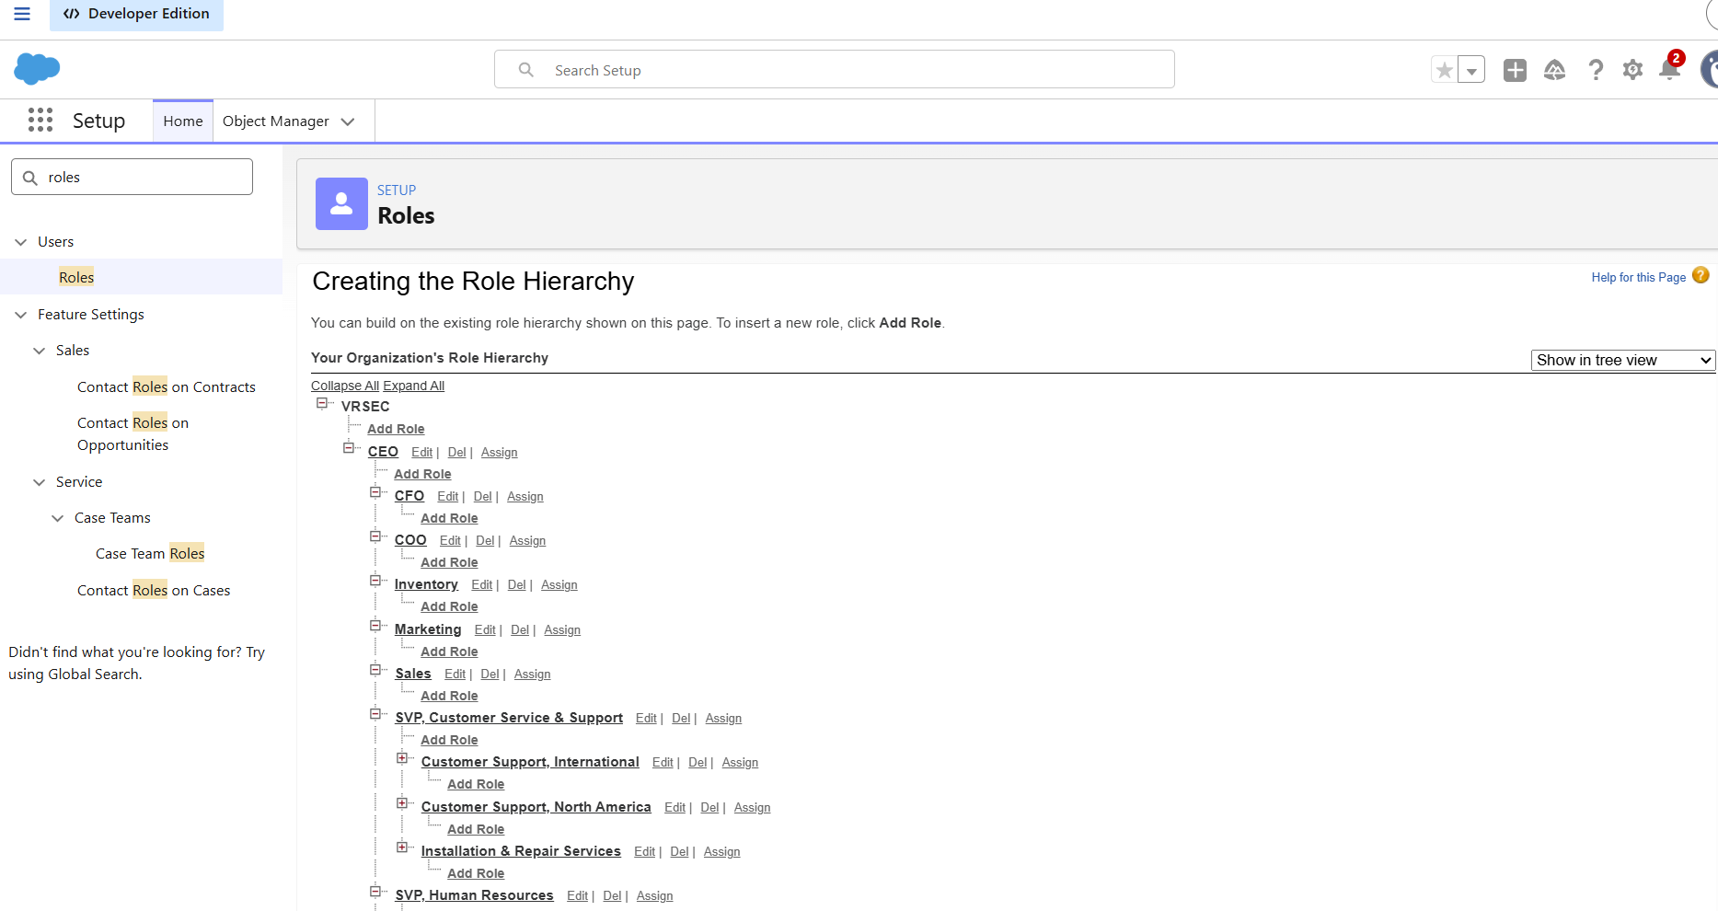

Sales Role
The Sales role was created under the CEO role, with CEO selected in the Reports To field.

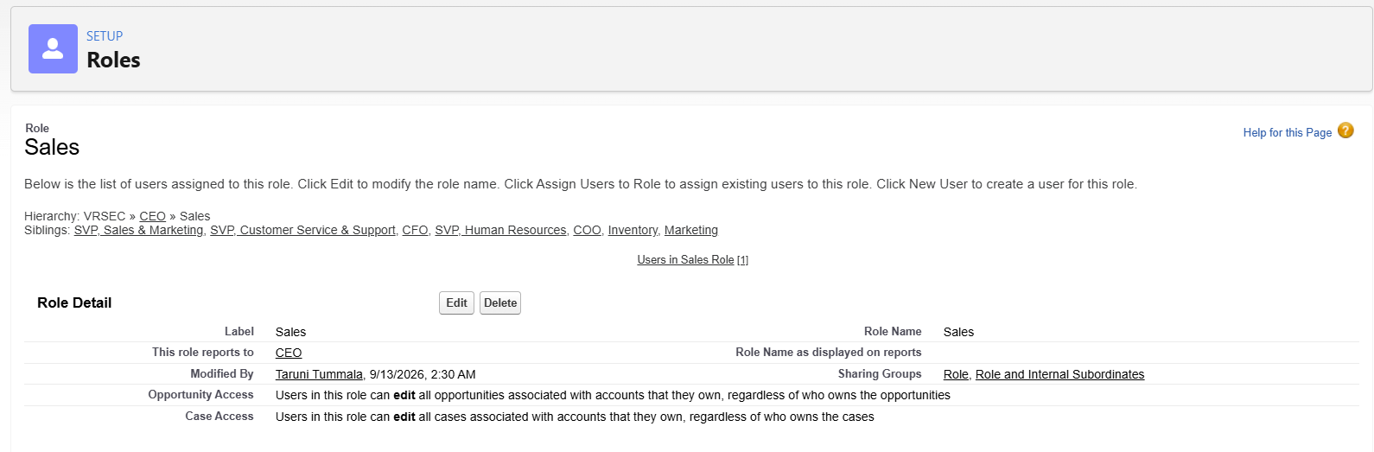

Inventory Role
The Inventory role is created using the same procedure and were placed under the CEO role.
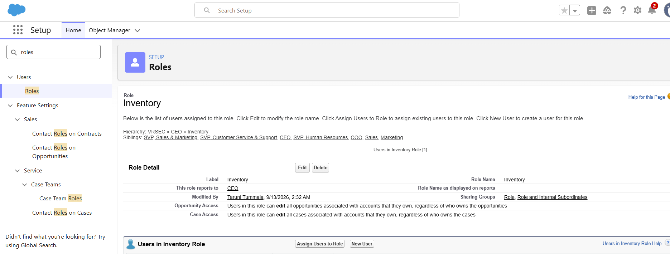
Marketing Role
The Marketing role is created to represent users responsible for marketing campaigns and customer engagement.
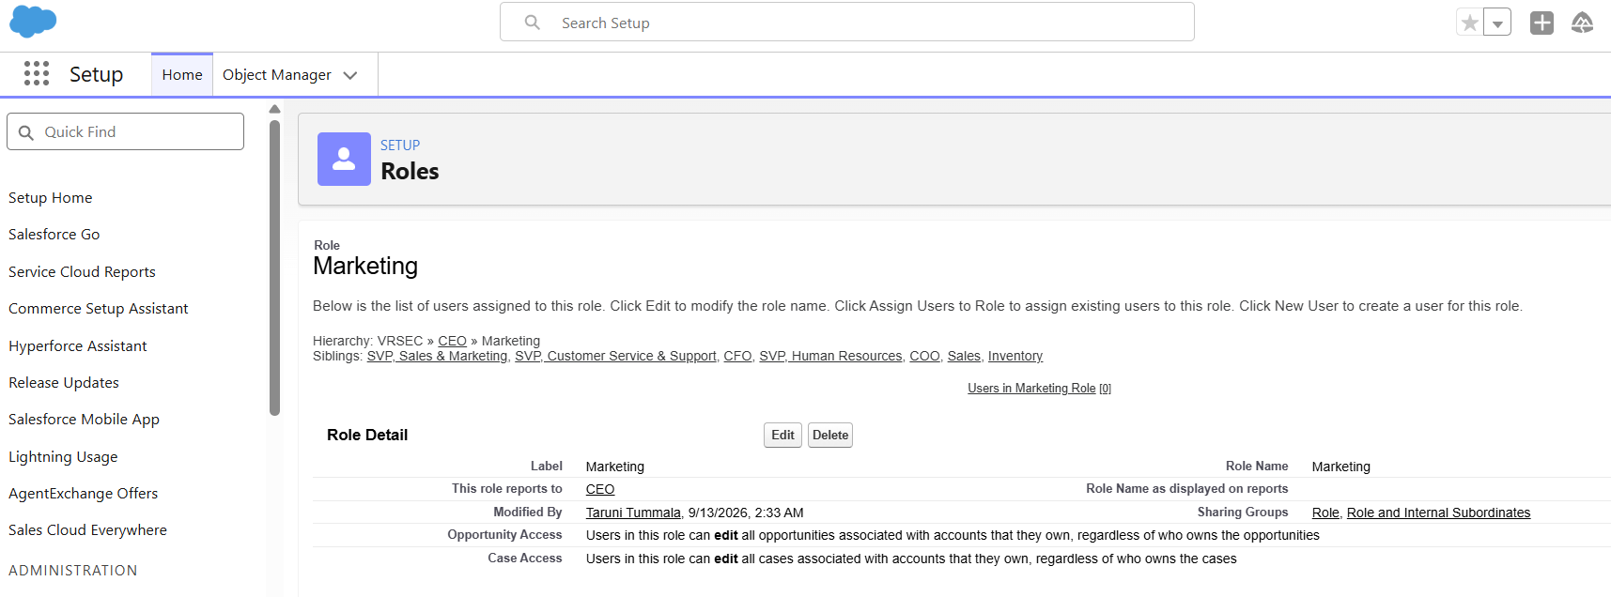

Data Security – Users

Creating Users
Users were created and assigned the appropriate roles and profile to access the HandsMen Threads Salesforce application.

User 1 – Sales
- Go to Setup → Users.
- Click New User.
- Enter the user details:
  - First Name: Niklaus
  - Last Name: Mikaelson
  - Alias: Enter an alias.
  - Email: Enter a personal email address.
  - Username: Use the format text@text.text.
  - Nickname: Enter a nickname.
  - Role: Sales
  - User License: Salesforce Platform
  - Profile: Platform 1
- Click Save.

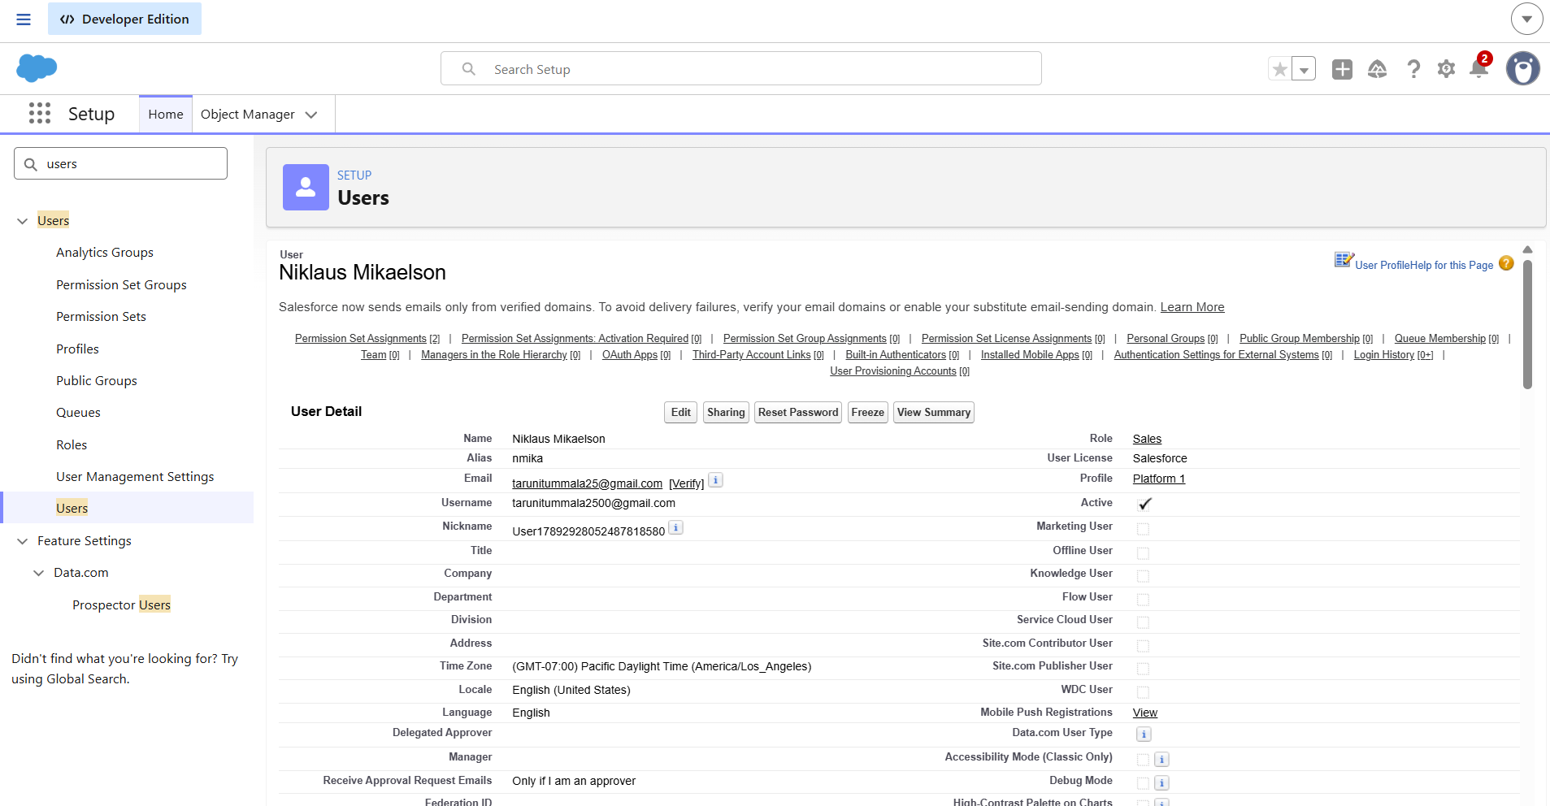

User 2 – Inventory
Create another user using the same procedure with the following details:
- First Name: Kol
- Last Name: Mikaelson
- Role: Inventory
- User License: Salesforce Platform
- Profile: Platform 1
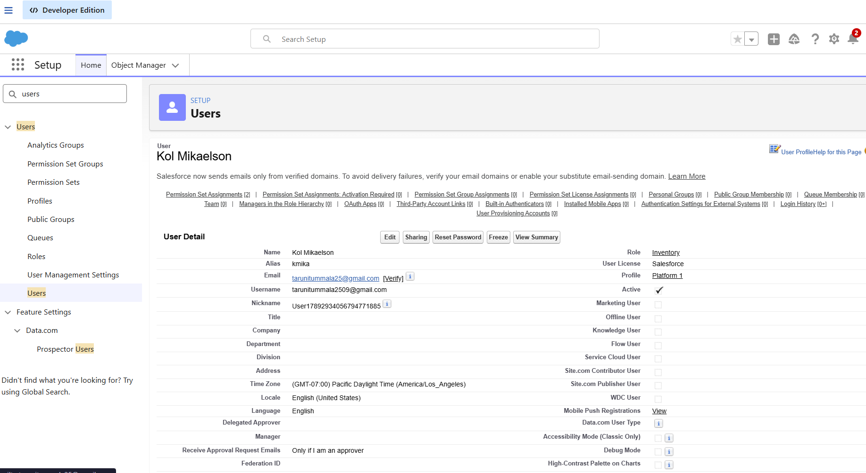

Data Security – Permission Set

Creating Permission Set
- Go to Setup → Permission Sets → New.
- Enter the label as Permission_Platform_1 and save.
- Under Apps, select Object Settings.
- Select the HandsMen Customer object → Edit → enable Read, Create, Edit, Delete.
- Click Save.
- Repeat the same process for the Order object and enable Read, Create, Edit, Delete.
- Open Manage Assignments.
- Click Add Assignment.
- Select a user with the Platform 1 profile and click Next.
- Click Assign and then Done.
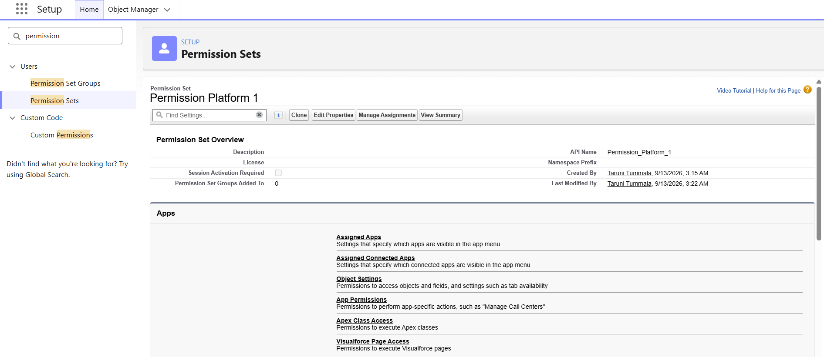
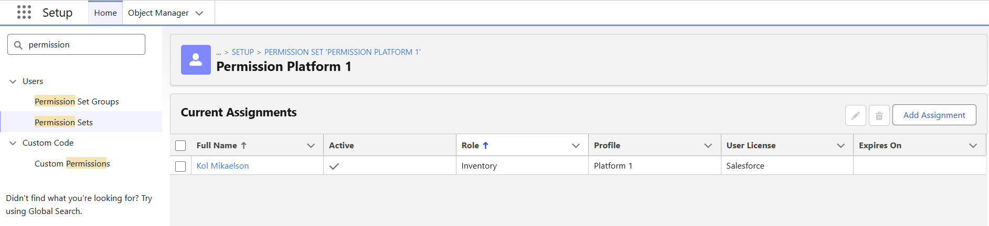
1.Sales Manager Permission Set
Purpose:Provides the Sales team with the required access to manage customer and order information.
Configuration:
- Permission Set: Sales Manager
- HandsMen Customer: Full Access
- HandsMen Order: Full Access
- Assigned User: Niklaus Mikaelson
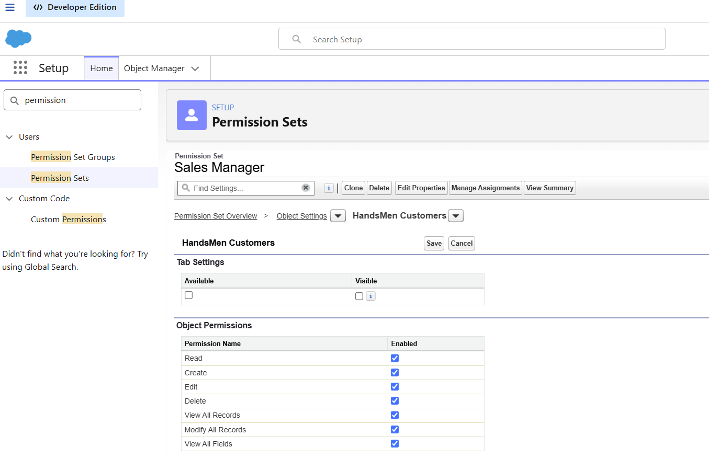
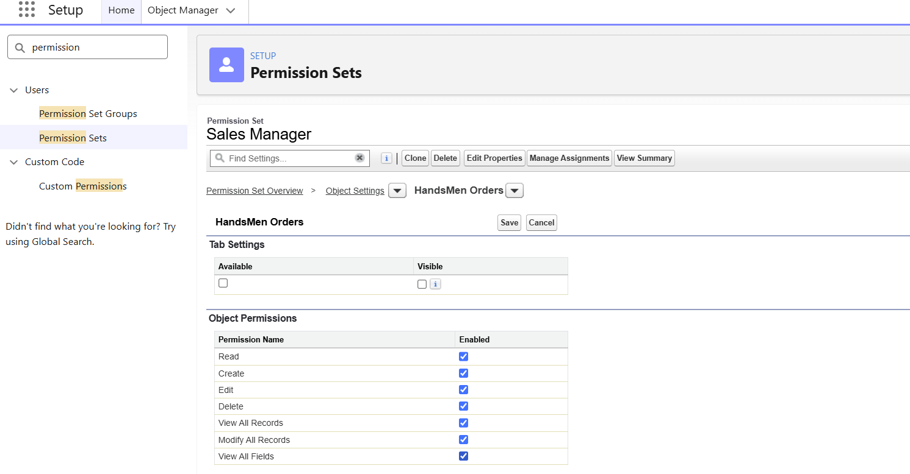
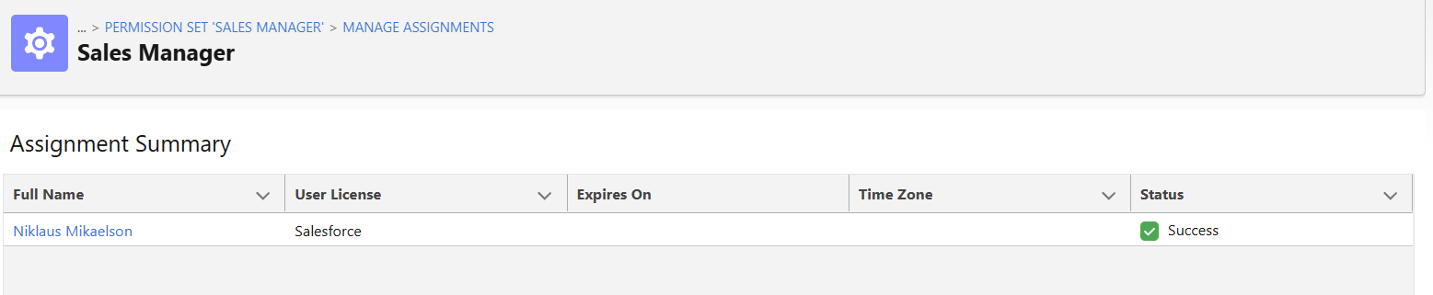
2. Inventory Manager Permission Set
Purpose: Provides the Inventory team with access to monitor and update inventory and product information.
Configuration:
- Permission Set: Inventory Manager
- Inventory: Read & Edit
- HandsMen Product: Read & Edit
- Assigned User: Kol Mikaelson
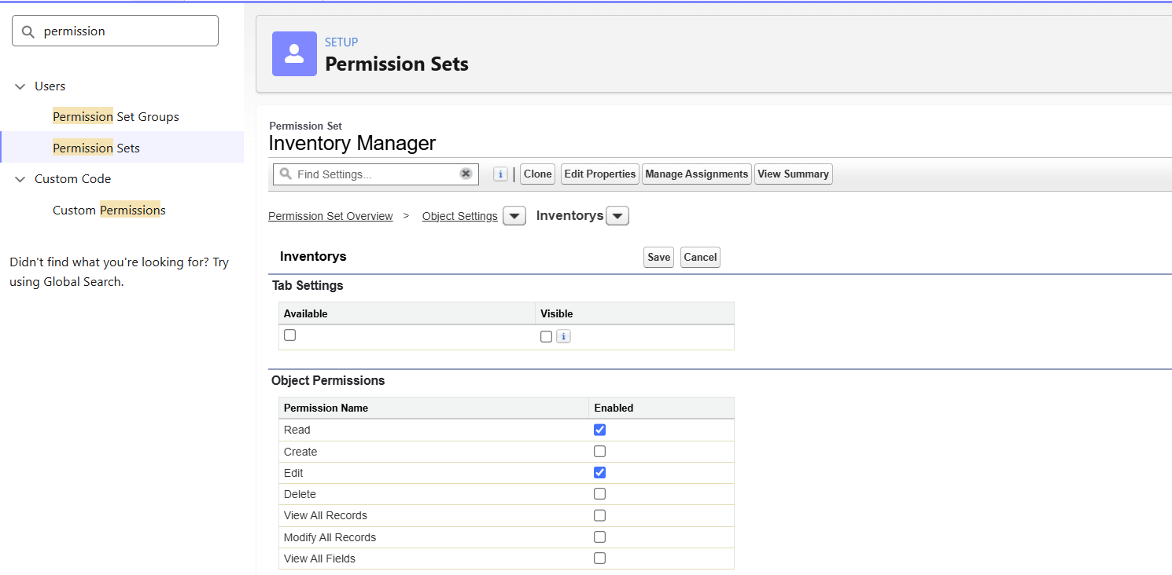

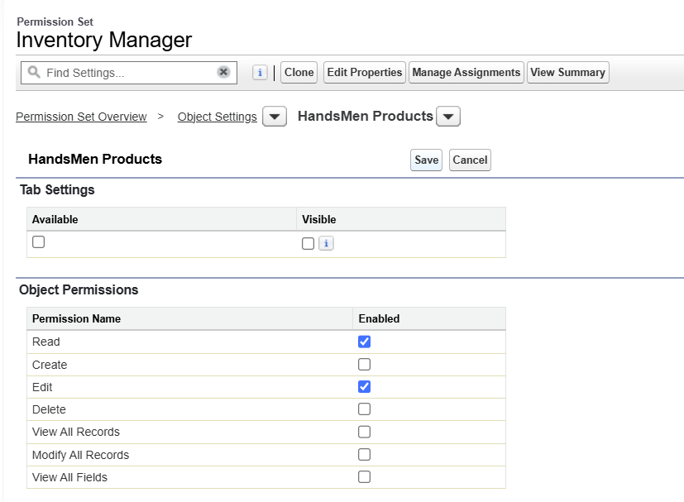
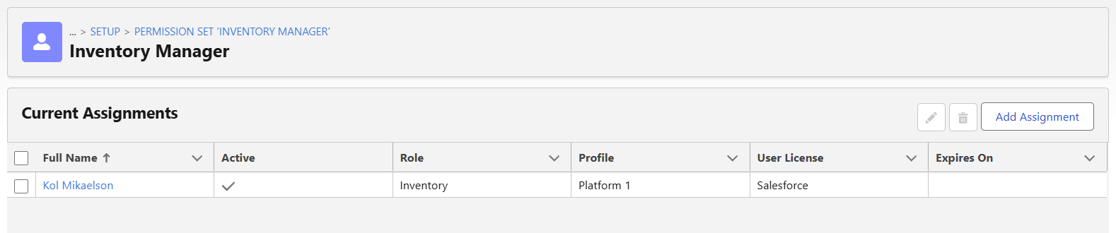
3. Marketing Team PermissionSet
Purpose:
Provides the Marketing team with read access to customer information and editing access to marketing campaigns.
Configuration:
- Permission Set: Marketing Team
- HandsMen Customer: Read
- Marketing Campaign: Read & Edit
- Assigned to: John Mikaelson
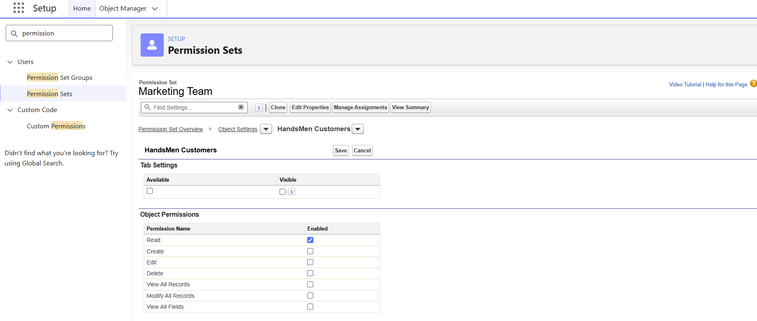
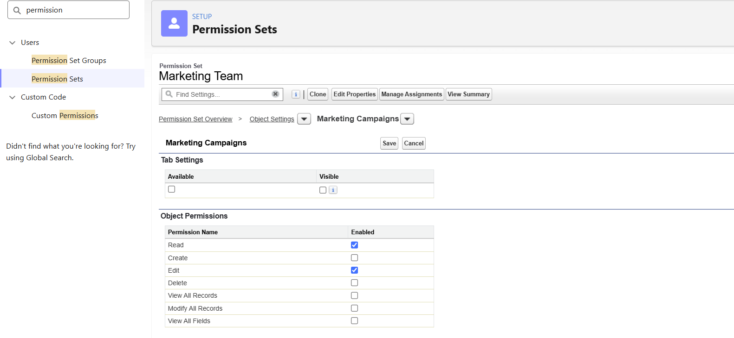

Email Templates
Email templates were configured to support the communication requirements of the HandsMen Threads Salesforce application. The templates are used for order confirmation, low-stock notifications, and loyalty program communication.

1.Order Confirmation Email
The Order Confirmation Email template was created to notify customers when their order is confirmed.
Template Configuration
- Template Type: HTML (with Classic Letterhead)
- Folder: Unfiled Public Email Templates
- Available for Use: Enabled
- Template Name: Order Confirmation Send
- Encoding: UTF-8
- Subject: Your Order has been Confirmed!
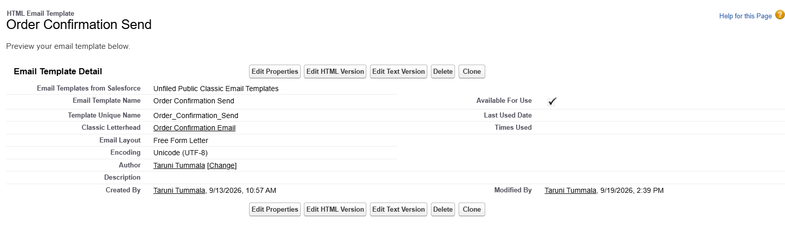

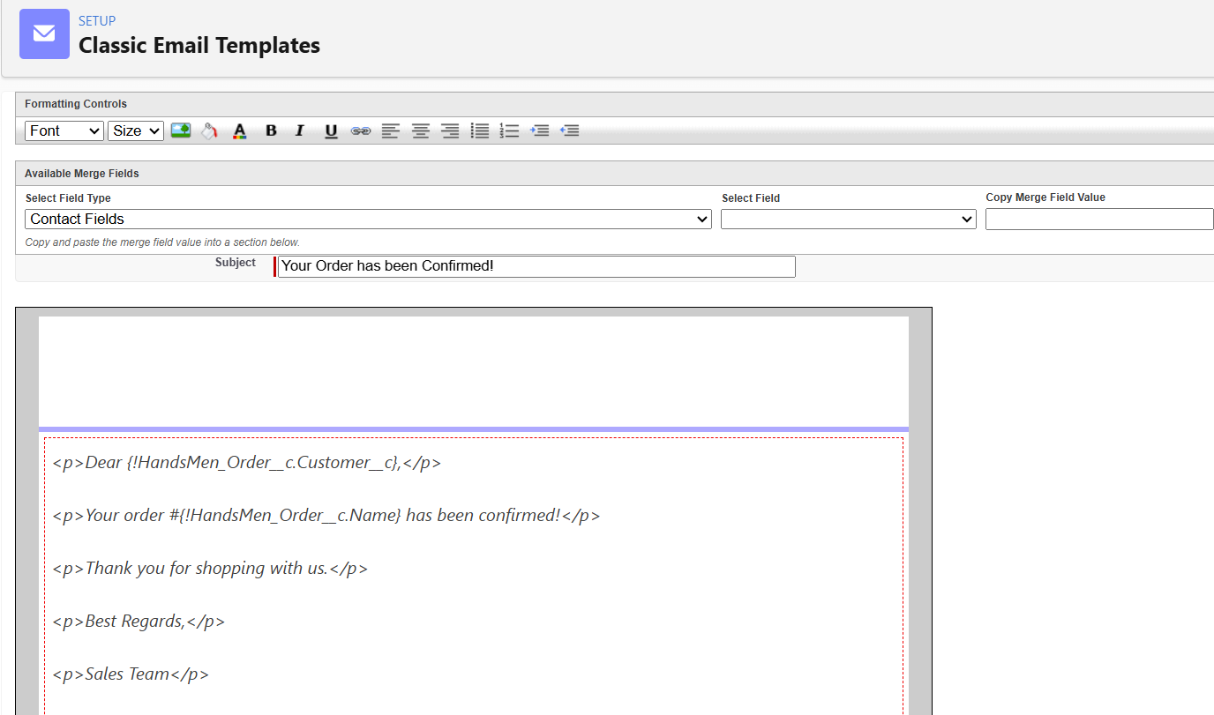

2.Low Stock Alert
The Low Stock Alert email template was created as a Text Email Template in Salesforce. The template is used to notify the warehouse team when the stock quantity falls below 5 units.
Subject: Low stock alert - inventory level is low
Configuration
Property | Value
Template Name | Low Stock Alert
Type | Text
Object | HandsMen Product
Trigger | Stock_Quantity__c < 5
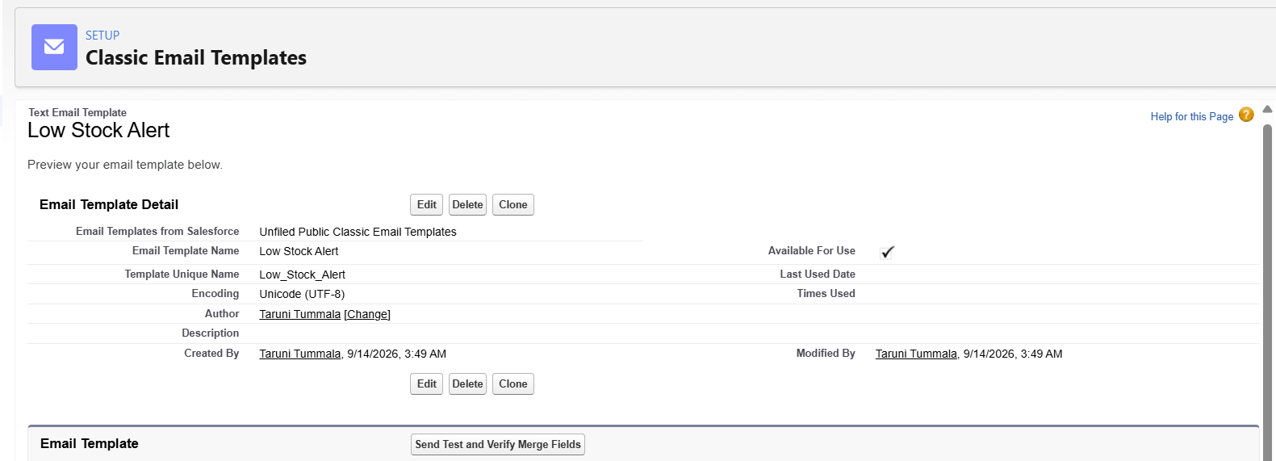
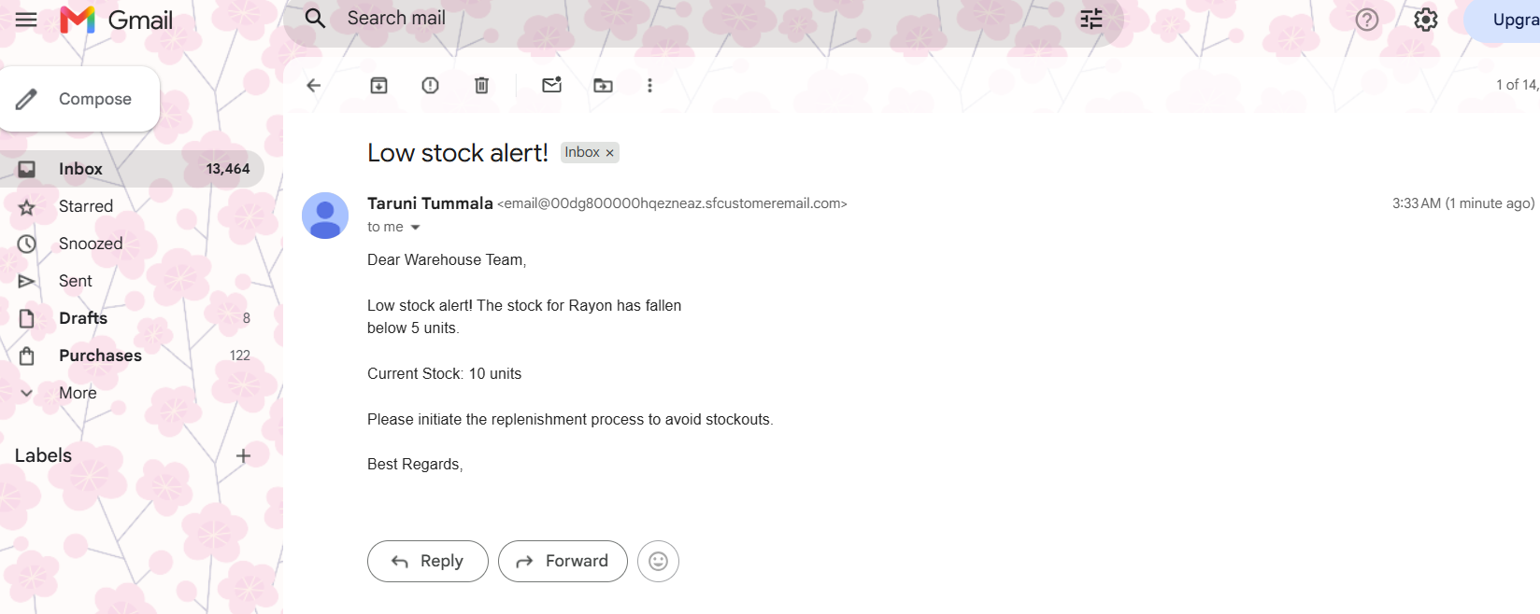

Loyalty Program Email
Purpose:
The Loyalty Program Email is used to communicate loyalty status updates based on the customer's purchase history, supporting personalized rewards and repeat business.
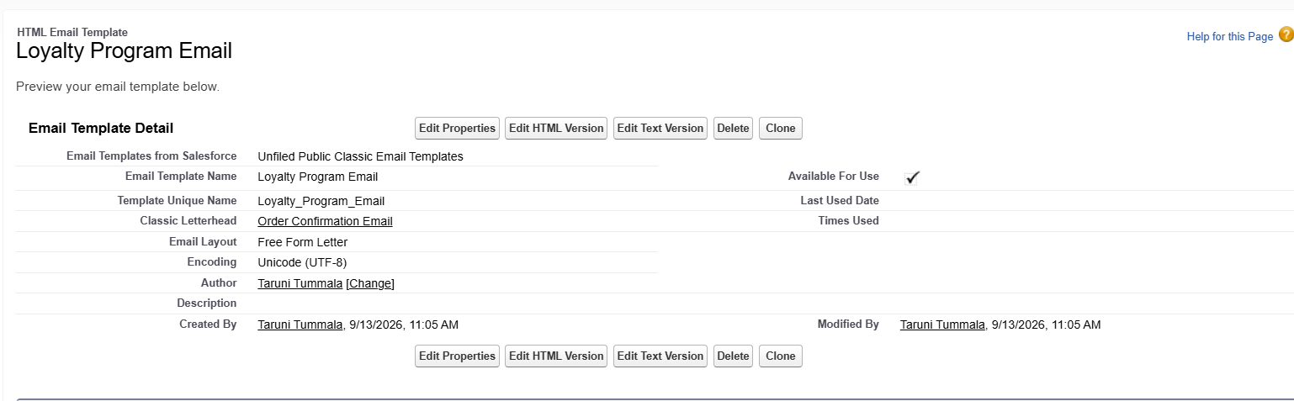
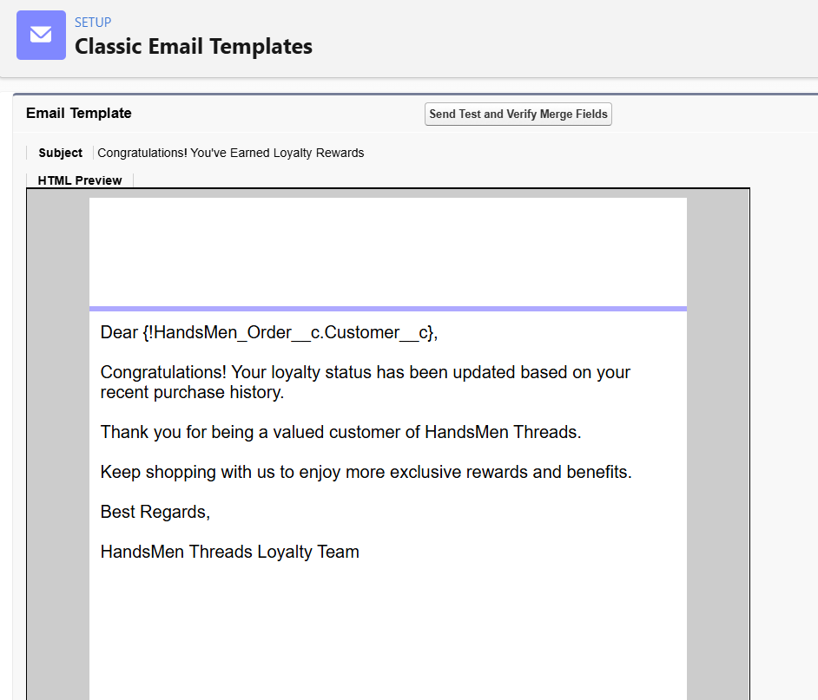
Flows
The HandsMen Threads project uses Salesforce Flows to automate order confirmations, stock alerts, and loyalty status updates.

1.Order Confirmation Email (Record-Triggered)
Go to Setup → Flows.
- In Quick Find, search for Flows and click on it.
- Click New Flow → Record-Triggered Flow → Create.
Set Flow Trigger Details
- Object: Order__c
- Trigger: When a record is updated
- Condition: Order__c.Status__c = "Confirmed"
- Select Only when a record is updated to meet the condition.
- Click Done.
Add an Action Element
- Click the + icon → Select Action.
- Action Type: Send Email Alert
- Email Alert: Order Confirmation Email Alert
- Label: Send Order Confirmation Email
- Record ID: {!$Record.Id}
- Click Save.
Save & Activate the Flow
- Name: Order Confirmation Flow
- Click Save → Activate.
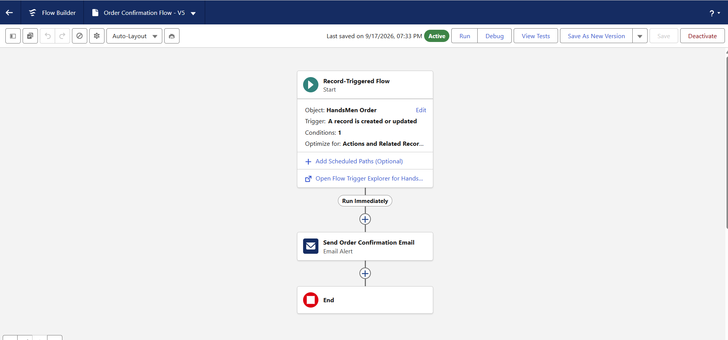

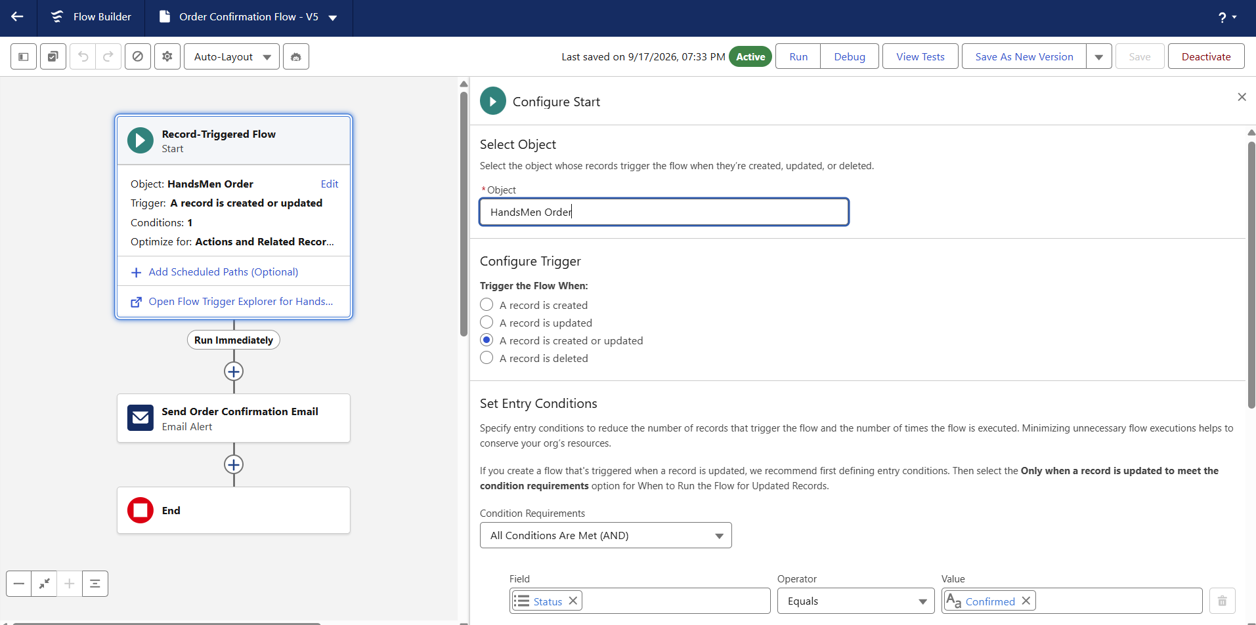
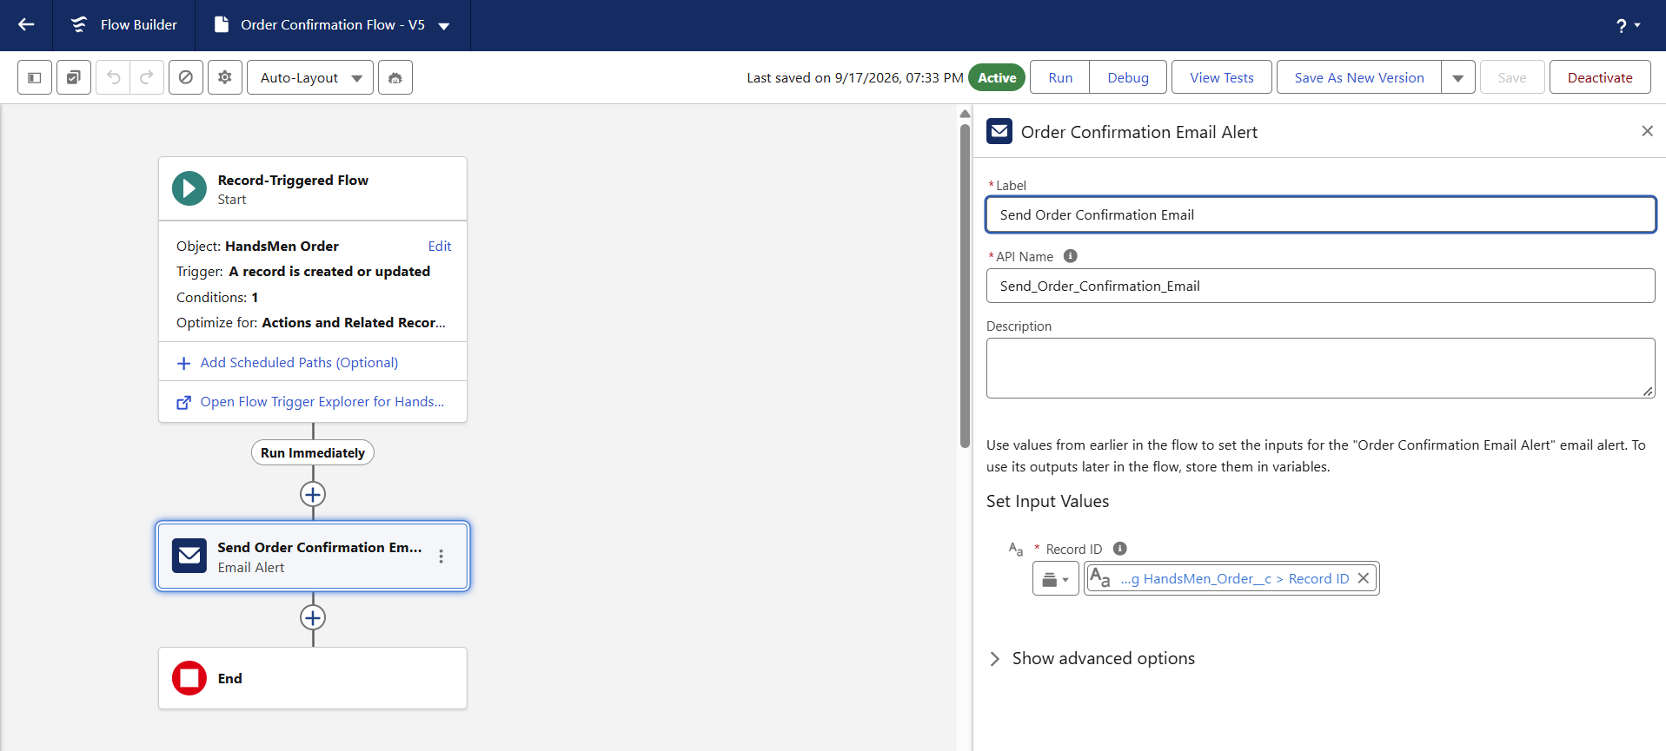
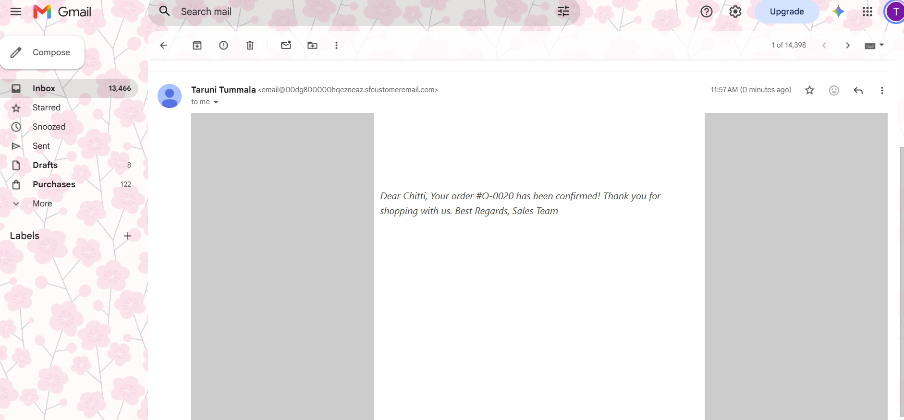

Stock Alert Flow
Go to Setup → Flows → New Flow.
- Select Record-Triggered Flow → Create.
Set Flow Trigger Details
- Object: Inventory__c
- Trigger: When a record is created or updated
- Condition: Stock_Quantity__c < 5
- Select Every time a record is updated and meets the condition requirements.
- Click Done.
Add an Action Element
- Click the + icon → Select Action.
- Action Type: Send Email Alert
- Create a new Email Alert similar to the Order Confirmation setup.
- Recipient: Inventory Manager
Save & Activate the Flow
- Name: Stock Alert Flow
- Click Save → Activate.
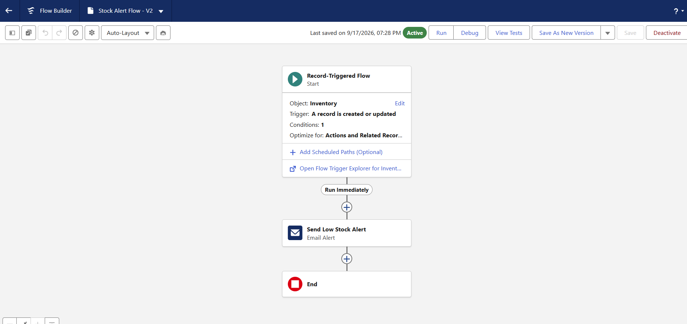
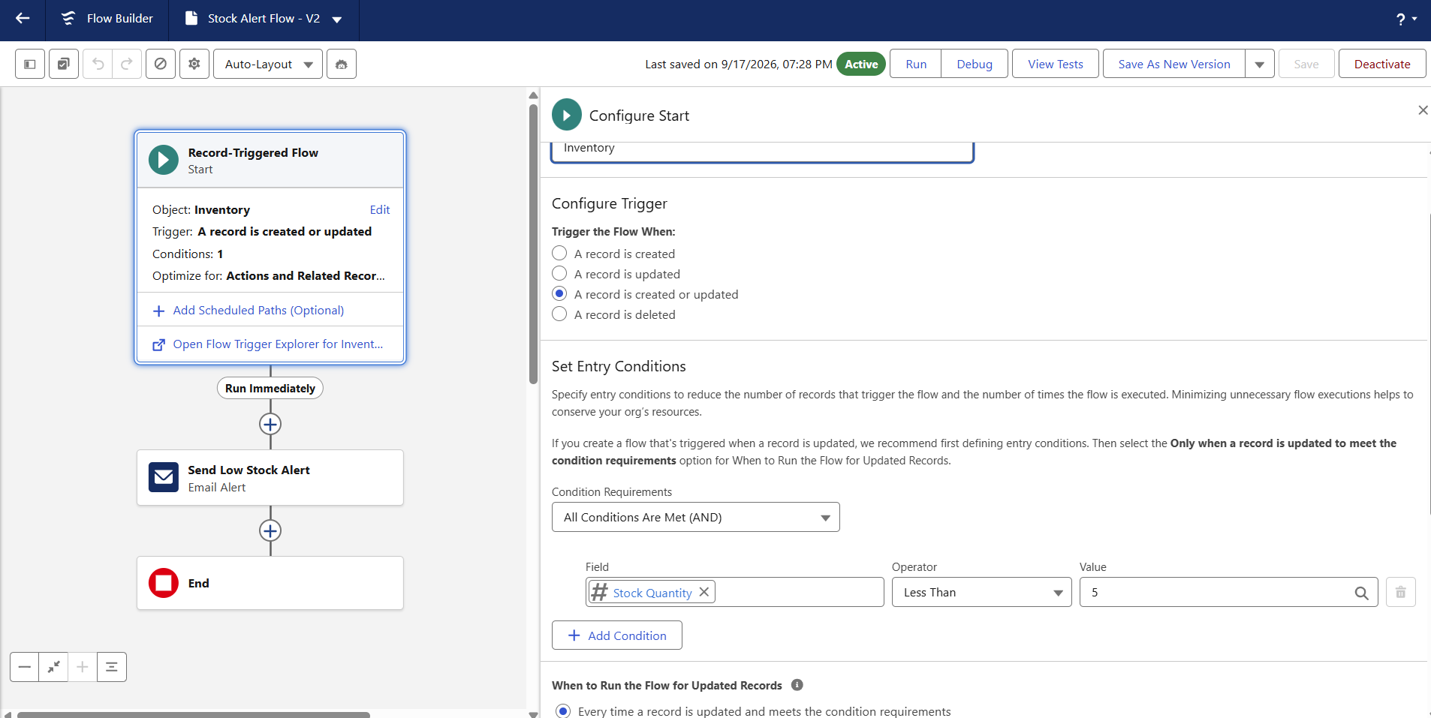
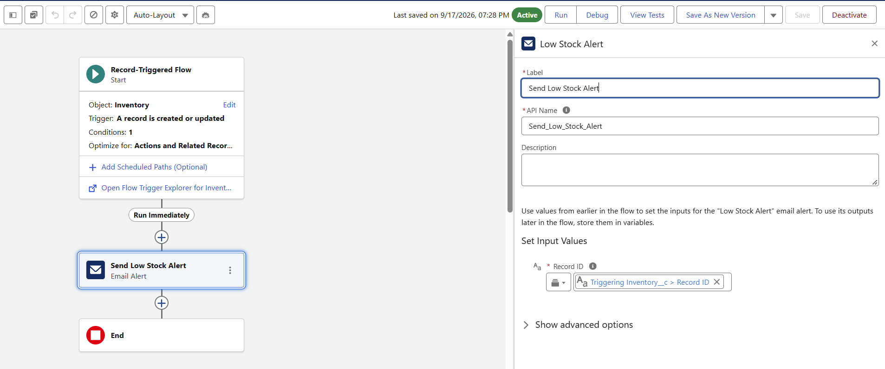
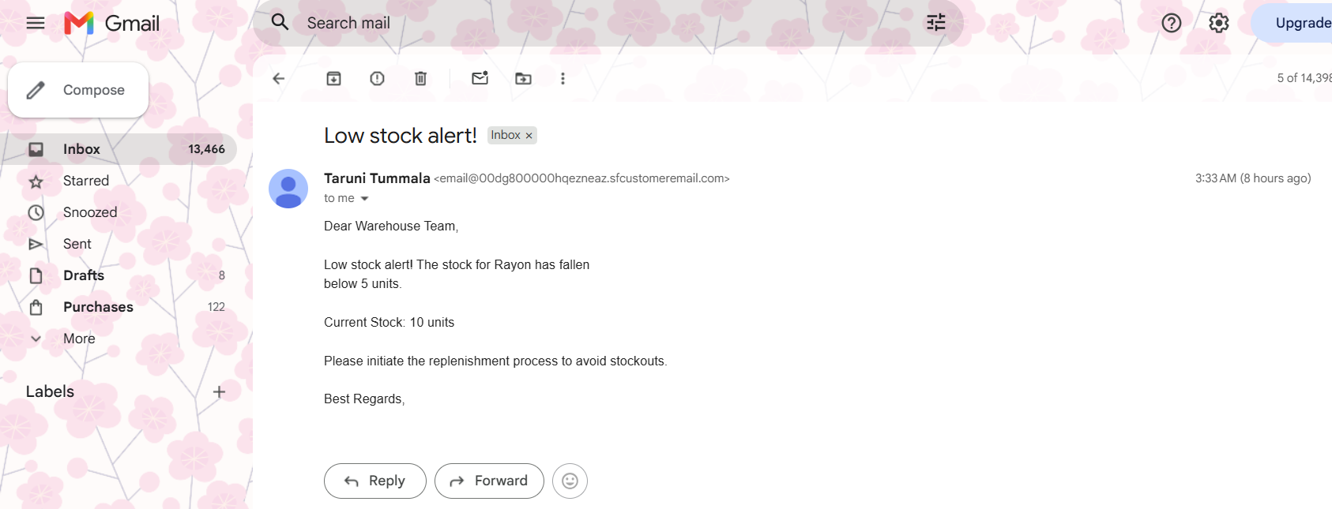

Loyalty Status Update (Scheduled Flow)
Go to Setup → Flows → New Flow.
- Select Schedule-Triggered Flow → Create.
Set Schedule Frequency
- Set Start Date & Time: Choose time to run daily.
- Frequency: Daily
- Click Done.
Add Get Records Element
- Click the + icon → Select Get Records.
- Object: HandsMen_Customer__c
- Filter: Retrieve all records
- Sort Order: None
- Click Done.
Add Loop Element
- Click the + icon → Select Loop.
- Collection: {!Get_Records}
- Direction: First to Last
- Click Done.
Inside Loop
- Click the + inside the loop → Select Decision.
- If Total_Purchases__c > 1000, set Loyalty_Status__c = Gold.
- Add Update Records:
  - Records to Update: Specify Condition
  - Object: HandsMen Customer
  - Field Value: Loyalty_Status__c = Gold
- Else if Total_Purchases__c < 500, set Loyalty_Status__c = Bronze.
- Else (Default Outcome), set Loyalty_Status__c = Silver.
- Click Done.
Save & Activate the Flow
- Name: Loyalty Status Update Flow
- Click Save → Activate

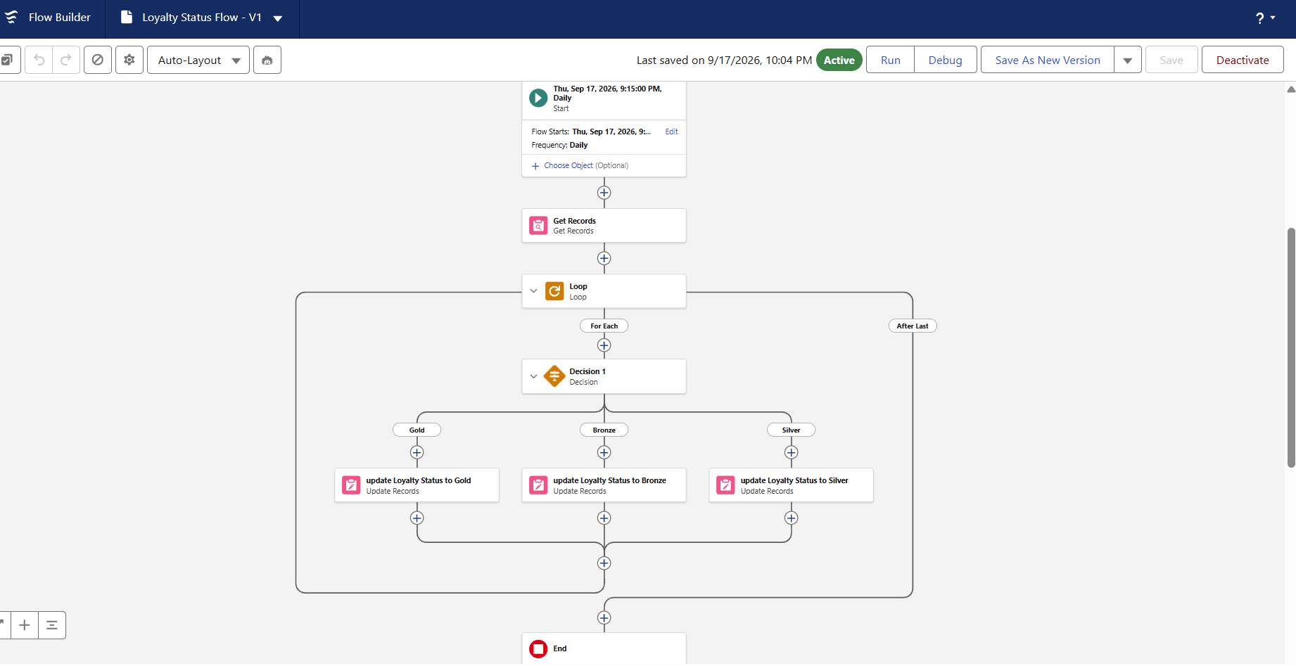
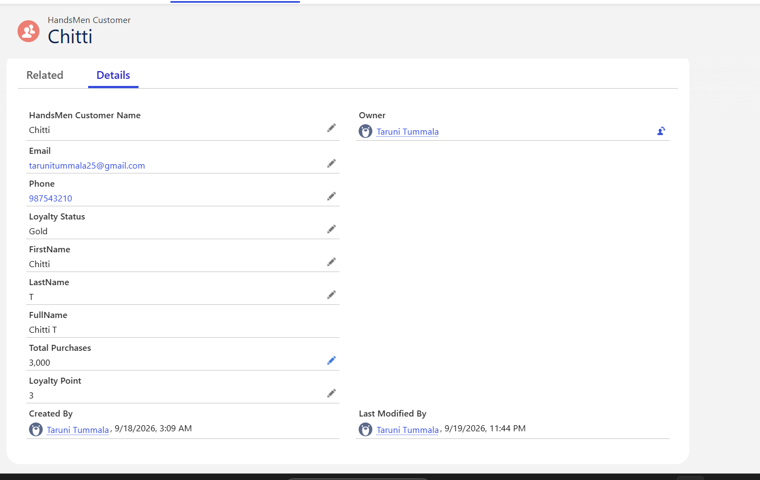
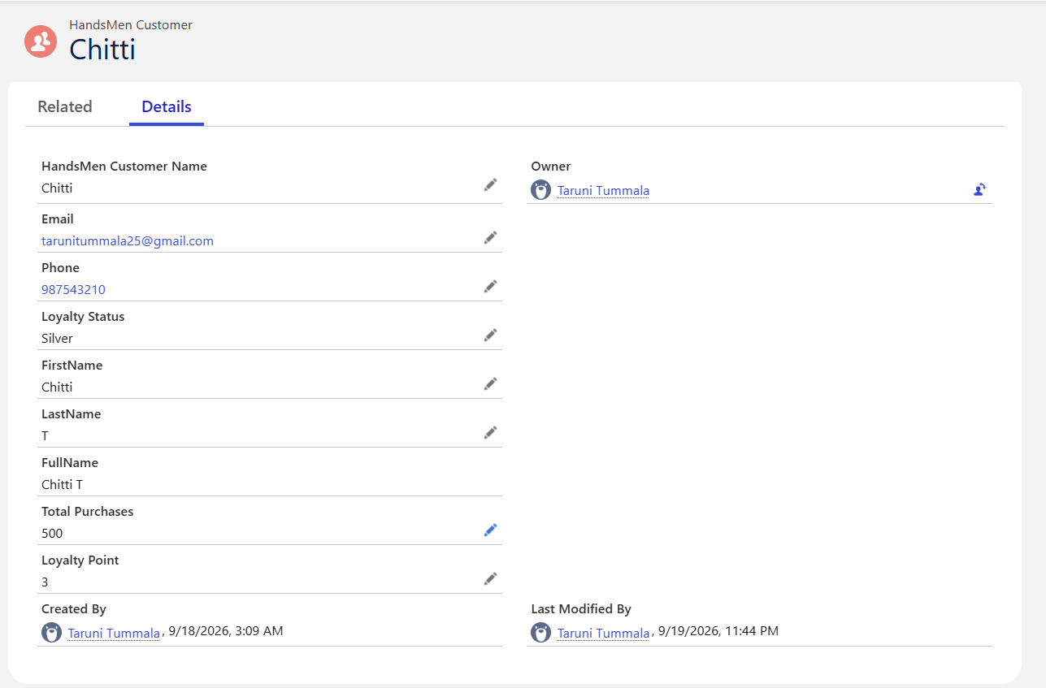

1.Apex Class – OrderTriggerHandler
The OrderTriggerHandler Apex class contains the validation logic for order quantities based on the order status. It validates the quantity for Confirmed, Pending, and Rejection statuses before the order is saved.
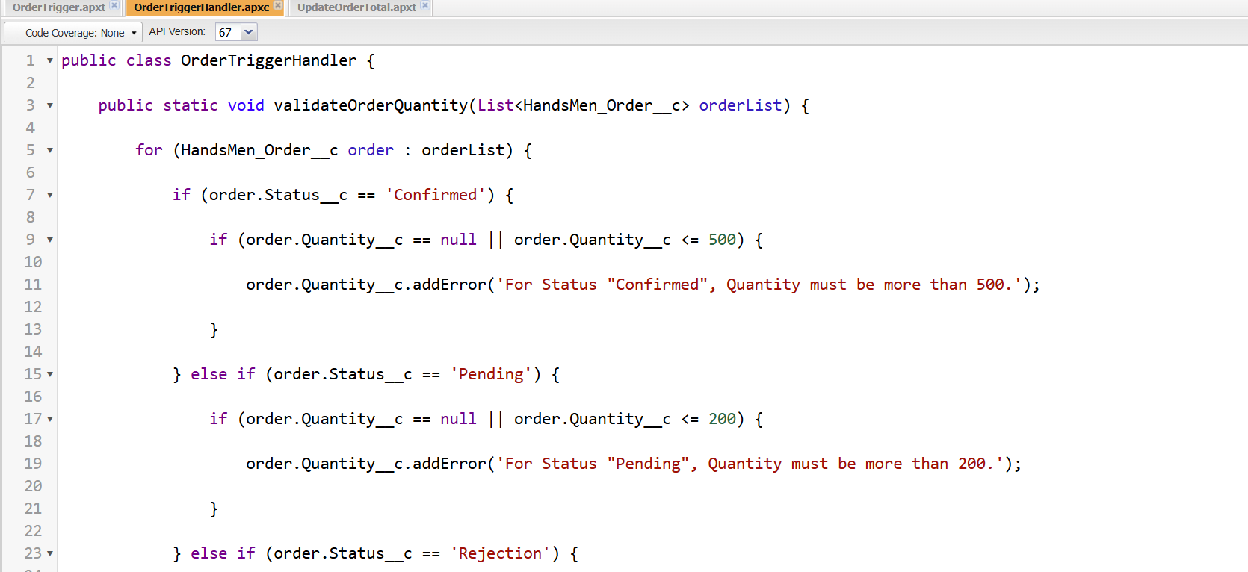
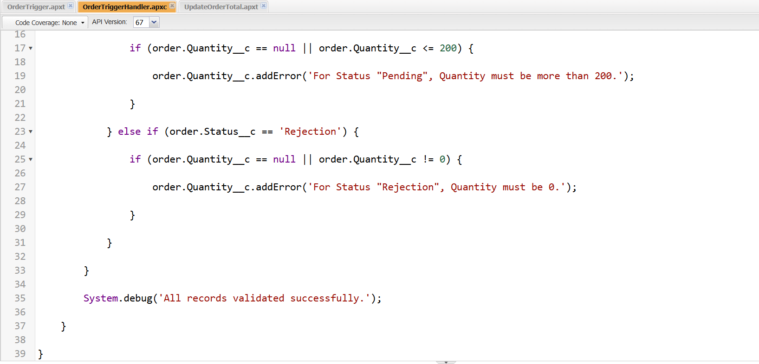
Apex Trigger – OrderTrigger
Purpose
The OrderTrigger automatically invokes the OrderTriggerHandler whenever a HandsMen Order is inserted or updated. The trigger is kept lightweight because the actual business logic is maintained in the handler class.
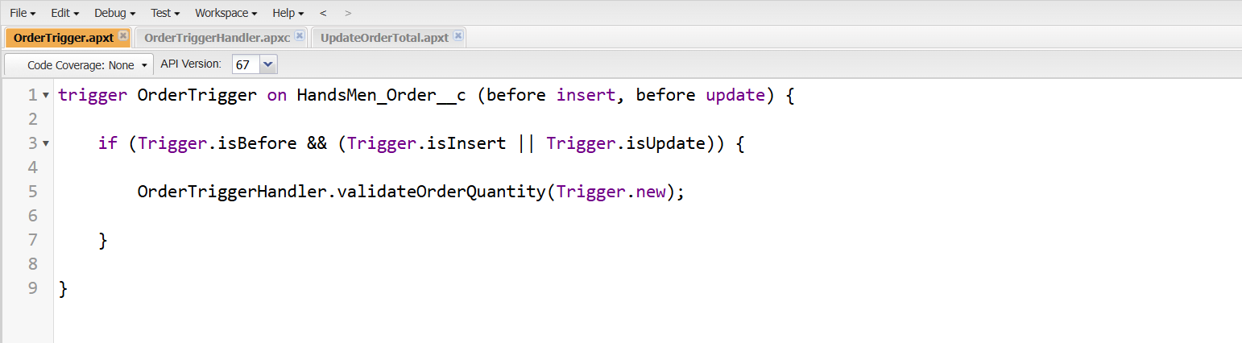
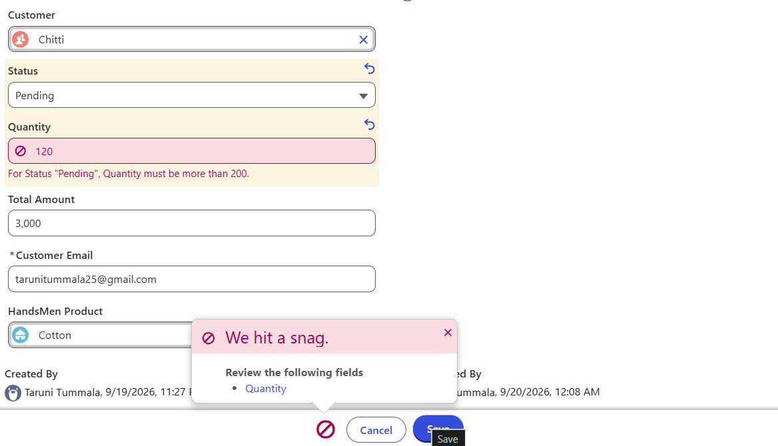

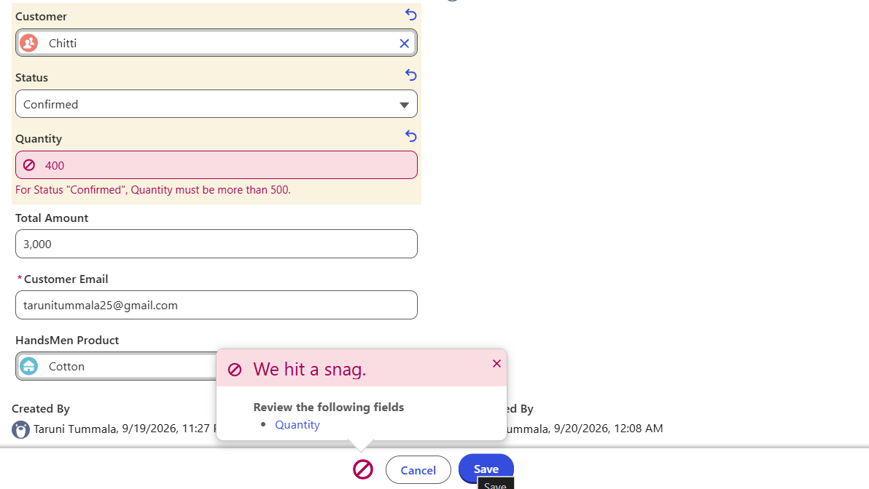

2. Update Order Total
The Update Order Total Apex Trigger is designed to automatically calculate and update the Total Amount of a HandsMen Order whenever an order is created or modified. This reduces manual calculation and helps maintain accurate order values.
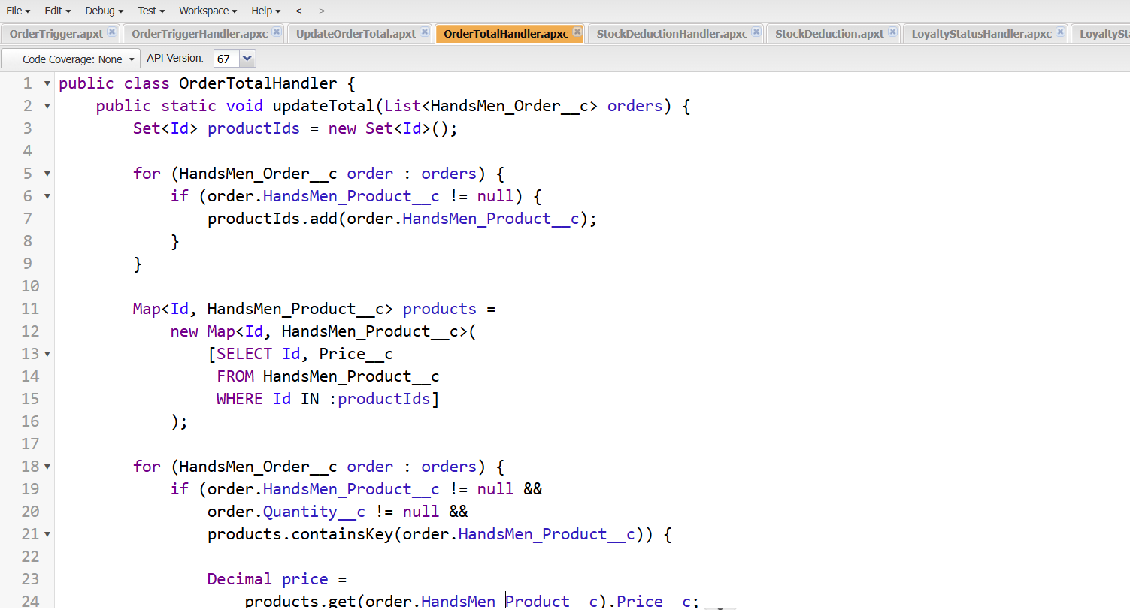

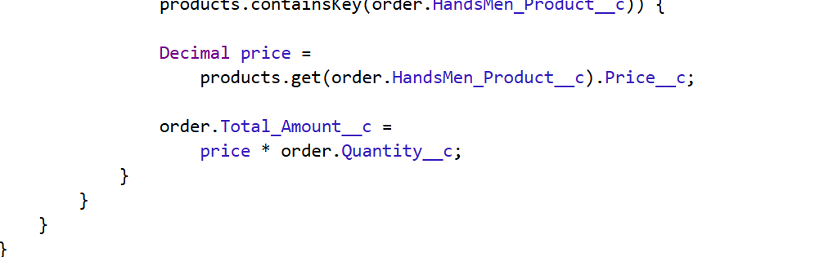
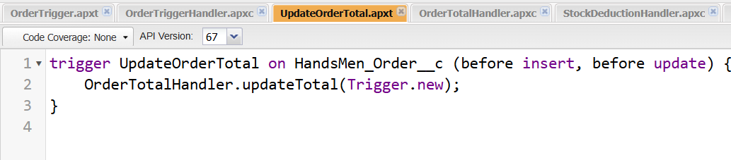
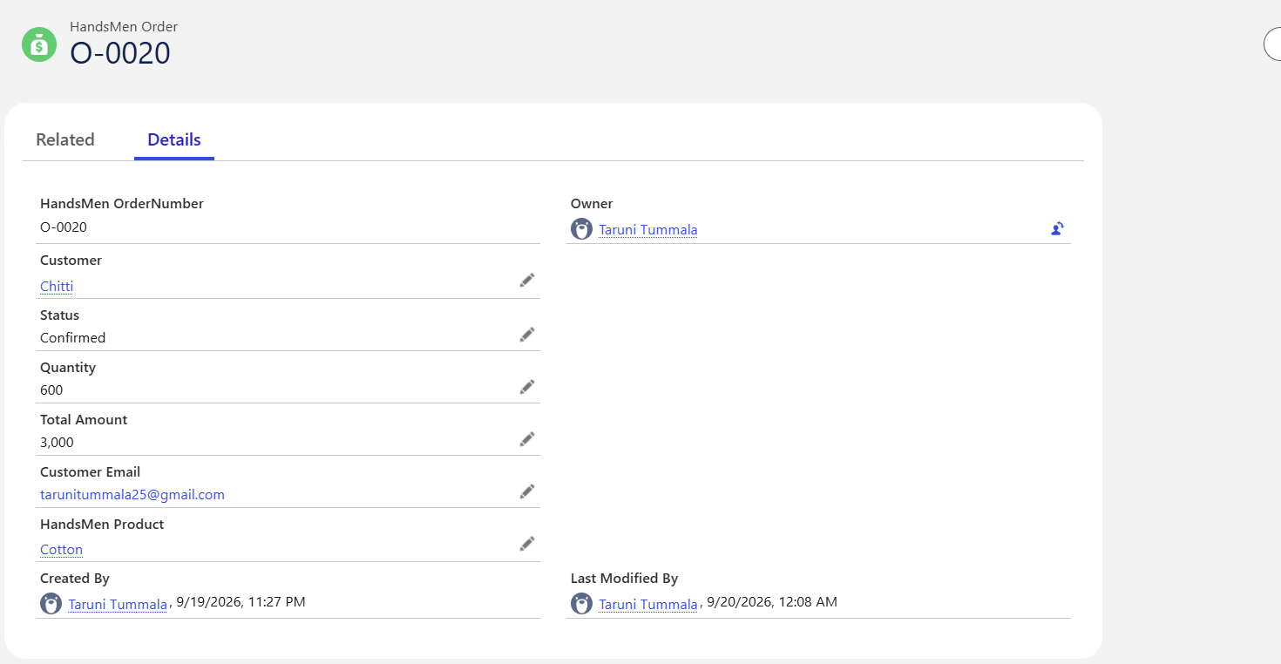
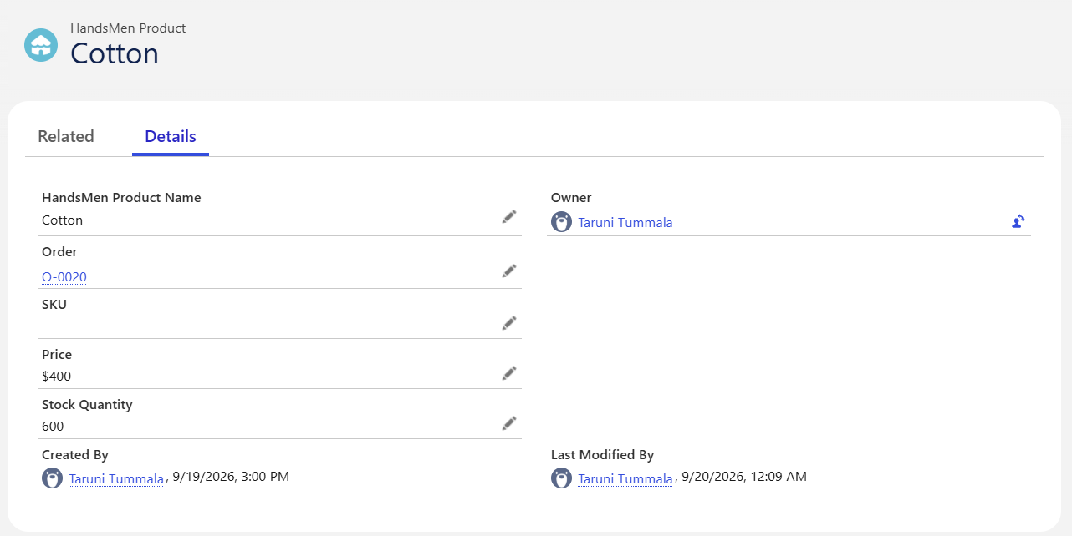

3. Apex Trigger– Stock Deduction
Description
The StockDeduction Apex Trigger automatically reduces the available inventory stock when an order is confirmed.
Configuration
Component | Details
Trigger Name | StockDeduction
Object | HandsMen_Order__c
Events | After Insert, After Update
Purpose | Reduce inventory stock when an order is confirmed
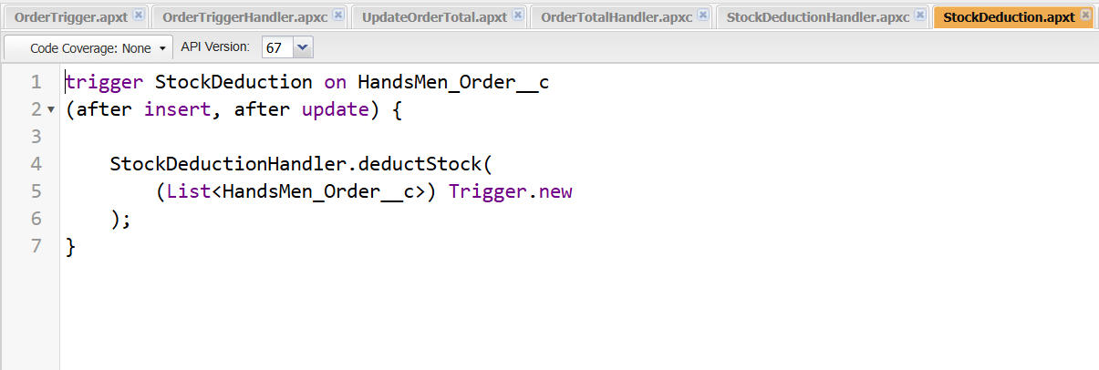
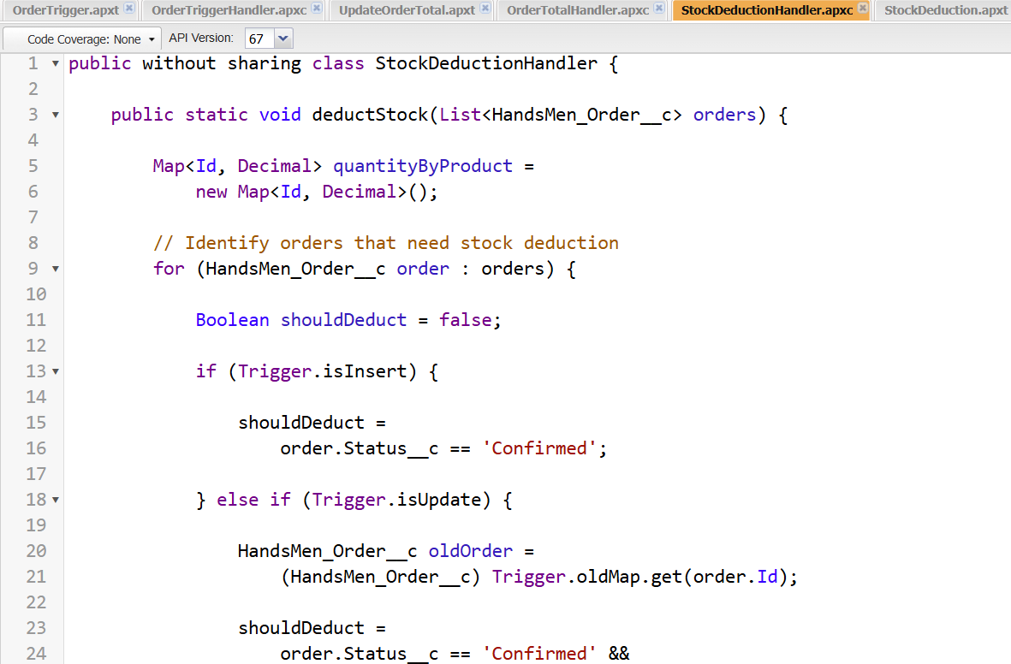
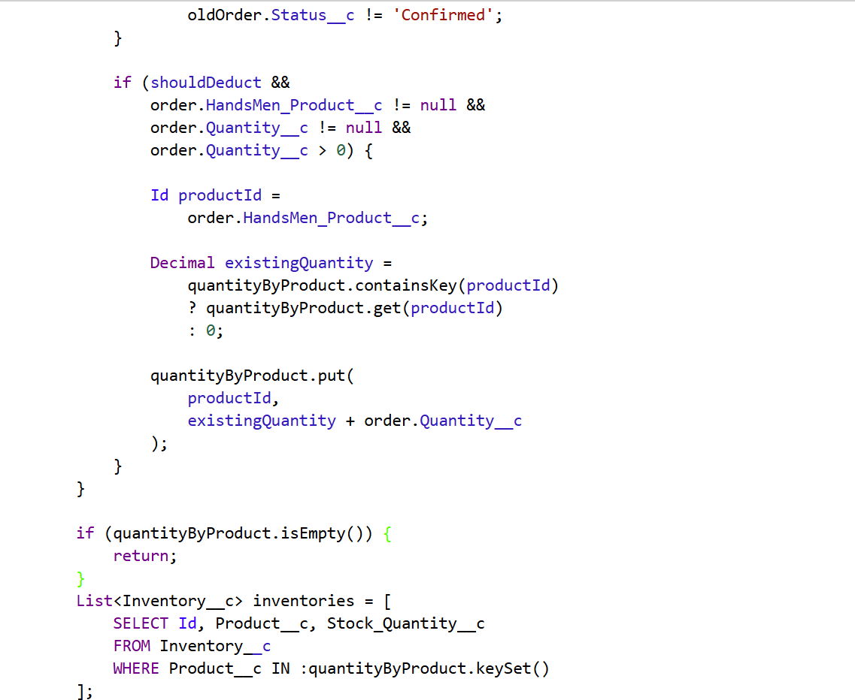
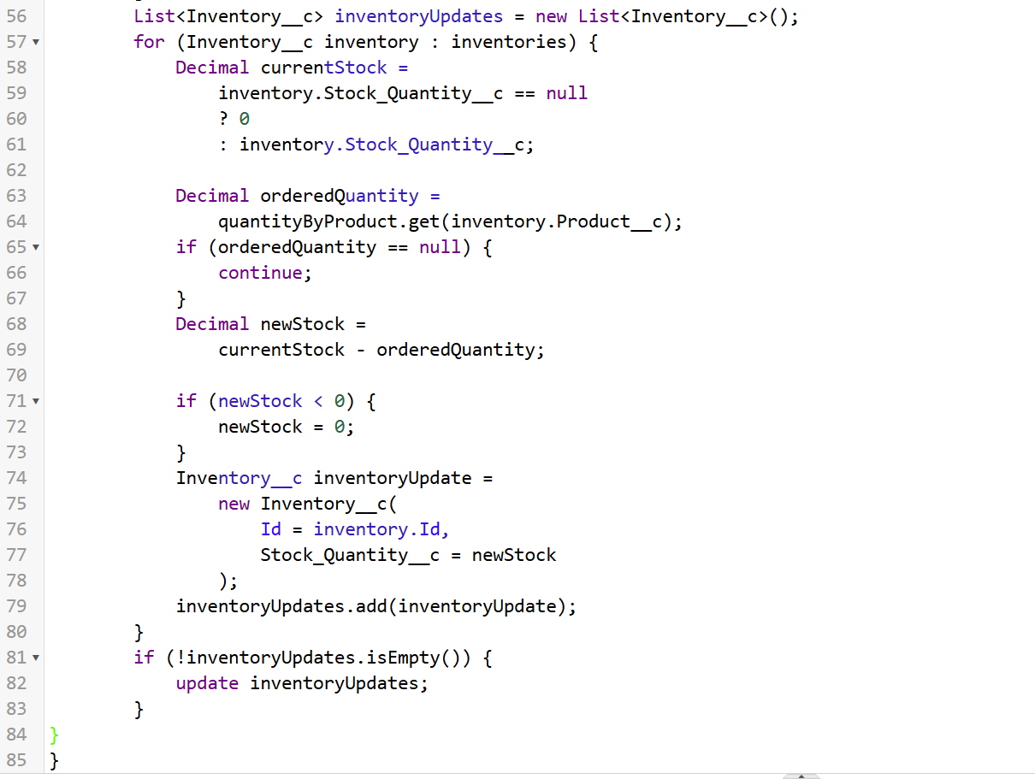

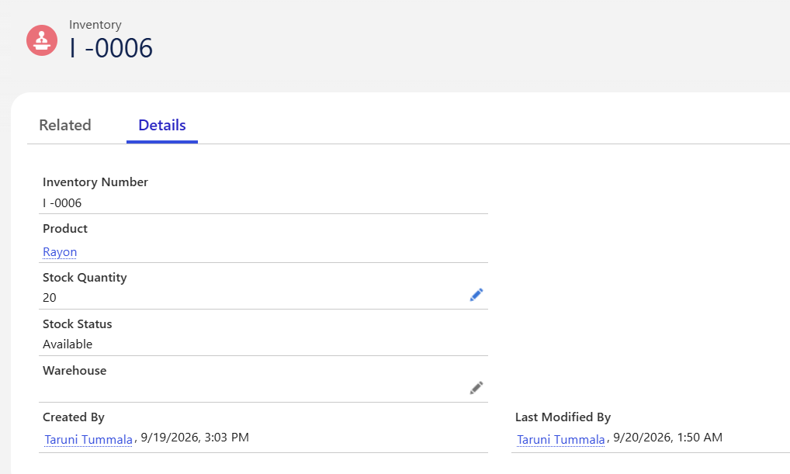
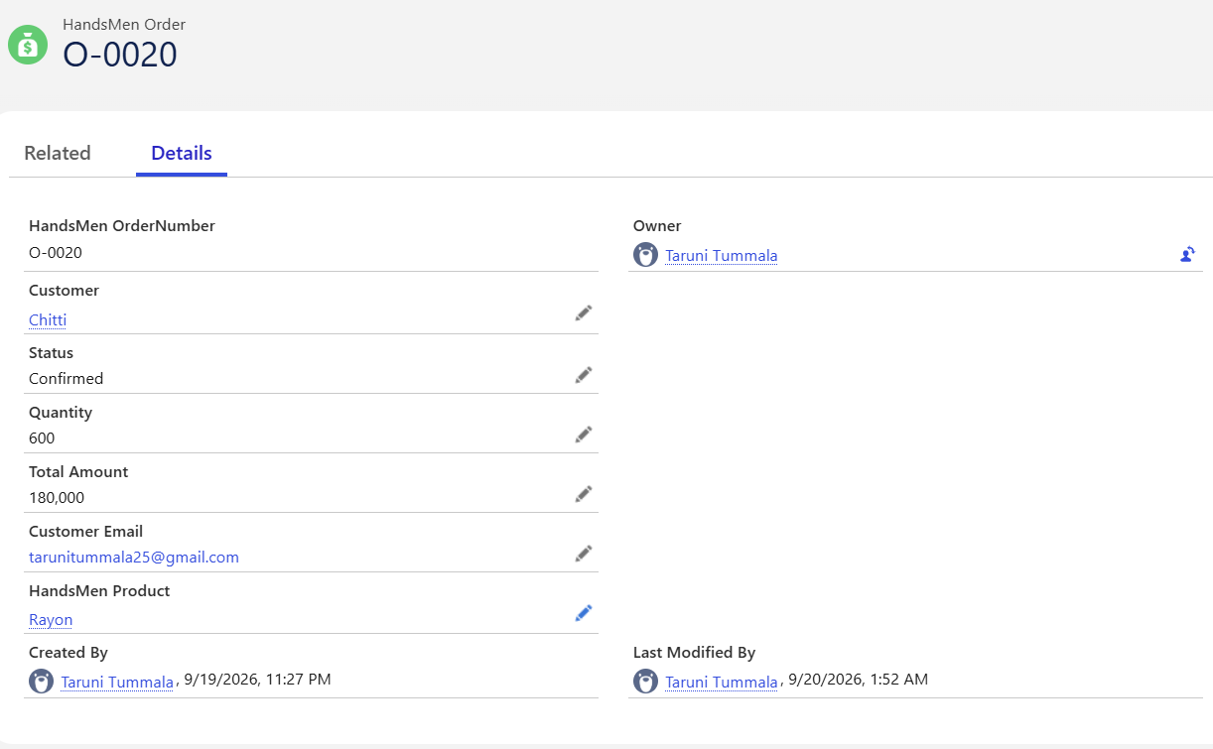

3. Loyalty Status Update
Apex Class - LoyaltyStatusHandler
The LoyaltyStatusHandler Apex Class handles the loyalty status update based on the customer's purchase history.
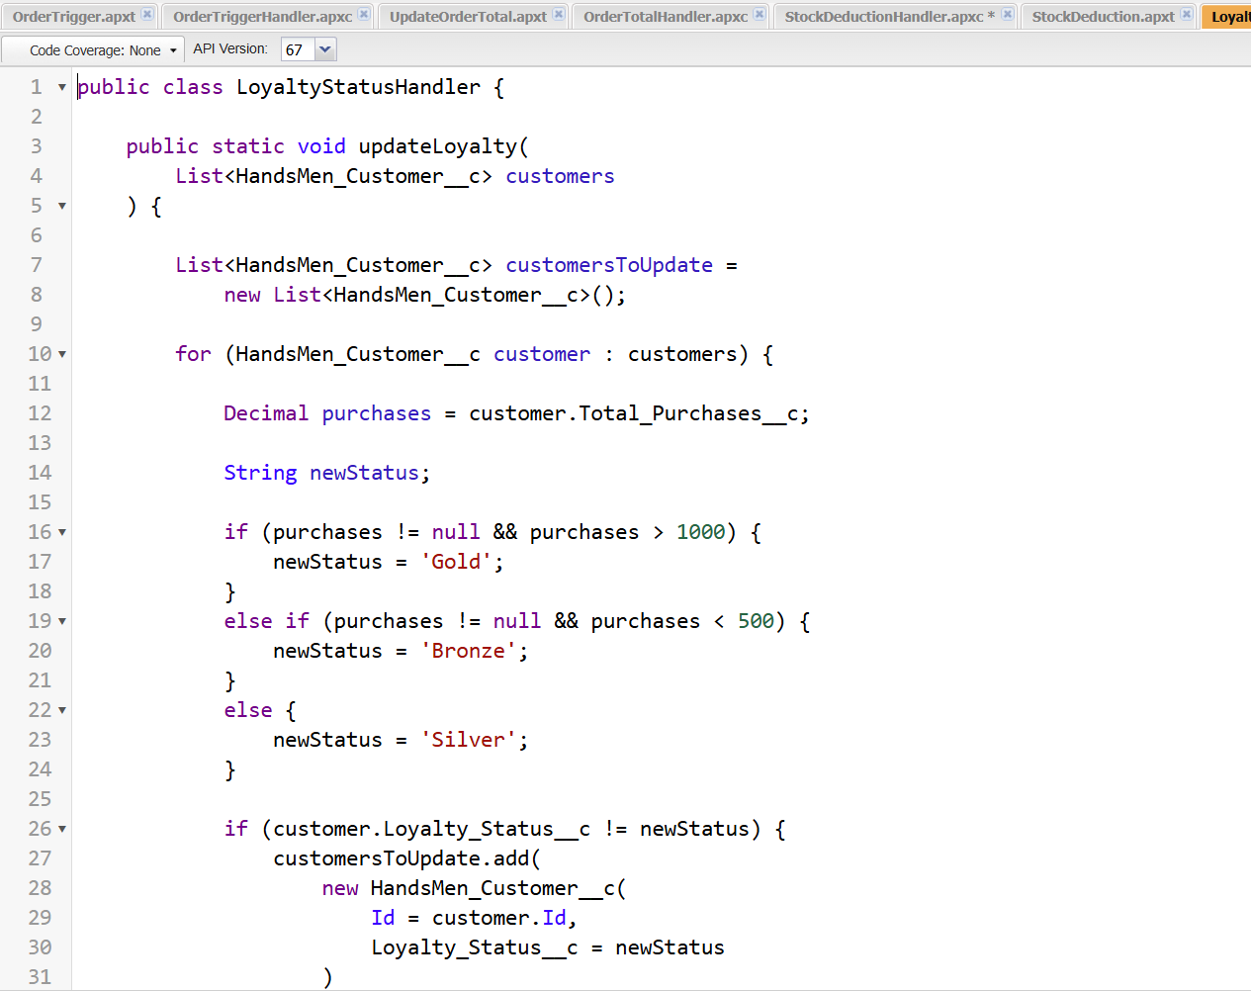
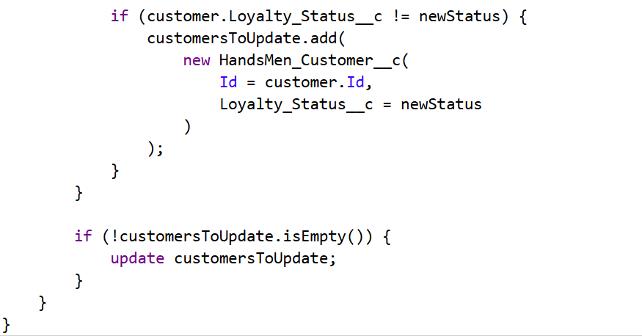

Apex Trigger-LoyaltyStatusUpdate
The LoyaltyStatusUpdate Apex Trigger invokes the loyalty status logic when the relevant customer information is updated.
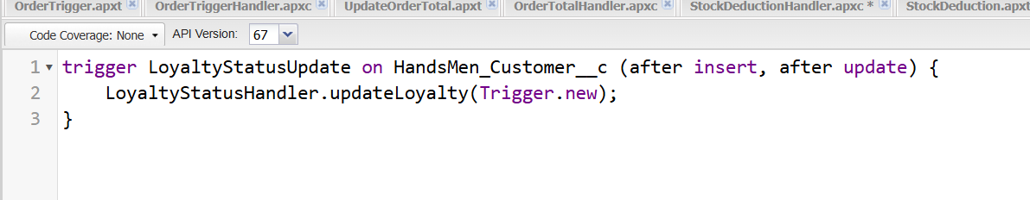

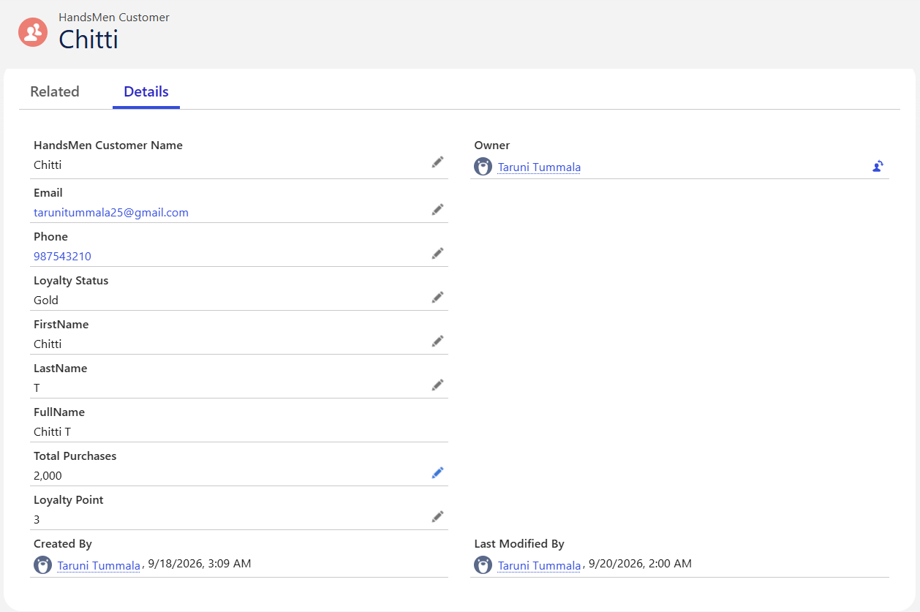
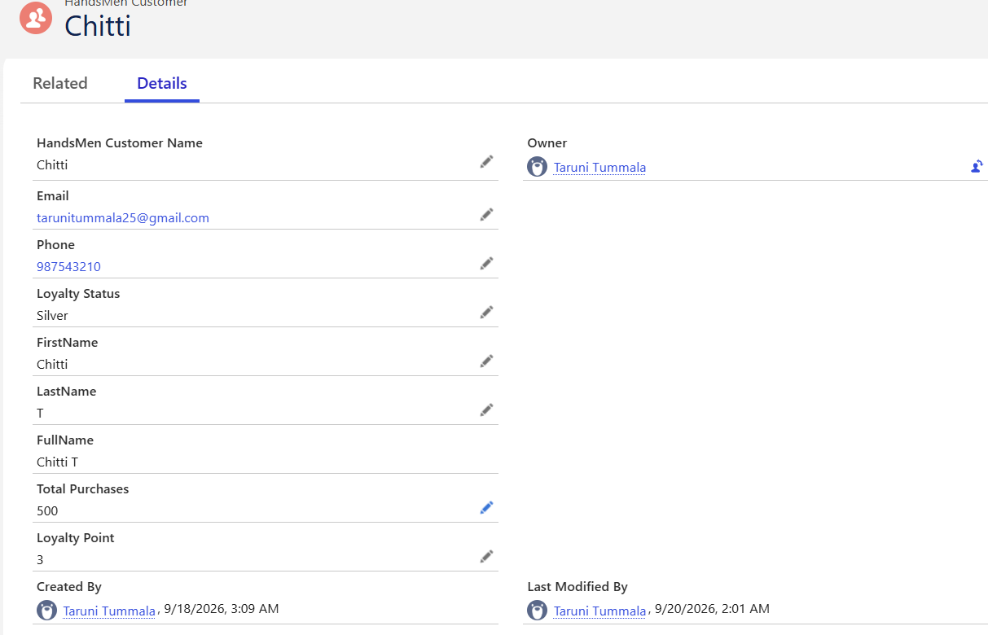
Batch Jobs
Description
The InventoryBatchJob Apex Class was created using Batch Apex and Schedulable Apex to process inventory records and automatically restock products with low stock levels.

Activity 1: Create an Apex Class
Go to Setup → Gear Icon → Developer Console.
In the Developer Console:
- Click File → New → Apex Class.
- Enter the Apex Class name as InventoryBatchJob.
- Click OK.
- Write the code logic.
- Click File → Save.
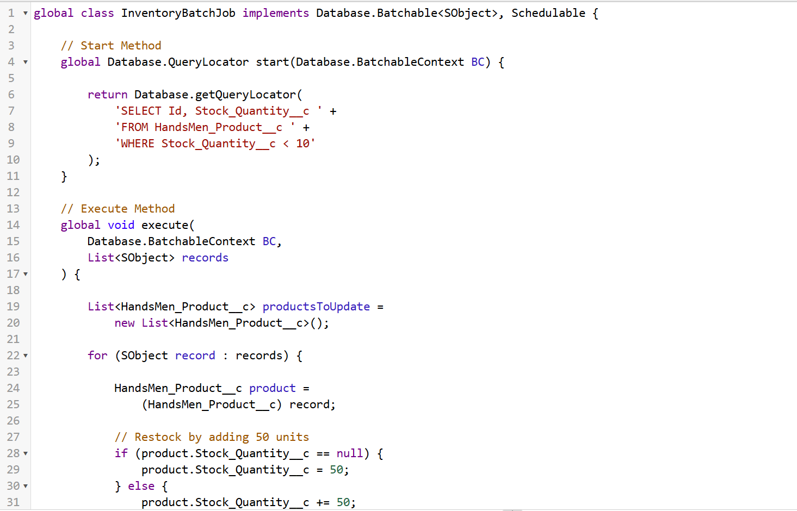
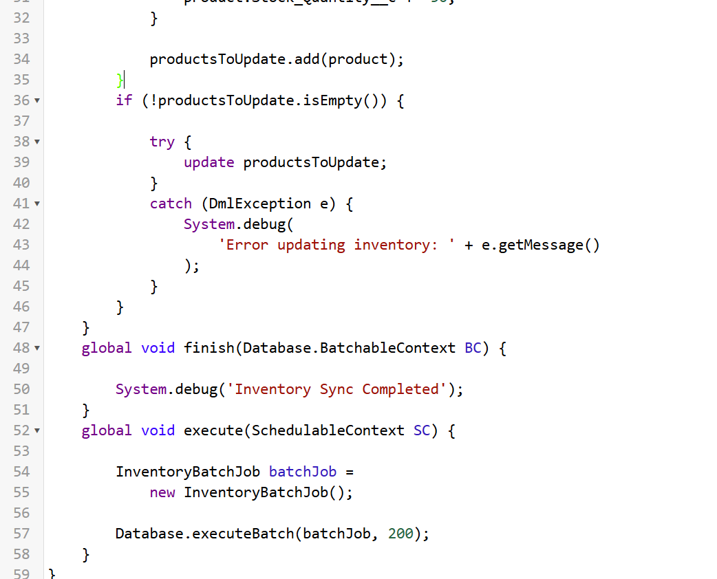

Activity 2: Schedule the Apex Class
Go to Developer Console → Debug → Open Execute Anonymous Window.
Enter the following code to schedule the inventory batch job:
System.schedule(
'Daily Inventory Sync',
'0 0 0 * * ?',
new InventoryBatchJob()
);
Verify the Scheduled Job
- Go to Setup.
- In Quick Find, search for Scheduled Jobs.
- Open Scheduled Jobs.
- Locate Daily Inventory Sync.
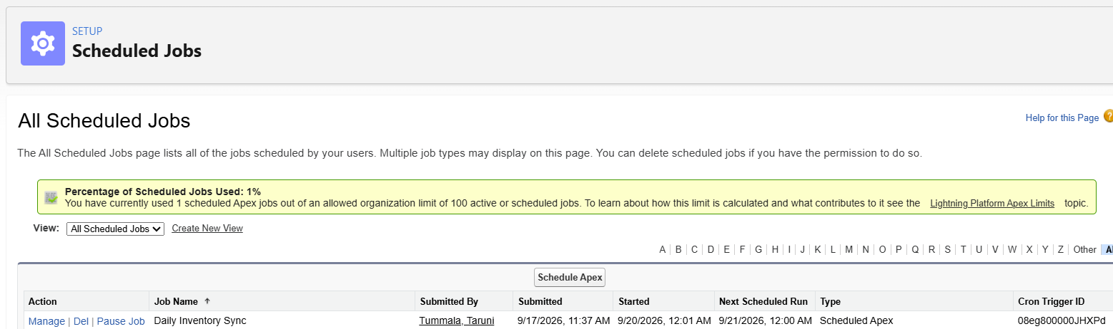
Batch Jobs – Loyalty Points Calculation
Description
The LoyaltyPointsBatch Apex Class is used to process customer records and update their loyalty points based on the purchase information.
Component | Details
Batch Class Name | LoyaltyPointsBatch
Object Used | HandsMen Customer
Purpose | Calculate and update customer loyalty points
Calculation | Loyalty points are calculated based on Total Purchases
Batch Size | 200 records

Activity 1: Create Loyalty Points Field
Go to Setup → Object Manager → HandsMen Customer → Fields & Relationships → New.
Field | Value
Field Label | Loyalty Points
Field Name | Loyalty Points
Data Type | Number
Decimal Places | 0

Activity 2: Create Loyalty Points Batch Apex
Go to Setup → Developer Console → File → New → Apex Class.
Enter the class name LoyaltyPointsBatch and click OK.
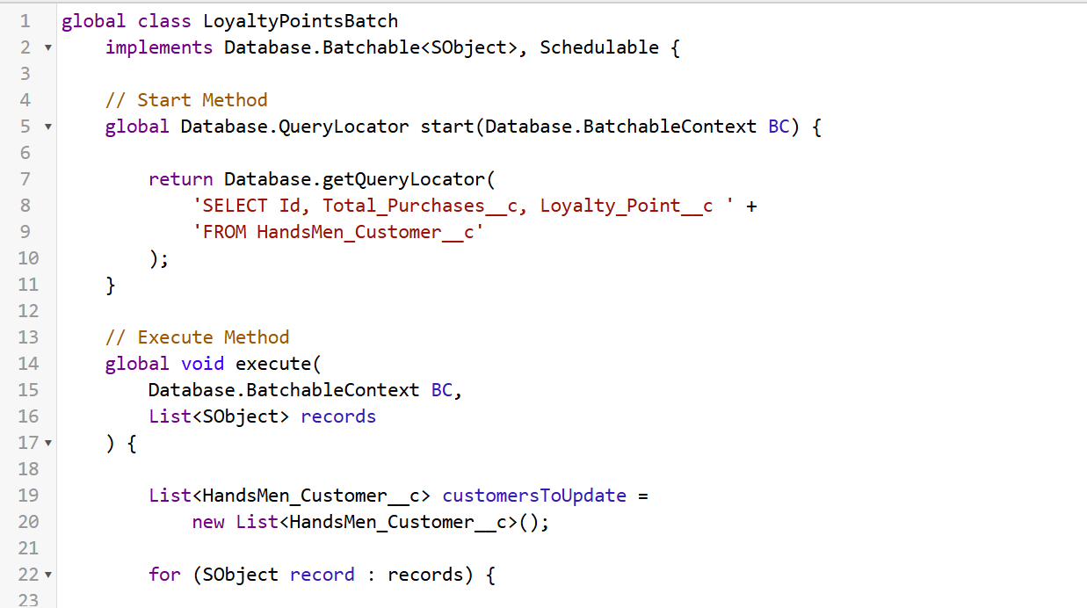

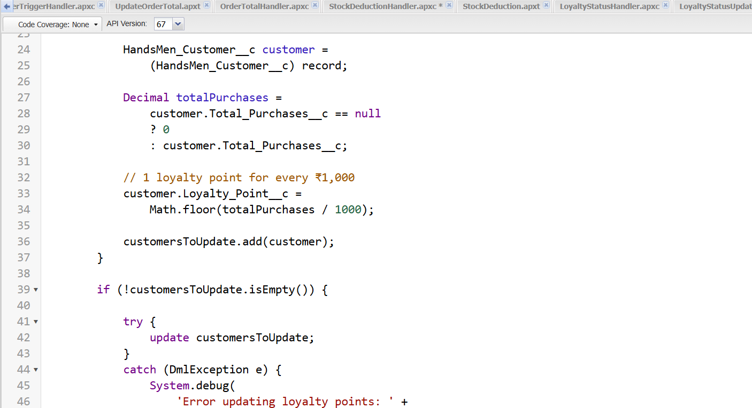
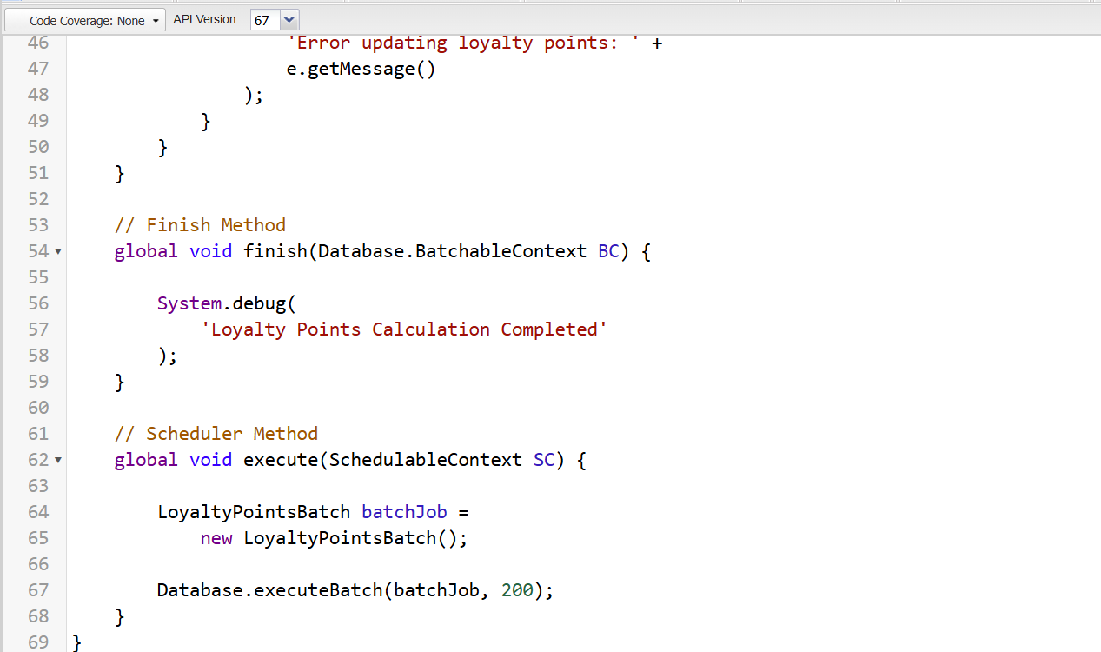

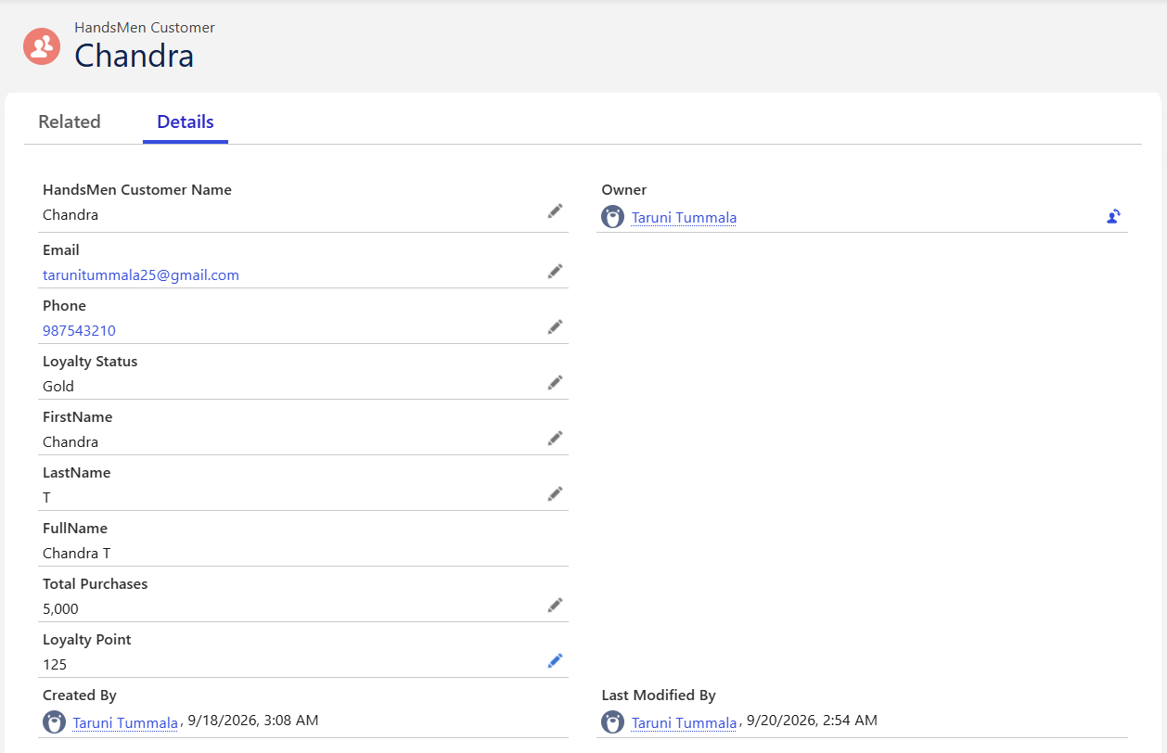

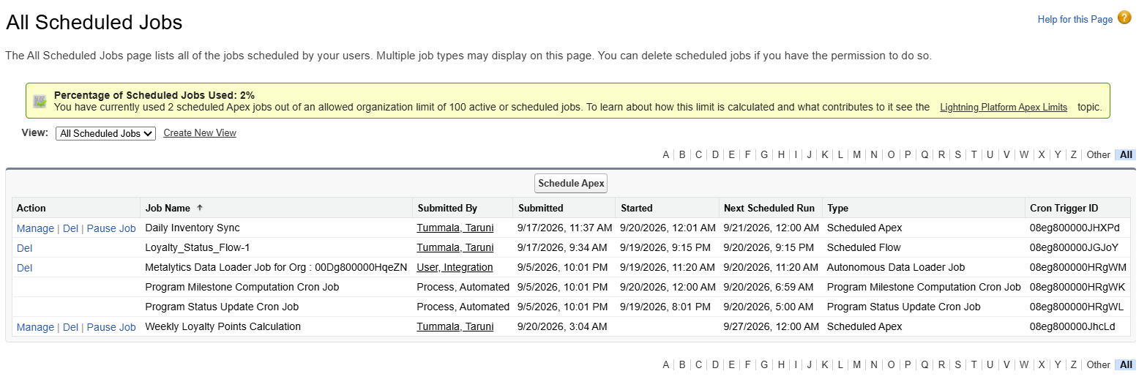

Conclusion
The HandsMen Threads Salesforce application was developed to organize and automate key business activities such as customer management, product and inventory management, order processing, and loyalty management. The system uses Salesforce features including custom objects, fields, relationships, validation rules, Lightning applications, profiles, roles, permission sets, Flows, Email Templates, Email Alerts, Apex Classes, Apex Triggers, and Batch Apex.
The implemented automation supports important business processes such as order confirmation, low-stock notifications, loyalty status management, automatic order total calculation, inventory processing, and loyalty point calculation. The InventoryBatchJob and LoyaltyPointsBatch provide background processing for inventory and customer loyalty information.
Overall, the project demonstrates the use of both declarative Salesforce tools and Apex programming to automate business processes, maintain data consistency, reduce manual work, and improve the management of customer, order, inventory, and loyalty-related information within the HandsMen Threads organization.

