SQL
SQL (Structured Query Language) is the standard language used with relational DBMSs to define schemas (DDL), manipulate and query data (DML/DQL) and optimize access so it’s a core skill for developers, data analysts and DBAs and a frequent interview focus. SQL covers:
- Data definition (defining schemas/structures)
- Data manipulation (inserting, updating, deleting data)
- Querying (retrieving data as needed)
- Optimization (tuning access/performance)
Together, these enable efficient storage, retrieval and management of data in relational database systems.

1. What is the difference between CHAR and VARCHAR2?
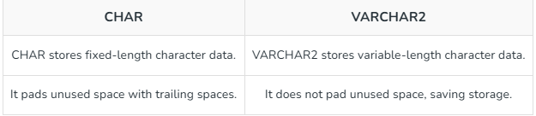

2. What is a view in SQL?
A view is a virtual table created from a SELECT query that displays data from one or more tables without storing it, helping simplify queries and improve security.

3. What is the purpose of the UNIQUE constraint?
The UNIQUE constraint ensures that all values in a column (or combination of columns) are distinct. This prevents duplicate values and helps maintain data integrity.

4. What is a query in SQL?
A query is a SQL statement used to retrieve, update or manipulate data in a database. The most common type of query is a SELECT statement, which fetches data from one or more tables based on specified conditions.

5. What is a subquery?
A subquery is a query nested within another query. It is often used in the WHERE clause to filter data based on the results of another query, making it easier to handle complex conditions.

6. What is a composite primary key?
A composite primary key uses two or more columns together to uniquely identify each row when one column alone isn’t sufficient.

7. Explain the difference between the WHERE and HAVING clauses
WHERE filters individual rows before grouping or aggregation, so it can’t use aggregate functions like SUM or COUNT; it’s best for narrowing raw data early (e.g., a date range or status).
HAVING filters the resulting groups after GROUP BY, so it’s meant for conditions on aggregates (e.g., groups with totals above a threshold).
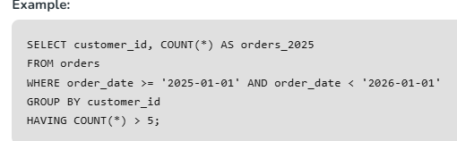

8. What are SQL joins and what are the differences between INNER, LEFT, RIGHT and FULL joins?
SQL joins combine rows from two tables based on a matching condition (typically keys) to answer questions that span both tables.
- An INNER JOIN returns only matches that exist in both tables (the intersection).
- A LEFT JOIN returns all rows from the left table and the matching rows from the right; when there’s no match, right-side columns are NULL.
- A RIGHT JOIN is the mirror image: all rows from the right table plus matches from the left, NULL when absent.
- A FULL (OUTER) JOIN returns all rows from either table, filling in NULL where a counterpart is missing.
9. Describe a PRIMARY KEY and how it differs from a UNIQUE key
- A PRIMARY KEY uniquely identifies each row in a table: it combines UNIQUE + NOT NULL, there can be only one per table (though it can be composite across multiple columns) and it’s the default target for foreign keys.
- A UNIQUE key also enforces uniqueness, but doesn’t require NOT NULL and you can have many UNIQUE constraints per table.

10. What is a CTE (Common Table Expression) and when would you use it?
A CTE (Common Table Expression) is a temporary named result set created using the WITH clause that exists only during the execution of a single SQL statement. It is used to simplify complex queries, improve readability, avoid repeating subqueries and write recursive queries.

11. Explain normalization and briefly describe the different normal forms
Normalization organizes relational data to minimize redundancy and prevent update/insert/delete anomalies by splitting tables based on dependencies while preserving meaning.
- 1NF: Each column contains atomic values, and there are no repeating groups.
- 2NF: Meets 1NF and removes partial dependencies on a composite primary key.
- 3NF: Meets 2NF and removes transitive dependencies.
- BCNF: Every determinant must be a candidate key.
- 4NF: Removes multi-valued dependencies.
- 5NF (PJNF): Removes join dependencies to avoid data redundancy.

12. What is the difference between UNION and UNION ALL?
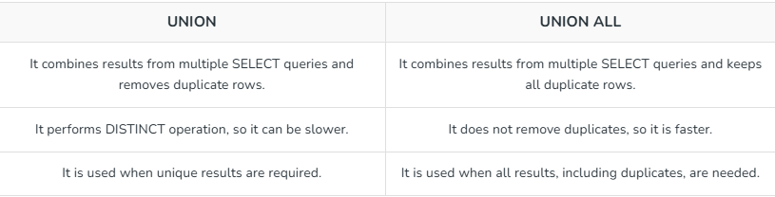

13. How do clustered and non‑clustered indexes differ ?
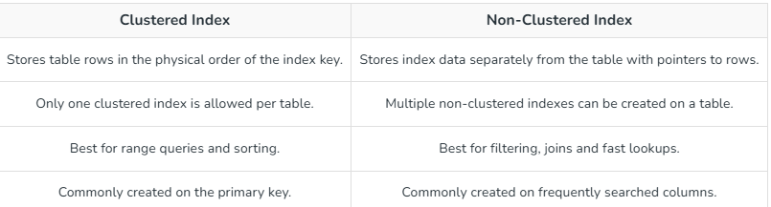

14. How do you perform pattern matching in SQL ?
Pattern matching in SQL is performed using the LIKE operator with wildcard characters.
% matches zero or more characters.
_ matches exactly one character.

15. How would you calculate the running total of sales for each product?
A running total is calculated using the SUM() window function with the OVER() clause. It adds each row's value to the cumulative total while keeping individual rows.
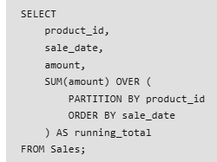
This query calculates the cumulative sales total for each product in chronological order.
16. Explain correlated subqueries and provide an example use case
A correlated subquery is a subquery that references columns from the outer query. It is executed once for each row processed by the outer query.
Example: Find employees whose salary is greater than the average salary of their department.
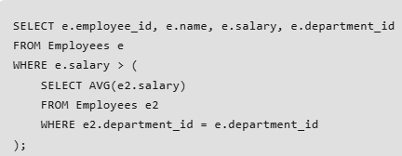
Output: Returns employees whose salary is higher than the average salary of their department.

17. What are EXISTS and NOT EXISTS and how do they differ from IN?
EXISTS returns TRUE if the subquery returns at least one row.
NOT EXISTS returns TRUE if the subquery returns no rows.
IN checks whether a value exists in a list or the result of a subquery.
Difference:
EXISTS and NOT EXISTS stop searching as soon as a matching row is found and work well with correlated subqueries.
IN compares a value against all values returned by the subquery and is best suited for small result sets.
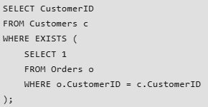
Output: Returns customers who have placed at least one order.

18. Explain anti-joins.
An anti-join returns rows from one table that do not have matching rows in another table. It is commonly implemented using NOT EXISTS or a LEFT JOIN with IS NULL.
Example: Find customers who have not placed any orders.
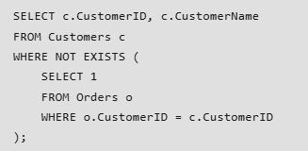
Output: Returns customers who have not placed any orders.

19. Explain the difference between RANK(), DENSE_RANK() and ROW_NUMBER()
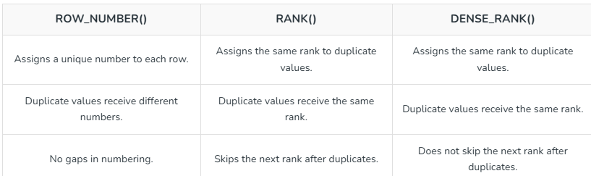

20. Explain the purpose of LAG and LEAD functions
- LAG and LEAD are window functions used to access values from the previous or next row without using a self-join.

- LAG() returns the value from the previous row.
- LEAD() returns the value from the next row.
They are commonly used to compare consecutive rows, calculate differences and analyze trends.

21. What is the difference between CROSS JOIN and INNER JOIN?
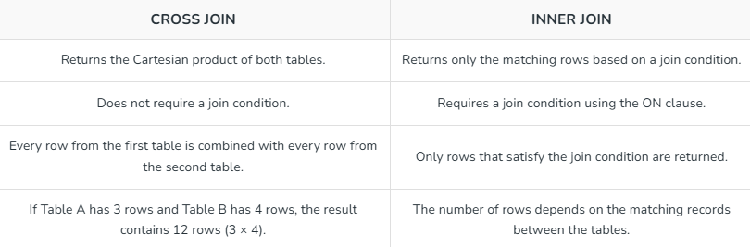

22. Explain foreign keys and how they enforce referential integrity
A foreign key is a column (or set of columns) in one table that references the primary key of another table. It enforces referential integrity by ensuring that values in the child table exist in the parent table, preventing invalid or orphan records.

23. Describe set operations like UNION, INTERSECT and EXCEPT and when each is useful
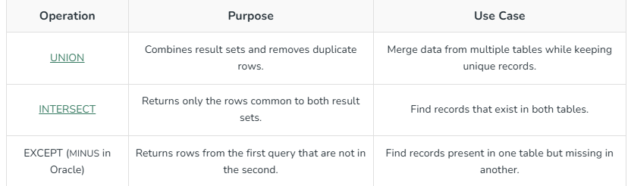

24. How would you optimize a slow query?
To optimize a slow query,
- Use EXPLAIN to find slow parts
- Add proper indexes and update statistics
- Use efficient conditions (avoid functions on columns)
- Filter data early and avoid SELECT *
- Optimize joins and reduce extra data
- Rewrite queries if needed (JOIN, UNION ALL)
- Use pagination, caching or partitioning for large data

25. Explain database partitioning.
Database partitioning is the process of dividing a large table into smaller, manageable partitions while treating it as a single logical table. It improves query performance, simplifies maintenance and enhances scalability.
Types:
- Horizontal Partitioning: Splits rows into different partitions.
- Vertical Partitioning: Splits columns into separate tables.

26. What strategies can protect a web application from SQL injection?
SQL injection can be prevented by following these best practices:
- Use parameterized queries (prepared statements).
- Validate and sanitize user input.
- Avoid dynamic SQL created through string concatenation.
- Use least-privilege database accounts.
- Use stored procedures securely.

27. What are the main types of SQL commands?
SQL commands are broadly classified into:
DDL (Data Definition Language): CREATE, ALTER, DROP, TRUNCATE.
DML (Data Manipulation Language): SELECT, INSERT, UPDATE, DELETE.
DCL (Data Control Language): GRANT, REVOKE.
TCL (Transaction Control Language): COMMIT, ROLLBACK, SAVEPOINT.

28. What is the purpose of the DEFAULT constraint?
The DEFAULT constraint assigns a default value to a column when no value is provided during an INSERT operation. This helps maintain consistent data and simplifies data entry.

29. What is denormalization and when is it used?
Denormalization is the process of combining normalized tables into larger tables for performance reasons. It is used when complex queries and joins slow down data retrieval and the performance benefits outweigh the drawbacks of redundancy.

30. What are the different operators available in SQL?
Arithmetic Operators: +, -, *, /, %
Comparison Operators: =, !=, <>, >, <, >=, <=
Logical Operators: AND, OR, NOT
Set Operators: UNION, INTERSECT, EXCEPT
Special Operators: BETWEEN, IN, LIKE, IS NULL
Concatenation Operators:|| (Oracle, PostgreSQL) or + (SQL Server) to combine strings.

31. What is a SELF JOIN and when is it used?
A SELF JOIN is a join in which a table is joined with itself. It is useful when rows within the same table have a relationship, such as employees and their managers or products with parent products. Separate table aliases are used to distinguish between the two instances of the same table.
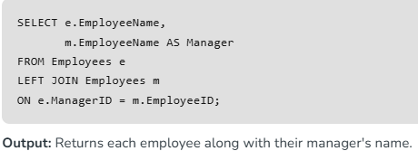

32. What is the purpose of the GROUP BY clause?
The GROUP BY clause is used to arrange identical data into groups. It is typically used with aggregate functions (such as COUNT, SUM, AVG) to perform calculations on each group rather than on the entire dataset.

33. What are aggregate functions in SQL?
Aggregate functions perform calculations on a set of values and return a single value. Common aggregate functions include:
COUNT(): Returns the number of rows.
SUM(): Returns the total sum of values.
AVG(): Returns the average of values.
MIN(): Returns the smallest value.
MAX(): Returns the largest value.

34. What are indexes and why are they used?
Indexes are database objects that improve query performance by allowing faster retrieval of rows. They function like a book’s index, making it quicker to find specific data without scanning the entire table. However, indexes require additional storage and can slightly slow down data modification operations. Types of Indexes:
Clustered Index: Sorts and stores data rows in order of the key (only one per table).
Non-Clustered Index: Separate structure with pointers to data rows (can be many per table).
Unique Index: Ensures no duplicate values.
Composite Index: Index on multiple columns.

35. What is the difference between DELETE and TRUNCATE commands?
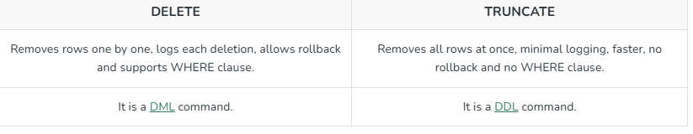

36. What are the differences between SQL and NoSQL databases?
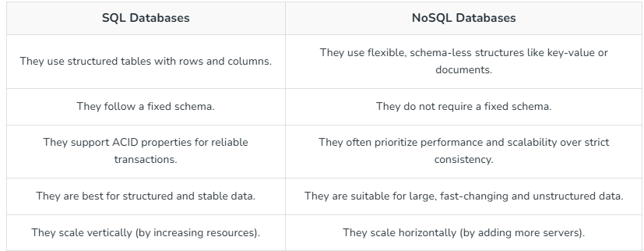

37. What are the types of constraints in SQL?
Common constraints include:
- NOT NULL: Ensures a column cannot have NULL values.
- UNIQUE: Ensures all values in a column are distinct.
- PRIMARY KEY: Uniquely identifies each row in a table.
- FOREIGN KEY: Ensures referential integrity by linking to a primary key in another table.
- CHECK: Ensures that all values in a column satisfy a specific condition.
- DEFAULT: Sets a default value for a column when no value is specified.

38. What is a cursor in SQL?
A cursor is a database object used to retrieve, manipulate and traverse through rows in a result set one row at a time. Cursors are helpful when performing operations that must be processed sequentially rather than in a set-based manner.
Types of Cursors (SQL Server):
- STATIC: Snapshot of result set, does not reflect changes.
- DYNAMIC: Reflects all changes made while the cursor is open.
- FORWARD_ONLY: Can only move forward through the result set.
- KEYSET: Uses a key to fetch rows; changes to non-key columns are visible.

39. What is a trigger in SQL?
A trigger is a set of SQL statements that automatically execute in response to certain events on a table, such as INSERT, UPDATE or DELETE. Triggers help maintain data consistency, enforce business rules and implement complex integrity constraints.
Types: BEFORE or AFTER triggers (depending on DB).
Uses: Enforce business rules, maintain audit logs, check data consistency.
40. What is the purpose of the SQL SELECT statement?
The SELECT statement retrieves data from one or more tables. It is the most commonly used command in SQL, allowing users to filter, sort and display data based on specific criteria.

41. What is the purpose of the ORDER BY clause?
ORDER BY sorts the result set of a query in ascending or descending order based on one or more columns.

42. What is a table in SQL?
A table is a structured collection of related data organized into rows and columns. Columns define the type of data stored, while rows contain individual records.

43. What are NULL values in SQL?
NULL represents a missing or unknown value. It is different from zero or an empty string. NULL values indicate that the data is not available or applicable.

44. What is a stored procedure?
A stored procedure is a precompiled set of SQL statements stored in the database. It can take input parameters, perform logic and queries and return output values or result sets. Stored procedures improve performance and maintainability by centralizing business logic.

45. What is the difference between DDL and DML commands?
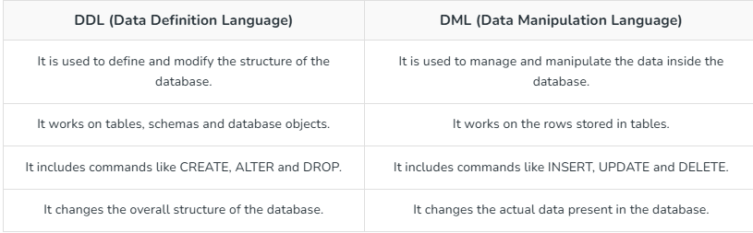

46. What is the purpose of the ALTER command in SQL?
The ALTER command is used to modify the structure of an existing database object. This command is essential for adapting our database schema as requirements evolve.
- Add or drop a column in a table.
- Change a column’s data type.
- Add or remove constraints.
- Rename columns or tables.
- Adjust indexing or storage settings.

47. How is data integrity maintained in SQL databases?
Data integrity refers to the accuracy, consistency and reliability of the data stored in the database. SQL databases maintain data integrity through several mechanisms:
- Constraints: Ensuring that certain conditions are always met. For example, NOT NULL ensures a column cannot have missing values, FOREIGN KEY ensures a valid relationship between tables and UNIQUE ensures no duplicate values.
- Transactions: Ensuring that a series of operations either all succeed or all fail, preserving data consistency.
- Triggers: Automatically enforcing rules or validations before or after changes to data.
- Normalization: Organizing data into multiple related tables to minimize redundancy and prevent anomalies.
- Cascading actions: Foreign keys can enforce integrity with ON DELETE CASCADE and ON UPDATE CASCADE, automatically updating or removing related rows.
These measures collectively ensure that the data remains reliable and meaningful over time.

48. How does the CASE statement work in SQL?
The CASE statement is SQL’s way of implementing conditional logic in queries. It evaluates conditions and returns a value based on the first condition that evaluates to true. If no condition is met, it can return a default value using the ELSE clause.
Example:
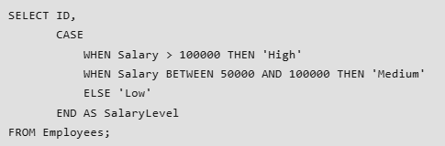

49. What is the purpose of the COALESCE function?
The COALESCE function returns the first non-NULL value from a list of expressions. It’s commonly used to provide default values or handle missing data gracefully.
Example:

50. What are the differences between SQL’s COUNT() and SUM() functions?
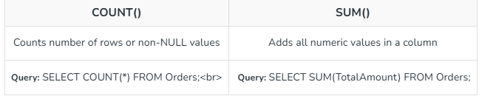

51. What is the difference between the NVL and NVL2 functions?
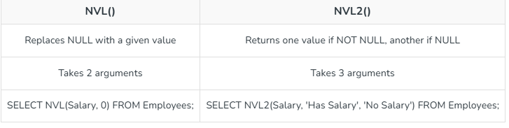

52. What are scalar functions in SQL?
Scalar functions operate on individual values and return a single value as a result. They are often used for formatting or converting data. Common examples include:
- LEN(): Returns the length of a string.
- ROUND(): Rounds a numeric value.
- CONVERT(): Converts a value from one data type to another.

53. What happens if you use COUNT() on NULLs?
COUNT(column) ignores NULL values and only counts non-NULL entries.
COUNT(*) counts all rows, including those with NULL values in columns.
Example:

54. What are window functions and how are they used?
Window functions perform calculations across a group of related rows while keeping each row separate. They are used for tasks like running totals, rankings and moving averages.
Example: Calculating a running total
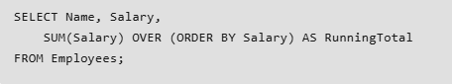

55. What is the difference between an index and a key in SQL?
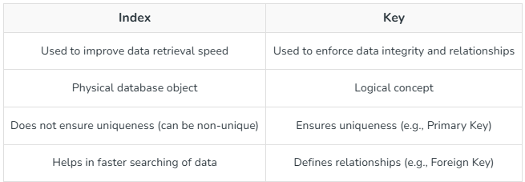

56. How does indexing improve query performance?
Indexing helps the database quickly find data without scanning the whole table, reducing time and improving query performance.
Example:
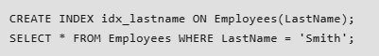
The index on LastName lets the database quickly find all rows matching ‘Smith’ without scanning every record.

57. What are the trade-offs of using indexes in SQL databases?
Advantages
- Faster query performance, especially for SELECT queries with WHERE clauses, JOIN conditions or ORDER BY clauses.
- Improved sorting and filtering efficiency.
Disadvantages:
- Increased storage space for the index structures.
- Additional overhead for write operations (INSERT, UPDATE, DELETE), as indexes must be updated whenever the underlying data changes.

58. What are temporary tables and how are they used?
Temporary tables are tables that exist only for the duration of a session or a transaction. They are useful for storing intermediate results, simplifying complex queries, or performing operations on subsets of data without modifying the main tables.

59. What is a materialized view and how does it differ from a standard view?
Standard View:
- A virtual table defined by a query.
- Does not store data; the underlying query is executed each time the view is referenced.
- A standard view shows real-time data.
Materialized View:
- A physical table that stores the result of the query.
- Data is precomputed and stored, making reads faster.
- Requires periodic refreshes to keep data up to date.
- materialized view is used to store aggregated sales data, updated nightly, for fast reporting.
- In Oracle/Postgres, you use: REFRESH MATERIALIZED VIEW my_view;
They can also be set up with ON DEMAND or ON COMMIT refresh policies depending on DBMS.

60. What is a sequence in SQL?
A sequence is a database object that generates a series of unique numeric values. It’s often used to produce unique identifiers for primary keys or other columns requiring sequential values.
Example:
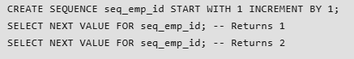

61. What is the purpose of the SQL EXCEPT operator?
The EXCEPT operator is used to return rows from one query’s result set that are not present in another query’s result set. It effectively performs a set difference, showing only the data that is unique to the first query.
Example:
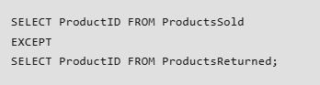
Use Case:
- To find discrepancies between datasets.
- To verify that certain data exists in one dataset but not in another.
- Performance Considerations:
- EXCEPT works best when the datasets involved have appropriate indexing and when the result sets are relatively small.
- Large datasets without indexes may cause slower performance because the database has to compare each row.

62. How do constraints improve database integrity?
Constraints enforce rules that the data must follow, preventing invalid or inconsistent data from being entered:
- NOT NULL: Ensures that a column cannot contain NULL values.
- UNIQUE: Ensures that all values in a column are distinct.
- PRIMARY KEY: Combines NOT NULL and UNIQUE, guaranteeing that each row is uniquely identifiable.
- FOREIGN KEY: Ensures referential integrity by requiring values in one table to match primary key values in another.
- CHECK: Validates that values meet specific criteria (e.g., CHECK (Salary > 0)).
By automatically enforcing these rules, constraints maintain data reliability and consistency.

63. What is the difference between a local and a global temporary table?
Local Temporary Table:
- Prefixed with # (e.g., #TempTable).
- Exists only within the session that created it.
- Automatically dropped when the session ends.
Global Temporary Table:
- Prefixed with ## (e.g., ##GlobalTempTable).
- Visible to all sessions.
- Dropped only when all sessions referencing it are closed.
Example:
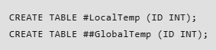

64. What is the purpose of the SQL MERGE statement?
The MERGE statement combines multiple operations INSERT, UPDATE and DELETE into one. It is used to synchronize two tables by:
- Inserting rows that don’t exist in the target table.
- Updating rows that already exist.
- Deleting rows from the target table based on conditions
- In SQL Server, MERGE can cause concurrency issues (race conditions or deadlocks).
Example:
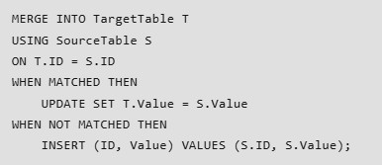
65. How can you handle duplicates in a query without using DISTINCT?
GROUP BY: Aggregate rows to eliminate duplicates
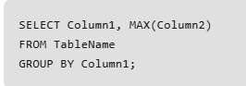
ROW_NUMBER(): Assign a unique number to each row and filter by that
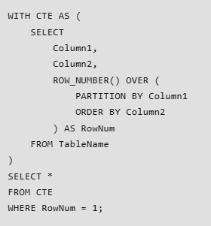
66. What are the ACID properties of a transaction?
ACID ensures database transactions are reliable and maintain data integrity.
- Atomicity: A transaction is completed entirely or not at all. If one operation fails, all changes are rolled back.
- Example: A bank transfer fails if either debit or credit is unsuccessful.
- Consistency: Ensures the database remains valid by following all rules and constraints.
- Example: Inventory quantity cannot become negative.
- Isolation: Multiple transactions execute independently without affecting each other.
- Example: Two users cannot book the same seat simultaneously.
- Durability: Once a transaction is committed, its changes are permanently saved, even after a system failure.
- Example: A confirmed order remains stored after a server restart.

67. What are the differences between isolation levels in SQL?
Isolation levels control how transactions interact to maintain data consistency.
- Read Uncommitted: Allows reading uncommitted data, which may cause dirty reads.
- Read Committed: Reads only committed data, preventing dirty reads.
- Repeatable Read: Ensures the same data remains unchanged during a transaction, preventing dirty and non-repeatable reads.
- Serializable: Provides the highest isolation level, preventing dirty reads, non-repeatable reads, and phantom reads, but may reduce performance due to increased locking.

68. What is the purpose of the WITH (NOLOCK) hint in SQL Server?
The WITH (NOLOCK) hint allows a query to read data without acquiring shared locks, effectively reading uncommitted data.
It can improve performance by reducing contention for locks, especially on large tables that are frequently updated.
Results may be inconsistent or unreliable, as the data read might change or be rolled back.
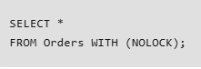
This query fetches data from the Orders table without waiting for other transactions to release their locks.

69. How do you handle deadlocks in SQL databases?
A deadlock occurs when two or more transactions wait indefinitely for each other to release resources.
- Deadlock Detection & Retry: The database detects the deadlock, aborts one transaction and retries it later.
- Reduce Lock Contention: Use indexes, optimize queries and keep transactions short.
- Choose Appropriate Isolation Levels: Select suitable isolation levels to balance consistency and locking.
- Consistent Resource Ordering: Access resources in the same order across transactions to avoid circular waits.

70. What is a database snapshot and how is it used?
Database Snapshot is a read-only copy of a database at a specific point in time.
Uses:
- Reporting on a consistent dataset.
- Point-in-time recovery.
- Testing without affecting the original database.
Example:
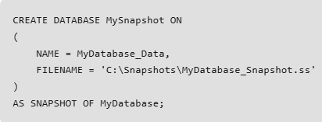

71. What are the differences between OLTP and OLAP systems?
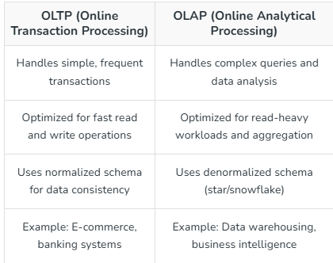

72. What is a live lock and how does it differ from a deadlock?
Live Lock
- Occurs when two or more transactions keep responding to each other’s changes, but no progress is made.
- Unlike a deadlock, the transactions are not blocked; they are actively running, but they cannot complete.
Deadlock
- A deadlock occurs when two or more transactions are waiting on each other’s resources indefinitely, blocking all progress.
- No progress can be made unless one of the transactions is terminated

73. How do you implement dynamic SQL and what are its advantages and risks?
Dynamic SQL is SQL code created and executed at runtime using variables or user input.
Advantages:
- Builds flexible queries dynamically.
- Useful for dynamic filtering, sorting, and table selection.
Risks:
- Vulnerable to SQL injection if inputs are not validated.
- Harder to debug and maintain.
- May reduce query performance due to limited execution plan reuse.

74. What is the difference between horizontal and vertical partitioning?
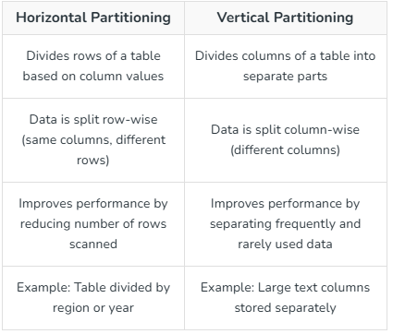

75. What are the considerations for indexing very large tables?
- Index Frequently Used Columns: Create indexes on columns used in WHERE, JOIN and ORDER BY clauses. Avoid indexing every column.
- Choose the Right Index Type: Use clustered indexes for primary keys and range queries, and non-clustered indexes for filtering and sorting.
- Use Partitioned Indexes: Create local indexes for partitioned tables to improve performance.
- Maintain Indexes: Rebuild fragmented indexes and perform maintenance during off-peak hours.
- Monitor Performance: Analyze execution plans and remove unused indexes to reduce maintenance overhead.

76. What is the difference between database sharding and partitioning?
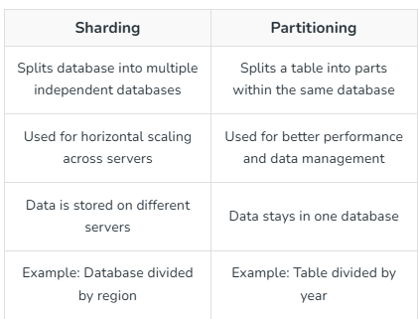

77. What are the best practices for writing optimized SQL queries?
- Write Simple Queries: Keep SQL queries clear and avoid unnecessary complexity.
- Filter Data Early: Use WHERE clauses to reduce the amount of data processed.
- Avoid SELECT *: Retrieve only the required columns.
- Use Indexes Effectively: Index frequently used columns in WHERE, JOIN and ORDER BY clauses.
- Analyze Execution Plans: Identify and fix slow query operations.
- Optimize Joins & Aggregations: Use appropriate joins and efficient GROUP BY operations.
- Monitor Performance: Regularly review and tune queries as data grows.

78. How can you monitor query performance in a production database?
- Use Execution Plans: Identify bottlenecks and optimize query performance.
- Analyze Wait Statistics: Detect delays caused by locks, I/O or CPU usage.
- Use Monitoring Tools: Use tools like EXPLAIN, Query Store and Performance Schema to analyze queries.
- Track Performance Metrics: Monitor query time, CPU usage and I/O to detect issues early.
- Continuously Tune Queries: Optimize queries and update indexes as data and workloads grow.

79. What are the trade-offs of using indexing versus denormalization?
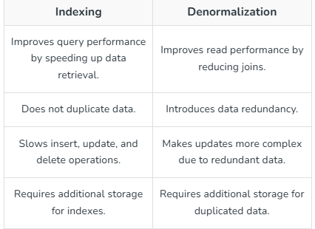

80. How does SQL handle recursive queries?
SQL uses recursive CTEs to retrieve hierarchical or tree-structured data.
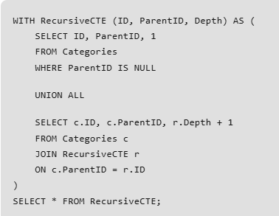

81. What are the differences between transactional and analytical queries?
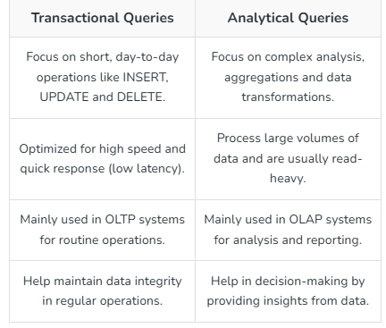

82. How can you ensure data consistency across distributed databases?
- Distributed Transactions: Ensure all databases commit or roll back together (e.g., 2PC).
- Eventual Consistency: Allow data to become consistent over time.
- Conflict Resolution: Use timestamps or versioning to resolve conflicts.
- Data Replication: Keep data synchronized across databases.
- Audits & Validation: Regularly check and fix inconsistencies.

83. What is the purpose of the SQL PIVOT operator?
The PIVOT operator transforms rows into columns, making it easier to summarize or rearrange data for reporting.
Example:
Converting a dataset that lists monthly sales into a format that displays each month as a separate column.
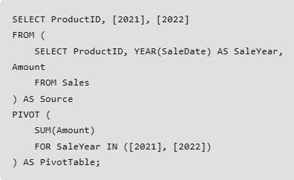

84. What is a bitmap index and how does it differ from a B-tree index?
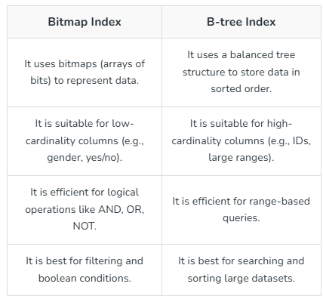

85: Difference between blocking and deadlocking.
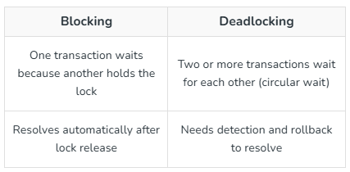

86. What is the difference between INNER JOIN and LEFT JOIN?
An INNER JOIN returns only the rows where there is a matching value in both the left and right tables, effectively filtering out any non-matching data. In contrast, a LEFT JOIN (or LEFT OUTER JOIN) returns every row from the left table regardless of a match; if no corresponding row exists in the right table, the result set will contain NULL values for those right-side columns.
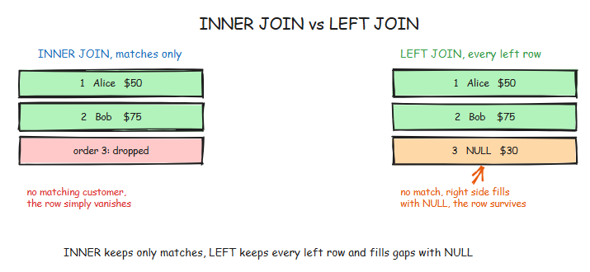
87. Explain the difference between WHERE and HAVING.
The WHERE clause is used to filter individual rows of data before any groupings or aggregations are performed by the database engine. The HAVING clause is specifically designed to filter the results of aggregate functions (like SUM or COUNT) and must be used after a GROUP BY clause has been defined.
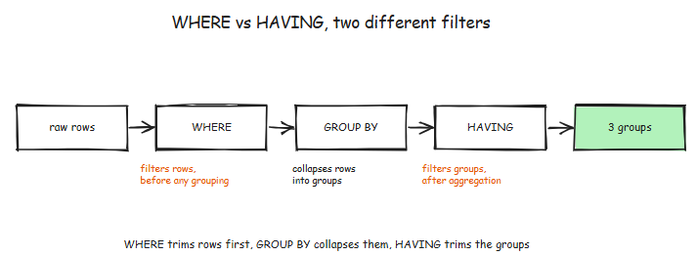

88. What is a Self Join and when would you use it?
A Self Join is a technique where a table is joined with itself by giving the table two different aliases within the same query. This is most commonly used when a table has a recursive relationship, such as an employee table that contains a "manager_id" pointing back to the "employee_id" of another row in the same table.
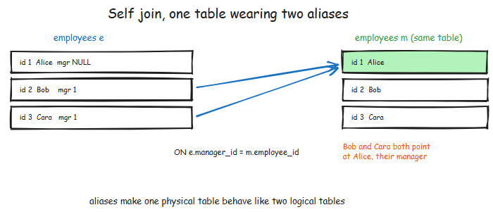
89. How do you find duplicate rows in a table?
To identify duplicates, you should select the columns you want to check, use the GROUP BY clause on those columns, and then apply a HAVING COUNT(*) > 1 filter. This identifies groups of data that appear more than once in the underlying dataset.

90. What is the difference between UNION and UNION ALL?
UNION performs a distinct operation on the combined result set, meaning it removes duplicate rows, which requires extra processing power and time. UNION ALL simply appends the result sets together without checking for duplicates, making it significantly faster and more efficient when you know your data is unique or when duplicates are acceptable.
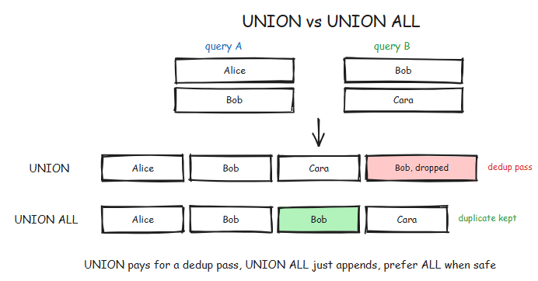

91. What is a CROSS JOIN?
A CROSS JOIN creates a Cartesian product between two tables, meaning every single row from the first table is paired with every single row from the second table. If Table A has 10 rows and Table B has 10 rows, the resulting CROSS JOIN will produce 100 rows.
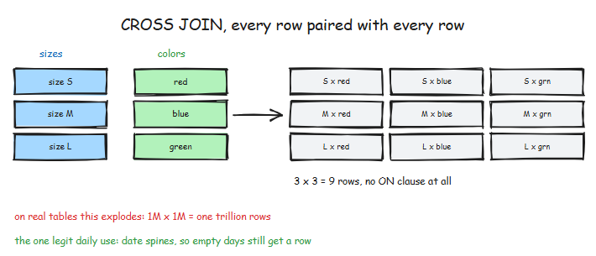

92. How do you select the top N records from a table?
The syntax varies by database engine: in PostgreSQL, MySQL, and BigQuery, you use the LIMIT N clause at the end of the query. In SQL Server, you use SELECT TOP N at the beginning, and in Oracle, you typically use FETCH FIRST N ROWS ONLY.

93. What does the COALESCE function do?
The COALESCE function evaluates a list of arguments in order and returns the first value that is not NULL. This is an essential tool for data engineers when merging multiple data sources where some fields might be missing, or when providing default values for reports.

94. What is the purpose of the DISTINCT keyword?
DISTINCT is used within a SELECT statement to remove duplicate rows from the output, ensuring that each row in the result set is unique based on the columns specified.

95. How do you handle NULL values in a comparison?
Standard comparison operators like = or != do not work with NULL because NULL represents an unknown value, not a zero or an empty string. You must use the specific operators IS NULL or IS NOT NULL to accurately filter for missing data.

96. What are Aggregate Functions?
Aggregate functions perform a calculation on a set of values across multiple rows to return a single, summary value. Common examples include SUM() for totals, AVG() for means, COUNT() for frequency, and MIN()/MAX() for range boundaries.

97. Explain the difference between RANK(), DENSE_RANK(), and ROW_NUMBER().
ROW_NUMBER() assigns a strictly unique, sequential integer to each row. RANK() assigns the same number to tied values but skips the next sequential numbers (e.g., 1, 2, 2, 4). DENSE_RANK() also assigns the same number to ties but does not skip any numbers (e.g., 1, 2, 2, 3), keeping the ranking "dense."
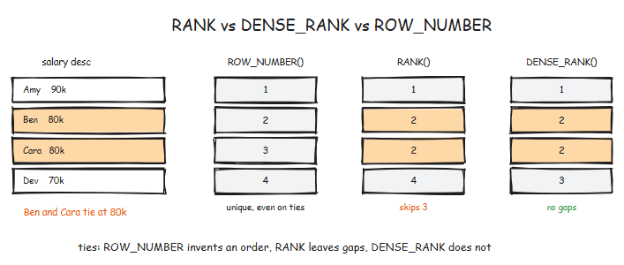

98. What is a Common Table Expression (CTE)?
A CTE is a temporary, named result set that exists only during the execution of a single query. Defined using the WITH keyword, CTEs make complex queries much easier to read and maintain compared to deeply nested subqueries, and they can also be used for recursive logic.
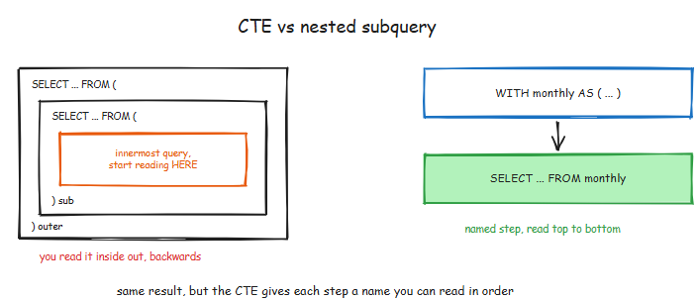

99. When would you use a Subquery vs. a CTE?
CTEs are generally preferred for readability, modularity, and when you need to reference the same temporary result set multiple times. Subqueries are often used for very simple, one-off filters inside a WHERE or FROM clause where the overhead of a CTE might feel unnecessary.

100. What is a Window Function?
A window function performs a calculation across a set of rows that are related to the current row, but unlike aggregate functions, it does not collapse the rows into a single output. Using the OVER() clause, it allows you to see the original row data alongside the calculated value (like a moving average).
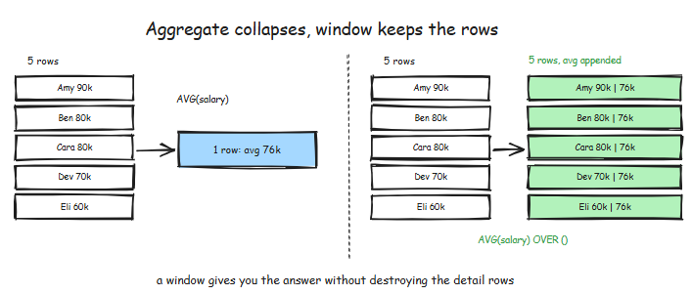

101. How do you calculate a running total in SQL?
You use the SUM() aggregate function as a window function by adding an OVER clause with an ORDER BY sub-clause. For example: SUM(sales) OVER (ORDER BY transaction_date). This tells the database to sum the values progressively as it moves through the ordered rows.

102. What is the LEAD() and LAG() function?
LAG() provides access to a value in a row "behind" the current row, while LEAD() provides access to a value in a row "ahead" of the current row. These are incredibly useful for calculating period-over-period growth or time-deltas between events without performing expensive self-joins.
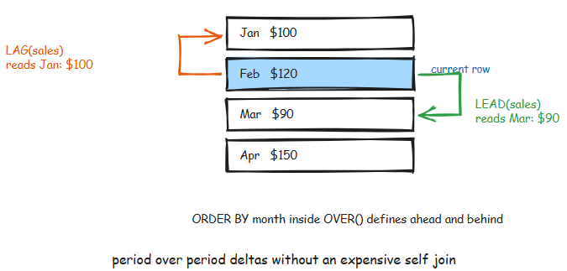

103. Explain the CASE statement.
The CASE statement is SQL's way of implementing "if-then-else" logic. It allows you to evaluate conditions and return specific values based on the result, which is essential for data cleaning, categorization, and creating custom flags in your data pipelines.

104. What is the difference between a Primary Key and a Unique Key?
A Primary Key uniquely identifies each record in a table and strictly prohibits NULL values; there can only be one per table. A Unique Key also ensures that all values in a column are distinct, but it allows for the presence of NULL values (usually only one), and you can have multiple Unique Keys on a single table.

105. What is a Foreign Key?
A Foreign Key is a column that creates a relationship between two tables by referencing the Primary Key of another table. This enforces "referential integrity," ensuring that you cannot have "orphan" records that point to non-existent data in a parent table.

106. What is an Index and how does it affect performance?
An index is a data structure (typically a B-Tree) that the database uses to find rows significantly faster than a full table scan. While they dramatically speed up read operations (SELECTs), they slow down write operations (INSERT, UPDATE, DELETE) because the index must be updated every time the underlying data changes.
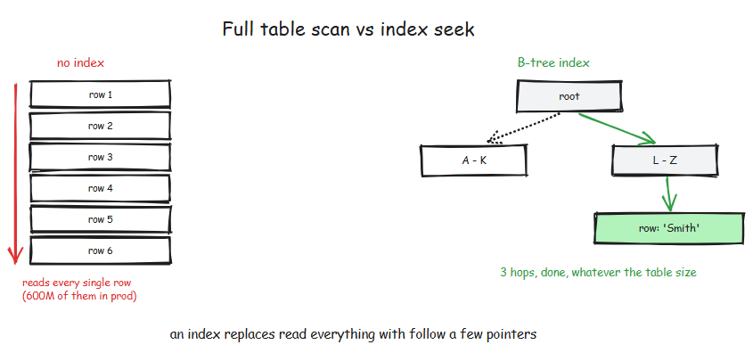

107. Explain the concept of Partitioning in SQL.
Partitioning involves physically dividing a large table into smaller, more manageable segments based on a specific column, such as a date or region. This improves performance through "partition pruning," where the database engine only scans the specific segments relevant to the query's filters.
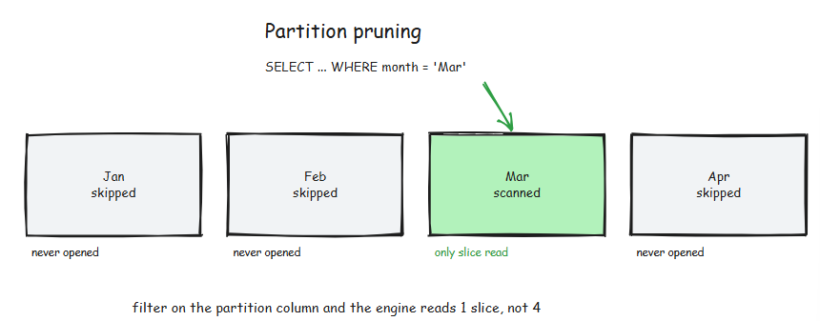

108. What is the difference between a Clustered and Non-Clustered index?
A Clustered Index determines the actual physical storage order of the rows on the disk; therefore, a table can only have one. A Non-Clustered Index is a separate object that contains pointers to the data rows, allowing you to have multiple such indexes to support different query patterns.

109. What is a View?
A View is a "virtual table" that consists of a stored SQL query. It does not store data itself; rather, it provides a way to simplify complex joins for end-users or provide a layer of security by restricting access to specific columns of the underlying tables.

110. What is a Materialized View?
Unlike a standard View, a Materialized View physically stores the result of the query on disk. It offers massive performance gains for complex analytical queries but requires a "refresh" strategy to ensure the stored data doesn't become too stale as the base tables change.

111. How would you delete duplicate records while keeping only one?
The most robust method is to use a CTE with a window function like ROW_NUMBER(). You partition by the columns that define the duplicate and order by a unique ID; then, you delete all rows where the assigned row number is greater than 1.
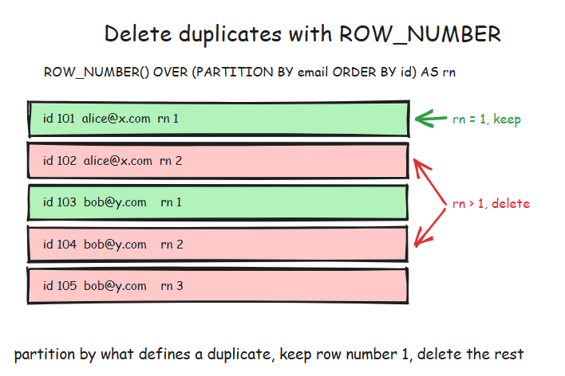
112. What are ACID properties?
ACID stands for Atomicity (all or nothing), Consistency (valid state transitions), Isolation (concurrent transactions don't interfere), and Durability (saved data persists). These four properties are the standard for ensuring database reliability and data integrity.

113. Explain "Normalization" and its levels.
Normalization is the process of structuring a relational database to reduce data redundancy and improve integrity. 1NF requires atomic values; 2NF removes partial dependencies (linking to only part of a composite key); and 3NF removes transitive dependencies (non-key columns depending on other non-key columns).
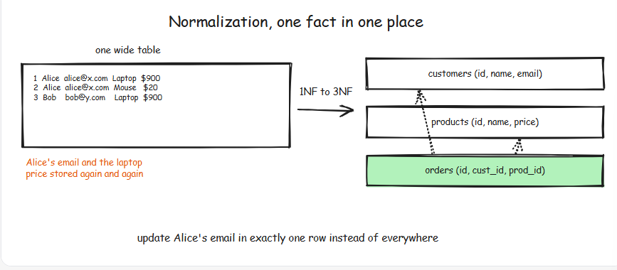

114. What is "Denormalization" and why do Data Engineers do it?
Denormalization is the intentional introduction of redundancy by combining tables. Data Engineers do this in analytical environments (like Data Warehouses) to reduce the number of joins required for queries, which significantly improves read performance for BI tools and dashboards.

115. What is a Star Schema?
A Star Schema is a data modeling design where a central "Fact Table" (containing quantitative metrics) is connected to several "Dimension Tables" (containing descriptive attributes). This structure is optimized for simple queries and fast aggregations in OLAP systems.
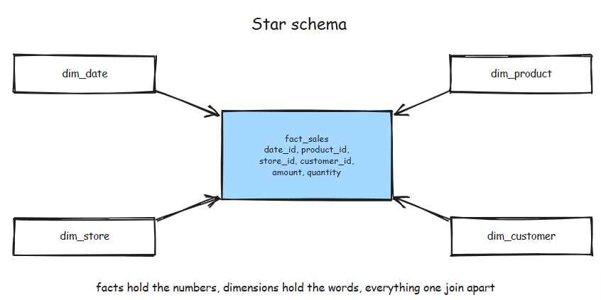

116. How do you optimize a slow-running query?
Start by reviewing the execution plan to find bottlenecks like full table scans. Common fixes include adding missing indexes, updating stale statistics, avoiding SELECT *, reducing the use of wildcard characters at the start of strings, and breaking complex logic into smaller CTEs or temporary tables.

117. What is an "Execution Plan"?
An execution plan is a report generated by the database's query optimizer that details the steps the engine will take to fulfill a query. It shows whether the engine will use indexes, how it will join tables (e.g., Hash Join vs. Nested Loop), and the estimated cost of each operation.

118. What is the "N+1 Problem" in the context of database queries?
This occurs when an application makes one query to get a list of IDs and then executes a separate query for each of those IDs to get details. In data engineering, we solve this by using set-based logic, joining the tables in a single SQL query, rather than using iterative loops in a programming language.

119. How do you find the second-highest salary in an Employee table?
A classic interview question solved by: SELECT MAX(salary) FROM Employee WHERE salary < (SELECT MAX(salary) FROM Employee);. Alternatively, you can use OFFSET 1 LIMIT 1 after sorting by salary in descending order.

120. How do you handle "SCD Type 2" (Slowly Changing Dimensions) in SQL?
SCD Type 2 tracks historical changes by creating a new row for every change. You manage this by including valid_from and valid_to timestamps (or an is_current boolean flag) to allow queries to "point-in-time" lookups of what the data looked like at any given moment.
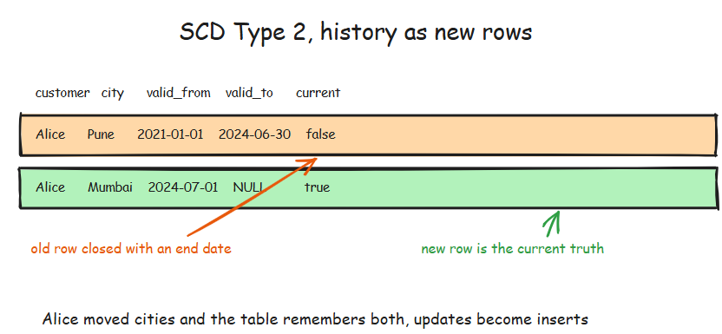

121. Explain the difference between TRUNCATE and DELETE.
DELETE is a DML command that removes rows one by one, logs each deletion (allowing for rollback), and can use a WHERE clause. TRUNCATE is a DDL command that deallocates the entire data pages of a table; it is much faster but cannot be filtered with a WHERE clause and typically resets identity columns.

122. What is a Stored Procedure?
A Stored Procedure is a group of SQL statements that are compiled and stored on the database server. They allow for complex procedural logic (like loops and variables), improve security by abstracting table access, and reduce network traffic by executing logic close to the data.

123. What is a Trigger?
A Trigger is a special type of stored procedure that automatically "fires" or executes in response to a specific event, such as an INSERT, UPDATE, or DELETE on a table. They are often used for auditing changes or enforcing complex business rules that simple constraints can't handle.

124. How do you handle Big Data in SQL (e.g., billions of rows)?
Standard relational databases struggle at this scale. Data engineers use distributed systems like Snowflake, BigQuery, or SparkSQL, which rely on columnar storage (storing data by column rather than row) and massively parallel processing (MPP) to distribute the workload across many nodes.

125. What is the difference between OLTP and OLAP?
OLTP (Online Transaction Processing) systems are optimized for frequent, small writes and lookups (like an e-commerce checkout). OLAP (Online Analytical Processing) systems are optimized for complex, long-running read queries that aggregate massive amounts of data for business intelligence.
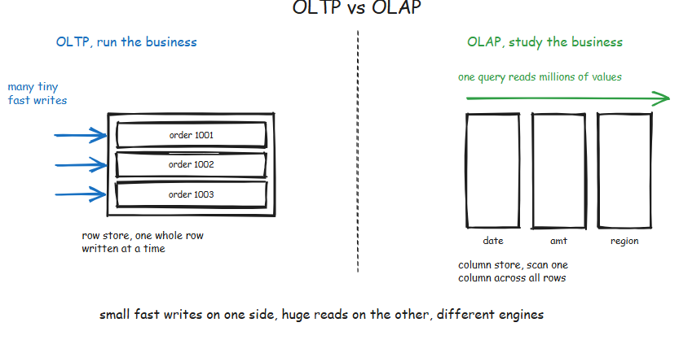
126. What is "Upsert"?
"Upsert" is a portmanteau of "Update" and "Insert." It refers to a database operation that attempts to update an existing record based on a unique key, but if that key is not found, it inserts a new record instead. In standard SQL, this is often implemented using the MERGE statement.

127. How do you convert a String to a Date in SQL?
The method depends on the SQL dialect: PostgreSQL uses TO_DATE(string, format), SQL Server uses CONVERT(DATE, string), and many modern warehouses like Snowflake or BigQuery allow for simple casting using string::DATE or CAST(string AS DATE).

128. What is a "Full Outer Join"?
A Full Outer Join combines the results of both a Left and Right Outer Join. It returns all records from both tables; where there is a match, the columns are joined, and where there is no match, the missing side contains NULL values.

129. What is "Data Profiling"?
Data profiling is the process of using SQL to explore and understand a new dataset. This includes calculating the percentage of NULLs, finding the distribution of values (min/max/avg), identifying unique counts, and uncovering potential data quality issues before building a pipeline.

130. How do you pivot data from rows to columns?
You can use the built-in PIVOT operator available in some dialects (like SQL Server or Snowflake). In dialects that lack it, you use an aggregate function combined with a CASE statement, such as SUM(CASE WHEN category = 'A' THEN amount ELSE 0 END).

131. Explain "Sharding".
Sharding is a horizontal scaling technique where data is split across multiple independent database instances (shards). Each shard has the same schema but holds a different subset of the data (e.g., Users A-M on Shard 1, N-Z on Shard 2), allowing the system to handle more traffic than a single server could.
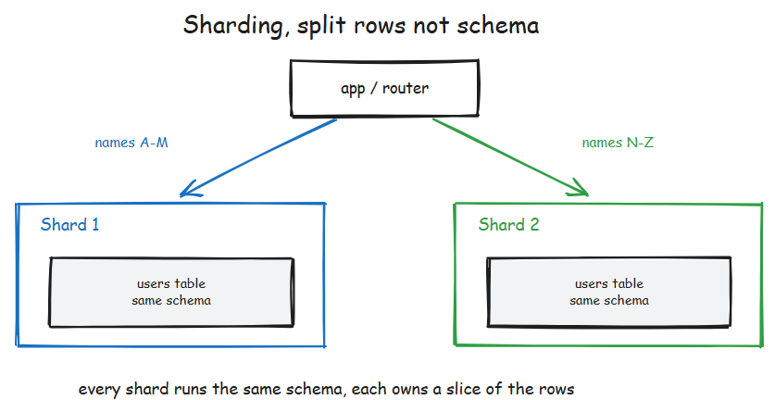

132. What is the difference between a Temporary Table and a Table Variable?
Temporary Tables are physical objects in the database's temp storage that support indexes and are visible across the entire session. Table Variables are typically stored in memory, have a more limited scope (usually just the current batch or procedure), and generally perform better for very small datasets.

133. How do you use the EXPLAIN keyword?
You simply place the word EXPLAIN (or EXPLAIN ANALYZE in some systems) before your SELECT statement. The database will return the query plan instead of the data, which is the primary way data engineers diagnose performance issues.

134. What is a "Correlation Subquery"?
A correlated subquery is a subquery that depends on the outer query for its values. Because the subquery must be re-evaluated for every single row processed by the outer query, it can be extremely slow on large datasets and should often be rewritten as a join.

135. Why is "Sargability" important?
Sargability (Search ARGument ABLE) refers to whether a query can utilize an index. A common "anti-pattern" that breaks sargability is wrapping a column in a function in the WHERE clause, such as WHERE LEFT(name, 1) = 'A', which prevents the database from using an index on the name column.
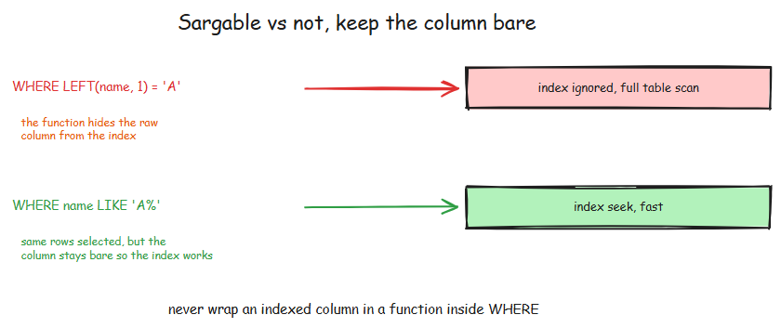

151. What happens if you SELECT a column not in the GROUP BY clause?
If you SELECT a column not in the GROUP BY clause, it will throw an error stating that the column must be in the GROUP BY clause or in an aggregate function. Let's use the table below as an illustration.
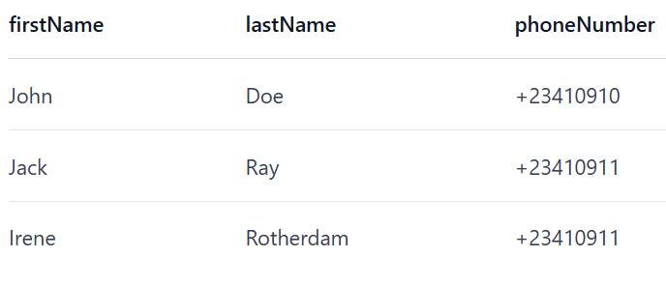
If you run the query below against the database:

The result will be an error because firstName is not in the GROUP BY clause and not using an aggregate function.

152. What is the difference between a subquery and a JOIN?
A subquery is a query that is inside another query. You use it for queries that require complex logic. You should use subqueries when you want to use the result of that subquery for another query. In the example below, the subquery is in brackets.
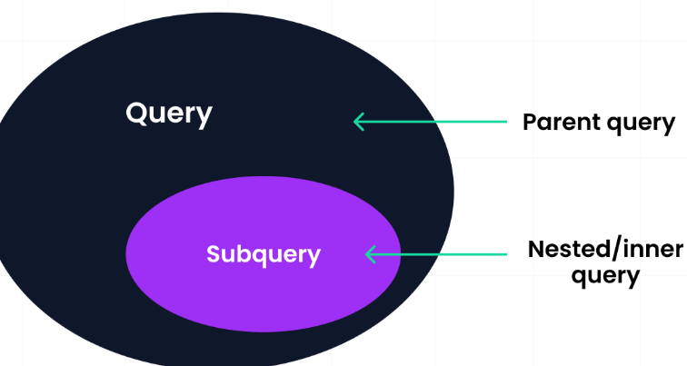
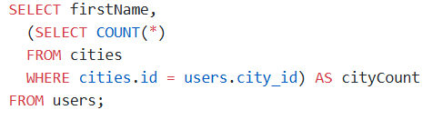
On the other hand, a JOIN combines two or more tables based on related columns between them. The related column is usually a foreign key. You should use JOINS when you want to pull related data from different tables together. The code below illustrates how to use a JOIN.
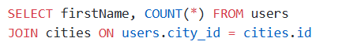
A JOIN is faster than a subquery in the following scenarios:
- When you are querying data from multiple tables.
- When you are filtering or joining on index columns.

153. Explain how a correlated subquery works
A correlated subquery is a subquery that depends on a value from the outer query. This means that the query is evaluated for each row that might be selected in the outer query. Below is an example of a correlated subquery.
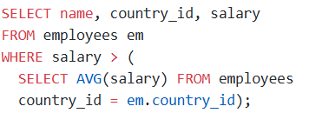
The code above:
- Runs the outer query through each row of the table.
- Takes the country_id from the employees table.
- Iterates through the other rows and does the same calculation.
This leads to a degrading performance as the data in the table grows.
You should use a correlated subquery if you want to perform row-specific operations or cannot achieve an operation using JOIN or other aggregate functions.

154. When should you use EXISTS instead of IN in a subquery?
EXISTS and IN are used in subqueries to filter results, but they perform different functions depending on their usage.
You should use EXISTS in the following situations:
- When you want to check if a row exists and not the actual values.
- When the subquery is a correlated query.
- When the subquery returns many rows but you want to get the first match.
You should use IN in the following scenarios:
- When you are comparing a column to a list of values.
- When the subquery returns a small or static list.

155.Can you nest subqueries multiple levels deep?
Yes, you can nest subqueries multiple levels deep when you want to perform complex logic. A nested subquery is a subquery inside another subquery, forming layers of subqueries. Many SQL engines allow multiple layers of subqueries, but this causes poor readability and degrades performance.

156. What is a window function?
A window function is a function that allows you to perform operations on a specific set of rows related to the current row. Unlike aggregate functions that perform calculations on an entire data set, window functions can perform operations on a subset of data. These calculations are valid for aggregates, ranking, and cumulative totals without altering the original dataset.

157. What is the difference between RANK(), DENSE_RANK(), and ROW_NUMBER()?
The RANK() function assigns each row a rank according to an ascending or descending order. If there are matching values, it assigns them the same position and then skips the next number for the next rank. For example, if two rows have equivalent values and are both assigned rank 1, the next rank would be 3 instead of 2.
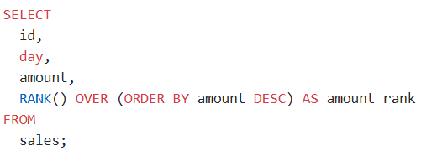
DENSE_RANK() function is similar to RANK() in that it assigns ranks to rows, but the difference is that DENSE_RANK does not leave a gap when there are two or more equivalent values. Let's illustrate it with the Sales table from above. The query is shown below.
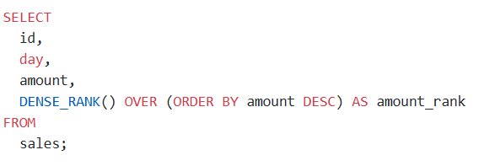
ROW_NUMBER assigns a unique number to each row depending on the order you specify. It does not skip numbers; even though there are equivalent values, it assigns them different numbers, unlike RANK and DENSE_RANK functions that give them the same rank.
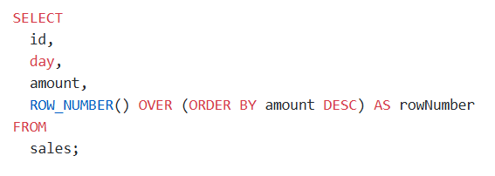
158. What is LAG() and LEAD() in SQL? Give an example use case
LAG() and LEAD() are window functions used to retrieve data from rows before and after a specified row. You can also refer to them as positional SQL functions.
LAG() allows you to access a value stored in rows before the current row. The row may be directly before or some rows before. Let's take a look at the syntax:

It takes three arguments.
- column_name: This specifies the column to fetch from the previous row.
- offset: This is an optional argument and specifies the number of rows behind to look at. The default is 1.
- default_value: This is the value to assign when no previous row exists. It is optional, and the default is NULL.
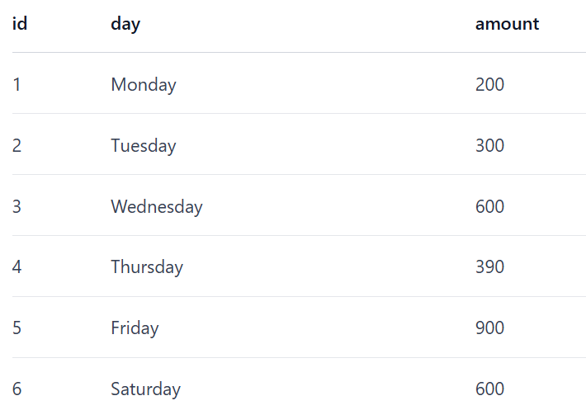
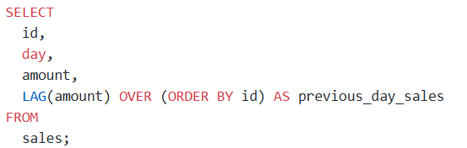
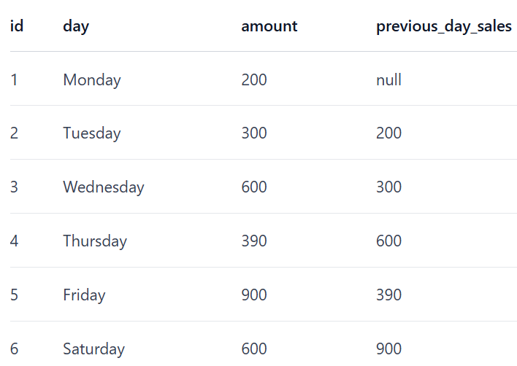
You use the LEAD() function to get data from rows after the current row. Its syntax is similar to that of the LAG() function. You can use it for forecasting future trends by looking ahead.
The query using the LEAD() function is shown below.
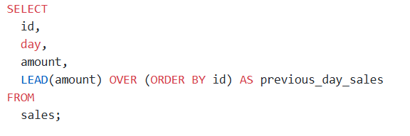
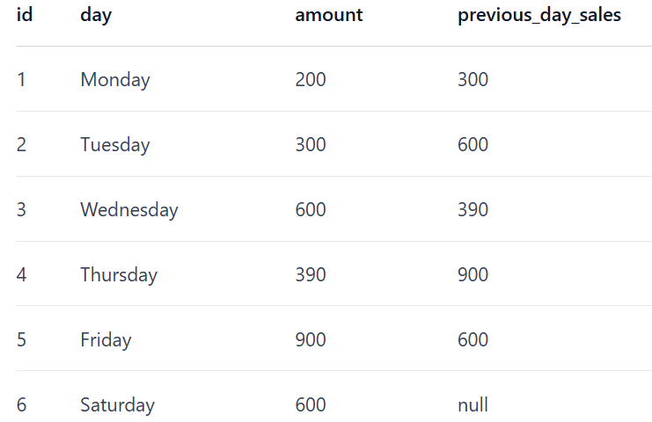

159. How will you detect gaps in a sequence of dates per user?
You will use the LAG() function to detect gaps in a sequence of dates per user. You will compare each date with the previous one and check if the difference is greater than 1.

160. What does the NTILE() function do, and how might it be useful in analyzing data?
NTILE() is a window function that divides rows into a pre-defined number of roughly equal groups. It's like breaking your data into different sets based on your defined criteria. For example, let's say you have some student scores from 1 to 100; you can use the NTILE() function to categorize the scores into different groups or buckets.
The syntax of the NTILE() function is:

- n: represents the number of groups you want to divide your rows into.
- ORDER BY: defines the order of the rows in each group where the function is applied.
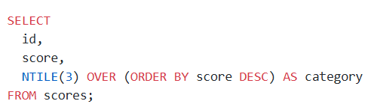
The NTILE() function is useful in data analysis because it can detect outliers in a data set and create histograms of data. It can also create percentiles and quartiles for data distribution.

161. How would you optimize slow-running queries?
- To optimize slow-running queries, you need to analyze the query first to know what to optimize. You can perform different optimizations depending on the query. Some of the optimizations include:
- Using indexes effectively: Indexes speed up queries by enabling the database to find entries that fit specific criteria quickly. Indexing is the process of mapping the values of one or more columns to a unique value that makes it easy to search for rows that match a search criteria. You can create indexes on columns used frequently in the WHERE, JOIN, and ORDER BY clauses. However, note that creating too many indexes can slow down inserts, updates, and deletions.
- **Avoid SELECT *** : Using the SELECT ***** statement can slow down your query performance because it returns all the columns in a table including the ones not needed for the query. You should select only the columns that you need for a query for optimal performance. So when you see a query that selects all columns, you should check if all the columns are really needed and used further down the query chain.
- Avoid using subqueries: Subqueries slow down query performance, especially when you use them in the WHERE or HAVING clauses. You should avoid using subqueries where possible and use JOINs or other techniques instead.
- Utilize stored procedures: Stored procedures are precompiled SQL statements stored in a database, and can be called from an application or directly from a query. Using stored procedures can improve your query performance by reducing the amount of data that is sent between the database and your application, and also saves time required to compile the SQL statements.

162. Why should you avoid SELECT * in production code?
You should avoid using **SELECT *** as much as possible in your production code for the following reasons:
- Increased IO: Using **SELECT ***, you can return unnecessary data that leads to increased Input/Output cycles at the database level since you will be reading all the data in a table. This effect will be more impactful on a table with a lot of data and even slow down your query.
- Increased network traffic: **SELECT *** returns more data than required to the client, which uses more network bandwidth than needed. The increase in network bandwidth causes data to take longer to reach the client application and impacts the application's performance.
- More application memory: The return of a lot of data would make your application require more memory to hold the unnecessary data which might you might not use and this impacts application performance.
- Makes maintenance more difficult: Using **SELECT *** makes code maintenance more challenging. If the table structure changes by adding, removing, or renaming columns, the queries using **SELECT *** could break unexpectedly. You should explicitly specify the columns from which you want to fetch data to ensure resilience against potential changes in the database schema.

163. What is the impact of missing indexes?
Missing indexes can affect the performance of queries, especially when the data grows. The major impacts of missing indexes are listed below:
- Slow queries: Without indexes, every read query will go through the whole table to find matching rows. This will get worse as the data in the table grows.
- Locking and concurrency issues: Scanning a table without indexes takes longer, and locking the table can prevent other queries from running, affecting application performance.
- Inefficient joins: Joins on tables without indexes on the join keys are extremely slow and result in bad query performance.
- Poor user experience: Missing indexes can lead to poor user experience in your applications. It can result to slower page loads, application hanging when data is being fetched from the database.

164.What is a SARGable query?
SARGable stands for Search Argumentable query, which uses indexes and leads to efficient queries. If a query is SARGable, the database engine quickly locates rows using indexes, avoids scanning the whole table, and improves query performance.

165.What are some common mistakes when using GROUP BY?
The common mistakes people encounter when using the GROUP BY clause include:
- Selecting non-aggregated columns not in the GROUP BY clause: This is a common mistake made my beginners and experts. An example query of this looks like this:
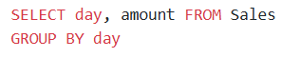
In the query above, the amount column is not part of the GROUP BY clause and will throw an error that it must appear in the GROUP BY clause. To fix this, you should add an aggregate function to the amount column.
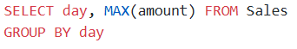
- Not using aggregate functions: It is also a common mistake to use GROUP BY without aggregate functions. GROUP BY usually goes with aggregate functions like MAX, MIN, COUNT, etc.
- Grouping by multiple columns: Grouping by multiple columns can make the query meaningless. It is not common to group by many columns, and when this happens, you should check if you really need to group by those columns.

166. Why can NOT IN lead to unexpected results with NULLS?
Since NULL is unknown, a NOT IN query containing a NULL or NULL in the list of possible values will always return 0 records because of the unknown result introduced by the NULL value. SQL cannot determine for sure whether the value is not in that list.

167.SQL Query to find the second highest salary of Employee
Answer: There are many ways to find the second highest salary of an Employee in SQL, you can either use SQL Join or Subquery to solve this problem. Here is an SQL query using Subquery:
SELECT MAX(Salary)
FROM Employee
WHERE Salary NOT IN (select MAX(Salary) from Employee );

168.SQL Query to find Max Salary from each department.
Answer: You can find the maximum salary for each department by grouping all records by DeptId and then using MAX() function to calculate the maximum salary in each group or each department.
SELECT DeptID, MAX(Salary)
FROM Employee
GROUP BY DeptID.
These questions become more interesting if the Interviewer will ask you to print the department name instead of the department id, in that case, you need to join the Employee table with Department using the foreign key DeptID, make sure you do LEFT or RIGHT OUTER JOIN to include departments without any employee as well.
Here is the query
SELECT DeptName, MAX(Salary)
FROM Employee e RIGHT JOIN Department d
ON e.DeptId = d.DeptID
GROUP BY DeptName;

169. Write SQL Query to display the current date?
Answer: SQL has built-in function called GetDate() which returns the current timestamp. This will work in Microsoft SQL Server, other vendors like Oracle and MySQL also have equivalent functions.
SELECT GetDate();

170. Write an SQL Query to check whether the date passed to Query is the date of the given format or not?
Answer: SQL has IsDate() function which is used to check passed value is a date or not of specified format, it returns 1(true) or 0(false) accordingly. Remember the ISDATE() is an MSSQL function and it may not work on Oracle, MySQL, or any other database but there would be something similar.

SELECT ISDATE('1/08/13') AS "MM/DD/YY";
It will return 0 because the passed date is not in the correct format.

171. Write an SQL Query to print the name of the distinct employee whose DOB is between 01/01/1960 to 31/12/1975.
Answer: This SQL query is tricky, but you can use BETWEEN clause to get all records whose dates fall between two dates.
SELECT DISTINCT EmpName
FROM Employees
WHERE DOB BETWEEN ‘01/01/1960’ AND ‘31/12/1975’;

172. Write an SQL Query to find the number of employees according to gender whose DOB is between 01/01/1960 to 31/12/1975.
Answer :
SELECT COUNT(*), sex
FROM Employees
WHERE DOB BETWEEN '01/01/1960' AND '31/12/1975'
GROUP BY sex;

173. Write an SQL Query to find an employee whose salary is equal to or greater than 10000.
Answer :
SELECT EmpName FROM Employees WHERE Salary>=10000;

174. Write an SQL Query to find the name of an employee whose name Start with ‘M’
Answer :
SELECT * FROM Employees WHERE EmpName like 'M%';

175. find all Employee records containing the word "Joe", regardless of whether it was stored as JOE, Joe, or joe.
Answer :
SELECT * from Employees WHERE UPPER(EmpName) like '%JOE%';

176. Write an SQL Query to find the year from date.
Answer: Here is how you can find Year from a Date in SQL Server 2008
SELECT YEAR(GETDATE()) as "Year";

