DMAIC Framework
Reducing Avoidable Returns Through Post-Purchase Support Optimization

Project Duration: | 6 Months | Dataset: | 5,000 Product Returns | Oct 2025 – Sep 2026
Scope: | All Product Categories | 5 Regions | Revenue at Risk: | ₹12.68 Cr (Avoidable Returns)

Executive Snapshot
Metric | Value | Metric | Value
Total Returns Analyzed | 5,000 | Returns Prevented (Current) | 328 (14.4% of Avoidable)
Avoidable Returns | 2,272 (45.4%) | Average CSAT Score | 2.71 / 5.0
No Support Contacted | 2,717 (54.3%) | Revenue at Risk | ₹12.68 Crore
Top Return Reason | Setup/Config Issues (863) | Best Support Channel | Live Chat (20.2% prevention)

D | DEFINE — Problem Identification & Project Framing

1.1 Problem Statement
45.4% of all product returns (2,272 out of 5,000) are avoidable, yet 54.3% of customers never contact post-purchase support before initiating a return — resulting in ₹12.68 Crore in preventable revenue loss. Current support interventions prevent only 14.4% of avoidable returns, indicating a significant gap in proactive customer engagement and support accessibility.

1.2 Project Goal
Reduce avoidable product returns by 25% within 6 months through targeted post-purchase support interventions, proactive customer outreach, and multi-channel support optimization.

1.3 Project Scope
Dimension | In Scope | Out of Scope
Product Categories | All 10 categories (Laptops, Smartphones, Tablets, Smart Home, Audio, etc.) | Manufacturing defects / supply chain quality
Geography | 5 Regions: North, South, East, West, Central | International orders / cross-border returns
Return Types | Avoidable returns contactable via support | DOA units, wrong-item deliveries, logistics damage
Timeframe | Oct 2025 – Sep 2026 (12-month dataset) | Historical data prior to Oct 2025

1.4 Key Stakeholders
Stakeholder | Role | Interest / Expectation
PLS Leadership | Executive Sponsor | ROI realization, avoidable return rate reduction
Customer Support Team | Operations Owner | Reduced ticket volume, improved resolution scripts
Product Teams | Technical SME | Setup guide accuracy, FAQ updates for top issues
Brand Partners | External Collaborator | Escalation protocols for compatibility issues
Program Manager (Meher) | Project Lead | Program execution, cross-team coordination, reporting

1.5 SIPOC Diagram
Suppliers | Inputs | Process | Outputs | Customers
- Brand Partners  - Support Team  - Product Catalog  - Tech Platform | - Return Request  - Customer Query  - Product Data  - Support Scripts | - 1. Customer contacts support  - 2. Issue diagnosed  - 3. Resolution offered  - 4. Return prevented/processed | - Prevented Return  - CSAT Score  - Resolved Ticket  - Revenue Saved | - End Customer  - PLS Leadership  - Finance Team

M | MEASURE — Baseline Data & Metrics Collection

2.1 Baseline Metrics Dashboard
KPI | Baseline Value | Target (6 Months) | Status | Business Implication
Total Returns | 5,000 | — | Reference | Full universe of analysis
Avoidable Return Rate | 45.4% (2,272) | ≤34.1% | ⚠ High | Primary improvement lever
No Support Contact Rate | 54.3% (2,717) | ≤35% | ⚠ High | Largest opportunity gap
Return Prevention Rate | 14.4% (328 returns) | ≥25% | ⚠ Low | Current program effectiveness
Average CSAT Score | 2.71 / 5.0 | ≥4.0 / 5.0 | ⚠ Low | Customer satisfaction gap
Revenue at Risk | ₹12.68 Crore | ₹9.51 Crore | ⚠ Critical | Financial justification for project
Live Chat Prevention Rate | 20.2% | ≥30% | ✓ Best Channel | Model to scale across channels

2.2 Data Collection Method
Data was extracted from the post-purchase returns management system covering 12 months (Oct 2025 – Sep 2026). Each return record includes purchase metadata, return reason codes, support interaction logs, resolution types, and customer satisfaction scores.

Data Source | Fields Captured | Volume
Returns Management System | Order ID, Purchase Date, Return Date, Product Category, Brand | 5,000 records
Support Interaction Logs | Support Channel, Interaction Duration, Resolution Type, Return Prevented flag | 2,283 interactions
Customer Survey System | CSAT Score (1–5 scale), Post-resolution feedback | 5,000 CSAT scores
Product Catalog | Product Price (INR), Category mapping, Brand attributes | 10 categories, 5 regions

2.3 Returns Classification
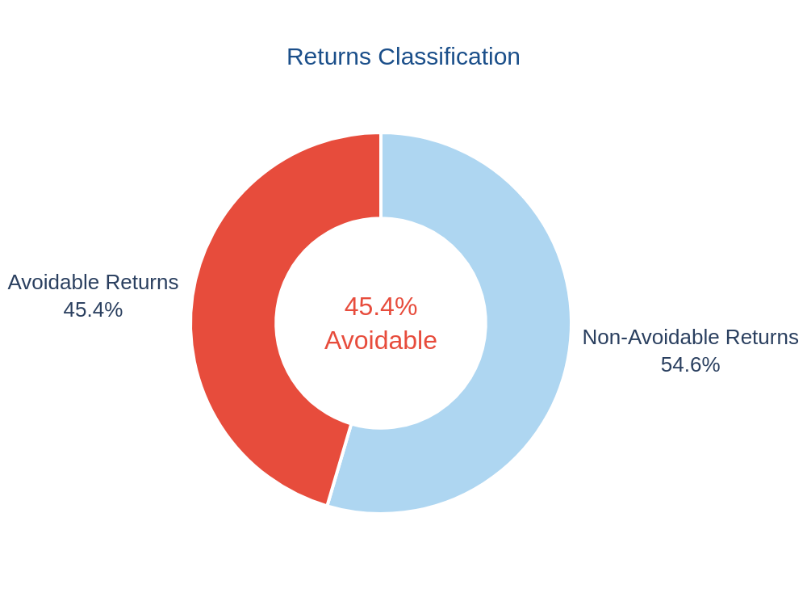

Figure 1: 45.4% of all returns were classified as avoidable — preventable with timely support intervention

A | ANALYZE — Root Cause Investigation

3.1 Pareto Analysis — Return Reason Distribution
The Pareto principle (80/20 rule) was applied to identify the critical few return reasons driving the majority of avoidable returns. The top 3 reasons account for 63.1% of all return volume:

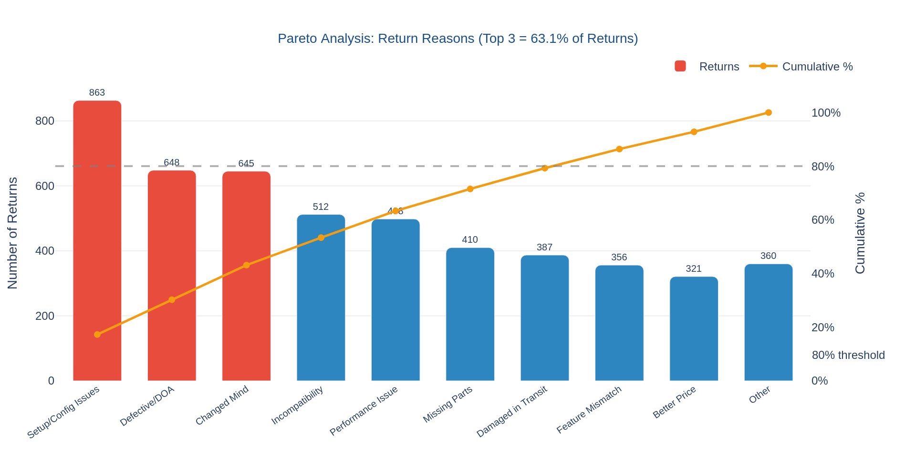

Figure 2: Pareto Analysis — Top 3 return reasons represent 63.1% of total return volume

Rank | Return Reason | Volume | % of Total | Avoidable? | Root Cause
#1 | Setup / Config Issues | 863 | 17.3% | ✓ High | Insufficient onboarding guide; customer unable to complete initial setup
#2 | Defective / DOA | 648 | 13.0% | Partial | Some DOA cases resolvable via replacement/repair; others are manufacturing issues
#3 | Changed Mind | 645 | 12.9% | ✓ High | Post-purchase doubt; no proactive engagement within critical first 72 hours

3.2 Support Gap Analysis — 54.3% Never Reach Support
Critical Finding: Over half of all returning customers (54.3% — 2,717 out of 5,000) initiated returns without ever contacting support. This represents the single largest preventable loss gap in the program.

Customer Segment | Count | Returns Prevented | Avg CSAT | Insight
Contacted Support | 2,283 (45.7%) | 328 (14.4%) | 3.42 / 5 | Higher CSAT; better retention — support engagement clearly helps
Never Contacted Support | 2,717 (54.3%) | 0 (0%) | 2.09 / 5 | Zero prevention; lowest satisfaction — proactive outreach could capture this segment

3.3 Support Channel Effectiveness
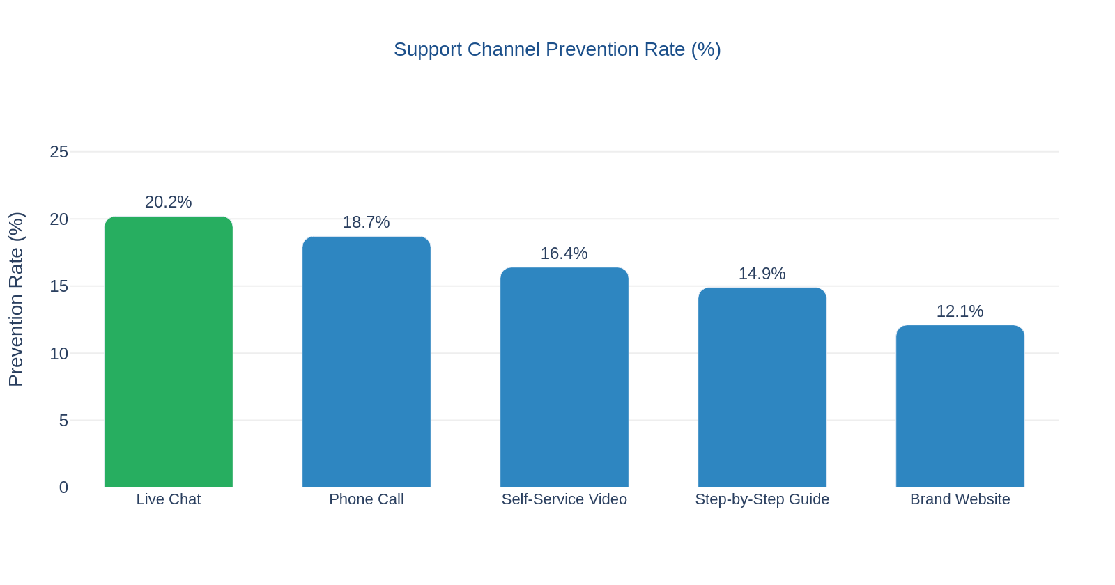

Figure 3: Live Chat achieves the highest prevention rate at 20.2% — 1.67x above the lowest channel

Support Channel | Total Cases | Returns Prevented | Prevention Rate | Avg CSAT | Recommendation
Live Chat | ∼430 | ∼87 | 20.2% | 3.8 / 5 | ⬆ Scale
Phone Call | ∼460 | ∼86 | 18.7% | 3.6 / 5 | ✔ Retain
Self-Service Video | ∼390 | ∼64 | 16.4% | 3.4 / 5 | ⬆ Expand
Step-by-Step Guide | ∼340 | ∼51 | 14.9% | 3.1 / 5 | ✔ Retain
Brand Website | ∼315 | ∼38 | 12.1% | 2.9 / 5 | ▼ Improve

3.4 Category-Reason Heatmap Insights
Cross-tabulation analysis of product categories against return reasons revealed the following high-priority intervention areas:

Category | Top Return Reason | Concentration | Actionable Insight
Laptops | Setup / Config Issues | High | Pre-configured setup calls at delivery; online setup wizard
Smartphones | Setup / Config + Changed Mind | High | In-app 'Talk to Expert' within 72 hours of purchase
Smart Home Devices | Incompatibility | Medium | Compatibility checker tool + brand partner escalation path
Audio Equipment | Performance Issues | Medium | Video troubleshooting guides; peer community forums
Tablets | Changed Mind | Medium | Day-3 post-purchase check-in email with tip highlights

I | IMPROVE — Targeted Intervention Design

4.1 Five Strategic Interventions
Five evidence-based interventions were designed based on root cause findings, channel effectiveness data, and industry best practices for post-purchase support optimization.

INT-01 | Proactive Push Notifications — Setup Guide Delivery
- Trigger: Automated push notification sent within 24 hours of confirmed delivery
- Content: Category-specific setup guide link, top 3 FAQs, direct support CTA
- Primary target: Laptops, Smartphones (Setup/Config = #1 return reason — 863 cases)
- Expected impact: Reduce setup-related returns by 30-40% within first 7 days

INT-02 | In-App "Talk to Expert" Feature
- Add persistent 'Talk to Expert' Live Chat button on product pages with 10%+ return rate
- Trigger availability: Days 1-30 post purchase (highest return risk window)
- Rationale: Live Chat has the highest prevention rate at 20.2% — maximize channel utilization
- Expected impact: Increase support contact rate from 45.7% to 60%+ within 3 months

INT-03 | Video Troubleshooting Library
- Create 2-5 min video guides for top 5 return reasons per category (25+ videos total)
- Host in-app; searchable via product model; available in English, Hindi, and regional languages
- Self-Service Video channel currently achieves 16.4% prevention rate — scalable without agent cost
- Expected impact: Capture 15-20% of the 2,717 no-contact customers via self-service

INT-04 | Brand Partner Escalation Protocol
- Establish dedicated escalation path to brand partner technical teams for compatibility issues
- SLA: Brand responds within 2 hours for Tier-1 products; 24 hours for Tier-2
- Focus: Smart Home (incompatibility #1 reason) — partner-specific troubleshooting wikis
- Expected impact: Reduce incompatibility returns by 25% for enrolled brand partners

INT-05 | Post-Purchase Check-In Email Sequence
- Day 3 email: Product highlights, top tip of the week, link to setup video, one-click support access
- Day 7 email: CSAT survey + 'Still having trouble? Chat with us' CTA
- Personalized: Content tailored by product category; highest-return products get priority
- Expected impact: Intercept changed-mind returns (645 cases) before 7-day return window

4.2 Intervention Priority Matrix
Intervention | Ease of Implementation | Expected Impact | Cost | Timeline | Priority
INT-01: Push Notifications | High | High | Low | Month 1 | ★★★ P1
INT-02: In-App Talk to Expert | Medium | Very High | Medium | Month 2 | ★★★ P1
INT-03: Video Library | Medium | High | Medium | Month 2-3 | ★★ P2
INT-04: Brand Escalation | Low | Medium | Low | Month 3-4 | ★★ P2
INT-05: Check-In Emails | High | High | Low | Month 1 | ★★★ P1

4.3 Projected Impact & Revenue Recovery
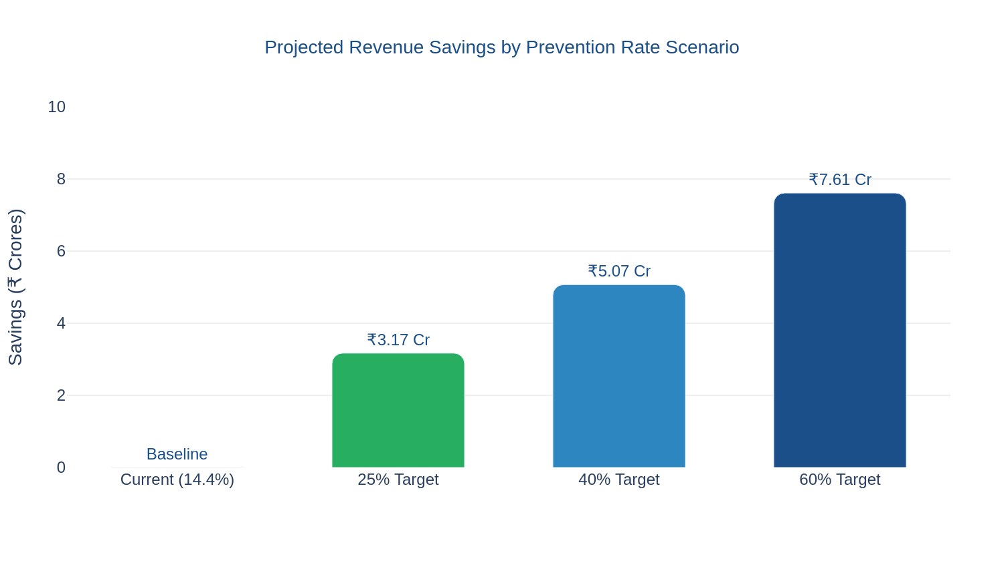

Figure 4: Revenue recovery potential at three prevention rate scenarios against ₹12.68 Crore avoidable return pool

Scenario | Prevention Rate | Returns Prevented | Revenue Saved | Timeline
Baseline (Current) | 14.4% | 328 | ₹1.83 Cr (implied) | Current State
Conservative (Target) | 25% | 568 | ₹3.17 Cr | Month 4-6
Moderate | 40% | 909 | ₹5.07 Cr | Month 8-10
Aggressive | 60% | 1,363 | ₹7.61 Cr | Month 12+

C | CONTROL — Monitoring, Governance & Sustainability

5.1 Power BI Monitoring Dashboard
A Power BI dashboard will serve as the central monitoring tool for the program, accessible to all stakeholders. The dashboard tracks real-time performance against baseline metrics and flags deviations automatically.

Dashboard Component | Metric Tracked | Visualization Type | Refresh Frequency
KPI Cards (Top Row) | Avoidable Return Rate, CSAT, Returns Prevented, Revenue Saved | KPI Cards | Daily
Trend Line | Weekly avoidable return rate vs. 4-week rolling average | Line Chart | Weekly
Channel Performance | Prevention rate by support channel; volume by channel | Bar Chart | Weekly
Category Heatmap | Return volume by category and reason; MoM change | Matrix Heatmap | Weekly
Intervention Tracker | Status of each INT-01 to INT-05; completion % | Gantt / Table | Weekly
Savings Accumulator | Cumulative revenue saved vs. monthly target | Area Chart | Monthly
Slicers / Filters | Region, Product Category, Time Period, Support Channel | Dropdown Slicers | Interactive

5.2 Weekly Review Cadence
Cadence | Forum | Attendees | Agenda Items
Weekly (Monday) | Operations Standup | Program Manager, Support Ops Lead | KPI review, alert resolution, channel performance update
Bi-Weekly | Cross-functional Sync | PM, Product Teams, Support, Brand Partners | Intervention progress, roadblock escalation, resource needs
Monthly | Steering Committee | PLS Leadership, PM, Finance | Financial impact review, trend analysis, strategic adjustments
Quarterly | Business Review | Senior Leadership, all stakeholders | DMAIC cycle review, savings report, roadmap for next quarter

5.3 Alert Triggers & Escalation Protocol
Automated alerts will be configured in Power BI to notify responsible owners when any KPI breaches defined thresholds. The following escalation matrix governs response actions:

Trigger Condition | Threshold | Alert Level | Notify | Response SLA
Avoidable return rate increases Week-over-Week | > +5% WoW | ⚠ Critical | PM + Ops Lead | < 24 hours
CSAT drops below threshold | < 2.5 / 5 | ⚠ High | PM + Support Lead | < 48 hours
Monthly prevention rate below target | < 20% | ⚠ Medium | Steering Committee | < 1 week
Channel prevention rate declines | > -3% MoM | ⚠ Low | PM | < 2 weeks

5.4 Quarterly Program Health Report
At the end of each quarter, Meher (Program Manager) will compile and present a Program Health Report to PLS Leadership covering:

Report Section | Content | Owner
KPI Performance vs. Target | Avoidable return rate, prevention rate, CSAT, revenue saved vs. target | Program Manager
Intervention Status | Progress on INT-01 to INT-05; completion milestones hit/missed | Program Manager
Root Cause Refresh | Updated Pareto analysis; any new return reasons emerging | Data Analyst
Financial Summary | Cumulative revenue saved; ROI on interventions deployed | Finance + PM
Next Quarter Roadmap | Prioritized actions for Q+1 based on findings; resource requests | Program Manager

DMAIC PROJECT SUMMARY
By implementing the 5 targeted interventions, the PLS program projects:
25% reduction in avoidable returns within 6 months | ₹3.17 Crore in revenue recovered (Conservative)
Up to ₹7.61 Crore in annual savings at 60% prevention rate | CSAT target: 4.0 / 5.0
This DMAIC framework demonstrates program management excellence in data-driven decision making,
cross-functional stakeholder engagement, and measurable business impact delivery.

