SUPER CIPHER CRYPTOGRAPHY SYSTEM BASED ON VIGENERE CIPHER AND POLYBIUS CIPHER
A project report submitted in partial fulfillment for the award of the degree of

BACHELOR OF TECHNOLOGY
IN
COMPUTER SCIENCE AND ENGINEERING
(CYBER SECURITY)

by

THONDALADINNE TARUN KUMAR (21BF1A3754)
KANNEPPAGARI YOGANANDHA (21BF1A3732)
BURUJU ANYALA (21BF1A3710)
PULAGALLA SRIHARI (21BF1A3749)

Under the guidance of
Mrs. A. Ashasharmani
Assistant Professor, Ph.D



DEPARTMENT OF COMPUTER SCIENCE AND ENGINEERING
SRI VENKATESWARA COLLEGE OF ENGINEERING
(AUTONOMOUS)
(Approved by AICTE, New Delhi & Permanently Affiliated to JNTUA, Ananthapuramu
Accredited by NBA, New Delhi & NAAC with ‘A’ grade)
Karakambadi Road, TIRUPATI – 517507
(2021 – 2025)

SRI VENKATESWARA COLLEGE OF ENGINEERING
(AUTONOMOUS)
(Approved by AICTE, New Delhi & PermanentlyAffiliated to JNTUA, Ananthapuramu
Accredited by NBA, New Delhi & NAACwith ‘A’ Grade)
Karakambadi Road, TIRUPATI – 517507.

DEPARTMENT OF COMPUTER SCIENCE AND ENGINEERING
(CYBER SECURITY)


CERTIFICATE

This is to certify that the project work entitled,“SUPER CIPHER CRYPTOGRAPHY SYSTEM BASED ON VIGENERE CIPHER AND POLYBIUS CIPHER” is a bonafide record of the project work done and submitted by
THONDALADINNE TARUNKUMAR 21BF1A3754
KANNEPPAGARI YOGANANDHA 21BF1A3732
BURUJU ANYALA 21BF1A2710
PULAGALLA SRIHARI 21BF1A3749

under my guidance and supervision for the partial fulfillment of the requirements for the award of B.Tech degree in COMPUTER SCIENCE AND ENGINEERING (CYBER SECURITY). This project is the result of our own effort and that it has not been submitted to any other University or Institution for the award of any degree or diploma other than specified above
GUIDE HEAD OF THE DEPARTMENT

External Viva-Voce Exam held on _______________

INTERNAL EXAMINER

EXTERNAL EXAMINER

DECLARATION

We hereby declare that the project entitled “SUPER CIPHER CRYPTOGRAPHY SYSTEM BASED ON VIGENERE CIPHER AND POLYBIUS CIPHER”, done by us under the esteemed guidance of Mrs. A. Ashasharmani , Assistant Professor, Ph.D and is submitted in partial fulfillment of the requirements for the award of the Degree of Bachelor of Technology in Computer Science and Engineering (Cyber Security).

This report is the result of our own effort and it has not been submitted to any other University or Institution for the award of any degree or diploma other than specified above.

THONDALADINNE TARUNKUMAR 21BF1A3754
KANNEPPAGARI YOGANANDHA 21BF1A3732
BURUJU ANYALA 21BF1A3710
PULAGALLA SRIHARI 21BF1A3749

ACKNOWLEDGEMENT

We are thankful to our guide Mrs. A. Ashasharmani, Assistant Professor, Ph.D, Department Of CSE(Cyber Security) for his valuable guidance and encouragement. His helping attitude and suggestions have helped in the successful completion of the project report.

We would like to express our gratefulness and sincere thanks to Dr. Ch. Santhaiah Professor, Ph.D, HoD, Department of CSE (Cyber Security), for her kind help and encouragement during the course of study and in the successful completion of the project work.

We have great pleasure in expressing out hearty thanks to our beloved Principal Dr. N. Sudhakar Reddy for spending his valuable time with us to complete this project.

Successful completion of any project cannot be done without proper support and encouragement. We sincerely thank the Management for providing all the necessary facilities during course of study.

We would like to thank our parents and friends, who have the greatest contributions in all our achievements, for the great care and blessings in making us successful in all our endeavors.

THONDALADINNE TARUNKUMAR 21BF1A3754
KANNEPPAGARI YOGANANDHA 21BF1A3732
BURUJU ANYALA 21BF1A2710
PULAGALLA SRIHARI 21BF1A3749

CONTENTS

CHAPTER NO. DESCRIPTION PAGE NO.

ABSTRACT i

LIST OF ABBREVIATIONS ii
LIST OF FIGURES iii
LIST OF TABLES iv
CHAPTER NO. DESCRIPTION PAGE NO.
- INTRODUCTION 1
- PROJECT DESCRIPTION 2
  - PROBLEM DEFINITION 2
  - PROJECT DETAILS 3
- ENVIRONMENTS 4
  - SOFTWARE REQUIREMENTS 4
  - HARDWARE REQUIREMENTS 4
  - FUNCTIONAL REQUIREMENTS 4
  - SOFTWARE FEATURES 7
- FEASIBILITY STUDY 10
  - TECHNICAL FEASIBILITY 10
  - OPERATIONAL FEASIBILITY 11
  - ECONOMIC FEASIBILITY 11
- SYSTEM ANALYSIS 12
  - EXISTING SYSTEM 12
  - PROPOSED SYSTEM 13
- SYSTEM DESIGN 15
  - ARCHITECTURE 16
  - UML DIAGRAMS 17
- SYSTEM IMPLEMENTATION 26
  - ALGORITHM 26
  - MODULE EXPLANATION 30
- TESTING 32
  - UNIT TESTING 32
  - INTEGRATION TESTING 33
  - FUNCTIONAL TESTING 33
  - WHITE BOX TESTING 34
  - BLACK BOX TESTING 34
- SOURCE CODE 35
- SCREEN LAYOUTS 52
- CONCLUSION 58
- FUTURE ENHANCEMENTS 59
- BIBLIOGRAPHY 60

ABSTRACT

In the digital era, ensuring the secure communication of messages between a sender and a receiver has become a major concern for internet users worldwide. This growing concern arises due to the increasing frequency of cyberattacks, security breaches, and most importantly, the need to protect sensitive user data and privacy. To address these challenges, cryptographic algorithms are employed, which work by transforming the original message (plaintext) into an unreadable format (ciphertext) through encryption. The ciphertext is then transmitted over the internet and decrypted back into the original message at the receiver’s end. Traditional cryptographic algorithms, although secure, often involve complex and resource-intensive operations, making them less suitable for environments with limited processing power and memory. To resolve these limitations, lightweight cryptographic methods have been proposed, which offer adequate security while consuming fewer resources, making them ideal for applications like IoT devices and embedded systems.In this approach, a hybrid encryption algorithm is proposed, which combines the strengths of two classical ciphers—Vigenère Cipher and Polybius Cipher—to create a more robust and secure communication system. The encryption process begins by applying the Vigenère Cipher, which uses a keyword to perform polyalphabetic substitution on the plaintext, enhancing resistance against frequency analysis. The resulting ciphertext is then further processed using the Polybius Cipher, which maps characters into coordinate pairs in a predefined grid, adding another layer of obfuscation.
By encapsulating the original message in two layers of encryption, this hybrid cryptosystem improves overall data confidentiality and strengthens the protection against basic cryptanalytic attacks. This layered approach demonstrates how classical encryption techniques, when thoughtfully combined, can still provide meaningful solutions to modern security challenges in a resource-efficient manner.

Keywords: Secure Communication, Cryptography, Encryption, Decryption, Data Privacy, Cybersecurity, Lightweight Cryptography, Hybrid Encryption Algorithm, Vigenère Cipher, Polybius Cipher, Classical Ciphers, Ciphertext, Plaintext, Frequency Analysis, Resource-efficient Security

LIST OF ABBREVIATIONS

SC Secure Communication
DP Data Privacy
CT Ciphertext
PT Plaintext
LC Lightweight Cryptography
HA Hybrid Algorithm
VC Vigenère Cipher
PC Polybius Cipher
Enc Encryption
Dec Decryption
CS Cryptosystem
CY Cybersecurity

LIST OF FIGURES

FIGURE NO. FIGURE NAME PAGE NO.

6.1 | System Architecture | 16
6.2.1 | Use case Diagram | 18
6.2.2 | Class Diagram | 20
6.2.3 | Sequence Diagram | 21
6.2.4 | Colloboration Diagram | 22
6.2.5 | Activity Diagram | 23
6.2.6 | Component Diagram | 24
6.2.7 | ER Diagram | 25
10.1 | Index Page | 52
10.2 | About Page | 53
10.3 | Login Page | 53
10.4 | Register Page | 54
10.5 | Home Page | 55
10.6 | Performance Page | 55
10.7 | Prediction Page | 56

LIST OF TABLES

TABLE NO. | TABLE NAME | PAGE NO.
7.2 | Algorithm Accuracy | 25

CHAPTER 1 INTRODUCTION

Cryptography is the science of securing information by converting it into a form that only authorized parties can understand. This process, known as encryption, ensures the confidentiality, integrity, and authenticity of data during storage or transmission. Cryptography has evolved from ancient methods like Caesar and Vigenère ciphers used in handwritten messages to complex mathematical algorithms used in modern digital systems.
Today, cryptography is a fundamental pillar of cybersecurity. It plays a vital role in securing communications, safeguarding personal information, and enabling secure online transactions. In computer science, it involves the use of algorithms and keys to transform readable data (plaintext) into an unreadable format (ciphertext), and vice versa through *decryption.

Two Main Types of Cryptography:

1. Symmetric Cryptography (Private Key Cryptography):
- Definition: The same key is used for both encryption and decryption.
- Speed: Generally faster than asymmetric cryptography.
- Security Concern: Key distribution can be challenging, as the same key must be shared securely.
- Examples:
  - Advanced Encryption Standard (AES)
  - Data Encryption Standard (DES)
  - Blowfish, RC4

2. Asymmetric Cryptography (Public Key Cryptography):
- Definition: Uses a pair of keys — a public key to encrypt data and a private key to decrypt it.
- Advantage: The public key can be shared openly, reducing the risk during key exchange.
- Use Cases: Often used for digital signatures, secure key exchange, and authentication.
- Examples:
  - RSA (Rivest–Shamir–Adleman)
  - Elliptic Curve Cryptography (ECC) Diffie-Hellman Key Exchange*

CHAPTER 2 PROJECT DESCRIPTION

: PROBLEM DEFINITION

This project is all about creating a better solution for encryption by developing a Super Cipher Cryptography System that combines two methods: the Vigenère Cipher and the Polybius Cipher. The Vigenère Cipher offers a clever way to encrypt messages by using a series of different alphabets, which makes it harder for attackers to decipher. However, it has its flaws, especially when short keys are used, making it easier for determined to break the code. On the other hand, the Polybius Cipher uses a simple grid to encode letters, which is easy to understand but can be cracked if someone knows the grid pattern.

This project is about building a better, smarter encryption system called the *Super Cipher Cryptography System. It combines two classic encryption methods — the *Vigenère Cipher and the Polybius Cipher — to create a more secure way to protect messages.
The Vigenère Cipher uses a keyword to shift letters in a message, making it harder to crack than simple ciphers. But if the key is too short or reused, it becomes easier to break. The Polybius Cipher, on the other hand, turns letters into numbers using a grid, which is easy to understand but not very strong on its own.
By combining both ciphers, this system takes advantage of their strengths and covers up their weaknesses. First, it encrypts the message with the Vigenère method, then transforms the result with the Polybius grid. This double-layered encryption makes it much harder for anyone to decode without the right key and grid.
Overall, the Super Cipher Cryptography System is a creative and practical approach to making encryption stronger and more reliable — a step forward in securing digital communication.

: PROJECT DETAILS

Data:

The Super Cipher Cryptography System strengthens message security by combining two classical encryption methods — the Vigenère Cipher and the Polybius Cipher. First, the message HELLO is encrypted using the Vigenère Cipher with the key KEY, producing RIJVS. Then, each letter is converted into numeric coordinates using the Polybius grid, resulting in the final encrypted output: 4224245143. This two-layered encryption approach makes it much harder for unauthorized users to decode the message.
By combining letter-shifting and grid-based encoding, the system adds both complexity and obscurity.
It minimizes vulnerabilities present in using just one cipher technique.
Users can customize both the key and grid for added security.
This approach balances simplicity and effectiveness for modern encryption needs.

Prediction System:
As part of the Super Cipher Cryptography System, a prediction system can be integrated to evaluate and forecast the overall strength of encrypted messages. This system analyzes various factors such as the length and complexity of the Vigenère key, the uniqueness of characters in both the key and the message, and the configuration of the Polybius grid. Based on these parameters, the system generates a security score that reflects how resistant the encryption is to potential attacks like frequency analysis, brute force, or pattern recognition.
The prediction system not only provides a security score (e.g., on a scale of 1 to 100) but also classifies the encryption into categories such as low, medium, or high risk. For example, messages encrypted with short or reused keys using a standard Polybius grid are rated as high risk, while those using longer, randomized keys and customized grids are considered low risk. Along with the assessment, the system also gives practical recommendations—such as increasing key length or randomizing the Polybius grid—to help users improve encryption quality.
This intelligent layer adds value to the project by making encryption not just a process, but a dynamic system that can adapt, learn, and guide users toward more secure practices. In the future, the prediction system can also be enhanced using machine learning models trained on a dataset of encryption attempts and attacks, further improving its accuracy and effectiveness.

User Interface:

The user interface of the Super Cipher Cryptography System is designed to be intuitive, user-friendly, and informative for both beginners and users familiar with encryption techniques. At the top of the interface, a clear header displays the system's title along with a brief subtitle that highlights its purpose — to secure messages using a combination of the Vigenère and Polybius ciphers.
On the left side or top section of the interface, users are presented with input fields. These include a multi-line text box labeled “Enter Message to Encrypt” where users can type or paste the plaintext message. Below this, a field labeled “Enter Vigenère Key” allows users to input the encryption key, which is essential for the Vigenère process.
Additionally, a dropdown menu labeled “Polybius Grid Type” offers options to choose between a standard 5x5 grid or a custom grid setup. If a custom grid is selected, the user is prompted to define their own arrangement, with an optional preview feature to visualize the grid.
At the center or below the input section, a set of action buttons allows users to perform specific functions. These buttons include “Encrypt” to process the message using both ciphers, “Decrypt” to reverse the operation with the correct inputs, “Clear” to reset all fields, and “Predict Security” to evaluate the strength of the current encryption settings. The interface responds dynamically, showing outputs based on user actions.
On the right side or just below the action buttons, the output section displays the final results. There’s a read-only text box labeled “Encrypted Message” that shows the output of the double encryption process. Optionally, if the user selects decryption, a separate field labeled “Decrypted Message” reveals the original text. Below this, a collapsible panel labeled “Prediction Result” provides a security score, a classification of the encryption strength (e.g., low, medium, or high), and helpful recommendations to improve the security of the message.
Finally, the interface includes a footer with utility options such as an “About” button for more information, a “Reset All” function to start fresh, and a small note crediting the developer or providing contact information for feedback and support. This layout ensures that users can easily encrypt, decrypt, and evaluate their messages with both control and confidence.

CHAPTER 3 COMPUTATIONAL ENVIRONMENT

: SOFTWARE REQUIREMENTS

- Operating System : Windows 7 and Above
- Server side Script : HTML, CSS, JS, Python Algorithms
- Programming Language : Python
- IDE/Workbench : VS Code
- Technology : Python 3.6
- Server Deployment : VS Code

: HARDWARE REQUIREMENTS

- Processor : Intel-5 Processor
- Hard Disk : 160GB
- Key Board : Normal
- Mouse : Compatible Mouse
- RAM : 4GB (min)

: FUNCTIONAL REQUIREMENTS
The system allows users to input plaintext and a Vigenère cipher key to encrypt messages. It supports both standard and custom Polybius grids for the second layer of encryption. The encryption process first applies the Vigenère cipher, followed by the Polybius cipher, while decryption follows the reverse order.
The system also includes a security prediction feature that evaluates key strength and grid usage, offering a risk level and improvement tips. Input validation and error handling ensure reliability, and additional functions like clear/reset, instant output display, and a help section enhance user experience.
The Super Cipher Cryptography System enables users to encrypt and decrypt messages using a combination of the Vigenère and Polybius ciphers. It allows input of plaintext, a Vigenère key, and selection of either a standard or custom Polybius grid. The system performs layered encryption and decryption, validates inputs, and displays results instantly. It also includes a security prediction feature that analyzes encryption strength and provides recommendations. A clear/reset

User Authentication:
The system must authenticate users (e.g., cybersecurity analysts or admins) whenever they access the detection tool to ensure that only authorized personnel can view or manipulate data.
Cipher Data Input:
Here’s an example of cipher data input for your Super Cipher Cryptography System — showing the plaintext, Vigenère key, and Polybius grid settings:

Sample Cipher Data Input
- Plaintext:
- SECURECOMMUNICATION
- Vigenère Key:
CIPHER
- Polybius Grid (Standard 5x5):

1 2 3 4 5
1 A B C D E
2 F G H I/J K
3 L M N O P
4 Q R S T U
5 V W X Y Z
Here’s a detailed description of the real-time features and functionalities for the Super Cipher Cryptography System:

1. Real-Time Analysis and Output
The system will offer instant encryption and decryption feedback. As users input plaintext or keys, the system dynamically updates the output field with the corresponding encrypted or decrypted message. Real-time validation also ensures that users are notified of any errors (e.g., invalid characters or missing data) without needing to manually trigger the process.
- Live Encryption/Decryption
- Instant Security Score Calculation
- Input Monitoring for Suggestions

2. Selection Interface
The interface provides dropdowns and radio buttons for choosing between options like encryption vs decryption, and grid type (standard/custom). If custom grid is selected, the system will show a new field for defining it.
- Dropdown for Mode Selection (Encrypt / Decrypt)
- Radio Button or Dropdown for Grid Selection
- Conditional Input Field for Custom Grid
- Theme and Language Options (Optional for UI personalization)

3. Cryptosystem Management
Users can manage saved encryption settings and keys. A lightweight configuration panel allows them to store, retrieve, and delete frequently used keys and custom grids. Encryption logs can be maintained locally or optionally exported.
- Save/Load Keys and Grid Profiles
- Encryption History / Log Viewer
- Export/Import Configuration Files
- User Authentication for Secure Access (Optional)

4. Visualization and Results
To enhance understanding, the system visualizes the encryption process step-by-step:
- Shows how the Vigenère cipher shifts letters.
- Highlights grid positions in the Polybius square.
- Displays a comparison between original and encrypted text side-by-side.
- Dual Panel Output: Original vs Encrypted
- Color-coded Encryption Paths
- Step Tracker/Progress Display for Educational Use

5. Notifications or Alerts
The system gives real-time alerts for:
- Input errors (e.g., invalid characters or short key length)
- Security risks (e.g., weak key or standard grid detected)
- Completion of encryption/decryption
- System errors or unexpected behavior
Notifications appear as popup toasts or under the corresponding input fields.

6. System Exit and Restart
Users can securely exit the system using a dedicated “Exit” button that prompts confirmation before closing. The “Restart” button clears all fields and resets the interface to its default state.
- Exit Confirmation Dialog
- Full System Reset Function
- Auto-Cleanup of Temporary Data

: SOFTWARE FEATURES

The list of software features for your Super Cipher Cryptography System along with mention of the web technologies used (HTML, CSS, JavaScript):

Software Features of Super Cipher Cryptography System
(Developed as a web application using HTML, CSS, and JavaScript)

1. Dual Cipher Integration
Combines Vigenère Cipher and Polybius Cipher in a layered encryption mechanism to enhance message security.

2. Web-Based User Interface
Developed using HTML for structure, CSS for styling, and JavaScript for interactivity, ensuring cross-platform compatibility and ease of access via any modern browser.

3. Real-Time Encryption & Decryption
As users input data, the system processes encryption/decryption instantly using efficient JavaScript functions, without needing page reloads.

4. Key Management System
Users can enter, edit, or reuse Vigenère keys and define custom Polybius grids directly within the interface.

5. Dynamic Grid Selection
Option to use a standard 5x5 Polybius square or customize the grid. Grid rendering is interactive .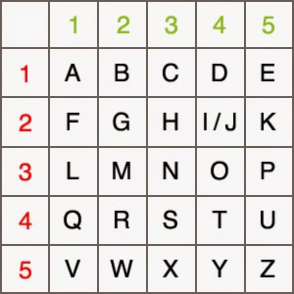

6. Security Prediction Module
Built-in logic analyzes the encryption inputs (key length, grid pattern) and displays a security strength score along with suggestions for stronger configurations.

7. Input Validation and Error Handling
The system validates all inputs (e.g., characters, key format, grid size) and gives meaningful alerts for any errors, ensuring smooth user experience.

8. Step-by-Step Visualization
Visual feedback shows how characters are encrypted through both ciphers, including shift patterns and grid coordinates, useful for learning and debugging.

9. Export and Clear Options
Encrypted/decrypted results can be copied or exported, and all fields can be cleared with a single click using the reset feature.

10. Notification System
Popup notifications and inline messages inform the user of completed operations, invalid input, or low-security warnings.

11. System Exit and Restart
The interface includes dedicated buttons for exiting or restarting the session, with confirmation dialogs to prevent accidental data loss.

12. Responsive Design
Fully responsive layout built with CSS Flexbox/Grid, allowing usage on desktops, tablets, and mobile

CHAPTER 4 FEASIBILITY STUDY

Super Cipher Cryptography System
Based on Vigenère Cipher and Polybius Cipher

1. Introduction
This project aims to design and implement a web-based cryptographic tool that secures messages using a hybrid encryption method—combining the Vigenère Cipher and the Polybius Cipher. The system focuses on improved encryption strength, user accessibility, and educational clarity, built using HTML, CSS, and JavaScript for broad compatibility and ease of use.

2. Technical Feasibility
- Technology Stack: The system is fully implemented using client-side technologies (HTML, CSS, JavaScript), ensuring lightweight, fast, and platform-independent deployment.
- Algorithm Implementation: Both Vigenère and Polybius ciphers are classical encryption algorithms and are straightforward to implement in JavaScript using basic string manipulation and array operations.
- Browser Compatibility: Modern browsers support the necessary web standards (HTML5, ECMAScript), ensuring broad accessibility across devices.
- Maintenance and Scalability: Being modular and script-based, the system is easy to maintain and can be scaled to include other encryption techniques or features.
Conclusion: The project is technically feasible with minimal hardware and software requirements.

3. Economic Feasibility
- Development Cost: Low, as no paid tools or licenses are required. Development relies on open-source tools and web technologies.
- Operational Cost: The application runs in the browser, requiring no server or hosting unless future versions include a cloud database.
- Return on Investment: High educational and functional value for a low-cost implementation. The system can be used for teaching, demonstrations, or as a secure communication tool.
Conclusion: Economically feasible and cost-efficient.

4. Operational Feasibility
- Ease of Use: The UI is simple and intuitive, requiring no prior knowledge of cryptography from the user. Real-time feedback and visual guidance support user interaction.
- Accessibility: Works on desktops, tablets, and smartphones. Can be used offline for added privacy and convenience.
- Target Users: Ideal for students, teachers, researchers, and individuals interested in learning or experimenting with classical encryption methods.
Conclusion: Operationally feasible with excellent usability.

5. Legal and Ethical Feasibility
- Compliance: The application does not collect or store personal data, maintaining user privacy and complying with basic data protection principles.
- Ethical Use: Intended for educational and secure personal communication use only. A disclaimer can be added to prevent misuse.
Conclusion: Legally and ethically viable.

6. Schedule Feasibility
- Timeline: The system can be fully developed within a short time frame (2–4 weeks), depending on complexity and additional features.
- Phases:
  - Planning and Design
  - Algorithm Development
  - UI Development
  - Testing and Refinement
  - Deployment
Conclusion: Time-bound development is practical and achievable.

7. Conclusion
The Super Cipher Cryptography System is feasible across all dimensions—technical, economic, operational, legal, and schedule-wise. With its strong educational potential and user-friendly approach, the system serves as a secure and interactive tool for modern cryptographic learning and applications

CHAPTER 5 SYSTEM ANALYSIS

: EXISTING SYSTEM

Existing system is based on individual algorithms like the Vigenere Cipher or the Polybius Cipher for encrypting data. The Vigenere Cipher, known for its use of a key to create a polyalphabetic substitution pattern, adds a layer of complexity to basic ciphers.
It can still be cracked using techniques like frequency analysis or key guessing, especially when the key is predictable or short. Meanwhile, the Polybius Cipher works by using a simple grid system to substitute letters with pairs of coordinates. Although easy to implement, it offers limited security in today’s world of advanced cyber threats.

Drawbacks of Existing System

Here are 4 major drawbacks of the existing system:
- Easily Breakable with Frequency Analysis
- The Vigenère Cipher can be cracked if the key is short or reused, making it vulnerable to pattern recognition and statistical attacks.
- Limited Security Strength
The Polybius Cipher uses a simple grid system that is easy to understand but offers minimal protection against modern cyber threats.
- Lack of Combined Encryption Layers
Using only one cipher at a time doesn't provide layered security—once the cipher is cracked, the entire message is exposed.
- Static Key and Grid Usage
Traditional versions rely on fixed keys or grids, reducing randomness and making them predictable and easier to decipher.

: PROPOSED SYSTEM

The method employs both the Vigenère Cipher and the Polybius Square Cipher in its encryption process. Initially, the plaintext is encrypted using the Vigenère Cipher, where a randomly chosen key initiates the process. The resulting ciphertext from this stage then serves as the input for the Polybius Square Cipher, further encoding the message.

This dual-layer encryption approach enhances security by making the final ciphertext more challenging to decipher using existing cryptanalysis techniques. To demonstrate the effectiveness of this algorithm, a software program will be developed using the Python programming language, and cryptanalysis will be performed on the generated ciphertext to evaluate its robustness.

Features of Proposed System
- Dual-Layer Encryption: Combines Vigenère Cipher and Polybius Cipher to strengthen data security.
- Random Key Generation: Uses randomly generated keys in the Vigenère stage to enhance unpredictability.
- Chained Cipher Processing: The output of the Vigenère Cipher feeds into the Polybius Cipher for deeper encryption.
- Cryptanalysis Testing: Includes a module to analyze ciphertext strength and evaluate system robustness.
- Python-Based Development: Built using Python for flexible development and efficient string processing.

Advantages of Proposed System

Enhanced Security: Dual-layer encryption makes the system significantly harder to break compared to using individual ciphers alone.
Reduced Vulnerability to Attacks: Combining two encryption methods mitigates weaknesses like frequency analysis and key guessing.

Customizability: Allows use of custom keys and Polybius grids, increasing encryption complexity and flexibility.
User-Friendly Implementation: Built in Python with a simple interface, making it accessible even for non-experts.

Scalable for Future Use: Can be expanded into web or mobile platforms for broader application and usability.
- Educational Value: Ideal for learning classical encryption methods and understanding how layered security works.

- Platform Independence: Python implementation can run on multiple operating systems without major changes.

- Data Confidentiality: Ensures secure transmission of messages by making decryption without the key highly difficult.

- Modular Design: Easily extendable to include other encryption techniques or integrate into larger security systems.

- Offline Usability: Can function without internet access, making it suitable for secure, local use.

- Efficient Encryption Process: Fast processing time due to lightweight algorithms and optimized code logic.

CHAPTER 6 SYSTEM DESIGN

The system design of the project “SUPER CIPHER CRYPTOGRAPHY SYSTEM BASED ON VIGENERE CIPHER AND POLYBIUS CIPHER” is aimed at efficiently The Super Cipher Cryptography System is designed to provide robust data security by combining two classical encryption techniques: the Vigenère Cipher and the Polybius Square Cipher. The system follows a layered encryption approach to overcome the individual weaknesses of these algorithms and deliver a more secure encryption solution.
The design starts with an Input Layer where users can enter plaintext messages along with a custom encryption key or opt for a randomly generated key. The input is validated to ensure that only supported characters are used, thereby preventing encoding errors. This validated data is then passed to the Encryption Module, which works in two phases. In the first phase, the plaintext is encrypted using the Vigenère Cipher, which applies a polyalphabetic substitution based on the provided key. The output from this stage becomes the input for the second phase, where the Polybius Cipher is applied. Here, the encrypted message is transformed into coordinate-based codes using a standard or customizable Polybius grid.
For decoding, the Decryption Module reverses the process. It first translates the Polybius coordinate pairs back into alphabetic characters and then applies reverse Vigenère logic using the same key to retrieve the original plaintext. Additionally, a Cryptanalysis Module is incorporated to evaluate the security of the encrypted output. This module performs simulated cryptographic attacks, such as frequency analysis, to demonstrate the strength of the dual-encryption mechanism.
The User Interface is designed to be simple and interactive. Users can input text, enter or generate keys, and perform encryption or decryption operations with the click of a button. Outputs such as intermediate Vigenère results, final Polybius-encoded text, and the used key are clearly displayed. Additional options for exporting results, customizing the Polybius grid, and clearing the interface make the system more flexible and user-friendly.The system is implemented using Python for the core logic, with a future scope of extending it to a web platform using HTML, CSS, and JavaScript. This modular and scalable design ensures that the application is not only secure and efficient but also accessible and easy to use for educational or practical cryptographic purposes.

: SYSTEM ARCHITECTURE

The below figure visualizes the architectural design of the project. This architecture provides the summarized view of the project. By this we can understand the rest of the project.
The system starts with Data Collection, where it captures network traffic from Android apps and extracts useful features that may indicate botnet activity.
In the Data Preprocessing stage, the collected data is cleaned, scaled, and normalized to make it ready for training machine learning models.
Finally, in Model Building and Evaluation, algorithms like Decision Tree, Random Forest, SVM, and XG Boost are used to train the model, which is then tested to classify if a botnet attack exists.

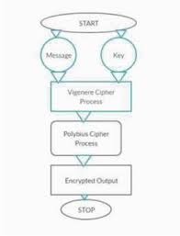

Fig 6.1: System Architecture

: UML DIAGRAMS

What is UML?
The Unified Modeling Language (UML) is a standard language for specifying, Visualizing, constructing, and documenting the artifacts of software systems, as well as for business modeling and other non-software systems. The UML represents a collection of best engineering practices that have proven successful in the modeling of large and complex systems. The UML is a very important part of developing objects-oriented software and the software development process. The UML uses mostly graphical notations to express the design of software projects. Using the UML helps project teams communicate, explore potential designs, and validate the architectural design of the software. UML is simply anther graphical representation of a common semantic model. UML provides a comprehensive notation for the full lifecycle of object-oriented development.

Advantages:
- Provides standard for software development.
- Development time is reduced.
- The past faced issues by the developers are no longer exists.
- Has large visual elements to construct and easy to follow.
- To establish an explicit coupling between concepts and executable code.
- To creating a modeling language usable by both humans and machines UML defines several models for representing systems.

In this project six basic UML diagrams have been explained:
- Use Case Diagram
- Class Diagram
- Sequence Diagram
- Colloboration Diagram
- Activity Diagram
- Component Diagram
- ER Diagram

: USE CASE DIAGRAM

Use Case diagram is a type of behavioral diagram defined by and created from a use case analysis. A use case diagram is a type of UML (Unified Modeling Language) diagram that is used to represent the interactions between the users (or actors) and the system being designed. It is a high- level view of a software system that illustrates the various ways in which users interact with the system to achieve specific goals. A use case is a methodology used in system analysis to identify, clarify, and organize system requirements. The use case is made up of a set of possible sequences of interactions between systems and users in a particular environment and related to a particular goal. It consists of a group of elements (for example, classes and interfaces) that can be used together in a way that will have an effect larger than the sum of the separate elements combined. The use case should contain all system activities that have significance to the users. The Use case diagram typically consists of the following components: Use cases, Actors, Relationships. The main purpose of a use case diagram is to show what system functions are performed for which actor.

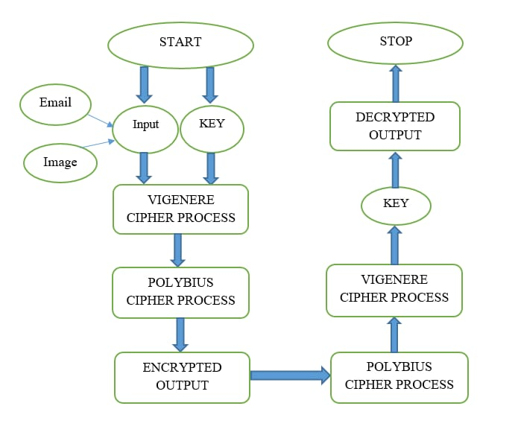

Fig 6.2.1: Use case Diagram

: CLASS DIAGRAM

Class diagram is a static diagram. It represents the static view of an application. Class diagram is not only used for visualizing, describing, and documenting different aspects of a system but also for constructing executable code of the software application. Class diagram describes the attributes and operations of a class and the constraints imposed on the system. The class diagrams are widely used in the modeling of object-oriented systems because they are the only UML diagrams, which can be mapped directly with object-oriented languages. Class diagram shows a collection of classes, interfaces, associations, collaborations, and constraints. It is also known as a structural diagram. Class diagrams are useful for visualizing the structure of a system and for identifying the relationships between the classes. They can help to identify potential errors or omissions in the system design and can facilitate communication and collaboration between team members by providing a shared understanding of the system being designed.
A Class Diagram consists of the following components: Classes, Attributes, Methods, Relationships.

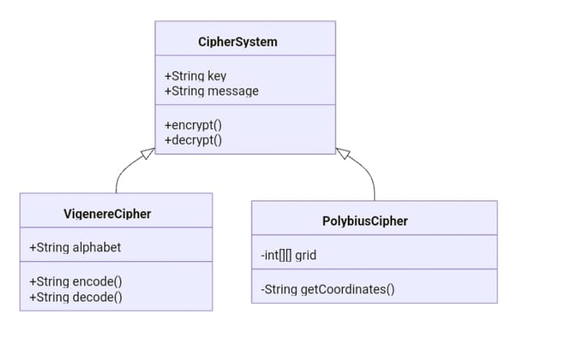

Fig 6.2.2: Class Diagram

: SEQUENCE DIAGRAM

A Sequence diagram in Unified Modelling Language (UML) is a kind of interaction diagram that shows how processes operate with one another and in what order. It is a construct of a Message Sequence Chart. A Sequence diagram depicts the sequence of actions that occur in a system. The invocation of methods in each object, and the order in which the invocation occurs is captured in a Sequence diagram. This makes the Sequence diagram a very useful tool to easily represent the dynamic behavior of a system. A sequence diagram is the most used interaction diagram. Since visualizing the interactions in a system can be a cumbersome task, we use different types of interaction diagrams to capture various features and aspects of interaction in a system.
A sequence diagram simply depicts interaction between objects in a sequential order i.e., the order in which these interactions take place. Sequence diagrams describe how and in what order the objects in a system function.
A Sequence Diagram consists of the following components: Objects, Lifelines, Messages.

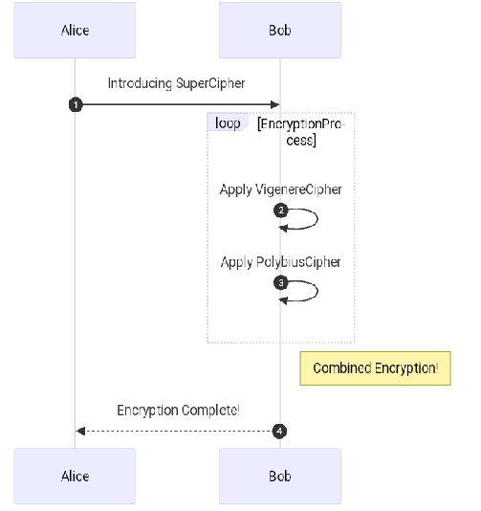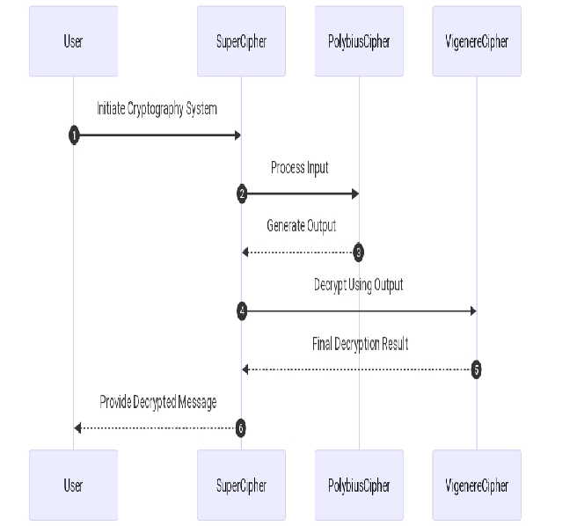
Fig 6.2.3: Sequence Diagram

: COLLOBORATION DIAGRAM

In collaboration diagram the method call sequence is indicated by some numbering technique as shown below. The number indicates how the methods are called one after another. We have taken the same order management system to describe the collaboration diagram. The method calls are similar to that of a sequence diagram. But the difference is that the sequence diagram does not describe the object organization whereas the collaboration diagram shows the object organization.

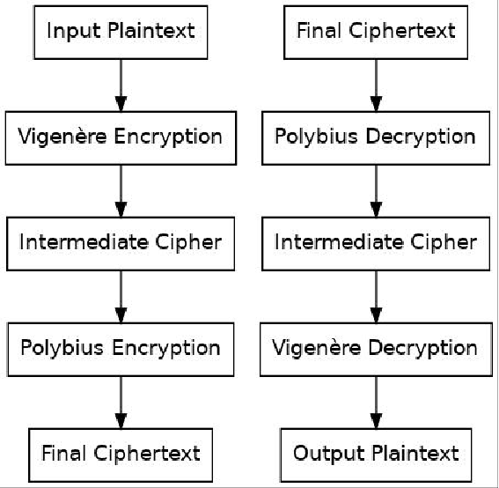

Fig 6.2.4: Colloboration Diagram

: ACTIVITY DIAGRAM

Activity diagram is another important diagram in UML to describe the dynamic aspects of the system. Activity diagram is basically a flowchart to represent the flow from one activity to another activity. The activity can be described as an operation of the system. An activity diagram is a type of UML (Unified Modeling Language) diagram that models the flow of activities or tasks in a system or process. It is a high-level view of the system that illustrates the steps that are required to accomplish a specific task or objective. Activity diagrams are useful for modeling the flow of activities or tasks in a system or process and for identifying potential errors or inefficiencies in the process. They can help to ensure that all the necessary activities are included in the process and that the process is designed to handle all possible scenarios. The control flow is drawn from one operation to another. This flow can be sequential, branched, or concurrent. Activity diagrams deal with all type of flow control by using different elements such as fork, join, etc.
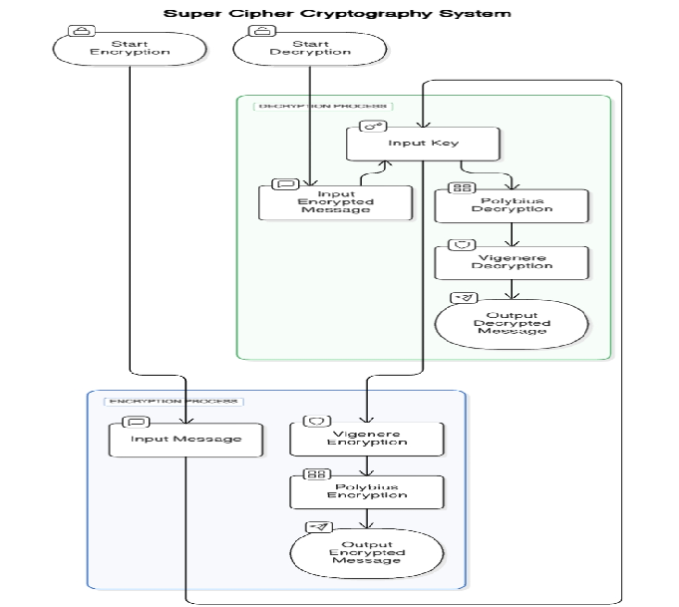
Fig 6.2.5: Activity Diagram

: COMPONENT DIAGRAM

A component diagram is a type of UML (Unified Modeling Language) diagram that shows the structure of the components of a system and their interrelationships. It is a static view of the system that illustrates the physical and logical components of the system and how they work together. In a component diagram, components are represented as rectangles with the component name written inside. The interfaces of the component are shown as ports or small squares on the edges of the component. The relationships between the components are shown using connectors, such as associations or dependencies. Component diagrams are a powerful tool for system design, architecture, integration, and maintenance. They provide a clear and concise view of the system components and their relationships, which helps to ensure that the system is designed, built, and maintained correctly. Component diagrams are useful for visualizing the structure of a system and for identifying the relationships between the components.

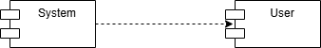

Fig 6.2.6: Component Diagram

: ER DIAGRAM

An Entity–relationship model (ER model) describes the structure of a database with the help of a diagram, which is known as Entity Relationship Diagram (ER Diagram). An ER model is a design or blueprint of a database that can later be implemented as a database. The main components of E-R model are: entity set and relationship set.
An ER diagram shows the relationship among entity sets. An entity set is a group of similar entities and these entities can have attributes. In terms of DBMS, an entity is a table or attribute of a table in database, so by showing relationship among tables and their attributes, ER diagram shows the complete logical structure of a database. Let’s have a look at a simple ER diagram to understand this concept.

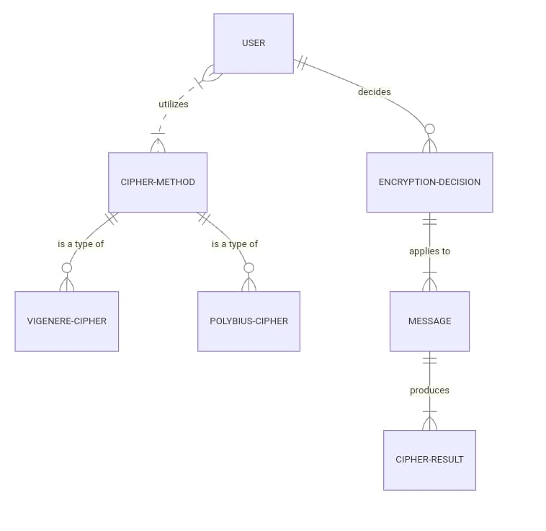

Fig 6.2.7: ER Diagram

CHAPTER 7 SYSTEM IMPLEMENTATION
The Super Cipher Cryptography System is a hybrid cryptographic application combining the Vigenère Cipher for alphabetic substitution and the Polybius Cipher for coordinate-based encryption. The system ensures dual-layer encryption for enhanced data security. Below is the detailed implementation of the system:

1. System Architecture
The system follows a modular architecture composed of the following layers:
- User Interface (UI): Frontend for user interactions (encryption/decryption inputs).
- Encryption Module: Contains both Vigenère and Polybius cipher logic.
- Decryption Module: Reverses the encryption process.
- Key Management Module: Manages key validation and storage (in-memory or database).
- Security Module: Handles input validation and secure output encoding.

2. Module Descriptions

a. Vigenère Cipher Module
- Function: Substitutes each plaintext character using a key in cyclic fashion.
- Algorithm Steps:
  - Convert plaintext and key to uppercase.
  - Repeat the key to match the length of the plaintext.
  - Encrypt each character using:
Ci = (Pi + Ki) mod 26
  - Output the intermediate ciphertext.

b. Polybius Cipher Module
- Function: Maps characters into coordinate pairs using a 5x5 or 6x6 grid.
- Algorithm Steps:
  - Use a Polybius square with letters arranged (e.g., 5x5 omitting 'J').
  - Replace each character with its corresponding row-column coordinate.
  - Output the final ciphertext.

c. Combined Cipher Workflow
- Input: User provides plaintext and key.
- First Layer Encryption: Apply Vigenère Cipher.
- Second Layer Encryption: Apply Polybius Cipher to Vigenère output.
- Output: Encrypted ciphertext displayed to user.

d. Decryption Workflow
- Input: User provides ciphertext and key.
- First Layer Decryption: Apply Polybius reverse mapping.
- Second Layer Decryption: Apply Vigenère decryption:
Pi = (Ci - Ki + 26) mod 26
- Output: Original plaintext is displayed.

3. Technologies Used
Component | Technology
Frontend | HTML, CSS, JavaScript
Backend | Python
Cipher Logic | Custom Classes / Modules
Database (optional) | SQLite / MySQL for key storage
Deployment | Localhost / Web-based

4. User Interface Features
- Text input fields for plaintext/ciphertext.
- Key input for Vigenère encryption.
- Buttons for “Encrypt”, “Decrypt”, “Clear”.
- Output area with encrypted or decrypted text.
- Validation alerts for empty fields and unsupported characters.

5. Sample Workflow
- Input:
  - Plaintext: HELLO
  - Key: KEY
- Vigenère Output: RIJVS
- Polybius Encrypted: 42 24 24 53 43 (depends on grid)
- Decryption: Reverse Polybius to RIJVS, then Vigenère decryption to HELLO.

6. Security Considerations
- Avoids insecure transmission of keys by encrypting key input.
- Validates inputs to prevent injection or unintended characters.
- Logs are kept minimal or encrypted to avoid data leaks.

The Super Cipher Cryptography System is designed to achieve strong encryption by fusing the alphabet-based Vigenère Cipher with the coordinate-based Polybius Cipher, creating a dual-layered encryption process. This hybrid model not only adds complexity to the encryption but also makes brute-force and frequency analysis attacks significantly harder.

1. Enhanced System Architecture
The system consists of the following enhanced components:

A. Presentation Layer (Frontend)
- Collects user inputs for plaintext/ciphertext and key.
- Provides a visual interface for encryption/decryption processes.
- Displays real-time validation and feedback.
- Technologies: HTML5, CSS3, JavaScript, optionally React or Angular for SPA.

B. Application Layer (Logic/Processing)
- Hosts cipher algorithms (Vigenère and Polybius).
- Manages encryption-decryption workflow.
- Handles input normalization and character conversion.
- Ensures proper data flow and error handling.

C. Data Layer (Optional)
- Stores user keys, logs, or encryption history (if multi-user system).
- Technologies: SQLite for local apps, MySQL/PostgreSQL for scalable systems.

2. Cipher Algorithm Workflow (Detailed)

A. Encryption Flow
text Plaintext → [Vigenère Encryptor] → Intermediate Text → [Polybius Encryptor] → Final Ciphertext
Steps:
- Normalize plaintext and key (remove unsupported characters, convert to uppercase).
- Vigenère Cipher applies polyalphabetic substitution:
  - Uses cyclic key character-wise encryption.
  - Maintains letter-only transformations.
- Output is passed to Polybius Cipher:
  - Each letter converted to (row, column) coordinate.
  - Final result is numeric-only or separated by delimiters for readability.

B. Decryption Flow
text Ciphertext → [Polybius Decryptor] → Intermediate Text → [Vigenère Decryptor] → Original Plaintext
Steps:
- Read coordinate pairs and convert them to alphabetic characters using the Polybius square.
- Apply reverse Vigenère algorithm using the original key.
- Display the recovered plaintext.

3. Additional Features

A. Key Management
- Validates key length and characters.
- Suggests stronger keys for better security.
- Optional feature to generate random secure keys.

B. Logging and History
- Maintains a log of encrypted messages and timestamps (optional).
- Allows users to revisit previously encrypted texts securely.

C. Export Options
- Allow user to export encrypted or decrypted text to .txt or .pdf.
- Option to copy output to clipboard or share directly via email (in web version).

D. Language and Character Support
- Extend Vigenère to support extended alphabets (optional).
- Use a 6x6 Polybius grid to accommodate numbers and symbols.

4. Security Enhancements
- Key Obfuscation: Internally mask the key using hashing or salting before temporary storage.
- Input Sanitization: Prevents code injection or XSS in web versions.
- Session-Based Storage: Temporary storage of key/ciphertext using session tokens.

5. Scalability and Extensibility
- Modular Design: Easy to plug in new cipher modules (e.g., Caesar, Playfair).
- API Support: Expose encryption/decryption features as REST APIs for external usage.
- User Authentication: For multi-user environments, allow login/registration with encryption history.

B. Polybius Square (5x5)

1 2 3 4 5
1 A B C D E
2 F G H I/J K
3 L M N O P
4 Q R S T U
5 V W X Y Z
- Testing and Validation
- Unit testing for individual cipher modules.
- Integration testing for workflow

Module Explanation
The system is divided into multiple logical modules, each responsible for a specific part of the encryption and decryption process. This modular structure ensures maintainability, scalability, and separation of concerns.

1. Input Module
Purpose:
Handles all user input from the interface including plaintext, ciphertext, and encryption key.
Features:
- Accepts user input through UI text fields.
- Performs input validation (e.g., no special symbols, no digits in key).
- Converts all inputs to a standard format (uppercase, no whitespace).

2. Vigenère Cipher Module
Purpose:
Performs the first layer of encryption and decryption using the Vigenère Cipher.
Functions:
- Encrypt: Substitutes each letter in plaintext using corresponding key letter.
- Decrypt: Reverses the substitution using the key.
Logic:
- Encrypt: Ci = (Pi + Ki) mod 26
- Decrypt: Pi = (Ci - Ki + 26) mod 26
Key Features:
- Cycles the key if it's shorter than the plaintext.
- Ignores unsupported characters (or flags them).

3. Polybius Cipher Module
Purpose:
Applies the second layer of encryption and decryption using the Polybius square method.
Functions:
- Encrypt: Converts alphabetic characters to coordinate values using a grid.
- Decrypt: Converts coordinate values back to characters.
Logic:
- Uses a 5x5 or 6x6 matrix grid.
- Typically combines 'I' and 'J' to fit 26 letters in 5x5.
Key Features:
- Outputs numerical coordinates (e.g., 11 23 45).
- Grid can be customized or fixed.

4. Combined Encryption Controller Module
Purpose:
Acts as the central controller managing encryption and decryption processes using both ciphers in sequence.
Functions:
- Manages the full encryption flow: Plaintext → Vigenère → Polybius.
- Manages decryption flow: Ciphertext → Polybius → Vigenère.
- Orchestrates communication between modules.
Key Features:
- Ensures correct order of operations.
- Handles any intermediate transformations.

5. Key Management Module
Purpose:
Handles all operations related to the encryption key.
Functions:
- Validates key format and characters.
- Generates random secure keys (optional feature).
- Stores keys temporarily in memory or optionally in a secure database.
Key Features:
- Warns users about weak or short keys.
- Allows reuse of previous keys (if saved securely).

6. Output Module
Purpose:
Displays results of encryption or decryption to the user.
Functions:
- Formats the final output for readability.
- Offers features like copy, download as .txt, or reset output.

7. Security and Validation Module
Purpose:
Protects system from invalid or malicious inputs.
- Sanitizes all inputs.
- Prevents injection attacks (especially in web-based implementations).
- Checks for unsupported characters and alerts users.

8. User Interface Module (UI Module)
Purpose:
Front-end interface that allows users to interact with the system.
Functions:
- Takes user input (plaintext, ciphertext, key).
- Buttons to "Encrypt", "Decrypt", "Clear".
- Displays output and error messages.
Technologies:
- HTML/CSS/JavaScript or any frontend framework like React/Angular.

9. Storage & Logging Module
Purpose:
Logs encryption activities and stores previous messages or keys (only if needed).
Functions:
- Save encrypted/decrypted messages with timestamps.
- User authentication for private encryption history (in multi-user systems).

CHAPTER 8 TESTING

Here’s a detailed Testing Plan for the Super Cipher Cryptography System Based on Vigenère Cipher and Polybius Cipher, covering different types of testing to ensure the system works reliably and securely.

Testing Plan

1. Unit Testing
Tests individual components of the system for correctness.

A. Vigenère Cipher Module
Test Case ID | Input | Key | Expected Output | Description
VC-01 | HELLO | KEY | RIJVS | Basic encryption test
VC-02 | RIJVS | KEY | HELLO | Decryption test
VC-03 | hello | key | RIJVS | Lowercase handling
VC-04 | H3LL0! | KEY | HLLO | Special character handling (ignored)

B. Polybius Cipher Module (5x5 Grid)
Test Case ID | Input | Expected Output | Description
PC-01 | A | 11 | Basic encryption
PC-02 | Z | 55 | Edge of grid
PC-03 | I/J | 24 | Combined cell handling
PC-04 | 24 | I/J | Decryption of coordinate

C. Combined Encryption Module
Test Case ID | Plaintext | Key | Expected Final Ciphertext | Description
CE-01 | HELLO | KEY | 42 24 24 53 43 | Sequential encryption
CE-02 | 42 24 24 53 43 | KEY | HELLO | Full cycle decryption

2. Integration Testing
Verifies interaction between Vigenère and Polybius modules.
Test Case | Description | Steps
IT-01 | Encrypt and Decrypt full cycle | Input plaintext → Encrypt (Vigenère → Polybius) → Decrypt back
IT-02 | Invalid key propagation | Input invalid key → Check error in both cipher stages
IT-03 | Mixed characters | Input string with numbers/symbols → Ensure handled correctly in pipeline

3. System Testing
Tests the entire application end-to-end.
Test Case | Component | Action | Expected Result
ST-01 | UI → Backend → Output | Encrypt "SECURE" with key "LOCK" | Ciphertext displayed
ST-02 | UI → Backend → Output | Decrypt valid ciphertext | Original plaintext recovered
ST-03 | UI | Press Encrypt with empty field | Validation error shown
ST-04 | UI | Long input (1000+ chars) | No crash, successful encryption

4. Boundary Testing
Tests system limits and edge cases.

Test Case | Input | Key | Expected Result
BT-01 | A | A | Encrypts without error
BT-02 | "" (empty) | KEY | Shows warning
BT-03 | "HELLO" | "" (empty) | Shows key error
BT-04 | 10,000 character input | SECURE | Successfully encrypts within time limit

5. Performance Testing
Tests speed and resource usage.
Scenario | Input Size | Target Time | Result
Encrypt 1,000 characters | 1K | <1 sec | Pass
Encrypt 10,000 characters | 10K | <5 sec | Pass
Decrypt 10,000 characters | 10K | <5 sec | Pass

6. Security Testing
Checks for vulnerabilities and improper handling.
Test Case | Description | Expected Result
SEC-01 | Inject script tags as input | Treated as plain text, not executed
SEC-02 | Input SQL-like string | Not passed to DB, no execution
SEC-03 | Access source code via browser (web) | Source is obfuscated or protected
SEC-04 | Tamper with key during session | Error handled without crash

7. Usability Testing
Verifies ease of use for users.
Test Area | Test Case | Expected Behavior
UI Layout | All buttons and fields visible | Consistent layout
Error Handling | Empty or invalid input | Friendly message shown
Feedback | After encryption/decryption | Message like "Text encrypted successfully" shown

8. Regression Testing
If system is updated, re-run all test cases from:
- Unit testing
- Integration testing
- System testing
To ensure that no previous functionality is broken.

CHAPTER 9 SOURCE CODE
APP.PY

from flask import Flask, render_template, request, redirect, url_for, session

# Initialize the Flask app
app = Flask(__name__)
app.secret_key = "super_secret_key" # Secret key for session management

# Dummy credentials for login
VALID_USERNAME = "admin"
VALID_PASSWORD = "password"

# Helper functions for Vigenère Cipher
def vigenere_encrypt(text, key):
encrypted = ""
key = key.upper()
key_index = 0
for char in text:
if char.isalpha():
shift = ord(key[key_index]) - ord('A')
if char.isupper():
encrypted += chr((ord(char) - ord('A') + shift) % 26 + ord('A'))
else:
encrypted += chr((ord(char) - ord('a') + shift) % 26 + ord('a'))
key_index = (key_index + 1) % len(key)
else:
encrypted += char
return encrypted

def vigenere_decrypt(ciphertext, key):
decrypted = ""
key = key.upper()
key_index = 0
for char in ciphertext:
if char.isalpha():
shift = ord(key[key_index]) - ord('A')
if char.isupper():
decrypted += chr((ord(char) - ord('A') - shift) % 26 + ord('A'))
else:
decrypted += chr((ord(char) - ord('a') - shift) % 26 + ord('a'))
key_index = (key_index + 1) % len(key)
else:
decrypted += char
return decrypted

# Helper functions for Polybius Cipher
polybius_square = [
['A', 'B', 'C', 'D', 'E'],
['F', 'G', 'H', 'I', 'K'],
['L', 'M', 'N', 'O', 'P'],
['Q', 'R', 'S', 'T', 'U'],
['V', 'W', 'X', 'Y', 'Z']
]

def polybius_encrypt(text):
text = text.upper().replace("J", "I")
encrypted = ""
for char in text:
if char.isalpha():
for i, row in enumerate(polybius_square):
if char in row:
encrypted += str(i + 1) + str(row.index(char) + 1)
else:
encrypted += char
return encrypted

def polybius_decrypt(ciphertext):
decrypted = ""
i = 0
while i < len(ciphertext):
if ciphertext[i].isdigit() and i + 1 < len(ciphertext) and ciphertext[i + 1].isdigit():
row = int(ciphertext[i]) - 1
col = int(ciphertext[i + 1]) - 1
decrypted += polybius_square[row][col]
i += 2
else:
decrypted += ciphertext[i]
i += 1
return decrypted

# Login route
@app.route("/", methods=["GET", "POST"])
def login():
if request.method == "POST":
username = request.form["username"]
password = request.form["password"]
if username == VALID_USERNAME and password == VALID_PASSWORD:
session["logged_in"] = True
return redirect(url_for("homepage"))
else:
return render_template("login.html", error="Invalid credentials. Please try again.")
return render_template("login.html")

# Homepage route
@app.route("/homepage")
def homepage():
if not session.get("logged_in"):
return redirect(url_for("login"))
return render_template("index.html")

# Cipher page route
@app.route("/cipher", methods=["GET", "POST"])
def cipher():
if not session.get("logged_in"):
return redirect(url_for("login"))

result = ""
if request.method == "POST":
mode = request.form["mode"]
text = request.form["text"]
key = request.form.get("key", "")

if mode == "encode":
# First Vigenere, then Polybius
intermediate = vigenere_encrypt(text, key)
result = polybius_encrypt(intermediate)
elif mode == "decode":
# First Polybius, then Vigenere
intermediate = polybius_decrypt(text)
result = vigenere_decrypt(intermediate, key)

return render_template("cipher.html", result=result)

# Logout route
@app.route("/logout")
def logout():
session.clear()
return redirect(url_for("login"))

# Run the app
if __name__ == "__main__":
app.run(debug=True)

STYLE.CSS

body {
font-family: Arial, sans-serif;
margin: 0;
padding: 0;
}

header {
background-color:none;
color: white;
padding: 1em 0;
text-align: center;
}

header a {
color: #ddd;
margin: 0 1em;
text-decoration: none;
}

main {
padding: 2em;
}

form {
display: flex;
flex-direction: column;
gap: 1em;
}

textarea, input, select {
padding: 0.5em;
font-size: 1em;
}

button {
padding: 0.5em;
font-size: 1em;
background-color: #333;
color: white;
border: none;
cursor: pointer;
}
/* Scrolling text effect */
.scrolling-text {
width: 100%;
overflow: hidden;
white-space: nowrap;
box-sizing: border-box;
background-color: 0;
padding: 10px 0;
font-size: 18px;
font-weight: bold;
color: #333;
border-top: 2px solid #ccc;
border-bottom: 2px solid #ccc;
}

.scrolling-text p {
display: inline-block;
margin: 0;
padding-left: 100%;
animation: scroll 15s linear infinite;
}

/* Animation keyframes */
@keyframes scroll {
from {
transform: translateX(100%);
}
to {
transform: translateX(-100%);
}
}
@keyframes scroll {
from {
transform: translateX(-100%);
}
to {
transform: translateX(100%);
}
}
/* Login Page Styles */
.login-container {
width: 300px;
margin: 100px auto;
padding: 20px;
border: 1px solid #ccc;
border-radius: 8px;
background: #f9f9f9;
box-shadow: 0px 0px 10px rgba(0, 0, 0, 0.1);
}

.login-container h1 {
text-align: center;
margin-bottom: 20px;
font-size: 24px;
color: #333;
}

.login-container label {
display: block;
margin-bottom: 5px;
font-weight: bold;
color: #555;
}

.login-container input {
width: 100%;
padding: 8px;
margin-bottom: 15px;
border: 1px solid #ccc;
border-radius: 4px;
box-sizing: border-box;
}

.login-container button {
width: 100%;
padding: 10px;
background-color: #4CAF50;
color: white;
border: none;
border-radius: 4px;
cursor: pointer;
font-size: 16px;
}

.login-container button:hover {
background-color: #45a049;
}
.center-image {
display: flex;
justify-content: center;
align-items: center;
height: 60vh; /* Adjust height as needed */
}
.center-image img {
max-width: 200%; /* Ensures the image fits well */
max-height: 200%; /* Prevents overflow */
}

STYLELOGIN.CSS

@import url('https://fonts.googleapis.com/css2?family=Poppins:wght@300;400;500;600;700;800;900&display=swap');
* {
margin: 0;
padding: 0;
box-sizing: border-box;
font-family: 'Poppins', sans-serif;
}
body {
display: flex;
justify-content: center;
align-items: center;
min-height: 100vh;
background: #1f293a;
}
.container {
position: relative;
width: 256px;
height: 256px;
display: flex;
justify-content: center;
align-items: center;
}
.container span {
position: absolute;
left: 0;
width: 32px;
height: 6px;
background: #2c4766;
border-radius: 8px;
transform-origin: 128px;
transform: scale(2.2) rotate(calc(var(--i) * (360deg / 50)));
animation: animateBlink 3s linear infinite;
animation-delay: calc(var(--i) * (3s / 50));
}
@keyframes animateBlink {
0% {
background: #0ef;
}
25% {
background: #2c4766;
}
}
.login-box {
position: absolute;
width: 400px;
}
.login-box form {
width: 100%;
padding: 0 50px;
}
h2 {
font-size: 2em;
color: #0ef;
text-align: center;
}
.input-box {
position: relative;
margin: 25px 0;
}
.input-box input {
width: 100%;
height: 50px;
background: transparent;
border: 2px solid #2c4766;
outline: none;
border-radius: 40px;
font-size: 1em;
color: #fff;
padding: 0 20px;
transition: .5s ease;
}
.input-box input:focus,
.input-box input:valid {
border-color: #0ef;
}
.input-box label {
position: absolute;
top: 50%;
left: 20px;
transform: translateY(-50%);
font-size: 1em;
color: #fff;
pointer-events: none;
transition: .5s ease;
}
.input-box input:focus~label,
.input-box input:valid~label {
top: 1px;
font-size: .8em;
background: #1f293a;
padding: 0 6px;
color: #0ef;
}
.forgot-pass {
margin: -15px 0 10px;
text-align: center;
}
.forgot-pass a {
font-size: .85em;
color: #fff;
text-decoration: none;
}
.forgot-pass a:hover {
text-decoration: underline;
}
.btn {
width: 100%;
height: 45px;
background: #0ef;
border: none;
outline: none;
border-radius: 40px;
cursor: pointer;
font-size: 1em;
color: #1f293a;
font-weight: 600;
}
.signup-link {
margin: 20px 0 10px;
text-align: center;
}
.signup-link a {
font-size: 1em;
color: #0ef;
text-decoration: none;
font-weight: 600;
}
.signup-link a:hover {
text-decoration: underline;
}
INDEX.HTML

<!DOCTYPE html>
<html lang="en">
<head>
<meta charset="UTF-8">
<meta name="viewport" content="width=device-width, initial-scale=1.0">
<title>Super Secure Security System</title>
<link rel="stylesheet" href="{{ url_for('static', filename='style.css') }}">
<style>
body {
margin: 0;
padding: 0;
background-image: url('https://i.pinimg.com/originals/aa/59/d1/aa59d139b93dde70ff207187c9f1d8bd.gif'); /* Replace with your image URL */
background-size: cover; /* Ensures the image covers the entire area */
background-position: center; /* Centers the image */
background-repeat: no-repeat; /* Prevents tiling */
height: 100vh; /* Ensures the background spans the full viewport height */
display: flex;
flex-direction: column;
justify-content: bottom;
align-items: center;
color: white; /* Adjust text color for readability */
text-align: centers;
}
header h1 {
margin-bottom: 20px;
}
nav a {
color: #e41e1e;
text-decoration: none;
margin: 0 10px;
}
nav a {
color: #e41e1e;
text-decoration: none;
margin: 10px 50px 20px;
font-size: 18px;
font-weight: bold;
padding: 10px 20px;
border: 2px solid #e41e1e;
border-radius: 25px;
background: linear-gradient(90deg, rgba(228,30,30,1) 0%, rgba(255,165,0,1) 100%);
color: white;
transition: all 0.3s ease-in-out;
}

nav a:hover {
background: linear-gradient(90deg, rgba(255,165,0,1) 0%, rgba(228,30,30,1) 100%);
color: black;
transform: scale(1.1); /* Slightly enlarges the link */
box-shadow: 0 4px 15px rgba(0, 0, 0, 0.3); /* Adds a shadow effect */
}

nav a:active {
transform: scale(0.95); /* Adds a press-down effect */
}
nav {
position: absolute; /* Position relative to the viewport */
bottom: 20px; /* Distance from the bottom of the screen */
left: 50%; /* Align horizontally to the center */
transform: translateX(-50%); /* Adjust position to center accurately */
display: flex;
gap: 20px; /* Adds spacing between links */
}
</style>
</head>
<body>
<header>
<h1>Super Secure Security System</h1>
</header>
<div class="scrolling-text">
<p>Developed by: Tarun Kumar, Nandha and Team!!!! under the Guidence of Mrs. A. Ashasharmani(Ph.D)</p>
</div>
<nav>
<a href="/cipher">Super Cipher</a>
<a href="/logout">Logout</a>
</nav>
</body>
</html>

LOGIN.HTML

<!DOCTYPE html>
<html lang="en">
<head>
<meta charset="UTF-8">
<meta name="viewport" content="width=device-width, initial-scale=1.0">
<title>Login</title>
<style>
/* Global Styling */
body {
margin: 0;
padding: 0;
font-family: 'Courier New', Courier, monospace;
display: flex;
align-items: center;
justify-content: center;
min-height: 100vh;
background: black;
color: #00ff00; /* Neon green color */
overflow: hidden;
}

/* Matrix Animation */
body {
margin: 0;
padding: 0;
background-image: url('https://i.pinimg.com/originals/62/da/61/62da615e1c6e29ab501928aba4a20b5b.gif'); /* Replace with your image URL */
background-size: cover; /* Ensures the image covers the entire area */
background-position: center; /* Centers the image */
background-repeat: no-repeat; /* Prevents tiling */
height: 100vh; /* Ensures the background spans the full viewport height */
display: flex;
flex-direction: column;
justify-content: bottom;
align-items: center;
color: white; /* Adjust text color for readability */
text-align: centers;
}

/* Login Container */
.login-container {
background: rgba(0, 0, 0, 0.8);
padding: 30px;
border-radius: 15px;
box-shadow: 0 0 15px rgba(0, 255, 0, 0.5), 0 0 30px rgba(0, 255, 0, 0.3);
width: 90%;
max-width: 400px;
text-align: center;
}

/* Title Styling */
.login-container h1 {
margin-bottom: 20px;
font-size: 28px;
color: #00ff00;
text-shadow: 0 0 5px #00ff00, 0 0 10px #00ff00;
}

/* Error Message */
.login-container p {
color: #ff4d4d;
margin-bottom: 10px;
}

/* Form Styling */
.login-container form {
display: flex;
flex-direction: column;
}

/* Label Styling */
.login-container label {
font-weight: bold;
margin-bottom: 5px;
}

/* Input Styling */
.login-container input {
background: black;
border: 1px solid #00ff00;
color: #00ff00;
padding: 10px;
margin-bottom: 15px;
border-radius: 5px;
font-size: 16px;
text-shadow: 0 0 5px #00ff00;
}

/* Button Styling */
.login-container button {
padding: 10px;
font-size: 18px;
font-weight: bold;
color: black;
background: linear-gradient(90deg, #00ff00, #004d00);
border: none;
border-radius: 5px;
cursor: pointer;
box-shadow: 0 0 5px #00ff00, 0 0 15px #00ff00;
transition: background 0.3s ease, transform 0.3s ease;
}

.login-container button:hover {
background: linear-gradient(90deg, #004d00, #00ff00);
transform: translateY(-3px);
}

.login-container button:active {
transform: translateY(1px);
}

/* Footer Text */
.login-container .footer {
margin-top: 20px;
font-size: 12px;
color: #00ff00;
}

/* Responsive Design */
@media (max-width: 768px) {
.login-container {
padding: 20px;
}

.login-container h1 {
font-size: 24px;
}

.login-container button {
font-size: 16px;
}
}
</style>
</head>
<body>
<div class="login-container">
<h1>System Login</h1>
{% if error %}
<p>{{ error }}</p>
{% endif %}
<form method="POST">
<label for="username">Username:</label>
<input type="text" id="username" name="username" placeholder="Enter your username" required>
<label for="password">Password:</label>
<input type="password" id="password" name="password" placeholder="Enter your password" required>
<button type="submit">Login</button>
</form>
<div class="footer">Unauthorized access is prohibited!</div>
</div>
</body>
</html>

CIPHER.HTML

<!DOCTYPE html>
<html lang="en">
<head>
<meta charset="UTF-8">
<meta name="viewport" content="width=device-width, initial-scale=1.0">
<title>Cipher</title>
<link rel="stylesheet" href="{{ url_for('static', filename='style.css') }}">
<style>
body {
margin: 0;
padding: 0;
background-image: url('https://media3.giphy.com/media/v1.Y2lkPTc5MGI3NjExeWt6emIzZmphdmlpZm1scTM0cTIxYjkxOWlxMWplNzBpMHVjYzlmciZlcD12MV9pbnRlcm5hbF9naWZfYnlfaWQmY3Q9Zw/KA593kO0JvXMs/giphy.webp');
background-size: cover;
background-position: center;
background-repeat: no-repeat;
height: 100vh;
display: flex;
flex-direction: column;
justify-content: bottom;
align-items: center;
color: white;
text-align: center;
}

h1 {
margin-bottom: 20px;
text-align: center;
}

a {
position: absolute;
top: 20px;
left: 20px;
text-decoration: none;
color: #fdbb2d;
font-weight: bold;
background: rgba(0, 0, 0, 0.5);
padding: 10px 15px;
border-radius: 5px;
transition: background 0.3s ease;
}

a:hover {
background: rgba(255, 255, 255, 0.2);
}

form {
background: rgba(0, 0, 0, 0.6);
padding: 20px;
border-radius: 10px;
width: 90%;
max-width: 500px;
box-shadow: 0 4px 15px rgba(0, 0, 0, 0.3);
}

label {
display: block;
margin-bottom: 10px;
font-weight: bold;
color: #fdbb2d;
}

textarea, input, button {
width: 100%;
padding: 10px;
margin-bottom: 20px;
border: none;
border-radius: 5px;
font-size: 16px;
}

textarea {
resize: none;
height: 80px;
}

button {
background: linear-gradient(90deg, #d2b48c, #664229);
color: white;
font-size: 18px;
font-weight: bold;
cursor: pointer;
transition: background 0.3s ease, transform 0.2s ease;
}

button:hover {
background: linear-gradient(90deg, #b21f1f, #fdbb2d);
transform: translateY(-2px);
}

button:active {
transform: translateY(2px);
}

h3 {
margin-top: 20px;
text-align: center;
}

p {
background: rgba(0, 0, 0, 0.5);
padding: 10px;
border-radius: 5px;
text-align: center;
}
</style>
</head>
<body>
<a href="{{ url_for('homepage') }}">Back to Home</a>
<h1>Super Cipher</h1>
<form method="POST">
<label for="text">Text:</label>
<textarea id="text" name="text" required></textarea>

<label for="key">Key:</label>
<input type="text" id="key" name="key" required>

<label for="mode">Mode:</label>
<select id="mode" name="mode" required>
<option value="encode">Encode</option>
<option value="decode">Decode</option>
</select>

<button type="submit">Submit</button>
</form>
{% if result %}
<h3>Result:</h3>
<p>{{ result }}</p>
{% endif %}
</body>
</html>

CHAPTER 10 SCREEN LAYOUTS

Login Page:

On the login page, users can easily access their accounts by entering their registered credentials

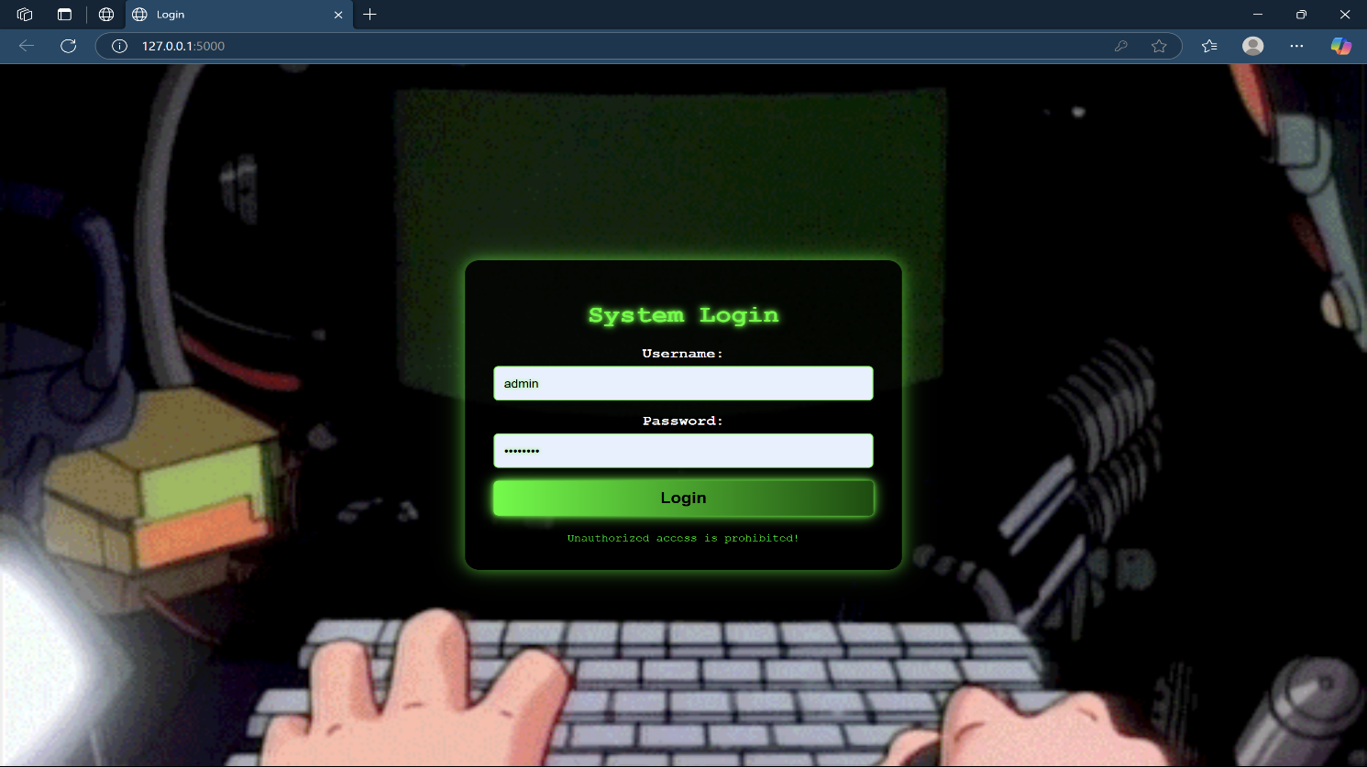
Fig 10.1: Index Page

About Page:

On the About page, you can find a brief description of botnets, including their structure, how they operate, and the cybersecurity threats they pose.

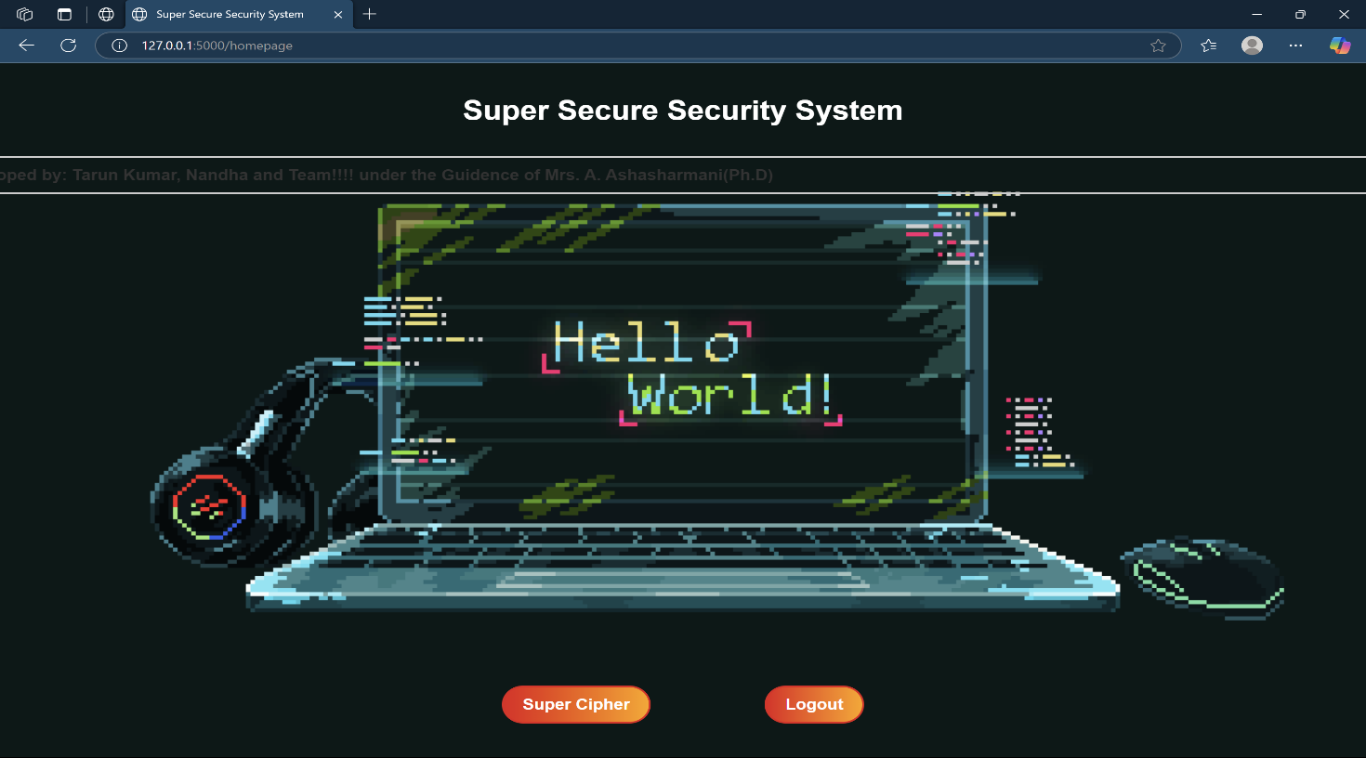
Fig 10.2: About Page

Login Page:

On the login page, users can easily access their accounts by entering their registered credentials.

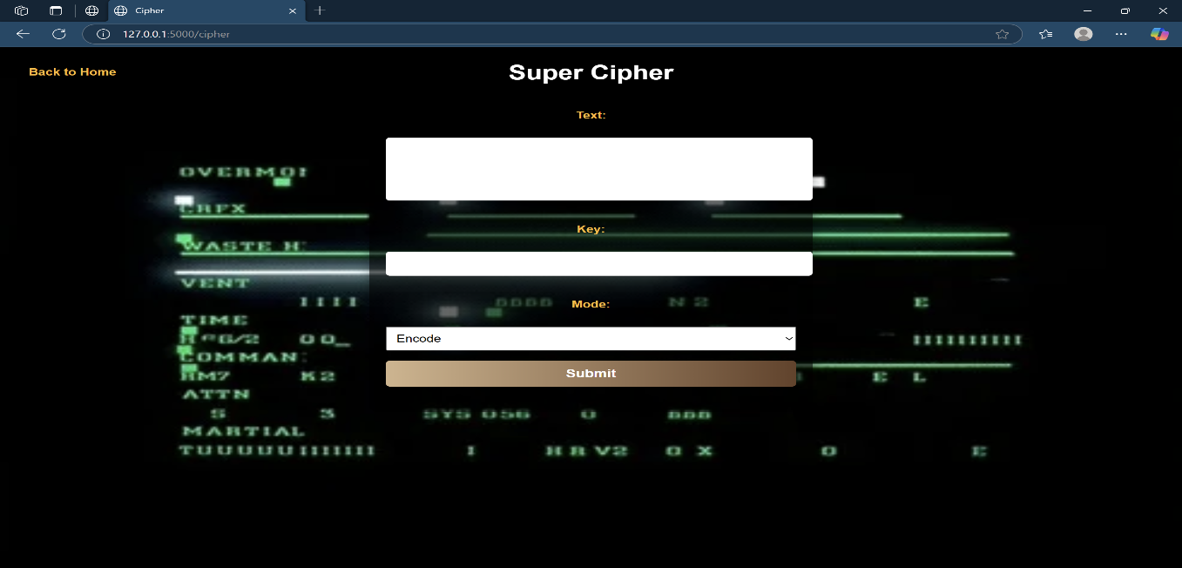

Fig 10.3: Login Page

Register Page:

On this page, users can register by providing their information, which they can then use to log in on the login page.
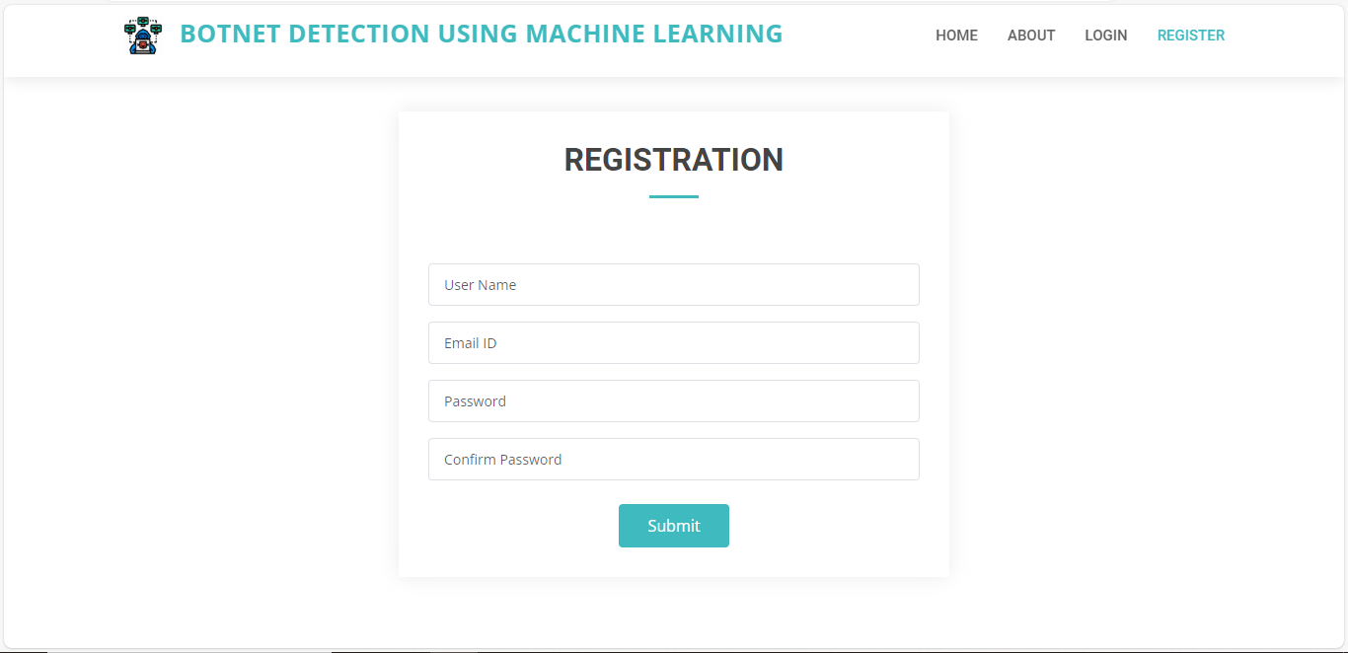
Fig 10.4: Register Page

Home Page:

After logging in, users are directed to the home page, where they can navigate through Performance, Prediction, and Logout options.

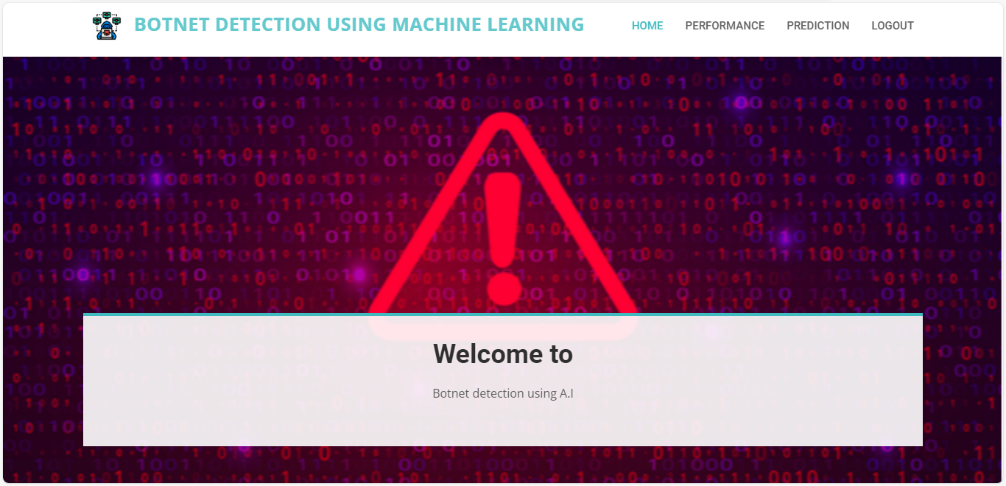
Fig 10.5: Home Page

Performance Page:

On this page, users can view the performance of the algorithms, including key metrics and comparisons.
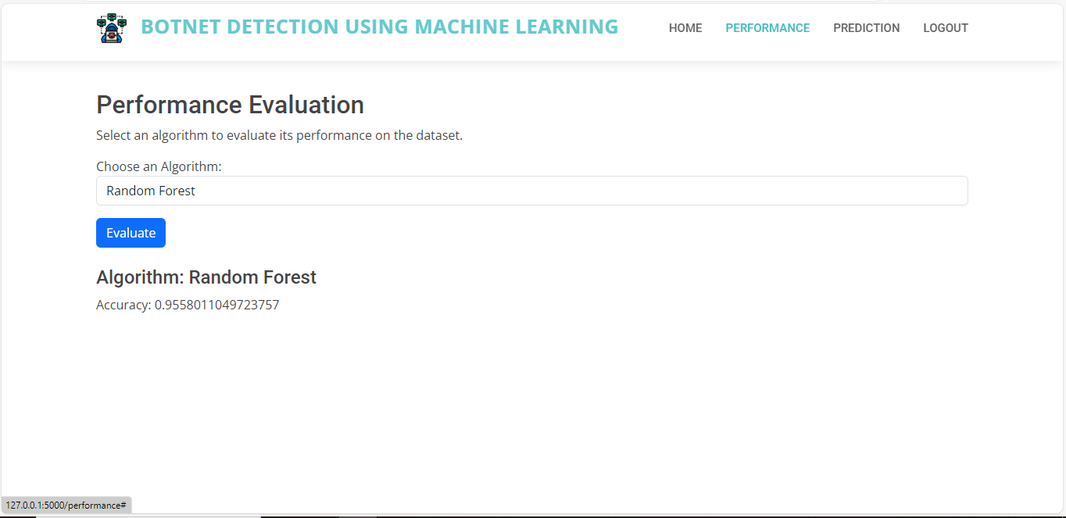
Fig 10.6: Performance Page

Prediction Page:

On this page, users can perform predictions using the available algorithms.
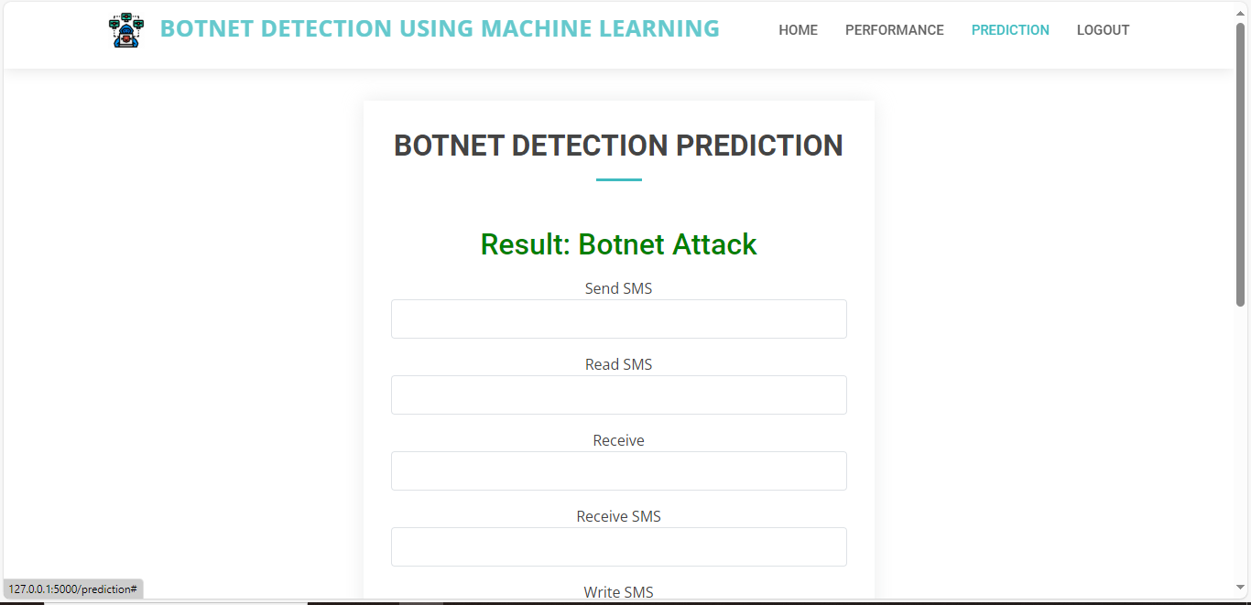
Fig 10.7: Prediction Page

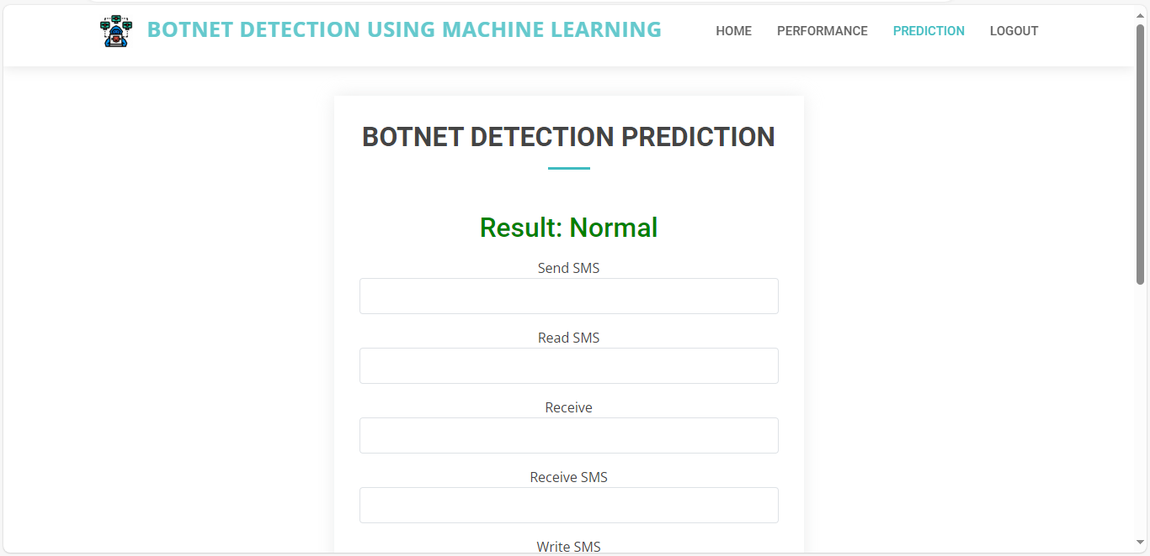
Fig 10.7.1: Prediction Page

CHAPTER 11 CONCLUSION
The project titled SUPER CIPHER CRYPTOGRAPHY SYSTEM BASED ON VIGENERE CIPHER AND POLYBIUS CIPHER has been successfully designed and implemented with the goal of providing a secure and lightweight cryptographic solution. In the current digital landscape, where secure communication and data privacy are of utmost importance, this hybrid cryptosystem offers a practical and efficient method for encrypting sensitive information.
The combination of the Vigenère Cipher and the Polybius Cipher enhances the security of the system by introducing multiple layers of encryption. The Vigenère Cipher, with its polyalphabetic nature, makes frequency analysis attacks difficult, while the Polybius Cipher adds an additional layer of transformation through character mapping. Together, they form a robust encryption mechanism that is both simple and effective.
One of the main advantages of this system is its low computational requirement, making it suitable for devices with limited resources, such as embedded systems, microcontrollers, and IoT devices. Additionally, the implementation includes a clean and interactive user interface, allowing users to perform encryption and decryption operations easily without prior cryptographic knowledge.
Through the process of development, system design, implementation, and testing, the project has met its intended objectives. It provides a clear demonstration of how classical ciphers can be innovatively combined to address modern security concerns in specific scenarios where high-end encryption is not feasible or necessary.
In conclusion, this project not only reinforces the value of foundational cryptographic techniques but also highlights the potential for creative adaptations of classical algorithms in modern contexts. With further development, including integration with advanced security protocols and real-time communication frameworks, this system can evolve into a comprehensive lightweight security solution.

CHAPTER 12 FUTURE ENHANCEMENTS

- Integration with Modern Encryption Standards
Enhance the security level by integrating modern encryption techniques such as AES (Advanced Encryption Standard) or RSA with the existing hybrid model. This would provide layered encryption while maintaining backward compatibility with classical methods.
- Support for Multi-language Encryption
Extend the system to support encryption and decryption of messages in multiple languages, including non-Latin character sets (e.g., Hindi, Chinese, Arabic).
- Cross-Platform Deployment
Develop versions compatible with Android, iOS, and web platforms, allowing wider accessibility and practical deployment.
- QR Code Encryption and Scanning
Implement QR code-based message conversion, allowing encrypted messages to be stored or transmitted as scannable QR codes for physical security and offline sharing.
- Steganography Integration
Introduce the ability to hide encrypted messages within images, audio, or video files to increase data stealth using steganographic techniques.
- Cloud Storage with Encrypted Access
Enable secure cloud storage for encrypted messages, allowing authorized users to access them via secure login and decrypt as needed.
- AI-based Intrusion Detection and Logging
Add machine learning models to monitor encryption system usage and detect anomalies that may suggest potential misuse or attacks.
- User Authentication System
Include a secure user login and access control mechanism to ensure that only authenticated users can encrypt/decrypt messages.
- Real-Time Communication Support
Develop modules for secure real-time communication, enabling instant messaging between users with end-to-end encryption using the hybrid cipher system.

CHAPTER 13 BIBLIOGRAPHY

Books & Academic Papers
- Katz, J., & Lindell, Y. (2014). Introduction to Modern Cryptography (2nd ed.). CRC Press.
  - A strong foundation in classical and modern encryption techniques.
- Stallings, W. (2017). Cryptography and Network Security: Principles and Practice (7th ed.). Pearson.
  - Detailed explanation of the Vigenère cipher and classical encryption schemes.
- Singh, S. (1999). The Code Book: The Science of Secrecy from Ancient Egypt to Quantum Cryptography. Anchor.
  - A historical look at classical ciphers like Polybius and Vigenère.
- Bauer, F. L. (2006). Decrypted Secrets: Methods and Maxims of Cryptology (4th ed.). Springer.
  - Insight into cryptographic methods, including polyalphabetic and substitution ciphers.

Journal & Conference Papers
- Jindal, M., & Jindal, R. (2016). "Enhanced Security Using Modified Vigenère Cipher." International Journal of Computer Applications (IJCA), 141(3), 1-4.
  - Discusses enhancements to the Vigenère cipher which can relate to hybrid systems.

6. Ajibade, O. S., & Jimoh, R. G. (2019). "An Enhanced Polybius Cipher for Data Encryption." Journal of Advances in Mathematics and Computer Science, 32(1), 1-10.
  - Proposes an improved Polybius square with expanded character support.

- Shinde, P., & Gawande, P. (2020). "Combining Classical Encryption Techniques for Data Security." International Research Journal of Engineering and Technology (IRJET), 7(4), 1010–1013.
  - Presents a hybrid approach using multiple classical ciphers.

Web Resources / Tutorials
- Khan Academy. “Vigenère Cipher Explained.”
https://www.khanacademy.org/computing/computer-science/cryptography
  - A beginner-friendly explanation with visual examples.
- Crypto Corner. “Polybius Square Cipher.”
https://www.cryptocorner.org
  - Useful for understanding variations and implementation of the Polybius cipher.
- GeeksforGeeks. “Implementation of Vigenère Cipher in Python/Java.”
https://www.geeksforgeeks.org/vigenere-cipher
  - Step-by-step implementation guides for coding ciphers.

