**HRM-CLIM IT — Project Documentation**

This is a full-featured Human Resource Management (HRM) system built with Angular 19 and Firebase, designed for employees, HR/admin roles and Management roles. It supports attendance tracking, task management, payroll, leave requests, and role-based dashboards with real-time data handling and many more.

**🛠️ Technology Stack**

* **Frontend Framework:** Angular 19
* **Authentication:** Firebase Authentication (Email/Password & Google Sign-In)
* **Backend Services:** Firebase Firestore (NoSQL Database)
* **Hosting:** Firebase Hosting
* **UI Components:** Angular Material
* **State Management:** Angular Services and Reactive Forms
* **Routing & Navigation:** Angular Router with Route Guards
* **Charting Libraries:** Chart.js or NGX-Charts (for visualizations)
* **Styling:** SCSS/CSS
* **Version Control:** Git & GitHub

**Project Tree**

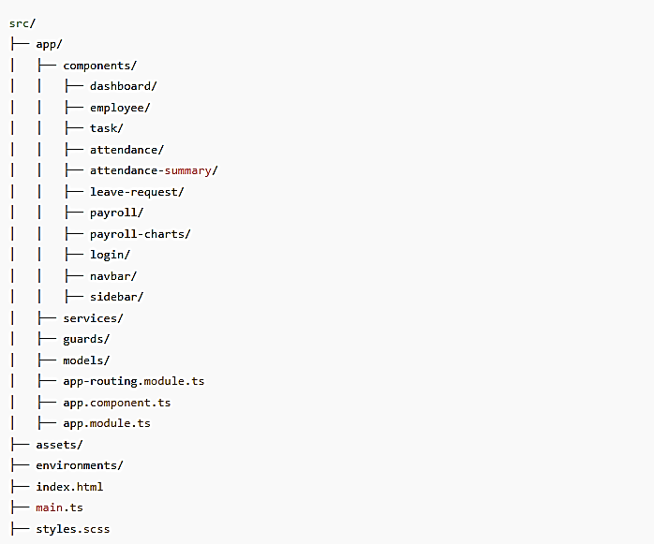

**1. Login Page:**

* **Authentication:**
  + Firebase OAuth with **Email & Password**
  + **Google Login** integration for quick authentication

**2. Employee Features:**

**Dashboard:**

* **Clock In/Out:** Employees can clock in/out for work.
* **Attendance Chart:** View past attendance, total departments.
* **Leave Application:** Employees can apply for leaves.
* **Task Management:** View assigned tasks — new, ongoing, completed.
* **Pay slip Access:** View and download pay slips.
* **Clock-in History:** View past 10 days' clock-in/out times and durations.

**People:**

* **Organization View:** See employees' roles, locations and departments.
* **Department Filter:** Categorized employee cards for easy filtering.

**Who's Away:**

* **Leave Calendar:** See who is on leave.
* **Monthly Holidays:** View holidays for the month
* **Employee Birthdays:** View birthdays of people of that organization for the month

**3. Admin (HR) Features:**

**Dashboard:**

* **Clock In/Out:** Admins can also clock in/out.
* **Attendance Chart:** View department-wise attendance and total hours worked for the day.
* **Leave Application:** Admin can apply leave on behalf of employees.
* **Task Management:** See completed/past tasks, assign new tasks to employees.
* **Employee Status:** View who is present and who is absent.
* **Leave Management:** Admin can approve or decline employee leave applications.
* **Pay slip Access:** Admin can view and download employee pay slips.
* **Clock-in History:** Admin can view their own clock-in/out history for the last 10 days.
* **Generate Reports:** Full employee report generation.

**Application Tracker:**

* **Applicant Status Management:** Track applicants' status (Applied, Interviewed, Offer, Hired).
* **Employee Database:** Add new employees, take all necessary details.
* **Employee Removal:** Ability to remove employees from the database.

**People:**

* **Organization View:** View employees' roles and locations.
* **Department Filter:** Filter employees by department and role.

**Who's Away:**

* **Leave Calendar:** See who is on leave for the day/month.
* **Employee-Specific Holidays:** View employee-specific holidays for any given day or month.

**4. Management Features:**

**Dashboard:**

* **Expense Tracking:** View monthly company expenses.
* **Attendance Summary:** Department-wise attendance for the day.
* **Task Management:** View and create employee tasks.
* **Employee Status:** See who is present/absent.
* **Leave Management:** Accept/Decline leave requests.
* **Pay slip Access:** View and download employee pay slips.
* **Generate Reports:** Full employee report generation.

**Application Tracker:**

* **Track Applicants:** Manage applicant status (Applied, Interviewed, Offered, Hired).
* **Employee Database:** Add new employees, manage their data.
* **Remove Employees:** Remove employees from the system.

**People:**

* **Organization View:** See employees' roles and their locations.
* **Department Filter:** Filter employees by department for easy access.

**Who's Away:**

* **Leave Calendar:** See who is on leave and track holidays.
* **Employee Holidays:** View employee-specific holidays for any month/day.

**GIT WORKFLOW DIAGRAM:**

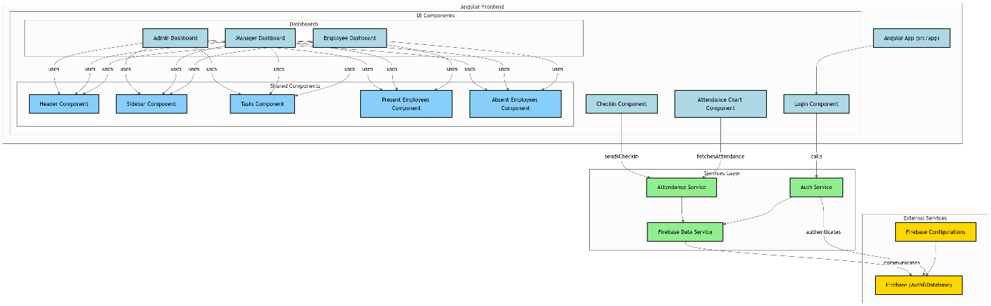

**🔐 Route Guards (Security)**

* **Purpose:**
  + Protect routes based on user roles (Employee, HR, Management).
  + Prevent unauthorized access to sensitive components.
* **Implementation:**
  + Angular's CanActivate interface checks user authentication and role before route activation.