Assignment 1

Screenshots –
- NUnit GUI with unit test cases
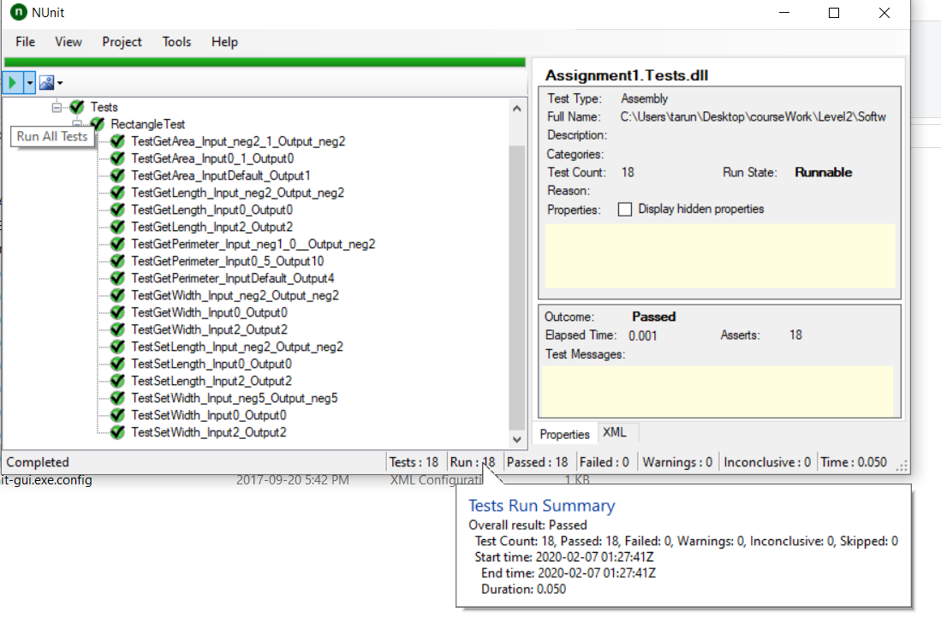
- Git log
