MediScan: Privacy-Preserving AI Deployment Platform
Final Project Report

1. Problem Statement & Objective
Deploying Artificial Intelligence models on sensitive clinical data presents massive privacy and security risks. Standard cloud-based inference architectures require raw patient data to be transmitted over the internet, potentially violating HIPAA guidelines and exposing Personally Identifiable Information (PII) to interception.
The objective of MediScan is to solve this by creating a highly secure, privacy-preserving AI inference platform. The platform guarantees that raw medical data is never stored, never transmitted to external APIs, and is strictly handled using role-based access controls and cryptographic hashing.

2. AI Architecture & Medical Logic
To prevent the misuse of real medical records, the platform was trained on a mathematically generated synthetic dataset of 5,000 profiles. The underlying logic uses strict clinical thresholds (e.g., Blood Pressure > 140, Glucose > 125) and advanced compounding synergy rules (e.g., Smoking + Age > 50).
The core AI Engine utilizes a Logistic Regression model anchored to these clinical thresholds. This ensures the model outputs beautifully smooth, scientifically grounded probability curves (0-100%) rather than chaotic binary jumps, allowing for accurate categorization into Low, Medium, High, and Critical risk tiers.

3. The Privacy-Preserving Pipeline
The core innovation of the platform is its strict data handling pipeline:
- Local Execution: The Logistic Regression model runs entirely locally. It does not require an internet connection or external API.
- PII Masking: Any identifiable user metadata is masked (e.g., J*** D***).
- Cryptographic Hashing: Raw medical metrics entered into the form are never stored in the database. Instead, they are combined and passed through a SHA-256 hashing algorithm.
- Immutable Audit Logging: The database logs only the cryptographic hash, the exact timestamp, the execution latency, and the final score. 1 Million records consume less than 150MB of storage.

4. User Interface & Access Control
The platform features a modern, responsive Glassmorphism UI built with Tailwind CSS. It dynamically changes colors, gradients, and health recommendations based on the probabilistic score.
Access is strictly governed by Django decorators (@approved_required). New users cannot execute inferences until an Administrator explicitly reviews and approves their account.

5. System Interface (Screenshots)
Sign-In & Authentication Barrier:
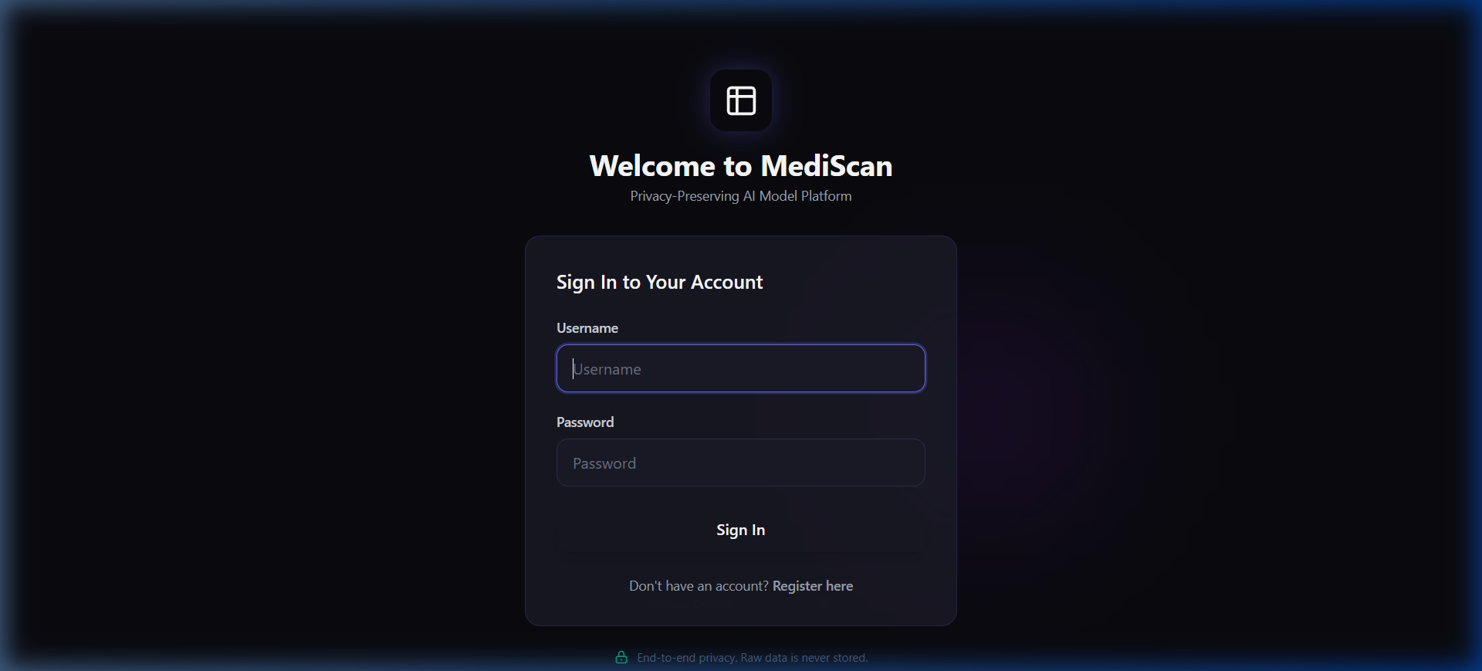

Dynamic Risk Banner & AI Factor Extraction:
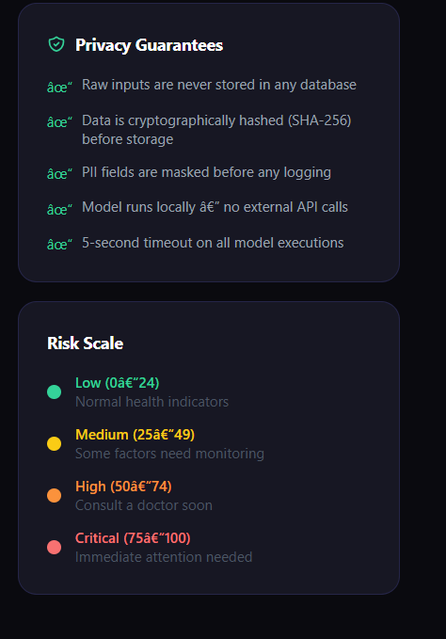
[ PLACEHOLDER: Insert Screenshot of the Immutable Audit Log Here ]

