Jira Automation - Visual Steps
Generated: 2025-11-10 03:35:23
Document: documents\Assignment-11 Monday.docx

1. Login to Jira
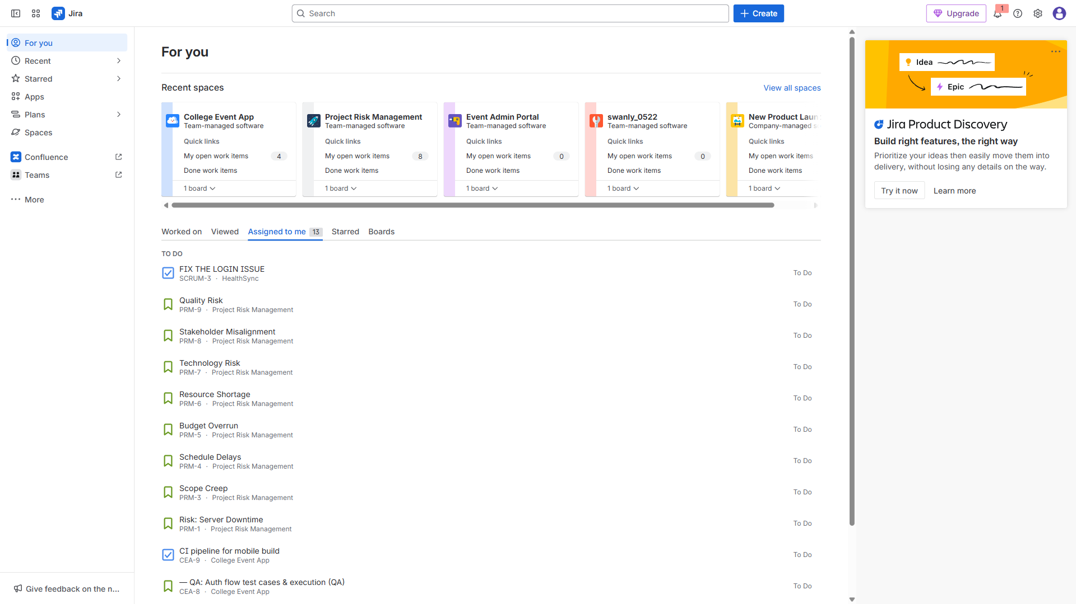

3.1. Epic: College Event App (Student-facing)
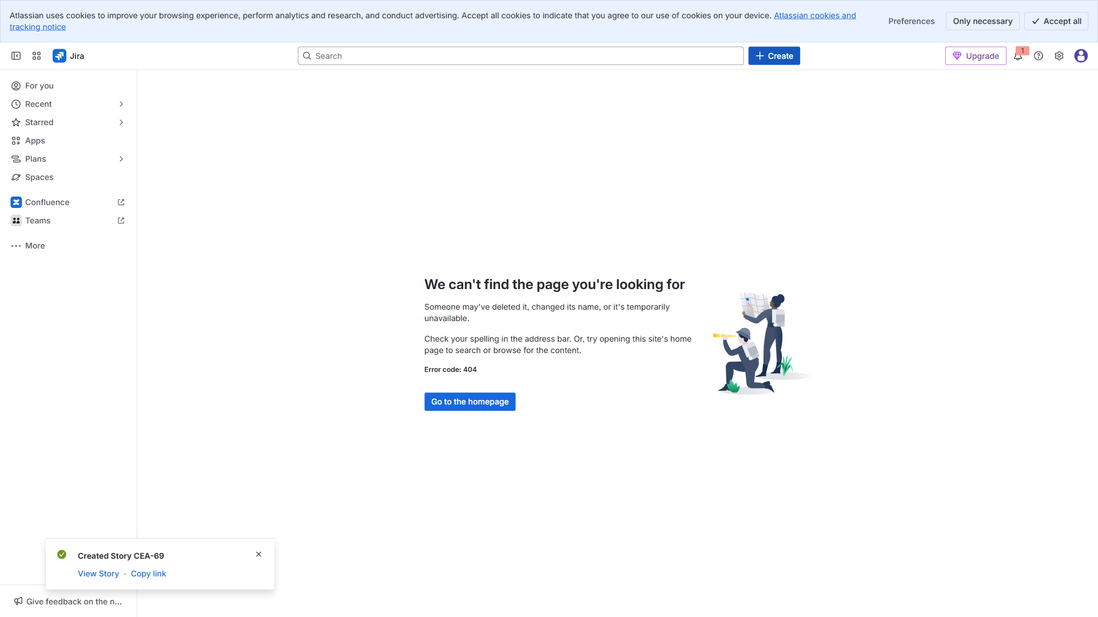

3.2. Epic: Student Registration & Login
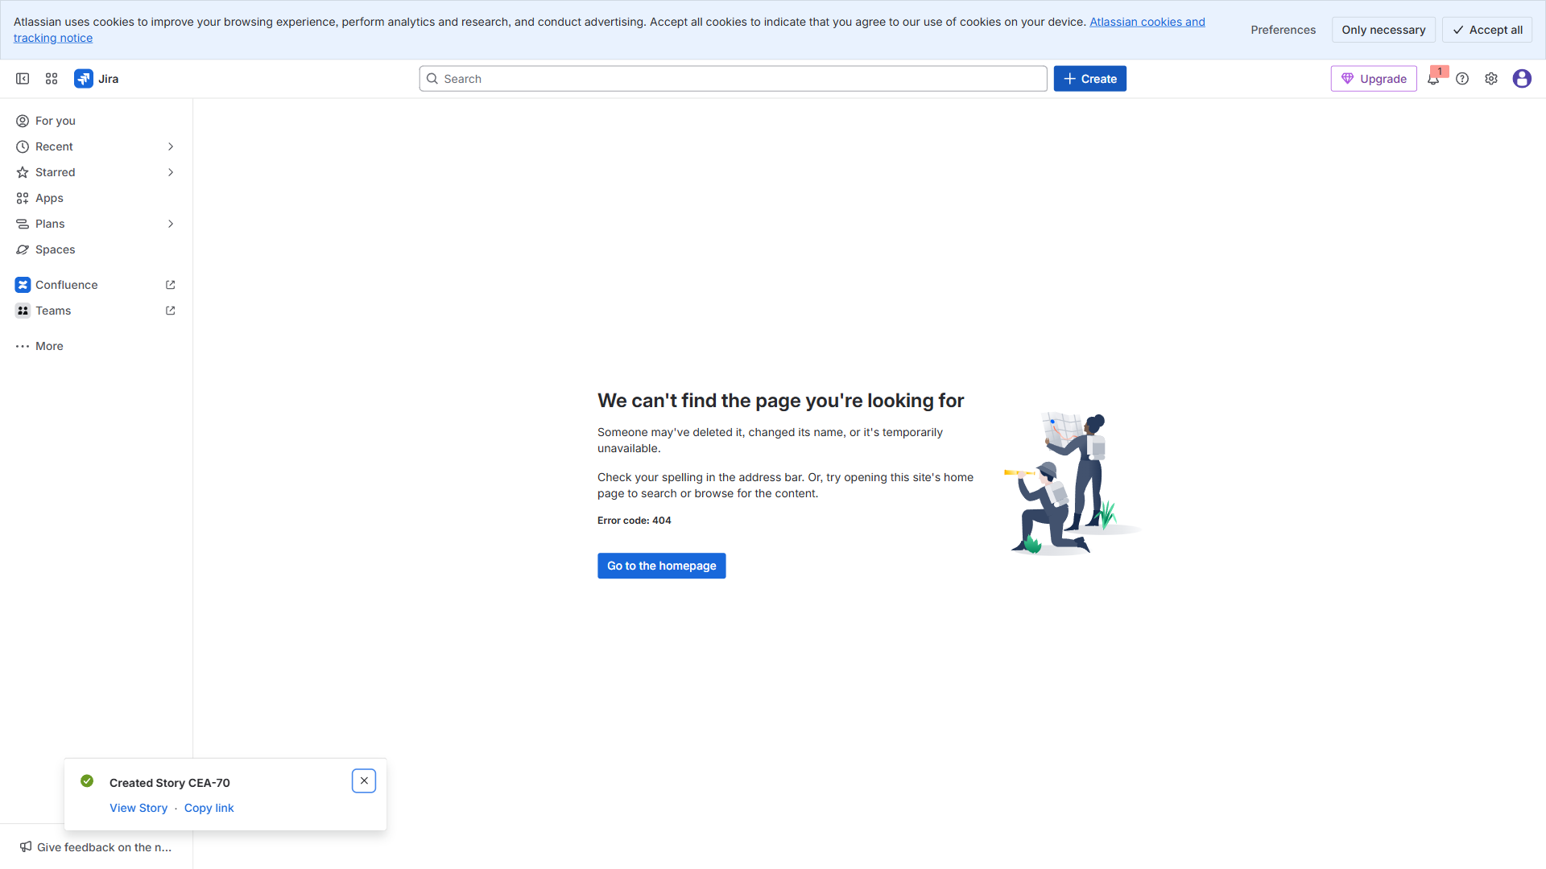

3.3. Epic: Event Discovery & Booking
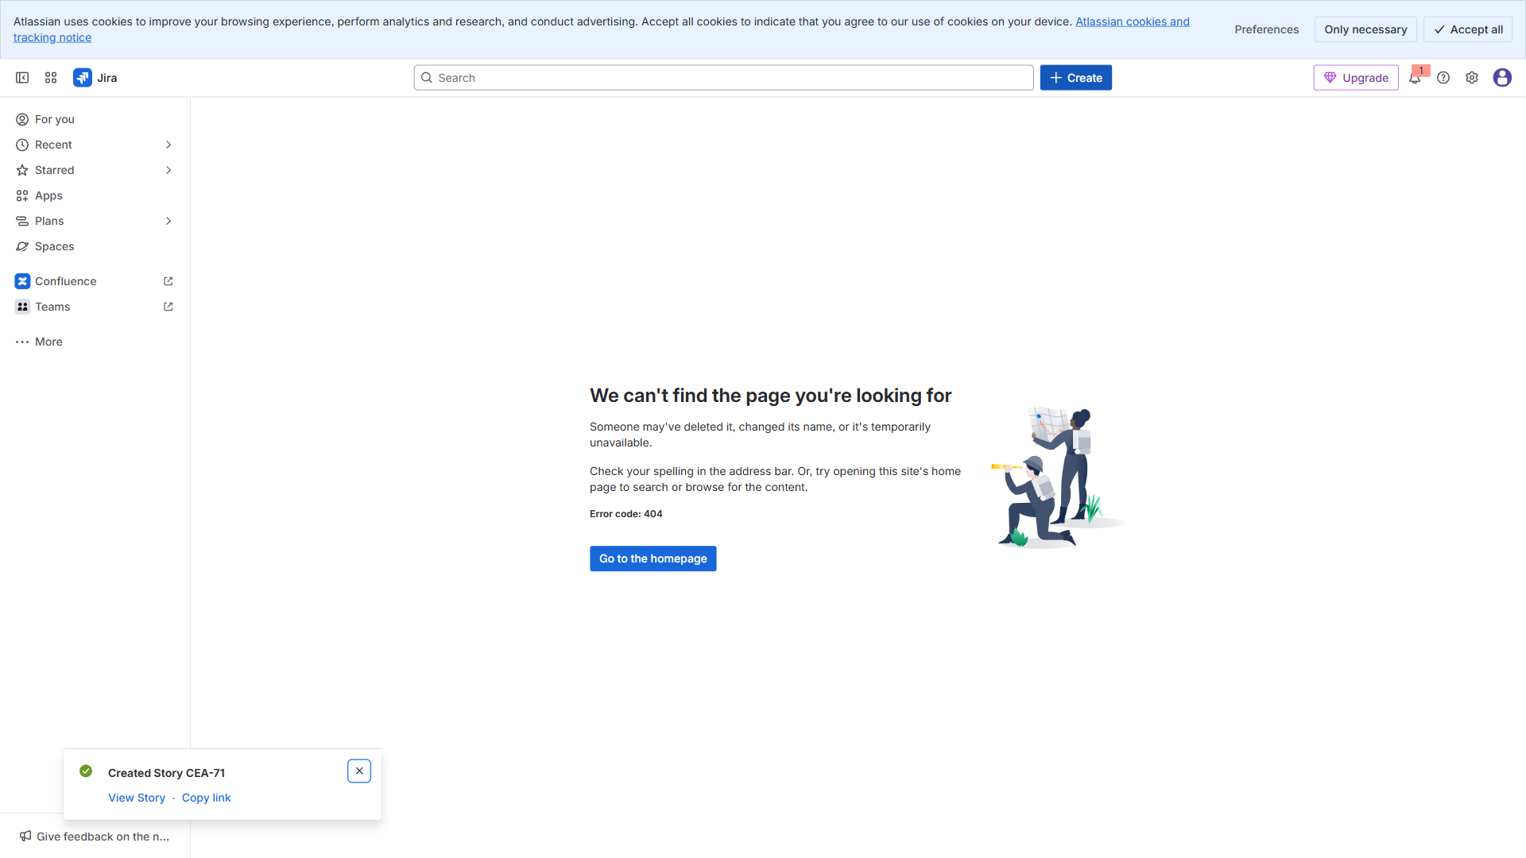

3.4. Epic: Admin Approvals & Scheduling
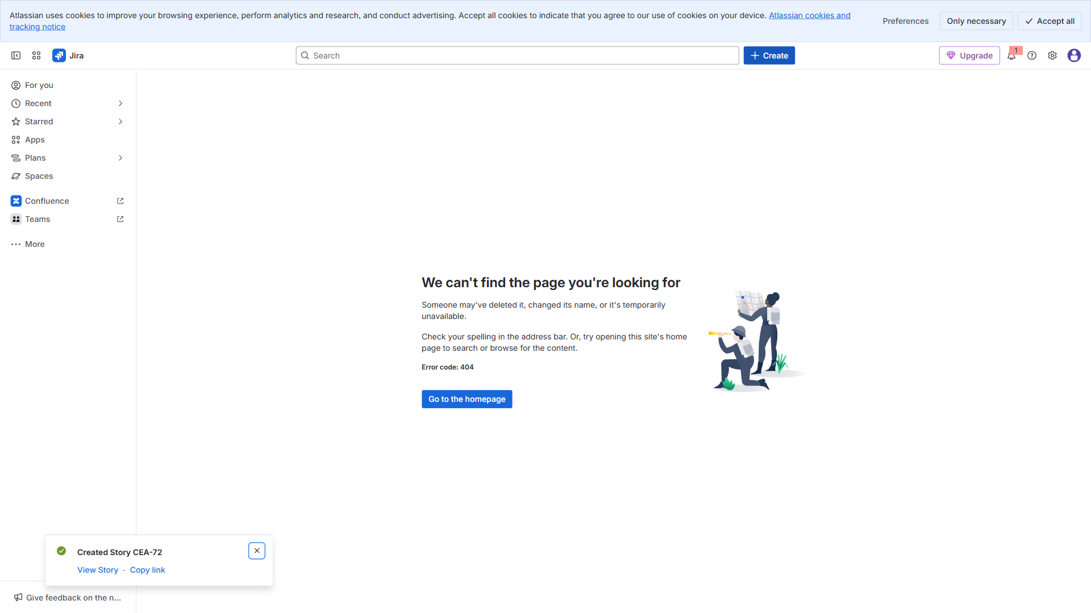

3.5. Epic: Results & Notifications
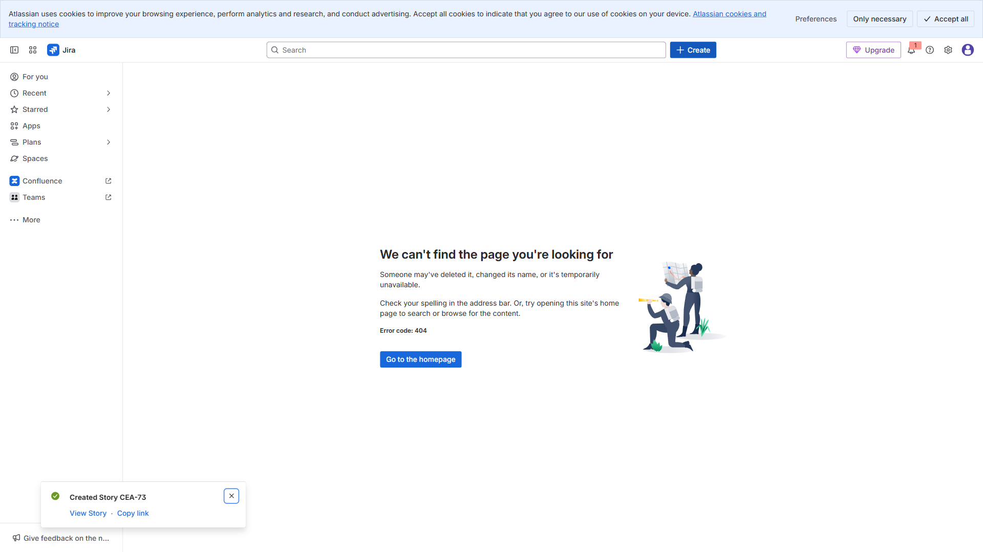

4.1. Story: Design login & signup screens (UX)
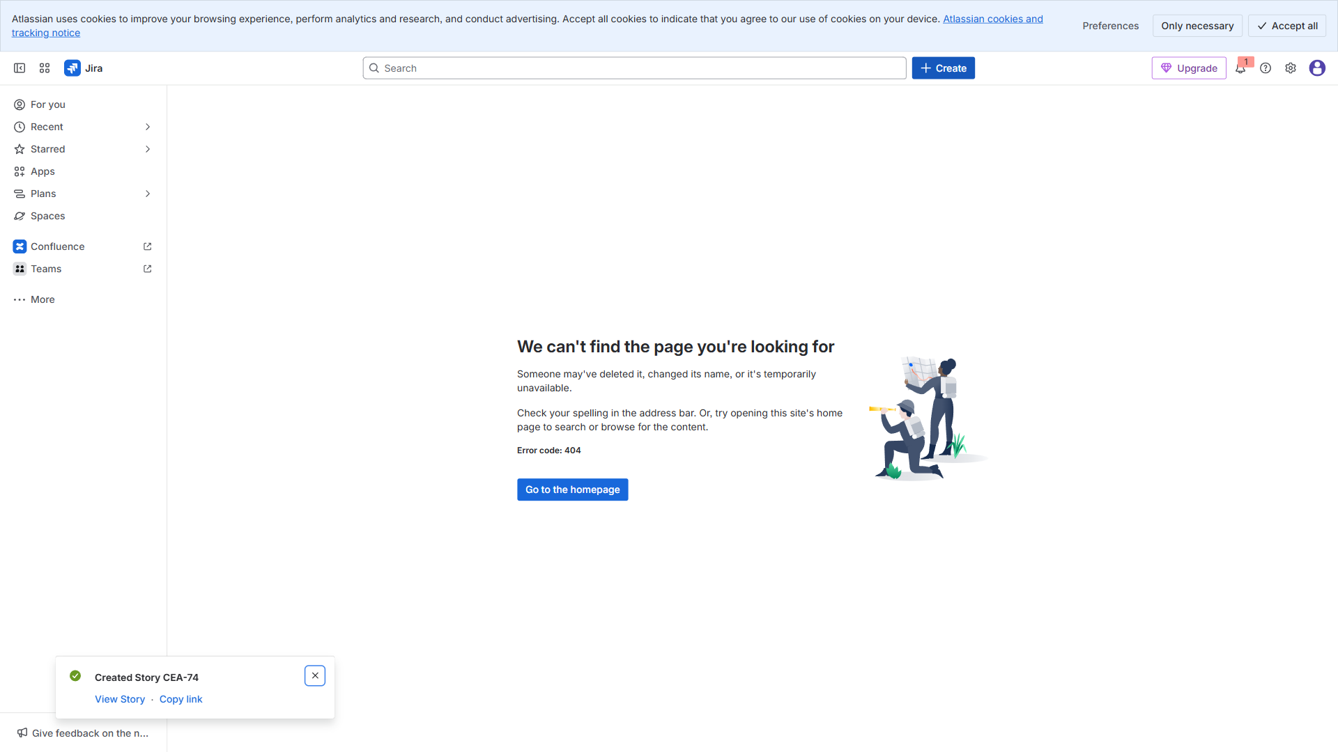

4.2. Story: Implement auth API integration (DEV)
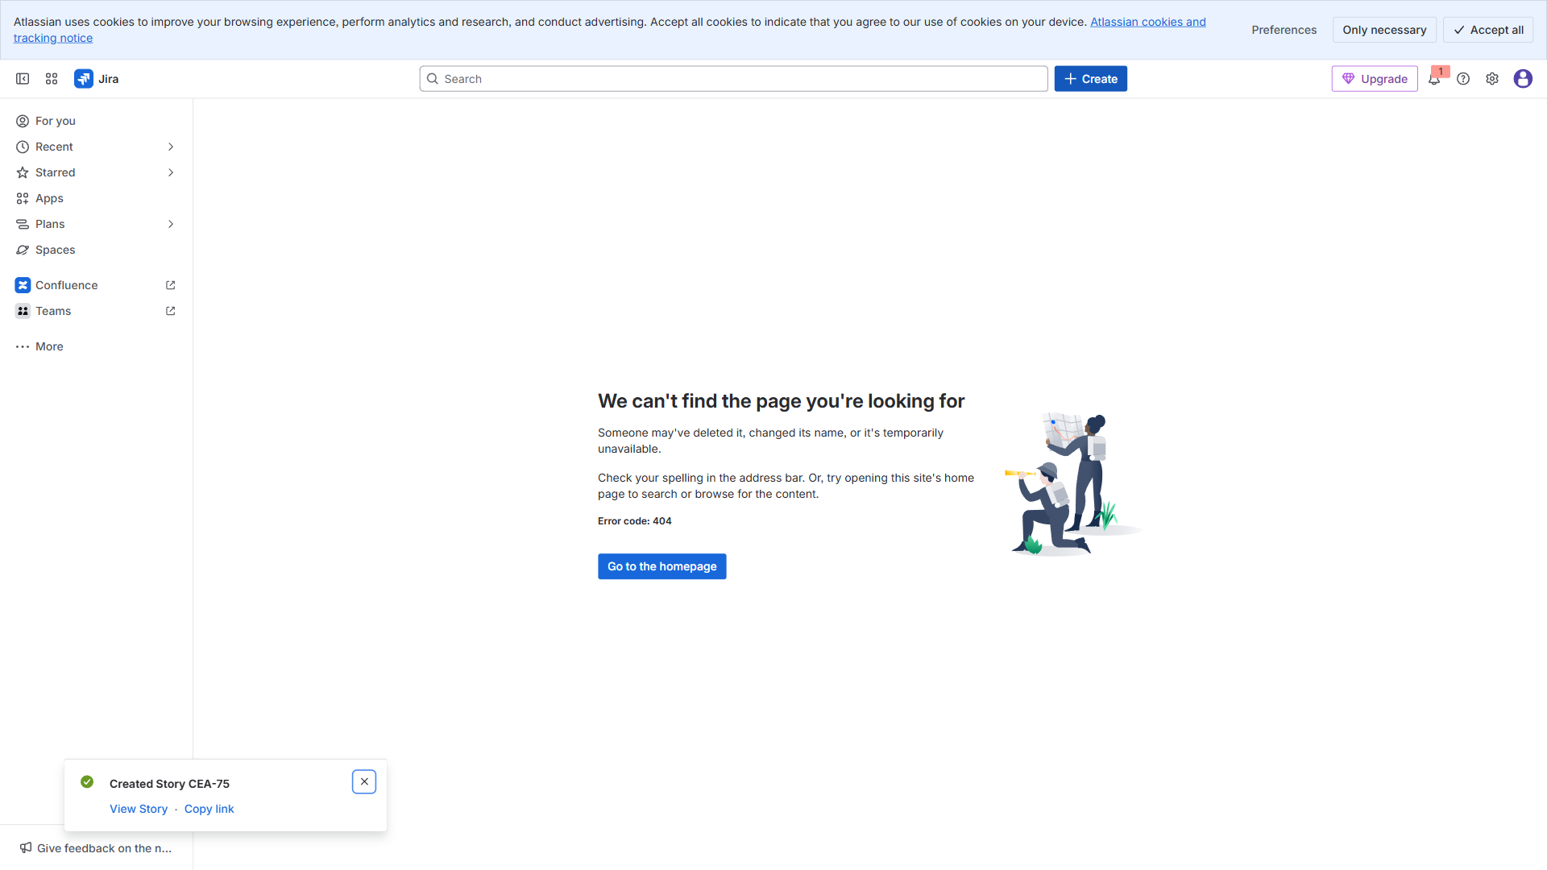

4.3. Story: QA: Auth flow test cases & execution (QA)
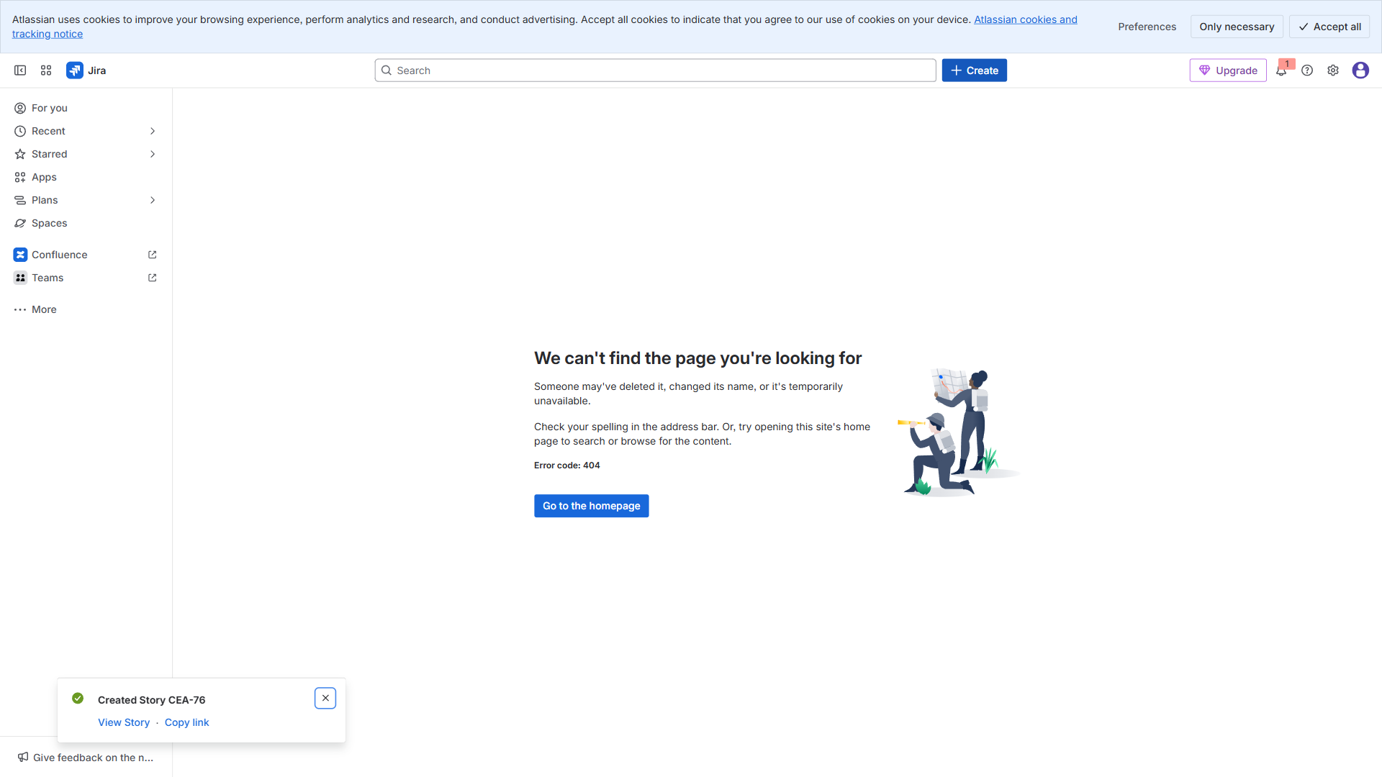

4.4. Story: CI pipeline for mobile build (DEVOPS)
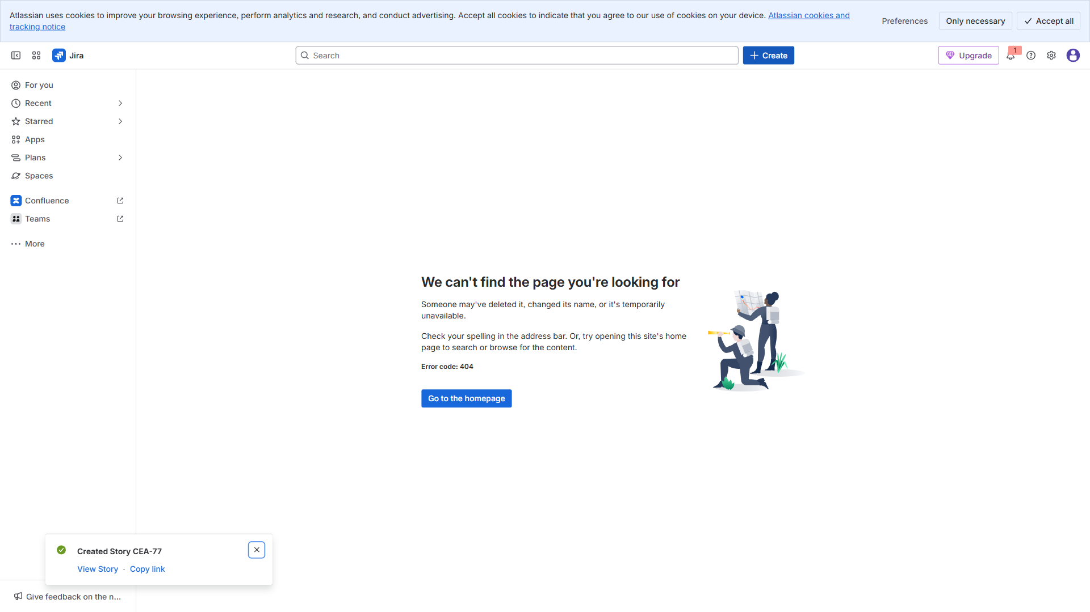

4.5. Story: Browse events UI (UX) — 25 Nov → 27 Nov —
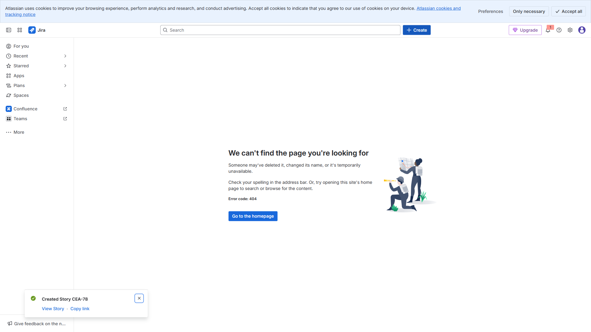

4.6. Story: List events API + pagination (DEV) — 28 Nov → 04 D
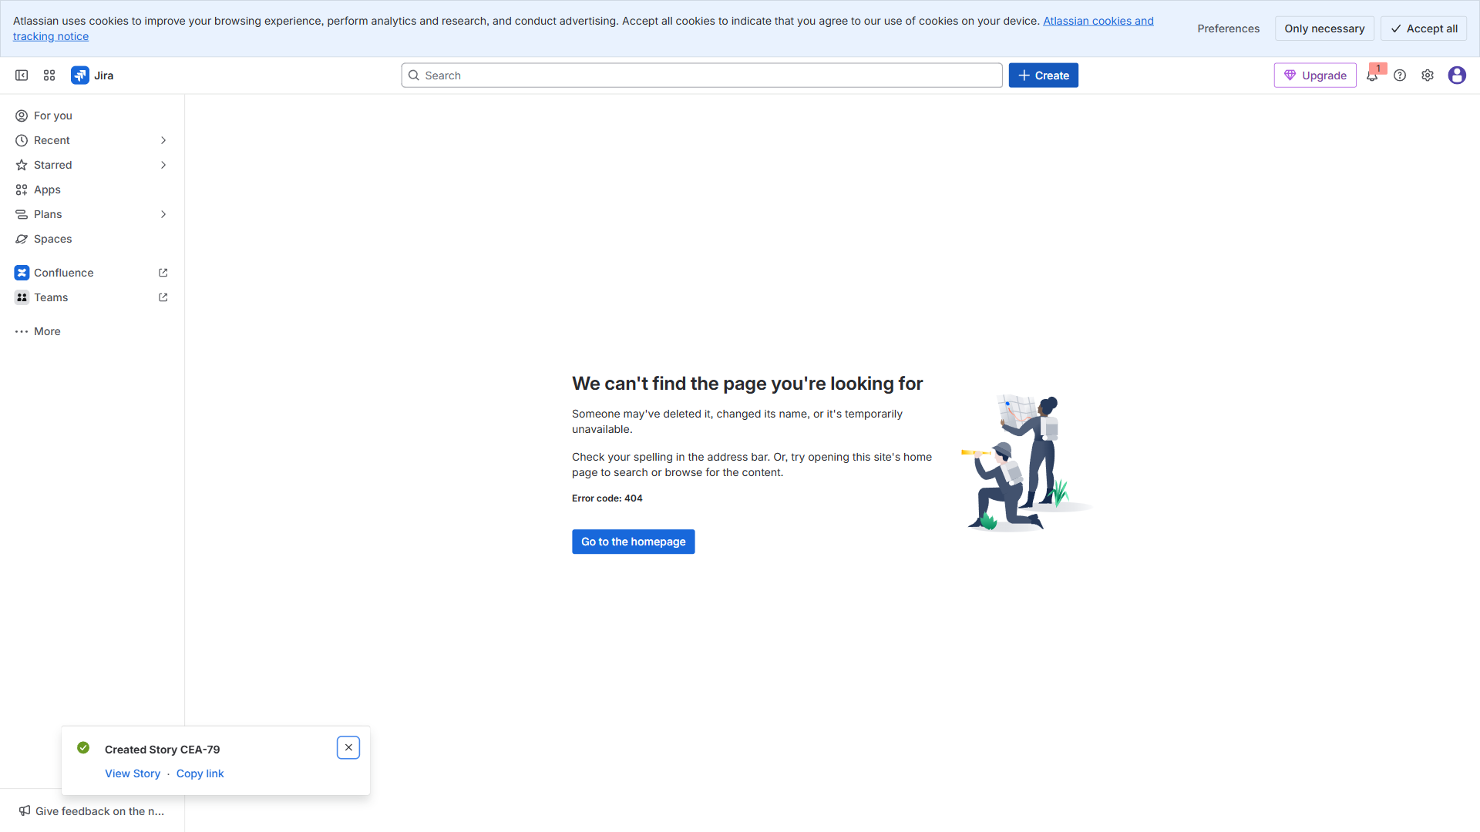

4.7. Story: Register for event + confirmation (DEV) — 05 Dec →
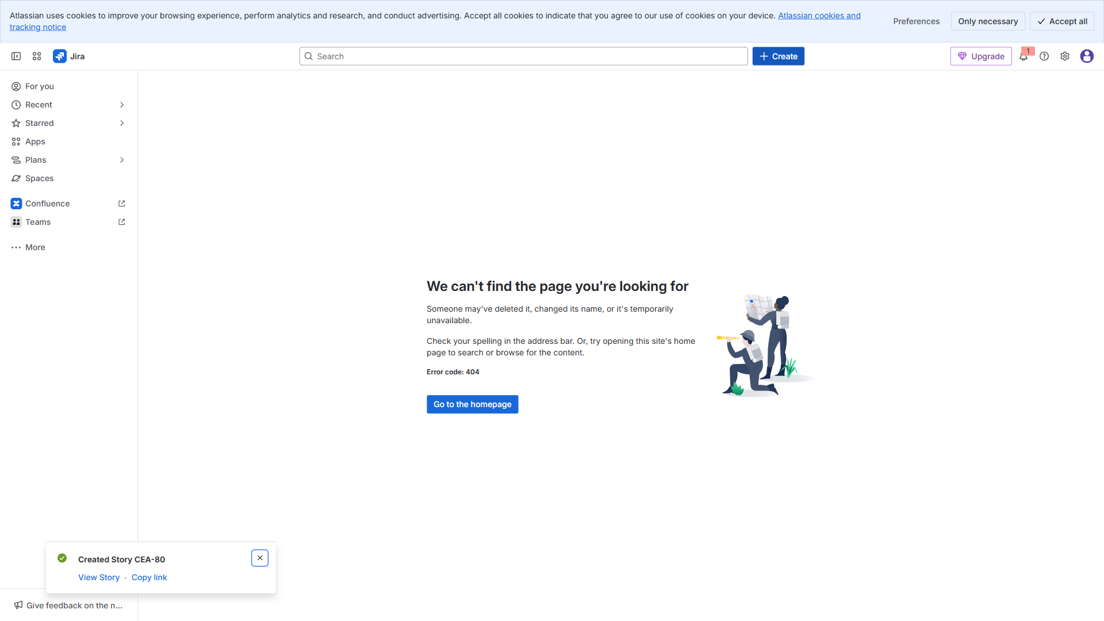

4.8. Story: QA booking flow (QA) — 11 Dec → 13 Dec —
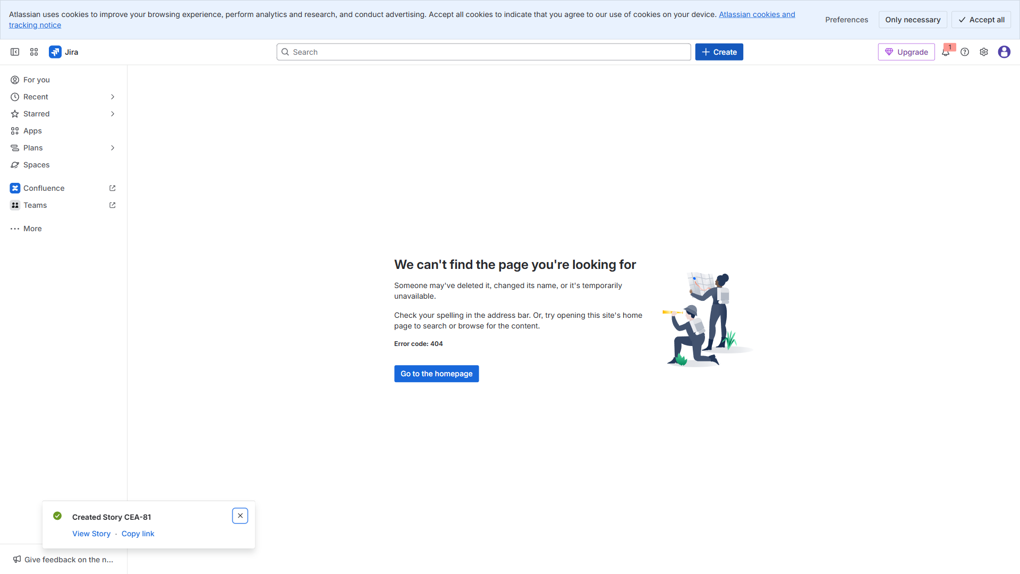

4.9. Story: Admin dashboard skeleton (DEV) — 04 Nov → 08 Nov —
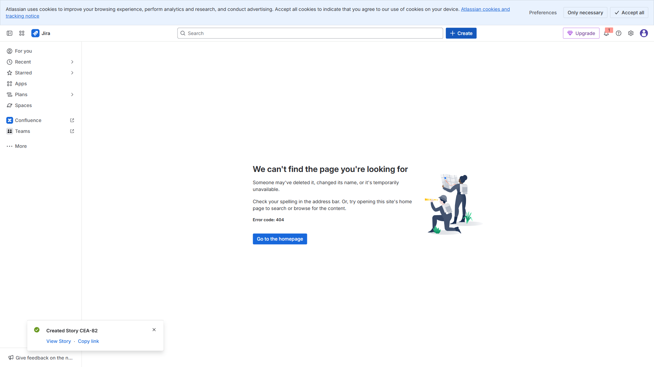

4.10. Story: Approve/reject registrations (DEV) — 10 Nov → 17 N
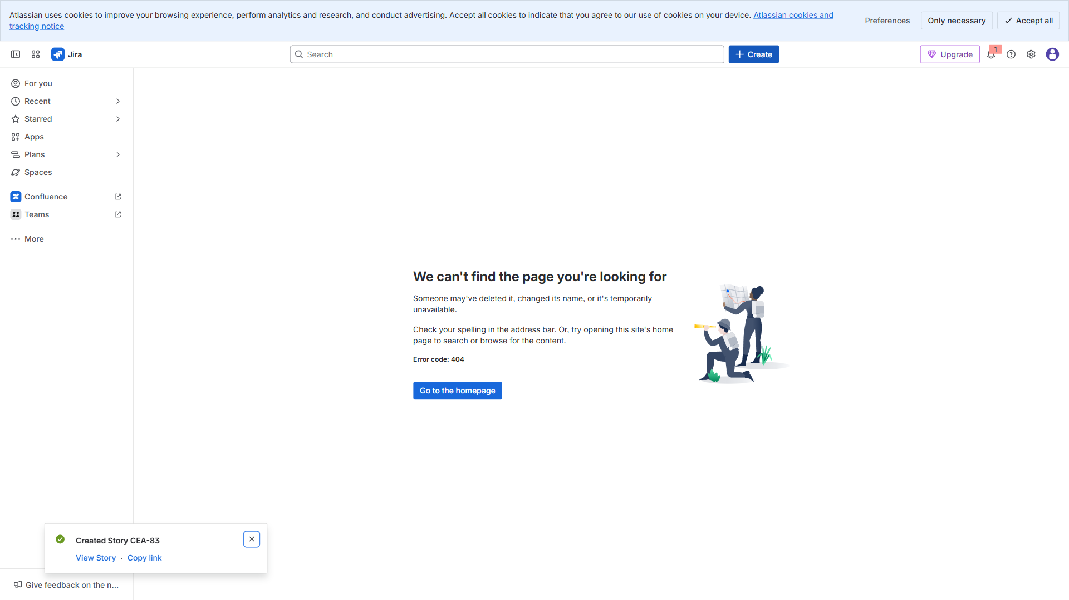

4.11. Story: Schedule management UI (UX) — 11 Nov → 14 Nov —
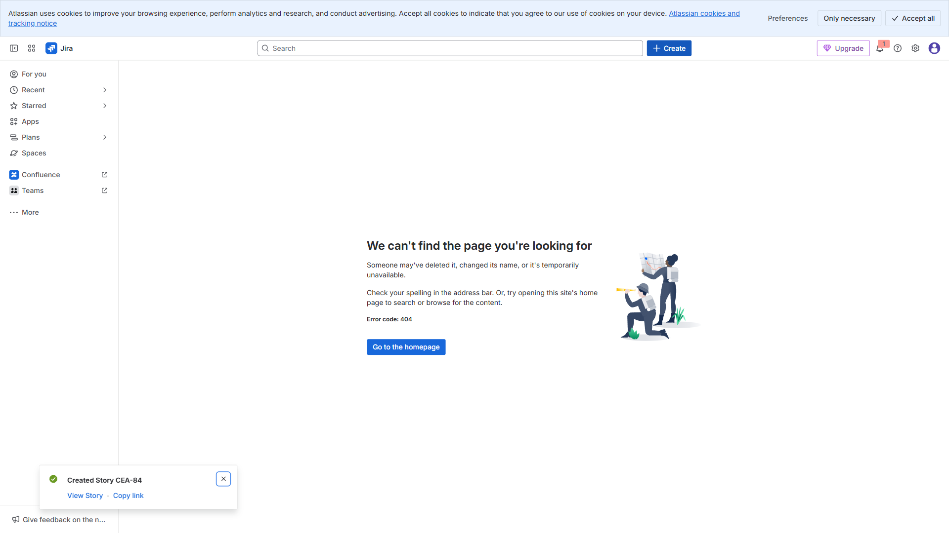

4.12. Story: QA regression pass (QA) — 03 Dec → 06 Dec —
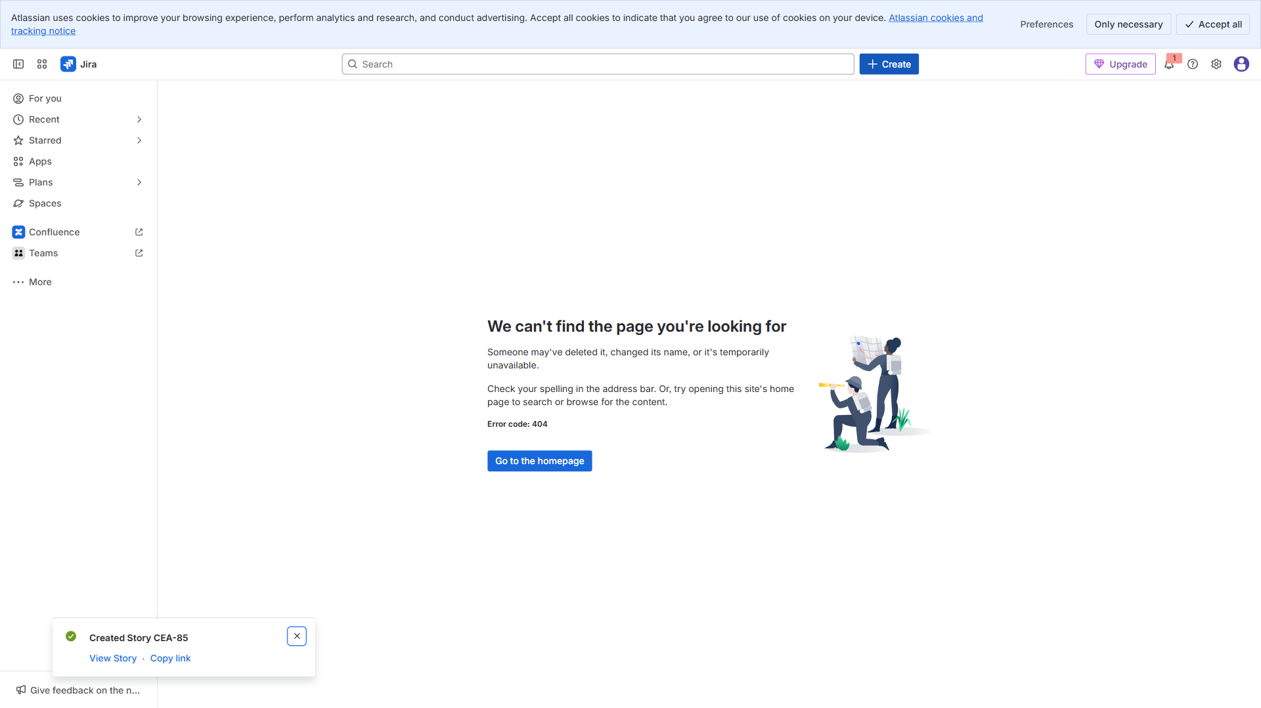

4.13. Story: Results publishing service (DEV) — 25 Nov → 02 Dec
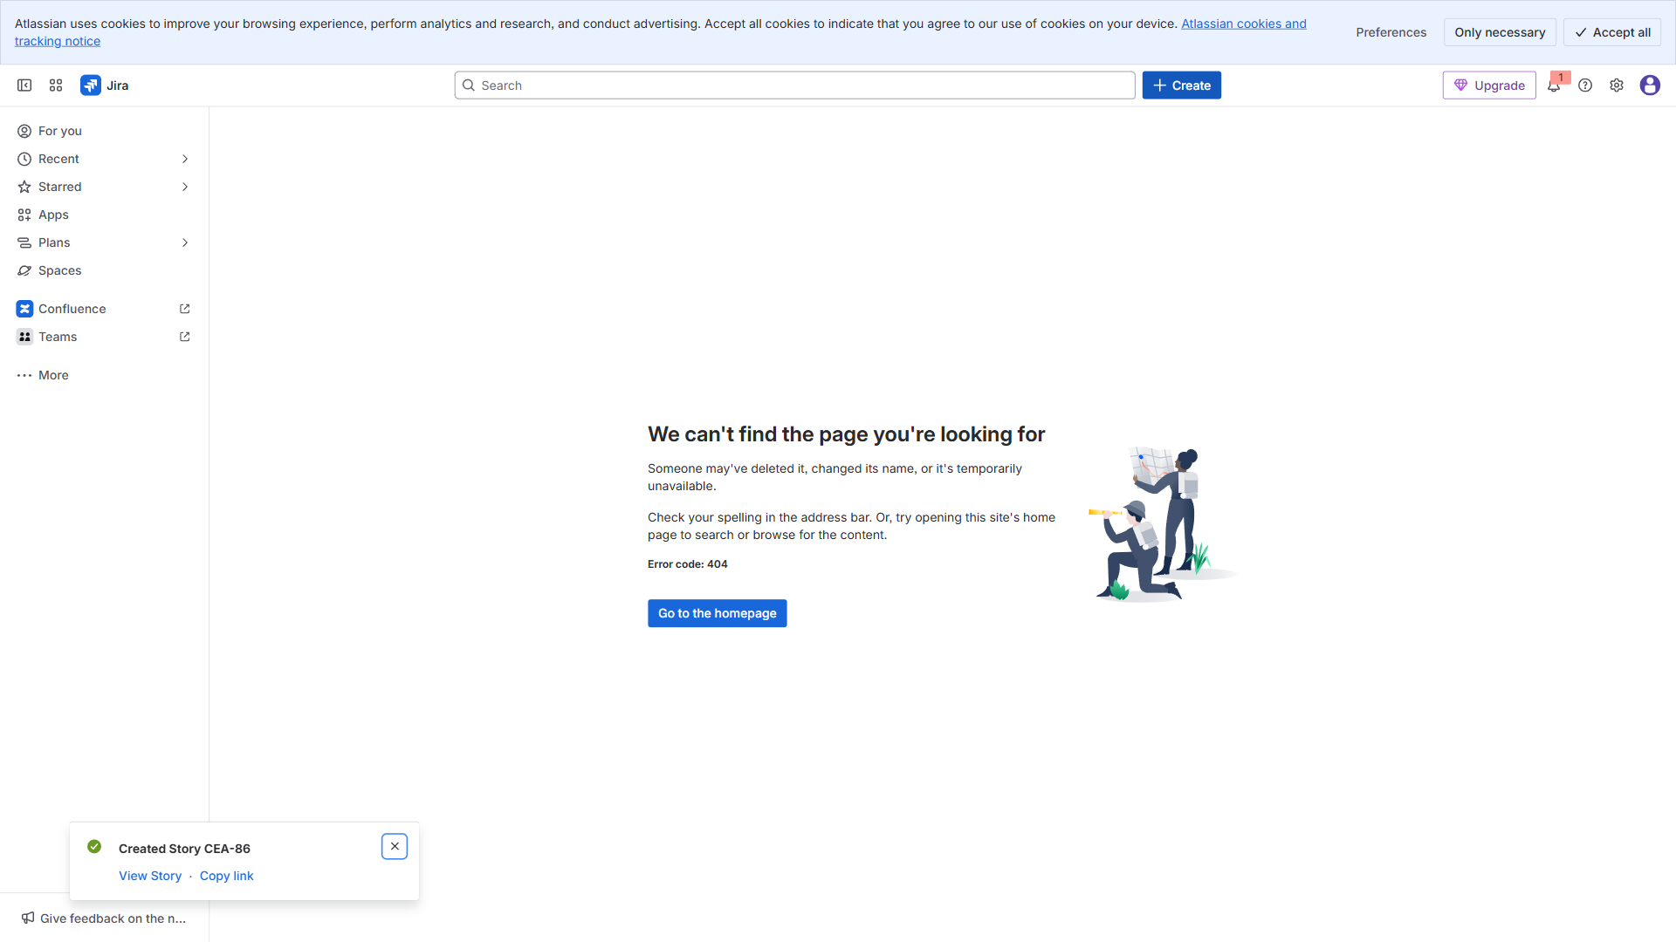

4.14. Story: Push/email notifications (DEVOPS) — 03 Dec → 09 De
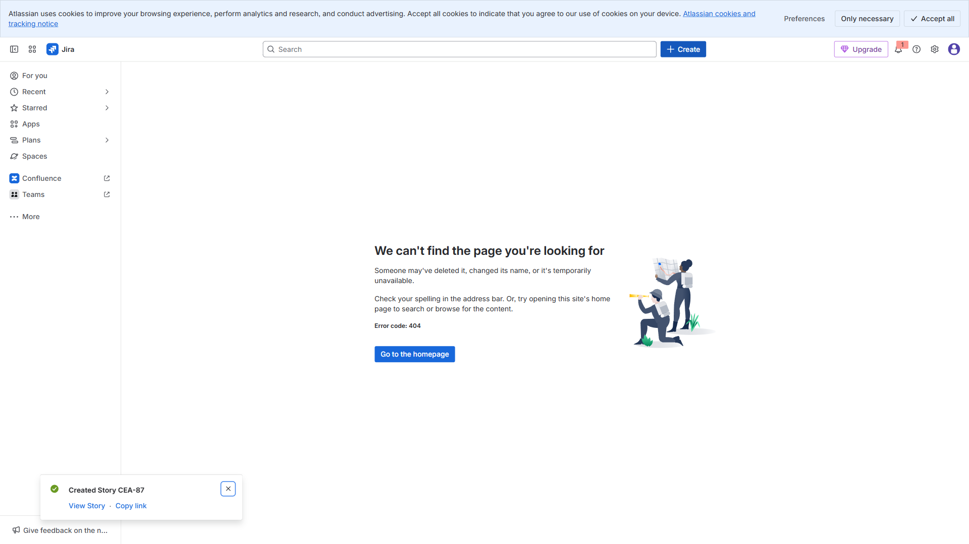

4.15. Story: QA: Notifications & results (QA) — 16 Dec → 18 Dec
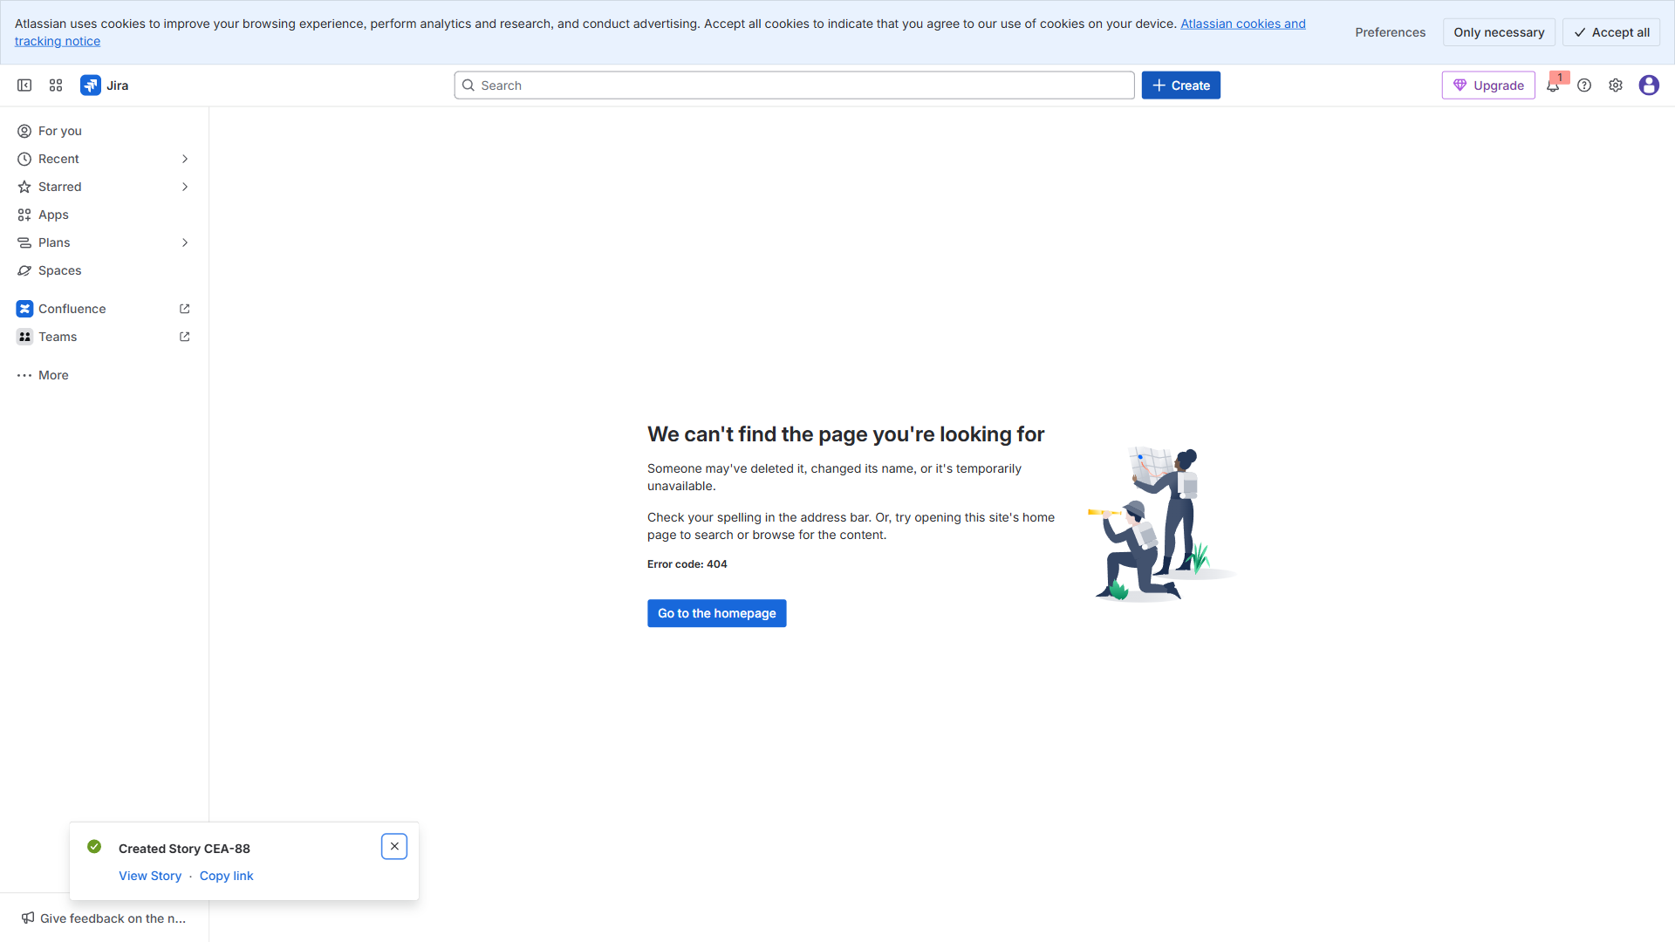

4.16. Story: 5: Build the portfolio roadmap in Swanly (step-by-
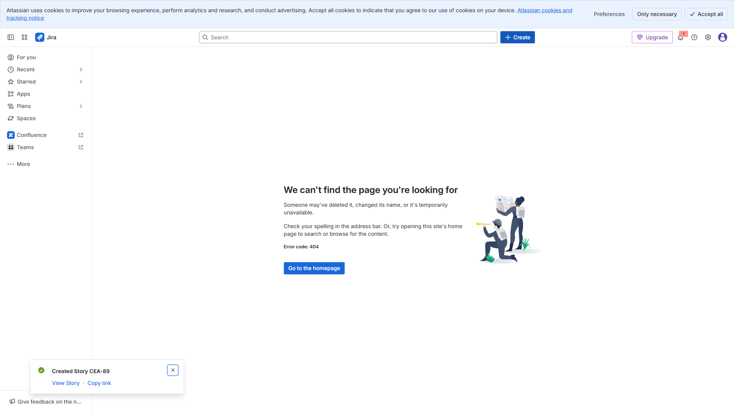

5. Final View


