Automation Screenshots
Generated: 2025-11-09 04:32:39

1. Login to Jira
Time: 04:33:00
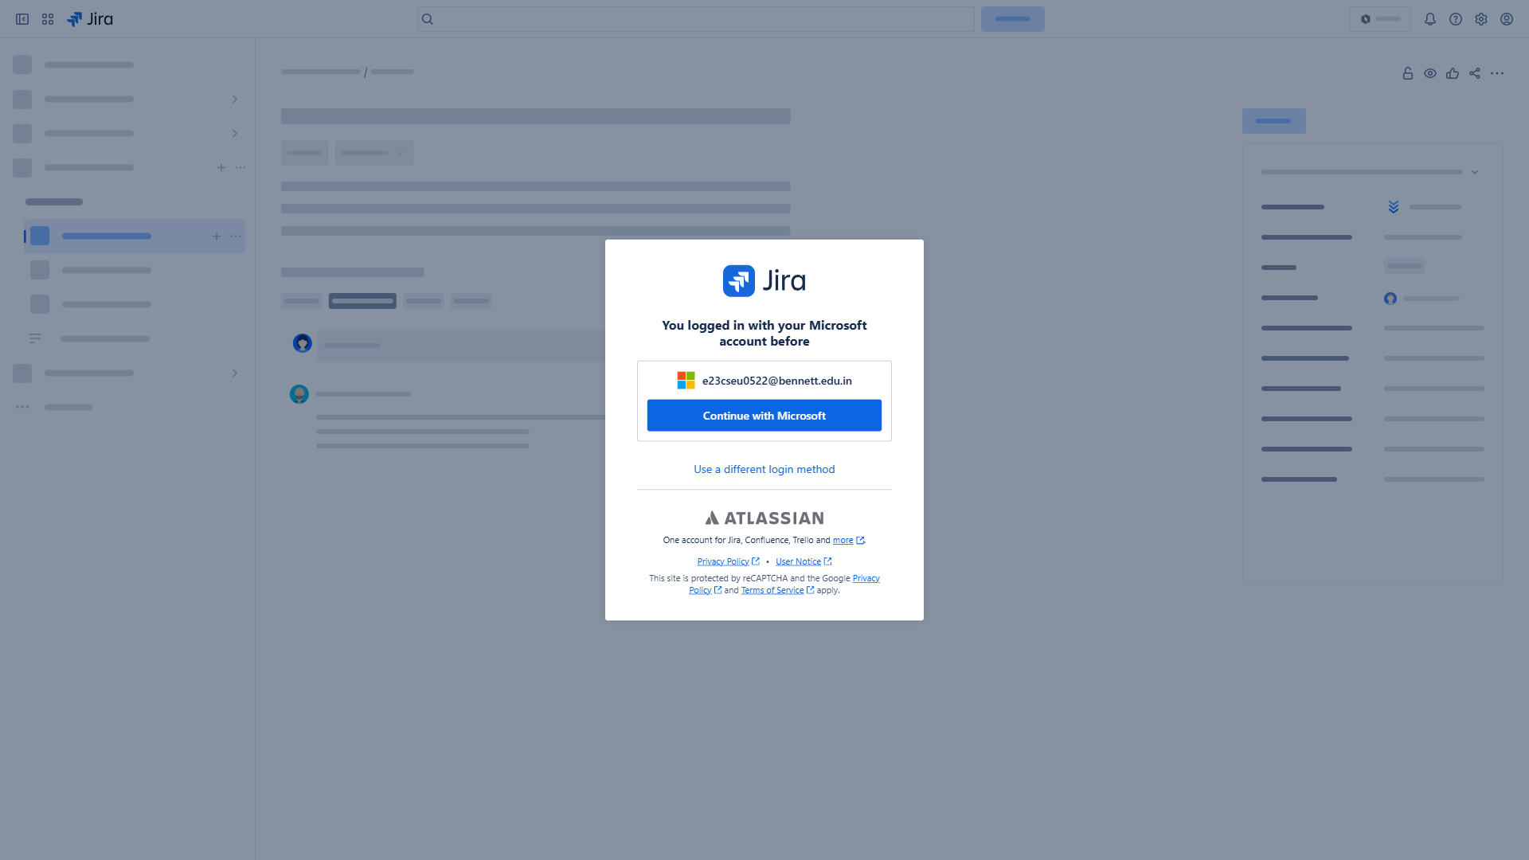

3.1. Epic: College Event App (Student-facing)
Time: 04:33:13
