Automation Screenshots
Generated: 2025-11-09 04:39:17

1. Login to Jira
Time: 04:40:39
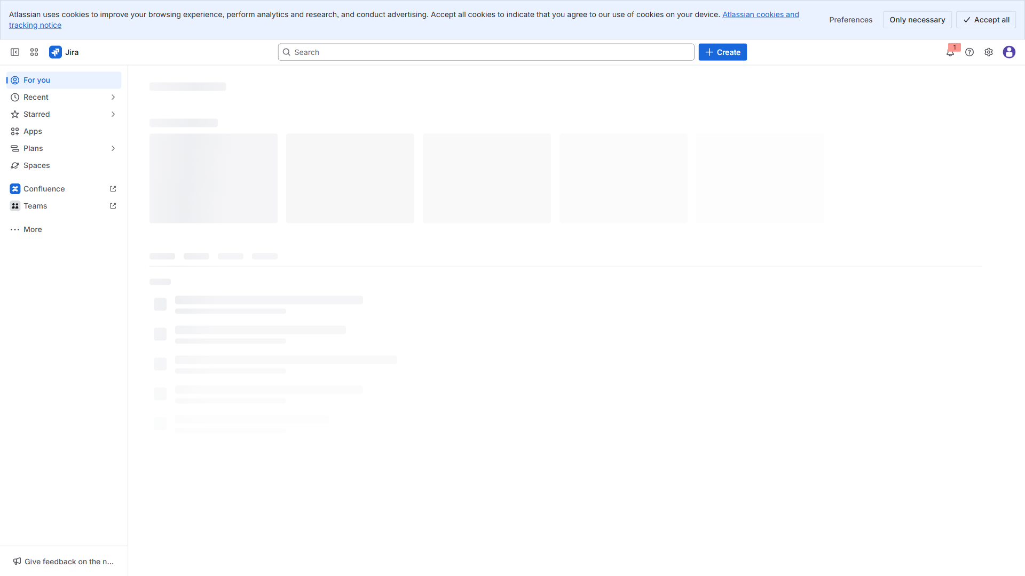

3.1. Epic: College Event App (Student-facing)
Time: 04:40:50
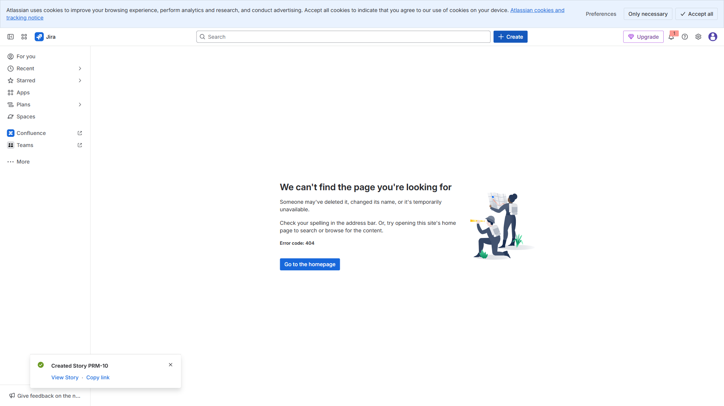

3.2. Epic: Student Registration & Login
Time: 04:41:00
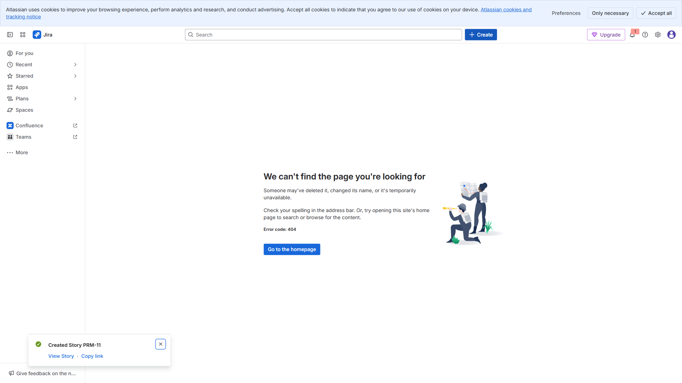

3.3. Epic: Event Discovery & Booking
Time: 04:41:10
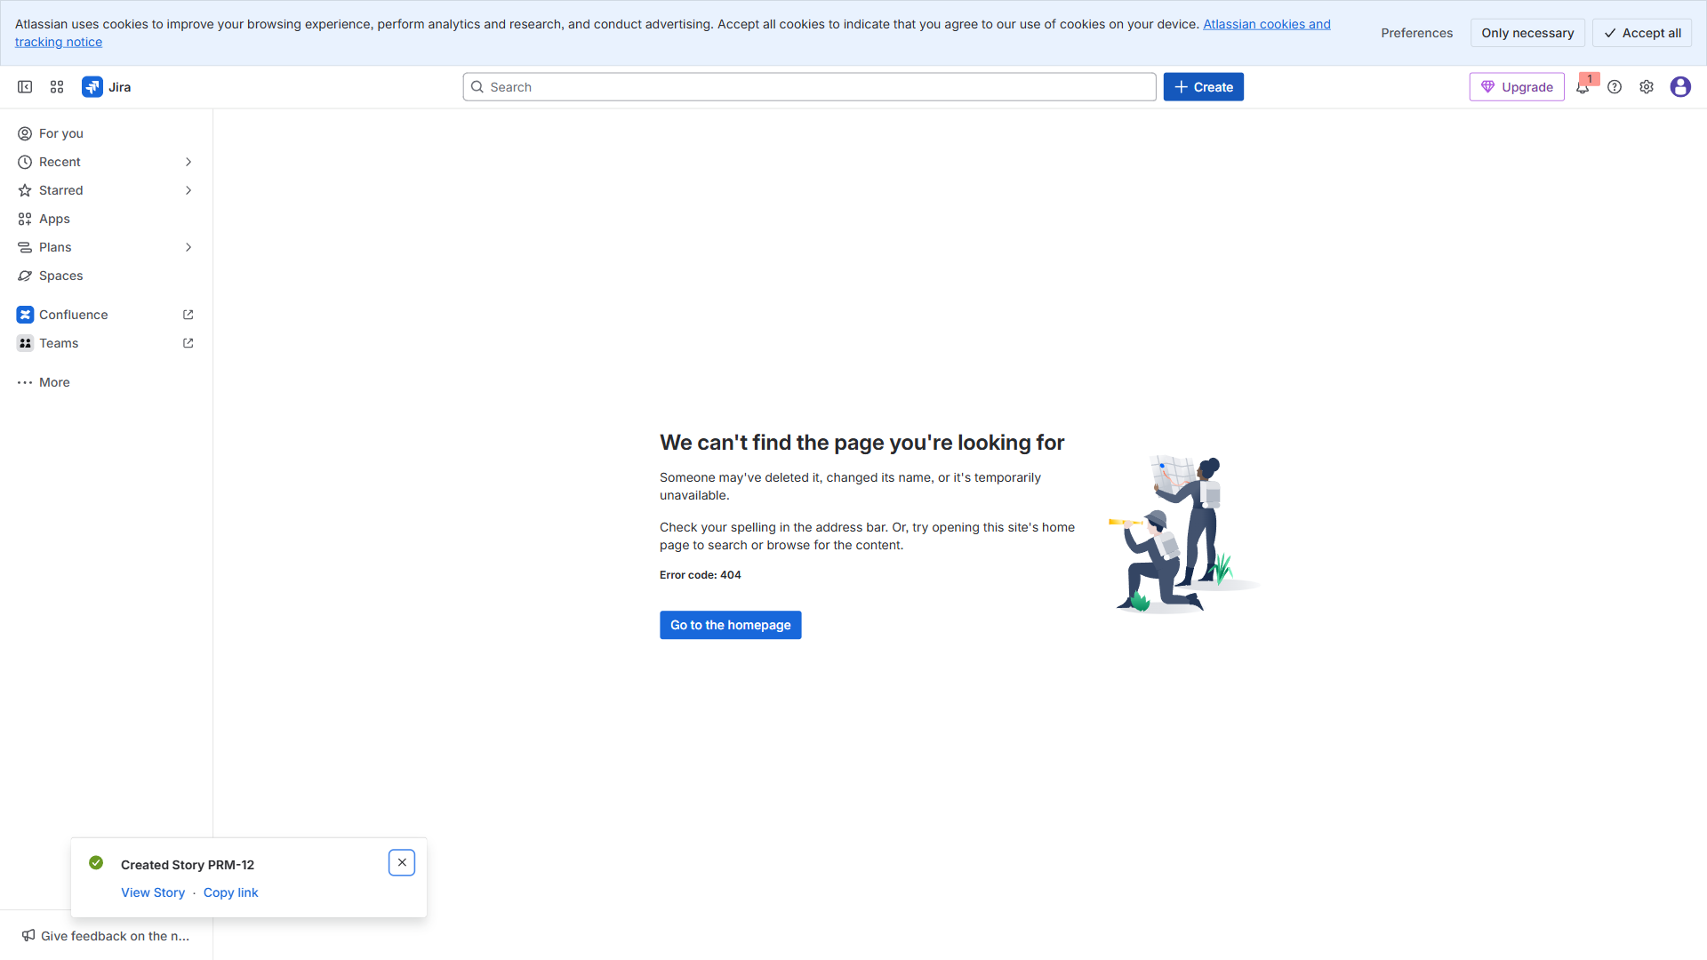

3.4. Epic: Admin Approvals & Scheduling
Time: 04:41:20
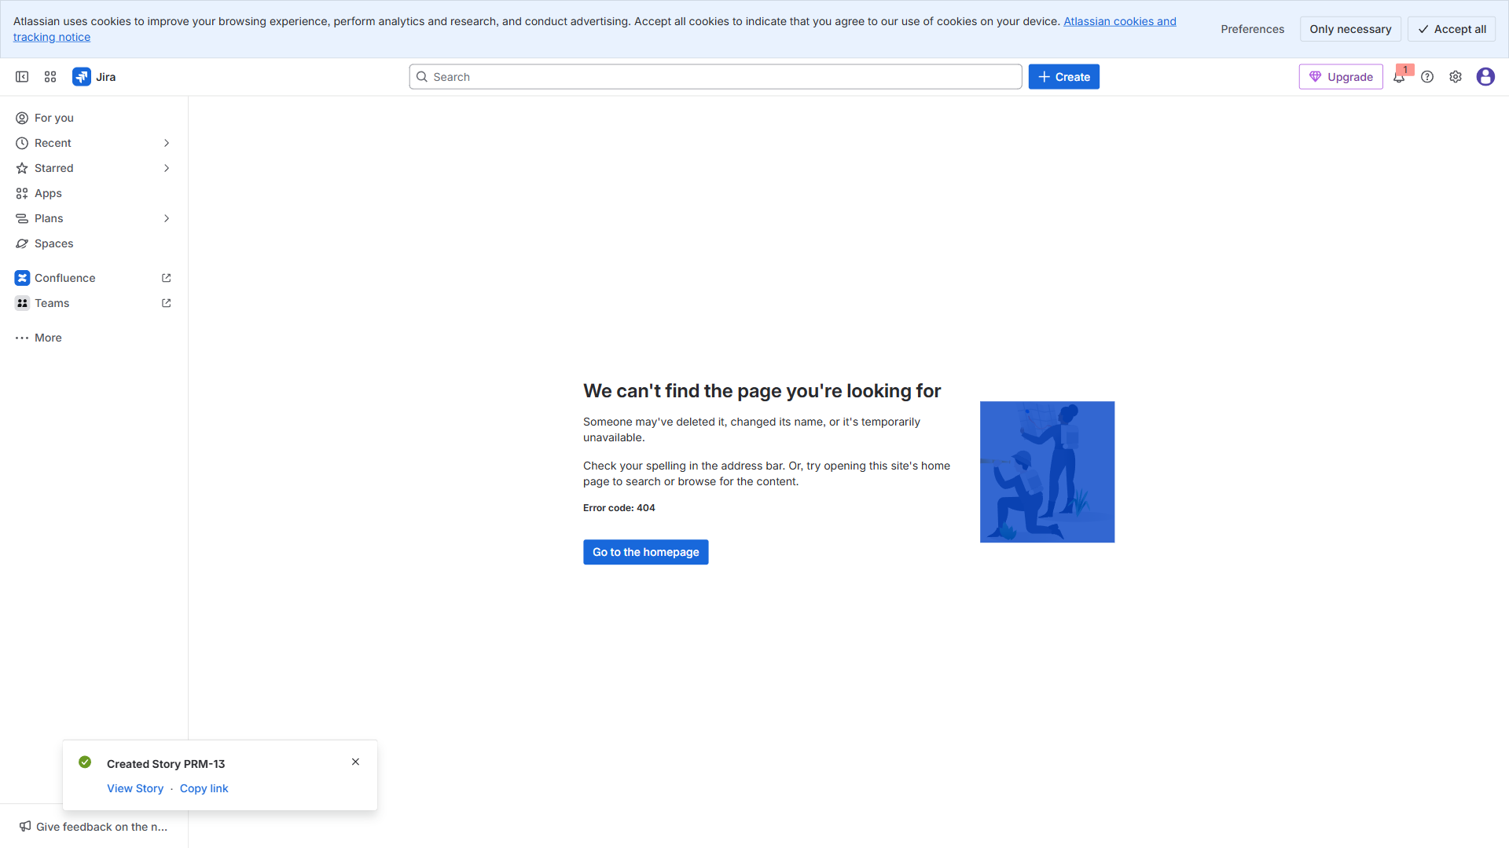

3.5. Epic: Results & Notifications
Time: 04:41:30
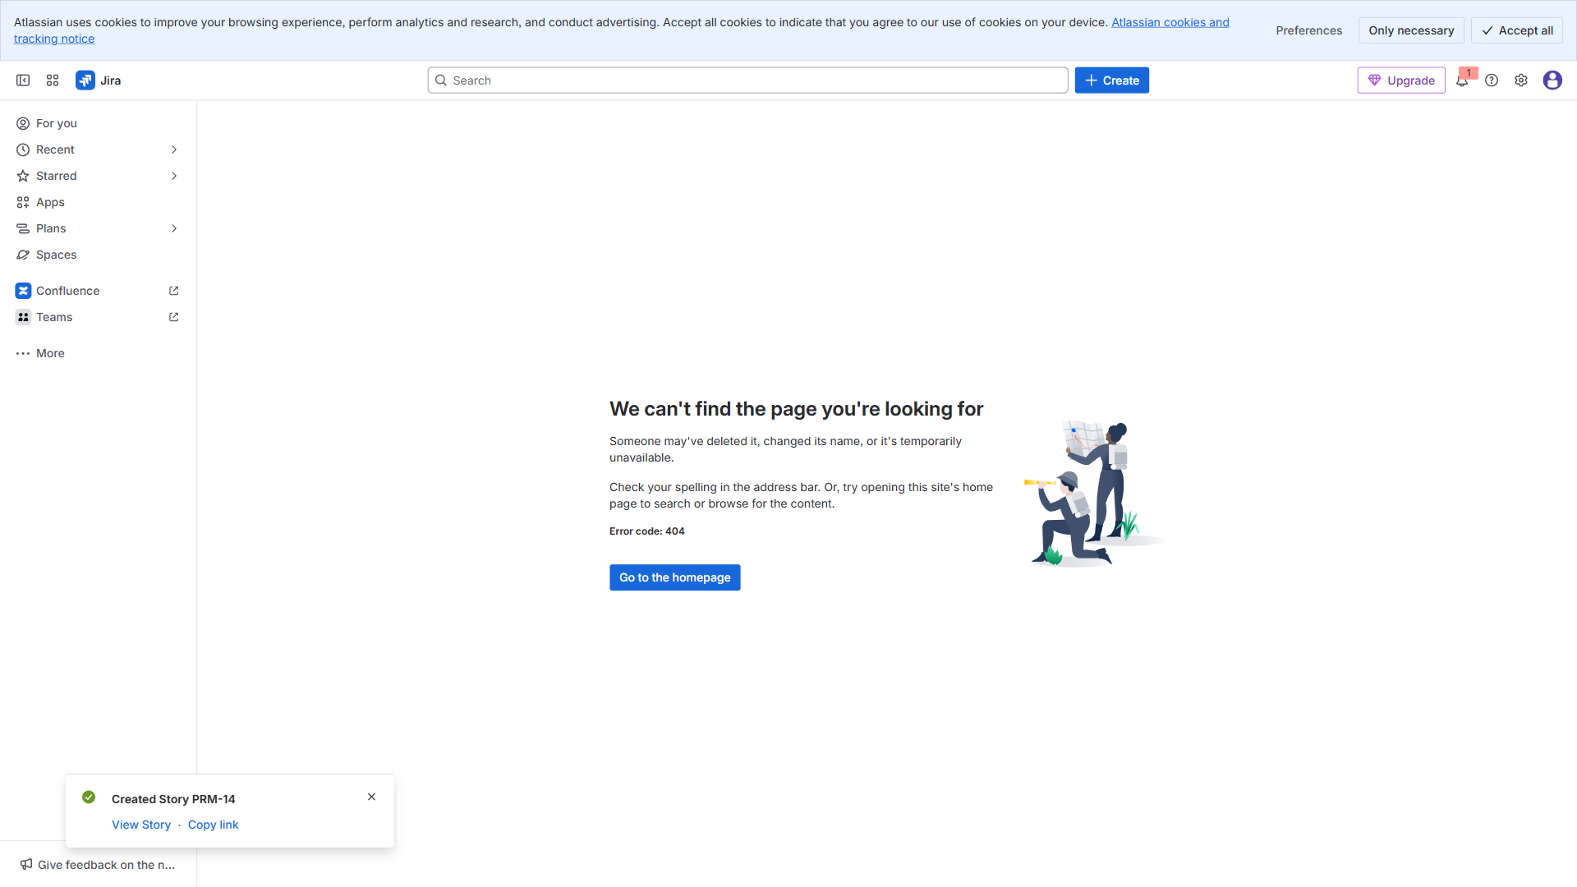

4.1. Story: Design login & signup screens (UX)
Time: 04:41:38
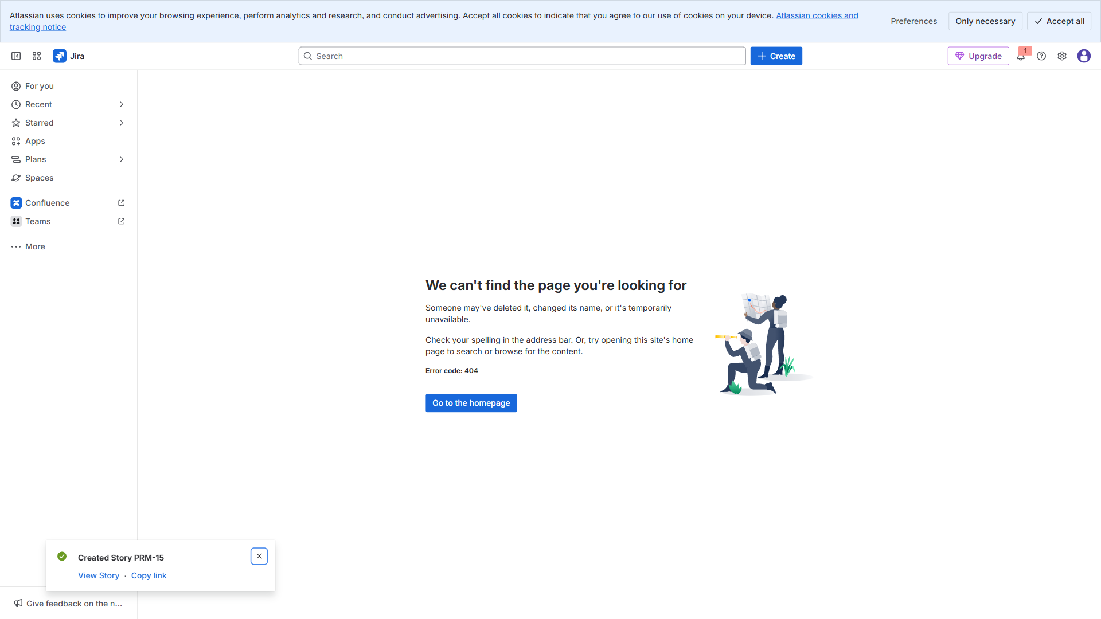

4.2. Story: Implement auth API integration (DEV)
Time: 04:41:46
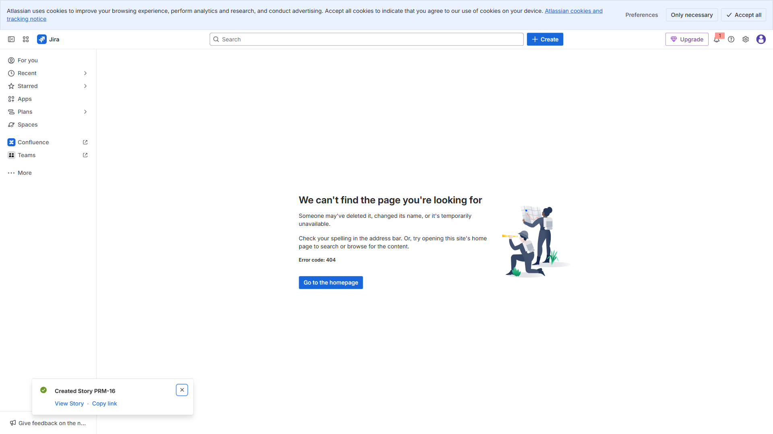

4.3. Story: QA: Auth flow test cases & execution (QA)
Time: 04:41:54
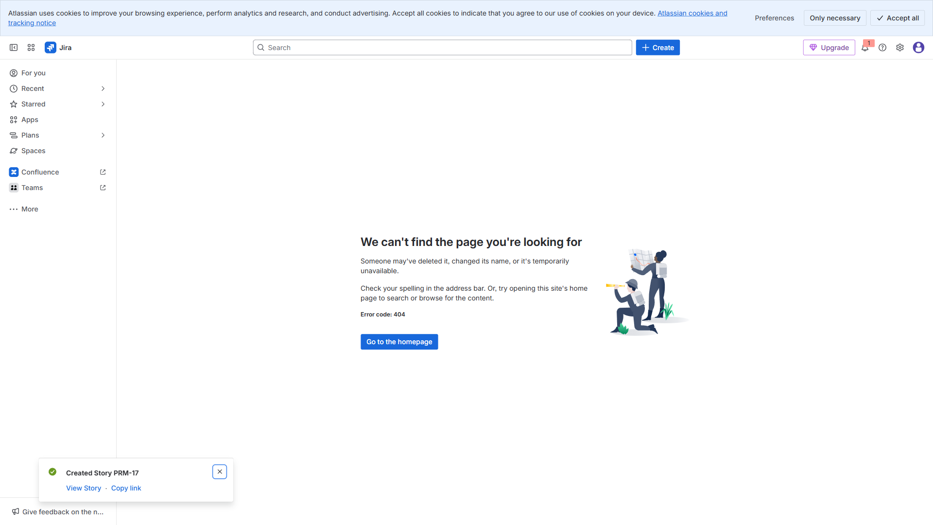

4.4. Story: CI pipeline for mobile build (DEVOPS)
Time: 04:42:02
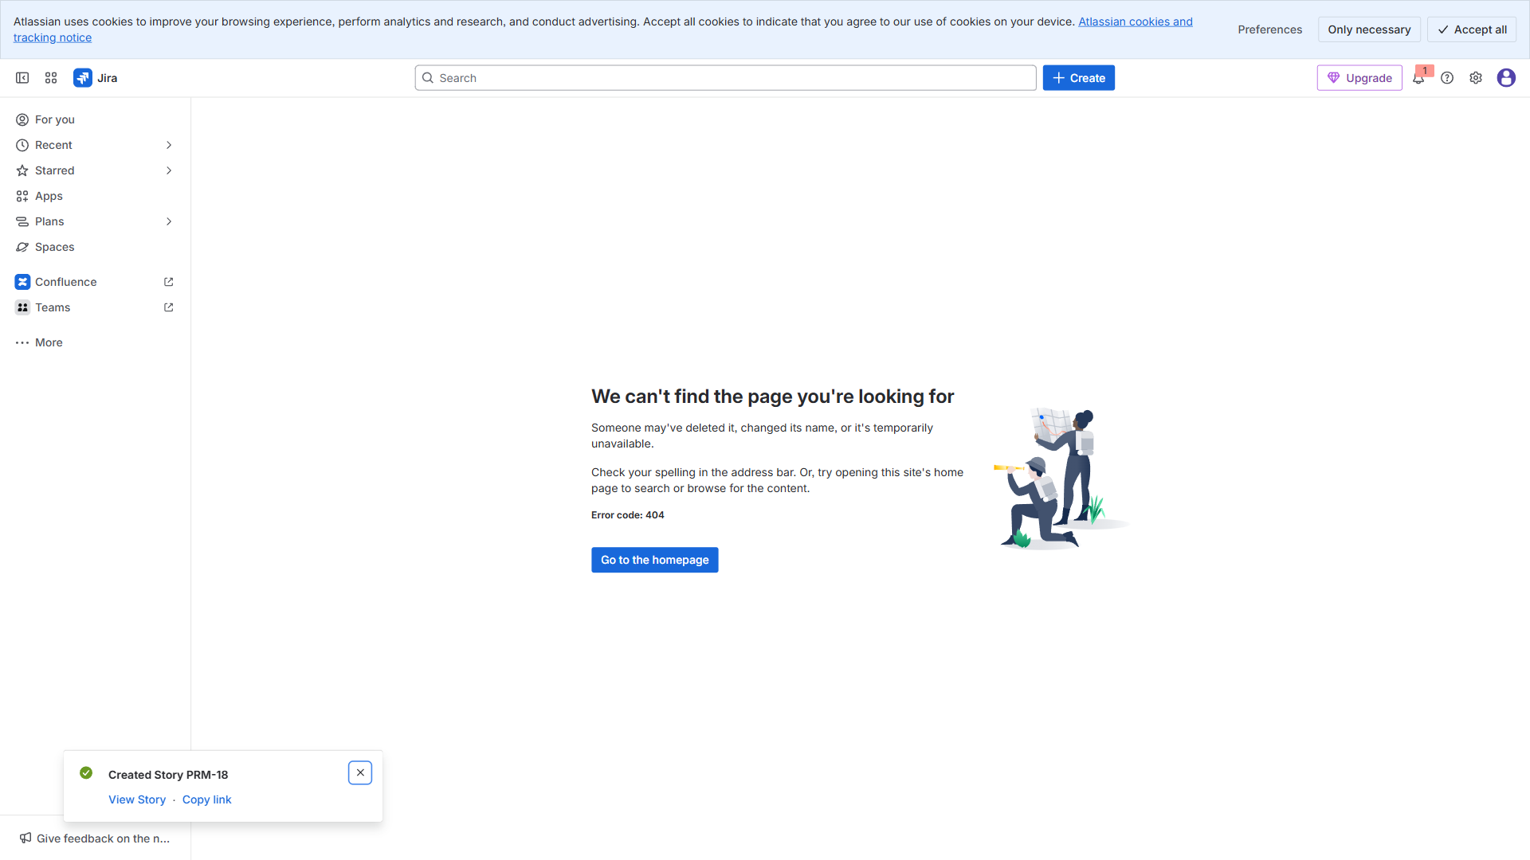

4.5. Story: Browse events UI (UX) — 25 Nov → 27 Nov —
Time: 04:42:09
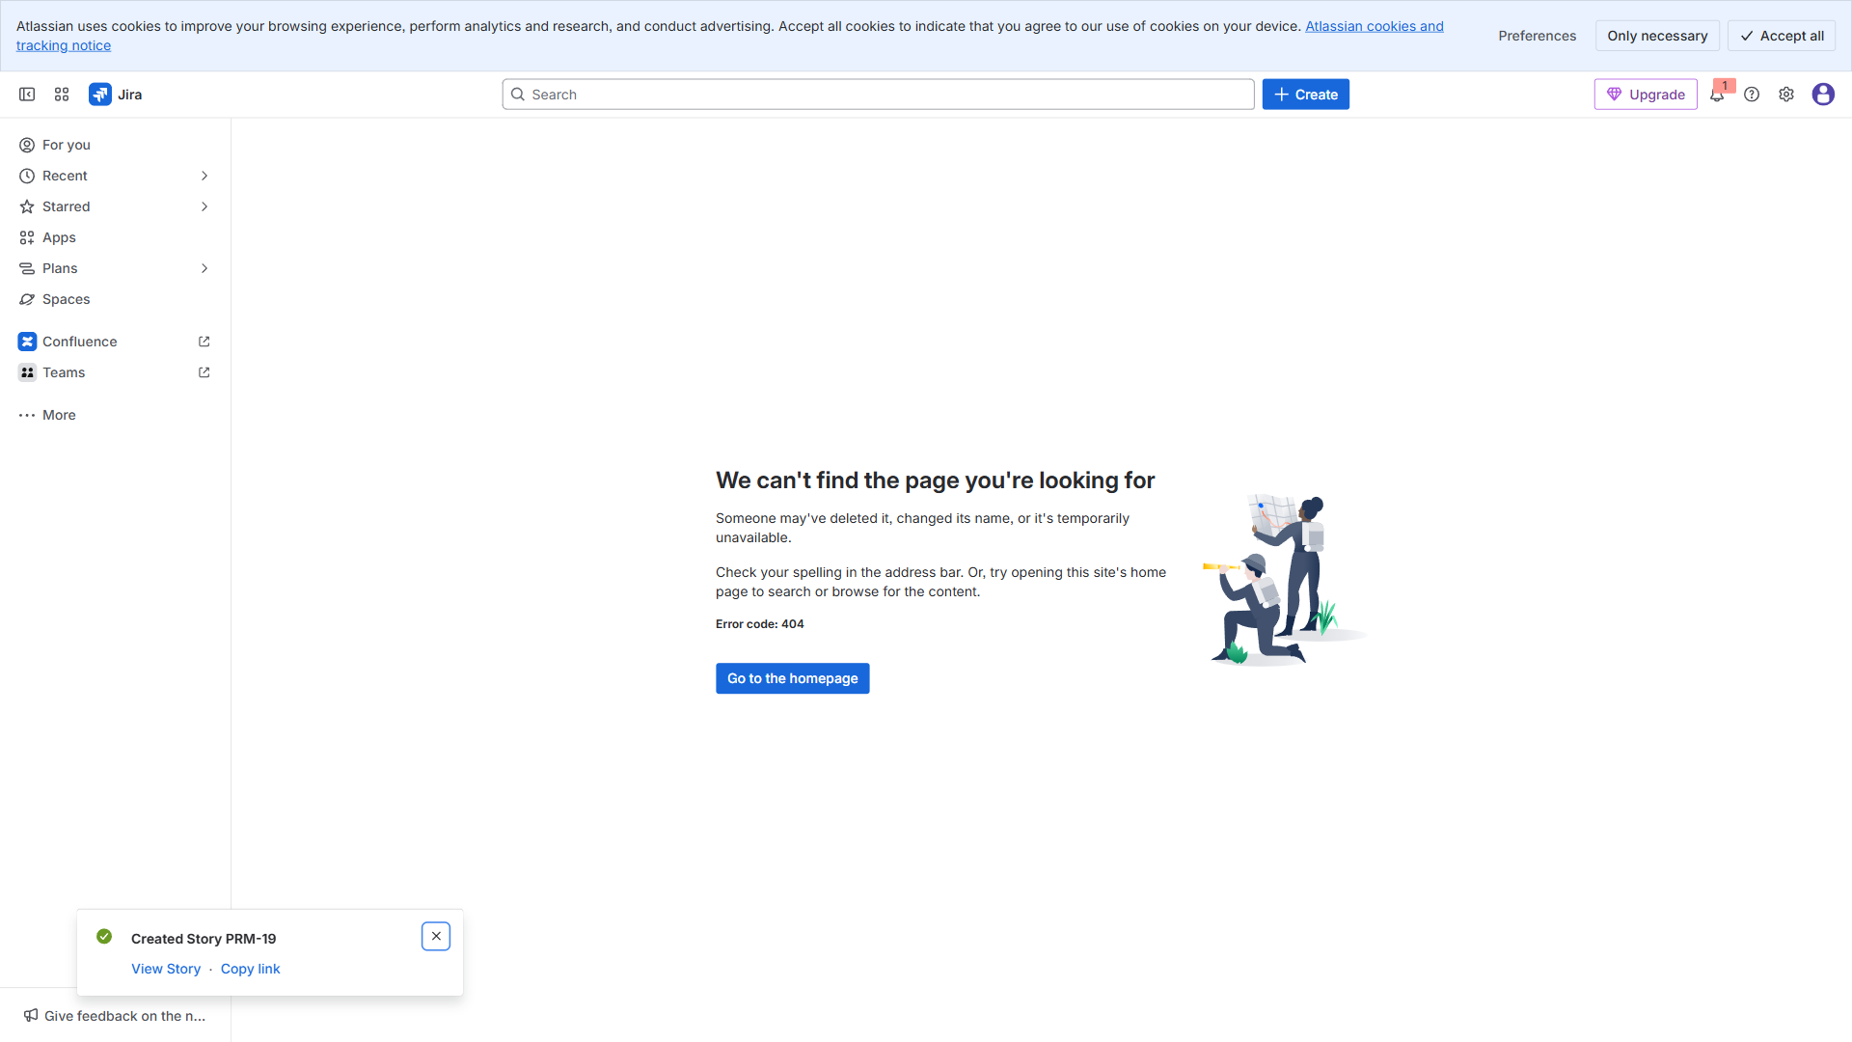

4.6. Story: List events API + pagination (DEV) — 28 Nov → 04 D
Time: 04:42:16
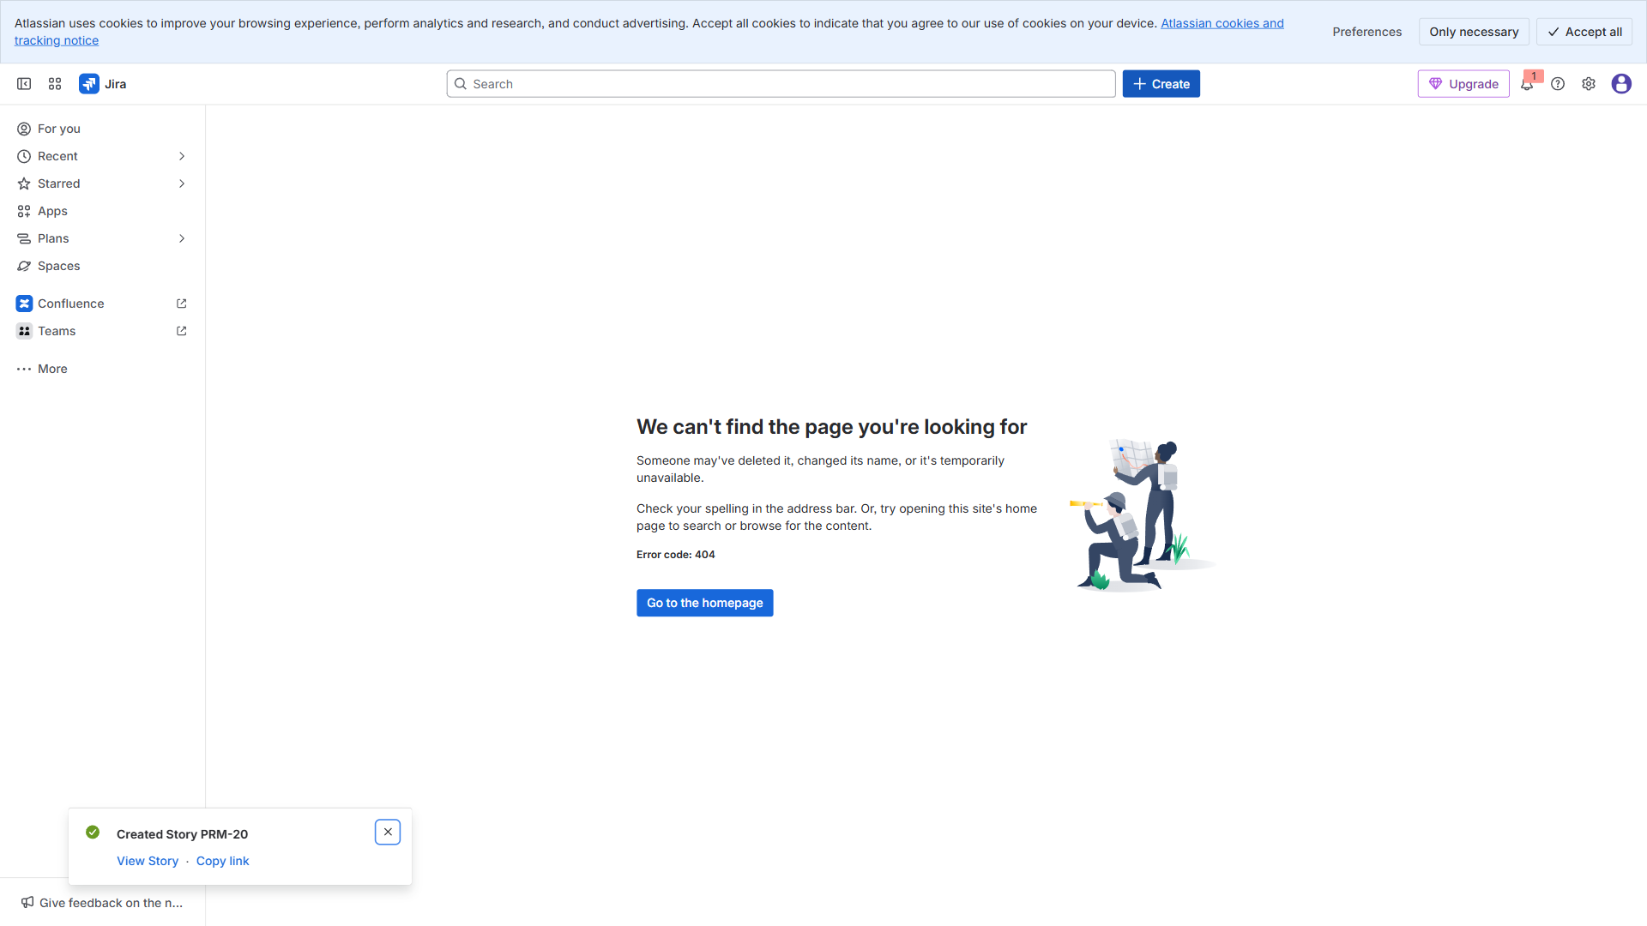

4.7. Story: Register for event + confirmation (DEV) — 05 Dec →
Time: 04:42:24
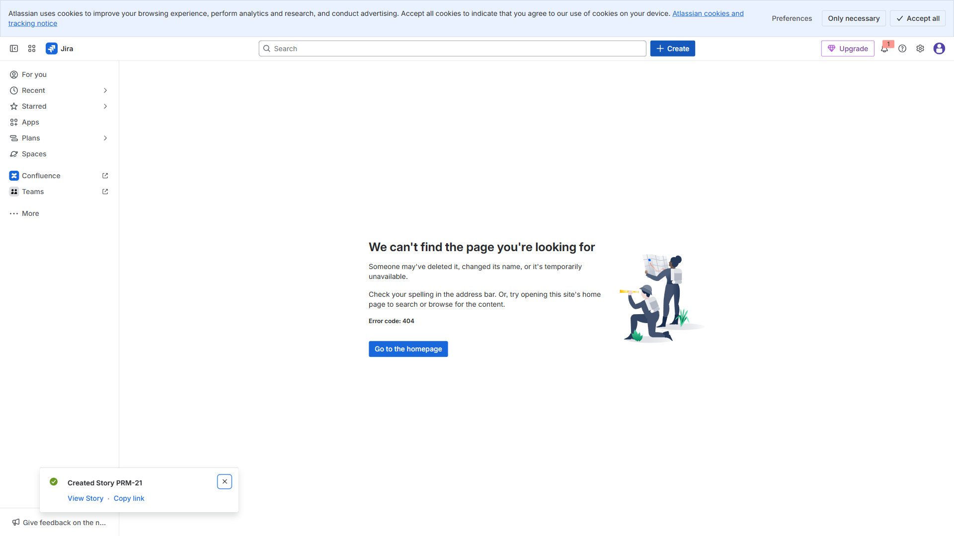

4.8. Story: QA booking flow (QA) — 11 Dec → 13 Dec —
Time: 04:42:32
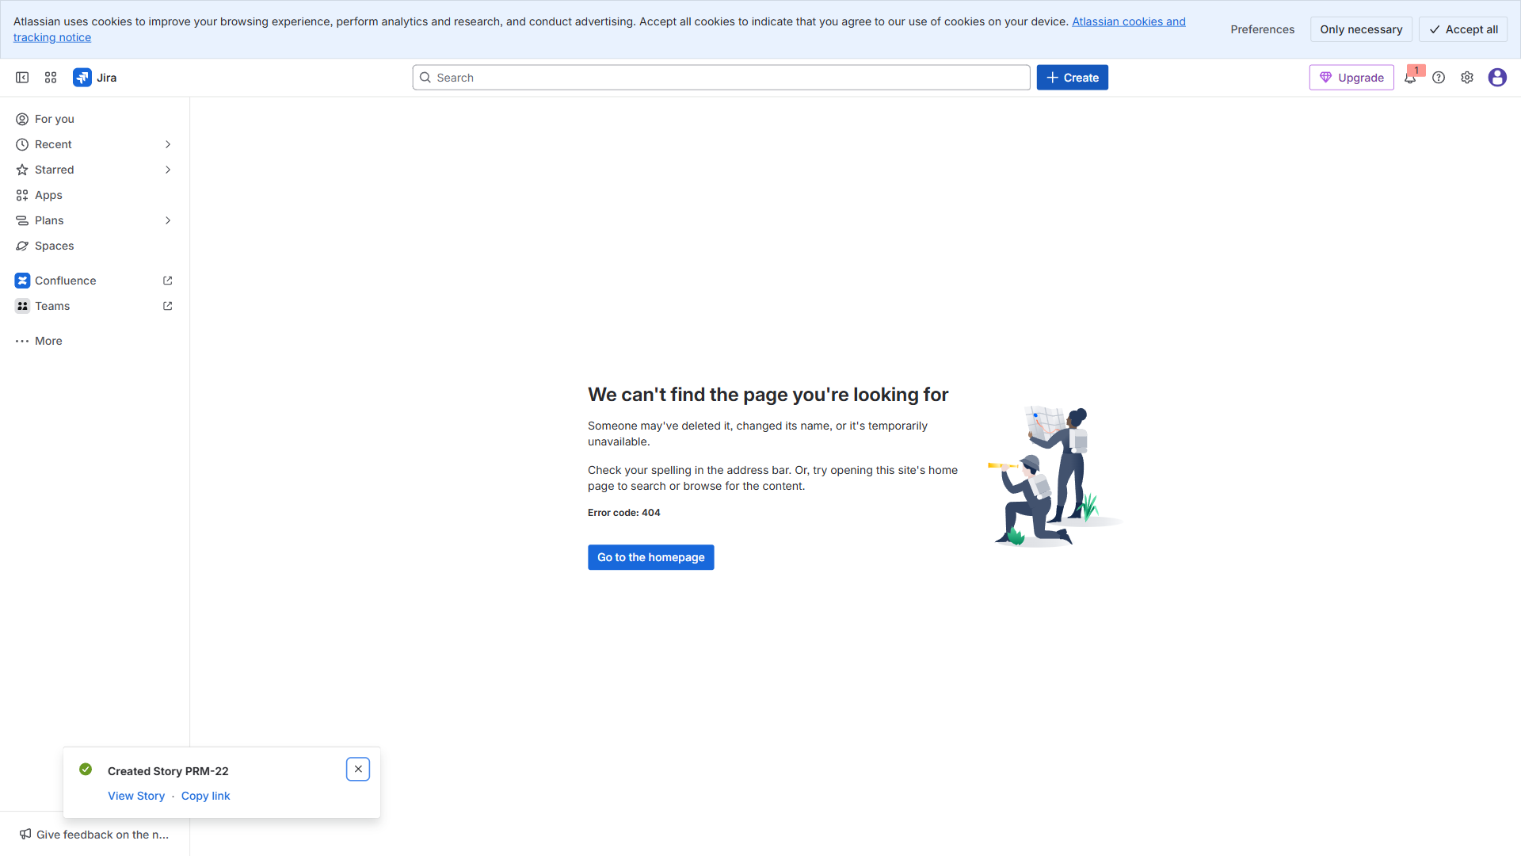

4.9. Story: Admin dashboard skeleton (DEV) — 04 Nov → 08 Nov —
Time: 04:42:40
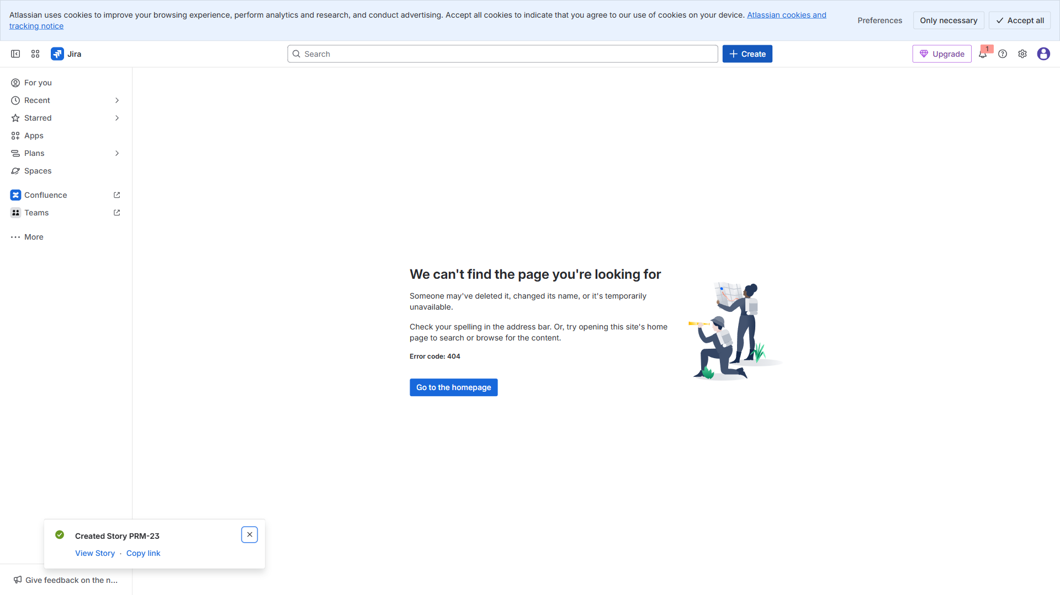

4.10. Story: Approve/reject registrations (DEV) — 10 Nov → 17 N
Time: 04:42:47
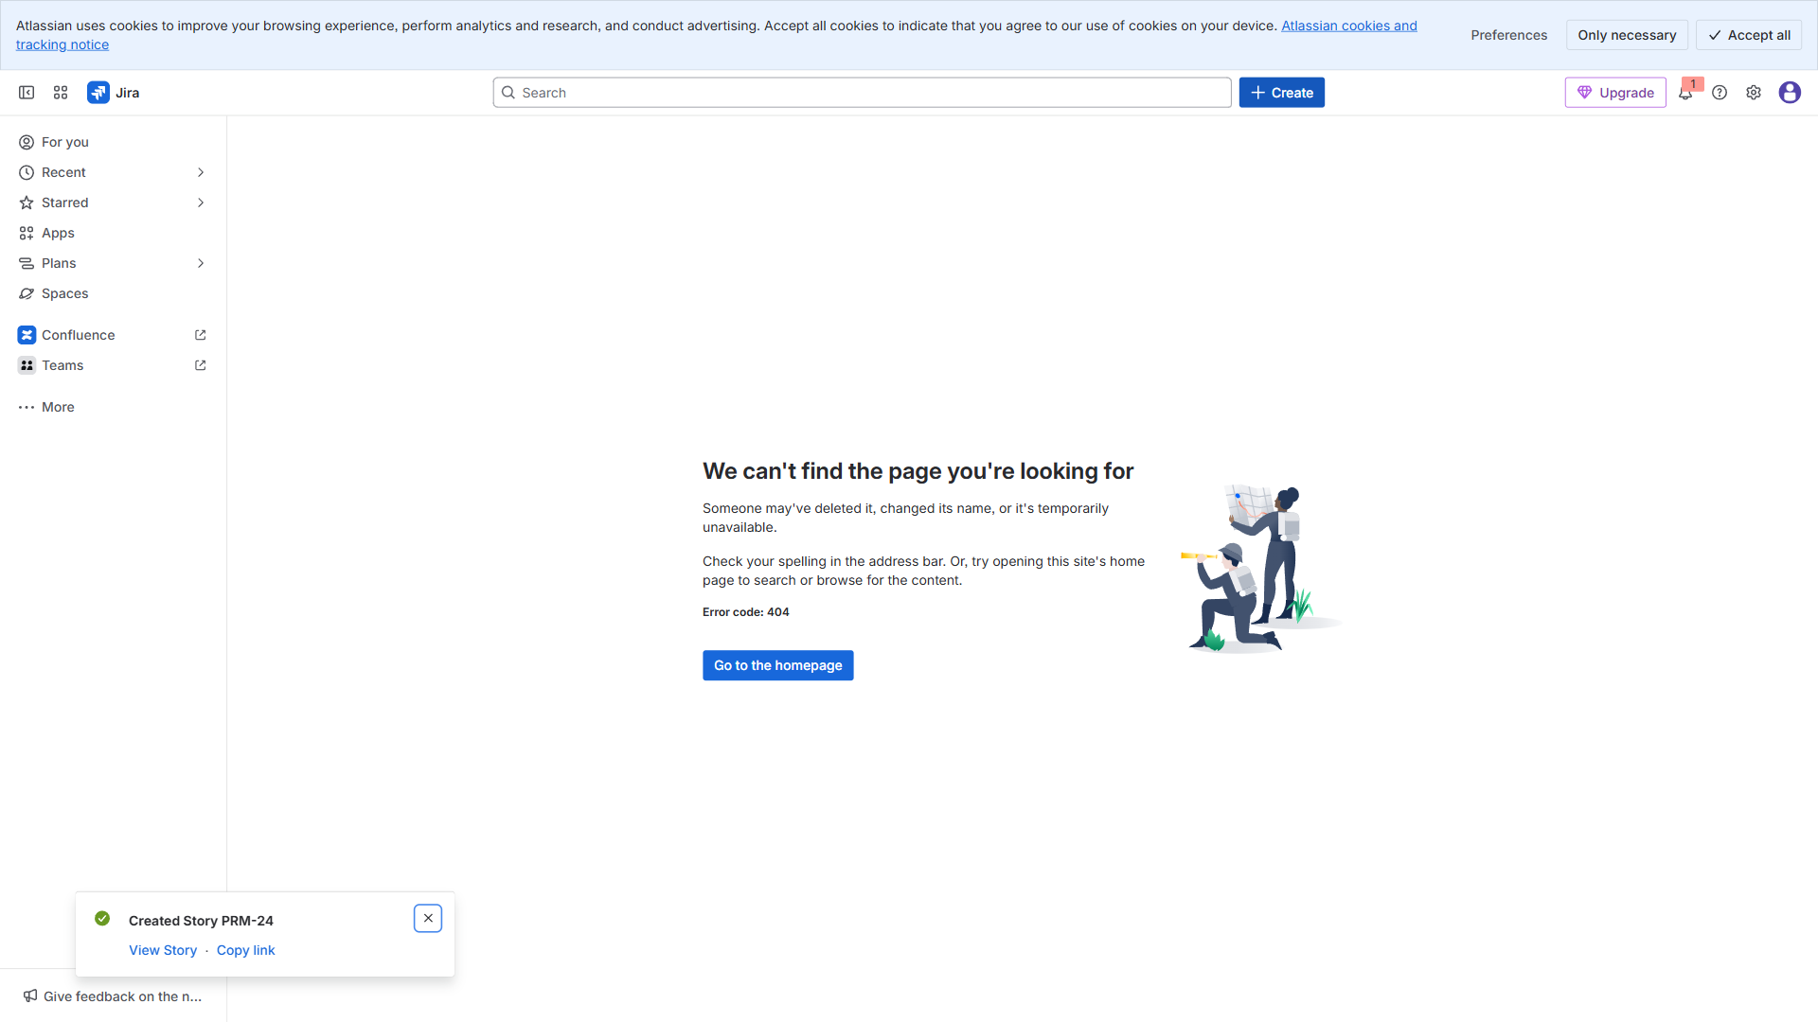

4.11. Story: Schedule management UI (UX) — 11 Nov → 14 Nov —
Time: 04:42:55
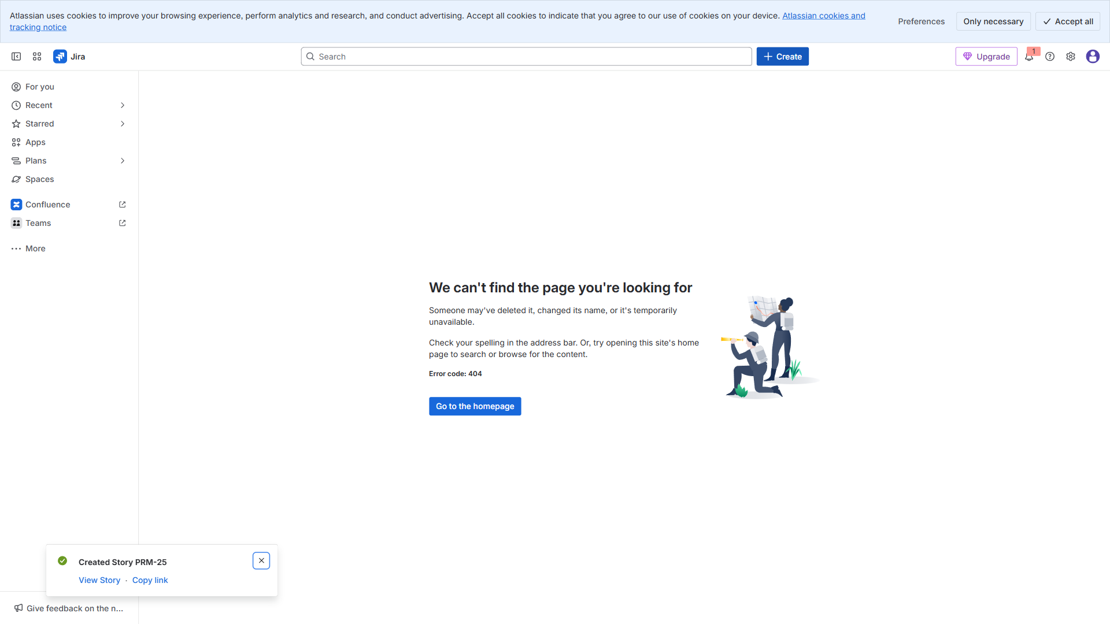

4.12. Story: QA regression pass (QA) — 03 Dec → 06 Dec —
Time: 04:43:10
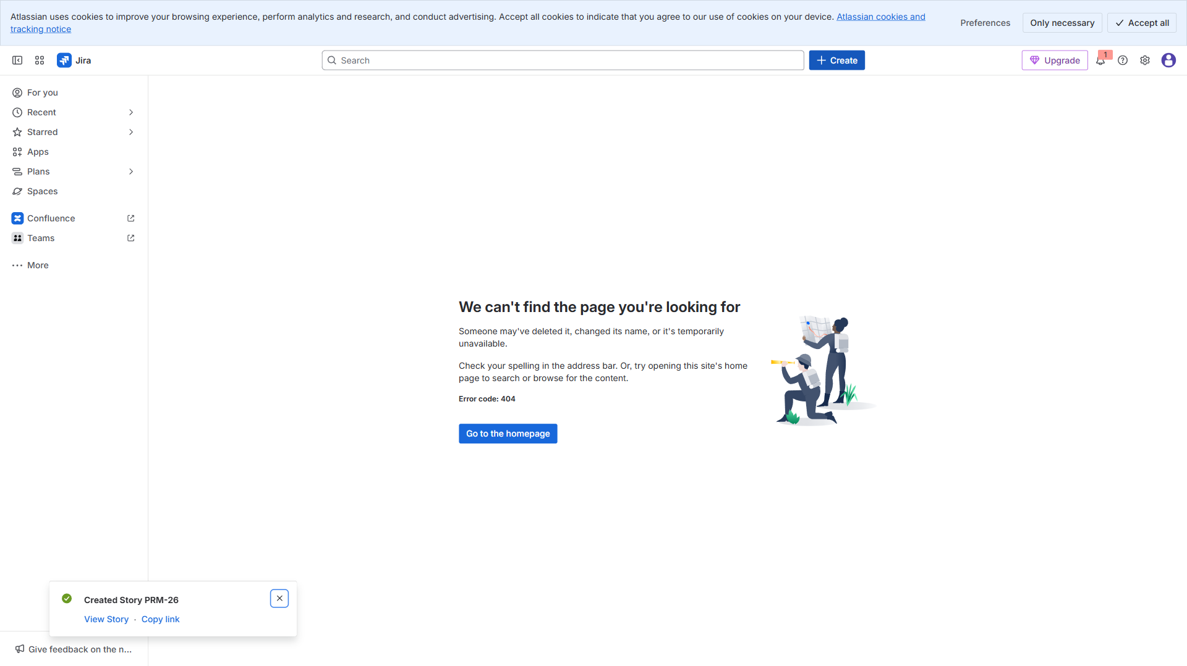

4.13. Story: Results publishing service (DEV) — 25 Nov → 02 Dec
Time: 04:43:19
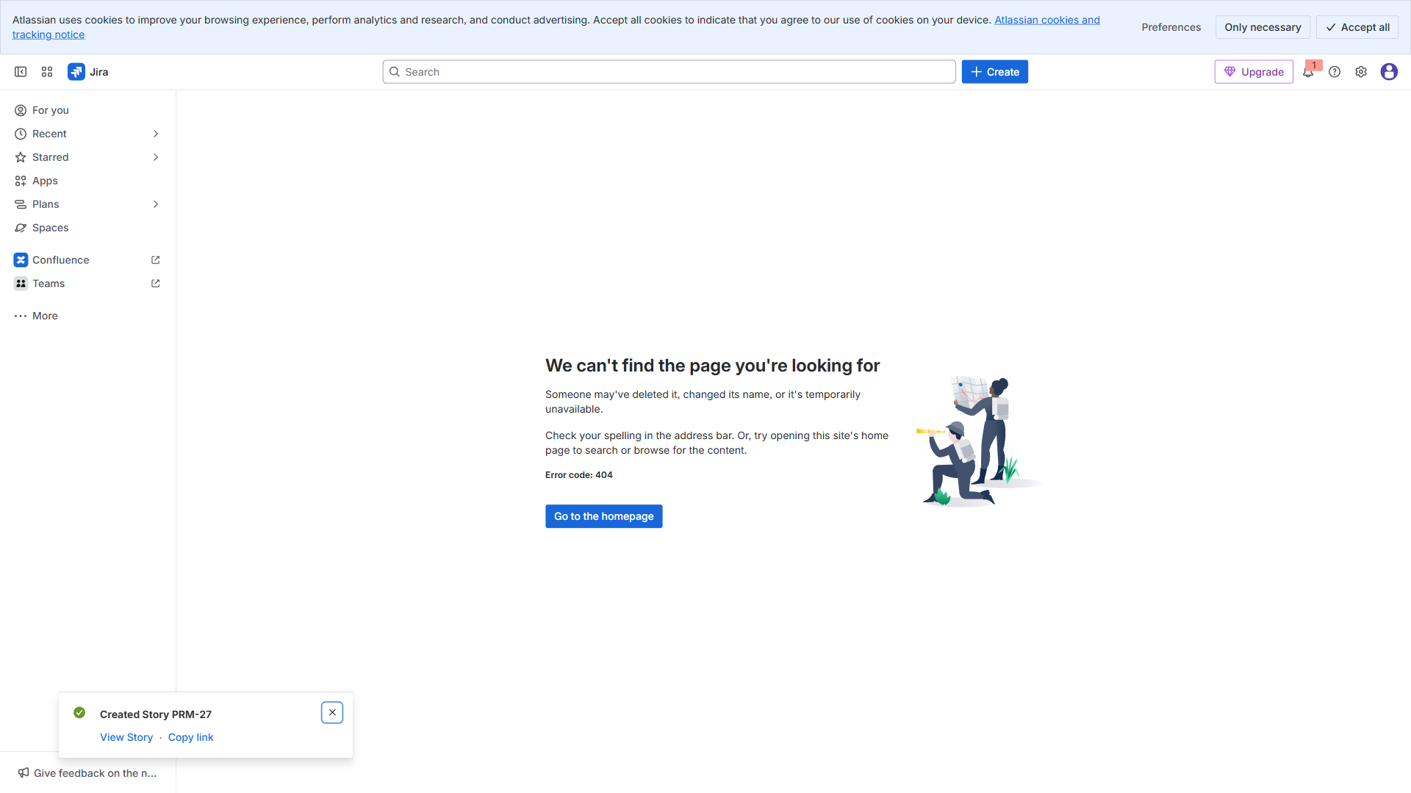

4.14. Story: Push/email notifications (DEVOPS) — 03 Dec → 09 De
Time: 04:43:27
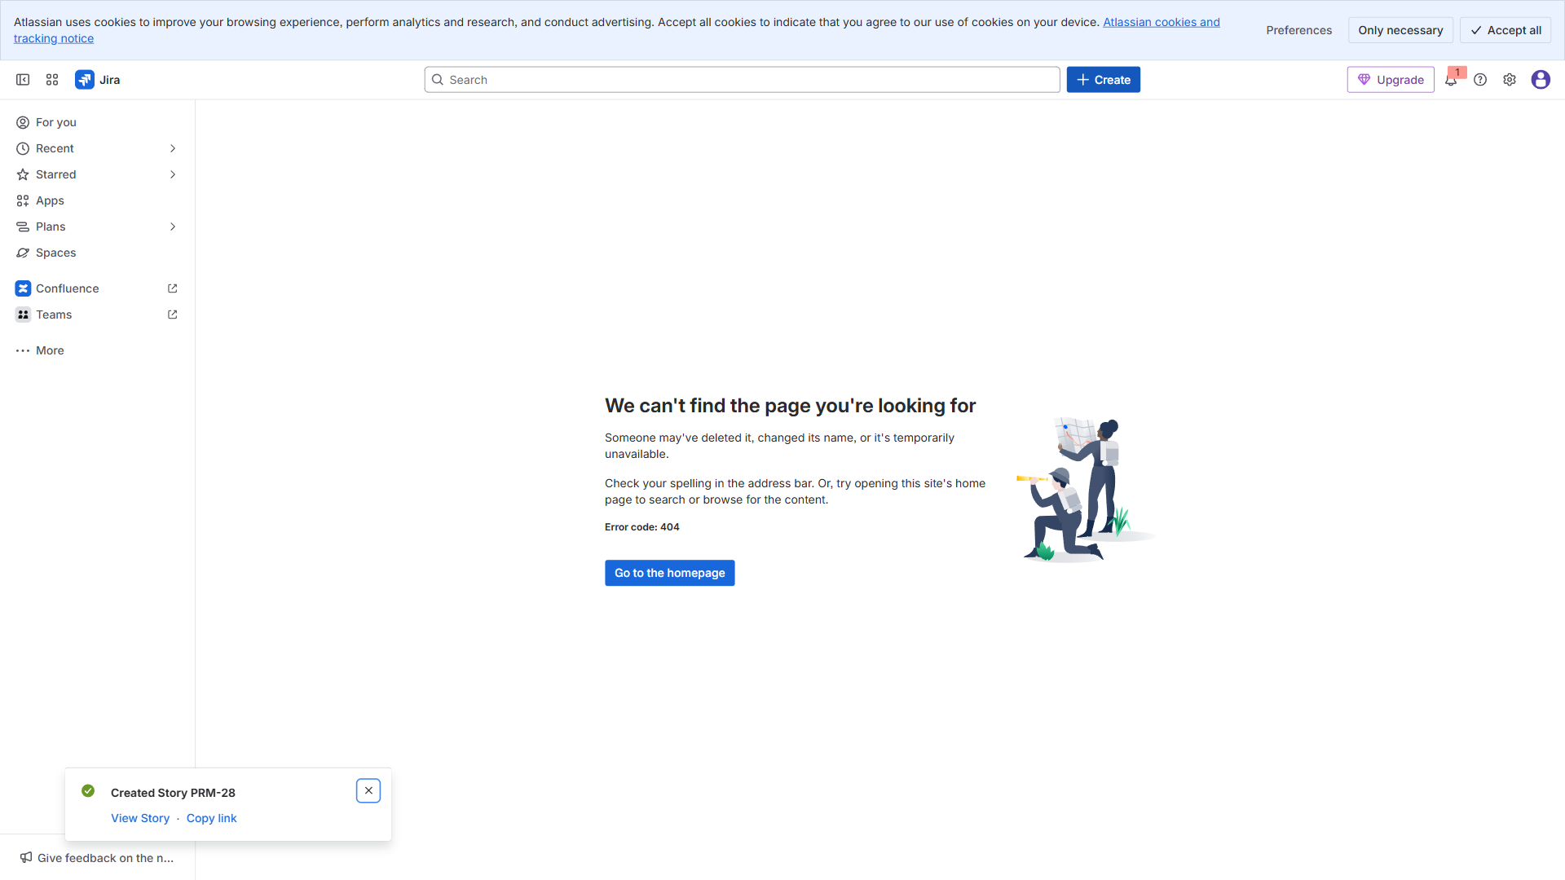

4.15. Story: QA: Notifications & results (QA) — 16 Dec → 18 Dec
Time: 04:43:34
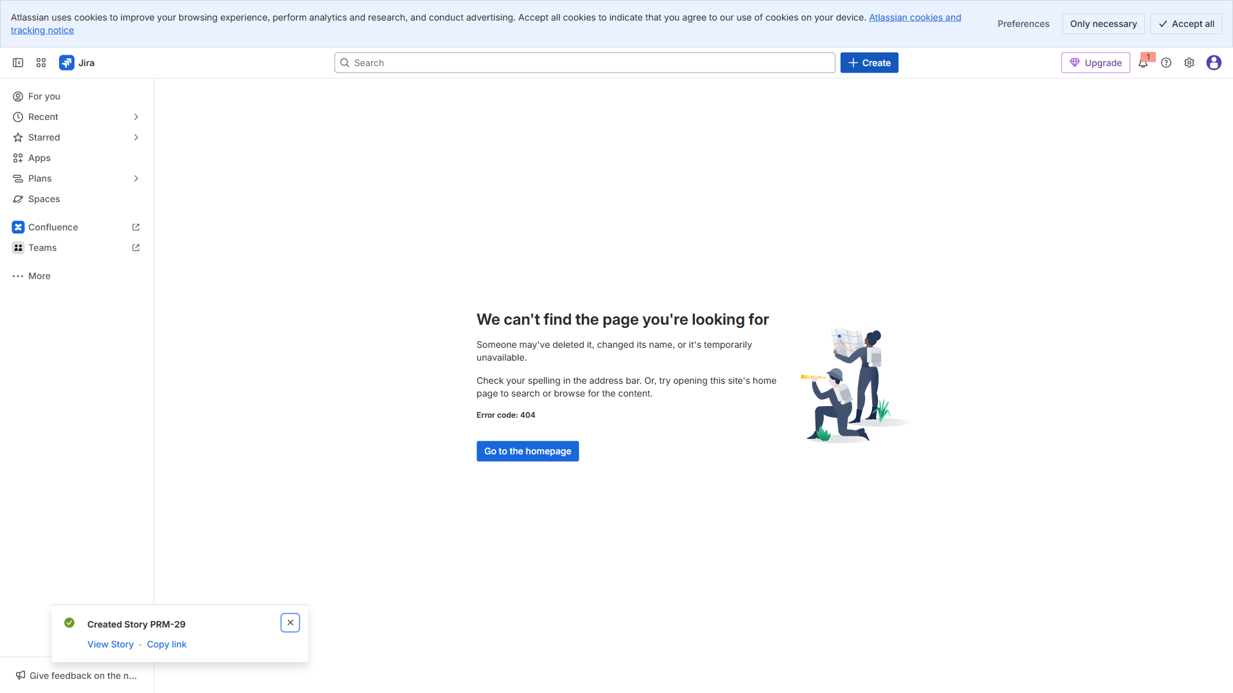

4.16. Story: 5: Build the portfolio roadmap in Swanly (step-by-
Time: 04:43:41
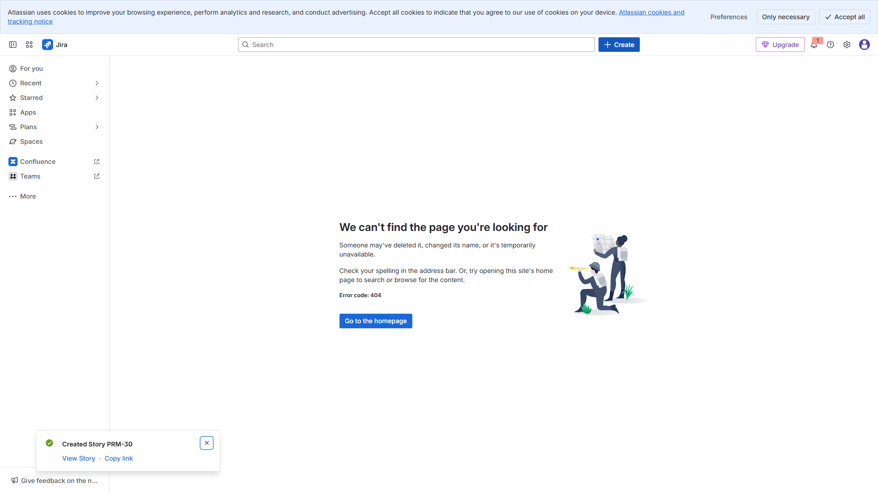

5. Final - All Created
Time: 04:43:42


