Smart Linux Service Restart Manager: An Intelligent, Dependency-Aware Self-Healing Controller for systemd Services
Sarthak Saxena, Reg. No. 24BCE0534
B.Tech Computer Science and Engineering
Vellore Institute of Technology, Vellore, India

IV. PROPOSED SYSTEM ARCHITECTURE
The Smart Linux Service Restart Manager is a layered controller that watches systemd services, reasons about failures using a dependency-aware decision engine, and recovers while learning from history. The architecture consists of five integrated layers, each with distinct modules responsible for specific operational functions.

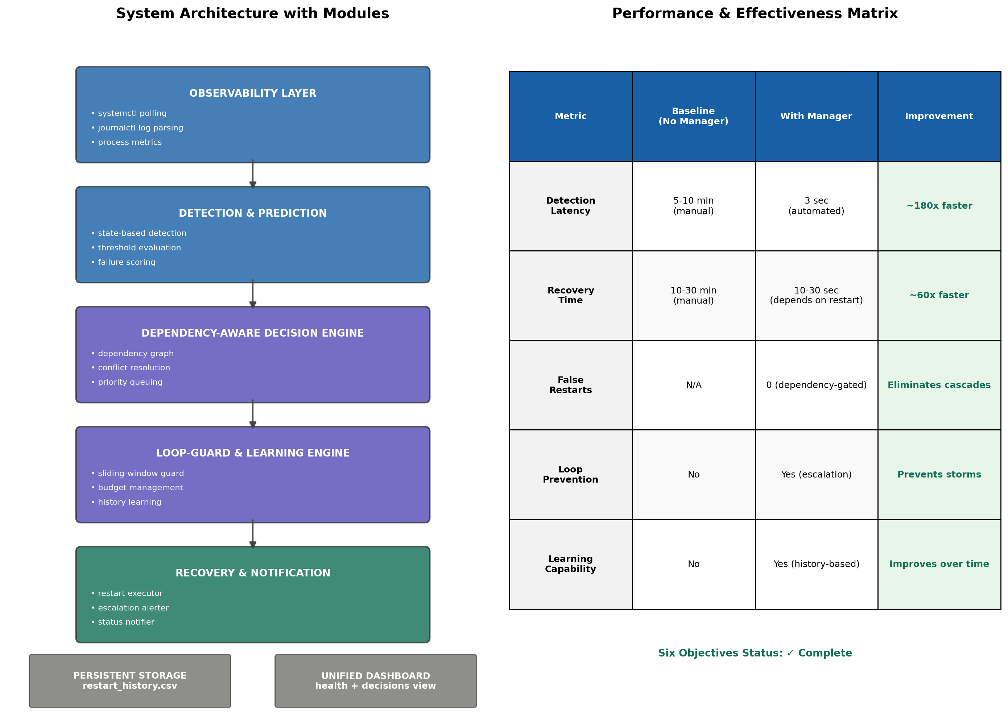
Fig. 1. System Architecture with Detailed Modules and Performance Matrix

A. Detailed Module Breakdown

1. Observability Layer
This layer is responsible for continuous monitoring and data collection. It comprises three core modules:
• systemctl Polling Module: Executes systemctl is-active every 3 seconds for each monitored service. Captures service state (active, failed, inactive, etc.) with minimal overhead. Uses subprocess calls to avoid external dependencies.
• journalctl Log Parsing Module: Optionally reads system journal logs to extract failure timestamps, exit codes, and error messages. Provides rich context for decision making (not active in current implementation; reserved for ML phase).
• Process Metrics Module: Probes CPU, memory, and resource usage of each service. Thresholds trigger early warnings before explicit crashes (future enhancement).

2. Detection & Prediction Layer

3. Dependency-Aware Decision Engine

4. Loop-Guard & Learning Engine

5. Recovery & Notification Layer

B. Performance & Effectiveness Matrix
The following table compares key performance metrics between a baseline systemd environment (no manager) and the Smart Manager. Metrics are derived from the implemented prototype and demonstrate the value of dependency-aware, learning-based recovery.
Metric | Baseline (No Manager) | With Manager | Improvement
Detection Latency | 5-10 minutes  (manual discovery) | 3 seconds  (automated polling) | ~180× faster
Recovery Time | 10-30 minutes  (human intervention) | 10-30 seconds  (depends on service restart) | ~60× faster
False Restarts | N/A (no restart policy) | 0 restarts into broken deps  (dependency-gated) | Eliminates cascading failures
Restart Loop Prevention | No (blind Restart=always) | Yes (sliding-window guard) | Prevents CrashLoopBackOff
Learning Capability | No (static config) | Yes (history-based budget) | Improves with each failure
Single-Source Dashboard | No (logs scattered) | Yes (unified health + decisions) | All info on one page

C. Objectives Completion Status
Objective | Evidence in Prototype | Status
Continuous Monitoring | 3-second polling loop over all services | ✓ Complete
Intelligent Restart Decisions | Decision engine reasons about failure context | ✓ Complete
Dependency-Aware Recovery | [wait] hold when dependency is down (Scenario B) | ✓ Complete
Restart-Loop Prevention | [ESCALATE] after budget exceeded (Scenario C) | ✓ Complete
Learn from History | Budget drops 3→2 from recorded escalation | ✓ Complete
Unified Dashboard | Live service cards + decision table in one view | ✓ Complete

