**Project Sprint #1**

The SOS game is described in CS449HomeworkOverview.docx. You should read the description very carefully.

Your submission must include the GitHub link to your project and you must ensure that the instructor has the proper access to your project. You will receive no points otherwise.

GitHub link: https://github.com/Tarycx/CS449SOSProject

In this assignment, you aim to specify the requirements (i.e., user stories and acceptance criteria) of the target software that allows a human player to play a simple or general SOS game against a human opponent. These requirements will be fully implemented by the end of sprint 3. The minimum features include **choosing the board size,** **choosing the game mode (simple or general)**, **starting a new game**, **making a move (in a simple or general game)**, **determining if a simple or general game is over**. The following is a sample GUI layout.

|  |  |  |
| --- | --- | --- |
| SOS Icon  Description automatically generated Simple game Icon  Description automatically generated General game Board size  8 | | |
| Blue player  Icon  Description automatically generated S  Icon  Description automatically generated O |  | Red player  Icon  Description automatically generated S  Icon  Description automatically generated O |
|  | Current turn: blue (or red) | New Game |

Figure 1. Sample GUI layout of the first working program by the end of Sprint 3

Use the following tables to document your user stories and acceptance criteria.

You are required to use the free ChatGPT version to complete 2 user stories and their respective acceptance criteria. You also need to ensure that the generated user stories are correct and refine them if not. At the end of the submission, provide screenshots of your ChatGPT prompts and answers, along with errors the ChatGPT made and that you had to correct. You may also use LLMs hosted locally. Points will be deducted if no screenshots are provided.

1. **User Stories (3 points)**

* **User Story Template**: As a <role>, I want <goal> [so that <benefit>]
* **Priority** High-medium-Low / essential, desirable

|  |  |  |  |  |
| --- | --- | --- | --- | --- |
| **ID** | **User Story Name** | **User Story Description** | **Priority** | **Estimated effort (hours)** |
| 1 | Choose a board size | As a Player,  I want to choose the board size before the SOS game begins,  So that I can customize the difficulty and duration of the game | High  essential | 8 |
| 2 | Choose the game mode of a chosen board | As a Player,  I want to choose between the “Simple Game” and “General Game” modes after selecting a board size,  So that I can decide the rules I want to play under for the SOS game | High  essential | 10 |
| 3 | Start a new game of the chosen board size and game mode | As a Player,  I want to start a new game with the chosen board size and game mode,  So that I can begin play a new game with selected settings | Low  essential | 6 |
| 4 | Make a move in a simple game | As a Player in simple game,  I want to make a move placing “O” or “S” on the board  So that I can try to form a sequence “SOS” and win the game | Medium  essential | 12 |
| 5 | A simple game is over | As a Player in simple game,  I want validation that simple game is over.  So that I can see the game results and decide to play another game. | Low  essential | 6 |
| 6 | Make a move in a general game | As a Player in a general game,  I want to make a move placing “O” or “S” on the board  So that I can create the most “SOS” sequences and win the game | Medium  essential | 12 |
| 7 | A general game is over | As a Player in a general game,  I want validation that general game is over  So that that I can see game results and decide to play another game. | Low  essential | 6 |

1. **Acceptance Criteria (AC) (8 points): Add/delete rows as needed.**

|  |  |  |  |
| --- | --- | --- | --- |
| **User Story ID and Name** | **AC**  **ID** | **Description of Acceptance Criterion** | **Status (completed, toDo, inProgress)** |
| 1. Choose a board size | 1.1 | AC 1.1 <scenario description> Inputting a custom board size  Given the player is on the game setup display,  When the player inputs a custom board size (n>2)  Then the game should validate the size and display it to the user | inProgress |
| 1.2 | AC 1.2 <scenario description> No Board size selected (default size)  Given the player is on the game setup display,  When the player does not select any board size,  Then the game should be at a default 3x3 board size and display to user | inProgress |
| 1.3 | AC 1.3 <scenario description> Invalid custom board size  Given the is on the game setup display  When the player inputs a custom board size that is out of the allowed range (n<=2)  Then the game should display an error message indicating that the size is invalid and prompt the player to select a valid size. | inProgress |
|  |  |  |  |
| 2. Choose the game mode of a chosen board | 2.1 | AC 2.1 <scenario description>Choosing the Simple Game Mode  Given the player is on the game setup display,  When the player chooses the “Simple Game” mode from the game mode options,  Then the game should apply the “Simple Game” logic and rules to user’s game | inProgress |
| 2.2 | AC 2.1 <scenario description> Choosing the General Game Mode  Given the player is on the game setup display,  When the player chooses the “General Game” rules from the game mode options  Then the game should apply the “General Game” logic and rules to user’s game | inProgress |
|  |  |  |  |
| 3. Start a new game of the chosen board size and game mode | 3.1 | AC 3.1 <scenario description> Starting new game with selected board size and game mode  Given the player has selected a board size and game mode,  When the player clicks start game button,  Then the new game using the chosen size and game type will initialize, displaying the game board and allowing player to make a move. | toDo |
| 3.2 | AC 3.2 <scenario description> Starting new game with default settings  Given the player has not selected board size and game mode  When the player clicks start game button  Then the game with initialize with default setting of board size: 3x3 and game type: Simple | toDo |
| 4. Make a move in a simple game | 4.1 | AC 4.1 <scenario description> Check SOS completion after move  Given the player has placed an “S” or “O”  When move forms “SOS” horizontally, vertically, or diagonally  Then the player should be declared the winner and the game should end. | toDo |
| 4.2 | AC 4.2 <scenario description> player makes a move  Given it is the player’s turn on a simple game  When the place selects an empty board slot for “S” or “O”  Then the player’s selected letter should appear on the select board slot and turn is passed to opponent . | toDo |
| 4.3 | AC 4.3 <scenario description> making last move on filled board  Given the board is filled and no “SOS” has been created  When final board slot has been taken  Then the game will be declared as a draw | toDo |
| 4.4 | AC 4.4 <scenario description> Attempting to make a move in a filled cell  Given it is the player’s turn  When player selects a filled board slot that is already filled,  Then the filled board slot and user turn should remain unchanged and user will be allowed to continue to find an empty space. | toDo |
| 5. A simple game is over | 5.1 | AC 5.1 <scenario description> Game over with winner  Given player has formed the sequence “SOS” in simple game  When game detects “SOS” Sequence formed horizontally, vertically or diagonally  Then the game will declare player as winner, output game over, and will provide option to start new game or exit | toDo |
| 5.2 | AC 5.2 <scenario description> Game over with draw  Given all board slots are filled and no “SOS” is formed  When final move is made by player or opponent  Then the game will declare a draw, output game over, and will provide option to start new game or exit | toDo |
| 5.3 | AC 5.3 <scenario description> game over display  Given the simple game is over (draw or winner)  When game over output is displayed  Then player will be routed to display for choose new options game or exit | toDo |
| 6. Make a move in a general game | 6.1 | AC 6.1 <scenario description> player makes a move on empty space  Given it’s the player’s turn in a general game  When the player selects an empty board slot on the board and chooses to place either an “S” or “O”  Then selected letter should appear on selected board slot | toDo |
| 6.2 | AC 6.2 <scenario description> “SOS” sequence is created  Given the player has placed an “S” or “O” on an empty board slot  When the move forms one or more “SOS” sequence horizontally, vertically, or diagonally,  Then the player score should reflect the sequences formed by the move and turn should change. | toDo |
| 6.3 | AC 6.3 <scenario description>Making a move on filled board slot  Given it is player’s turn in general game  When the player selects a filled board slot  Then the filled board slot and user turn should remain unchanged, and user will be allowed to continue to find an empty space. | toDo |
| 6.4 | AC 6.4 <scenario description> general game ends  Given the board slots are filled and no more moves can be made  When board slot has been taken  Then the game will declare player with most “SOS” sequences as match winner, if player score is tied game will be a draw | toDo |
| 7. A general game is over | 7.1 | AC 7.1 <scenario description> Game over with winner  Given no moves can be made and board slots are completely filled  When player “SOS” sequence count is higher than opponent  Then the game will declare player with higher count as winner and output game over and final scores | toDo |
| 7.2 | AC 7.2 <scenario description> Game over with draw  Given no moves can be made and board slots are completely filled  When both player “SOS” sequence counts are equal  Then the game will declare a draw, output of final scores and game over | toDo |
| 7.3 | AC 7.3 <scenario description> final score game over display  Given the game is over (draw or win)  When the game over message and final score is displayed  Then player’s ID and scores are displayed side by side with winner or draw messages | toDo |

**ChatGPT Screenshots:**

**User Story 1: Chose Board Size**

**Notes: ChatGPT provided a detailed response. The response was good but due to my lack of defining the necessary parameters in the prompt the LLM assumed that the board size would have preset options and not customized options (n>2).**

**User Story 2: Choose the game mode of a chosen board**

**Notes: The response given was less detailed than the first. The LLM response seems straightforward on providing a proper User Story and Acceptance Criteria. Special instructions have to be prompted to provide Given-When-Then formatting on acceptance criteria**

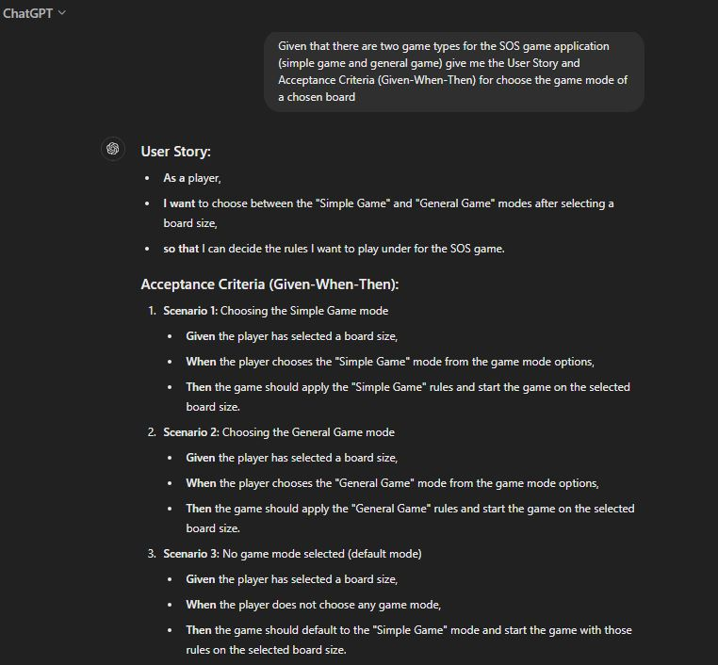

1. **Data flow diagram (DFD) (4 points):**

Consider a web-based SOS game that allows players from all over the world to play SOS games against each other (similar to chess.com for chess). Using data flow digram examples presented in class, draw the data flow diagram for your global SOS game. You may use the tool of your choice, but it is a good idea to get familiar with draw.io (https://app.diagrams.net/) or other similar tools.

