AI-Driven Real-Time Interview Platform
Final Year Project Report — Version 4.0
Implementation snapshot: branch uthman, commit 612ae79
Generated: 2026-07-20
Hamdard University Islamabad
Supervisors: Engr. Usman Javed; Engr. M. Abdullah Umar
Team: Muhammad Usman Sajid, Taimur Ali Sakhawat, Eimaan Khan Bangash, Bismah Khan Bangash

Abstract
Artificial Intelligence has transformed recruitment, yet many interview tools remain text-based,
scripted, or unable to adapt follow-ups to candidate answers in real time. This Final Year Project
delivers an AI-driven voice interview platform for Junior AI Engineer candidates: the candidate speaks
naturally in a browser; the system transcribes speech, manages a ten-domain structured interview,
evaluates answers with a transparent six-dimension LLM rubric, and produces recruiter-oriented Report v2
artifacts (JSON and HTML).
The implementation integrates Pipecat for real-time orchestration, Deepgram nova-2 for streaming speech-to-text,
Groq Llama 3.3 70B for question generation and evaluation, Cartesia for text-to-speech, and Silero voice activity
detection. A guarded dialogue pipeline (echo, meta, IDK, intent, incomplete, domain) prevents non-answers from
being scored. CoverageEngine and DecisionEngine coordinate PROBE and ADVANCE actions until the interview blueprint
is covered or a safety turn ceiling is reached.
Reporting separates candidate and recruiter experiences: after the session the candidate sees a professional
thank-you message; detailed assessment is available as HTML for recruiters (FYP demo stand-in for a future dashboard).
Evaluation calibration (July 2026) aligned hire thresholds and persona wording for junior voice interviews.
Multimodal emotion recognition, Docker production deployment, and multi-tenant scaling were deferred to preserve
a reliable end-to-end voice demo suitable for academic evaluation.

Dedication
We dedicate this project to our parents and families whose support made this work possible, and to our teachers
who guided us throughout the Final Year Project journey at Hamdard University Islamabad.

Acknowledgments
We express sincere gratitude to our supervisors Engr. Usman Javed and Engr. M. Abdullah Umar for guidance,
feedback, and support throughout this project. We thank Hamdard University Islamabad faculty and administration
for providing an environment conducive to research and development, and our families and colleagues for
encouragement during the degree program.

Project Brief
Field | Detail
Project name | AI-Driven Real-Time Interview Platform
Repository | AI-interviewer-fyp-v2
Primary branch | uthman
Objective | Adaptive voice technical interviews with automated evaluation and recruiter reports
Tools | Python, FastAPI, Pipecat, Deepgram, Groq, Cartesia, HTML/CSS/JS, GitHub, PostgreSQL (optional)

Note: In Microsoft Word, update the Table of Contents via References → Table of Contents → Update Table after opening this document.

List of Abbreviations
Abbreviation | Meaning
ASR | Automatic Speech Recognition
LLM | Large Language Model
STT | Speech-to-Text
TTS | Text-to-Speech
VAD | Voice Activity Detection
WS | WebSocket
API | Application Programming Interface
JSON | JavaScript Object Notation
FYP | Final Year Project

List of Figures
Figure | Title
3.1 | Overall system architecture (runtime entry points)
4.1 | Real-time voice processing pipeline
4.2 | Pre-evaluation guard pipeline
4.3 | Report generation and presentation flow
4.4 | Pre-interview lobby and session handshake
5.1 | Adaptive decision flow (PROBE / ADVANCE / WRAPUP)

Replace placeholder screenshots in Appendix C with captures from your demo machine before submission.

Chapter 1 — Introduction
Recruitment for technical roles increasingly relies on remote hiring and high application volumes.
Human-conducted interviews remain the gold standard for assessing communication and problem-solving,
but they are costly, difficult to scale, and subject to inconsistency. AI-assisted interviewing can
standardize structure and evaluation if the system supports natural voice interaction, adaptive follow-ups,
and honest reporting limitations.
This project implements a real-time voice interviewer that simulates a senior engineer interviewing a
junior candidate. Unlike static question banks, the platform evaluates each answer before deciding whether
to probe deeper or advance across a fixed Junior AI Engineer blueprint (ten domains). The product demo path
is a Pipecat WebSocket server with a modular browser client; FastAPI provides REST endpoints for testing and
report retrieval.

1.1 Problem Statement
Existing tools often fail on latency, turn-taking, scoring of non-answers (echoes, meta-requests, IDK),
unfair penalization due to speech recognition noise, and misleading “complete” reports after partial coverage.
This project addresses these gaps with ordered guards, transcript fairness reweighting, coverage-first wrap-up,
tiered Report v2 completion types, and live voice hardening (barge-in, silence handling, tail-fragment safety).

1.2 Objectives and Scope
ID | Objective | Status
O1 | Real-time voice interview simulation | Achieved
O2 | Adaptive questioning across blueprint domains | Achieved
O3 | Interruption / barge-in handling | Achieved with limits (RMS + VAD grace)
O4 | Behavioural / communication evaluation | Partial — text rubric proxies; no SER/facial models
O5 | Automated recruiter reporting | Achieved — Report v2 JSON + HTML
O6 | Evaluation methodology and regression tests | Achieved

1.3 Organization of Report
Chapter 2 reviews related work. Chapter 3 explains underlying technologies. Chapter 4 presents methodology
and architecture. Chapter 5 discusses results. Chapter 6 details design and implementation. Chapter 7 concludes
with limitations and future work. Appendices list configuration and report components.

Chapter 2 — Literature Review
Prior research spans resume screening chatbots, LLM conversational interview agents, ASR-based mock interviews,
adaptive dialogue managers, and multimodal behavioural analysis. Common gaps include lack of real-time voice loops,
weak follow-up adaptivity, limited guardrails for spoken meta-dialogue, and insufficient recruiter-facing structured reports.
Table 2.1 summarizes representative approaches. Our delivered system emphasizes voice robustness, deterministic guard
ordering, blueprint coverage policy, and auditable LLM rubric scoring rather than multimodal emotion fusion.
Study / approach | Technique | Limitation addressed by our work
LLM mock interview agents | Contextual question generation | Adds full voice loop + guards + coverage
ASR interview platforms | Speech input | Adds adaptive dialogue + fairness + tiered reports
Multimodal facial + speech | Behaviour features | Deferred — scope traded for stable voice MVP
Rule-based chatbots | Fixed flows | Replaced by CoverageEngine + DecisionEngine + LLM bounds
Proposed platform (this FYP) | ASR+LLM+TTS+VAD+guards+Report v2 | End-to-end Junior AI Engineer voice path

Chapter 3 — System Background

3.1 Speech and Voice Stack
Deepgram nova-2 provides streaming transcription with interim and final hypotheses. Cartesia synthesizes
interviewer speech with low latency. Silero VAD segments speech vs silence for debouncing and barge-in grace.
Pipecat composes STT, custom InterviewProcessor, and TTS in a frame-based pipeline over WebSocket transport.

3.2 Large Language Models
Groq hosts Llama 3.3 70B Versatile for JSON-structured evaluation and bounded question generation. The system
does not maintain a full chat messages[] history; each call uses constructed prompts with selective context
(recent Q&A pairs, sliding question window, resume-by-domain evidence).

3.3 Real-Time Communication
The primary demo uses WebSocket binary PCM on port 8765. A separate report HTTP server on port 8766 serves
latest JSON and HTML for FYP demonstrations. FastAPI on port 8000 supports REST testing when run in the same
process as SessionService (in-memory sessions are not shared across separate processes).

3.4 Overall Architecture
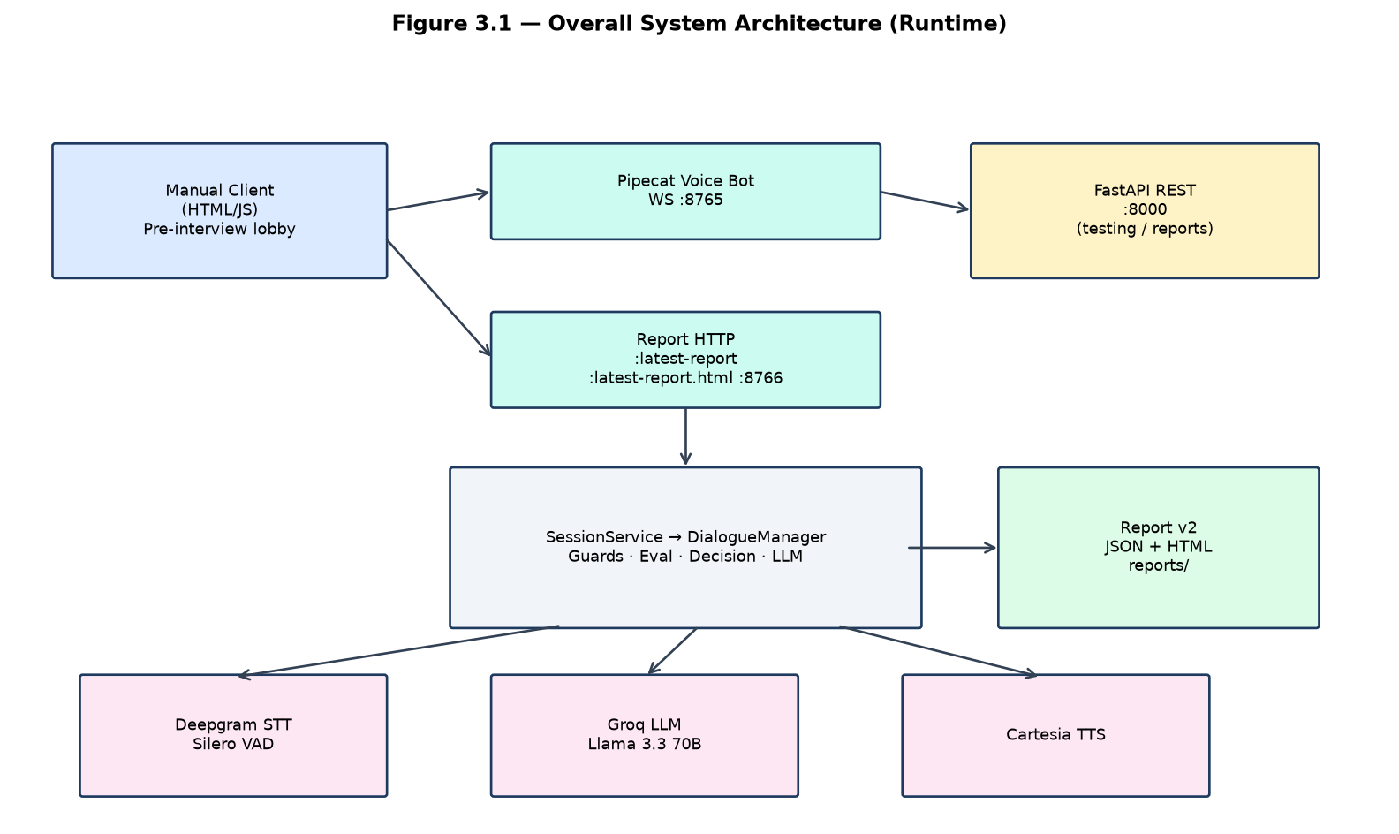
Figure 3.1 — Overall system architecture (three runtime entry points).

3.5 Automatic Speech Recognition
Streaming ASR converts candidate speech to text incrementally. Interim hypotheses support UI feedback; final
hypotheses trigger turn submission after debouncing, grace windows, and echo suppression in InterviewProcessor.
Domain keyword boosting improves recognition of technical terms (e.g. FastAPI, preprocessing). Residual errors
are mitigated by transcript cleanup, incomplete guards, and STT fairness reweighting during evaluation.

3.6 Text-to-Speech
Interviewer speech is synthesized through Cartesia and streamed to the browser as audio frames. Spoken questions
are kept short (soft ~25-word cap for domain primaries) to suit voice UX. Pre-interview instructions use the same
Cartesia voice as the live interviewer for consistent candidate experience.

3.7 Voice Activity Detection and Turn-Taking
Silero VAD identifies speech segments. VoiceTurnPolicy configures debounce duration, short-answer grace, echo
cooldown after bot speech, silence nudge/rephrase timers, and tail-fragment resume windows. Client-side RMS
barge-in may send interrupt messages; server-side grace reduces false interrupts during bot speak-out.

3.8 Evaluation Model
Dimension | Default weight
structure | 0.25
result_orientation | 0.20
ownership | 0.20
leadership | 0.15
clarity | 0.10
confidence | 0.10

Methodology identifier: llm_rubric_ensemble_lite_v1. Optional rethink pass runs on borderline weighted scores or
high spread across dimensions. Hire signal thresholds (per answer and interview aggregate alignment): Strong Hire ≥ 4.0,
Hire ≥ 3.0, Borderline ≥ 2.5. Communication and technical composites are derived for reporting profiles.

Chapter 4 — Methodology

4.1 Development Approach
Phase | Deliverable
1 | SessionService, config, interviewer policy
2 | Guard pipeline, transcript utilities, sanitizer
3 | CoverageEngine, role_registry, resume bootstrap
4 | Rubric, rethink ensemble, human-study export
5 | VoiceTurnPolicy, async Groq in Pipecat loop
6A–6C | Meta/IDK guards, transcript fairness, reporting profiles
Post-6 | Report v2, full coverage, lobby, calibration, recruiter HTML UX

Development followed phased modularisation: unified SessionService (Phase 1), guard pipeline (Phase 2),
coverage and resume bootstrap (Phase 3), evaluation rubric and rethink ensemble (Phase 4), voice operability
(Phase 5), interview flow and transcript fairness (Phase 6A–6C), then July 2026 product fixes: Report v2 package,
full blueprint coverage policy, canonical question store, pre-interview lobby, evaluation calibration, and
candidate/recruiter reporting UX separation.

4.1.1 Functional Requirements (implemented)
ID | Requirement | Implementation
FR-1 | Voice capture | Browser mic PCM over WebSocket
FR-2 | Speech recognition | Deepgram nova-2 streaming
FR-3 | Adaptive questions | CoverageEngine + LLMAdapter + DecisionEngine
FR-4 | Evaluation | Six-dimension Groq rubric + guards
FR-5 | Voice responses | Cartesia TTS via Pipecat
FR-6 | Reports | Report v2 JSON/HTML + tiered completion
FR-7 | Candidate UX | Pre-interview lobby + thank-you completion
FR-8 | Recruiter view (FYP demo) | HTML assessment + /latest-report.html

Note: Full user authentication and multi-tenant recruiter portal are out of scope for this FYP delivery.

4.2 Interview Blueprint and Policy
Junior AI Engineer domains (in order): project_overview, python, machine_learning, data_preprocessing,
model_evaluation, nlp_speech_ai, apis_backend, deployment, debugging_problem_solving, behavioral_ownership.
Policy highlights: one primary question and up to one probe per domain; max 28 total turns (safety ceiling);
max 2 hard skips; coverage-first wrap-up requiring visited blueprint for “complete” reports (~100% coverage,
wrap-up state, minimum evaluated turns).

4.3 Voice Pipeline
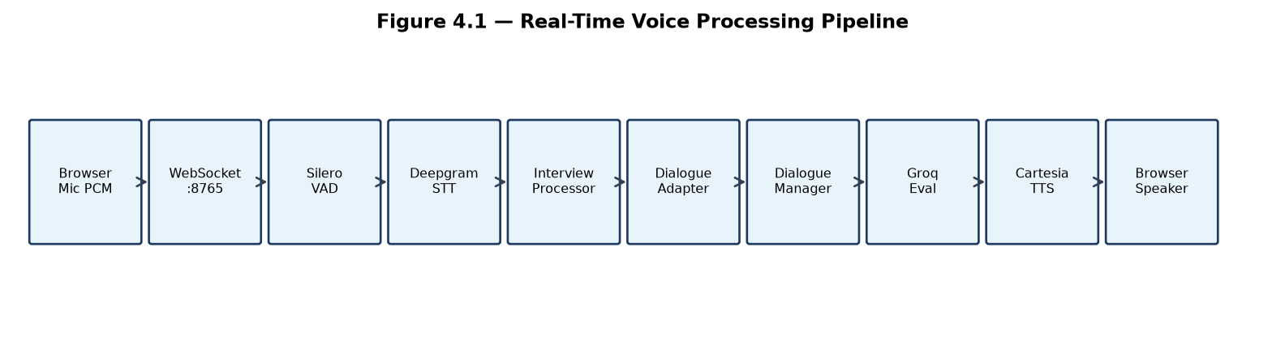
Figure 4.1 — Voice processing pipeline.

4.4 Guard and Evaluation Pipeline
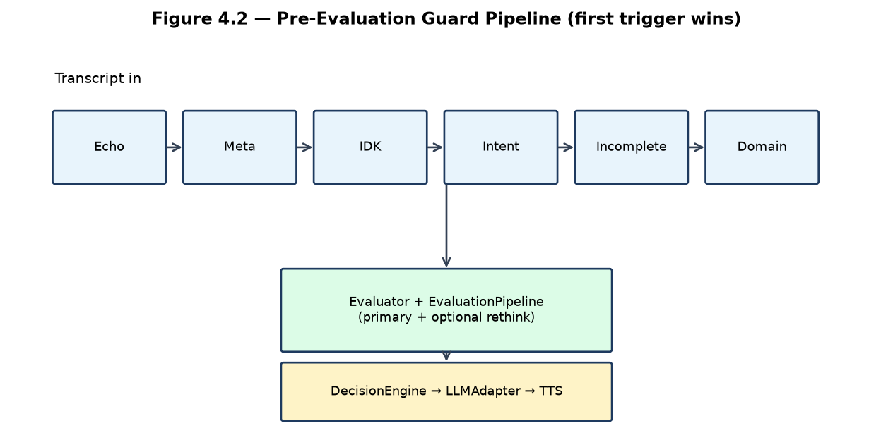
Figure 4.2 — Guard pipeline order.
Six dimensions are weighted (structure, result_orientation, ownership, leadership, clarity, confidence).
Borderline answers may trigger a rethink pass. STT fairness adjusts weights when noise, stutter, or tail-fragment
signals are detected. Per-answer hire signals use thresholds hire ≥ 3.0 and strong hire ≥ 4.0 (calibrated July 2026).
Evaluator persona: fair senior engineer for junior voice interviews.

4.5 Pre-Interview Lobby
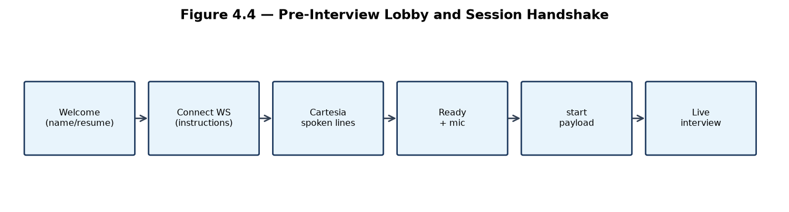
Figure 4.4 — Lobby handshake (instructions then start).
The manual client presents Welcome → Cartesia-spoken instructions (same voice as interviewer) → Ready.
WebSocket connect does not auto-start the interview; explicit {type:instructions} and {type:start} messages
separate preamble from scored dialogue.

4.6 Reporting Methodology
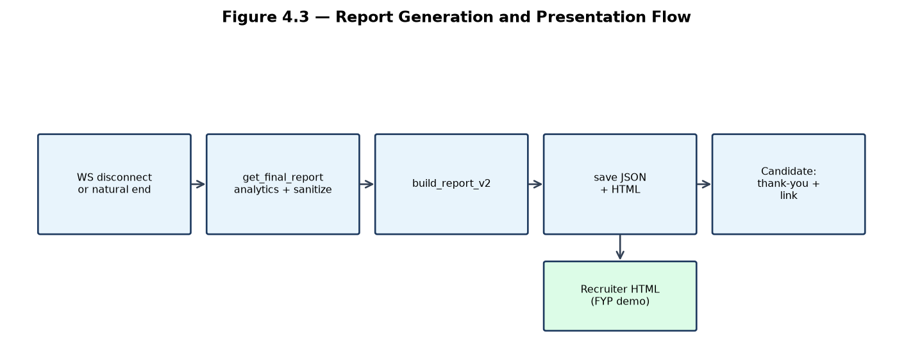
Figure 4.3 — Report generation flow.
On disconnect, DialogueManager.get_final_report builds legacy analytics, sanitizes technical-interview wording,
wraps Report v2 (report_meta, executive_summary, ratings_summary, domain_ratings, question_review,
detailed_analytics), and persists JSON plus HTML (except aborted-only JSON under reports/aborted/).
Recruiter HTML uses ratings_summary.final_recommendation; incomplete sessions show N/A recommendation with caveats.
Candidates see a thank-you panel with a demo link to /latest-report.html — not in-panel scores.

Chapter 5 — Results and Discussion

5.1 Testing Strategy
Automated regression covers session service, guards, evaluation rubric, reporting v2, canonical question behaviour,
voice UX fixes, and Pipecat integration smoke tests (scripts/run_regression.sh and backend/tests/). Live sessions
validated STT merge quality, barge-in, lobby flow, and report persistence.

5.2 Adaptive Decisions
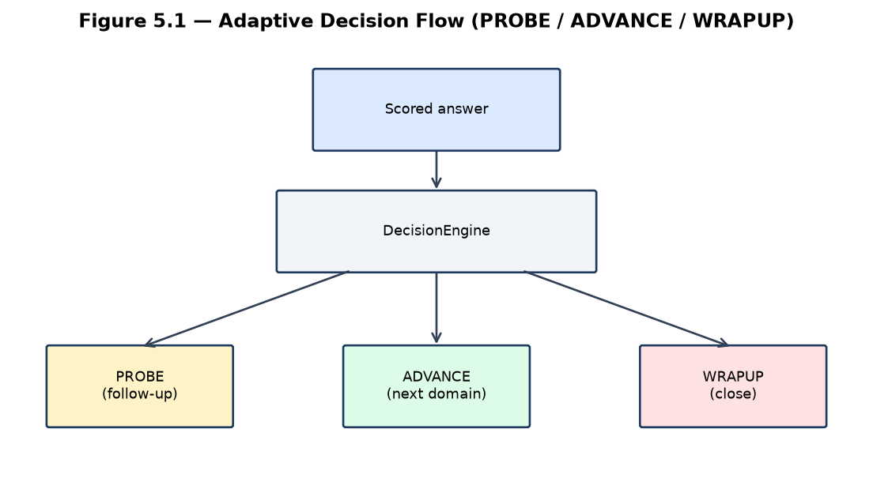
Figure 5.1 — DecisionEngine outcomes.

5.3 Illustrative Live Session Metrics
The table below illustrates metrics from a representative incomplete session (early disconnect). Low scores
reflect candidate performance, not pipeline failure; the session still produced Report v2 artifacts and adaptive trace.
Metric | Example value
Evaluated turns | 17
Domains assessed | 4 / 10
Coverage | 40%
Report type | incomplete
Recruiter recommendation (v2) | N/A (insufficient completion tier)

5.4 Discussion
The project demonstrates that a defensible FYP voice interviewer requires engineering investment in turn-taking and
guardrails, not only LLM prompt tuning. Deferred proposal items (facial emotion, Docker/Kubernetes production,
IRT/CAT psychometrics, React/Firebase frontend) were replaced by blueprint adaptivity, transcript fairness,
canonical recoveries, and honest completion tiers — choices that improved demo reliability.
Limitations remain: single concurrent voice client per bot process, cloud API dependency, ASR errors under noise,
and barge-in based on energy/VAD rather than semantic interruption detection.

Chapter 6 — System Design and Implementation

6.1 Layered Architecture
Layer | Components
Presentation | manual_client: lobby, live conversation, thank-you UX
Voice transport | interview_bot.py, InterviewProcessor, VoiceTurnPolicy
Integration | InterviewDialogueAdapter → SessionService
Dialogue brain | DialogueManager, guards, DecisionEngine, CoverageEngine, LLMAdapter
AI services | Deepgram, Groq, Cartesia, Silero via Pipecat
Reporting | backend/reporting/*, analytics.py, HTML renderer
Storage | reports/, optional PostgreSQL

6.2 Key Modules
SessionService holds in-process InterviewSession objects. DialogueManager.handle_turn orchestrates guards,
EvaluationPipeline, decisions, and question commits via set_active_question (canonical store). rephrase_policy
and idk_policy implement recovery speech without stacking duplicate questions in TTS. role_registry maps
target_role junior_ai_engineer to blueprint (extension point for future roles).

6.2.1 Canonical Question and Recovery Speech
When a primary or probe question is committed, a canonical one-sentence intent is stored. Recoveries (repeat,
clarify, redirect, IDK hint) rephrase that intent rather than concatenating prior TTS strings — preventing
multi-question stacking heard in early live demos.

6.2.2 Evaluation Calibration (July 2026)
Evaluator prompts and Groq system messages were recalibrated for junior voice interviews (fair senior engineer
persona). Per-answer hire thresholds were aligned to interview aggregates (Hire ≥ 3.0, Strong Hire ≥ 4.0). This
was a calibration change only; weights, pipeline architecture, and DecisionEngine semantics were unchanged.

6.2.3 Reporting UX
Candidates see a thank-you message and an FYP-only link to open recruiter HTML. Recruiters (or examiners) review
structured HTML generated from the same Report v2 JSON stored under reports/. See docs/RECRUITER_REPORT_CONTRACT.md
in the repository for the presentation field contract.

6.3 REST and Voice APIs
Endpoint | Purpose
POST /start, POST /chat | Text-mode interview testing
GET /report/{id} | Report v2 JSON
GET /export/human-study/{id} | Cohen's κ study export
WS :8765 | Voice PCM + control messages
GET :8766/latest-report | Latest JSON envelope
GET :8766/latest-report.html | Latest recruiter HTML

6.4 Report v2 Components
Component | Description
report_meta | Candidate, session, report_type, filename
ratings_summary | Overall, technical, communication, final_recommendation
domain_ratings | Per-blueprint-domain status
question_review | Condensed Q&A cards
interview_completion | Coverage %, evaluated turns, termination_reason
detailed_analytics | Legacy analytics blob for researchers

Chapter 7 — Conclusion
This Final Year Project delivered a working real-time AI voice interviewer with structured domain coverage,
guarded dialogue, transparent LLM evaluation, resume-aware questioning, pre-interview candidate UX, and
recruiter-oriented Report v2 output. Development evolved through six engineering phases plus focused July 2026
calibration and reporting UX work on branch uthman (commit 612ae79).
The system satisfies primary objectives for voice simulation, adaptive questioning, and automated reporting
while honestly deferring multimodal emotion analysis and production multi-tenant deployment. Future work includes
recruiter dashboard API, human κ validation using the export endpoint, optional Docker packaging, WebRTC transport,
and additional role blueprints via role_registry without forking the dialogue engine.
For viva defence: data (Report v2 JSON) is separated from presentation (HTML assessment); candidates receive
completion confirmation; scoring methodology changes in July 2026 were calibration of persona and thresholds,
not a rewrite of the evaluation pipeline architecture.

References
[1] Groq Inc., Groq API Documentation, https://console.groq.com/docs
[2] Pipecat AI, Pipecat Documentation, https://docs.pipecat.ai
[3] Deepgram Inc., Speech-to-Text API Documentation, https://developers.deepgram.com
[4] Cartesia AI, Text-to-Speech Documentation, https://docs.cartesia.ai
[5] FastAPI, FastAPI Documentation, https://fastapi.tiangolo.com
[6] H. Sun et al., MockLLM: An LLM-Based Mock Interview System, arXiv:2405.18113, 2024.
[7] I. Sommerville, Software Engineering, 10th ed., Pearson, 2016.
[8] J. Cohen, A Coefficient of Agreement for Nominal Scales, Educational and Psychological Measurement, 1960.

Appendix A — Environment Variables (selected)
Variable | Purpose
GROQ_API_KEY | LLM authentication
DEEPGRAM_API_KEY | STT authentication
CARTESIA_API_KEY / CARTESIA_VOICE_ID | TTS authentication and voice
PIPECAT_WS_PORT | Voice WebSocket (default 8765)
REPORT_HTTP_PORT | Report server (default 8766)
DATABASE_URL | Optional PostgreSQL
DEBUG_LIVE_LOGGING | Optional Groq prompt/reply traces

Appendix B — Git Evolution (summary)
Period | Theme
Jun 2026 | Phases 1–5 modular refactor
Jul 2026 early | Phase 6 voice quality, Report v2, modular client
Jul 2026 mid | Full coverage, tail fragments, canonical Q, voice UX fixes
Jul 2026 late | Pre-interview lobby, eval calibration, recruiter HTML UX

Appendix C — Suggested Screenshots for Submission
Figure | Capture
C.1 | Pre-interview Welcome screen (name/resume)
C.2 | Instructions panel with incremental bullet lines
C.3 | Live conversation transcript during interview
C.4 | Thank-you / After the interview panel
C.5 | Recruiter HTML assessment (recommendation + domain table)
C.6 | Sample JSON report file in reports/ folder
C.7 | Terminal showing interview_bot and report HTTP server

