ABSTRACT
Artificial Intelligence (AI) has transformed recruitment by enabling organizations to automate screening, assessment, and interview workflows. Nevertheless, many existing AI interview tools remain limited to text chatbots, static question banks, or shallow voice demos. Such systems often fail to simulate a realistic technical interview, struggle with live speech challenges, and provide limited structured feedback for decision-makers.

To address these limitations, this project presents AI Powered Interview Simulation and Feedback Platform, an AI-powered platform that simulates adaptive voice-based technical interviews and returns structured evaluation feedback to recruiters. The current primary use case is recruitment-oriented interviewing: a recruiter selects an interview role, creates an invite link, a candidate completes a live voice interview, and the recruiter receives an automated assessment report. The delivered specifications currently include AI Engineer, Frontend Developer, and Backend Developer tracks; these configurations illustrate the platform’s role-based design and are not a permanent limit on future domains or experience levels.

The system adopts a modular architecture comprising a recruiter dashboard, a browser-based candidate interface with a pre-interview lobby, a FastAPI session and report layer, a Pipecat real-time WebSocket voice pipeline, an intelligent dialogue management engine with a pre-evaluation guard pipeline, an evaluation module, and a Report V2 feedback subsystem. Candidate speech is transcribed using Deepgram Speech-to-Text with Silero Voice Activity Detection for turn-taking, while conversational intelligence is powered by a Groq-hosted Llama 3.3 language model. Interviewer speech is synthesised using Cartesia Text-to-Speech. Supporting components—including transcript quality assessment, silence and interruption handling, semantic duplicate prevention, coverage tracking, and completion-aware reporting—improve interview realism and the reliability of feedback.

The platform was implemented using Python, FastAPI, Pipecat, WebSockets, JavaScript, HTML, CSS, and modern AI APIs. Delivered capabilities include role-template interviews, invite-based candidate access, adaptive probe-and-advance questioning, automated multi-dimension evaluation, and recruiter-facing Report V2 outputs (JSON and HTML) with explicit complete, partial, incomplete, and aborted completion tiers. Experimental testing demonstrated stable real-time communication, effective adaptive questioning, consistent dialogue control, and reliable report generation aligned with blueprint coverage.

This project contributes an end-to-end interview simulation and feedback platform that bridges traditional online assessments and human-led interviews by combining speech technologies, adaptive dialogue control, and automated evaluation into a unified recruitment workflow. Candidate self-paced practice and personalized improvement guidance for low scores are identified as future enhancements and are not claimed as present deliverables. Speech Emotion Recognition and facial behaviour analysis likewise remain future work.

DEDICATION

We dedicate this project to our parents and families whose unconditional love, sacrifices, encouragement, and continuous support have been the foundation of our academic journey. Their belief in our abilities has motivated us to overcome challenges and pursue excellence throughout the development of this project.
We also dedicate this work to our teachers, mentors, and friends who provided guidance, inspiration, and encouragement at every stage of our studies. Their support played a significant role in helping us successfully complete this research and development effort.
Finally, this project is dedicated to all students and researchers who strive to use Artificial Intelligence for creating practical solutions that contribute positively to society and technological advancement.

ACKNOWLEDGMENTS

We express our sincere gratitude to our respected supervisors, Engr. Usman Javed and Engr. Adnan Naseem, for their invaluable guidance, continuous support, constructive feedback, and encouragement throughout the development of our project, AI Powered Interview Simulation and Feedback Platform. Their expertise and mentorship greatly contributed to the successful completion of this work.
We are also thankful to the faculty members and administration of Hamdard University, Islamabad Campus, for providing a supportive academic environment and the necessary resources required for conducting this project.
Our heartfelt appreciation goes to our families for their patience, motivation, prayers, and unwavering support during the entire duration of our degree program and project development process.
We would also like to acknowledge our friends and colleagues who assisted us through discussions, testing, feedback, and encouragement during various stages of this project.
Lastly, we are grateful to all individuals who directly or indirectly contributed to the completion of this research and development work.
Muhammad Usman Sajid (ECI-IT-22-030)
Taimur Ali Sakhawat (ECI-IT-22-030)
Eimaan Khan Bangash (ECT-IT-21-127)
Bismah Khan Bangash (ECT-IT-21-126)

PROJECT BRIEF

Project Name | AI Powered Interview Simulation and Feedback Platform
Objective | To design and develop an AI-powered interview simulation and feedback platform that enables recruiters to create role-based voice interviews, invite candidates, conduct adaptive real-time technical interviews, and obtain structured automated evaluation reports.
Submitted By | Muhammad Usman Sajid (ECI-IT-22-xxx)  Taimur Ali Sakhawat (ECI-IT-22-xxx)  Eimaan Khan Bangash (ECI-IT-22-xxx)  Bismah Khan Bangash (ECI-IT-22-xxx)
Project Supervisors | Engr. Usman Javed
Date Started | October 2025
Date Completed | July 2026
Tools Used | Python, FastAPI, Pipecat, Deepgram, Groq API, Cartesia TTS, Silero VAD, Visual Studio Code, GitHub, HTML, CSS, JavaScript, Recruiter Dashboard (Uvicorn), SMTP
System Used | Personal workstation (Windows 10/11), Python 3.12 virtual environment; local demo services on ports 8001 (recruiter dashboard), 3000 (candidate UI), and 8765/8766 (voice bot WebSocket and report HTTP).

CONTENTS

Abstract i
Dedication iii
Acknowledgments iv
Project Brief v
List of Figures vii
List of Tables x
List of Abbreviations xi

1 Introduction 1
1.1.1 Problem Statement 5
1.1.2 Organization of Project 6
2 Literature Review 8
3 System Background 16
3.1 Overall System Architecture 17
3.1.1 Frontend Layer 19
3.1.2 Backend Layer 19
3.2 Speech Processing Pipeline 20
3.2.1 Voice Activity Detection (VAD) 21
3.2.2 Automatic Speech Recognition (Speech-to-Text) 21
3.2.3 Text-to-Speech (TTS) 21
3.2.4 Real-Time Speech Processing Workflow 21
3.3 Dialogue Management 22
3.3.1 Conversation State Management 23
3.5 Large Language Model (LLM) 24
3.5.1 Prompt Engineering 24
3.5.2 Adaptive Question Generation 24
3.5.3 Follow-up Question Generation 25
3.5.4 Interview Completion 25
3.6 Candidate Evaluation Engine 26
3.6.1 Evaluation Criteria 26
3.6.2 Response Scoring 27
3.6.3 Interview Report Generation 28
3.6.4 Advantages of Automated Evaluation 28
3.7 Technology Stack 28
3.7.1 Frontend Technologies 28
3.7.2 Backend Framework 29
3.7.3 Artificial Intelligence Services 29
3.7.4 Database and Session Management 30
3.8 Real-Time Communication Framework 30
3.8.1 WebSocket Communication 30
3.8.2 Low-Latency Audio Streaming 31
3.8.3 Scalability Considerations 31
4 Methodology 32
4.1 Requirement Analysis 33
4.1.1 Functional Requirements 33
4.1.2 Non-Functional Requirements 34
4.1.3 Technology Selection 35
4.2 System Development Methodology 35
4.2.1 Requirement Gathering 36
4.2.2 System Design 36
4.2.3 System Implementation 37
4.2.4 System Testing 37
4.3 System Implementation 38
4.3.1 Frontend Implementation 38
4.3.2 Backend Implementation 38
4.3.3 WebSocket Communication 38
4.3.4 AI Service Integration 39
4.3.5 Interview Session Management 39
4.4 Speech Processing Implementation 40
4.4.1 Voice Activity Detection 40
4.4.2 Speech-to-Text Implementation 41
4.4.3 Dialogue Manager 41
4.4.4 Large Language Model Integration 41
4.4.5 Text-to-Speech Implementation 41
4.5 Interview Workflow 42
4.5.1 Interview Initialization 42
4.5.2 Candidate Interaction 43
4.5.3 Adaptive Question Generation 43
4.5.4 Candidate Evaluation 44
4.5.5 Report Generation 45
5 Results and Discussion 47
5.1 Results and Discussion 48
5.2 System Performance 50
5.3 Voice Pipeline Performance 52
5.4 Testing Results 53
5.5 System Performance Metrics 54
5.6 Sample Interview Results 55
5.7 Overall Performance Analysis 56
6 System Design and Implementation 58
6.1 System Design and Architecture 59
6.1.1 Dialogue Manager Implementation 61
6.1.2 Voice Processing Workflow 62
6.1.3 Adaptive Interview Flow 63
Guard Pipeline 64
Decision Engine 65
Coverage Engine 65
6.1.4 Service Interfaces and REST API Endpoints 65
6.1.5 Voice Runtime 67
6.1.6 Interview Reporting 67
6.1.7 Voice Quality 68
6.1.8 Security and Error Handling 68
6.1.9 Deployment Considerations 69
6.1.10 Practical Applications and Future Extensions 69
7 Conclusion 71
Bibliography 76
Appendix A Project Configuration and System Information 82
A.1 System Architecture Overview 83
A.2 Software Environment 85
A.3 Role-Specific Interview Blueprints 85
A.4 System Configuration 86
A.5 Sample Interview Screens 89
A.6 Interview Report Statistics 92
A.7 Configuration Notes 93
A.8 Development Challenges 94
Voice Processing 94
Transcript Fragmentation 94
Adaptive Interview Flow 94
Meta Conversation 95
Fair Evaluation 95
Live Voice Reliability 95
Appendix B Code Snippets 96
B.1 DialogueManager Implementation 97
B.2 Interview Processor (Pipecat) 102
B.3 FastAPI REST API 104
B.4 Evaluation Pipeline 106
B.5 Guard Pipeline 109
B.6 Transcript Processing 110
B.7 Voice Pipeline Configuration 111
B.8 Report Generation 112
B.9 Human Study Export 116
B.10 Recruiter Invite and Candidate Lobby (Excerpts) 118
Appendix C Sustainable Development Goals (SDGs) 120

LIST OF FIGURES
No. | Caption
3.1 | Overall architecture of AI Powered Interview Simulation and Feedback Platform
3.2 | Voice Activity Detection Pipeline
3.3 | Real-time Speech-to-Text processing pipeline
3.4 | Speech-to-Text Pipeline
3.4 | Text-to-Speech Pipeline
3.5 | Text-to-Speech generation process for interviewer responses
3.6 | Dialogue Management Architecture
3.8 | Large Language Model Processing Pipeline
3.9 | Candidate Evaluation Workflow
3.10 | Software technology stack of AI Powered Interview Simulation and Feedback Platform
3.11 | Real-Time Communication Pipeline
4.1 | Overall Development Methodology of AI Powered Interview Simulation and Feedback Platform
4.2 | Modular System Architecture
4.3 | Overall Implementation Workflow
4.4 | WebSocket Communication Framework
4.5 | Interview Session Management
4.6 | Speech Processing Pipeline
4.7 | Voice Activity Detection Process
4.8 | Speech-to-Text Processing
4.9 | Dialogue Management Workflow
4.10 | Large Language Model Integration
4.11 | Text-to-Speech Processing
4.12 | Complete Interview Workflow
4.13 | Adaptive Question Generation Process
4.14 | Interview Report Generation
5.1 | Complete AI Interview System Running During a Live Voice Interview
5.2 | Voice Pipeline (Candidate → STT → Dialogue Manager → LLM → TTS)
5.3 | Sample Generated Interview Report Showing Communication and Technical Score Profiles
5.4 | Domain Assessment Map Generated After Interview Completion
5.5 | Recruiter Summary and Hiring Recommendation
5.6 | Adaptive Interview Flow Showing PROBE / ADVANCE / CLOSING Decision Paths
6.1 | Overall System Architecture of AI Powered Interview Simulation and Feedback Platform
6.2 | Real-Time Voice Processing Pipeline
6.3 | Sample Generated Interview Report
A.1 | Overall architecture of AI Powered Interview Simulation and Feedback Platform
A.2 | Browser-based interview client connected to the voice server
A.3 | Live terminal showing Pipecat voice pipeline
A.4 | Real-time transcript generation using Deepgram STT
A.5 | Generated interview report in JSON format
A.6 | Recruiter report summarizing candidate performance

LIST OF TABLES

No. | Title
2.1 | Comparison of Existing AI-Based Interview Systems
4.1 | Functional Requirements of AI Powered Interview Simulation and Feedback Platform
4.2 | Non-Functional Requirements
4.3 | Development Technologies
4.4 | Development Phases of the Proposed System
4.5 | AI Services Used in the Proposed System
4.6 | Candidate Evaluation Criteria
5.1 | Final System Capabilities
5.2 | Testing Summary
5.3 | Runtime Performance
5.4 | Sample Interview Session
6.1 | Primary FastAPI REST Endpoints (Optional Text/API Path, Port 8000)
A.1 | Software environment used in the proposed system
A.2 | Interview blueprint domains
A.3 | Primary Environment Variables
A.4 | Report Components
C.1 | Alignment of AI Powered Interview Simulation and Feedback Platform with Sustainable Development Goals (SDGs)

LIST OF ABBREVIATIONS

Abbreviation | Meaning
AI | Artificial Intelligence
API | Application Programming Interface
ASR | Automatic Speech Recognition
CPU | Central Processing Unit
CSS | Cascading Style Sheets
HTML | HyperText Markup Language
HTTP | HyperText Transfer Protocol
JSON | JavaScript Object Notation
LLM | Large Language Model
NLP | Natural Language Processing
OS | Operating System
PCM | Pulse Code Modulation
RAM | Random Access Memory
REST | Representational State Transfer
RMS | Root Mean Square
SQL | Structured Query Language
SSD | Solid State Drive
STT | Speech-to-Text
TTS | Text-to-Speech
UI | User Interface
UX | User Experience
VAD | Voice Activity Detection
WS | WebSocket
SMTP | Simple Mail Transfer Protocol

CHAPTER 01

Introduction

INTRODUCTION
The rapid advancement of Artificial Intelligence (AI) has transformed numerous industries by automating complex tasks, improving decision-making, and enhancing interactive user experiences. In recruitment and talent acquisition, organizations increasingly adopt AI-powered tools for screening, ranking, online assessment, and interview coordination. Despite this progress, the technical interview remains heavily dependent on human interviewers, making it time-consuming, costly, and susceptible to inconsistency across candidates and interviewers.
Traditional online interviewing platforms often focus on scheduling or video connectivity rather than actively conducting and evaluating the interview. Many AI-based solutions rely on scripted conversations, static questionnaires, or text chatbots that do not simulate a realistic spoken technical interview. As a result, such systems provide limited support for adaptive questioning, live conversational recovery, and structured feedback that recruiters can use with confidence.
Recent advances in Large Language Models (LLMs), Automatic Speech Recognition (ASR), Text-to-Speech (TTS), and real-time conversational AI create an opportunity to build interview systems that listen, reason, speak, and report in a continuous loop. Integrated carefully, these technologies can move beyond shallow question–answer bots toward interview simulation with adaptive dialogue and automated feedback generation.
Demand for remote hiring has increased the need for standardized, scalable interview assistance. Organizations may receive large application volumes for a single role, while human interview quality can vary with interviewer style, fatigue, or question selection. An AI-powered interview simulation and feedback platform can help recruiters run consistent technical screens and obtain structured assessment artefacts after each session.
This project presents AI Powered Interview Simulation and Feedback Platform, designed to simulate professional technical interviewing behavior and to return recruiter-facing evaluation feedback. In the current implementation, the primary user is the recruiter: the recruiter authenticates to a dashboard, selects a role profile, creates an invite link, optionally shares it by copy or email, and later reviews the generated assessment report. The candidate joins through the invite, completes a pre-interview lobby, and participates in a live voice interview. Unlike conventional chatbot systems, the platform conducts natural voice conversation transcribing speech, evaluating answers, generating context-aware follow-ups, synthesizing interviewer speech, and producing structured Report V2 feedback upon completion.
To achieve real-time performance, the system adopts a modular multi-service architecture. The recruiter dashboard (FastAPI) manages authentication, invite creation, and report browsing. The candidate browser client captures audio and communicates with a Pipecat voice pipeline over WebSockets, using Silero Voice Activity Detection and Deepgram Speech-to-Text. An intelligent dialogue management engine evaluates answers, determines the next interview action, and generates interviewer responses using a Groq-hosted Llama 3.3 language model. Responses are converted to speech with Cartesia Text-to-Speech. An optional FastAPI REST layer supports text-based testing and report services alongside the voice path.
A distinguishing feature of the platform is adaptive, coverage-first dialogue management over role-specific interview blueprints. The current delivery includes configured role profiles for AI Engineer, Frontend Developer, and Backend Developer interviews; the architecture is role-driven so additional domains or experience levels may be added later without redesigning the core pipeline. Instead of relying only on a fixed question list, the system analyses responses in real time and decides whether to probe further, advance to the next domain, or move toward wrap-up after coverage goals are met. Before scoring, conversational control checks filter unsuitable or non-substantive turns so that only valid candidate answers enter the evaluation process. Question continuity controls keep interviewer prompts stable across recoveries and reduce repeated spoken questions. Coverage tracking and completion-aware reporting then provide accurate and honest feedback, even when only part of the interview blueprint has been assessed.
Feedback is a core outcome of the platform. Candidate answers are evaluated using a multi-dimensional weighted rubric spanning technical and communication-related criteria, with transcript-quality awareness so ASR artefacts do not unfairly dominate communication scores. Evaluations are aggregated into Report V2 outputs (JSON and HTML) with explicit completion tiers—complete, partial, incomplete, and aborted—so recruiters can interpret assessment results honestly rather than treating every session as fully complete.
The platform also emphasizes conversational realism through interruption handling, silence detection, transcript refinement, duplicate-question prevention, and timing policies. Voice Activity Detection recognizes when candidates begin and finish speaking, while barge-in handling allows candidates to interrupt the interviewer when appropriate.
The implementation uses Python and FastAPI for backend and recruiter services, Pipecat for real-time voice orchestration, Deepgram for Speech-to-Text, Groq for conversational intelligence and evaluation, Cartesia for Text-to-Speech, and Silero for VAD. HTML, CSS, and JavaScript implement the candidate and recruiter browser interfaces. Speech Emotion Recognition (SER) and facial behavior analysis are not part of the delivered system and remain future work. Candidate self-paced interview preparation and personalized improvement recommendations for low overall scores are likewise planned enhancements and are not claimed as present features. The current release focuses on recruiter-driven interview simulation, guarded live dialogue, coverage-first interviewing, fair text-based evaluation, and automated feedback reporting.
The significance of this project is practical as well as academic. Intelligent interview simulation can reduce interviewer workload and improve consistency of early technical screening, while structured reports provide reusable feedback artefacts for hiring discussions. The modular, role-based design supports later extension to additional interview domains, candidate self-practice modes, and richer personalized feedback without requiring those capabilities in the present deliverable.
In summary, AI Powered Interview Simulation and Feedback Platform delivers an end-to-end recruiter-oriented interview simulation and feedback workflow that integrates speech technologies, conversational AI, adaptive decision-making, guard-based recovery, coverage-first domain assessment, and automated reporting. The following sections describe the problem addressed by this research, the organization of the project, the underlying technologies, system architecture, implementation methodology, experimental evaluation, and future directions.

1.1.1 Problem Statement
The rapid growth of remote recruitment and online hiring has increased demand for intelligent interview systems that can assess candidates efficiently while reducing interviewer workload. Traditional interview processes require substantial time and expertise, and differences in interviewer style can lead to inconsistent or biased decisions.
Although several AI-based interview platforms exist, most rely on predefined questionnaires, rule-based conversations, or text-based interactions that do not accurately simulate a real technical interview. They often lack natural voice conversations, context-aware follow-up questioning, structured multi-domain coverage across selectable interview roles, recruiter-controlled invitation workflows, and completion-aware feedback reporting. Where voice interaction is implemented, practical issues such as speech recognition errors, fragmented transcripts, weak conversational control, and inaccurate completion labeling can reduce interview realism and weaken the reliability of automated feedback.
Developing a reliable interview simulation and feedback platform therefore requires not only ASR, VAD, LLM reasoning, and TTS, but also recruiter-facing session control, guard-based recovery for non-answers, coverage-first progression across a defined domain blueprint, transcript-fair evaluation, and honest report completion tiers.
There is a need for AI Powered Interview Simulation and Feedback Platform capable of conducting adaptive voice-based technical interviews under recruiter control while providing consistent, objective assessment feedback. The proposed system addresses these challenges by integrating Automatic Speech Recognition (ASR), Voice Activity Detection (VAD), Large Language Models (LLMs), Text-to-Speech (TTS), a guarded adaptive dialogue manager, coverage-first interview policy, invite-based candidate access, and Report V2 automated feedback reporting into a unified framework. Speech Emotion Recognition, facial analysis, candidate self-practice mode, and personalized study recommendations for low scores are deferred to future work and are not required for the present deliverable.

1.1.2 Organization of Project
The project is organized into seven chapters, followed by a bibliography and appendices:
- Chapter 1: Introduction presents the background of AI in recruitment, the problem statement, the scope of AI Powered Interview Simulation and Feedback Platform, and the overall organization of the project.
- Chapter 2: Literature Review reviews existing research on AI-based interview systems, conversational AI, speech processing technologies, and intelligent recruitment platforms, and identifies current limitations and research gaps.
- Chapter 3: System Background explains the system architecture and supporting technologies used in the proposed system, including the speech processing pipeline (VAD, ASR, and TTS), dialogue management, large language model integration, candidate evaluation and feedback reporting, the technology stack, recruiter and candidate interfaces, and real-time WebSocket communication.
- Chapter 4: Methodology describes requirement analysis, development methodology, system implementation, speech-processing implementation, and the end-to-end interview workflow, including adaptive questioning and evaluation.
- Chapter 5: Results and Discussion presents implementation results, phase-wise improvements, voice-pipeline behavior, testing outcomes, performance metrics, sample interview results, and overall analysis of effectiveness and limitations.
- Chapter 6: System Design and Implementation details the layered software architecture, dialogue manager, voice-processing workflow, adaptive interview flow (including guards, decisioning, and coverage), recruiter dashboard and service interfaces, Pipecat voice runtime, reporting and feedback artefacts, and deployment considerations for AI Powered Interview Simulation and Feedback Platform.
- Chapter 7: Conclusion summarizes the research contributions, discusses overall findings, identifies limitations, and outlines future work including candidate self-paced practice, personalized improvement feedback for low scores, Speech Emotion Recognition, and related multimodal extensions that remain outside the current implementation.
- Appendix A provides project configuration and system information. Appendix B presents selected code snippets. Appendix C discusses alignment with Sustainable Development Goals (SDGs).

Chapter 02
Literature Review

In this chapter, a detailed literature review of recent studies related to Artificial Intelligence (AI)-based interview systems is presented to provide an understanding of the latest developments in intelligent recruitment technologies. Researchers have proposed various approaches that integrate Machine Learning (ML), Natural Language Processing (NLP), Automatic Speech Recognition (ASR), Large Language Models (LLMs), speech synthesis, and conversational AI to automate candidate screening and interviewing. These systems aim to reduce recruitment time, improve evaluation consistency, and enhance candidate experience by minimizing manual effort and supporting intelligent decision-making. Recent advancements in speech processing, dialogue management, and generative AI have further enabled adaptive interview platforms capable of conducting interactive, context-aware conversations. The increasing demand for remote recruitment has also encouraged organizations to adopt interviewing solutions that are scalable and more consistent than purely manual processes. However, existing solutions still face challenges such as limited real-time voice interaction, weak adaptive follow-up behavior, incomplete automated evaluation and feedback reporting, rigid predefined workflows, and limited support for recruiter-controlled interview delivery. Reviewing previous research therefore helps identify these gaps and provides the foundation for developing the proposed AI Powered Interview Simulation and Feedback Platform.
The study proposed an AI-powered recruitment framework that integrates Machine Learning techniques to automate candidate screening and preliminary interviews [2]. The system analyzes applicant resumes, compares candidate qualifications with predefined job requirements, and conducts structured interviews using predefined conversational workflows. Machine learning algorithms are employed to rank candidates according to their technical skills, educational background, work experience, and overall suitability for specific job roles. The proposed framework significantly reduces manual effort during the initial stages of recruitment while improving consistency in candidate selection. Experimental results demonstrated improved recruitment efficiency by reducing manual screening effort, increasing consistency in candidate evaluation, and shortening the overall hiring process. The framework also assists recruiters by filtering large numbers of applications within a shorter period. However, the system relies on fixed interview questions and lacks adaptive dialogue management, real-time voice communication, intelligent follow-up questioning, and contextual understanding, limiting its ability to simulate realistic technical interviews and evaluate higher-order problem-solving abilities.
The authors presented a conversational AI interview system based on Large Language Models (LLMs) for conducting intelligent candidate interviews [3]. The proposed system generates context-aware interview questions, maintains conversational flow, and evaluates candidate responses using Natural Language Processing techniques. By understanding previous responses, the system is capable of producing more relevant follow-up questions, thereby creating a more engaging and personalized interview experience. The integration of transformer-based language models enables the interviewer to provide human-like interactions while maintaining coherence throughout the conversation. Experimental evaluation showed improved interaction quality, better candidate engagement, and more natural conversations compared to traditional rule-based chatbot systems. Despite these advantages, the system depends heavily on cloud-based AI services and requires high computational resources, which may increase response latency, operational cost, deployment complexity, and dependency on reliable internet connectivity.
The research introduced an Automatic Speech Recognition (ASR)-based interview platform that enables candidates to communicate through natural voice instead of text [4]. Speech input is converted into textual form for further processing and evaluation, providing a more realistic and interactive interview experience. The platform incorporates modern speech recognition algorithms capable of handling continuous voice conversations while reducing the need for manual typing during interviews. Integration with language processing modules enables automatic understanding of candidate responses and supports conversational interaction. Experimental results demonstrated high transcription accuracy under controlled environments and significantly improved user interaction by enabling hands-free communication. Nevertheless, speech recognition performance decreased in noisy environments, for speakers with diverse accents, and during overlapping speech, affecting transcription quality and the overall reliability of candidate evaluation.
The study developed an adaptive dialogue management system capable of generating follow-up interview questions according to candidate responses [5]. The system continuously analyzes conversation context, determines candidate knowledge levels, and dynamically adjusts interview difficulty based on previous answers. This adaptive questioning strategy enables more effective assessment of technical skills while maintaining a natural interview flow throughout the session. The dialogue manager also attempts to prevent abrupt topic transitions and ensures logical progression between interview questions. Experimental results demonstrated improved interview flexibility, enhanced candidate engagement, and better evaluation of technical knowledge when compared to static interview systems. However, maintaining long conversational context, preventing repetitive questioning, handling unexpected candidate responses, and balancing interview coverage across multiple technical topics remained significant challenges during extended interview sessions.
The authors proposed an AI-based candidate assessment system that combines Natural Language Processing (NLP) and Machine Learning algorithms to evaluate candidate responses during interviews [6]. The system analyzes semantic meaning, communication quality, response relevance, grammatical correctness, and linguistic patterns to generate automated performance scores. By applying machine learning models, the framework provides objective and consistent evaluation across multiple candidates while reducing dependence on manual scoring by recruiters. The proposed approach also assists interviewers by identifying strengths and weaknesses in candidate responses through automated analysis. Experimental results indicated improved evaluation consistency, reduced recruiter workload, and faster candidate assessment compared to conventional manual evaluation methods. However, the system primarily focused on textual responses and lacked support for real-time voice interaction, adaptive questioning, emotional understanding, and continuous conversational assessment.
The study presented a multimodal interview analysis framework that integrates speech, facial expressions, and textual responses to assess candidate performance [7]. The proposed system extracts verbal and non-verbal features using deep learning models to evaluate communication skills, confidence, behavioural characteristics, and overall interview performance. By combining multiple sources of information, the framework achieves more comprehensive candidate assessment than systems relying solely on textual responses. Experimental evaluation demonstrated improved prediction accuracy and better understanding of candidate behavior during interviews. The proposed approach also supports behavioral analysis by incorporating visual cues alongside speech and language processing. However, the framework requires high computational resources, specialized hardware, high-quality video input, and additional processing time, making large-scale real-time deployment more challenging in practical recruitment environments.
The researchers developed a real-time conversational AI platform designed to simulate human interviewers using Large Language Models and speech processing technologies [8]. The platform supports continuous dialogue, generates context-aware follow-up questions, and provides automated feedback based on candidate responses. Integration of speech recognition, language generation, and speech synthesis enables candidates to interact naturally without relying on predefined conversational scripts. The adaptive nature of the platform improves interview realism by allowing conversations to evolve according to candidate performance and response quality. Experimental results showed enhanced interview realism, improved user engagement, and more personalized interview experiences compared to conventional chatbot systems. Despite these advantages, the platform experienced occasional response latency, increased computational requirements, and dependency on stable internet connectivity because most processing was performed using cloud-based AI services.
The study proposed an intelligent recruitment platform that integrates Automatic Speech Recognition (ASR), Large Language Models (LLMs), and Text-to-Speech (TTS) technologies to conduct voice-based interviews [9]. The system enables candidates to communicate naturally while automatically evaluating technical knowledge, communication skills, response quality, and overall interview performance. The integration of speech recognition, conversational AI, and speech synthesis creates a complete voice-based interviewing pipeline that closely resembles interviews conducted by human recruiters. The platform also generates automated evaluation reports that assist recruiters during the hiring process. Experimental results demonstrated improved interview automation, reduced recruiter workload, consistent candidate evaluation, and enhanced interview efficiency. However, the proposed system provided limited support for dynamic interview progression, interruption handling, duplicate question prevention, advanced conversational memory, and comprehensive recruiter reporting, leaving opportunities for further research and improvement.
Despite progress in AI-assisted recruitment, several gaps remain between published systems and a reliable live technical interview simulation and feedback platform. Many platforms still depend on text chatbots or fixed questionnaires and therefore do not deliver continuous adaptive voice interviews. Where voice is supported, speech pipelines often under-address practical turn-taking and conversational-control problems that reduce interview realism and can distort automated scoring. Adaptive dialogue work frequently improves follow-up generation but provides limited mechanisms for structured multi-domain coverage across selectable interview roles, prevention of premature interview completion, and transparent progression across a role-specific blueprint.
Automated evaluation studies commonly score textual answers, yet fewer systems combine speech processing, conversational control, multi-dimensional scoring, and recruiter-oriented feedback reporting in one pipeline. Multimodal approaches that incorporate facial expression or speech-emotion recognition can enrich behavioral analysis in research settings, but they introduce hardware, privacy, and compute costs that are difficult to deploy in a real-time interview loop; such modalities are treated in this project as a future research direction rather than a present implementation requirement. Likewise, reporting modules in prior systems are often shallow, lacking completion-aware summaries that distinguish complete, partial, or incomplete interviews when blueprint coverage is unfinished.
Collectively, the literature indicates a need for an integrated system that unifies adaptive voice interview simulation, conversational AI dialogue control, robust speech processing, automated evaluation, and structured feedback reporting while supporting recruiter-controlled delivery and coverage-aware interview progression.

Table 2.1 Comparison of Existing AI-Based Interview Systems
Study / Model | Key Technique | Dataset Evaluation | Performance Metric | Notes
AI Interview Systems Survey [1] | Comprehensive review of AI-based recruitment, NLP, ASR, and LLM technologies | Review of existing AI interview literature | Identifies current trends and research challenges | Highlights limitations such as lack of adaptive dialogue, real-time voice interaction, and comprehensive evaluation frameworks; limited emphasis on recruiter invite workflows and completion-aware feedback reporting.
MockLLM (Sun et al.) [2] | LLM-based adaptive interview agent with contextual dialogue | Mock interview benchmark and human evaluation | High contextual relevance and human-like questioning | Generates adaptive questions but lacks real-time voice interaction and interruption handling.
InterviewBot (Wang et al.) [3] | Conversational AI using LLMs for technical interviews | Simulated technical interview sessions | Improved interview quality and automated evaluation | Limited transparency in scoring and recruiter reporting.
InterviewEase (Kothari et al.) [4] | Resume-aware interview generation using NLP | Resume dataset and interview scenarios | Personalized interview generation | Focuses mainly on resume-based questioning and lacks adaptive dialogue.
Khapekar et al. (2025) [5] | AI-powered mock interview platform | User evaluation and mock interview sessions | Improved interview preparation and user engagement | Limited support for real-time voice conversations.
Jagtap et al. (2025) [6] | Multimodal interview analysis using speech and facial expressions | Video interview datasets | Enhanced behavioural assessment | Requires facial analysis and high computational resources.
Koshti et al. (2025) [7] | Machine Learning-based recruitment and candidate screening | Recruitment datasets | Improved candidate filtering efficiency | Primarily designed for screening rather than technical interviewing.
Amrutha et al. (2024) [8] | Voice and emotion analysis for interview assessment | Speech and interview recordings | Better communication assessment | Emotion analysis is sensitive to environmental noise and recording quality.

Building on the reviewed literature, this project contributes AI Powered Interview Simulation and Feedback Platform, aligned to the identified gaps. In adaptive voice interviewing, the system conducts live WebSocket-based interviews using Pipecat orchestration with Deepgram speech recognition, Silero voice activity detection, and Cartesia speech synthesis, enabling continuous spoken interaction rather than text-only assessment. In conversational AI, a dialogue manager applies coverage-first progression over role-specific blueprints currently including AI Engineer, Frontend Developer, and Backend Developer roles and uses conversational control checks so non-substantive turns do not enter scoring as valid answers. In automated evaluation, candidate answers are assessed with a multi-dimensional weighted rubric and transcript-quality awareness so recognition noise does not unfairly dominate communication scores. In feedback reporting, Report V2 produces recruiter-facing JSON and HTML artefacts with explicit completion tiers that reduce premature “complete” labelling when interviews are unfinished. The current primary use case is recruiter-driven interviewing via invite links and dashboard report review. Candidate self-paced practice and personalized improvement guidance for low scores, together with multimodal emotion and facial analysis, are acknowledged as future directions and remain outside the scope of the delivered system.

Chapter 3
System Background

This chapter presents the technical background of AI Powered Interview Simulation and Feedback Platform. The system unifies real-time speech processing, adaptive dialogue management, automated evaluation, and recruiter-oriented feedback reporting. The descriptions below reflect the current repository implementation, including the Pipecat voice path, the recruiter dashboard, FastAPI services, and the DialogueManager-centred interview engine.

3.1 Overall System Architecture
The system follows a modular multi-service architecture with a single interview brain. The primary interview path is a Pipecat WebSocket voice server that streams Pulse Code Modulation (PCM) audio between the candidate browser client and the backend. A dedicated recruiter dashboard application provides authentication, role-based invite creation, optional invitation email, and report browsing. A FastAPI application provides REST endpoints for session control, text-based testing, and report retrieval. The voice runtime shares an in-process SessionService that owns interview sessions and delegates each turn to the DialogueManager.
The implemented ports are as follows. The recruiter dashboard listens on port 8001. The candidate browser interface is typically served on port 3000. The Pipecat voice WebSocket listens on port 8765 for PCM audio and JSON control messages such as start and interrupt. A lightweight Report HTTP helper on port 8766 serves the latest report artefact after an interview ends. An optional FastAPI REST application may listen on port 8000 for text-based testing.
In the delivered recruitment workflow, a recruiter selects an interview role, creates an invite link, and shares it with a candidate. The candidate joins through the invite, completes a pre-interview lobby, and then streams microphone audio continuously as WebSocket PCM. WebRTC is not part of the current transport and remains future work only. On the voice path, Deepgram performs streaming speech-to-text, Silero provides voice activity detection, and Cartesia synthesises interviewer speech. Between speech services and the dialogue engine, InterviewProcessor applies turn-taking policy and submits candidate text through InterviewDialogueAdapter into SessionService. SessionService then invokes DialogueManager for conversational control, evaluation, coverage decisions, and next-question generation. Completed interviews persist Report V2 JSON and HTML feedback artefacts under the project reports directory for recruiter review.

Figure 3.1 Overall System Architecture

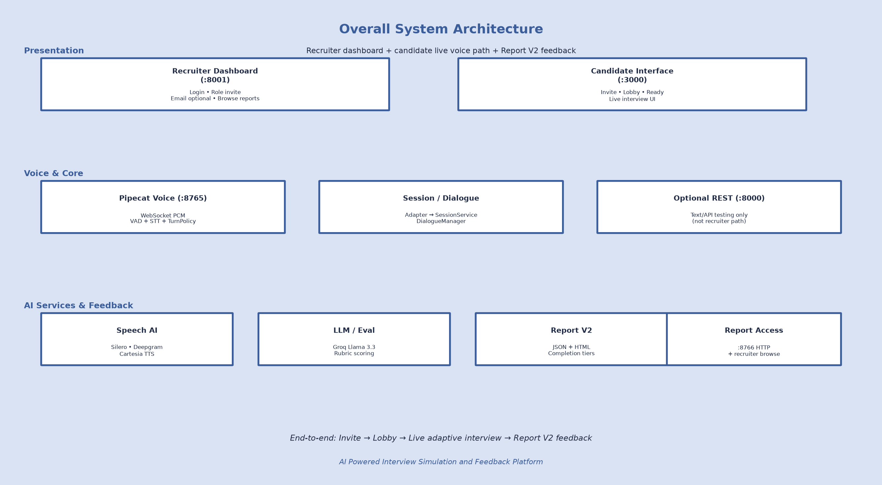

3.1.1 Frontend Layer
The frontend comprises two browser surfaces. The candidate interface is a modular HTML, CSS, and JavaScript client that resolves invite links, presents a pre-interview lobby, captures microphone audio, streams PCM over the Pipecat WebSocket, plays Text-to-Speech audio, renders live conversation events, and provides post-interview thank-you navigation to the assessment report. The recruiter dashboard is a separate HTML/CSS/JavaScript FastAPI application used to sign in, create role-based invites, copy or optionally email invitation links, and browse generated feedback reports.

3.1.2 Backend Layer
The backend comprises the Pipecat interview bot for real-time voice, FastAPI services for optional text testing and report helpers, and the recruiter dashboard application for invite and report management. InterviewDialogueAdapter is the plain-text bridge from the voice processor into SessionService. SessionService creates and updates sessions, while DialogueManager orchestrates each scored turn. Supporting packages include role configuration, evaluation, reporting, an invite store persisted as local JSON, and optional PostgreSQL persistence with an in-memory fallback.
Frontend
Browser Manual Client
Mic PCM + TTS playback
conversation_event UI
Backend Runtimes
• Pipecat interview_bot :8765
• FastAPI main.py :8000
• Report HTTP :8766
Shared brain
SessionService → DialogueManager
InterviewDialogueAdapter bridges voice path to dialogue logic
Figure 3.12: Frontend–Backend Architecture of AI Powered Interview Simulation and Feedback Platform.
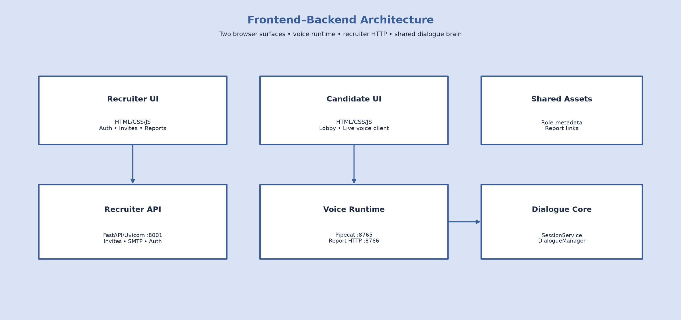

3.2 Speech Processing Pipeline
Speech processing is central to the live interview experience. The implemented pipeline combines Silero Voice Activity Detection, Deepgram Speech-to-Text, Cartesia Text-to-Speech, and VoiceTurnPolicy controls for debounce, silence handling, barge-in, and tail-fragment safety.
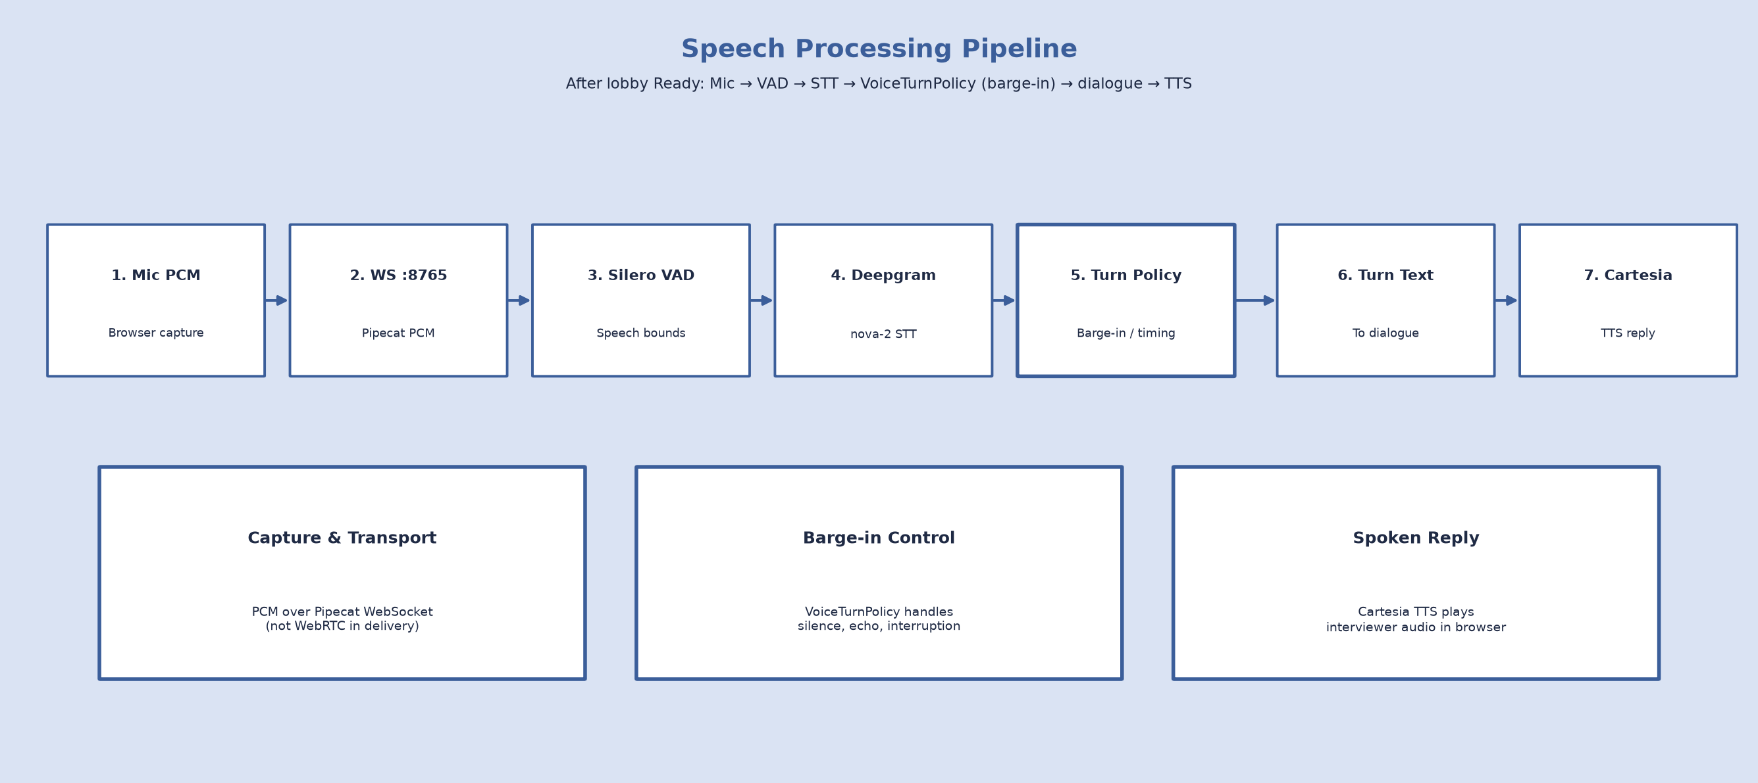
Figure 3.2: Speech Processing Pipeline (Silero VAD, Deepgram STT, VoiceTurnPolicy, Cartesia TTS).

3.2.1 Voice Activity Detection (VAD)
Silero VAD, integrated through Pipecat, detects when the candidate starts and stops speaking. Speaking frames drive turn debounce, silence watches, and barge-in grace windows so the system does not treat every pause or noise burst as a completed answer.


3.2.2 Automatic Speech Recognition (Speech-to-Text)
Deepgram provides streaming Speech-to-Text using the nova-2 model configuration. Interim and final transcripts are merged and cleaned before dialogue submission. Transcript quality signals support fairness adjustments later in evaluation when recognition artefacts are likely.

3.2.3 Text-to-Speech (TTS)
Cartesia converts interviewer questions and recovery prompts into spoken audio returned over the WebSocket to the browser playback path. Closing and recovery speech use controlled wording so recoveries do not stack duplicated spoken questions.

3.2.4 Real-Time Speech Processing Workflow
The end-to-end voice workflow is: browser microphone PCM over WebSocket port 8765; Silero VAD; Deepgram STT; InterviewProcessor with VoiceTurnPolicy; InterviewDialogueAdapter and SessionService; DialogueManager; Cartesia TTS; browser playback; and on disconnect, Report V2 persistence with client fetch from Report HTTP port 8766.
VoiceTurnPolicy coordinates debounce timing, echo cooldown, short-answer grace, silence nudge and rephrase behaviour, and a post-submit tail-fragment resume window so late speech fragments are not mishandled as new answers. Client-side barge-in uses RMS-based interruption signalling, complemented by server VAD grace to reduce false interrupts. These mechanisms address common live-interview failures including premature finalisation and truncated speech-recognition tails.

3.3 Dialogue Management
Dialogue management is implemented primarily in DialogueManager. Each candidate transcript is prepared for evaluation, passed through conversational control checks, and if the turn is eligible evaluated and advanced by DecisionEngine under CoverageEngine constraints. The interview progresses from INTRO, through technical and behavioural domain coverage on the selected role blueprint, to WRAPUP. Current role profiles include AI Engineer, Frontend Developer, and Backend Developer; additional roles may be introduced later without redesigning the core dialogue pipeline.
Before scoring, ordered conversational control checks filter unsuitable or non-substantive turns so that only valid answers enter evaluation. These checks improve live-interview robustness under noisy speech conditions and conversational interruptions without treating control or recovery turns as scored interview content.
Canonical question handling stores a clean active question intent when a primary or probe question is committed. Recovery speech is produced through rephrase policy so the interviewer can restated or clarify a question while preserving meaning and reducing stacked spoken prompts. CoverageEngine tracks domain progression, probe limits, and wrap-up rules under a coverage-first policy: the interview prefers full blueprint coverage before closing, and a turn ceiling acts as a safety limit rather than an early hard stop.

Figure 3.3: Dialogue Management Architecture
prepare_transcript
GuardPipeline
Evaluator
(adaptive)
DecisionEngine
+ CoverageEngine
LLM generate /
canonical question
InterviewContext
update
Figure 3.3: Architecture of the dialogue management module illustrating the interaction between the conversation memory, evaluation engine, interview state management, and language model.

3.3.1 Conversation State Management
Interview state lives in InterviewContext, accessed through SessionService. The context records turn history, evaluations, coverage status, canonical question fields, and recent question–answer pairs used for continuity. Optional PostgreSQL persistence stores sessions for reporting recovery; it is not replayed as a full chat history into every LLM call.
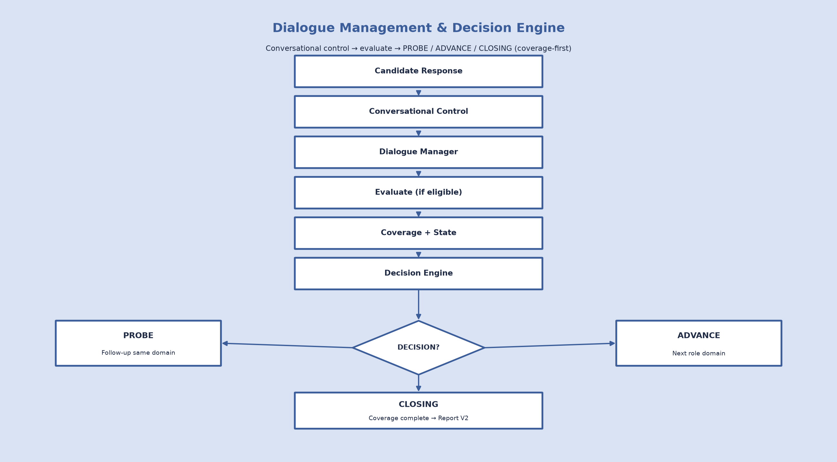

3.5 Large Language Model (LLM)
Conversational intelligence and adaptive evaluation use the Groq API with the Llama 3.3 70B Versatile model (configurable via environment settings). The LLM supports introduction generation, bounded domain questioning, follow-up probes, and adaptive evaluation prompts.

3.5.1 Prompt Engineering
System and task prompts enforce interviewer behaviour: ask one question at a time, avoid coaching sample answers in normal flow, and stay on the current domain intent. Output sanitization removes coaching-style phrasing when needed.

3.5.2 Adaptive Question Generation
When advancing domains, question generation prefers on-domain resume evidence and domain seeds, then a bounded LLM ask, with fallback to seed wording. Technical domains avoid unrelated generic bank fallbacks. Spoken domain primaries are constrained to short questions, rejecting multi-question or overlong outputs where possible.
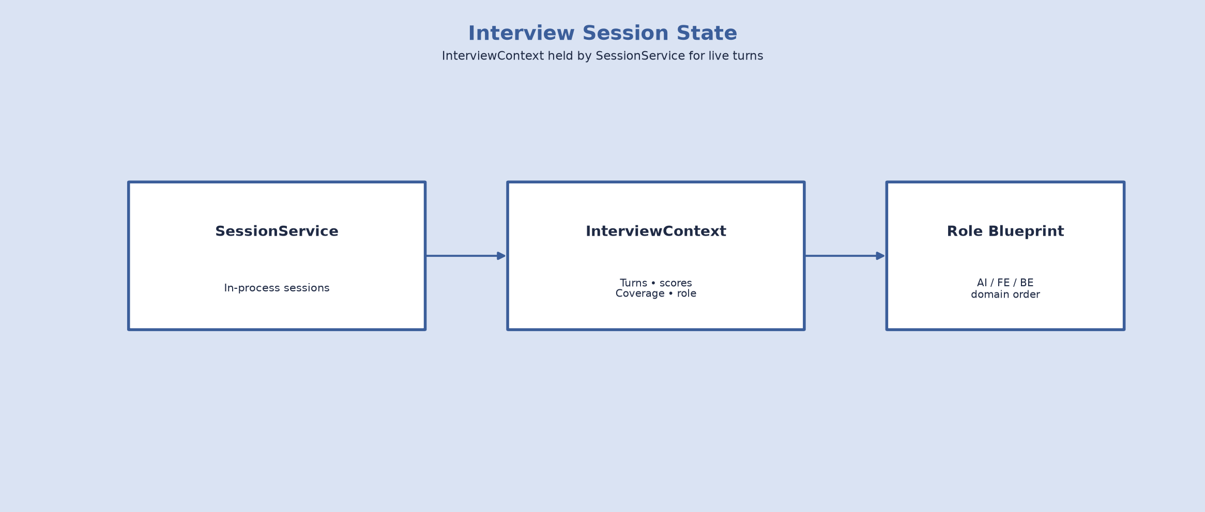

3.5.3 Follow-up Question Generation
Follow-ups are produced when DecisionEngine selects PROBE within per-domain probe limits. Recent Q&A memory injects the last few answer-aware pairs into question prompts, and a sliding window of recent questions reduces near-duplicate asks together with semantic deduplication.

3.5.4 Interview Completion
Completion is coverage-aware. After blueprint domains are visited under coverage-first rules, or when the safety turn ceiling is reached, the system moves to WRAPUP, speaks a controlled closing message, ends the voice task, and generates Report V2 feedback with an explicit completion tier such as complete, partial, incomplete, or aborted.

3.6 Candidate Evaluation Engine
Each scored answer is evaluated using an auditable large-language-model rubric rather than a single opaque score. The implemented method is a lite ensemble rubric in which a primary evaluation may be followed by a borderline rethink pass. Evaluation occurs only after GuardPipeline allows the turn to proceed.

3.6.1 Evaluation Criteria
The system uses exactly six rubric dimensions:
- 1. structure (weight 0.25) — organization of the answer;
- 2. result_orientation (weight 0.20) — outcomes and impact;
- 3. ownership (weight 0.20) — personal responsibility;
- 4. leadership (weight 0.15) — influence and coordination;
- 5. clarity (weight 0.10) — communicative clarity;
- 6. confidence (weight 0.10) — delivery confidence.
- These weights sum to 1.0 and are defined in the central rubric module used by evaluation, analytics, and reporting.

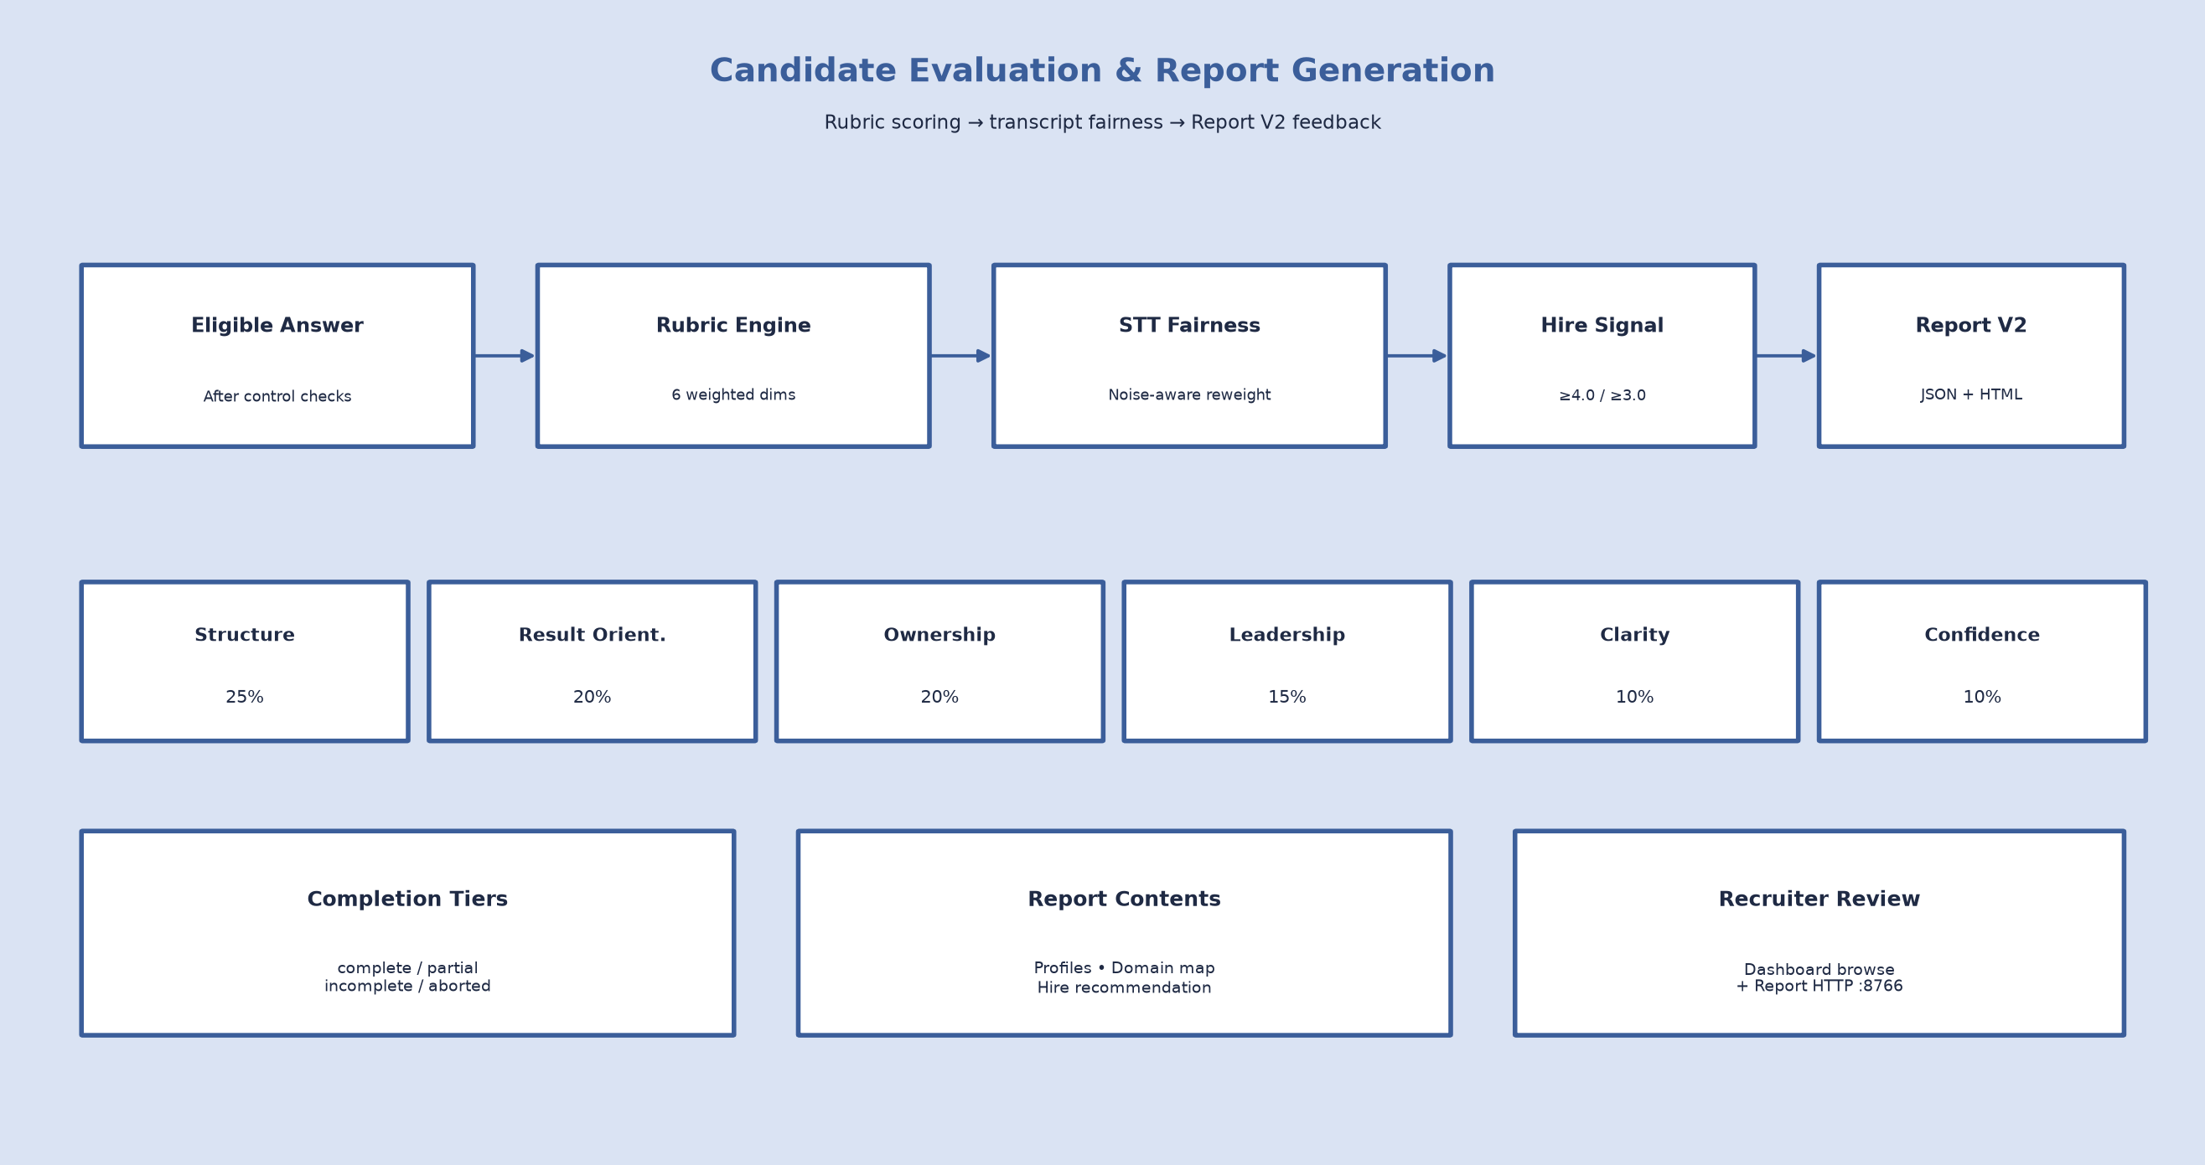

Figure 3.9: Candidate evaluation workflow illustrating the assessment of multiple performance criteria.

3.6.2 Response Scoring
Dimension scores are combined into a weighted overall score. Per-answer hire-signal bands include strong hire at or above 4.0 and hire at or above 3.0 on the weighted scale. When transcript quality indicates speech-recognition artefacts such as noise flags, stutter prefixes, high cleanup reduction, or likely tail fragments alternate fairness weights reduce the influence of communication-oriented dimensions so candidates are not unfairly penalized for ASR errors. Communication and technical profile aggregates are derived for feedback reporting.

3.6.3 Interview Report Generation
After the interview, analytics are wrapped by the Report V2 generator into versioned JSON and HTML feedback artefacts. Reports include score profiles, domain assessment maps, adaptive traces where available, hire recommendations, and completion classification. Aborted sessions with no evaluated turns are isolated under an aborted reports path. Recruiters review these artefacts through the dashboard report browser as well as via the Report HTTP helper.

3.6.4 Advantages of Automated Evaluation
Automated rubric scoring improves consistency across candidates, reduces manual scoring effort, supports adaptive probe-or-advance decisions, and produces recruiter-readable feedback artefacts. Transcript-fair weighting improves robustness under imperfect live transcription without claiming speech-emotion or facial analysis capabilities.

3.7 Technology Stack
The delivered stack is defined by the repository requirements files and runtime configuration. Core Python dependencies include FastAPI, Uvicorn, python-dotenv, websockets, the Groq client, and optional psycopg2-binary for PostgreSQL. The voice path depends on pipecat-ai with Deepgram, Cartesia, WebSocket, and Silero extras. Exact package versions are those resolved from requirements.txt and requirements-pipecat.txt in the project environment; the repository pins the package set rather than hard-coding marketing version numbers in source.

3.7.1 Frontend Technologies
HTML, CSS, and modular JavaScript implement the candidate client and the recruiter dashboard, including invite resolution, lobby interaction, WebSocket PCM streaming, barge-in control, conversation rendering, and report loading.

3.7.2 Backend Framework
Python with FastAPI and Uvicorn provides the recruiter dashboard on port 8001 and optional REST testing services on port 8000. Pipecat provides the real-time voice runtime on WebSocket port 8765, with Report HTTP on port 8766.
Client
HTML, CSS, JavaScript
Orchestration
Pipecat + Silero VAD
STT / TTS
Deepgram nova-2 · Cartesia
LLM
Groq Llama 3.3-70B
REST / State
FastAPI · SessionService
Reporting
Report V2 JSON/HTML · :8766
Figure 3.7: Software technology stack of AI Powered Interview Simulation and Feedback Platform.

3.7.3 Artificial Intelligence Services
Deepgram nova-2 is used for streaming STT. Groq hosts Llama 3.3 70B Versatile for dialogue and evaluation. Cartesia provides TTS. Silero provides VAD through Pipecat.

3.7.4 Database and Session Management
SessionService maintains in-process interview state for the voice runtime. Recruiter invites are stored in a local JSON invite store. Optional PostgreSQL persistence stores sessions and responses when DATABASE_URL is configured; otherwise the system continues with in-memory sessions and file-based Report V2 feedback artefacts.

3.8 Real-Time Communication Framework
Real-time interviewing uses persistent WebSocket connections for PCM audio and control events. This design avoids request–response HTTP polling for every audio frame.

3.8.1 WebSocket Communication
The browser connects to the Pipecat WebSocket server for bidirectional audio and JSON messages, including conversation_event payloads for the live transcript UI. FastAPI may optionally expose a development text WebSocket for simulation, separate from the product voice path.
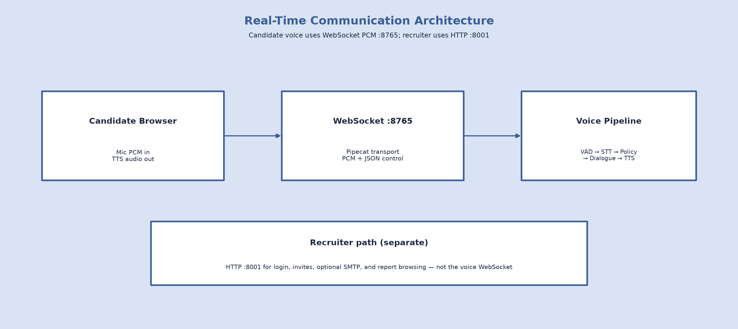

Figure 3.8: Real-time communication architecture using WebSocket technology.

3.8.2 Low-Latency Audio Streaming
PCM streaming, interim transcription, and asynchronous offloading of LLM calls from the voice event loop reduce blocking during live turns. VoiceTurnPolicy timings further stabilise turn boundaries.

3.8.3 Scalability Considerations
The current architecture targets a single-demo, single-process voice deployment suitable for academic evaluation, alongside a separate recruiter dashboard process. Multi-worker shared session stores, container orchestration, and WebRTC transport are out of scope for the present implementation and may be considered in future work. Candidate self-paced practice and personalised improvement guidance for low scores are likewise future enhancements rather than delivered capabilities.

Chapter 4
Methodology

This chapter describes the methodology used to design and implement AI Powered Interview Simulation and Feedback Platform. It covers requirement analysis, phased development, system and speech-processing implementation, and the end-to-end interview workflow as realized in the repository, including recruiter-driven invite delivery and structured feedback reporting.

4.1 Requirement Analysis
Requirement analysis identified functional and non-functional needs for a live voice interview simulation and feedback platform with recruiter-controlled session delivery, adaptive questioning, conversational control, coverage-first progression, rubric evaluation, and Report V2 feedback outputs.

4.1.1 Functional Requirements
Functional requirements cover recruiter invite creation and role selection, candidate lobby access, microphone PCM capture and streaming, STT/TTS, conversational control, coverage-first adaptive questioning with PROBE / ADVANCE / CLOSING decisions, six-dimension evaluation, and Report V2 feedback generation. The major functional requirements are summarised in Table 4.1.

Table 4.1: Functional Requirements of AI Powered Interview Simulation and Feedback Platform
Requirement ID | Functional Requirement | Description
FR-1 | Recruiter Invite and Session Start | Recruiter authenticates, selects an interview role (AI Engineer, Frontend Developer, or Backend Developer), and creates an invite. Candidate opens the invite, completes the lobby, and SessionService bootstraps the selected role profile.
FR-2 | Voice Input | Browser captures microphone PCM and streams over WebSocket (Pipecat WebSocket port 8765).
FR-3 | Speech Recognition | Streaming STT with VAD and turn policy (Deepgram nova-2 + Silero VAD + VoiceTurnPolicy).
FR-4 | Adaptive Questioning | Role-blueprint domain progression with PROBE / ADVANCE / CLOSING decisions (CoverageEngine + DecisionEngine + Groq Llama 3.3).
FR-5 | Candidate Evaluation | Six-dimension weighted rubric with transcript fairness (evaluation/rubric.py via Evaluator).
FR-6 | Voice Response | Interviewer speech synthesis and playback (Cartesia TTS over WebSocket).
FR-7 | Feedback Report Generation | Versioned recruiter feedback reports with completion tiers (Report V2 JSON/HTML), available via Report HTTP and the recruiter dashboard report browser.

4.1.2 Non-Functional Requirements
Non-functional requirements emphasise low-latency voice turn-taking, reliability under STT noise (including conversational recovery), maintainability of the modular backend, and honest completion-aware feedback for recruiters. The primary non-functional requirements are presented in Table 4.2.
Table 4.2: Non-Functional Requirements
Attribute | Requirement
Performance | Low-latency voice turn-taking and interview interaction
Reliability | Stable interview execution with guard-based recovery under STT noise
Scalability | Support concurrent interview sessions
Availability | Continuous service operation
Maintainability | Modular software architecture
Security | Secure API communication
Usability | Simple and intuitive interface

4.1.3 Technology Selection
Technology selection prioritized real-time voice I/O and modular AI composition: FastAPI, Pipecat, Deepgram, Groq, Cartesia, Silero VAD, a vanilla HTML/CSS/JS candidate client, and a separate recruiter dashboard application. The technologies utilized during development are summarized in Table 4.3.

Table 4.3: Development Technologies
Component | Technology
Programming Language | Python
Backend Framework | FastAPI
Frontend | HTML, CSS, JavaScript
Speech-to-Text | Deepgram nova-2
Large Language Model | Groq Llama 3.3-70B
Text-to-Speech | Cartesia
Voice Pipeline | Pipecat + Silero VAD
Communication | WebSocket PCM
Version Control | Git & GitHub
Database (optional) | PostgreSQL

4.2 System Development Methodology
Development followed a modular, phase-based methodology. Early phases established shared session and dialogue foundations; later phases hardened live voice behavior, evaluation fairness, and reporting honesty. Table 4.4 summarizes Phase 1 through Phase 6 and subsequent product polish.

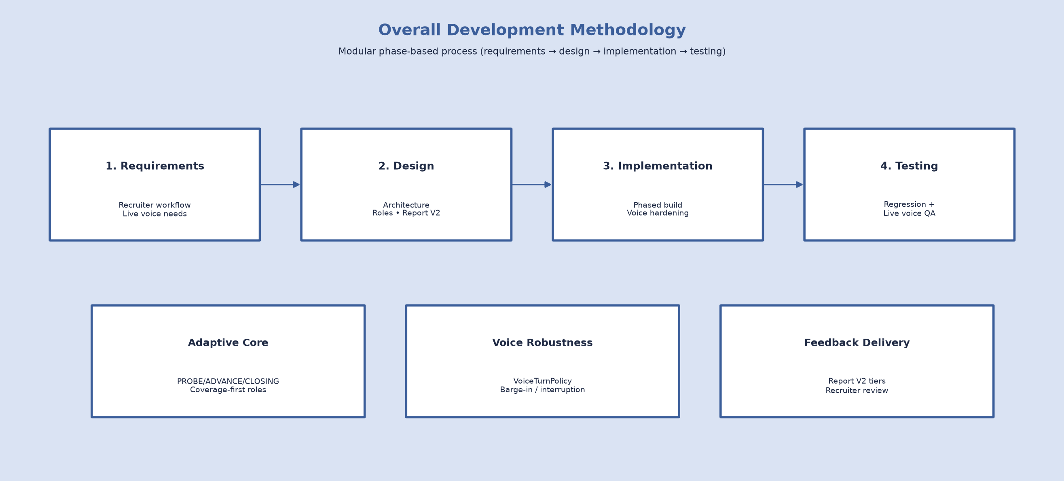

Figure 4.1: Overall Development Methodology of AI Powered Interview Simulation and Feedback Platform

4.2.1 Requirement Gathering
Requirement gathering focused on gaps in existing voice interview practice: the need for adaptive questioning, reliable turn-taking, conversational recovery from unsuitable or non-substantive turns, recruiter-controlled invite workflows, and honest feedback reporting rather than a fixed script alone.

4.2.2 System Design
System design adopted a multi-service architecture with a shared DialogueManager brain: a recruiter dashboard for invites and report browsing, a FastAPI control path for optional text testing, and a Pipecat WebSocket voice path, bridged by SessionService and InterviewDialogueAdapter so voice turns and text turns share the same interview state.

4.2.3 System Implementation
Implementation proceeded module-by-module according to the development phases: session and config foundations, dialogue conversational control, coverage and role bootstrap, the evaluation rubric engine, voice hardening, then flow-quality, fairness, reporting polish, and recruiter-facing invite delivery.

4.2.4 System Testing
Testing used pytest regression suites covering voice turn-taking (VoiceTurnPolicy), conversational control behavior, adaptive progression, multi-role bootstrap, evaluation/reporting outputs, and end-to-end session flows after each major phase.

Table 4.4: Development Phases of the Proposed System
Phase | Description
Phase 1 — Unified Core | SessionService singleton, central config, interviewer policy
Phase 2 — Dialogue Core / Guards | GuardPipeline before scoring, transcript utilities, interviewer persona
Phase 3 — Structured Flow & Resume | CoverageEngine, role registry, session bootstrap, optional resume
Phase 4 — Evaluation Engine | Central rubric.py, rethink ensemble, human-study export
Phase 5 — Voice Hardening | VoiceTurnPolicy, async Groq offload, unified submit turn, logging/regression
Phase 6A — Interview Flow Quality | Meta/IDK guards, question dedup, domain tracking
Phase 6B — Transcript Fairness | Transcript quality assessment, noisy-STT weight adjustment
Phase 6C — Reporting Clarity | Communication/technical profiles, domain assessment map, completion fields
Phase 6+ — Voice QA & Product Polish | Barge-in/silence/tail-fragment fixes, Report V2, coverage-first policy, canonical questions, live conversation events

4.3 System Implementation
Implementation uses a modular client–server design: an HTML/CSS/JS candidate client (typically port 3000); a recruiter dashboard on port 8001; optional FastAPI REST on port 8000; Pipecat WebSocket voice on port 8765; Report HTTP on port 8766; and SessionService with InterviewDialogueAdapter bridging voice turns into DialogueManager.

4.3.1 Frontend Implementation
The candidate frontend is a modular JavaScript client that resolves invite links, presents a pre-interview lobby, streams microphone PCM, supports barge-in, renders live conversation events, and provides post-interview thank-you navigation to the assessment report. The recruiter dashboard is a separate browser application used to authenticate, select an interview role, create and share invites, and browse Report V2 feedback artefacts.

4.3.2 Backend Implementation
The backend exposes FastAPI services for the recruiter dashboard and optional text testing, hosts the Pipecat interview bot/processor path, and includes dialogue, evaluation, reporting, and role-configuration packages that own session state, scoring, and Report V2 assembly. Invites are persisted in a local JSON store.

4.3.3 WebSocket Communication
WebSocket communication carries PCM audio plus JSON control messages (for example start and interrupt). The server also emits conversation_event messages for the live UI. WebRTC is treated as future work only.

4.3.4 AI Service Integration
AI services are composed through Pipecat: Deepgram for STT, Silero for VAD, Groq for LLM dialogue and evaluation prompts, and Cartesia for TTS playback to the client.

Table 4.5: AI Services Used in the Proposed System
Service | Function
Deepgram | Speech-to-Text (nova-2)
Silero VAD | Voice activity detection within the Pipecat pipeline
Groq Llama 3.3 | Question generation and response evaluation
Cartesia | Text-to-Speech conversion
Pipecat | Voice pipeline management and service composition
FastAPI | Backend REST server
WebSocket | Real-time PCM and control-message communication

4.3.5 Interview Session Management
SessionService owns interview sessions for the voice runtime. InterviewContext holds coverage state, the canonical question, and evaluations for the selected role blueprint. Recruiter invites are stored as local JSON. Optional PostgreSQL persistence is supported when configured; otherwise sessions remain in-process for the live path.

Transition
The implementation discussed in this section establishes the software foundation of the proposed interview platform. The following section explains the implementation of the speech processing pipeline, including voice activity detection, speech recognition, dialogue management, language model integration, and speech synthesis, which collectively enable real-time AI-powered interview conversations.

4.4 Speech Processing Implementation
Speech processing combines Silero VAD, Deepgram STT, Cartesia TTS, and VoiceTurnPolicy inside InterviewProcessor to support low-latency, barge-in-aware voice interviews.

Figure 4.4: Speech Processing Pipeline


Figure 4.4: End-to-end sequential speech processing pipeline and transport layer integration.

4.4.1 Voice Activity Detection
Silero VAD detects speaking start and stop on incoming PCM frames. Silence nudge and rephrase schedules, together with barge-in grace, keep turn-taking responsive without cutting the candidate off prematurely.

4.4.2 Speech-to-Text Implementation
Deepgram nova-2 provides streaming interim and final transcripts that are merged and cleaned before dialogue handling. After a turn is submitted, a short tail-fragment resume window reduces loss of trailing speech artefacts.

4.4.3 Dialogue Manager
DialogueManager.handle_turn prepares the transcript, applies conversational control checks, performs adaptive evaluation when the turn is eligible, then applies DecisionEngine decisions PROBE, ADVANCE, or CLOSING before question generation, deduplication, and context update. Canonical questions and rephrase policy support recoveries while reducing stacked spoken prompts. Coverage-first progression prefers full role-blueprint coverage before WRAPUP; the turn ceiling is a safety limit only. Current role profiles include AI Engineer, Frontend Developer, and Backend Developer.

4.4.4 Large Language Model Integration
Groq Llama 3.3 generates intro lines, domain asks, follow-ups, and evaluation prompts. Prompts use role-aware domain seeds, optional resume or skill evidence, and recent Q&A memory, and keep spoken questions short for TTS clarity.

4.4.5 Text-to-Speech Implementation
Cartesia TTS speaks one controlled line per interviewer turn. Closing turns use shared closing copy so the end of the interview remains consistent across sessions.
The speech processing components discussed in Figure 4.4 collectively enable real-time voice communication between the candidate and the AI interviewer. The following section presents the complete interview workflow, describing how these components interact with recruiter invite delivery to conduct adaptive interviews, evaluate candidate performance, and generate automated feedback reports.

4.5 Interview Workflow
The interview workflow runs from recruiter invite creation and candidate lobby access through scored adaptive turns to CLOSING/WRAPUP and Report V2 feedback generation for recruiter review.
Figure 4.5 Complete Interview Workflow

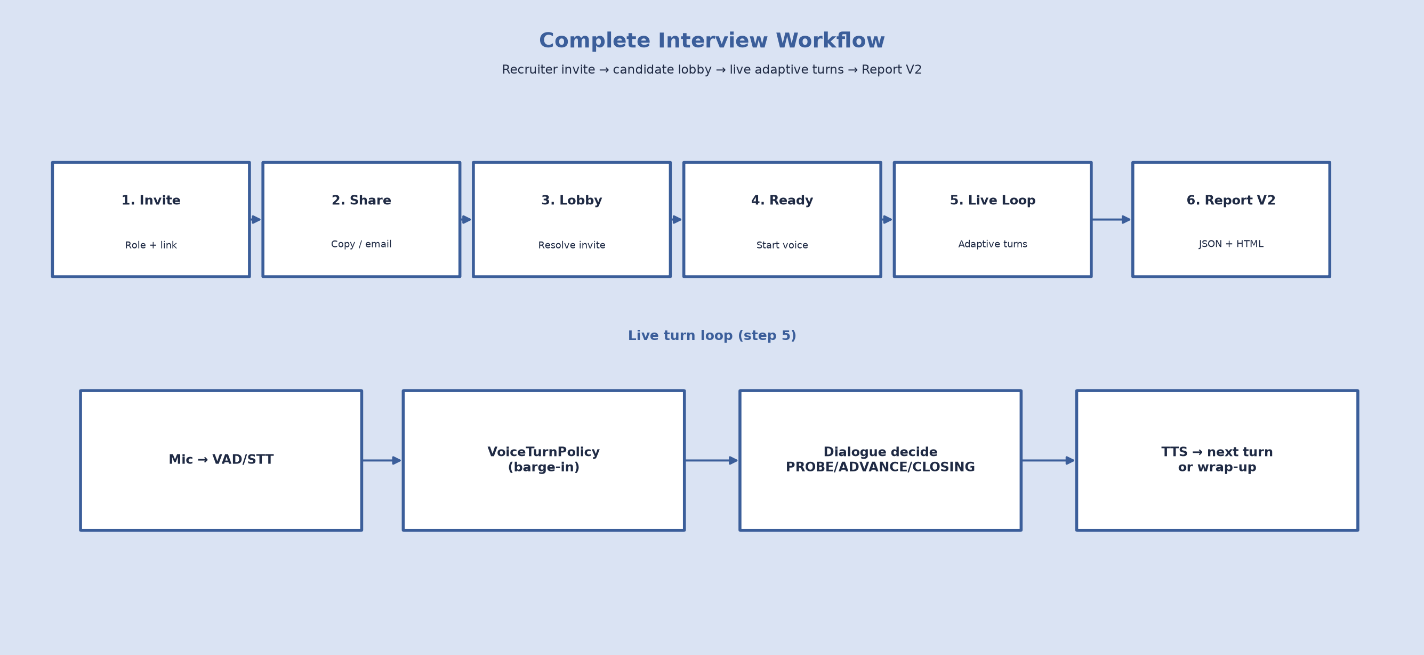

4.5.1 Interview Initialization
A recruiter selects an interview role in the dashboard and creates an invite link, which may be copied or optionally emailed to the candidate. The candidate opens the invite, completes the pre-interview lobby, and the client sends a start message with the resolved target_role. The server bootstraps the corresponding role profile and delivers an INTRO greeting without scoring.

4.5.2 Candidate Interaction
Candidate audio follows PCM → VAD → STT → VoiceTurnPolicy (debounce, silence, barge-in, tail fragment) → InterviewDialogueAdapter → DialogueManager for each scored or guarded turn.

4.5.3 Adaptive Question Generation
After guards and evaluation, DecisionEngine selects PROBE (at most one probe per domain), ADVANCE to the next domain, or CLOSING when coverage-first conditions or the safety turn ceiling are met. COMPLETE is never used as a decision label; progression uses PROBE, ADVANCE, and CLOSING only.
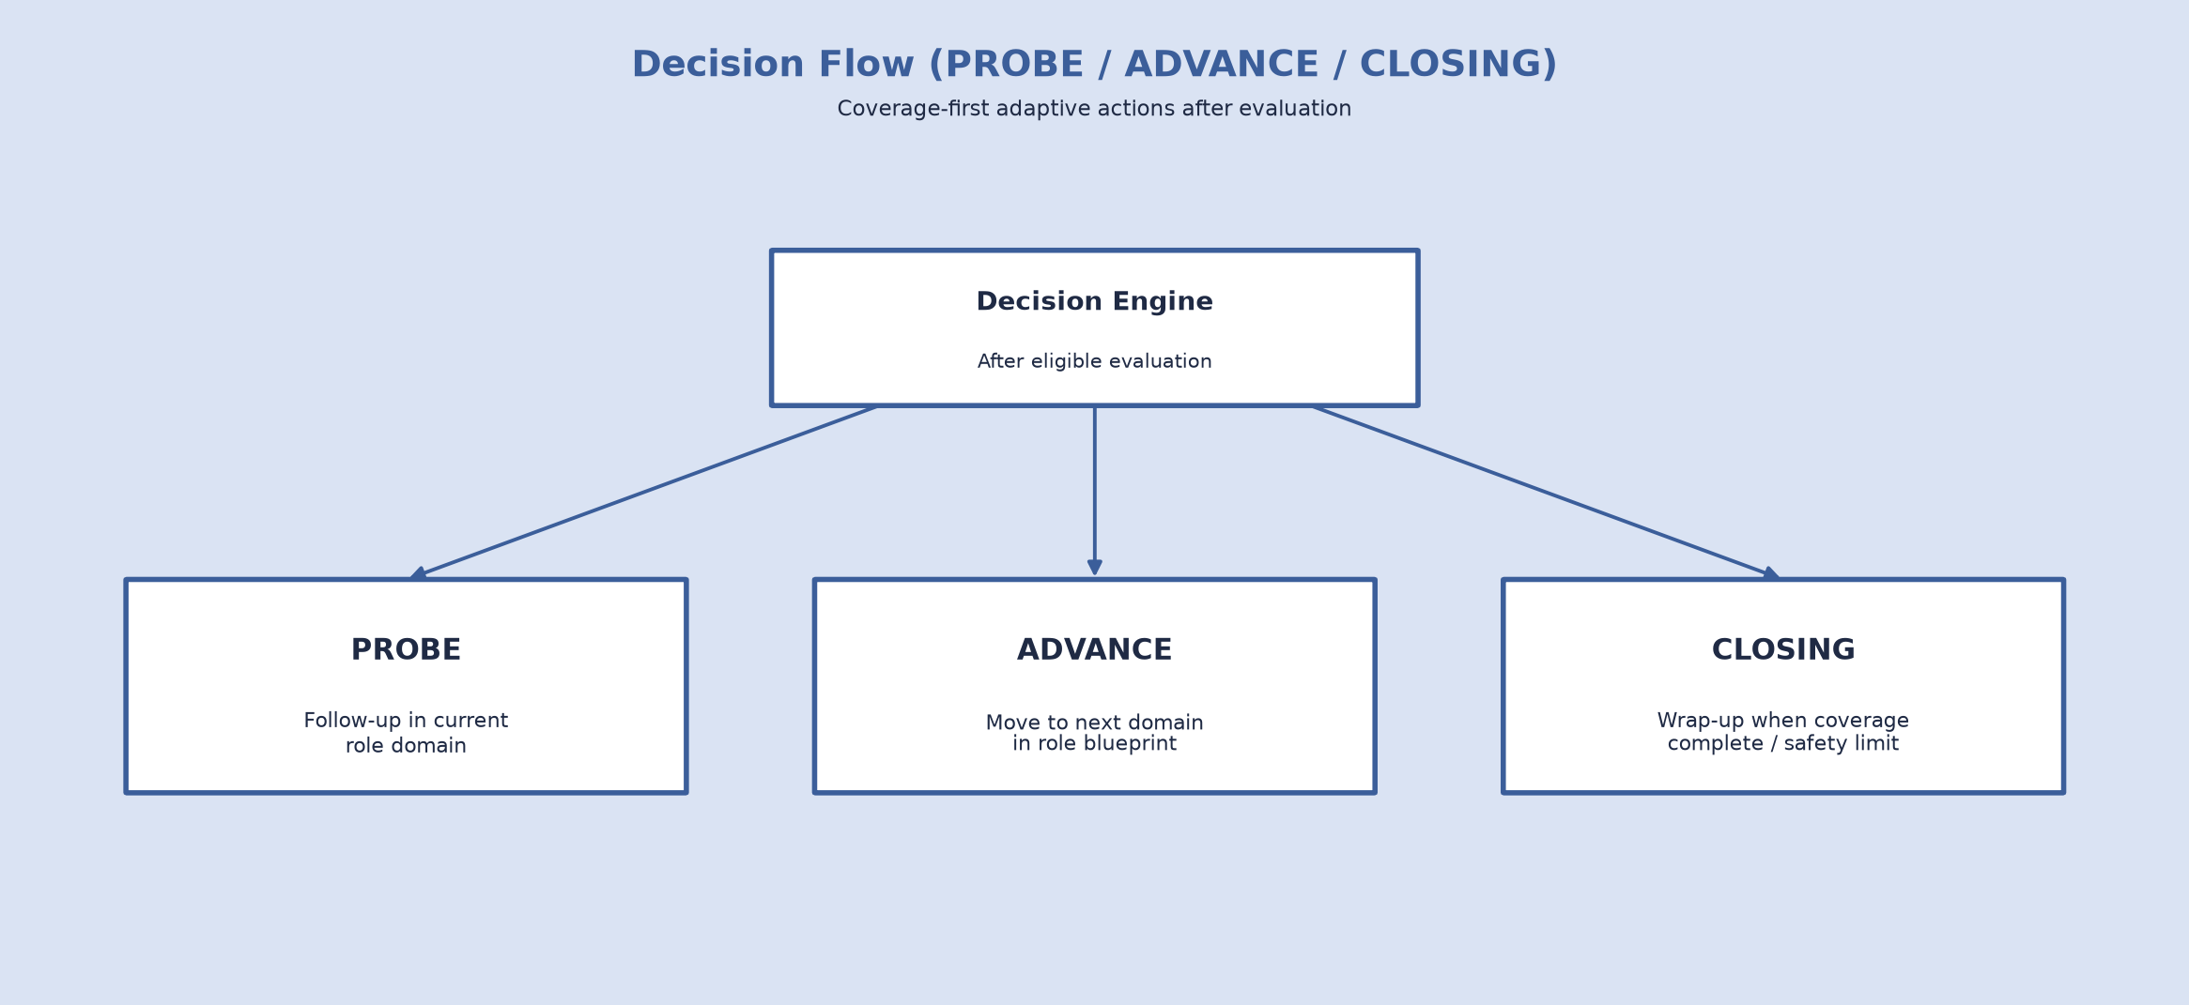

Figure : Decision Flow (PROBE / ADVANCE / CLOSING).

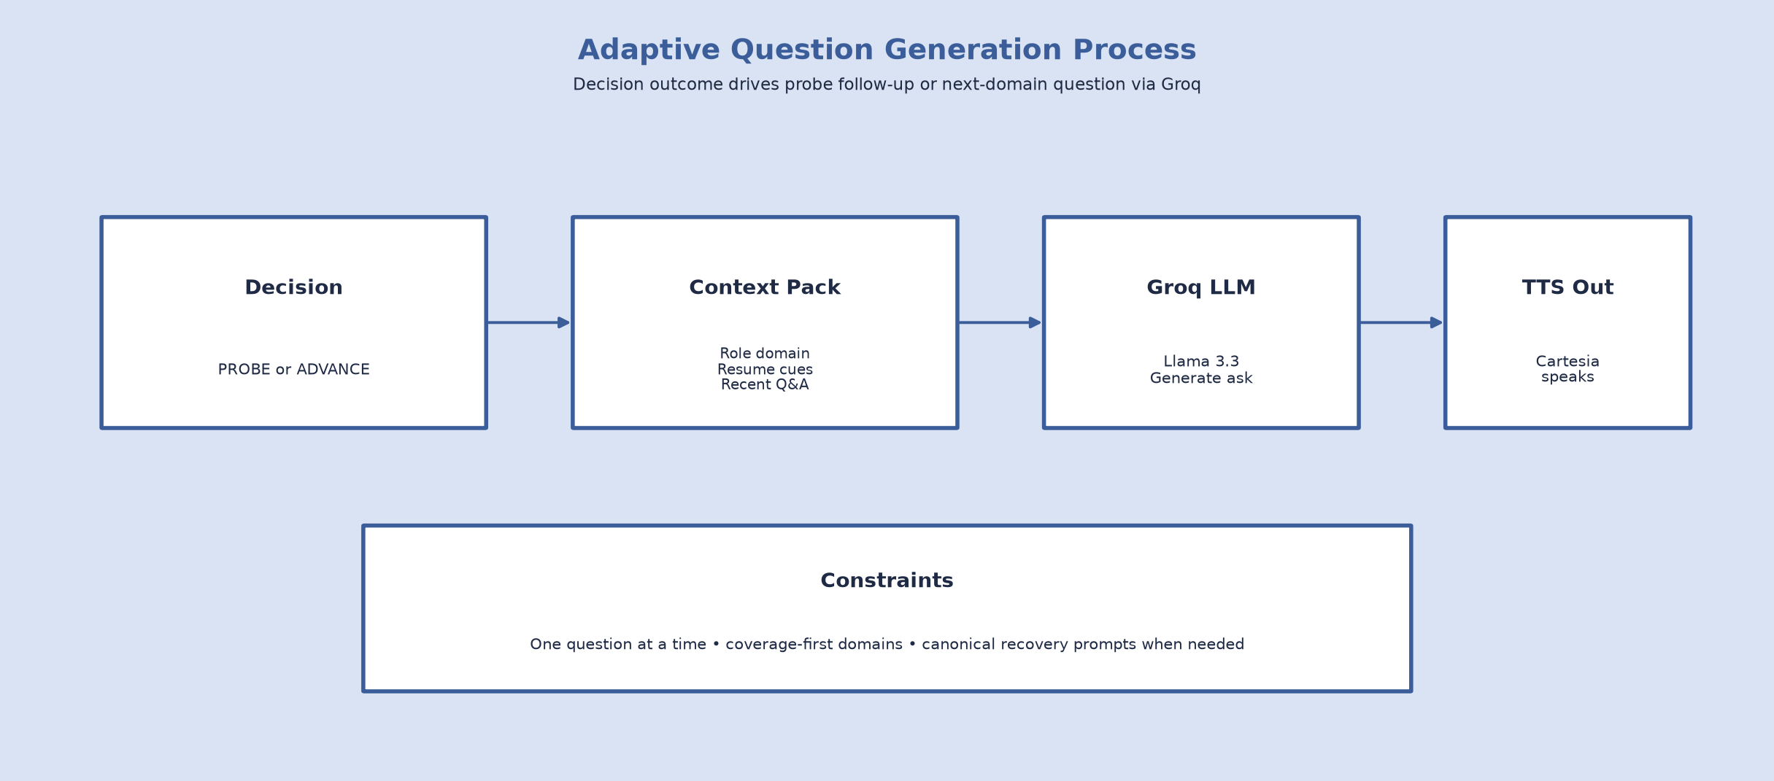

Figure 4.5.3: Adaptive Question Generation Process

4.5.4 Candidate Evaluation
Each answer is scored on the six rubric dimensions and weights in Table 4.6 (structure, result_orientation, ownership, leadership, clarity, confidence). Optional rethink ensemble scoring and transcript-fairness reweighting adjust communication-related dimensions when STT artefacts are detected.


Table 4.6: Candidate Evaluation Criteria
Figure 4.15: Evaluation Workflow.  Criterion | Weight | Description
structure | 0.25 | Organisation of the answer
result_orientation | 0.20 | Outcomes and impact
ownership | 0.20 | Personal responsibility
leadership | 0.15 | Influence and coordination
clarity | 0.10 | Communicative clarity
confidence | 0.10 | Delivery confidence

Hire-signal bands: strong hire at or above 4.0, hire at or above 3.0. Transcript fairness reweights communication dimensions when STT artefacts are detected.

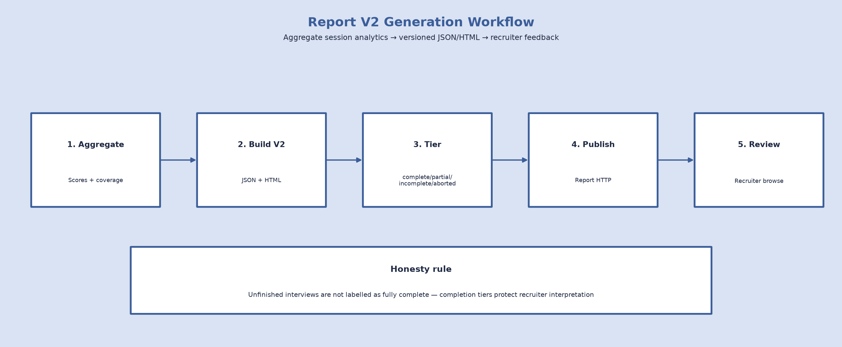

4.5.5 Report Generation
Report generation calls build_report_v2 and assigns completion tiers complete, partial, incomplete, or aborted. JSON and HTML feedback artefacts are written under the reports directory and may be loaded via Report HTTP on port 8766 or browsed in the recruiter dashboard on port 8001.
The interview workflow described in this section integrates recruiter invite delivery, speech processing, dialogue management, candidate evaluation, and feedback report generation into a unified process. Candidate self-paced practice and personalised improvement guidance for low scores remain future enhancements and are not claimed as present methodology deliverables.

Chapter 5

Results and Discussion

This chapter presents implementation results and evaluation of AI Powered Interview Simulation and Feedback Platform. The delivered system integrates Groq (Llama 3.3 70B Versatile), Deepgram Nova-2, Cartesia TTS, Pipecat with Silero VAD, FastAPI services (including the recruiter dashboard), and modular HTML/CSS/JavaScript clients. Results are discussed in terms of functional capability, phased quality improvements, voice-pipeline behaviour, regression testing, practical runtime observations, and representative interview sessions. Conventional machine-learning classification metrics (for example accuracy or AUC) are not claimed because the system is an interactive interview pipeline rather than a trained classifier.
Unlike traditional interview simulators that rely on static questionnaires, the delivered platform conducts dynamic interviews under recruiter control by analysing candidate responses, adapting subsequent questions according to interview progress, maintaining conversational context, and producing structured feedback reports. Throughout development, multiple implementation phases and extensive testing were conducted to improve interview quality, transcript reliability, fairness, and reporting honesty. The following sections discuss the final implementation results and system behaviour.

5.1 Results and Discussion
The completed system achieved the primary objectives defined for the delivered scope: recruiter-driven invite delivery, real-time voice interview simulation across selectable roles (AI Engineer, Frontend Developer, and Backend Developer), adaptive questioning under role-specific blueprints, automated rubric evaluation, domain coverage tracking, and recruiter-oriented Report V2 feedback. Table 5.1 summarises final capabilities, including post–Phase-6 product features.
The system architecture combines several AI services into a unified interview pipeline. Recruiters create role-based invites through the dashboard; candidates join via lobby and stream speech through Deepgram for transcription; the dialogue and voice-turn layer evaluates answers using Groq’s large language model and converts interviewer replies into speech with Cartesia. Pipecat manages the voice communication pipeline while Silero VAD detects speech activity to support turn-taking and reduce idle listening latency.
Table 5.1 summarises the major capabilities implemented in the final system.

Table 5.1: Final System Capabilities
Feature | Status
Real-time voice interview | Implemented
Adaptive questioning (PROBE / ADVANCE / CLOSING) | Implemented
Role-specific blueprints (AI Engineer, Frontend Developer, Backend Developer) | Implemented
Coverage-first completion policy | Implemented
Conversational control before scoring | Implemented
Canonical question handling and rephrase recoveries | Implemented
[Resume/domain evidence mapping | Implemented
Six-dimension evaluation rubric | Implemented
Transcript quality and STT fairness adjustment | Implemented
Communication and technical score profiles | Implemented
Report V2 tiers (complete / partial / incomplete / aborted) | Implemented
Live conversation events in client UI | Implemented
Voice UX improvements (short asks, hint routing, silence/barge-in/tail-fragment handling) | Implemented
Human-study export API | Implemented
Optional PostgreSQL persistence | Implemented
REST helpers, Report HTTP, and recruiter dashboard report browser | Implemented
Recruiter dashboard (login, invites, report browse) | Implemented
Pre-interview candidate lobby | Implemented
Invite link delivery (copy link; optional SMTP email) | Implemented
The completed platform demonstrates that modern LLMs combined with real-time speech technologies can support an interview experience that closely resembles human-led technical interviews within the delivered scope. Throughout testing, the system maintained coherent dialogue while dynamically selecting follow-up questions according to candidate performance, blueprint coverage, and interview progression, and returned structured feedback suitable for recruiter review.

5.2 System Performance
Several implementation phases were completed during development to improve interview quality, conversation flow, transcript reliability, and reporting honesty. Phase 6 introduced the largest improvements through three major modules, after which additional post–Phase-6 product work strengthened live-demo reliability and completion labelling.

Phase 6A – Interview Flow Improvements
The first set of improvements focused on conversation management and guarded interview flow.
Major additions included:
- Semantic duplicate question detection
- Conversational control for navigational turns
- Uncertainty and recovery handling
- Domain synchronization
- Improved interview progression
The duplicate question detection module prevents the interviewer from asking semantically similar questions multiple times. Conversational control checks process non-substantive or navigational turns without treating them as scored content, and recovery policies support rephrasing, hints, and controlled domain progression. Together these mechanisms produced a more natural interview experience under role-specific blueprint progression.

Phase 6B – Transcript Quality and Fairness
Live speech transcription frequently contains repeated words, sentence fragments, and recognition noise. To address this issue, transcript preprocessing was introduced before answer evaluation so that STT artefacts are less likely to distort communication-related scores unfairly.
Major improvements include:
- Stutter removal
- N-gram repetition removal
- Progressive phrase collapsing
- Transcript quality scoring
- Fairness-aware rubric adjustment
The transcript quality module calculates repeated token ratios and reduction statistics to determine whether speech recognition quality is sufficiently reliable. When excessive transcription noise is detected, communication-related evaluation weights are automatically reduced while technical understanding receives greater emphasis. This approach reduces unfair penalties caused by imperfect speech recognition rather than claiming perfect transcription accuracy.

Phase 6C – Reporting Improvements
The final reporting system produces significantly more informative interview feedback than earlier project versions, with clearer separation of technical and communication evidence for recruiter review through Report V2 artefacts and the recruiter dashboard.
The generated report now includes:
- Technical score profile
- Communication score profile
- Domain assessment map
- Interview completion percentage
- Adaptive questioning trace
- Recruiter hiring recommendation
- Bias-awareness documentation
These additions improve report transparency and make the evaluation easier for recruiters and academic reviewers to interpret. Later Report V2 work further refined completion honesty through explicit completion tiers, as discussed below.
Post–Phase-6 Improvements
Following Phase 6A–6C, additional product work strengthened live-demo reliability, reporting honesty, and recruiter-facing delivery. Report V2 introduced explicit completion tiers—complete, partial, incomplete, and aborted—so interviews are not labelled complete when blueprint coverage is unfinished. A coverage-first completion policy prefers full role-blueprint visitation before wrap-up, using a safety turn ceiling rather than early hard closure. Canonical question storage with bounded rephrase recoveries prevents stacked spoken prompts after recovery handling. Role-aware bootstrap and optional skill or resume evidence mapping improve relevance of domain asks. A pre-interview lobby and recruiter invite workflow (copy link, optional email) were added for end-to-end recruitment demos. Live conversation events stream interviewer and candidate turns into the browser transcript UI. Voice UX improvements include short spoken domain questions, silence nudge/rephrase behaviour, barge-in handling, and tail-fragment resume protection after turn submission. These results align with repository regression coverage for reporting, coverage policy, multi-role behaviour, and voice turn-taking.

5.3 Voice Pipeline Performance
The voice subsystem was extensively tested under real interview conditions. Turn handling is coordinated through VoiceTurnPolicy and InterviewProcessor, with InterviewDialogueAdapter bridging spoken turns into the interview dialogue path.
The complete processing pipeline consists of:
Candidate Speech → Silero VAD → Deepgram STT → VoiceTurnPolicy / InterviewProcessor → InterviewDialogueAdapter → Dialogue Manager → Groq Evaluation → Cartesia TTS → Candidate Response

Figure 5.3: Voice Processing Pipeline
Several practical issues were observed during live testing, including speech interruptions, VAD sensitivity, transcript fragmentation, reconnect failures, and nested TTS responses. Operational improvements focused on barge-in handling, silence nudge/rephrase behaviour, and tail-fragment resume protection after turn submission; these are reported as qualitative stability gains rather than new numeric accuracy metrics.
A dedicated Voice Hotfix phase addressed these problems through:
- Browser microphone gain adjustment
- Improved Silero VAD thresholds
- Interim speech fallback after silence
- Improved interruption handling
- Better TTS response sanitization
- Skip-question intent detection
These improvements increased conversation stability and reduced missed or truncated speech events during live interviews, without claiming formal end-to-end recognition accuracy benchmarks.

5.4 Testing Results
The developed platform was evaluated through an extensive automated regression suite (backend/tests and scripts/run_regression.sh) together with manual live voice sessions.

Table 5.2: Testing Summary
Test Category | Purpose | Status
Phase 3 Tests | Session management | Passed
Phase 4 Tests | Evaluation pipeline | Passed
Phase 5 Tests | Voice turn policy | Passed
Phase 6A Tests | Interview flow | Passed
Phase 6C Tests | Reporting | Passed
Full coverage policy tests | Coverage-first wrap-up and completion honesty | Passed
Canonical question and resume tests | Canonical store, rephrase, resume domain preference | Passed
Reporting V2 tests | Completion tiers and report generation | Passed
Live conversation event tests | UI conversation_event wiring | Passed
Voice UX / turn-taking tests | Silence, barge-in, tail fragment, demo UX | Passed
Integration Tests | Pipecat integration | Passed
Dialogue Adapter Tests | Voice communication | Passed
Manual Voice Testing | End-to-end interview | Passed
Multi-role / domain-aware tests | Role bootstrap and role-aware UX checks | Passed
Demo pipeline stabilization tests | Report review, soft-advance, aborted HTML | Passed

Overall, dozens of automated regression cases were executed successfully across interview flow, evaluation, reporting, coverage policy, multi-role bootstrap, and voice turn-taking. Manual interviews further confirmed stable interaction between Deepgram, Groq, Cartesia, and Pipecat under realistic conditions, including recruiter invite → lobby → interview → feedback report demos.

5.5 System Performance Metrics
The developed interview platform was evaluated using practical runtime observations rather than conventional machine-learning classification metrics. The timings in Table 5.3 are observed operational timings from development and demo conditions and are not presented as formal benchmark SLAs or classification accuracy metrics.

Table 5.3: Runtime Performance
Metric | Observation
Greeting TTS latency | Approximately 10–12 seconds
Average response generation | 3–8 seconds
Speech finalization | Dependent on VAD endpointing
Regression execution | Under 2 minutes
Supported interview duration | Approximately 8–15 minutes
Maximum interview domains | 10
During evaluation, asynchronous processing prevented long language-model inference times from blocking the voice pipeline, resulting in smoother interaction between interviewer and candidate under the observed demo conditions.

5.6 Sample Interview Results
Two classes of live session are summarised here. Table 5.4 presents a representative complete Frontend Developer demo session with full blueprint coverage and a Hire feedback signal, illustrating the intended end-to-end outcome under Report V2. Earlier development sessions with unfinished coverage remain useful as counter-examples: under Report V2 they must be labelled partial or incomplete rather than complete, which demonstrates honest completion-aware feedback rather than pipeline failure.

Table 5.4: Sample Interview Session
Metric | Value
Interview Duration | ~12–15 minutes (demo)
Total Conversation Turns | 13
Domains Assessed | Full role blueprint
Coverage | 100%
Average Weighted Score | 3.26
Communication Composite | Strong / Hire-band communication profile
Technical Composite | Strong / Hire-band technical profile
Recruiter Recommendation | Hire
Report completion tier | Complete (100% domain coverage)
In the complete Frontend Developer session, scores and the Hire recommendation reflect candidate responses under full coverage. Complementary unfinished sessions demonstrated adaptive questioning, transcript processing, evaluation, report generation, and—under Report V2—honest partial/incomplete completion labelling when domain coverage was incomplete.

5.7 Overall Performance Analysis
The final implementation successfully integrates recruiter invite delivery, speech processing, conversational dialogue management, coverage-first interviewing, rubric evaluation, and Report V2 feedback labelling into a unified platform—AI Powered Interview Simulation and Feedback Platform. Compared with the initial proposal, the completed system prioritised conversational robustness and evaluation/reporting honesty over speech emotion recognition (SER), facial analysis, and psychometric IRT/CAT adaptation.
The platform demonstrates several significant achievements. First, it supports end-to-end voice interviews through integration of Pipecat, Deepgram, Groq, Cartesia, FastAPI, and the recruiter dashboard. Second, the dialogue and voice-turn layer adapts interview flow based on candidate performance while pursuing role-blueprint coverage and conversational coherence across AI Engineer, Frontend Developer, and Backend Developer roles. Third, transcript preprocessing and fairness mechanisms improve evaluation reliability under noisy speech conditions. Fourth, Report V2 provides recruiter-oriented feedback with explicit complete, partial, incomplete, and aborted tiers so unfinished coverage is not mislabelled as complete. Soft edges remain in echo edge cases, STT chunking, and energy-based barge-in, but these are operational limitations rather than failures of the overall pipeline design.
Facial emotion recognition, speech emotion recognition, Docker/cloud packaging, candidate self-paced practice, personalised improvement guidance for low overall scores, and a formal human inter-rater reliability (κ) study remain clearly future work and are not claimed as implemented results. Within the delivered scope, the completed system demonstrates that large language models combined with real-time speech technologies can provide an intelligent interview simulation and feedback solution suitable for recruiter-oriented academic demonstration and further research.

Chapter 6
System Design and Implementation

This chapter describes the system design and implementation of AI Powered Interview Simulation and Feedback Platform. It details the layered architecture, Dialogue Manager, voice workflow, adaptive interview flow, recruiter and candidate service interfaces, feedback reporting, and deployment constraints as realised in the repository.

6.1 System Design and Architecture
The implemented system follows a modular multi-layer architecture that separates presentation (candidate and recruiter), real-time communication, dialogue control, AI services, reporting, and session data concerns.
1. Presentation layer
Two browser surfaces: (1) a modular HTML/CSS/JavaScript candidate client for invite resolution, pre-interview lobby, microphone capture, live transcript, and thank-you navigation; and (2) a recruiter dashboard for authentication, role-based invite creation, optional invitation email, and feedback-report browsing.
2. Communication layer
Pipecat WebSocket transport carrying PCM audio and JSON control messages on port 8765, enabling bidirectional streaming between the candidate browser and the voice runtime; HTTP APIs on ports 8001 (recruiter) and optionally 8000 (text testing).
3. Dialogue layer
SessionService, DialogueManager, conversational control checks, CoverageEngine, and DecisionEngine, which together manage interview state, recovery, evaluation, and adaptive progression for the selected role blueprint.
4. AI services layer
Deepgram STT, Silero VAD, Groq LLM, and Cartesia TTS, each performing a dedicated role within the Pipecat-orchestrated pipeline.
5. Reporting layer
Report V2 generation, HTML rendering, persistence, the Report HTTP helper on port 8766, and recruiter dashboard report indexing used after an interview ends.
6. Data and session layer
InterviewContext held in-process via SessionService, recruiter invites in a local JSON store, optional PostgreSQL persistence, and file-based Report V2 feedback artefacts.
Component | Technology
Large Language Model | Groq (Llama 3.3 70B Versatile)
Speech Recognition | Deepgram Nova-2
Speech Synthesis | Cartesia
Voice Activity Detection | Silero VAD
Voice Framework | Pipecat v1.4
REST Backend | FastAPI
In addition, ConversationEventPublisher emits live conversation_event and phase messages to the client transcript user interface so that dialogue state remains visible during the session.

Figure 6.1: Overall System Architecture of AI Powered Interview Simulation and Feedback Platform.

6.1.1 Dialogue Manager Implementation
The Dialogue Manager is the central orchestration component that controls interview progression for each candidate turn. Evaluation preparation and canonical question commit are explicit stages in this path; semantic question deduplication is applied separately from the conversational control pipeline.
During every candidate response, the Dialogue Manager performs the following control-first sequence:
- Prepare the transcript for evaluation (cleanup and quality signals).
- Execute conversational control checks and stop at the first triggered recovery path.
- If the turn is eligible for scoring, perform adaptive evaluation against the rubric.
- Invoke DecisionEngine to select PROBE, ADVANCE, or CLOSING.
- Generate or select the next question, commit the canonical question, and apply semantic deduplication.
- Sanitize spoken output, update InterviewContext, and optionally persist to the database.
This modular workflow supports adaptive interviewing while keeping evaluation preparation, conversational control, decisioning, and canonical question commit clearly separated.

6.1.2 Voice Processing Workflow
The voice pipeline realises end-to-end spoken interviewing between the candidate browser client and the backend services after invite-based session start.
The realised workflow proceeds as follows:
- Browser PCM audio is streamed over the WebSocket on port 8765.
- Silero VAD segments speech activity.
- Deepgram STT produces the candidate transcript.
- InterviewProcessor applies VoiceTurnPolicy (debounce, silence handling, barge-in, and tail-fragment control).
- InterviewDialogueAdapter routes the turn into SessionService and DialogueManager.
- Cartesia TTS synthesises the interviewer reply and streams audio back to the browser.
- ConversationEventPublisher updates the live client transcript UI.
- On interview end, Report V2 feedback artefacts are produced; the candidate client may retrieve them via Report HTTP on port 8766, and recruiters browse the same artefacts in the dashboard on port 8001.
The cycle continues until coverage and decision policy determine wrap-up under closing.

WS PCM in
Silero VAD
Deepgram STT
InterviewProcessor
+ VoiceTurnPolicy
InterviewDialogueAdapter
DialogueManager
Cartesia TTS
WS audio out
Figure 6.2: Real-Time Voice Processing Pipeline.

6.1.3 Adaptive Interview Flow
Interview progression is coverage-first against the selected role blueprint (currently AI Engineer, Frontend Developer, or Backend Developer). Soft next-topic preferences are retained where appropriate, and recovery policies guide the interview when answers are non-substantive or incomplete, without treating those turns as scored content.
The adaptive mechanism comprises conversational control checks, DecisionEngine, and CoverageEngine.

Figure 6.1.3: Dialogue Manager Architecture.


Guard Pipeline
Conversational control executes ordered checks before answer evaluation and stops at the first applicable recovery path so non-substantive turns do not enter scoring.
The ordered guard list is:
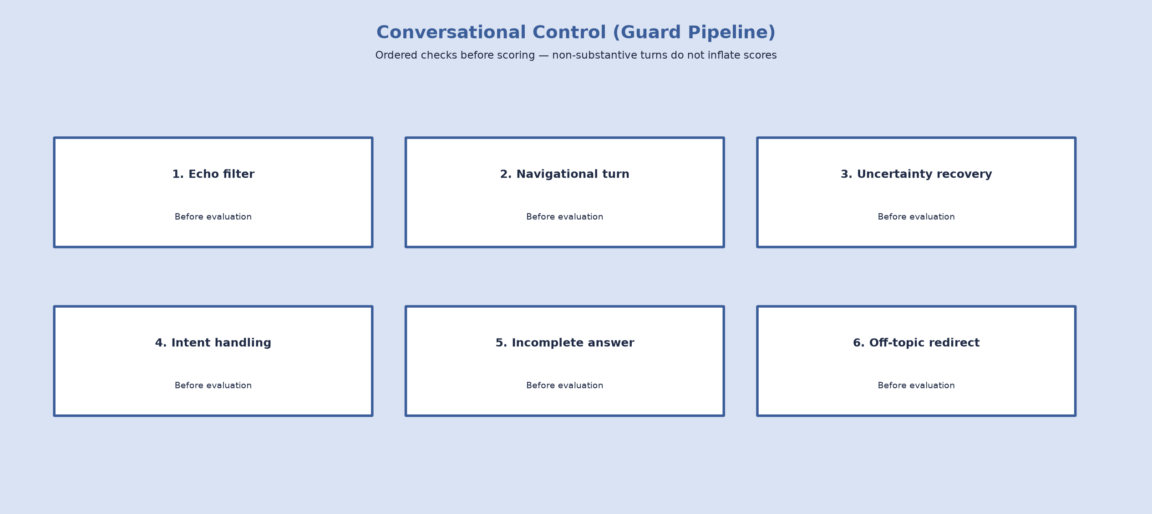Figure : Guard Pipeline Architecture.
- Echo filtering
- Navigational-turn handling
- Uncertainty / recovery handling
- Intent handling
- Incomplete-answer handling
- Off-topic domain redirect
Semantic question deduplication is implemented separately (question_dedup) and is not a member of the conversational control pipeline. Together these mechanisms prevent common live-interview failures while ensuring that non-substantive turns are not unfairly scored.

Decision Engine
After evaluation, the Decision Engine selects one of three actions only:
- PROBE
- ADVANCE
- CLOSING
PROBE requests a follow-up within the current topic, ADVANCE moves coverage forward, and CLOSING initiates interview wrap-up under coverage and safety policy.

Coverage Engine
The Coverage Engine maintains coverage tracking, probe limits, coverage-first wrap-up behaviour, and a safety turn ceiling so that interviews remain balanced and bounded for the active role blueprint.

6.1.4 Service Interfaces and REST API Endpoints
The platform exposes several communication surfaces that must not be conflated. The recruiter dashboard on port 8001 provides authentication, invite create/list/send, role listing, and report browse/download APIs. Optional FastAPI REST on port 8000 supports session control, text testing, and report retrieval; Table 6.1 lists those primary REST endpoints. Pipecat WebSocket on port 8765 carries PCM audio and JSON control messages (including start with target_role and interrupt), together with server conversation_event payloads for the live user interface. Report HTTP on port 8766 serves latest and session report artefacts after interviews end (for example GET /latest-report).

Table 6.1: Primary FastAPI REST Endpoints (Optional Text/API Path, Port 8000)
Method | Endpoint | Purpose
POST | /start | Start interview session
POST | /chat | Process text interview turn
GET | /session/{id} | Session state
GET | /report/{id} | Full report
GET | /report/hr/{id} | Recruiter summary
GET | /sessions | List sessions
GET | /sessions/rank | Rank candidates
GET | /sessions/{id}/summary | Compact summary
GET | /roles | Available roles
GET | /health | Health
GET | /export/human-study/{id} | Human-study export
WebSocket traffic on port 8765, Report HTTP on port 8766, and recruiter dashboard routes on port 8001 are not REST rows in Table 6.1; they are separate communication surfaces used by the voice runtime, post-interview report retrieval, and recruiter operations respectively.
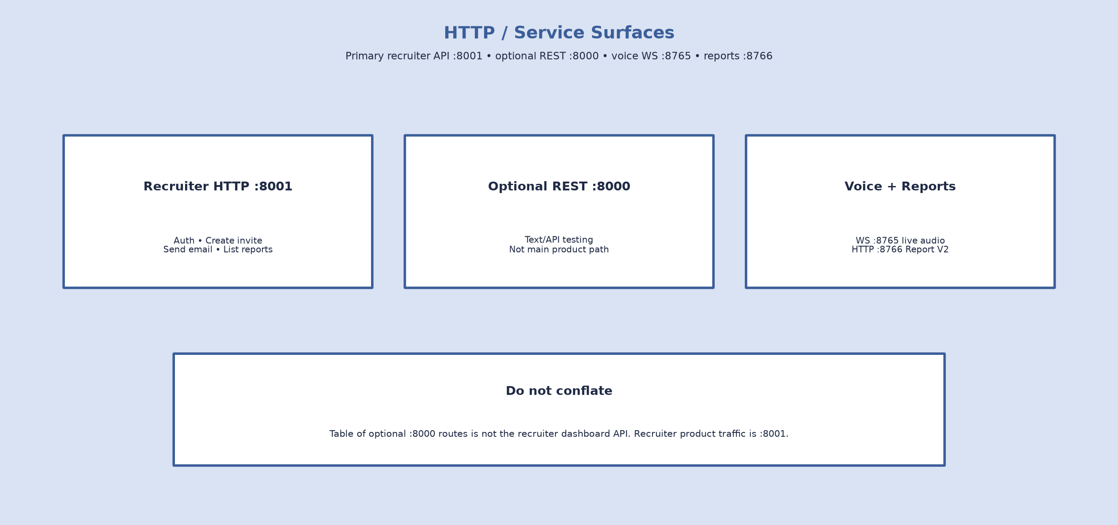

Figure 6.7: REST API Architecture

6.1.5 Voice Runtime
The Pipecat interview_bot assembles the transport, VAD, STT, InterviewProcessor, TTS, and Report HTTP server into a single voice runtime process.
Only one active voice client is supported per process under the current SessionService design.
InterviewProcessor coordinates turn policy with the dialogue path, while ConversationEventPublisher keeps the candidate client transcript aligned with server-side phase changes.

6.1.6 Interview Reporting
Report V2 (backend/reporting/) wraps interview analytics into versioned feedback reports with tiers complete, partial, incomplete, and aborted.

Figure 6.1.6: Report Generation Workflow.

A complete report requires wrap-up with sufficient evaluated turns and full blueprint coverage under policy. Reports include communication and technical profiles, a domain map, and a hire recommendation. HTML is produced alongside JSON; aborted artefacts are stored under reports/aborted/.
Optional PostgreSQL storage may persist session data, while file reports remain the primary feedback deliverable for Report HTTP and the recruiter dashboard. Candidate thank-you UI is separate from the recruiter HTML assessment view.
Figure 6.3 illustrates an example interview report.
Figure 6.3: Sample Generated Interview Report.
(screenshots of the actual interview report)

6.1.7 Voice Quality
Voice quality behaviour is governed by implementation-aligned turn policy rather than invented numerical metrics.
Relevant mechanisms include:
- VoiceTurnPolicy for turn timing and control
- Barge-in handling during interviewer speech
- Silence nudge and rephrase prompts
- Tail-fragment window for late transcript pieces
- Canonical rephrase recoveries
- Preference for short spoken questions

These controls improve continuity of live interviews without claiming unverified latency or accuracy percentages.

6.1.8 Security and Error Handling
Operational safeguards focus on configuration hygiene and graceful degradation rather than enterprise security claims that are not implemented in the repository.
In particular:
- API keys and secrets are loaded from the .env file rather than hard-coded source; recruiter dashboard access uses demo-grade environment credentials and a signed session cookie
- Database access fails gracefully when PostgreSQL is unavailable
- Conversational control prevents non-substantive turns from receiving unfair rubric scores
- Structured exception handling supports orderly interview termination
These measures support reliable local operation without overstating the security posture of the current research prototype.

6.1.9 Deployment Considerations
Deployment as delivered in this project is a local multi-process development configuration suitable for academic demonstration.
Typical operation requires running the Pipecat voice bot (ports 8765/8766), serving the candidate client (port 3000), and starting the recruiter dashboard (port 8001). An optional FastAPI text API may run on port 8000. SessionService is single-process on the voice runtime; the repository does not deliver multi-client or multi-worker voice scalability.
Docker packaging, Kubernetes orchestration, and cloud deployment are recorded as future work only and are not implemented in the repository.

6.1.10 Practical Applications and Future Extensions
Within the present scope, practical applications of AI Powered Interview Simulation and Feedback Platform centre on recruiter-driven technical interview simulation for selectable roles, structured feedback-report review, and academic demonstration of the adaptive voice pipeline.
Current applications include:
- Recruiter-driven role-based interview simulation (AI Engineer, Frontend Developer, Backend Developer)
- Recruiter feedback-report review via dashboard and Report HTTP
- Academic demonstration of the adaptive interview and feedback system
Future extensions only—not implemented in the repository—include:
- WebRTC transport
- Docker and cloud packaging
- Speech emotion recognition and facial analysis
- Candidate self-paced practice mode
- Personalised improvement feedback for low overall scores
These items remain prospective enhancements and must not be read as delivered capabilities of the current system. Multi-role blueprints for AI Engineer, Frontend Developer, and Backend Developer are already implemented and are not listed as future work.
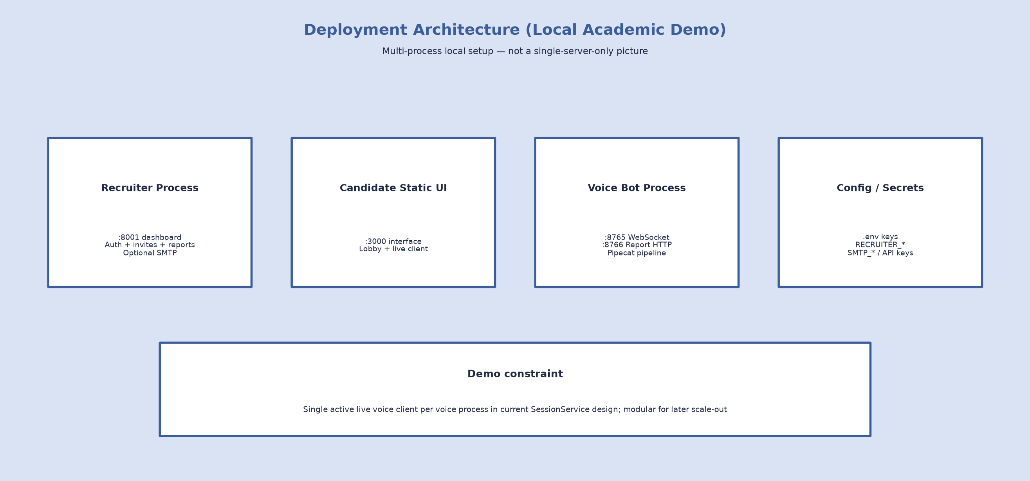Figure 6.8: Deployment Architecture.

Chapter 7
Conclusion

This Final Year Project aimed to design and implement AI Powered Interview Simulation and Feedback Platform, capable of simulating adaptive technical interviews through natural voice interaction while providing structured evaluation feedback for recruiter use. The motivation was to address limitations of conventional online assessment systems that often rely on static questionnaires, limited interaction, and manual evaluation. By integrating modern artificial intelligence technologies with real-time speech processing and a recruiter-facing delivery workflow, the developed system offers a more realistic interview experience that more closely resembles interaction with a human interviewer.
The final implementation successfully achieves the primary objectives defined for the delivered scope. In the current system, a recruiter creates a role-based invite, a candidate completes a live voice interview via lobby access, and the recruiter receives an automated assessment report. The platform dynamically adapts questions according to candidate responses, applies conversational control so non-substantive turns are not scored as content, evaluates answers using a structured multi-dimensional rubric with transcript-fair scoring, and generates Report V2 feedback artefacts with explicit completion labelling. Unlike traditional chatbot-based interview systems, the platform maintains conversational flow and tracks coverage across selectable role blueprints—currently AI Engineer, Frontend Developer, and Backend Developer—under a coverage-first policy.
The completed system integrates several complementary technologies into a unified architecture. A recruiter dashboard on port 8001 supports authentication, invite creation, optional invitation email, and report browsing. FastAPI also provides optional REST services for session management and text testing, while Pipecat provides real-time voice orchestration connecting speech recognition, dialogue management, and speech synthesis over WebSocket PCM audio. Deepgram Nova-2 performs streaming speech-to-text transcription, Silero supports voice activity detection, Groq Llama 3.3 70B Versatile is used for question generation and candidate evaluation, and Cartesia produces interviewer speech through text-to-speech synthesis. Modular HTML, CSS, and JavaScript clients support the candidate lobby/interview UI and the recruiter workspace.
A central contribution is the structured adaptive dialogue system. Rather than asking questions only from a static bank, the system evaluates each eligible candidate response before deciding whether to PROBE the current topic, ADVANCE to another domain, or move to CLOSING under coverage-first rules. This behaviour is coordinated through the DialogueManager, DecisionEngine, and CoverageEngine, enabling interviews to progress naturally while ensuring balanced assessment across the active role blueprint.
Another major contribution is conversational control that improves robustness during live conversations. Ordered checks recover from common live-interview failures—such as echo, navigational turns, uncertainty, incomplete fragments, and off-topic answers—without treating those turns as scored content. Semantic question deduplication operates separately from this control path. Transcript quality assessment and fairness-aware score adjustment further reduce unfair penalties caused by speech-recognition artefacts.
Coverage-first assessment and Report V2 feedback reporting are also significant deliverables. Interviews prefer full blueprint coverage before wrap-up, and reports use explicit tiers—complete, partial, incomplete, and aborted—so unfinished sessions are not labelled as complete. Reports include communication and technical score profiles, domain assessment maps, adaptive traces where available, hire recommendations, and documented limitations, increasing transparency for recruiters and researchers.
Post–Phase-6 product improvements further strengthened the delivered system beyond the Phase 6A–6C quality modules. Canonical question handling with bounded rephrase recoveries prevents stacked spoken prompts. Role-aware bootstrap and optional skill or resume evidence mapping improve relevance of technical asks. A pre-interview lobby and recruiter invite workflow (copy link and optional email) complete the recruitment demo path. Live conversation events stream turns into the browser transcript UI. Voice UX refinements include short spoken questions, silence handling, barge-in support, and tail-fragment protection. Together with earlier phases, these changes produced a coherent, testable interview simulation and feedback pipeline suitable for academic demonstration.
Extensive testing accompanied development. An automated regression suite validates session management, adaptive dialogue flow, evaluation logic, transcript processing, reporting, coverage policy, multi-role behaviour, and voice turn-taking components, complemented by manual live interview sessions. These evaluations confirmed that the architecture functions reliably under realistic demo conditions while remaining subject to practical soft edges such as occasional echo misclassification, imperfect STT chunking, and energy-based rather than ASR-gated barge-in.
Although the platform fulfils the primary delivered objectives, several limitations remain. Speech recognition quality depends on microphone hardware, background noise, connectivity, and cloud transcription services. Evaluation uses an LLM-as-judge rubric rather than a psychometrically validated instrument. Recruiter authentication is demo-grade (environment credentials and a session cookie), and invites are stored in a local JSON file. The current implementation supports a single active voice client per process because SessionService and the Pipecat transport are process-local. Advanced multimodal analysis proposed in early planning—including facial expression recognition and speech emotion recognition—was intentionally deferred to keep scope manageable and to prioritise a stable end-to-end voice interviewing system.
The project also shows that practical engineering decisions can provide greater value than pursuing overly ambitious research features too early. Components such as full Item Response Theory (IRT), Computerised Adaptive Testing (CAT), TensorFlow-based emotion recognition, and webcam behavioural analysis were replaced by blueprint-driven adaptive questioning, structured LLM evaluation, transcript fairness adjustment, robust dialogue management, recruiter-facing invite delivery, and honest Report V2 completion labelling. These decisions produced a more reliable and demonstrable system while remaining academically defensible.
Future work may extend the platform in several directions. Candidate self-paced practice could allow independent interview preparation outside recruiter invites. Personalised improvement feedback for low overall scores (for example below 3/5) could highlight weak areas and suggest study topics before another attempt. Speech emotion recognition (SER) and facial analysis could enrich behavioural insight once a stable voice core is retained. WebRTC transport may be explored as an alternative to the current WebSocket PCM path. Docker-based and broader cloud deployment packaging could improve packaging and concurrent operation beyond the present local demo. Additional research may include IRT/CAT-style adaptivity where calibration data become available, multilingual expansion, a shared multi-process session store, and human inter-rater validation using the prepared export framework. These items remain future work and are not claimed as implemented capabilities. Role blueprints for AI Engineer, Frontend Developer, and Backend Developer are already delivered and are not listed as future work.
From an academic perspective, the project demonstrates that large language models can be integrated effectively into structured assessment systems when combined with deterministic dialogue controls, transparent rubric evaluation, coverage-aware feedback reporting, and clearly documented limitations. Rather than replacing human interviewing entirely, the platform illustrates how AI can augment technical interviewing by improving consistency, reducing manual effort, and providing standardised evaluation feedback while preserving human oversight of hiring decisions.
In conclusion, this Final Year Project delivers AI Powered Interview Simulation and Feedback Platform, combining real-time voice interview simulation, adaptive questioning, conversational control, coverage-first assessment, fair evaluation, recruiter invite delivery, and Report V2 feedback reporting into a unified system. Through phased development, Phase 6 quality work, and post–Phase-6 product improvements—validated by regression testing and live demos—the project evolved from an early prototype into a coherent interview simulation and feedback framework suitable for academic demonstration and further research. The completed system establishes a foundation for future multimodal assessment, candidate self-practice, richer personalised feedback, and scalable deployment, while demonstrating the practical potential of artificial intelligence to improve modern technical recruitment practice.

Bibliography

[1] M. Raghavan, S. Barocas, J. Kleinberg, and K. Levy, "Mitigating Bias in Algorithmic Hiring: Evaluating Claims and Practices," in Proc. 2020 Conf. Fairness, Accountability, and Transparency (FAT*), New York, NY, USA, 2020, pp. 469–481, doi: 10.1145/3351095.3372828.
[2] H. Sun, H. Lin, H. Yan, Y. Song, X. Gao, and R. Yan, "MockLLM: A Multi-Agent Behavior Collaboration Framework for Online Job Seeking and Recruiting," in Proc. 31st ACM SIGKDD Conf. Knowledge Discovery and Data Mining (KDD), 2025, pp. 2714–2724, doi: 10.1145/3711896.3737051.
[3] Z. Wang, N. Keyes, T. Crawford, and J. D. Choi, "InterviewBot: Real-Time End-to-End Dialogue System for Interviewing Students for College Admission," Information, vol. 14, no. 8, Art. no. 460, 2023, doi: 10.3390/info14080460.
[4] P. Kothari, P. Mehta, S. Patil, and V. Hole, "InterviewEase: AI-Powered Placement Assistance," in Multi-disciplinary Trends in Artificial Intelligence (MIWAI 2024), Lecture Notes in Computer Science, vol. 15431, Springer, 2024, pp. 297–308, doi: 10.1007/978-981-96-0692-4_24.
[5] S. Khapekar, S. Bothara, T. Babar, and R. Kine, "AI Powered Mock Interview System with Real-Time Voice and Emotion Analysis," Int. J. Novel Res. Dev. (IJNRD), vol. 10, no. 2, pp. d178–d184, 2025. [Online]. Available: https://www.ijnrd.org/papers/IJNRD2502318.pdf
[6] S. R. Jagtap, V. Kulkarni, Y. Pachorkar, O. Taur, S. Gupta, and U. Pujeri, "AI-Driven Real-Time Interview Simulation App with Voice Recognition and Facial Analysis," Indian J. Sci. Technol., vol. 18, no. 25, pp. 2058–2066, 2025, doi: 10.17485/IJST/v18i25.760.
[7] H. Koshti, P. Gosavi, R. Pagar, P. Khairnar, and S. Talekar, "AI-Powered Interview Preparation System: Integrating Resume Analysis, HR Simulation, and Technical Skill Assessment," J. Eng. Res. Rep., vol. 27, no. 5, pp. 21–33, 2025, doi: 10.9734/jerr/2025/v27i51489.
[8] M. B. Amrutha, T. N. Kumar, M. N. Sathwika, P. Pavansai, and B. Khasim, "Enhancing Interview Evaluation: AI-Based Emotion and Confidence Analysis in Mock Interviews," J. Nonlinear Anal. Optim., vol. 15, no. 1, 2024.
[9] T. Brown et al., "Language Models are Few-Shot Learners," in Advances in Neural Information Processing Systems (NeurIPS), vol. 33, 2020, pp. 1877–1901.
[10] A. Vaswani et al., "Attention Is All You Need," in Advances in Neural Information Processing Systems (NeurIPS), vol. 30, 2017, pp. 5998–6008.
[11] J. Devlin, M.-W. Chang, K. Lee, and K. Toutanova, "BERT: Pre-training of Deep Bidirectional Transformers for Language Understanding," in Proc. NAACL-HLT, Minneapolis, MN, USA, 2019, pp. 4171–4186, doi: 10.18653/v1/N19-1423.
[12] OpenAI, "GPT-4 Technical Report," arXiv preprint arXiv:2303.08774, 2023.
[13] H. Touvron et al., "Llama 2: Open Foundation and Fine-Tuned Chat Models," arXiv preprint arXiv:2307.09288, 2023.
[14] A. Radford et al., "Robust Speech Recognition via Large-Scale Weak Supervision," arXiv preprint arXiv:2212.04356, 2022.
[15] A. Graves, "Sequence Transduction with Recurrent Neural Networks," arXiv preprint arXiv:1211.3711, 2012.
[16] D. Jurafsky and J. H. Martin, Speech and Language Processing, 3rd ed. draft. Stanford University, 2023. [Online]. Available: https://web.stanford.edu/~jurafsky/slp3/
[17] S. Watanabe et al., "ESPnet: End-to-End Speech Processing Toolkit," in Proc. INTERSPEECH, Hyderabad, India, 2018, pp. 2207–2211, doi: 10.21437/Interspeech.2018-1456.
[18] J. Li et al., "Recent Advances in End-to-End Automatic Speech Recognition," APSIPA Trans. Signal Inf. Process., vol. 11, no. 1, 2022, doi: 10.1561/116.00000050.
[19] Y. Wang, R. Skerry-Ryan, D. Stanton, Y. Wu, R. J. Weiss, N. Jaitly, Z. Yang, Y. Xiao, Z. Chen, S. Bengio, Q. Le, Y. Agiomyrgiannakis, R. Clark, and R. A. Saurous, "Tacotron: Towards End-to-End Speech Synthesis," in Proc. INTERSPEECH, Stockholm, Sweden, 2017, pp. 4006–4010, doi: 10.21437/Interspeech.2017-1452.
[20] J. Shen et al., "Natural TTS Synthesis by Conditioning WaveNet on Mel Spectrogram Predictions," in Proc. IEEE ICASSP, Calgary, AB, Canada, 2018, pp. 4779–4783, doi: 10.1109/ICASSP.2018.8461368.
[21] S. Ö. Arık et al., "Deep Voice: Real-time Neural Text-to-Speech," in Proc. ICML, Sydney, Australia, 2017, pp. 195–204.
[22] S. Team, "Silero VAD: Pre-trained Enterprise-Grade Voice Activity Detector," GitHub, 2021. [Online]. Available: https://github.com/snakers4/silero-vad
[23] J. Sohn, N. S. Kim, and W. Sung, "A Statistical Model-Based Voice Activity Detection," IEEE Signal Process. Lett., vol. 6, no. 1, pp. 1–3, Jan. 1999, doi: 10.1109/97.736233.
[24] V. W. Zue and J. R. Glass, "Conversational Interfaces: Advances and Challenges," Proc. IEEE, vol. 88, no. 8, pp. 1166–1180, Aug. 2000, doi: 10.1109/5.880078.
[25] D. Traum and S. Larsson, "The Information State Approach to Dialogue Management," in Current and New Directions in Discourse and Dialogue. Springer, 2003, pp. 325–353, doi: 10.1007/978-94-010-0019-2_15.
[26] S. Ultes et al., "PyDial: A Multi-domain Statistical Dialogue System Toolkit," in Proc. ACL System Demonstrations, Vancouver, Canada, 2017, pp. 73–78, doi: 10.18653/v1/P17-4013.
[27] P. Budzianowski et al., "MultiWOZ - A Large-Scale Multi-Domain Wizard-of-Oz Dataset for Task-Oriented Dialogue Modelling," in Proc. EMNLP, Brussels, Belgium, 2018, pp. 5016–5026, doi: 10.18653/v1/D18-1547.
[28] J. Cohen, "A Coefficient of Agreement for Nominal Scales," Educ. Psychol. Meas., vol. 20, no. 1, pp. 37–46, 1960, doi: 10.1177/001316446002000104.
[29] K. Krippendorff, Content Analysis: An Introduction to Its Methodology, 4th ed. Thousand Oaks, CA, USA: Sage, 2018.
[30] I. Sommerville, Software Engineering, 10th ed. Boston, MA, USA: Pearson, 2016.
[31] IEEE Standards Association, Ethically Aligned Design: A Vision for Prioritizing Human Well-Being with Autonomous and Intelligent Systems, 1st ed. IEEE, 2019.
[32] Groq, Inc., "Groq API Documentation," 2025. [Online]. Available: https://console.groq.com/docs
[33] Deepgram, Inc., "Deepgram Speech-to-Text API Documentation," 2025. [Online]. Available: https://developers.deepgram.com
[34] Cartesia AI, "Cartesia Text-to-Speech Documentation," 2025. [Online]. Available: https://docs.cartesia.ai
[35] Daily / Pipecat, "Pipecat Documentation," 2025. [Online]. Available: https://docs.pipecat.ai
[36] S. Ramírez, "FastAPI Documentation," 2025. [Online]. Available: https://fastapi.tiangolo.com
[37] Mozilla Developer Network, "The WebSocket API (WebSockets)," 2025. [Online]. Available: https://developer.mozilla.org/en-US/docs/Web/API/WebSockets_API
[38] The PostgreSQL Global Development Group, "PostgreSQL Documentation," 2025. [Online]. Available: https://www.postgresql.org/docs/
[39] Python Software Foundation, "The Python Language Reference," 2025. [Online]. Available: https://docs.python.org/3/reference/
[40] Encode OSS Ltd., "Uvicorn — An ASGI web server," 2025. [Online]. Available: https://www.uvicorn.org
[41] Python Software Foundation, "smtplib — SMTP protocol client," Python 3 Standard Library Documentation, 2025. [Online]. Available: https://docs.python.org/3/library/smtplib.html
[42] Python Software Foundation, "email — An email and MIME handling package," Python 3 Standard Library Documentation, 2025. [Online]. Available: https://docs.python.org/3/library/email.html
[43] Pallets, "ItsDangerous: Safely pass trusted data to untrusted environments," 2025. [Online]. Available: https://itsdangerous.palletsprojects.com/
[44] The python-dotenv authors, "python-dotenv Documentation," 2025. [Online]. Available: https://saurabh-kumar.com/python-dotenv/
[45] Meta AI, "Llama 3.3 Model Card (70B Instruct)," 2024. [Online]. Available: https://www.llama.com/docs/model-cards-and-prompt-formats/llama3_3/

APPENDIX

Chapter A

Project Configuration and System Information

This appendix presents the implementation-specific information for AI Powered Interview Simulation and Feedback Platform. It summarises project configuration, role-specific interview blueprints, software environment, Report V2 feedback artefacts, recruiter/candidate ports, and development observations. Unlike the main chapters, which focus on methodology and evaluation, this appendix serves as a practical reference for reproducing and configuring the deployed system.

A.1 System Architecture Overview
The delivered system uses a multi-process local demo architecture. The recruiter dashboard (FastAPI/Uvicorn) listens on port 8001 for authentication, invite creation, optional SMTP email, and report browsing. The candidate browser UI is typically served on port 3000. The Pipecat WebSocket voice server streams PCM audio on port 8765, with Report HTTP on port 8766. An optional FastAPI text/API path may run on port 8000 for testing. SessionService holds interview state inside the voice process; InterviewDialogueAdapter bridges the voice path to dialogue logic. Live audio uses WebSocket PCM transport (WebRTC remains future work only). Figure A.1 illustrates the overall architecture of the implemented system.

Figure A.1: Overall architecture of AI Powered Interview Simulation and Feedback Platform.
The interview pipeline consists of the following stages:
- Recruiter creates role-based invite on dashboard (port 8001)
- Candidate opens lobby via invite link (port 3000) and clicks Ready
- Browser microphone PCM capture
- WebSocket transport (Pipecat, port 8765)
- Silero VAD (VAD_STOP_SECS tunable)
- Deepgram streaming STT (nova-2)
- InterviewProcessor with VoiceTurnPolicy
- InterviewDialogueAdapter → SessionService → DialogueManager (conversational control, coverage-first, canonical questions, role blueprint)
- Groq evaluation/question generation and Cartesia TTS
- Report V2 JSON/HTML; Report HTTP (8766) and recruiter browse (8001)

A.2 Software Environment
Table A.1 summarizes the primary technologies and frameworks used during development.
Table A.1: Software environment used in the proposed system.
Component | Technology Used | Purpose
Programming Language | Python 3 (documented runtime Python 3.12 in project technical report) | Backend implementation
Web Framework | FastAPI + Uvicorn | Recruiter dashboard (:8001) and optional REST testing (:8000)
Voice Framework | Pipecat (pipecat-ai with deepgram, cartesia, websocket, silero extras) | Real-time voice orchestration
Speech-to-Text | Deepgram Nova-2 | Live transcription
Text-to-Speech | Cartesia | Interviewer speech synthesis
Large Language Model | Groq Llama 3.3 70B Versatile | Question generation and evaluation
Voice Activity Detection | Silero VAD | Speech segmentation and turn cues
Turn Policy | VoiceTurnPolicy (config-driven) | Debounce, silence, barge-in, tail-fragment handling
Database | PostgreSQL (optional) | Persistent storage with in-memory fallback
Report Storage | Report V2 JSON + HTML | Feedback reports (complete/partial/incomplete/aborted)
Frontend | HTML, CSS, JavaScript (candidate client + recruiter dashboard) | Lobby, live interview UI, and recruiter invite/report UI
API Communication | Recruiter HTTP (:8001) + optional REST (:8000) + WebSocket PCM (:8765) + Report HTTP (:8766) | Recruiter, candidate, and voice client-server communication
Version Control | Git/GitHub | Source management

A.3 Role-Specific Interview Blueprints
Interviews follow role-specific blueprints rather than a single fixed domain list. The current delivery includes three selectable roles—AI Engineer, Frontend Developer, and Backend Developer—each with its own ordered domain set. Table A.2 summarises the domains for each role. Additional roles may be added later through the role registry without redesigning the core pipeline.
Table A.2: Role-specific interview blueprint domains.
Role | Domains (ordered) | Assessment focus
AI Engineer | project overview; Python; machine learning; data preprocessing; model evaluation; NLP/speech AI; APIs/backend; deployment; debugging; behavioural ownership | ML/NLP technical depth with APIs, deployment, and ownership
Frontend Developer | project overview; HTML/CSS; JavaScript; React; frontend APIs; debugging; behavioural ownership | UI implementation, client-side logic, API integration, and ownership
Backend Developer | project overview; backend language; APIs; databases; auth/security; deployment; debugging; behavioural ownership | Services, data, security, deployment, and ownership
Coverage-first policy constants from interviewer_policy include MAX_TURNS_PER_DOMAIN = 1, MAX_PROBES_PER_DOMAIN = 1, MAX_TOTAL_INTERVIEW_TURNS = 28 (safety ceiling), MAX_SKIPS_PER_INTERVIEW = 2, and MAX_CONTEXT_FOLLOWUPS_TOTAL = 3. Wrap-up prefers full blueprint coverage for the active role; soft navigation stays on the current question while hard skips consume budget. Canonical question storage and rephrase policy support stable recovery prompts. Speech Emotion Recognition and facial analysis are not configured in the delivered system and remain future work only.

A.4 System Configuration
The application is configured using environment variables stored in the .env file (see .env.example and CONFIGURATION.md). This separates credentials from source code and supports local demo deployment. Recruiter dashboard and optional SMTP settings live alongside voice/LLM keys. Note: coverage-first limits and canonical question behaviour are defined in interviewer_policy.py / dialogue modules rather than .env.
The major configuration categories include:
- Groq API configuration
- Deepgram Speech-to-Text configuration
- Cartesia Text-to-Speech configuration
- Pipecat networking, Report HTTP, CANDIDATE_ORIGIN, and recruiter dashboard auth
- Voice turn timing (debounce, grace, startup gate, echo cooldown)
- Silence nudge/rephrase, barge-in thresholds, and VAD_STOP_SECS
- Tail-fragment handling (turn resume / tail word limits)
- Logging and live debug flags
- Optional PostgreSQL (DATABASE_URL) and local invite JSON store
- Optional SMTP invitation email (SMTP_HOST / SMTP_USER / SMTP_PASSWORD / EMAIL_FROM)
- Coverage/interview policy and canonical recoveries (code modules; not .env)

Table A.3: Primary Environment Variables
Variable | Purpose
GROQ_API_KEY | Required — Groq authentication for question generation and evaluation
GROQ_MODEL | Default llama-3.3-70b-versatile — Primary LLM for interview questions
GROQ_EVALUATOR_MODEL | Falls back to GROQ_MODEL — Model for evaluation scoring
DEEPGRAM_API_KEY | Required — Deepgram Speech-to-Text authentication
DEEPGRAM_MODEL | Default nova-2 — Streaming STT model
DEEPGRAM_LANGUAGE | Default en — Recognition language
DEEPGRAM_ENDPOINTING_MS | Default 500 — Endpointing silence threshold (ms)
DEEPGRAM_SMART_FORMAT | Default true — Smart formatting of transcripts
DEEPGRAM_PUNCTUATE | Default true — Punctuation in transcripts
DEEPGRAM_KEYWORDS | Optional boost terms — Domain keyword boosting for STT
CARTESIA_API_KEY | Required — Cartesia Text-to-Speech authentication
CARTESIA_VOICE_ID | Configured voice UUID — Interviewer voice selection
PIPECAT_WS_HOST | Default localhost — Voice WebSocket bind host
PIPECAT_WS_PORT | Default 8765 — Voice WebSocket port
REPORT_HTTP_PORT | Default 8766 — Report HTTP server port
TRANSCRIPT_DEBOUNCE_SECONDS | Default 3.0 — Wait after VAD stop before finalizing utterance
SHORT_ANSWER_GRACE_SECONDS | Default 2.5 — Extra wait when transcript is short
SHORT_ANSWER_WORD_THRESHOLD | Default 6 — Word count that triggers grace period
STARTUP_AUDIO_GATE_SECONDS | Default 4.0 — Ignore mic input during intro startup
STARTUP_REFRESH_SECONDS | Default 3.0 — Extend startup gate while bot speaks first question
BOT_ECHO_COOLDOWN_SECONDS | Default 1.2 — Echo suppression while/after bot TTS
BOT_STOP_ECHO_COOLDOWN_SECONDS | Default 0.8 — Cooldown after bot stops speaking
CLOSING_DELAY_SECONDS | Default 2.5 — Pause before end-of-interview close
CANDIDATE_SILENCE_NUDGE_SECONDS | Default 8.0 — Soft nudge after candidate silence (0 disables)
CANDIDATE_SILENCE_REPHRASE_SECONDS | Default 15.0 — Rephrase after prolonged silence (0 disables)
BARGE_IN_MIN_BOT_SPEAK_SECONDS | Default 0.25 — Ignore barge-in shortly after bot TTS starts
FINAL_TRANSCRIPT_DEBOUNCE_SECONDS | Default 0.35 — Debounce after final STT before turn submit
TURN_RESUME_WINDOW_SECONDS | Default 0.75 — Window to absorb/suppress STT tail fragments
TURN_TAIL_MAX_WORDS | Default 6 — Max words treated as a suspicious post-answer tail
TURN_TAIL_MIN_WORDS_FOR_SUSPICION | Default 10 — Prior answer length before tail suppression applies
LOG_LEVEL | Default INFO — Root log level
PROCESSOR_LOG_FRAMES | Default false — Log every Pipecat frame type (verbose)
DEBUG_LIVE_LOGGING | Default false — Append live interview debug traces
DATABASE_URL | Optional — PostgreSQL connection; in-memory fallback if unset
ENABLE_DEV_TEXT_VOICE_WS | Default false — Dev-only FastAPI text WebSocket simulation
CANDIDATE_ORIGIN | Default http://localhost:3000 — Base URL baked into invite links
RECRUITER_AUTH_ENABLED | Default true — Gate recruiter dashboard and protected APIs
RECRUITER_USERNAME | Default recruiter — Dashboard login username
RECRUITER_PASSWORD | Required when auth enabled — Dashboard login password
RECRUITER_SESSION_SECRET | Session cookie signing secret (replace demo default)
SMTP_HOST | Optional — SMTP server for invitation email
SMTP_PORT | Default 587 — SMTP port
SMTP_USER | Optional — SMTP username
SMTP_PASSWORD | Optional — SMTP password / app password
EMAIL_FROM | Optional — From address for invitation email
COMPANY_NAME | Default AI Interviewer — Name shown in invitation email
VAD_STOP_SECS | Default 0.90 — Silero end-of-speech silence (raise in noisy rooms)

A.5 Sample Interview Screens
The following screenshots demonstrate different stages of the implemented interview system, including recruiter invite creation, the candidate lobby, live voice interviewing, and feedback-report review. Replace placeholder images with the latest UI captures before final submission.
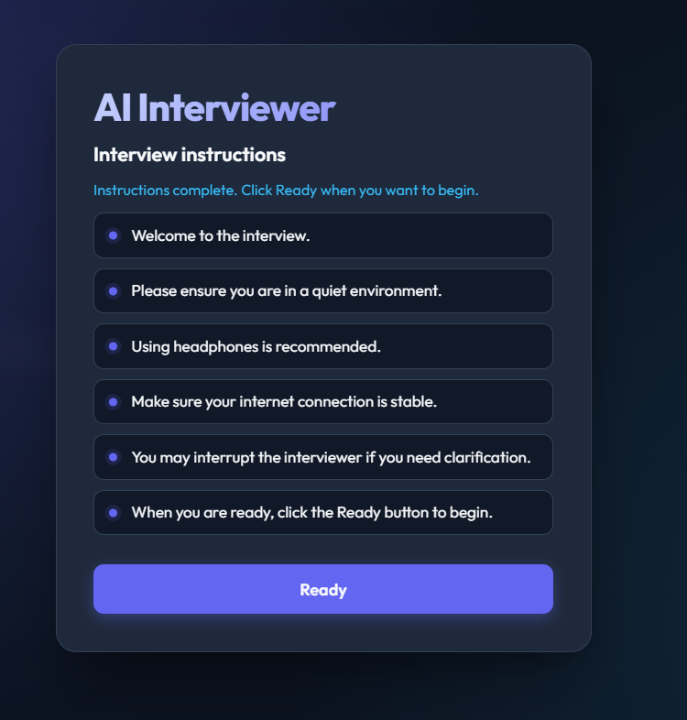
Figure A.2: Candidate browser client (lobby / live interview) connected to the voice server.

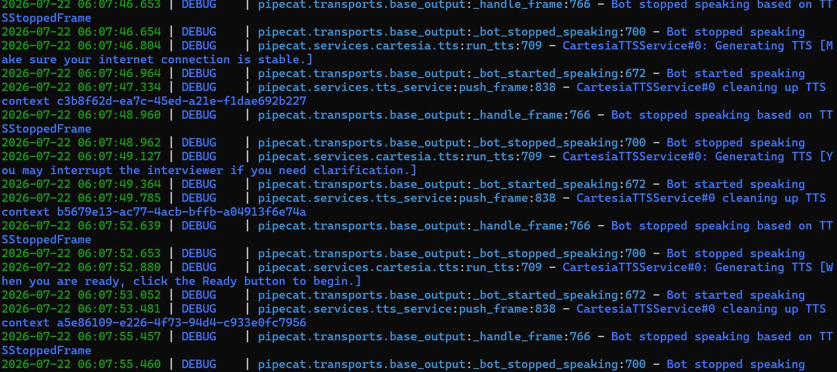
Figure A.3: Live terminal showing Pipecat voice pipeline.
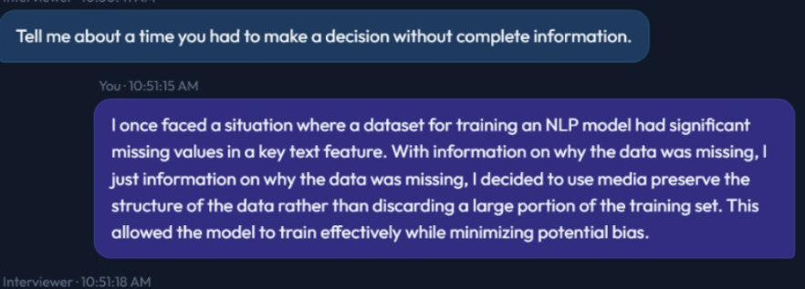

Figure A.4: Real-time transcript generation using Deepgram STT.

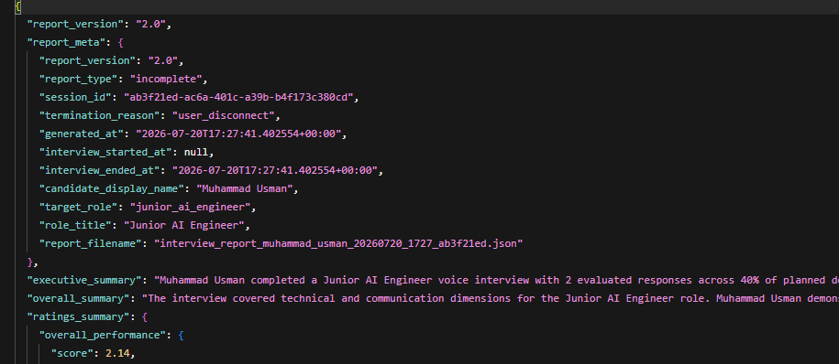
Figure A.5: Generated interview report in JSON format.

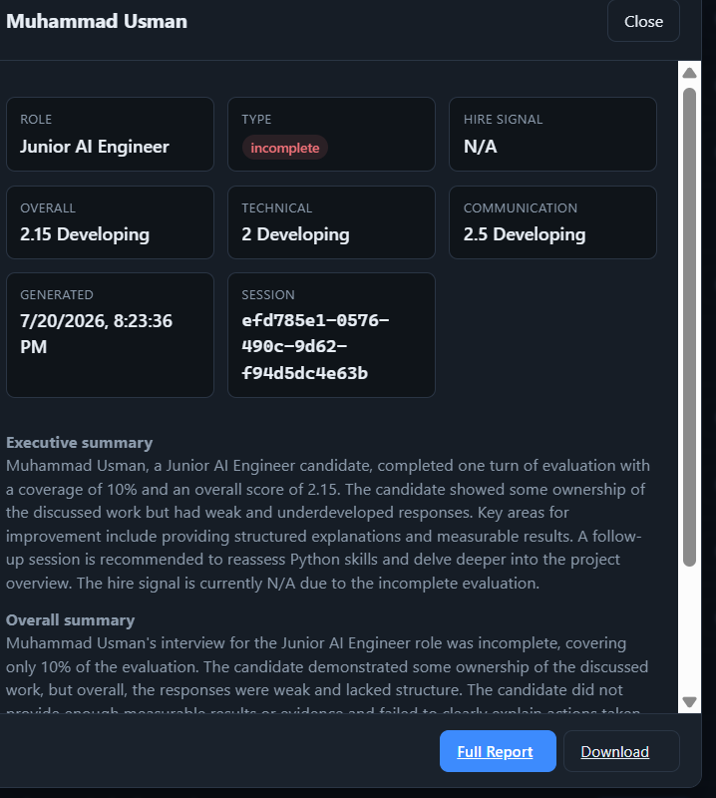
Figure A.6: Recruiter dashboard feedback report summarizing candidate performance.

A.6 Interview Report Statistics
Each interview can produce a Report V2 artefact (report_version 2.0) as JSON with companion HTML. Supported completion types are complete, partial, incomplete, and aborted (aborted reports under reports/aborted/). Reports include communication and technical profiles, domain_assessment_map, adaptive traces, hire recommendation, and a completion summary. Recruiters browse these artefacts on port 8001; candidates may open HTML via Report HTTP on port 8766.
The report includes:
- Report V2 metadata (report_version 2.0)
- Completion tier: complete, partial, incomplete, or aborted
- Communication and technical profiles
- domain_assessment_map (per-domain coverage)
- Adaptive decision traces (PROBE / ADVANCE / CLOSING)
- Hire recommendation and recruiter summary
- Completion and blueprint coverage summary
- HTML report alongside JSON persistence
- Aborted artefacts stored under reports/aborted/

Table A.4: Report Components
Component | Description
Overall Score | Weighted rubric score
Communication Profile | clarity, structure, confidence aggregate
Technical Profile | ownership, leadership, result_orientation aggregate
Domain Assessment | Per-domain coverage / not_assessed map
Adaptive Trace | PROBE / ADVANCE / CLOSING and related decisions
Hire Recommendation | strong_hire / hire / borderline bands and recruiter summary
Completion Tier | complete | partial | incomplete | aborted
Completion / Coverage | Blueprint coverage summary
Transcript Quality | Noise and artefact assessment
Fairness Adjustment | STT-fair weight shift when triggered
Report Version | Report V2 (2.0)

A.7 Configuration Notes
Several implementation decisions were made during development to improve interview quality and system robustness.
These include:
- Pipecat is the primary product voice path (WebSocket PCM on 8765/8766); the recruiter dashboard runs on port 8001; optional FastAPI REST may run on port 8000.
- Coverage-first interviewing per selected role blueprint; wrap-up prefers full domain coverage.
- Conversational control filters non-substantive turns before evaluation.
- Canonical questions plus rephrase_policy support stable recovery prompts.
- VoiceTurnPolicy governs debounce, silence nudge/rephrase, barge-in, and tail-fragment handling.
- Report V2 supports complete, partial, incomplete, and aborted completion tiers (JSON + HTML).
- Role registry maps AI Engineer, Frontend Developer, and Backend Developer blueprints into session state.
- Groq Llama 3.3 70B Versatile for evaluation and question generation; Deepgram nova-2 STT; Cartesia TTS; Silero VAD.
- Phase 6C reporting introduces separate communication and technical profiles.
- Human-study export supports thesis validation workflows.
- Speech Emotion Recognition, facial analysis, candidate self-paced practice, and personalised low-score improvement feedback remain future work only and are not configured in the delivered system.

A.8 Development Challenges
Several practical challenges were encountered throughout the implementation.

Voice Processing
Browser microphone capture and Silero VAD required careful tuning so turn boundaries remained reliable under variable ambient conditions and hardware differences.

Transcript Fragmentation
Streaming STT occasionally produced overlapping fragments and post-answer tails. Debounce settings, VoiceTurnPolicy tail-fragment handling, and transcript cleanup were used to stabilise turn submission.

Adaptive Interview Flow
Probing could risk repeated or near-duplicate questions. Semantic deduplication and coverage-first advancement were applied to keep progression consistent with the blueprint.

Meta Conversation
Candidates sometimes use navigational or uncertain responses during live interviews. Conversational control distinguishes these from substantive technical answers so recovery behaviour remains controlled without scoring non-substantive turns.

Fair Evaluation
Noisy transcripts can unfairly depress communication-related scores. Transcript-quality assessment supports an STT-fair weight shift when artefact levels indicate that communication scoring would otherwise be distorted.

Live Voice Reliability
Early live testing exposed interrupted speech, reconnect edge cases, and overly aggressive VAD behaviour. Subsequent voice hotfixes improved turn timing, echo cooldowns, barge-in handling, and VAD_STOP_SECS tuning without altering the multi-process demo architecture.

Appendix B

Code Snippets

This appendix presents selected implementation excerpts from AI Powered Interview Simulation and Feedback Platform. Only the most important components are included to illustrate system architecture and core behaviour—including dialogue orchestration and a short recruiter-invite excerpt. Complete source code is available in the project repository.

B.1 DialogueManager Implementation
DialogueManager is the central orchestration module of the simulator. It coordinates transcript preparation, conversational control, adaptive evaluation, decisioning (probe, advance, or closing), and turn recording for each candidate response.
Listing B.1: DialogueManager implementation (backend/dialogue/dialogue_manager.py).
def handle_turn(self, transcript):
raw_transcript_for_debug = transcript
transcript, transcript_quality = prepare_transcript_for_evaluation(transcript)
try:
last_q_for_debug = self.context.question_history[-1] if getattr(self.context, "question_history", []) else ""
self._debug_live_log("BOT_LAST_QUESTION", last_q_for_debug)
self._debug_live_log("CANDIDATE_RAW_TRANSCRIPT", raw_transcript_for_debug)
self._debug_live_log("CANDIDATE_CLEAN_TRANSCRIPT", transcript)
self._debug_live_log("TRANSCRIPT_QUALITY", transcript_quality.to_dict())
except Exception:
pass
def final_log_and_return(res, decision_val):
try:
self._debug_live_log("DECISION", decision_val)
self._debug_live_log("BOT_NEXT_QUESTION", res.get("question", ""))
except Exception:
pass
return res
"""
Handle one conversation turn:
1. If INTRO state -> generate greeting (no evaluation)
2. Otherwise -> use adaptive evaluation (score + decide + generate in one call)
3. Fallback to legacy pipeline if adaptive fails
"""
# -- INTRO: no answer to evaluate yet --
if not transcript and self.context.state.value == "intro":
action = self.engine.decide(self.context, transcript)
question = self.llm.generate(action, self.context)
self.context.add_turn(question, transcript)
res = {
"question": question, "evaluation": None,
"decision_type": None, "latency_ms": 0,
}
return final_log_and_return(res, "INTRO")
# -- WRAPUP: close the interview --
if self.context.state.value == "wrapup":
question = "Thank you for your time. This concludes the interview."
self.context.add_turn(question, transcript)
res = {
"question": question, "evaluation": None,
"decision_type": "CLOSING", "latency_ms": 0,
}
return final_log_and_return(res, "CLOSING")
# -- ADAPTIVE PATH: evaluate + decide in one call --
last_question = (
self.context.question_history[-1]
if self.context.question_history
else ""
)
# -- Pre-evaluation guard pipeline --
guard_ctx = GuardContext(
transcript=transcript,
last_question=last_question,
interview_context=self.context,
llm_client=self.llm.client,
llm_model=self.llm.model,
transcript_quality=transcript_quality.to_dict(),
)
guard_hit = self.guard_pipeline.run(guard_ctx)
if guard_hit:
return final_log_and_return(
self._handle_guard_hit(
guard_hit,
transcript,
last_question,
transcript_quality.to_dict(),
),
f"{guard_hit.decision_type} - ignored transcript, no scoring",
)
try:
answered_domain = getattr(self.context, "current_domain", "")
adaptive_result = self.evaluator.adaptive_evaluate(
question=last_question,
answer=transcript,
previous_evaluations=self.context.get_previous_evaluations_summary(),
interview_stage=self.context.interview_stage,
domain=answered_domain,
transcript_quality=transcript_quality.to_dict(),
recent_qa_memory=self.context.format_recent_qa_for_prompt(n=3),
)
evaluation = adaptive_result.get("evaluation", {})
if evaluation.get("overall_score", 0) > 0 and answered_domain:
if hasattr(self.context, "mark_domain_assessed"):
self.context.mark_domain_assessed(answered_domain)
decision = adaptive_result.get("decision", {})
latency_ms = adaptive_result.get("latency_ms", 0)
eval_method = adaptive_result.get("evaluation_method", {})
self.latency_history.append(latency_ms)
# Store evaluation in context
self.context.add_evaluation(evaluation)
# answered_domain captured before DecisionEngine advances current_domain.
# Store the current transcript temporarily so DecisionEngine can make
# probe decisions using the actual current answer, not the previous turn.
self.context.latest_answer_for_decision = transcript
self.context.latest_transcript_quality = transcript_quality.to_dict()
engine_result = self.engine.decide_from_adaptive(
adaptive_result, self.context
)
# Decide final next question using DecisionEngine policy.
# If the engine allows the PROBE, use evaluator's follow-up.
# If probe limit is reached, ignore evaluator follow-up and generate next domain question.
engine_decision_type = engine_result.get("decision_type", decision.get("type", "ADVANCE"))
engine_action_type = engine_result.get("type", "")
engine_reason = engine_result.get("reason", "")
if engine_reason == "probe_limit_reached_moving_to_next_domain" or engine_action_type == "ask":
# Force next blueprint domain question through LLMAdapter.
question = self._ensure_unique_question(
self.llm.generate(engine_result, self.context)
)
decision_type = "ADVANCE"
elif engine_action_type == "closing" or engine_decision_type == "CLOSING":
question = engine_result.get("next_question", "Thank you for your time. This concludes the interview.")
decision_type = "CLOSING"
else:
# PROBE / ADVANCE from evaluator — always dedupe against history
question = self._ensure_unique_question(
decision.get("next_question", "")
)
decision_type = decision.get("type", "ADVANCE")
if question and hasattr(self.context, "set_active_question"):
self.context.set_active_question(
question,
domain_intent=getattr(self.context, "current_domain", ""),
)
# Record this turn
if decision_type == "PROBE":
question = f"[Follow-up] {question}"
if hasattr(self.context, "set_active_question"):
clean_probe = (
question.replace("[Follow-up]", "")
.replace("[follow-up]", "")
.strip()
)
self.context.set_active_question(clean_probe)
decision_log = {
"decision_type": decision_type,
"engine_decision_type": engine_decision_type,
"engine_action_type": engine_action_type,
"engine_reason": engine_reason,
"weakest_dimension": evaluation.get("weakest_dimension", ""),
"weighted_score": evaluation.get("weighted_overall_score", evaluation.get("overall_score", 0)),
"hire_signal": evaluation.get("hire_signal", ""),
}
# Record this turn (skip error strings from question history)
if question.startswith("[Error"):
self.context.transcript_history.append(transcript)
self.context.turn_count += 1
else:
self.context.add_turn(question, transcript)
# Store adaptive/contextual questioning trace for final report.
# This proves why the system asked a follow-up or moved forward.
try:
weakest_dimension = evaluation.get("weakest_dimension", "unknown")
decision_type = engine_result.get("decision_type") or decision.get("type", "UNKNOWN")
next_question = (
question.replace("[Follow-up]", "")
.replace("[follow-up]", "")
.replace("Follow-up:", "")
.replace("follow-up:", "")
.strip()
)
follow_up_reason = self._build_follow_up_reason(
weakest_dimension=weakest_dimension,
decision_type=decision_type,
evaluation=evaluation,
answer=transcript,
)
followup_type = engine_result.get("followup_type", "")
policy_followup_reason = engine_result.get("followup_reason", "")
if policy_followup_reason:
follow_up_reason = policy_followup_reason
skill_focus = self._infer_skill_focus(last_question, transcript)
clean_last_question = (
last_question.replace("[Follow-up]", "")
.replace("[follow-up]", "")
.replace("Follow-up:", "")
.replace("follow-up:", "")
.strip()
)
self.context.add_adaptive_trace({
"turn": self.context.turn_count,
"question_answered": clean_last_question,
"candidate_answer": transcript,
"decision_type": decision_type,
"engine_action": engine_result.get("type", ""),
"engine_reason": engine_result.get("reason", ""),
"domain": answered_domain,
"next_domain": engine_result.get("domain", getattr(self.context, "current_domain", "")),
"weakest_dimension": weakest_dimension,
"follow_up_reason": follow_up_reason,
"followup_type": followup_type,
"followup_label": build_followup_label(followup_type) if followup_type else "",
"guard_passed": True,
"transcript_quality": transcript_quality.to_dict(),
"transcript_quality_adjusted": evaluation.get(
"transcript_quality_adjusted", False
),
"score_profiles": evaluation.get("score_profiles", {}),
"next_question": next_question,
"skill_focus": skill_focus,
"interview_stage": self.context.interview_stage,
"scores": {
"clarity": evaluation.get("clarity", 0),
"structure": evaluation.get("structure", 0),
"confidence": evaluation.get("confidence", 0),
"ownership": evaluation.get("ownership", 0),
"leadership": evaluation.get("leadership", 0),
"result_orientation": evaluation.get("result_orientation", 0),
"overall_score": evaluation.get("overall_score", 0),
"weighted_overall_score": evaluation.get("weighted_overall_score", 0),
},
"star_breakdown": evaluation.get("star_breakdown", {}),
"hire_signal": evaluation.get("hire_signal", "N/A"),
"evaluation_method": {
"rethink_applied": eval_method.get("rethink_applied", False),
"method": eval_method.get("method", ""),
},
})
except Exception as trace_error:
logger.warning("Could not store adaptive trace: %s", trace_error)
# Persist to DB (non-blocking, graceful fallback)
self._save_response_to_db(
question=question,
answer=transcript,
evaluation=evaluation,
decision_type=decision_type,
latency_ms=latency_ms,
)
res = {
"question": question,
"evaluation": evaluation,
"decision_type": decision_type,
"latency_ms": latency_ms,
}
return final_log_and_return(res, decision_log)
except Exception as e:
logger.warning("Adaptive path failed, using legacy: %s", e)
res = self._legacy_handle_turn(transcript)
return final_log_and_return(res, "LEGACY")
def get_final_report(self):
"""Generate the complete final interview report with all analytics."""
from dialogue.analytics import (
generate_final_report,
sanitize_recruiter_summary_for_technical_interview,
)
report = generate_final_report(self.context)
report = sanitize_recruiter_summary_for_technical_interview(report)
# Final hard safety for Junior AI Engineer technical interview reports:
# Never expose STAR-style report sections or STAR-heavy wording as the main evaluation basis.
if isinstance(report, dict):
report.pop("star_effectiveness_analysis", None)
if "technical_evidence_analysis" not in report:
report["technical_evidence_analysis"] = {
"framework": "Evidence-Based Junior AI Engineer Technical Competency Rubric",
"expected_level": "Beginner-to-intermediate practical understanding, not expert-level production mastery.",
"focus_areas": [
"technical_correctness",
"implementation_thinking",
"tool_and_framework_understanding",
"validation_and_testing",
"debugging_approach",
"communication_clarity",
"ownership_evidence",
],
"note": (
"The candidate is evaluated on junior-level technical understanding, practical implementation, "
"validation/testing, debugging approach, clarity, and personal contribution."
),
}
summary = report.get("recruiter_summary", {}) or {}
bad_phrases = [
"Candidate repeatedly missed result/impact in STAR-style answers.",
"Ask for measurable project impact, outcomes, or success metrics.",
]
for key in ["main_concerns", "recommended_follow_up_areas"]:
if isinstance(summary.get(key), list):
summary[key] = [
item for item in summary[key]
if item not in bad_phrases
and "STAR" not in str(item)
and "result/impact" not in str(item)
]
report["recruiter_summary"] = summary
for item in report.get("adaptive_questioning_trace", []) or []:
reason = str(item.get("follow_up_reason", ""))
if "result/impact" in reason or "STAR" in reason:
item["follow_up_reason"] = (
"Candidate answer needed more concrete technical detail, so the system asked for clearer steps, reasoning, or validation."
)
item.pop("star_breakdown", None)
# --- Report-time transcript cleanup ---
# Reuse the existing STT dedup logic to clean repeated fragments
# in candidate_answer and evidence_snippets before saving.
for item in report.get("adaptive_questioning_trace", []) or []:
raw = item.get("candidate_answer", "")
if raw:
item["candidate_answer"] = self._clean_live_transcript(raw)
scm = report.get("skill_coverage_map", {}) or {}
for skill_data in scm.values():
snippets = skill_data.get("evidence_snippets", [])
if snippets:
skill_data["evidence_snippets"] = [
self._clean_live_transcript(s) for s in snippets
]
# Persist final scores to DB
self._persist_session_finals(report)
# Add latency metrics
if self.latency_history:
sorted_l = sorted(self.latency_history)
n = len(sorted_l)
report["latency_metrics"] = {
"avg_ms": round(sum(sorted_l) / n, 2),
"p95_ms": round(sorted_l[min(int(n * 0.95), n - 1)], 2),
"max_ms": round(max(sorted_l), 2),
"total_calls": n,
"source": "in_memory",
}
else:
report["latency_metrics"] = {
"avg_ms": 0, "p95_ms": 0, "max_ms": 0,
"total_calls": 0, "source": "no_data",
}
# Try to enrich from DB
if self.session_id:
try:
from dialogue.database import get_latency_metrics
db_metrics = get_latency_metrics(self.session_id)
if db_metrics.get("source") == "postgres":
report["latency_metrics"] = db_metrics
except Exception:
pass
from reporting.generator import build_report_v2
return build_report_v2(
context=self.context,
legacy_report=report,
session_id=self.session_id,
)

B.2 Interview Processor (Pipecat)
InterviewProcessor is the Pipecat FrameProcessor that bridges live voice turns to the dialogue backend. It submits recognised speech asynchronously, emits conversation events for the UI, and triggers Cartesia TTS output.
Listing B.2: InterviewProcessor implementation (backend/pipecat_integration/interview_processor.py).
async def _submit_turn(self, user_text: str, direction: FrameDirection) -> None:
"""Process one complete transcript through the adapter and push TTS response."""
self._note_candidate_activity()
# Ready for a new silence cycle after the next interview question finishes.
self._silence_stage = None
self.last_processed_transcript = user_text
self.first_real_user_turn_seen = True
self._open_resume_window(user_text)
was_barge_in = self.barge_in_active
turn_id = self.conversation.new_turn_id()
logger.info("Processing user transcript: %r", user_text)
if was_barge_in:
logger.info("Transcript from barge-in turn — dialogue policy will classify.")
await self._emit_conversation(
self.conversation.message(role="user", text=user_text, turn_id=turn_id),
direction,
)
await self._emit_phase("thinking", direction)
try:
response = await asyncio.to_thread(
self.adapter.process_user_text,
self.session_id,
user_text,
)
if was_barge_in:
logger.debug("Resetting barge-in state after transcript processing.")
self.barge_in_active = False
if response.get("error"):
logger.error("Adapter error: %s", response["error"])
await self._speak_to_client(
"I'm sorry, I had trouble processing that response. Could you please repeat?",
direction,
turn_id=turn_id,
)
return
ai_text = sanitize_tts_text(response.get("ai_response_text", ""))
is_complete = response.get("is_complete", False)
if ai_text:
await self._speak_to_client(
ai_text, direction, role="assistant", turn_id=turn_id
)
if is_complete:
logger.info(
"Interview %s complete — spoken closing then EndTaskFrame.",
self.session_id,
)
closing_already = "concludes the interview" in (ai_text or "").lower()
if not closing_already:
await self._speak_to_client(
INTERVIEW_CLOSING_SPOKEN,
direction,
role="system",
turn_id=turn_id,
)
await asyncio.sleep(self.policy.closing_delay_seconds)
await self.push_frame(EndTaskFrame(), FrameDirection.UPSTREAM)
except Exception:
logger.exception("Failed to process turn in InterviewProcessor")
await self._speak_to_client(
"I'm sorry, I encountered an internal error. Let's try again.",
direction,
turn_id=turn_id,
)

B.3 FastAPI REST API
The FastAPI service exposes REST endpoints used for text-mode session control in the AI-Based Real-Time Interview Simulator. The primary routes start an interview, process chat turns, and retrieve the final Report V2 artefact.
Listing B.3: FastAPI endpoints
(main.py)
@app.post("/start", response_model=StartResponse)
def start_interview(req: StartRequest):
"""
Start a new interview session.
Resume is optional. When omitted, the system uses the default profile for
target_role (default: junior_ai_engineer).
"""
session_start = req.model_dump(exclude_none=True)
session_id, result = sessions.start_interview(session_start=session_start)
stored = sessions.get(session_id)
resume_data = stored.resume_data if stored else {}
return StartResponse(
session_id=session_id,
greeting=result["question"],
profile_source=resume_data.get("profile_source", "default"),
target_role=resume_data.get("target_role", DEFAULT_TARGET_ROLE),
)
@app.post("/chat", response_model=ChatResponse)
def chat(req: ChatRequest):
"""
Send a candidate's answer and receive the next interview question
along with evaluation of the previous answer.
"""
try:
result = sessions.process_turn(req.session_id, req.input_text)
status = sessions.get_status(req.session_id)
except SessionNotFoundError:
raise HTTPException(
status_code=404,
detail="Session not found. Start a new interview with POST /start.",
)
# Build evaluation response if one was generated
eval_data = None
if result.get("evaluation"):
eval_data = EvaluationResponse(**result["evaluation"])
return ChatResponse(
question=result["question"],
evaluation=eval_data,
decision_type=result.get("decision_type"),
status=status,
)
@app.get("/session/{session_id}")
def get_session_status(session_id: str):
"""
Get the current status of an interview session, including
aggregate evaluation scores.
"""
try:
return sessions.get_status(session_id)
except SessionNotFoundError:
raise HTTPException(status_code=404, detail="Session not found.")
@app.get("/roles")
def list_roles():
"""List available target interview roles."""
return {"roles": list_target_roles(), "default": DEFAULT_TARGET_ROLE}
@app.get("/health")
def health_check():
"""Health check endpoint."""
return {
"status": "ok",
"active_sessions": sessions.active_count(),
"primary_runtime": "pipecat",
"dev_text_voice_ws": settings.enable_dev_text_voice_ws,
}
@app.get("/export/human-study/{session_id}")
def export_human_study(session_id: str, fmt: str = "json"):
"""
Export scored turns for manual human rating (thesis κ study).
Query param fmt: json (default) returns row data; csv returns file paths info.
"""
from evaluation.human_study_export import export_from_dialogue_manager, extract_rows_from_context
try:
dm = sessions.get_dialogue_manager(session_id)
except SessionNotFoundError:
raise HTTPException(status_code=404, detail="Session not found.")
rows = extract_rows_from_context(dm.context)
if fmt == "csv":
from core.config import settings
paths = export_from_dialogue_manager(
dm,
settings.reports_dir,
basename=f"human_study_{session_id[:8]}",
)
return {"session_id": session_id, **paths}
return {
"session_id": session_id,
"row_count": len(rows),
"rows": rows,
"instructions": "Fill human_rating_overall (1-5) for κ agreement study.",
}
@app.get("/report/{session_id}")
def get_final_report(session_id: str):
"""
Generate a full final interview report with:
- Weighted score summary
- STAR effectiveness analysis
- Performance trend analysis
- Consistency rating
- Behavioral profile (5-axis)
- Bias awareness section
"""
try:
return sessions.get_report(session_id)
except SessionNotFoundError:
raise HTTPException(status_code=404, detail="Session not found.")
# ── Recruiter Report Endpoints ─────────────────────────────────
@app.get("/report/hr/{session_id}")
def get_hr_report(session_id: str):
"""
Generate a structured recruiter-facing report including:
- Candidate summary
- Per-dimension scores
- Hire recommendation (STRONG_HIRE / HIRE / LEAN_HIRE / NO_HIRE)
- Risk flags
"""
try:
dm = sessions.get_dialogue_manager(session_id)
except SessionNotFoundError:
raise HTTPException(status_code=404, detail="Session not found.")
return generate_hr_report(dm)

B.4 Evaluation Pipeline
The evaluation pipeline applies fixed rubric dimension weights, runs primary adaptive scoring, optionally adjusts for transcript quality, and may invoke a conservative rethink step on borderline cases before returning structured scores.
Listing B.4: Evaluation pipeline (backend/dialogue/evaluation_pipeline.py).
"""
Evaluation pipeline — orchestrates primary scoring, optional rethink ensemble, and follow-up decision.
Phase 4: separates scoring reliability (ensemble) from turn decision while preserving
the adaptive_evaluate() response contract for DialogueManager.
"""
from __future__ import annotations
import logging
from typing import TYPE_CHECKING, Any
from evaluation.rubric import (
apply_transcript_quality_adjustment,
compute_profile_scores,
get_evaluation_methodology,
merge_evaluations,
should_trigger_rethink,
)
if TYPE_CHECKING:
from dialogue.evaluator import Evaluator
logger = logging.getLogger(__name__)
class EvaluationPipeline:
"""
Lite ensemble evaluation pipeline (SWE-Judge inspired).
Flow:
1. Primary adaptive call (score + follow-up decision)
2. Optional rethink pass when score is borderline
3. Merge scores conservatively; decision from primary pass
"""
def __init__(self, evaluator: "Evaluator"):
self._evaluator = evaluator
def evaluate_turn(
self,
question: str,
answer: str,
previous_evaluations: list,
interview_stage: str,
domain: str = "",
transcript_quality: dict | None = None,
recent_qa_memory: str = "",
) -> dict[str, Any]:
"""
Run full evaluation for one candidate turn.
Returns same shape as legacy adaptive_evaluate():
evaluation, decision, latency_ms, evaluation_method
"""
total_latency = 0.0
rethink_applied = False
primary = self._evaluator._run_primary_adaptive(
question=question,
answer=answer,
previous_evaluations=previous_evaluations,
interview_stage=interview_stage,
transcript_quality=transcript_quality,
recent_qa_memory=recent_qa_memory,
)
total_latency += primary.get("latency_ms", 0)
evaluation = primary.get("evaluation", {})
decision = primary.get("decision", {})
evaluation = apply_transcript_quality_adjustment(evaluation, transcript_quality)
if evaluation and "score_profiles" not in evaluation:
evaluation["score_profiles"] = compute_profile_scores(evaluation)
if should_trigger_rethink(evaluation):
rethink_result = self._evaluator.rethink_evaluation(
question=question,
answer=answer,
primary_evaluation=evaluation,
domain=domain,
)
total_latency += rethink_result.get("latency_ms", 0)
if rethink_result.get("evaluation"):
evaluation = merge_evaluations(evaluation, rethink_result["evaluation"])
evaluation = apply_transcript_quality_adjustment(
evaluation, transcript_quality
)
evaluation["score_profiles"] = compute_profile_scores(evaluation)
rethink_applied = True
logger.debug(
"Rethink ensemble applied: primary=%.2f merged=%.2f",
primary["evaluation"].get("weighted_overall_score", 0),
evaluation.get("weighted_overall_score", 0),
)
method = get_evaluation_methodology()
method["primary_pass"] = True
method["rethink_applied"] = rethink_applied
method["total_latency_ms"] = round(total_latency, 2)
if transcript_quality:
method["transcript_quality"] = transcript_quality
return {
"evaluation": evaluation,
"decision": decision,
"latency_ms": round(total_latency, 2),
"evaluation_method": method,
}
def score_answer_only(self, question: str, answer: str, domain: str = "") -> dict[str, Any]:
"""Score without follow-up decision — for export / offline analysis."""
return self._evaluator.score_answer(question, answer, domain=domain)
DIMENSION_WEIGHTS: dict[str, float] = {
"structure": 0.25,
"result_orientation": 0.20,
"ownership": 0.20,
"leadership": 0.15,
"clarity": 0.10,
"confidence": 0.10,
SCORE_DIMENSIONS: tuple[str, ...] = (
"clarity",
"structure",
"confidence",
"ownership",
"leadership",
"result_orientation",
COMMUNICATION_DIMENSIONS: tuple[str, ...] = ("clarity", "structure", "confidence")
TECHNICAL_DIMENSIONS: tuple[str, ...] = ("ownership", "leadership", "result_orientation")
NOISY_TRANSCRIPT_WEIGHTS: dict[str, float] = {
"structure": 0.10,
"result_orientation": 0.28,
"ownership": 0.28,
"leadership": 0.18,
"clarity": 0.04,
"confidence": 0.12,
HIRE_SIGNAL_THRESHOLDS: dict[str, float] = {
"strong_hire": 4.2,
"hire": 3.4,
"borderline": 2.5,
def should_apply_transcript_quality_adjustment(
transcript_quality: dict[str, Any] | None,
) -> bool:
"""True when STT artifacts likely distorted communication scoring."""
if not transcript_quality:
return False
if transcript_quality.get("is_noisy"):
return True
flags = set(transcript_quality.get("flags") or [])
if flags & {"stutter_prefix", "likely_tail_fragment", "high_cleanup_reduction"}:
return True
if float(transcript_quality.get("reduction_ratio") or 0) >= 0.20:
return True
if float(transcript_quality.get("repeated_token_ratio") or 0) >= 0.22:
return True
if bool(transcript_quality.get("stutter_prefix")):
return True
if bool(transcript_quality.get("is_likely_tail_fragment")):
return True
return False
# Per-answer hire signal thresholds (weighted score)
HIRE_SIGNAL_THRESHOLDS: dict[str, float] = {
"strong_hire": 4.2,
"hire": 3.4,
"borderline": 2.5,
}
# Recruiter aggregate recommendation tiers
RECRUITER_HIRE_THRESHOLDS: dict[str, float] = {
"strong_hire": 4.0,
"hire": 3.0,
"lean_hire": 2.0,
}
# Rethink ensemble triggers (SWE-Judge lite — second pass on uncertain scores)
RETHINK_WEIGHTED_MIN = 2.2
RETHINK_WEIGHTED_MAX = 3.5
# High variance between dimensions also triggers rethink
RETHINK_DIMENSION_SPREAD_MIN = 1.5

B.5 Guard Pipeline
Before adaptive scoring, every candidate turn passes through an ordered guard pipeline. Guards execute in sequence (Echo, MetaConversation, Idk, Intent, Incomplete, Domain) and short-circuit on the first trigger.
Listing B.5: Guard pipeline (backend/dialogue/guards/).
"""Ordered guard pipeline executed before adaptive evaluation."""
from __future__ import annotations
from typing import Optional
from dialogue.guards.domain_guard import DomainGuard
from dialogue.guards.echo_guard import EchoGuard
from dialogue.guards.idk_guard import IdkGuard
from dialogue.guards.incomplete_guard import IncompleteGuard
from dialogue.guards.intent_guard import IntentGuard
from dialogue.guards.meta_conversation_guard import MetaConversationGuard
from dialogue.guards.types import Guard, GuardContext, GuardResult
class GuardPipeline:
"""Run pre-evaluation guards in fixed order; stop at first trigger."""
def __init__(self, guards: Optional[list[Guard]] = None, llm_client=None, llm_model: str = ""):
if guards is not None:
self._guards = guards
else:
self._guards = [
EchoGuard(),
MetaConversationGuard(),
IdkGuard(),
IntentGuard(llm_client=llm_client, llm_model=llm_model),
IncompleteGuard(),
DomainGuard(),
]
def run(self, ctx: GuardContext) -> Optional[GuardResult]:
for guard in self._guards:
result = guard.check(ctx)
if result.triggered:
return result
return None

B.6 Transcript Processing
Transcript utilities clean live speech-recognition text and assess quality before evaluation. The cleaned transcript and quality metadata are supplied to DialogueManager and the evaluation pipeline.
Listing B.6: Transcript preprocessing (backend/dialogue/transcript_utils.py).
def clean_live_transcript(text: str) -> str:
"""Clean repeated ASR fragments before evaluation and reporting."""
original = (text or "").strip()
if not original:
return ""
cleaned = re.sub(r"\s+", " ", original).strip()
cleaned = cleaned.replace(" ,", ",").replace(" .", ".")
cleaned = _collapse_progressive_interim_phrases(cleaned)
cleaned = _remove_stutter_prefix(cleaned)
tokens = _remove_adjacent_repeated_ngrams(cleaned.split())
cleaned = " ".join(tokens)
phrase_pattern = re.compile(
r"\b((?:\w+[,.]?\s+){2,12}\w+[,.]?)(?:\s+\1\b)+",
flags=re.IGNORECASE,
)
previous = None
while previous != cleaned:
previous = cleaned
cleaned = phrase_pattern.sub(r"\1", cleaned).strip()
cleaned = re.sub(r"\b(\w+)(\s+\1\b)+", r"\1", cleaned, flags=re.IGNORECASE)
cleaned = _remove_overlapping_repeated_phrases(cleaned)
cleaned = re.sub(r"\s+", " ", cleaned).strip()
if not cleaned:
return original
if len(original.split()) >= 10 and len(cleaned.split()) < max(
5, int(len(original.split()) * 0.40)
):
return original
return cleaned
def prepare_transcript_for_evaluation(text: str) -> tuple[str, TranscriptQuality]:
"""Clean transcript and return quality assessment for evaluation fairness."""
raw = (text or "").strip()
cleaned = clean_live_transcript(raw)
quality = assess_transcript_quality(raw, cleaned)
return cleaned, quality

B.7 Voice Pipeline Configuration
The voice runtime assembles a Pipecat pipeline for the real-time interview simulator: Silero VAD, Deepgram STT (nova-2), InterviewProcessor, Cartesia TTS, and WebSocket transport, with Report HTTP available on port 8766.
Listing B.7: Voice pipeline (backend/pipecat_integration/interview_bot.py).
def start_report_http_server(host="localhost", port=None):
"""
Small local HTTP server for the manual browser client.
It serves the latest saved report from the reports folder.
"""
if port is None:
port = settings.report_http_port
class ReportHandler(BaseHTTPRequestHandler):
def _send_json(self, status_code, payload):
body = json.dumps(payload, ensure_ascii=False, indent=2).encode("utf-8")
self.send_response(status_code)
self.send_header("Content-Type", "application/json; charset=utf-8")
self.send_header("Access-Control-Allow-Origin", "*")
self.send_header("Access-Control-Allow-Methods", "GET, OPTIONS")
self.send_header("Access-Control-Allow-Headers", "Content-Type")
self.send_header("Content-Length", str(len(body)))
self.end_headers()
self.wfile.write(body)
def do_OPTIONS(self):
self._send_json(200, {"ok": True})
def do_GET(self):
if self.path not in ["/latest-report", "/reports/latest"]:
self._send_json(404, {"error": "Not found"})
return
reports_dir = settings.reports_dir
if not reports_dir.exists():
self._send_json(404, {"error": "No reports folder found yet"})
return
report_files = sorted(
reports_dir.glob("interview_report_*.json"),
key=lambda p: p.stat().st_mtime,
reverse=True
)
if not report_files:
self._send_json(404, {"error": "No report files found yet"})
return
latest = report_files[0]
try:
data = json.loads(latest.read_text(encoding="utf-8"))
self._send_json(200, {
"file": str(latest),
"report": data
})
except Exception as exc:
self._send_json(500, {"error": str(exc)})
def log_message(self, format, *args):
return
try:
server = HTTPServer((host, port), ReportHandler)
except OSError as exc:
logger.warning(f"Report HTTP server not started on {host}:{port}: {exc}")
return
thread = threading.Thread(target=server.serve_forever, daemon=True)
thread.start()
logger.info(f"Report HTTP server running at http://{host}:{port}/latest-report")
stt_service = DeepgramSTTService(
api_key=config.DEEPGRAM_API_KEY,
settings=DeepgramSTTService.Settings(
model=settings.deepgram_model,
language=settings.deepgram_language,
endpointing=settings.deepgram_endpointing_ms,
smart_format=settings.deepgram_smart_format,
punctuate=settings.deepgram_punctuate,
keywords=[
item.strip()
for item in settings.deepgram_keywords.split(",")
if item.strip()
]
or None,
),
)
tts_service = CartesiaTTSService(
api_key=config.CARTESIA_API_KEY,
settings=CartesiaTTSService.Settings(
voice=config.CARTESIA_VOICE_ID
)
)
# 5. Initialize our custom processor with a placeholder session_id
# session_id will be dynamically updated when a client connects
interview_processor = InterviewProcessor(adapter=adapter, session_id="")
json_serializer.processor = interview_processor
# 6. Assemble Pipecat pipeline
# Use DiagnosticSileroVADAnalyzer with more sensitive thresholds for browser mic audio.
# Default thresholds (confidence=0.7, min_volume=0.6) are too strict for browser mic.
vad_analyzer = DiagnosticSileroVADAnalyzer(
params=VADParams(
confidence=0.30,
min_volume=0.015,
start_secs=0.12,
stop_secs=0.90,
)
)
pipeline = Pipeline([
transport.input(),
VADProcessor(vad_analyzer=vad_analyzer, audio_idle_timeout=2.0),
stt_service,
interview_processor,
tts_service,
transport.output()
])

B.8 Report Generation
Report V2 generation classifies interview completion (complete, partial, incomplete, or aborted) and assembles versioned ratings summaries for recruiter review. DialogueManager.get_final_report() wraps legacy analytics via build_report_v2().
Listing B.8: Report V2 generation
(`backend/reporting/generator.py`, `backend/reporting/completion_policy.py`).
"""Classify interview completion tier from evaluated turns and domain coverage."""
from __future__ import annotations
from dataclasses import dataclass
from dialogue.states import InterviewState
from reporting.schema import REPORT_TYPES
@dataclass(frozen=True)
class CompletionThresholds:
complete_min_turns: int = 5
# Full Junior AI Engineer interviews must visit the whole blueprint.
complete_min_coverage_percent: float = 100.0
partial_min_turns: int = 3
partial_min_coverage_percent: float = 30.0
DEFAULT_THRESHOLDS = CompletionThresholds()
def count_evaluated_turns(context) -> int:
"""Scored turns only — excludes guard redirects and errors."""
return sum(
1
for evaluation in getattr(context, "evaluations", []) or []
if evaluation.get("overall_score", 0) > 0 and not evaluation.get("is_error")
)
def classify_report_type(
context,
coverage_percent: float,
*,
thresholds: CompletionThresholds = DEFAULT_THRESHOLDS,
) -> str:
"""
Return one of: complete | partial | incomplete | aborted.
Priority:
1. aborted — zero evaluated turns
2. complete — wrap-up + enough turns + coverage
3. partial — enough turns + coverage (any termination)
4. incomplete — everything else
"""
evaluated = count_evaluated_turns(context)
if evaluated == 0:
return "aborted"
is_wrapup = getattr(context, "state", None) == InterviewState.WRAPUP
if (
is_wrapup
and evaluated >= thresholds.complete_min_turns
and coverage_percent >= thresholds.complete_min_coverage_percent
):
return "complete"
if (
evaluated >= thresholds.partial_min_turns
and coverage_percent >= thresholds.partial_min_coverage_percent
):
return "partial"
return "incomplete"
def infer_termination_reason(context, explicit: str | None = None) -> str:
if explicit:
return explicit
if getattr(context, "state", None) == InterviewState.WRAPUP:
return "natural_completion"
return "user_disconnect"
def completion_note_for_type(report_type: str) -> str:
notes = {
"complete": "Interview reached wrap-up with full blueprint domain coverage.",
"partial": (
"Interview ended with preliminary assessed data. Ratings are not final."
),
"incomplete": (
"Interview ended before sufficient assessment. Use this report for traceability only."
),
"aborted": "No evaluated turns — session produced no assessable interview data.",
}
return notes.get(report_type, "Interview status unknown.")
"""Orchestrate report v2 from InterviewContext and legacy analytics."""
from __future__ import annotations
from datetime import datetime, timezone
from reporting.builders import (
build_domain_ratings,
build_question_review,
build_ratings_summary,
build_strengths_and_improvements,
)
from reporting.completion_policy import (
classify_report_type,
completion_note_for_type,
count_evaluated_turns,
infer_termination_reason,
)
from reporting.naming import build_report_filename
from reporting.narrative import generate_narrative_summaries
from reporting.schema import LEGACY_TOP_LEVEL_KEYS, REPORT_VERSION
def build_report_v2(
context,
legacy_report: dict,
*,
session_id: str | None = None,
termination_reason: str | None = None,
interview_started_at: datetime | None = None,
interview_ended_at: datetime | None = None,
llm_client=None,
llm_model: str | None = None,
) -> dict:
"""
Wrap legacy analytics in report v2 structure.
Mirrors legacy top-level keys for backward compatibility with existing UI/API.
"""
legacy = dict(legacy_report or {})
ended_at = interview_ended_at or datetime.now(timezone.utc)
started_at = interview_started_at
completion = legacy.get("interview_completion", {}) or {}
coverage_percent = float(completion.get("coverage_percent", 0) or 0)
evaluated_turns = count_evaluated_turns(context)
report_type = classify_report_type(context, coverage_percent)
termination = infer_termination_reason(context, termination_reason)
candidate_name = (
context.resume_data.get("name")
or context.resume_data.get("display_name")
or "Candidate"
)
role_title = legacy.get("interview_metadata", {}).get("role_title", "Junior AI Engineer")
filename = build_report_filename(
candidate_name=candidate_name,
session_id=session_id,
generated_at=ended_at,
)
domain_ratings = build_domain_ratings(legacy.get("domain_assessment_map", {}))
question_review = build_question_review(legacy.get("adaptive_questioning_trace", []))
ratings_summary = build_ratings_summary(legacy, report_type, evaluated_turns)
strengths, areas_for_improvement = build_strengths_and_improvements(legacy)
narrative_facts = {
"report_type": report_type,
"candidate_name": candidate_name,
"role_title": role_title,
"evaluated_turns": evaluated_turns,
"coverage_percent": coverage_percent,
"overall_score": ratings_summary["overall_performance"]["score"],
"hire_signal": ratings_summary["final_recommendation"]["signal"],
"strengths": strengths,
"areas_for_improvement": areas_for_improvement,
"domain_ratings": domain_ratings,
}
executive_summary, overall_summary = generate_narrative_summaries(
narrative_facts,
llm_client=llm_client,
llm_model=llm_model,
)
extended_completion = {
**completion,
"report_type": report_type,
"evaluated_turns": evaluated_turns,
"termination_reason": termination,
"completion_note": completion_note_for_type(report_type),
"thresholds_met": {
"complete": report_type == "complete",
"partial": report_type == "partial",
},
}
report_meta = {
"report_version": REPORT_VERSION,
"report_type": report_type,
"session_id": session_id,
"termination_reason": termination,
"generated_at": ended_at.isoformat(),
"interview_started_at": started_at.isoformat() if started_at else None,
"interview_ended_at": ended_at.isoformat(),
"candidate_display_name": candidate_name,
"target_role": getattr(context, "target_role", "junior_ai_engineer"),
"role_title": role_title,
"report_filename": filename,
}
limitations = legacy.get("bias_awareness", {}) or {}
if report_type != "complete":
limitations = {
**limitations,
"data_quality_caveat": extended_completion["completion_note"],
}
v2 = {
"report_version": REPORT_VERSION,
"report_meta": report_meta,
"executive_summary": executive_summary,
"overall_summary": overall_summary,
"ratings_summary": ratings_summary,
"domain_ratings": domain_ratings,
"strengths": strengths,
"areas_for_improvement": areas_for_improvement,
"question_review": question_review,
"detailed_analytics": legacy,
"limitations_and_bias": limitations,
"interview_completion": extended_completion,
}
for key in LEGACY_TOP_LEVEL_KEYS:
if key in legacy:
v2[key] = legacy[key]
# Keep interview_completion at root aligned with extended version.
v2["interview_completion"] = extended_completion
return v2

B.9 Human Study Export
Human-study export extracts guard-passed adaptive-trace rows into a flat schema for offline rating and agreement analysis. Columns include dimension scores, hire signal, rethink flags, and fields reserved for human overall ratings.
Listing B.9: Human Study Export (backend/evaluation/human_study_export.py).
"""
Human study export — offline CSV/JSON for manual rating and thesis κ analysis.
Phase 4: export scored turns for 15–20 human-rated answers validation study.
"""
from __future__ import annotations
import csv
import json
from pathlib import Path
from typing import Any
from evaluation.rubric import SCORE_DIMENSIONS
EXPORT_COLUMNS = [
"turn",
"domain",
"question",
"candidate_answer",
*SCORE_DIMENSIONS,
"overall_score",
"weighted_overall_score",
"weakest_dimension",
"hire_signal",
"rethink_applied",
"human_rating_overall",
"human_rater_id",
"human_notes",
]
def _trace_row(item: dict, turn_index: int) -> dict[str, Any]:
scores = item.get("scores") or {}
eval_method = item.get("evaluation_method") or {}
return {
"turn": item.get("turn", turn_index),
"domain": item.get("domain", ""),
"question": item.get("question_answered", ""),
"candidate_answer": item.get("candidate_answer", ""),
"clarity": scores.get("clarity", 0),
"structure": scores.get("structure", 0),
"confidence": scores.get("confidence", 0),
"ownership": scores.get("ownership", 0),
"leadership": scores.get("leadership", 0),
"result_orientation": scores.get("result_orientation", 0),
"overall_score": scores.get("overall_score", 0),
"weighted_overall_score": scores.get("weighted_overall_score", 0),
"weakest_dimension": item.get("weakest_dimension", ""),
"hire_signal": item.get("hire_signal", ""),
"rethink_applied": eval_method.get("rethink_applied", False),
"human_rating_overall": "",
"human_rater_id": "",
"human_notes": "",
}
def extract_rows_from_report(report: dict) -> list[dict[str, Any]]:
"""Extract rateable rows from a final report dict."""
trace = report.get("adaptive_questioning_trace") or []
rows = []
for idx, item in enumerate(trace, start=1):
if not item.get("guard_passed", True):
continue
if not item.get("candidate_answer"):
continue
rows.append(_trace_row(item, idx))
return rows
def extract_rows_from_context(context) -> list[dict[str, Any]]:
"""Extract rows directly from InterviewContext adaptive trace."""
rows = []
for idx, item in enumerate(context.get_adaptive_trace(), start=1):
if not item.get("guard_passed", True):
continue
if not item.get("candidate_answer"):
continue
rows.append(_trace_row(item, idx))
return rows
def export_to_csv(rows: list[dict[str, Any]], output_path: str | Path) -> Path:
"""Write human-study CSV with empty human rating columns."""
path = Path(output_path)
path.parent.mkdir(parents=True, exist_ok=True)
with path.open("w", newline="", encoding="utf-8") as f:
writer = csv.DictWriter(f, fieldnames=EXPORT_COLUMNS)
writer.writeheader()
for row in rows:
writer.writerow({col: row.get(col, "") for col in EXPORT_COLUMNS})
return path
def export_to_json(rows: list[dict[str, Any]], output_path: str | Path) -> Path:
"""Write human-study JSON bundle."""
path = Path(output_path)
path.parent.mkdir(parents=True, exist_ok=True)
payload = {
"format": "human_study_v1",
"instructions": (
"Rate human_rating_overall 1-5 for each row. "
"Leave human_rater_id and human_notes as needed for κ study."
),
"columns": EXPORT_COLUMNS,
"rows": rows,
}
path.write_text(json.dumps(payload, ensure_ascii=False, indent=2), encoding="utf-8")
return path
def export_from_dialogue_manager(dm, output_dir: str | Path, basename: str = "human_study") -> dict[str, str]:
"""
Export human-study files from a DialogueManager instance.
Returns dict with csv and json paths.
"""
rows = extract_rows_from_context(dm.context)
out = Path(output_dir)
csv_path = export_to_csv(rows, out / f"{basename}.csv")
json_path = export_to_json(rows, out / f"{basename}.json")
return {"csv": str(csv_path), "json": str(json_path), "row_count": len(rows)}
def export_from_report_file(report_path: str | Path, output_dir: str | Path, basename: str = "human_study") -> dict:
"""Export from a saved interview report JSON file."""
report = json.loads(Path(report_path).read_text(encoding="utf-8"))
if "report" in report:
report = report["report"]
rows = extract_rows_from_report(report)
out = Path(output_dir)
csv_path = export_to_csv(rows, out / f"{basename}.csv")
json_path = export_to_json(rows, out / f"{basename}.json")
return {"csv": str(csv_path), "json": str(json_path), "row_count": len(rows)}

B.10 Recruiter Invite and Candidate Lobby (Excerpts)
The recruiter dashboard exposes invite create/resolve endpoints used by the candidate lobby. Listing B.10 shows the create-interview request body and role normalisation used when generating a candidate link. Listing B.11 summarises the lobby phase machine that runs before the voice interview starts.
Listing B.10: Recruiter invite create (recruiter_dashboard/api/invites.py).
class CreateInterviewBody(BaseModel):
target_role: str = Field(default="junior_ai_engineer")
label: str | None = None
candidate_email: str | None = None
candidate_name: str | None = None

@router.post("/interviews")
def create_interview(body: CreateInterviewBody, _auth=Depends(require_recruiter)):
target_role = normalize_role(body.target_role)
# builds candidate_url with ?invite=TOKEN for lobby resolve

// Listing B.11: Candidate lobby phases (manual_client/js/ui/preInterviewFlow.js)
const CONNECT_HINT = "Connecting to the interviewer…";
const LISTENING_HINT = "Listening to instructions…";
const READY_HINT = "Instructions complete. Click Ready when you want to begin.";

function showPanel(refs, panelKey) {
// welcome → loading → instructions; Ready starts the voice session
document.body.dataset.prePhase = panelKey;
}

Chapter C
Alignment with Sustainable
Development Goals (SDGs)

This appendix summarises how AI Powered Interview Simulation and Feedback Platform aligns with selected United Nations Sustainable Development Goals (SDGs). The mapping emphasises education, decent work, innovation, and reduced inequality outcomes relevant to fairer interview preparation and recruiter-facing feedback.

Table C.1: Alignment of AI Powered Interview Simulation and Feedback Platform with Sustainable Development Goals (SDGs)
No. | SDG Name | Goal | Implementation | Impact
1 | Quality Education (SDG 4) | Improve learning opportunities through intelligent, real-time interview practice. | The system provides real-time voice mock interviews with adaptive questioning, coverage-first progression, guard-based recovery, and Report V2 feedback for Junior AI Engineer interview training and continuous learning. | Enhances technical skills, interview confidence, and graduate employability through consistent practice.
2 | Decent Work and Economic Growth (SDG 8) | Improve employment readiness and support more consistent hiring-related assessment. | Adaptive real-time voice interviews with fair, transcript-aware rubric evaluation and Report V2 artefacts simulate recruitment processes and support consistent candidate assessment. | Helps job seekers prepare effectively while supporting organisations with fairer, more consistent hiring support.
3 | Industry, Innovation and Infrastructure (SDG 9) | Promote innovation using modern AI and real-time speech technologies. | Integrates Groq LLM, Pipecat, Deepgram, Cartesia, FastAPI, adaptive dialogue management, guard-based recovery, and coverage-first interviewing into a unified real-time interview simulator. | Demonstrates practical application of AI, speech technologies, and intelligent software systems.
4 | Reduced Inequalities (SDG 10) | Provide equal access to interview preparation regardless of background. | The platform offers automated Junior AI Engineer mock interviews and practice without requiring access to expensive coaching or professional recruiters. | Enables wider access to quality interview preparation and reduces barriers for students and graduates.
5 | Peace, Justice and Strong Institutions (SDG 16) | Encourage transparent and fair AI-assisted evaluation. | Structured rubrics, fair transcript-aware evaluation, domain coverage reporting, and Report V2 completion labelling improve evaluation transparency and accountability. | Supports more explainable and accountable AI-based assessment practices.
6. | Partnerships for the Goals (SDG 17) | Promote collaboration through the integration of complementary AI and software technologies. | The platform combines Groq LLM, Pipecat, Deepgram, Cartesia, FastAPI, WebRTC, adaptive dialogue management, coverage-first interviewing, and Report V2 into a unified real-time interview simulation framework, demonstrating interoperability across modern AI, speech processing, and web technologies. | Demonstrates how multiple AI services and software components can be integrated into a cohesive intelligent system, encouraging technological collaboration, reusable architectures, and future research and development.

