Department of Electrical & Computer Engineering (ECE)

North South University

Course Code: 331, Section: 5 6 (Noon)

Course Title: Microprocessor Interfacing & Embedded System

Mid Exam 1, Fall 2020

|  |  |
| --- | --- |
| **Time: 90 Minutes**  **Name:** | **Marks: 30** |

**Student ID:**

*Please read the questions very carefully and answer accordingly.* ***All the answers should be written in the answer script that has been provided****. Calculators/pens/pencils are allowed.* ***You must surrender any textbook/notebook/cell-phone****. Adopting any unfair means during the exam will automatically result in expulsion without any prior/post notice.* ***You must return back your question paper with your answer script.*** *Answer* ***any 3 of the 4 sets*** *of the questions given.* ***Clearly indicate the number of the questions being answered (Example: Answer to the question: 3 (a)(i)***

1. Answer all the questions given below. **[10]**
2. In the given 8086 block diagram, write down the sizes of the (i) registers (ii) segments (iii) data bus and (iv) address bus How many instructions can be stored in the queue?

**(CO1**) [1+1+1+1+1]

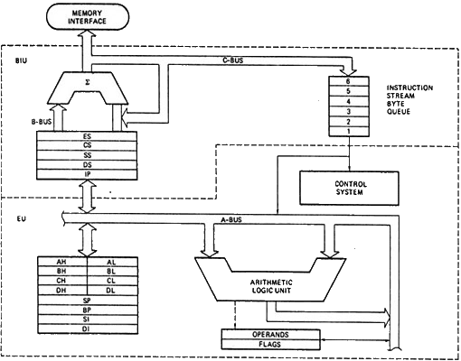

1. Construct the assembly code for 8086 in order to find the maximum in a given array using **LEA**. You may take the given algorithm into account. **Use comments where needed**  **[CO2]** **[5]**

**a** DB 10h, 5h, 25h, 65h, 02h

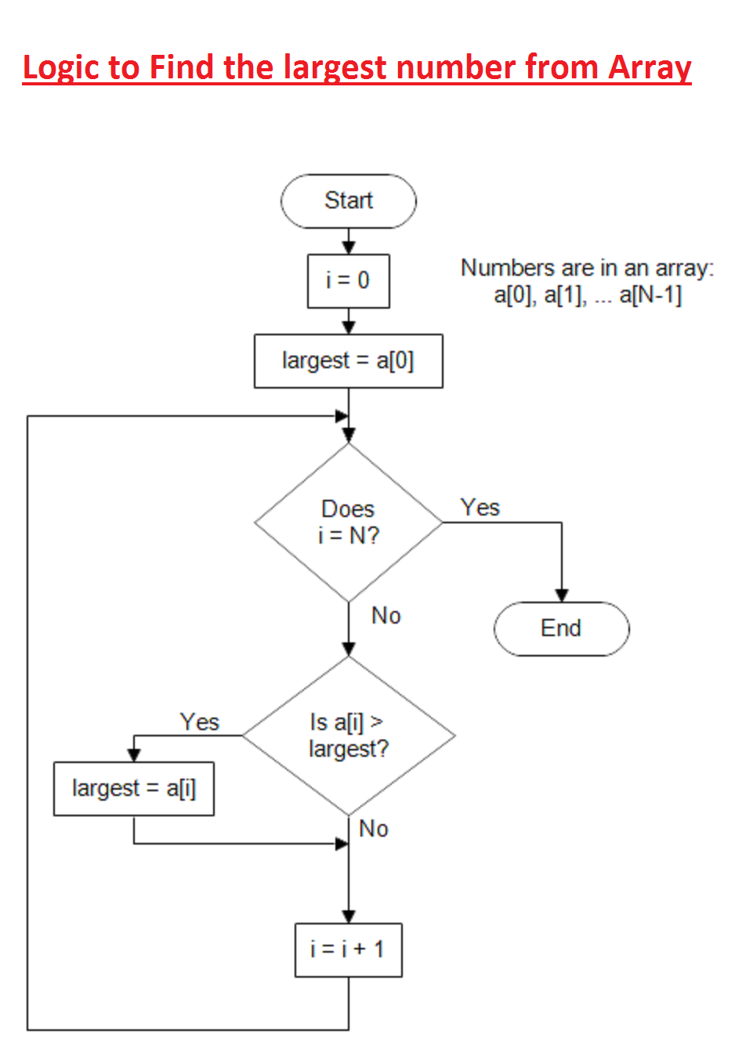

1. Answer all the questions given below. **[10]**

1. -For the given code segment , find the value of **ax [CO2] [2.5+2.5]**

(i)

**mov** ax, 5A

**mov** cx, 20

**mul** cx

DAA

(ii) Show the mathematical operation involved in hexadecimal multiplication

1. Construct the code to transfer 50H to the end of the segment. Use comments where necessary. Use direct addressing mode, i.e., **MOV AX, [Address]**  [**CO1 , CO2**]  **[5]**

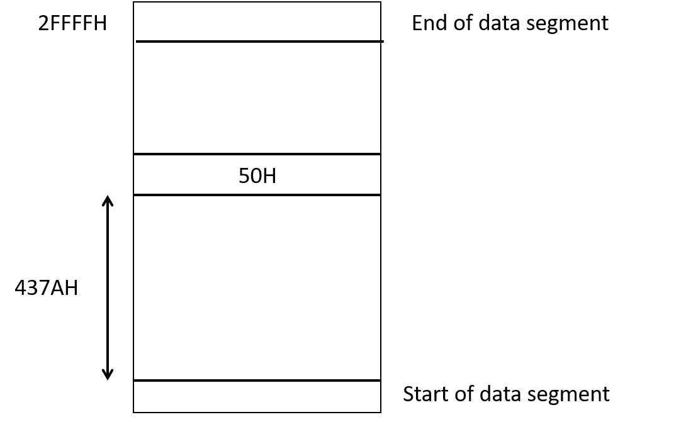

1. Answer all the questions given below. **[10]**
2. Consider LIFO and FIFO algorithm as below, **[CO2]**

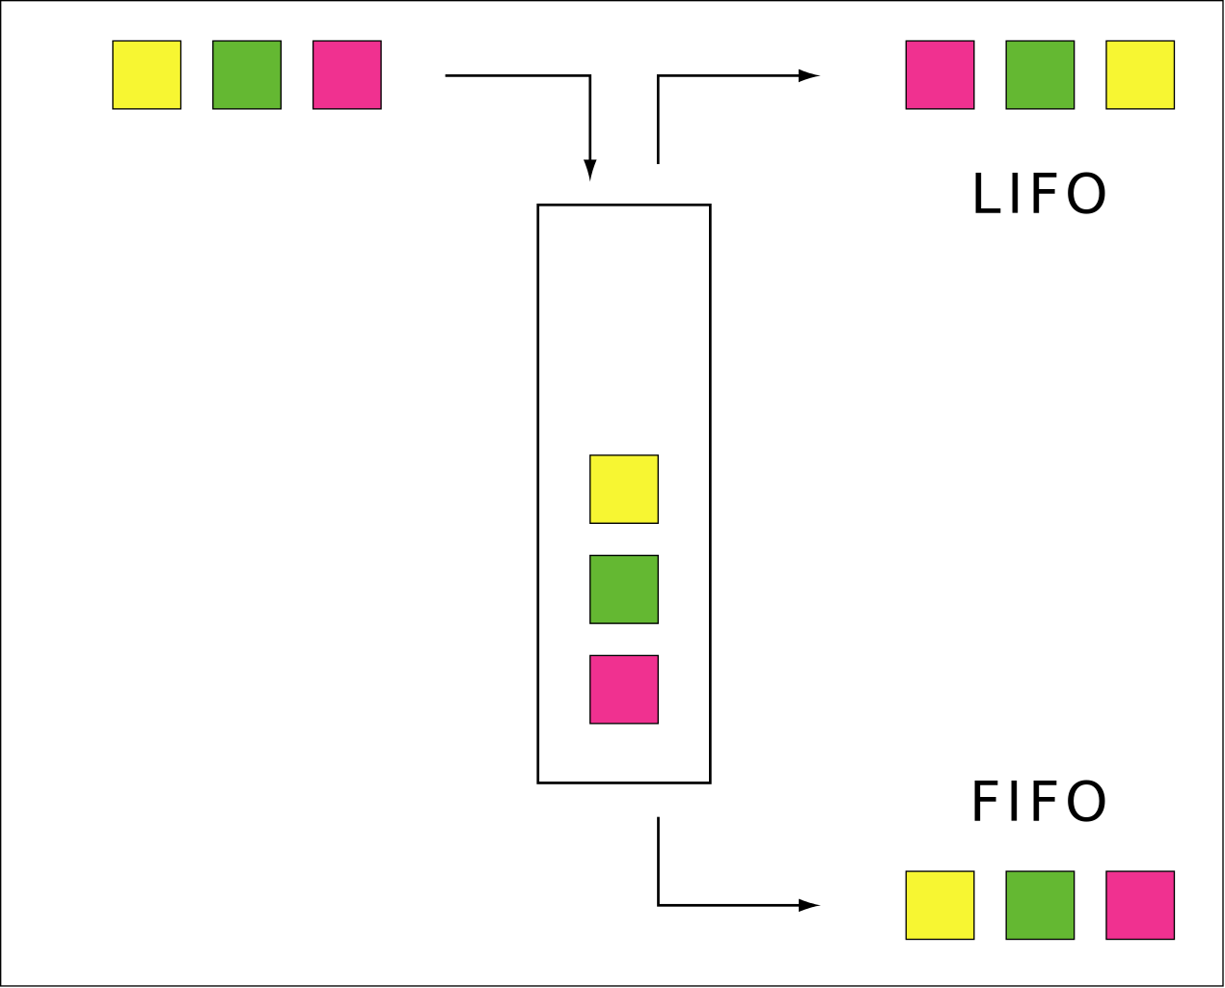

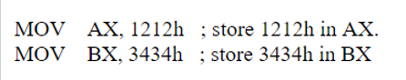

Using PUSH-POP command and stack segment only, show how the value of AX and BX can be exchanged  **[3]**

1. Write a delay loop which produces a delay of 500 μs on an 8086 with a 5 MHz clock **[7]**

**Hints: MOV-4 cycles ; NOP-3 cycles ; Loop – 17 cycles if return, 5 cycles if exit**

1. Answer all the questions below , **[CO4] [10]**

An array of LEDs as connected below, is needed to be accessed by the 8255a interfacing.

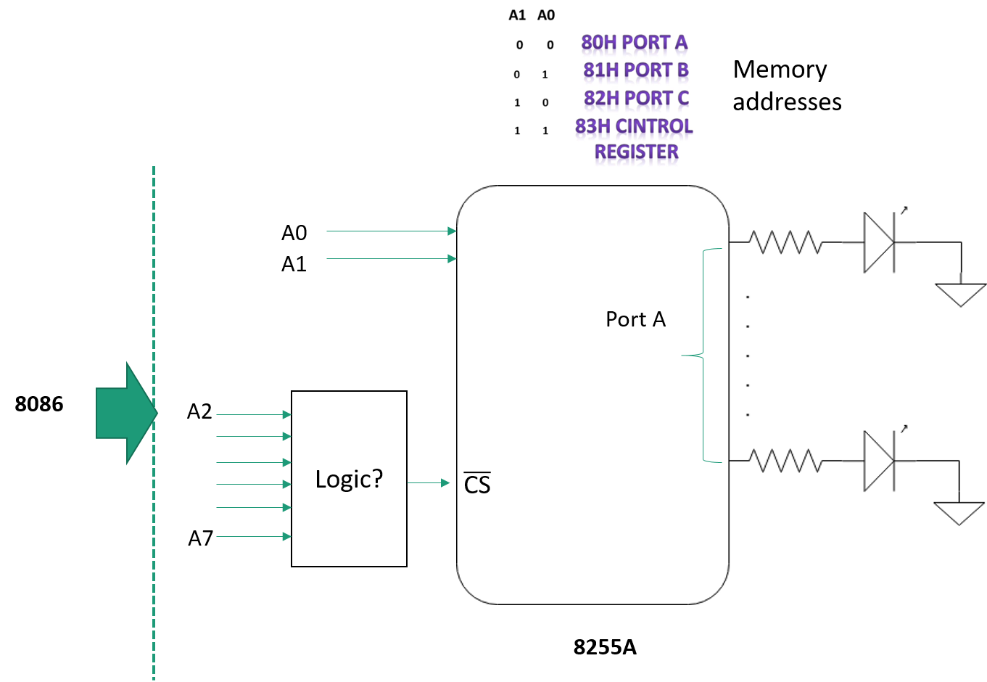

1. Find the value of A0 to A7 in order to address port A and control register **[2.5]**
2. Find the logic circuit in order to keep chip select low while accessing control register and port A  **[2.5]**
3. Construct the code segment in order to keep the LED array blinking on and off in an infinite loop. Initialize the 8255a as needed. Use 99h as the control word. Provide comments wherever necessary **[5]**