Does yield hide flood losses? Harvested area, flood timing and Boro rice in Bangladesh’s 64 districts, 2011–2025
Tasnim Ahmad Mumuª, Rezaul Karim^{b,*}
ª Department of Agronomy and Agricultural Extension, University of Rajshahi, Rajshahi 6205, Bangladesh
^{b} Department of Statistics and Data Science, University of Rajshahi, Rajshahi 6205, Bangladesh
* Corresponding author. E-mail address: mrkarim@ru.ac.bd (R. Karim); Tel.: +880 1726 433752

Abstract
Flood losses to crops are often measured through yield, but official yield comes from sample crop cuts, so a field destroyed before harvest may leave no trace in it. We tested this for Boro rice across Bangladesh’s 64 districts, 2011–2025, using official statistics, Sentinel-1 and JRC flood data, and a written analysis plan. In the 2017 flash flood, harvested area in the seven haor districts fell by 31 % relative to other districts, while yield changed by −0.9 %. In Sunamganj, harvested area fell by 72.4 %, while yield changed by only −0.8 %. Official damage reports, satellite greenness loss and published figures support these losses. The evidence for a general relationship is only suggestive: the harvested-area effect per 10 points of flood was −21.6 % with Sentinel-1 and −4.7 % with JRC, its size was unstable, and it was close to zero without 2016 and 2017. The 2016 and 2022 flood years showed no comparable fall. An exploratory analysis points to flood timing, but rests on 2017. Yield alone can therefore miss large losses, so damage assessment should also track harvested area and production.
Keywords: flood loss; flash flood; Boro rice; harvested area; crop yield statistics; Bangladesh

Software and data availability
- Code, notebooks and outputs: https://github.com/TasMumu/bd-boro-flood-risk; the version described here is archived on Zenodo at https://doi.org/10.5281/zenodo.23829199
- Data: the panel archived at https://doi.org/10.5281/zenodo.23795046 (Mumu and Karim, 2026b). The Earth Engine extracts used here are included with the code
- Software: Python 3.13 with the packages listed in the code repository, and Google Earth Engine for the new extracts

1. Introduction
Assessing what a flood costs a farming region depends on what is measured. Most research on weather and crops has focused on yield (Cui, 2020; Wei et al., 2023), and yield is the natural outcome when a flood reduces grain per hectare. But a flood can also destroy a crop outright. If official yield is measured on crop that survives to be cut, a destroyed field does not lower the yield estimate, and the loss can appear only as lost area. Disaster assessments and research that look at yield alone could then miss the losses that matter most.
The evidence on this point is mixed, and the answer appears to depend on the setting. Globally, drought reduced cereal production through both area and yield, extreme heat mainly through yield, and no effect of floods could be identified in national data (Lesk et al., 2016). A recent global study reports that submergence for more than a week reduces annual rice yield by 4.3 % (Li et al., 2025). In the United States, harvested ratios fall under extreme heat (Cui, 2020), and shocks in planted and harvested area coincided with more than half of the production shocks across seven crops, although yield contributed more for some of them (Wei et al., 2023). In Kansas wheat, however, losses came from yield and not from abandonment (Obembe et al., 2021). For rice, typhoons reduced provincial production in a Philippine panel (Blanc and Strobl, 2016).
Boro rice in Bangladesh is a useful test. It is the country’s main rice crop, grown in the dry season and harvested from April to May. In the haor wetlands of the north-east, early flash floods can destroy the standing crop shortly before harvest (Kamruzzaman and Shaw, 2018; Rashid and Yasmeen, 2018), and the 2017 flood alone was reported to have cost 0.88 million tonnes of Boro (Hossain et al., 2023). The Bangladesh Bureau of Statistics (BBS) estimates yield from sample crop cuts, estimates crop area separately from sample clusters, and derives production by multiplying the two (Bangladesh Bureau of Statistics, 2026). The reporting explanation can therefore be tested: if destroyed fields leave the area estimate, a flood should appear in area and production but not in yield.
We asked five questions. Q1: do flash floods reduce Boro production through harvested area rather than yield? Q2: do monsoon floods, which come before planting, act differently? Q3: are flood effects concentrated in the haor? Q4: does the vegetation index NDVI explain yield within a district? Q5: where is risk concentrated, and how stable is that ranking?
The analysis makes three contributions. It uses a validated panel of all 64 districts, with values printed by BBS and no modelled yields (Mumu and Karim, 2026a). It checks the official area series against other evidence, namely two flood records, a satellite measure of greenness loss, BBS’s own damage reports and published damage figures. And it follows a written analysis plan with set pass rules, so that a weak result is reported as weak, although the plan was not preregistered (Section 4.1). That turned out to matter: the evidence is strong for the 2017 flood, but only suggestive for a general relationship.

2. Background

2.1 Flash floods and Boro in the haor
The haor basin is a low-lying wetland in north-eastern Bangladesh, where Boro is often the only crop of the year (Kamruzzaman and Shaw, 2018). Two hazards dominate: cold at the reproductive stage and flash flood at maturity (Rashid and Yasmeen, 2018). Floods are typically described as arriving in the first two weeks of April (Hossain et al., 2023), and the 2017 flood began on 27 March (Ahmed et al., 2017). Timing is therefore central, because the same water can destroy a standing crop or arrive after the harvest. Evidence on these losses is mostly from single events or small areas: satellite mapping of the 2017 damage (Ahmed et al., 2017), household surveys (Dey et al., 2021; Ahmed, 2024) and local studies (Khan et al., 2012; Mondal et al., 2021). The haor is also an adaptation setting, where short-duration varieties and earlier sowing are recommended (Hossain et al., 2023) and farmers report barriers to adapting (Baishakhy et al., 2023).

2.2 Floods and rice in Bangladesh
In Bangladesh, floods are not simply harmful. Districts more prone to flooding had higher cultivated area and productivity in 1978–2000, with yield falling in extreme floods and rising in normal floods and in the months after (Banerjee, 2010). Boro production rose after the 1988 and 1998 floods, helped by residual water, while the Aman crop fell through both area and yield (Asada et al., 2005). A district panel found meaningful flood effects on Boro production but no meaningful yield results (Hassan, 2019). Studies of climate and rice mostly examine yield, using regions, stations or national series (Sarker et al., 2014; Hasan et al., 2016; Rahman et al., 2017). One study covers both yield and cropping area, using national time series and climate variables (Amin et al., 2015). Rainfall and self-reports are weak proxies for flood exposure in Bangladesh, which supports the use of satellite data (Guiteras et al., 2015).

2.3 The gap
These studies differ in what they show. Climate studies describe yield responses, damage studies describe single events, and adaptation studies describe how farmers respond, so few bear directly on whether a loss appears in harvested area or in yield. Table 1 compares the closest studies with this one. We found no study that uses a multi-year district panel with satellite flood data to split Boro flash-flood losses into harvested area and yield. This rests on a documented search of 1,383 records, screened on titles and abstracts (Appendix B). A recent study addresses monsoon flood disasters and crop production in Bangladesh (Rahman et al., 2025).
Table 1. Closest studies compared with this paper, classified from their titles and abstracts. “Not stated” means not stated there, and does not mean that a study lacked the feature.
Study | Flood type | Unit and period | Satellite flood data | Area and yield separated | Haor focus
Banerjee (2010) | Monsoon | Districts, 1978–2000 | Not stated | Partly | No
Asada et al. (2005) | Severe monsoon | National, long term | No | Yes, descriptive | No
Hassan (2019) | Flood damage indicators | Districts | Not stated | No | No
Amin et al. (2015) | None, climate only | National, 1972–2010 | No | Yes | No
Ahmed et al. (2017) | Flash, 2017 only | North-east, one event | Yes | Damaged area only | Yes
This paper | Flash and monsoon | 64 districts, 2011–2025 | Yes, two records | Yes | Yes

3. Data

3.1 Panel
The analysis uses the panel built and tested in the framework paper (Mumu and Karim, 2026a) and archived separately (Mumu and Karim, 2026b): 960 district-years for all 64 districts and harvest years 2011–2025, where harvest year t is the crop sown in November of t−1 and harvested in April–May of t. Boro harvested area, yield and production are values printed in the BBS yearbooks, each with its edition and page, and no value is modelled or filled. Weather comes from ERA5-Land (Muñoz-Sabater et al., 2021). Flood fractions come from the monthly surface water record of the Joint Research Centre (JRC) (Pekel et al., 2016) and from Sentinel-1 radar (Torres et al., 2012), and are kept as separate records. Table 2 lists the sources. The seven haor districts are Sunamganj, Habiganj, Netrokona, Kishoreganj, Sylhet, Moulvibazar and Brahmanbaria, a list fixed before the models were run. They produced 17.5 % of Boro over the period.
Table 2. Data sources.
Variable | Source | Resolution | Period
Boro area, yield, production | BBS yearbooks, from the panel of Mumu and Karim (2026b) | 64 districts | 2011–2025
Flood, Sentinel-1 | COPERNICUS/S1_GRD, VV, −18 dB | Analysed at 60 m | Harvest years 2015–2025
Flood, JRC | Global Surface Water v1.4, monthly | 30 m | Harvest years 2011–2021
Boro mask, greenness loss, NDVI | MODIS MOD13Q1 v061, WorldCover v200 cropland | 250 m | 2011–2025
Weather | ERA5-Land daily aggregates | 0.1° | 2011–2025
Flash flood is the share of district area under water in April or May of year t and not in January–March of t. Monsoon flood is the share under water in June–October of t−1 and not in January–March of t−1. A pixel counts as water in JRC if it is classed as water in that month, and in Sentinel-1 if its monthly median VV backscatter, after a 50 m median filter, is below −18 dB on slopes under 5°. One month of water is enough, with no minimum duration. Fractions are shares of all pixels in the district, and pixels without a valid observation count as not water, so floods under persistent cloud can be missed: JRC’s valid observations in April–May covered a median of 100 % of a district, but as little as 27 %. JRC ends in December 2021 and Sentinel-1 begins in October 2014, so the two flash-flood records each cover 704 district-years. The main models use harvest years 2011–2021 for JRC (704 observations) and 2016–2025 for Sentinel-1 (640), because Sentinel-1 has no monsoon value for 2015.

3.2 How BBS measures Boro
BBS estimates Boro in three steps (Bangladesh Bureau of Statistics, 2026). Area comes from sample clusters of plots, visited four times a year and expanded to districts by a ratio estimator. Yield comes from crop cuts of 20 m² on sample plots in fields growing the crop. Production is area multiplied by yield, so it adds no information beyond those two, and the agreement between area, yield and production effects below is arithmetic. The methods describe area under the crop, while the yearbook’s crop reports call the same figure harvested area, and we follow that term. The methods do not say how a destroyed field is treated. BBS also estimates flood damage separately, and reports it by district in some years (Section 5.4).

3.3 Relation to the framework paper
The framework paper describes how the panel was built and tested, and uses the 2017 flood and a simple index only as brief examples (Mumu and Karim, 2026a). This paper asks a different question, and adds new variables, three designs and independent checks. Two differences need explaining. For Sunamganj in 2017, the framework paper reports −71.5 % area and −0.1 % yield against the mean of 2015–2016. Here the baseline is the mean of 2015 and 2018, giving −72.4 % and −0.8 %, because 2016 was itself a flood year. The risk index also differs. The framework paper’s illustrative index has five equally weighted components with whole-district JRC flood. Ours has seven components grouped as exposure and sensitivity, flood on Boro land from both records, and stage-specific heat and cold, and it is tested under many combinations of choices, so the two top tens differ.

3.4 New variables
New variables were computed in Google Earth Engine (Gorelick et al., 2017). Every extract was tested for completeness, and no value was filled.
Boro mask. Published Boro maps cover only 2017 (Singha et al., 2019) or 2014–2018 (Shew and Ghosh, 2019), so we built a consistent mask for the whole period, following earlier MODIS mapping of Boro (Mosleh and Hassan, 2014). Using the normalised difference vegetation index (NDVI) from MODIS (Didan, 2021) on WorldCover cropland (Zanaga et al., 2022), a pixel is counted as Boro land in year t if its peak NDVI from February to mid-March reaches 0.50 and has risen by at least 0.20 since December–January. These images all end before the flood window, so the mask describes the crop before any loss. Mean national area for 2014–2018 is 4.02 million ha at a threshold of 0.40, 3.99 at 0.50 and 3.66 at 0.60. A stable mask, covering land that meets the rule in at least five of the 15 years, is used for flood fractions on Boro land. It covers 4.70 million ha, against about 4.8 million ha harvested in BBS statistics, and agrees with BBS area between districts (r = 0.91). This shows a similar spatial distribution; it is not a test of accuracy, because the mask was not validated with field data. The yearly mask is noisier (Table A.2) and is used only to define the land on which crop loss is measured.
Satellite greenness loss. Following the logic of the Disaster Vegetation Damage Index (Rahman et al., 2021), we took the change in NDVI from the pre-flood peak to the two composites starting in April, and subtracted the same pixel’s median change over all years. Greenness loss is the share of Boro land with an anomaly below −0.20. This measure uses no BBS data. It identifies an unusual fall in greenness, not confirmed crop destruction, and early harvest can give the same signal.
Flood timing. The flash-flood window was split into early and late parts against a January–February baseline, so that water from a March flood is not treated as dry-season water. For Sentinel-1, early is 15 March to 15 April and late is 16 April to 15 May, each from two half-month medians. JRC is monthly, so early is March–April and late is May.
Other variables. We also computed flood fractions at water thresholds of −16 and −20 dB, Sentinel-1 scene counts, hot days above 35 °C from mid-March to April (Jagadish et al., 2007), and days below 20 °C from mid-February to March. The cold threshold is provisional. Adaptive capacity is not covered, because no published district series was assembled, and nothing was estimated in its place.

3.5 Data checks
All 18 checks passed (Table A.3). The new code recomputed the published flood fractions of the panel, and the largest difference was below 10⁻⁹, so the variants are computed by verified code. The panel’s checksum matches the archived version.

4. Methods

4.1 Analysis plan
Questions, models, pass rules and the bound for a negligible yield effect were written in a plan before any new model was run. The plan was not registered with a public timestamp. It entered version control together with the results, in the first commit of the repository (54ca10f, 31 October 2026), so readers cannot verify the order independently, and this study should not be read as preregistered. The plan and its log of changes are in the repository. The basic models in the framework paper (Mumu and Karim, 2026a) had been seen and count as exploratory. Two changes were made before the outcome models were run, based on flood and mask data and BBS area between districts: flood fractions on rice land use a stable mask built here, because the yearly mask proved noisy and published rice maps do not cover the period; and Sentinel-1 early and late windows use half-month medians, because a single monthly median diluted a flood arriving midway. After the planned results were seen, we added the analyses in Section 5.6, one extra synthetic-control test, a variant without districts with a small Boro base, a variant without Chandpur, and BBS’s damage reports (Section 5.4). These are labelled or described as additions, and they do not change the verdict.

4.2 Flood models
For district i in harvest year t, each outcome Y (harvested area, yield or production) is modelled as
$$lnY_{it}=βF_{it}+γM_{it}+x_{it}^{′}δ+α_{i}+τ_{t}+ε_{it},$$
where F is flash flood and M monsoon flood, both per 10 points of district area, x holds mean temperature, precipitation and hot days, α and τ are district and year effects, and ε is the error term. Since BBS derives production as area times yield, the area and yield effects add up to the production effect in log points; the largest gap was below 0.0001. Effects are reported in per cent, as 100[exp(b) − 1] for a coefficient b. This is the standard panel approach to weather effects (Hsiang, 2016; Blanc and Schlenker, 2017; Auffhammer et al., 2013). Results are estimates under the stated assumptions: floods are not randomly assigned, and we avoid causal language.

4.3 Three designs for flash floods
Flash floods were studied in three ways that must point the same way: the dose-response model above; a year-by-year comparison of haor and other districts relative to 2015, the last year before the two largest floods; and synthetic control (Abadie, 2021) for the five most flooded districts in 2017, where a weighted mix of non-haor districts matches each district’s path in 2011–2015.
In the synthetic control, the donor pool is the 57 non-haor districts. Each outcome is in logs and centred on its own 2011–2015 mean. Weights are non-negative, sum to one, and minimise the squared gap over 2011–2015, with a very small ridge penalty. For inference, the same method is run for each donor, using the other 56 as its pool. The test statistic is the absolute 2017 gap divided by the root mean squared gap over 2011–2015, and the placebo rank p is (1 + placebos at or above the treated value) / (1 + 57).

4.4 Uncertainty
Few districts are treated and they are atypical, a setting in which clustered errors and the wild bootstrap can fail, and randomisation inference has limits (Conley and Taber, 2011; MacKinnon and Webb, 2017, 2018, 2020). So no single method was relied on, and the four methods below are not interchangeable confirmations, because each addresses a different risk. Errors clustered by district allow serial correlation within a district. Driscoll–Kraay errors (Driscoll and Kraay, 1998) also allow shocks shared across districts in a year. Conley spatial errors (Conley, 1999) allow correlation between districts up to 100 km apart, with two years of serial correlation. Randomisation inference needs no large-sample assumption, but assumes that flood years are exchangeable.
In randomisation inference, the unit permuted is the whole year: each year’s flood map across all districts is moved to another year, which keeps its spatial pattern, while the outcome and the other variables stay in place. Main estimates use 9,999 random permutations, out of about 3.6 million possible orderings of the 10 Sentinel-1 years and 39.9 million of the 11 JRC years, and checks use 999 or 1,999. The statistic is the coefficient. The two-sided p-value is (1 + c) / (1 + n), where c counts permutations with an absolute coefficient at least as large as the observed one and n is the number of permutations, so the observed assignment is included. With T years, one event alone cannot reach a p-value below 1/T, about 0.10 here, and two events below about 0.01. These limits apply only when one or two years carry all the variation. Because the flood pattern of every year is permuted, smaller p-values are possible when several years contribute, as in Table 4.

4.5 How results were judged
A result is called supported only if it has the same sign and similar size under all three designs, p < 0.05 under all four uncertainty methods in both flood records, the same direction in both records, and passes every required check. If the significance rule holds in one record it is suggestive, and otherwise not supported. Leave-out checks pass with the same sign and at least half the main size. Placebos pass if not significant at 5 % under clustered and Driscoll–Kraay errors. Satellite greenness loss passes if flood raises it and it lowers BBS area, each with p < 0.05 under Driscoll–Kraay errors. Measurement checks pass with the same sign and p < 0.05 under Driscoll–Kraay errors. Synthetic control passes if the 2017 gap is negative and its size relative to the pre-flood fit ranks in the top 5 % of placebo districts.
A yield effect counts as negligible only if its 95 % interval lies within ±2 % per 10 points under every interval method. An insignificant coefficient alone is not evidence of no effect.

4.6 Index and spatial analysis
The risk index combines exposure (flash and monsoon flood on Boro land, heat at flowering and cold at the reproductive stage) with sensitivity (production instability, worst fall in area, low yield). In line with the handbook on composite indicators (OECD and European Commission Joint Research Centre, 2008) and uncertainty analyses of such indices (Saisana et al., 2005; Tate, 2012), we rebuilt it under 6,018 combinations of three normalisations, two aggregations and four weighting schemes, including 1,000 random draws of weights. Global Moran’s I (Moran, 1950) and LISA (Anselin, 1995) were run under four neighbour definitions, with false discovery rate correction (Benjamini and Hochberg, 1995). Monsoon-flood and haor-interaction tests were corrected the same way as secondary tests.

5. Results

5.1 Few events carry the flash-flood estimates
Flash floods are concentrated in a few places and years (Fig. 1, Fig. 2). Sentinel-1 has 704 district-years with flood data but only about 11 effective observations (Table 3). Effective observations are the inverse of the sum of squared shares of the flood variation left after removing district and year means, so they fall as a few district-years dominate. Seven districts carry nearly all the variation, and two years carry most of it, so the flash-flood analysis is really a study of a few events. Monsoon floods are spread much more widely. Sentinel-1 also has a coverage break: scenes per haor district more than double after 2016 (Fig. 2b), which matters because 2016 is a key flood year.
Fig. 1. Flash flood and satellite greenness loss. Panel (a) shows mean flash flood on Boro land. Panel (b) shows the share of Boro land with a sharp fall in greenness in 2017.
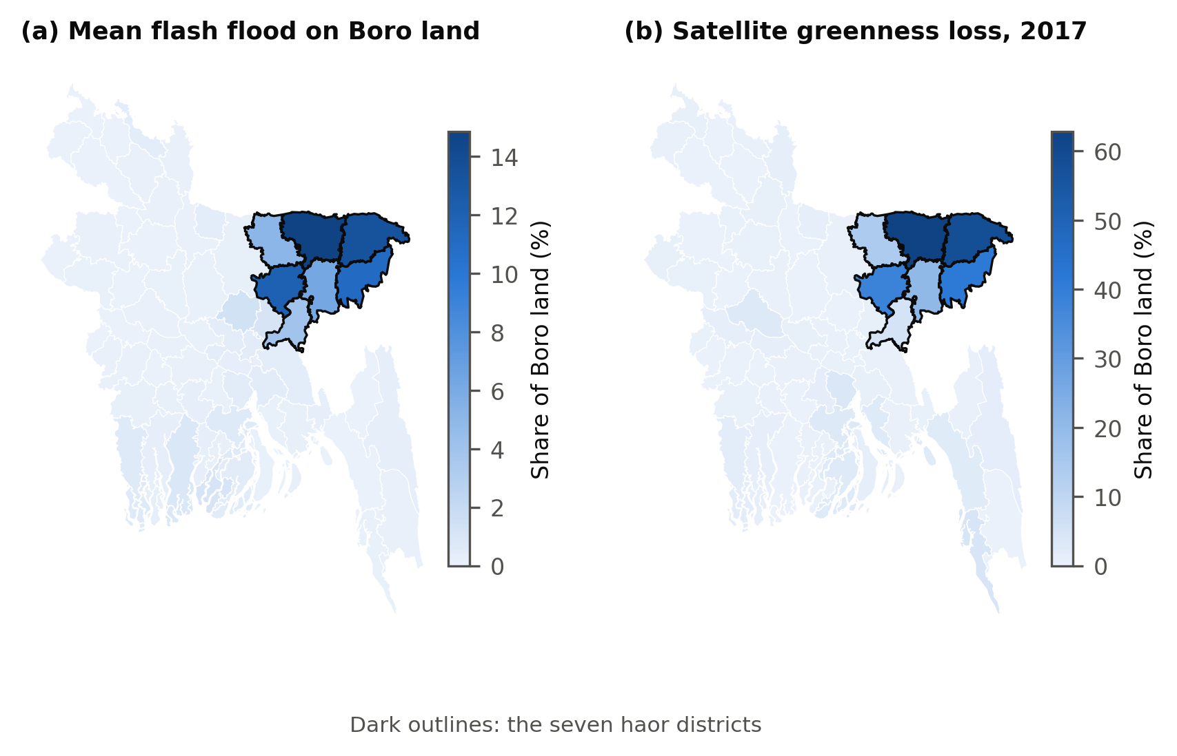
Fig. 2. How few events carry the estimates. Panel (a) shows each year’s share of flash-flood variation after removing district and year means. Panel (b) shows Sentinel-1 scenes per haor district.
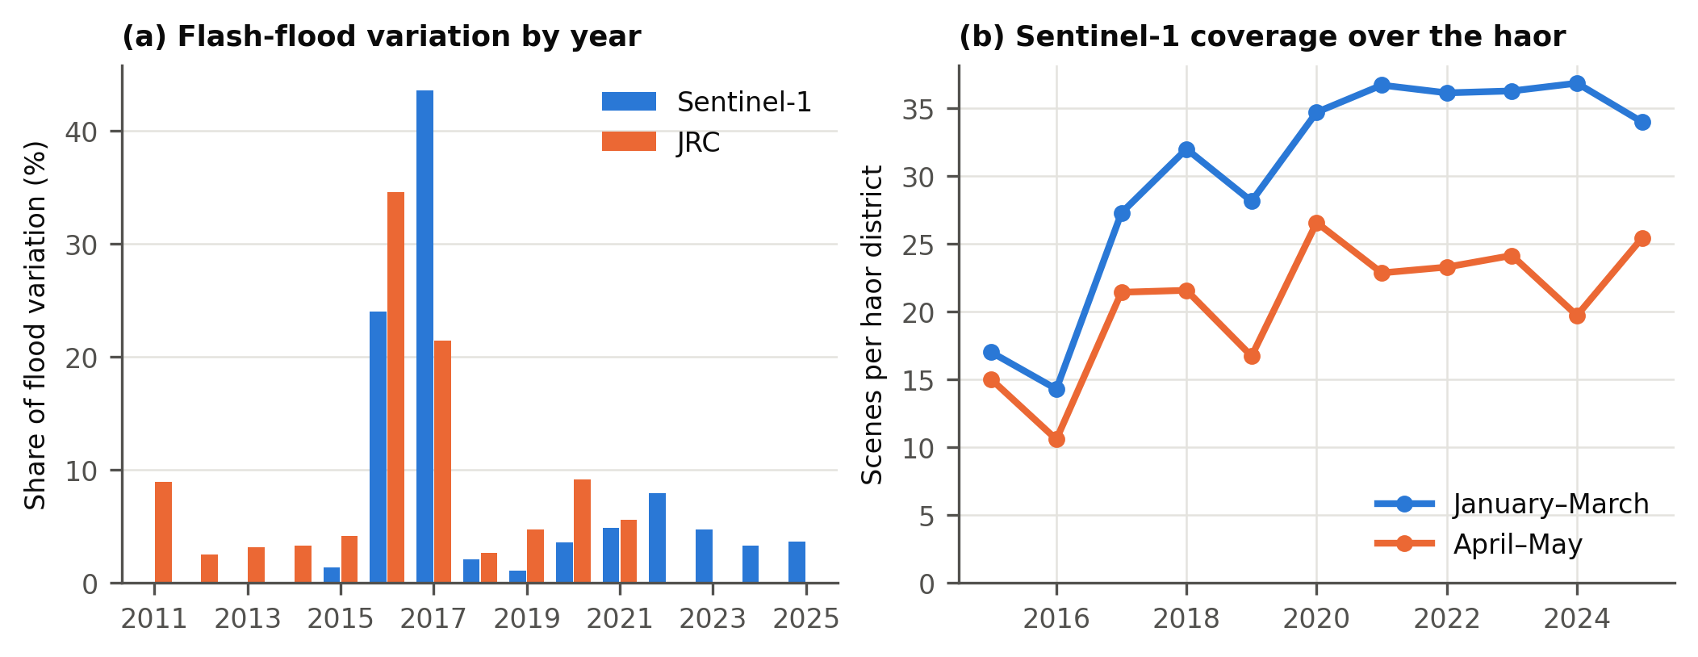
Table 3. Where the flood variation comes from. District-years are all available flood observations, before restricting to the years of each main model, so main models can have fewer (Table 4). Effective observations are defined in the text.
Flood variable | District-years | Effective observations | From the seven haor districts (%) | From 2016 and 2017 (%)
Flash flood, Sentinel-1 | 704 | 11 | 88 | 68
Flash flood, JRC | 704 | 23 | 90 | 56
Monsoon flood, Sentinel-1 | 640 | 52 | 47 | 13
Monsoon flood, JRC | 768 | 103 | 41 | 19

5.2 Main flood models
With Sentinel-1, 10 more points of flash flood went with 21.6 % less harvested area and 21.7 % less production, significant under all four methods, and with no detectable change in yield (−0.2 %) (Table 4). With JRC the area effect was much smaller (−4.7 %) and not significant under any method. Yield rose slightly with JRC (1.1 %), significant under Driscoll–Kraay errors and randomisation inference only.
Table 4. Flash-flood effects per 10 points of district area, with p-values from four methods.
Flood record | Outcome | Effect per 10 points (%) | Clustered p | Driscoll–Kraay p | Conley p | Randomisation p | N
Sentinel-1 | Harvested area | −21.6 | 0.021 | < 0.001 | 0.007 | 0.002 | 640
Sentinel-1 | Yield | −0.2 | 0.862 | 0.878 | 0.871 | 0.891 | 640
Sentinel-1 | Production | −21.7 | 0.027 | < 0.001 | 0.010 | 0.004 | 640
JRC | Harvested area | −4.7 | 0.080 | 0.140 | 0.114 | 0.238 | 704
JRC | Yield | 1.1 | 0.098 | 0.022 | 0.051 | 0.013 | 704
JRC | Production | −3.7 | 0.167 | 0.215 | 0.220 | 0.369 | 704
The yield interval was narrow but just exceeded the ±2 % bound: −2.3 to 2.0 % for Sentinel-1 under Driscoll–Kraay errors, and up to 2.4 % for JRC under clustered errors. So the planned test for a negligible yield effect was not met. Yield effects were small, and no method gave a sizeable negative one.

5.3 The 2017 flood
The year-by-year comparison shows why the two records differ (Fig. 3). In 2017, haor districts fell 30.6 % in area and 31.2 % in production relative to other districts and to 2015, while yield changed by −0.9 %. Area recovered at once, to 14.4 % in 2018. The 2016 and 2022 flood years did not show a comparable decline in measured harvested area: haor harvested area was 13.1 % in 2016 and 5.9 % in 2022. Differences before the floods reach 8.3 %, so smaller movements should not be over-read.
Fig. 3. Haor districts against other districts, relative to 2015, on one shared scale. Flood years are shaded. Intervals are clustered by district and can be too narrow with few treated districts.
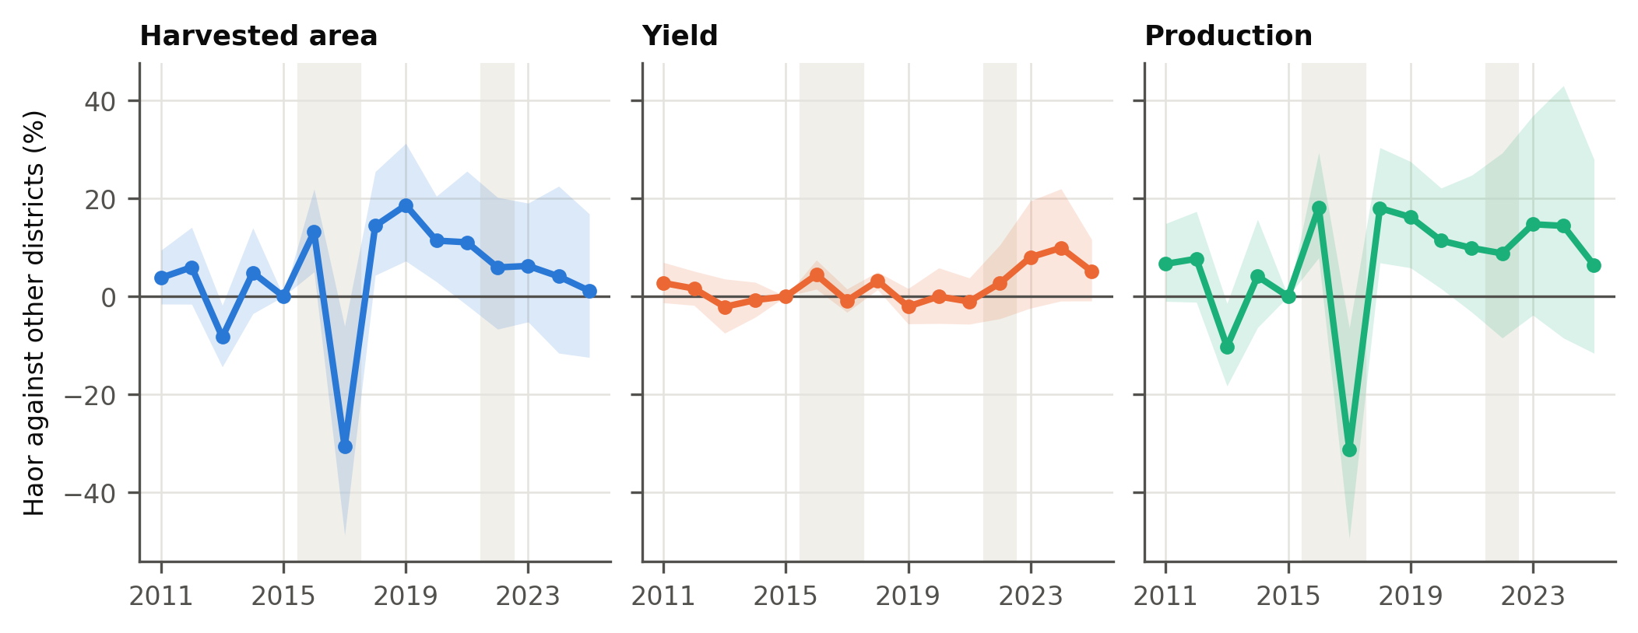
Sunamganj shows the pattern most clearly: 189 thousand ha harvested in 2016, 54 thousand ha in 2017 and 201 thousand ha in 2018. Against the mean of 2015 and 2018, its area fell by 72.4 % and its yield by 0.8 % (Table 5, Fig. 4).
Table 5. The 2017 flood in the most flooded districts. BBS changes are from the mean of 2015 and 2018.
District | Sentinel-1 flood (%) | JRC flood (%) | Satellite greenness loss (%) | BBS harvested area (%) | BBS yield (%) | BBS production (%)
Sunamganj | 44.7 | 37.2 | 62.8 | −72.4 | −0.8 | −72.6
Kishoreganj | 27.0 | 30.0 | 38.4 | −29.2 | 1.3 | −28.2
Netrokona | 17.4 | 16.2 | 14.1 | −19.4 | −1.3 | −20.5
Sylhet | 12.7 | 26.7 | 58.6 | −23.1 | −3.8 | −26.1
Habiganj | 10.2 | 14.1 | 20.8 | −13.2 | −3.1 | −15.9
Moulvibazar | 8.4 | 9.5 | 41.4 | −24.1 | 1.3 | −23.1
Lalmonirhat | 7.9 | 0.4 | 0.3 | −3.0 | 6.2 | 2.9
Brahmanbaria | 5.8 | 5.7 | 5.2 | −11.8 | −0.1 | −12.0
Fig. 4. The 2017 flood across all 64 districts. Panel (a) sets satellite greenness loss against BBS harvested area. Panel (b) sets the flood against BBS yield, on the same scale.
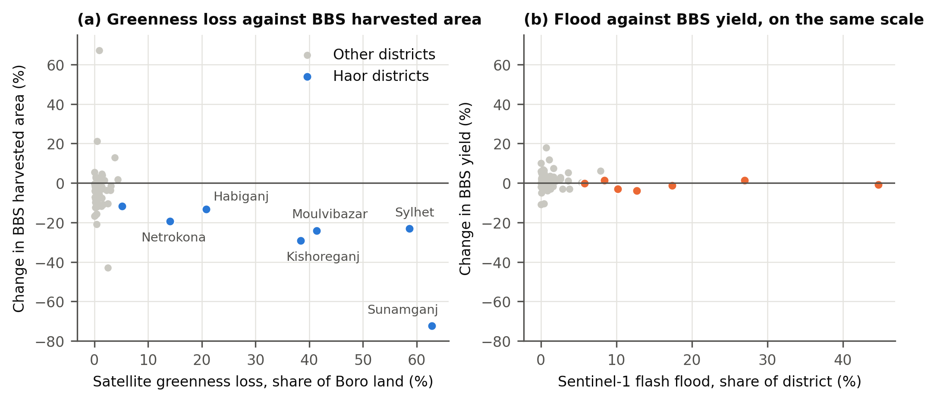
Two non-haor districts stand out in Fig. 4a, with large changes in BBS area and almost no satellite loss. Patuakhali fell by 43 %, but from a base of under 2,000 ha. Chandpur rose by 67 %: its 2017 area is 110,467 ha, against 64,424 ha in 2015 and 67,733 ha in 2018. This appears to be a duplication in the source: the yearbooks print the same 136,046 acres for both HYV and hybrid Boro, while hybrid area was 12,856 acres the year before and 15,730 acres the year after. We keep the value as printed, and leaving out Chandpur changes little (Table A.1). No check on printed values can detect such a case, because it is repeated in two editions and included in the national total. Both districts show that BBS area can move for reasons other than flood, by as much as the flood signal.
Synthetic control gave the same pattern. The estimated 2017 area gaps were −70.4 % in Sunamganj, −29.3 % in Kishoreganj, −17.4 % in Sylhet, −13.2 % in Netrokona and −8.5 % in Habiganj, while yield gaps stayed within 3.9 % (Table 6). The planned test was not met: no gap ranked in the top 5 % relative to its pre-flood fit. With five years to match and many donors, the pre-flood fit is almost perfect, so this ratio is unstable. An exploratory test on the gap’s size alone ranks Sunamganj at p = 0.017 and Kishoreganj at p = 0.052, and the other three above 0.1.
Table 6. Synthetic control for the five most flooded districts. Placebo rank p is the planned test.
District | Outcome | Gap 2016 (%) | Gap 2017 (%) | Gap 2018 (%) | Placebo rank p
Sunamganj | Harvested area | 0.8 | −70.4 | 3.5 | 0.103
Kishoreganj | Harvested area | 1.6 | −29.3 | −9.1 | 0.103
Netrokona | Harvested area | 3.8 | −13.2 | 2.1 | 0.776
Sylhet | Harvested area | −3.3 | −17.4 | 5.1 | 0.121
Habiganj | Harvested area | 1.3 | −8.5 | −1.8 | 0.603
Sunamganj | Yield | 1.4 | −1.1 | 1.1 | 0.241
Kishoreganj | Yield | 0.5 | 1.7 | 3.6 | 0.431
Netrokona | Yield | 1.9 | −2.3 | 2.5 | 0.483
Sylhet | Yield | −1.6 | −3.9 | 2.1 | 0.759
Habiganj | Yield | 0.5 | −0.1 | 0.7 | 0.759

5.4 Other evidence on the 2017 loss
BBS’s own reports show how the loss was recorded. The yearbook for 2016–17 states that flash flood fully damaged Boro on 296,701 ha (Bangladesh Bureau of Statistics, 2018), and its national Boro area fell by 296,697 ha from the year before. The same report attributes a higher yield to management. Its damage table, for floods in March and April, lists six haor districts (Table 7), where the reported damaged area is close to the fall in BBS harvested area, and its production loss of 865,696 t is close to the 0.88 million t in the literature (Hossain et al., 2023). These reports come from the same agency, so they do not independently confirm the area series, but they show that in 2017 destroyed crop was recorded as lost area and not as lower yield. For the 2016 flood, BBS reported far less: a production loss of 97,592 t, with 28,927 ha damaged in its table and 40,198 ha fully damaged in its crop report (Bangladesh Bureau of Statistics, 2017). That fits the absence of a fall in area in 2016. For 2022 it reported Boro damage only in Netrokona: 3,920 ha and 21,305 t (Bangladesh Bureau of Statistics, 2023). So the two flood years without a fall in harvested area are also years in which BBS reported little Boro damage. Even so, Sunamganj’s reported damage in 2016 (23,411 ha) exceeds its fall in harvested area that year, so reported damage does not always appear in the area series.
Table 7. BBS reported damage and the fall in BBS harvested area and production in 2017, against the mean of 2015 and 2018.
District | BBS damaged area (ha) | Fall in BBS harvested area (ha) | BBS production loss (t) | Fall in BBS production (t)
Sunamganj | 125,866 | 142,482 | 457,376 | 520,428
Kishoreganj | 39,399 | 47,860 | 170,437 | 197,796
Habiganj | 21,755 | 14,550 | 82,600 | 63,808
Sylhet | 20,362 | 17,419 | 57,840 | 59,328
Netrokona | 16,575 | 33,998 | 66,611 | 145,082
Moulvibazar | 8,863 | 12,456 | 30,834 | 39,786
Six districts | 232,819 | 268,764 | 865,698 | 1,026,230
The satellite measure uses no BBS data, and it passed its planned test. Each 10 points of flood raised satellite greenness loss by 7.5 points with Sentinel-1 (Driscoll–Kraay p = 0.001) and 6.2 points with JRC (p = 0.005), and greenness loss lowered BBS harvested area (p = 0.041) but not yield (p = 0.226). In 2017, greenness loss reached 63 % of Boro land in Sunamganj and 59 % in Sylhet, and at most 4.4 % outside the haor (Fig. 1b, Fig. 4a). This supports the location and scale of the loss, but it does not prove that every flagged pixel was flood-damaged, and the 2016 mismatch (Section 5.6) limits its use as a general measure of crop loss.
Published damage figures are of the same order, although areas and definitions differ, so these comparisons are of scale only. Against the mean of 2015 and 2018, the BBS series shows a production loss of 1.08 million t in the seven haor districts in 2017, compared with 0.88 million t reported for the haor regions (Hossain et al., 2023). For Sunamganj, it implies 142,482 ha and 520,428 t lost, compared with 149,224 ha affected and 393,855 t damaged in a published estimate (Mondal et al., 2021).

5.5 Checks and verdict
The required checks gave a mixed picture (Table 8, Fig. 5). Because the main Sentinel-1 sample starts in 2016, the planned check without 2015–2016 is the same model as leaving out 2016, so it is counted once. All leave-out checks passed for Sentinel-1, and the flood-after-harvest placebo passed in both records. Next year’s flood, however, failed for Sentinel-1 (11.6 %, clustered p = 0.033), possibly because haor area was high in 2016, just before the 2017 flood. For JRC, the effect disappeared without 2017 (0.6 %) or Sunamganj (−1.5 %), and was not significant on rice land only. Most importantly, the estimated effect was close to zero in both records when 2016 and 2017 were both excluded (0.1 % and −0.1 %). Flood size also mattered: only the largest group, 20 % or more of a district, showed clear losses (−31.9 % with Sentinel-1, from 5 district-years, and −15.7 % with JRC, from 8; Fig. 6). The size of the Sentinel-1 estimate also partly reflects small districts. Leaving out the six districts with a small Boro base gave −13.8 % with Sentinel-1 and −6.2 % with JRC, and a Poisson model, which weights by area, gave −10.9 % and −5.3 % (Table A.1). The two records are closer in both cases.
Table A.4 summarises the required checks. The JRC failures matter most for the general claim, because they show that its estimate rests on one event and one district. The rice-only JRC estimate weakened because, on rice land, flood in Sylhet in 2017 (52 %) matched that in Sunamganj (51 %), while Sylhet’s harvested area fell far less (Table 5).
Table 8. Required checks of the harvested-area effect, per 10 points of flood. Pass or fail follows the criterion for each check in Section 4.5, and does not indicate significance under every estimator.
Check | Flood record | Area effect (%) | Clustered p | Driscoll–Kraay p | Result
Leave out 2016 | Sentinel-1 | −16.7 | 0.005 | < 0.001 | Pass
Leave out 2016 | JRC | −9.5 | 0.011 | 0.013 | Pass
Leave out 2017 | Sentinel-1 | −20.8 | 0.258 | 0.004 | Pass
Leave out 2017 | JRC | 0.6 | 0.688 | 0.752 | Fail
Leave out 2022 | Sentinel-1 | −24.4 | 0.012 | < 0.001 | Pass
Leave out Sunamganj | Sentinel-1 | −21.6 | 0.176 | 0.009 | Pass
Leave out Sunamganj | JRC | −1.5 | 0.379 | 0.533 | Fail
Leave out Kishoreganj | Sentinel-1 | −25.5 | 0.018 | < 0.001 | Pass
Leave out Kishoreganj | JRC | −5.7 | 0.073 | 0.151 | Pass
Leave out Sylhet | Sentinel-1 | −24.1 | 0.014 | < 0.001 | Pass
Leave out Sylhet | JRC | −5.6 | 0.047 | 0.101 | Pass
Leave out Netrokona | Sentinel-1 | −22.2 | 0.023 | < 0.001 | Pass
Leave out Netrokona | JRC | −5.0 | 0.070 | 0.122 | Pass
Next year’s flash flood (placebo) | Sentinel-1 | 11.6 | 0.033 | 0.225 | Fail
Next year’s flash flood (placebo) | JRC | 0.6 | 0.678 | 0.820 | Pass
Flood after harvest (placebo) | Sentinel-1 | 0.9 | 0.758 | 0.756 | Pass
Flood after harvest (placebo) | JRC | 2.3 | 0.328 | 0.125 | Pass
Rice land only | Sentinel-1 | −15.3 | 0.037 | 0.001 | Pass
Rice land only | JRC | −2.5 | 0.220 | 0.233 | Fail
January–February baseline, early window | Sentinel-1 | −14.0 | 0.077 | < 0.001 | Pass
January–February baseline, early window | JRC | −19.5 | 0.036 | < 0.001 | Pass
Scene counts as controls | Sentinel-1 | −21.5 | 0.020 | < 0.001 | Pass
Fig. 5. How the flash-flood estimates hold up. Each row reruns the main model with one change. Intervals are 95 %, clustered by district. The shaded band marks ±2 %.
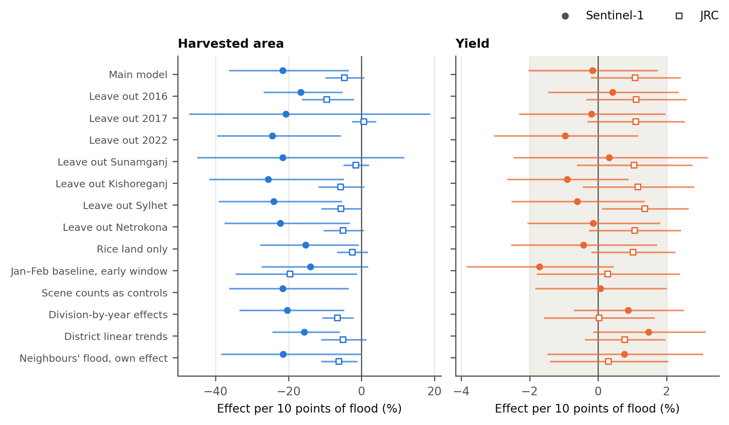
Fig. 6. Normal and extreme floods, against the group below 1 %. Intervals are 95 %, clustered by district. Under each label, n gives the district-years in the bin, Sentinel-1 first.
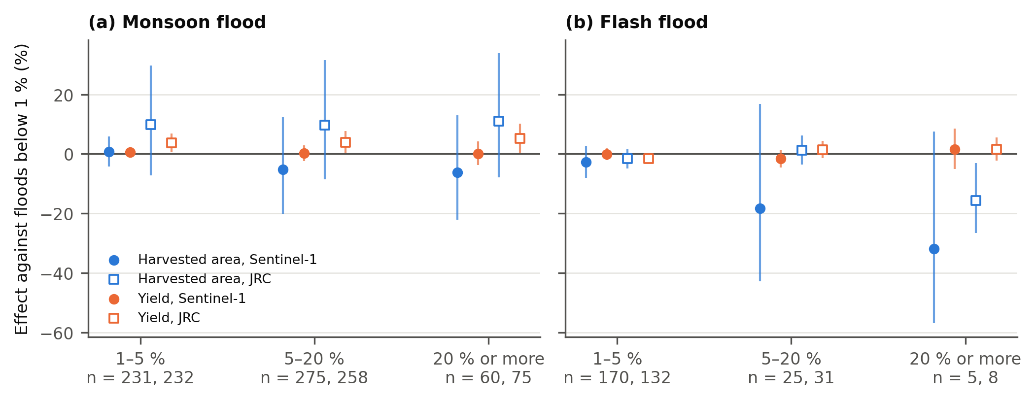
Under the plan’s rule, the evidence on Q1 is suggestive and does not establish a general relationship. The significance rule held for Sentinel-1 but not for JRC, 18 of 22 required checks passed, and the planned synthetic-control test failed. Direction and design agreed throughout. For Q3, concentration in the haor could not be tested properly: outside it, Sentinel-1 flood reached 5 % in only 1.8 % of district-years, so any slope there is an extrapolation, and no haor interaction survived false discovery rate correction.

5.6 Flood timing (exploratory)
Why did 2017 stand out? This analysis was added after the planned results were seen, and it offers a hypothesis for future work, not an established explanation. Table 9 suggests that timing is one possible reason. In 2017, more water arrived early, while in 2016 most Sentinel-1 water came late, and BBS dates the 2017 damage to March and April. The planned early-window check had already brought the two records close together: −14.0 % with Sentinel-1 and −19.5 % with JRC per 10 points (Table 10). This is consistent with the JRC estimate in Table 4 being weak because its window mixes water before and after harvest.
This reading has clear limits. Without 2017 the early-window effect disappears or reverses in both records, so it rests on that one event. And greenness loss in 2016 (16.2 %) did not match BBS, where harvested area rose. NDVI also falls when fields are harvested early, so this measure cannot separate harvest from destruction.
Table 9. Flood timing in the haor districts (exploratory). Flood and greenness loss are mean shares; BBS harvested area is from the year-by-year model.
Harvest year | Sentinel-1 early (%) | Sentinel-1 late (%) | JRC early (%) | JRC late (%) | Satellite greenness loss (%) | BBS harvested area against 2015 (%) | BBS reported production loss (t)
2015 | 0.4 | 2.9 | 2.3 | 10.7 | 1.5 | 0.0 | –
2016 | 1.8 | 15.9 | 8.4 | 23.6 | 16.2 | 13.1 | 97,592
2017 | 13.7 | 18.3 | 10.7 | 16.8 | 34.5 | −30.6 | 865,696
2018 | 0.2 | 3.2 | 0.0 | 12.6 | 0.9 | 14.4 | –
2022 | 1.4 | 3.6 | – | – | 3.6 | 5.9 | 21,305
Table 10. Early-window effects per 10 points (exploratory). RI is randomisation inference.
Flood record | Outcome | Sample | Effect per 10 points (%) | Clustered p | Driscoll–Kraay p | Conley p | RI p
Sentinel-1 | Harvested area | All years | −14.0 | 0.077 | < 0.001 | 0.043 | 0.079
Sentinel-1 | Harvested area | Without 2017 | 9.9 | 0.085 | 0.009 | 0.068 | 0.178
Sentinel-1 | Harvested area | Without 2016 | −9.6 | 0.127 | < 0.001 | 0.104 | 0.061
Sentinel-1 | Yield | All years | −1.7 | 0.117 | 0.067 | 0.096 | 0.751
Sentinel-1 | Yield | Without 2017 | 6.9 | 0.078 | 0.017 | 0.013 | 0.009
Sentinel-1 | Yield | Without 2016 | −3.2 | 0.047 | 0.045 | 0.029 | 0.334
JRC | Harvested area | All years | −19.5 | 0.036 | < 0.001 | 0.011 | 0.001
JRC | Harvested area | Without 2017 | −2.5 | 0.455 | 0.486 | 0.455 | 0.641
JRC | Harvested area | Without 2016 | −24.3 | 0.054 | < 0.001 | 0.008 | 0.004
JRC | Yield | All years | 0.3 | 0.791 | 0.737 | 0.763 | 0.795
JRC | Yield | Without 2017 | 1.4 | 0.364 | 0.448 | 0.384 | 0.411
JRC | Yield | Without 2016 | 0.0 | 0.972 | 0.970 | 0.971 | 0.982

5.7 Monsoon floods (Q2)
Monsoon floods gave no clear result (Table 11). JRC pointed to more area (5.7 % per 10 points) and Sentinel-1 to less (−4.9 %), and neither was significant. With JRC, flooded years in every bin had higher yields than years below 1 % (Fig. 6a), consistent with earlier work (Banerjee, 2010; Asada et al., 2005), but Sentinel-1 showed nothing similar. The expected harm from extreme monsoon floods did not appear in either record. None of these tests survived correction.
Table 11. Monsoon-flood effects per 10 points of district area.
Flood record | Outcome | Effect per 10 points (%) | Clustered p | Driscoll–Kraay p | Conley p | Randomisation p
Sentinel-1 | Harvested area | −4.9 | 0.350 | 0.169 | 0.306 | 0.354
Sentinel-1 | Yield | 0.8 | 0.406 | 0.247 | 0.423 | 0.572
Sentinel-1 | Production | −4.1 | 0.459 | 0.303 | 0.422 | 0.441
JRC | Harvested area | 5.7 | 0.073 | 0.098 | 0.054 | 0.090
JRC | Yield | 0.4 | 0.690 | 0.616 | 0.649 | 0.655
JRC | Production | 6.1 | 0.064 | 0.103 | 0.053 | 0.074

5.8 NDVI (Q4)
NDVI tracked differences between districts and the shared rise in yield, but not year-to-year departures within a district (Table 12). Over January–April, the correlation with yield was 0.46 between districts and 0.42 within districts, and fell to −0.07 once year effects were removed. No window gave a significant effect, including peak greenness (Mosleh et al., 2016), and the result did not depend on how much of a district is rice land (a correlation of 0.05 in districts with more rice land and 0.06 in those with less). NDVI-based yield estimates at national or division level (Mosleh et al., 2016; Alam et al., 2019) may therefore capture broad differences and trends, not shocks to a district.
Table 12. NDVI and Boro yield.
NDVI window | Between districts | Within districts | Within, year effects removed | Effect on log yield per 0.1 NDVI | Clustered p | Randomisation p
January–April | 0.46 | 0.42 | −0.07 | −0.027 | 0.289 | 0.211
February to mid-March | 0.52 | 0.29 | 0.05 | 0.016 | 0.095 | 0.202
Late March to early April | 0.15 | 0.33 | 0.04 | 0.012 | 0.217 | 0.263

5.9 Risk index and spatial patterns (Q5)
Haor districts dominate the highest-risk positions in the base index: 6 of the top ten are in the haor, led by Sunamganj (Table 13, Fig. 7). The index is a screening tool, and its ranks are not precise. Six districts with a mean Boro area below 15,000 ha are flagged, a threshold set after the first results: Patuakhali, Barguna, Rangamati, Bandarban, Khagrachhari and Jhalokati. Their high ranks are not reliable. Hill districts such as Rangamati have so little rice land that their flood shares rest on few pixels, and Patuakhali and Barguna rank high because Boro expanded there from a very small base, which appears as instability but is not loss. Without these six, all 7 haor districts are in the top ten.
The ranking is not stable, however. Across 6,018 combinations, the median correlation with the base ranking was 0.66, the median district stayed in its risk tier in 35 % of cases, and no district was in the top ten in at least 90 % of them.
Table 13. The ten highest-ranked districts, with rank range and stability across all combinations.
Rank | District | Haor | Small Boro base | Rank range, 5th–95th percentile | In top ten (%) | Same tier (%)
1 | Sunamganj | Yes | No | 1–36 | 88 | 89
2 | Sylhet | Yes | No | 2–58 | 77 | 78
3 | Patuakhali | No | Yes | 1–52 | 59 | 65
4 | Barguna | No | Yes | 2–53 | 56 | 61
5 | Kishoreganj | Yes | No | 2–30 | 78 | 81
6 | Moulvibazar | Yes | No | 2–24 | 88 | 89
7 | Rangamati | No | Yes | 1–14 | 86 | 93
8 | Habiganj | Yes | No | 4–34 | 67 | 72
9 | Meherpur | No | No | 2–51 | 34 | 42
10 | Netrokona | Yes | No | 5–46 | 60 | 65
Fig. 7. Risk tier and rank under all combinations. Hatched districts, starred in panel (b), have a small Boro base, so their high ranks are not reliable. Bars show the 5th to 95th percentile of rank, and dots the base ranking.
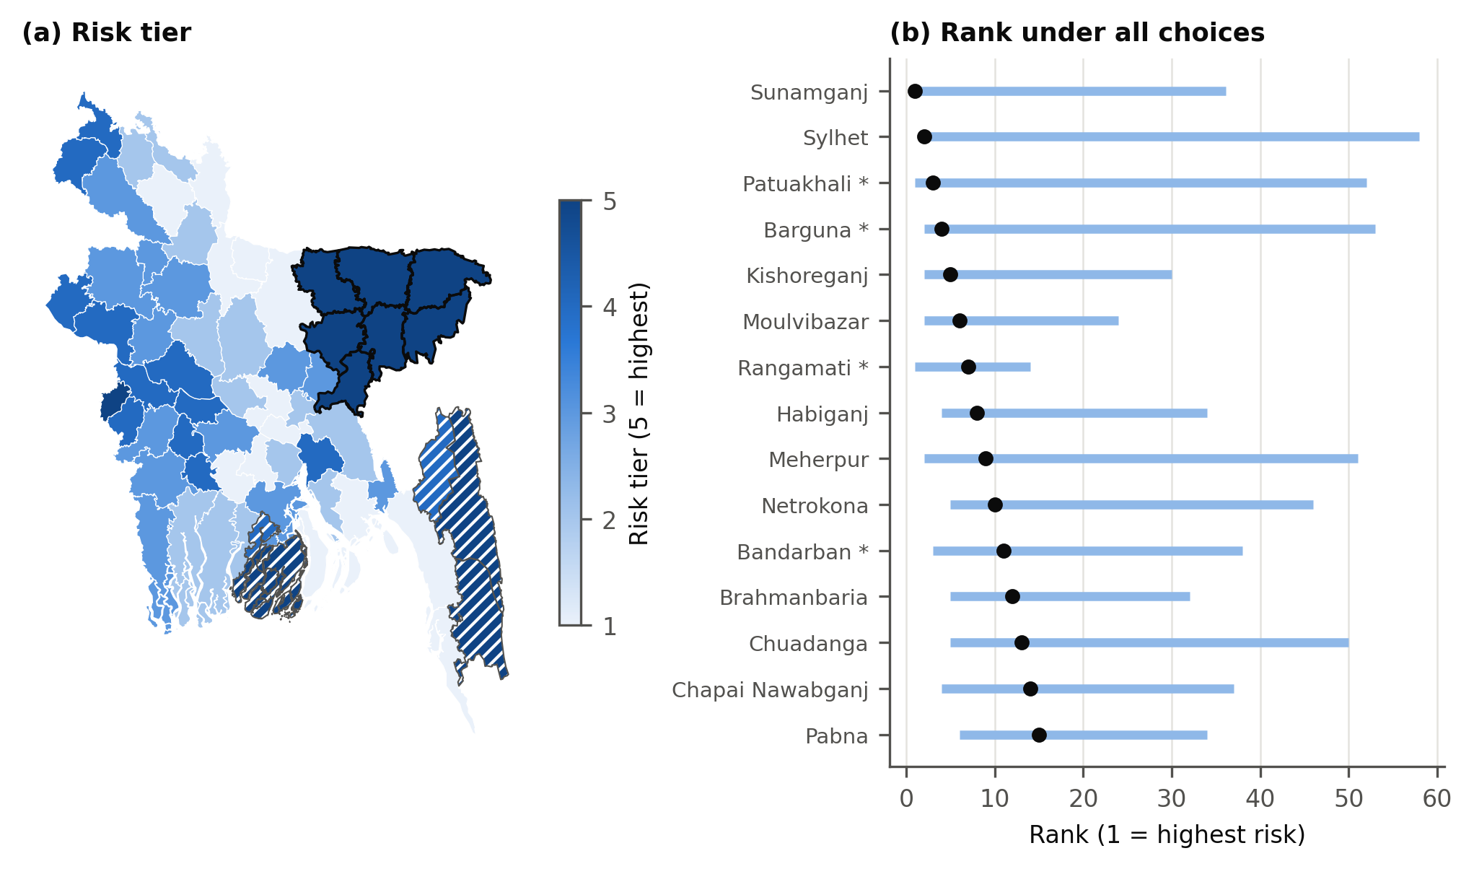
Spatial clustering was clear (Table 14). Moran’s I ranged from 0.31 to 0.45, and Habiganj, Moulvibazar, Netrokona, Sunamganj and Sylhet formed a high-risk cluster under all four neighbour definitions before correction. After false discovery rate correction, Habiganj, Sunamganj and Sylhet remained under all four, and Moulvibazar under three.
Table 14. Spatial clustering of the index under four neighbour definitions.
Neighbours | Moran’s I | p | High-risk cluster, p < 0.05 | After false discovery rate
Contiguity | 0.451 | < 0.001 | Habiganj, Kishoreganj, Moulvibazar, Netrokona, Sunamganj, Sylhet | Habiganj, Sunamganj, Sylhet
4 nearest | 0.419 | < 0.001 | Habiganj, Moulvibazar, Netrokona, Sunamganj, Sylhet | Habiganj, Moulvibazar, Sunamganj, Sylhet
6 nearest | 0.313 | < 0.001 | Habiganj, Moulvibazar, Netrokona, Sunamganj, Sylhet | Habiganj, Moulvibazar, Sunamganj, Sylhet
100 km band | 0.323 | < 0.001 | Habiganj, Moulvibazar, Netrokona, Sunamganj, Sylhet | Habiganj, Moulvibazar, Sunamganj, Sylhet
A yield-only view gives a different picture. Sunamganj ranks 25th of 64 on yield instability but 3rd on production instability, and the two rankings correlate at only 0.61.

6. Discussion

6.1 What can and cannot be claimed
One claim is strongly supported as a description of a single event. In the 2017 flood, the loss in BBS statistics appeared in harvested area and production, and almost none in yield. The three designs agree in direction, in both flood records, although the planned synthetic-control test failed and the JRC estimate depends on 2017. BBS’s own damage reports, a satellite measure that uses no BBS data and published figures point to the same districts and to losses of similar scale, and BBS reported far less Boro damage in 2016 and 2022, when no comparable fall appears. This is strong evidence consistent with flood-related crop destruction, although no single comparison proves that the whole fall in area was caused by the flood.
The broader claim, that flash floods generally reduce Boro through area, is not established. Under the plan’s rule the evidence is suggestive, and the estimate rests on 2016 and 2017. Two questions need to be kept apart: whether flood exposure is associated with lost harvested area, and whether the size of that loss is stable. The first has support, particularly for 2017. The second is much weaker (Table 15): the Sentinel-1 estimate falls by a third or more when small districts are left out or larger districts get more weight, and it then lies closer to JRC. This bears on how flood effects are read elsewhere: with few events and a few treated districts, an estimate from a large panel can be one event in disguise.
Table 15. The harvested-area effect per 10 points of flood under three specifications.
Specification | Sentinel-1 (%) | JRC (%)
Main model | −21.6 | −4.7
Districts with a small Boro base left out | −13.8 | −6.2
Poisson model, weighting by area | −10.9 | −5.3

6.2 Why area and not yield
The likely reason is how the statistics are built. BBS estimates yield from crop cuts on plots in fields growing the crop, and area separately (Bangladesh Bureau of Statistics, 2026). Its report for 2016–17 describes flash flood as fully damaging crop on 296,701 ha, its national area fell by the same amount, and it attributes higher yield to management (Bangladesh Bureau of Statistics, 2018). So in 2017 destroyed crop left the area estimate, and the yield estimate reflects the crop that remained. Since Boro is planted before flash floods arrive, a same-season fall in harvested area means crop lost and not a planting decision. The yearbooks do not state this as a general rule, and it cannot be assumed for every year: in 2016, reported damage is not fully visible in area. The small positive yield effect with JRC could mean that weaker fields are lost first, but the evidence for this is thin.
This does not contradict Li et al. (2025), who report yield losses from submergence worldwide. Li et al. and this study measure different things in different statistical systems. Whether crop that is totally lost appears in yield or area depends on how each country’s data are collected. Similarly, national data may fail to show flood effects at all (Lesk et al., 2016), because a loss such as 2017 is confined to a few districts. Our results differ from the Kansas wheat findings (Obembe et al., 2021) and resemble those on harvested ratios (Cui, 2020), which suggests that the answer depends on the crop, hazard and data system.

6.3 Implications
Disaster assessment. This recommendation follows directly from our results. Yield alone is a poor signal of the largest flood losses in this system. Sunamganj lost 73 % of its production in 2017 with no visible change in yield. Assessments should track harvested area and production alongside yield, and research on Bangladesh’s rice should not treat stable yields as evidence of low flood risk. BBS’s damage tables are a useful source, but we found them for few years. A routine estimate of planted area before the flood window would show directly what share of the crop was lost.
Satellite monitoring. Greenness-based measures located the 2017 damage without official data, as earlier work found for the same event (Ahmed et al., 2017), and similar methods have been used elsewhere (Rahman and Di, 2020; Qamer et al., 2023). They are useful for rapid assessment, but the 2016 mismatch shows that a fall in greenness should not be read as crop loss without information on harvest progress. NDVI alone should not be used to infer yield shocks in a district.
Timing and adaptation. Recommendations in this area come mainly from earlier work, and our exploratory timing result is consistent with them without establishing them. Earlier sowing and short-duration varieties are recommended so that harvest finishes before the flood window (Hossain et al., 2023), though farmers face barriers to adopting them (Baishakhy et al., 2023). Flood-tolerant rice has improved outcomes in north-west Bangladesh (Bairagi et al., 2021), but that evidence does not transfer directly to Boro in the haor, where the threat comes at maturity. Interest in crop insurance exists (Islam et al., 2021), and our results suggest that a payout tied to district yield would not have been triggered in 2017, so any index for the haor should consider area or satellite-observed loss.

6.4 Limitations
The study covers 15 years and few large flash floods, and one event dominates, so the findings describe these events and do not give a general law. Floods are not randomly assigned. BBS harvested area comes from official estimates, and BBS’s damage reports are not independent of them. Other evidence checks them only partly and only for large events, and printed values can contain errors, as Chandpur’s 2017 area appears to. The analysis plan has no public timestamp from before the results. The Boro mask relies on a fixed NDVI rule and a static cropland map, is not validated with field data, and has noisy yearly totals. Sentinel-1 has fewer scenes before 2017, and controlling for scene counts does not remove every consequence of uneven coverage. Optical records such as JRC can miss short floods that radar observes (Uddin et al., 2019; Twele et al., 2016). Flood fractions in the main models cover whole districts, and the required rice-only check weakened the estimates. Satellite greenness loss cannot separate destruction from early harvest. Cold-stress thresholds are provisional. The risk index omits adaptive capacity and salinity (Dasgupta et al., 2018), so it is a partial picture, and its rank ranges are wide. It should guide where to look more closely, and should not be used as an allocation rule.

7. Conclusion
Using printed BBS statistics for all 64 districts and a written analysis plan, we asked whether flash floods reduce Boro rice through harvested area rather than yield. For the 2017 flood the evidence is strong: haor harvested area and production fell by about a third, yield barely moved, and BBS’s damage reports and other evidence support the loss. For a general relationship the evidence is only suggestive, because the estimates rest on 2016 and 2017, their size is unstable, and the 2016 and 2022 flood years showed no comparable fall in harvested area. Flood timing is one possible reason, but that remains a hypothesis resting on one event. The practical lesson is that yield alone can miss large flood losses in this system, so flood assessment and risk indices should also use harvested area and production.

CRediT authorship contribution statement
Tasnim Ahmad Mumu: Conceptualization, Methodology, Software, Validation, Formal analysis, Investigation, Data curation, Writing – original draft, Writing – review & editing, Visualization. Rezaul Karim: Supervision, Methodology, Validation, Writing – review & editing.

Funding
This research did not receive any specific grant from funding agencies in the public, commercial, or not-for-profit sectors.

Declaration of competing interest
The authors declare that they have no known competing financial interests or personal relationships that could have appeared to influence the work reported in this paper.

Declaration of generative AI and AI-assisted technologies in the manuscript preparation process
During the preparation of this work the authors used Claude (Anthropic) to assist with code development, data validation and analysis scripts, and drafting and editing of the manuscript text. After using this tool, the authors reviewed and edited the content as needed and take full responsibility for the content of the published article.

Data availability
The panel is archived at https://doi.org/10.5281/zenodo.23795046. The derived data remain subject to the terms of their sources. The BBS yearbook PDFs and the GADM v4.1 boundaries (GADM, 2022) are not redistributed and must be obtained from the Bangladesh Bureau of Statistics and gadm.org. Code, notebooks, the analysis plan and the Earth Engine extracts for this paper are in the repository given in the Software and data availability section and archived at https://doi.org/10.5281/zenodo.23829199.

References
Abadie, A., 2021. Using Synthetic Controls: Feasibility, Data Requirements, and Methodological Aspects. Journal of Economic Literature 59 (2), 391–425. https://doi.org/10.1257/jel.20191450
Ahmed, M.R., 2024. How to Enhance Resilience Against the Adverse Effects of Climate Change: Evidence from Boro Rice Farmers in Northeast Bangladesh. Food and Energy Security 13 (6), e70028. https://doi.org/10.1002/fes3.70028
Ahmed, M., Rahaman, K., Kok, A., Hassan, Q., 2017. Remote Sensing-Based Quantification of the Impact of Flash Flooding on the Rice Production: A Case Study over Northeastern Bangladesh. Sensors 17 (10), 2347. https://doi.org/10.3390/s17102347
Alam, M.S., Kalpoma, K., Karim, M.S., Al Sefat, A., Kudoh, J.-i., 2019. Boro rice yield estimation model using MODIS NDVI data for Bangladesh. In: IGARSS 2019 - 2019 IEEE International Geoscience and Remote Sensing Symposium, 7330–7333. https://doi.org/10.1109/igarss.2019.8899084
Amin, M., Zhang, J., Yang, M., 2015. Effects of Climate Change on the Yield and Cropping Area of Major Food Crops: A Case of Bangladesh. Sustainability 7 (1), 898–915. https://doi.org/10.3390/su7010898
Anselin, L., 1995. Local Indicators of Spatial Association—LISA. Geographical Analysis 27 (2), 93–115. https://doi.org/10.1111/j.1538-4632.1995.tb00338.x
Asada, H., Matsumoto, J., Rahman, R., 2005. Impact of Recent Severe Floods on Rice Production in Bangladesh. Geographical Review of Japan 78 (12), 783–793. https://doi.org/10.4157/grj.78.783
Auffhammer, M., Hsiang, S.M., Schlenker, W., Sobel, A., 2013. Using Weather Data and Climate Model Output in Economic Analyses of Climate Change. Review of Environmental Economics and Policy 7 (2), 181–198. https://doi.org/10.1093/reep/ret016
Bairagi, S., Bhandari, H., Kumar Das, S., Mohanty, S., 2021. Flood-tolerant rice improves climate resilience, profitability, and household consumption in Bangladesh. Food Policy 105, 102183. https://doi.org/10.1016/j.foodpol.2021.102183
Baishakhy, S.D., Islam, M.A., Kamruzzaman, M., 2023. Overcoming barriers to adapt rice farming to recurring flash floods in haor wetlands of Bangladesh. Heliyon 9 (3), e14011. https://doi.org/10.1016/j.heliyon.2023.e14011
Banerjee, L., 2010. Effects of Flood on Agricultural Productivity in Bangladesh. Oxford Development Studies 38 (3), 339–356. https://doi.org/10.1080/13600818.2010.505681
Bangladesh Bureau of Statistics, 2017. Yearbook of Agricultural Statistics-2016 (28th series). Statistics and Informatics Division, Ministry of Planning, Dhaka.
Bangladesh Bureau of Statistics, 2018. Yearbook of Agricultural Statistics-2017 (29th series). Statistics and Informatics Division, Ministry of Planning, Dhaka.
Bangladesh Bureau of Statistics, 2023. Yearbook of Agricultural Statistics-2022 (34th series). Statistics and Informatics Division, Ministry of Planning, Dhaka.
Bangladesh Bureau of Statistics, 2026. Yearbook of Agricultural Statistics-2025 (37th series). Statistics and Informatics Division, Ministry of Planning, Dhaka.
Benjamini, Y., Hochberg, Y., 1995. Controlling the False Discovery Rate: A Practical and Powerful Approach to Multiple Testing. Journal of the Royal Statistical Society Series B: Statistical Methodology 57 (1), 289–300. https://doi.org/10.1111/j.2517-6161.1995.tb02031.x
Blanc, E., Schlenker, W., 2017. The Use of Panel Models in Assessments of Climate Impacts on Agriculture. Review of Environmental Economics and Policy 11 (2), 258–279. https://doi.org/10.1093/reep/rex016
Blanc, E., Strobl, E., 2016. Assessing the Impact of Typhoons on Rice Production in the Philippines. Journal of Applied Meteorology and Climatology 55 (4), 993–1007. https://doi.org/10.1175/jamc-d-15-0214.1
Conley, T.G., 1999. GMM estimation with cross sectional dependence. Journal of Econometrics 92 (1), 1–45. https://doi.org/10.1016/s0304-4076(98)00084-0
Conley, T.G., Taber, C.R., 2011. Inference with “Difference in Differences” with a Small Number of Policy Changes. Review of Economics and Statistics 93 (1), 113–125. https://doi.org/10.1162/REST_a_00049
Cui, X., 2020. Beyond Yield Response: Weather Shocks and Crop Abandonment. Journal of the Association of Environmental and Resource Economists 7 (5), 901–932. https://doi.org/10.1086/709859
Dasgupta, S., Hossain, M.M., Huq, M., Wheeler, D., 2018. Climate Change, Salinization and High-Yield Rice Production in Coastal Bangladesh. Agricultural and Resource Economics Review 47 (1), 66–89. https://doi.org/10.1017/age.2017.14
Dey, N.C., Parvez, M., Islam, M.R., 2021. A study on the impact of the 2017 early monsoon flash flood: Potential measures to safeguard livelihoods from extreme climate events in the haor area of Bangladesh. International Journal of Disaster Risk Reduction 59, 102247. https://doi.org/10.1016/j.ijdrr.2021.102247
Didan, K., 2021. MODIS/Terra Vegetation Indices 16-Day L3 Global 250m SIN Grid V061. NASA Land Processes Distributed Active Archive Center. https://doi.org/10.5067/MODIS/MOD13Q1.061
Driscoll, J.C., Kraay, A.C., 1998. Consistent Covariance Matrix Estimation with Spatially Dependent Panel Data. Review of Economics and Statistics 80 (4), 549–560. https://doi.org/10.1162/003465398557825
GADM, 2022. Database of Global Administrative Areas, version 4.1. https://gadm.org.
Gorelick, N., Hancher, M., Dixon, M., Ilyushchenko, S., Thau, D., Moore, R., 2017. Google Earth Engine: Planetary-scale geospatial analysis for everyone. Remote Sensing of Environment 202, 18–27. https://doi.org/10.1016/j.rse.2017.06.031
Guiteras, R., Jina, A., Mobarak, A.M., 2015. Satellites, Self-reports, and Submersion: Exposure to Floods in Bangladesh. American Economic Review 105 (5), 232–236. https://doi.org/10.1257/aer.p20151095
Hasan, M.M., Sarker, M.A.R., Gow, J., 2016. Assessment of climate change impacts on Aman and Boro rice yields in Bangladesh. Climate Change Economics 07 (03), 1650008. https://doi.org/10.1142/s2010007816500081
Hassan, S.M.K., 2019. Impacts of flooding on the rice production of Bangladesh: a panel data study. Thesis, Colorado State University. https://mountainscholar.org/handle/10217/197396.
Hossain, M., Biswas, P., Islam, M.R., 2023. Cold-Tolerant and Short-Duration Rice (Oryza sativa L.) for Sustainable Food Security of the Flash Flood-Prone Haor Wetlands of Bangladesh. Sustainability 15 (24), 16873. https://doi.org/10.3390/su152416873
Hsiang, S., 2016. Climate Econometrics. Annual Review of Resource Economics 8 (1), 43–75. https://doi.org/10.1146/annurev-resource-100815-095343
Islam, D.I., Rahman, A., Sarker, M.S.R., Luo, J., Liang, H., 2021. Factors affecting farmers’ willingness to adopt crop insurance to manage disaster risk: evidence from Bangladesh. International Food and Agribusiness Management Review 24 (3), 463–480. https://doi.org/10.22434/ifamr2019.0190
Jagadish, S., Craufurd, P.Q., Wheeler, T.R., 2007. High temperature stress and spikelet fertility in rice (Oryza sativa L.). Journal of Experimental Botany 58 (7), 1627–1635. https://doi.org/10.1093/jxb/erm003
Kamruzzaman, M., Shaw, R., 2018. Flood and Sustainable Agriculture in the Haor Basin of Bangladesh: A Review Paper. Universal Journal of Agricultural Research 6 (1), 40–49. https://doi.org/10.13189/ujar.2018.060106
Khan, M., Mia, M.Y., Hossain, M.R., 2012. Impacts of Flood on Crop Production in Haor Areas of Two Upazillas in Kishoregonj. Journal of Environmental Science and Natural Resources 5 (1), 193–198. https://doi.org/10.3329/jesnr.v5i1.11581
Lesk, C., Rowhani, P., Ramankutty, N., 2016. Influence of extreme weather disasters on global crop production. Nature 529 (7584), 84–87. https://doi.org/10.1038/nature16467
Li, Z., Rosa, L., Gorelick, S., 2025. Severe floods significantly reduce global rice yields. Science Advances 11 (46), eadx7799. https://doi.org/10.1126/sciadv.adx7799
MacKinnon, J.G., Webb, M.D., 2017. Wild Bootstrap Inference for Wildly Different Cluster Sizes. Journal of Applied Econometrics 32 (2), 233–254. https://doi.org/10.1002/jae.2508
MacKinnon, J.G., Webb, M.D., 2018. The wild bootstrap for few (treated) clusters. The Econometrics Journal 21 (2), 114–135. https://doi.org/10.1111/ectj.12107
MacKinnon, J.G., Webb, M.D., 2020. Randomization inference for difference-in-differences with few treated clusters. Journal of Econometrics 218 (2), 435–450. https://doi.org/10.1016/j.jeconom.2020.04.024
Mondal, S., Akter, L., Hiya, H.J., Farukh, M.A., 2021. Effects of 2017 Early Flash Flooding on Agriculture in Haor Areas of Sunamganj. Journal of Environmental Science and Natural Resources 12 (1-2), 117–125. https://doi.org/10.3329/jesnr.v12i1-2.52007
Moran, P.A.P., 1950. Notes on continuous stochastic phenomena. Biometrika 37 (1-2), 17–23. https://doi.org/10.1093/biomet/37.1-2.17
Mosleh, M., Hassan, Q., 2014. Development of a Remote Sensing-Based “Boro” Rice Mapping System. Remote Sensing 6 (3), 1938–1953. https://doi.org/10.3390/rs6031938
Mosleh, M.K., Hassan, Q.K., Chowdhury, E.H., 2016. Development of a remote sensing-based rice yield forecasting model. Spanish Journal of Agricultural Research 14 (3), e0907. https://doi.org/10.5424/sjar/2016143-8347
Mumu, T.A., Karim, R., 2026a. An open, tested data engineering framework for integrating official crop statistics with satellite and climate data: district-level Boro rice in Bangladesh. Manuscript submitted to Environmental Modelling & Software.
Mumu, T.A., Karim, R., 2026b. bd-boro-data-framework: an open, tested data engineering framework for integrating official crop statistics with satellite and climate data, district-level Boro rice in Bangladesh. Zenodo. https://doi.org/10.5281/zenodo.23795046
Muñoz-Sabater, J., Dutra, E., Agustí-Panareda, A., Albergel, C., Arduini, G., Balsamo, G., Boussetta, S., Choulga, M., Harrigan, S., Hersbach, H., et al., 2021. ERA5-Land: a state-of-the-art global reanalysis dataset for land applications. Earth System Science Data 13 (9), 4349–4383. https://doi.org/10.5194/essd-13-4349-2021
Obembe, O.S., Hendricks, N.P., Tack, J., 2021. Decreased wheat production in the USA from climate change driven by yield losses rather than crop abandonment. PLOS ONE 16 (6), e0252067. https://doi.org/10.1371/journal.pone.0252067
OECD, European Commission Joint Research Centre, 2008. Handbook on Constructing Composite Indicators: Methodology and User Guide. OECD Publishing, Paris. https://doi.org/10.1787/9789264043466-en
Pekel, J.-F., Cottam, A., Gorelick, N., Belward, A.S., 2016. High-resolution mapping of global surface water and its long-term changes. Nature 540 (7633), 418–422. https://doi.org/10.1038/nature20584
Qamer, F.M., Abbas, S., Ahmad, B., Hussain, A., Salman, A., Muhammad, S., Nawaz, M., Shrestha, S., Iqbal, B., Thapa, S., 2023. A framework for multi-sensor satellite data to evaluate crop production losses: the case study of 2022 Pakistan floods. Scientific Reports 13 (1), 4240. https://doi.org/10.1038/s41598-023-30347-y
Rahman, M.S., Di, L., 2020. A Systematic Review on Case Studies of Remote-Sensing-Based Flood Crop Loss Assessment. Agriculture 10 (4), 131. https://doi.org/10.3390/agriculture10040131
Rahman, M.A., Kang, S., Nagabhatla, N., Macnee, R., 2017. Impacts of temperature and rainfall variation on rice productivity in major ecosystems of Bangladesh. Agriculture & Food Security 6 (1), 10. https://doi.org/10.1186/s40066-017-0089-5
Rahman, M.S., Di, L., Yu, E., Lin, L., Yu, Z., 2021. Remote Sensing Based Rapid Assessment of Flood Crop Damage Using Novel Disaster Vegetation Damage Index (DVDI). International Journal of Disaster Risk Science 12 (1), 90–110. https://doi.org/10.1007/s13753-020-00305-7
Rahman, M.A., Alam, M.S., Sultana, R., Sultana, R., 2025. Assessing the interrelationship between monsoon flood disasters and major crop production in Bangladesh. International Journal of Disaster Risk Reduction 121, 105401. https://doi.org/10.1016/j.ijdrr.2025.105401
Rashid, M.M., Yasmeen, R., 2018. Cold Injury and Flash Flood Damage in Boro Rice Cultivation in Bangladesh: A Review. Bangladesh Rice Journal 21 (1), 13–25. https://doi.org/10.3329/brj.v21i1.37360
Saisana, M., Saltelli, A., Tarantola, S., 2005. Uncertainty and Sensitivity Analysis Techniques as Tools for the Quality Assessment of Composite Indicators. Journal of the Royal Statistical Society Series A: Statistics in Society 168 (2), 307–323. https://doi.org/10.1111/j.1467-985X.2005.00350.x
Santos Silva, J.M.C., Tenreyro, S., 2006. The Log of Gravity. The Review of Economics and Statistics 88 (4), 641–658. https://doi.org/10.1162/rest.88.4.641
Sarker, M.A.R., Alam, K., Gow, J., 2014. Assessing the effects of climate change on rice yields: An econometric investigation using Bangladeshi panel data. Economic Analysis and Policy 44 (4), 405–416. https://doi.org/10.1016/j.eap.2014.11.004
Shew, A.M., Ghosh, A., 2019. Identifying Dry-Season Rice-Planting Patterns in Bangladesh Using the Landsat Archive. Remote Sensing 11 (10), 1235. https://doi.org/10.3390/rs11101235
Singha, M., Dong, J., Zhang, G., Xiao, X., 2019. High resolution paddy rice maps in cloud-prone Bangladesh and Northeast India using Sentinel-1 data. Scientific Data 6 (1), 26. https://doi.org/10.1038/s41597-019-0036-3
Tate, E., 2012. Social vulnerability indices: a comparative assessment using uncertainty and sensitivity analysis. Natural Hazards 63 (2), 325–347. https://doi.org/10.1007/s11069-012-0152-2
Torres, R., Snoeij, P., Geudtner, D., Bibby, D., Davidson, M., Attema, E., Potin, P., Rommen, B., Floury, N., Brown, M., et al., 2012. GMES Sentinel-1 mission. Remote Sensing of Environment 120, 9–24. https://doi.org/10.1016/j.rse.2011.05.028
Twele, A., Cao, W., Plank, S., Martinis, S., 2016. Sentinel-1-based flood mapping: a fully automated processing chain. International Journal of Remote Sensing 37 (13), 2990–3004. https://doi.org/10.1080/01431161.2016.1192304
Uddin, K., Matin, M.A., Meyer, F.J., 2019. Operational Flood Mapping Using Multi-Temporal Sentinel-1 SAR Images: A Case Study from Bangladesh. Remote Sensing 11 (13), 1581. https://doi.org/10.3390/rs11131581
Wei, D., Gephart, J.A., Iizumi, T., Ramankutty, N., Davis, K.F., 2023. Key role of planted and harvested area fluctuations in US crop production shocks. Nature Sustainability 6 (10), 1177–1185. https://doi.org/10.1038/s41893-023-01152-2
Zanaga, D., Van De Kerchove, R., Daems, D., De Keersmaecker, W., Brockmann, C., Kirches, G., Wevers, J., Cartus, O., Santoro, M., Fritz, S., et al., 2022. ESA WorldCover 10 m 2021 v200. Zenodo. https://doi.org/10.5281/zenodo.7254221

Appendix A. Supplementary tables
Table A.1. Other variants of the area effect, reported without a pass rule. The Poisson model (Santos Silva and Tenreyro, 2006) gives more weight to large districts.
Variant | Flood record | Area effect (%) | Clustered p | Driscoll–Kraay p
Division-by-year effects | Sentinel-1 | −20.4 | 0.012 | < 0.001
Division-by-year effects | JRC | −6.6 | 0.003 | 0.042
District linear trends | Sentinel-1 | −15.7 | 0.002 | 0.018
District linear trends | JRC | −5.0 | 0.107 | 0.162
Poisson model | Sentinel-1 | −10.9 | < 0.001 | –
Poisson model | JRC | −5.3 | < 0.001 | –
Districts under 15,000 ha left out | Sentinel-1 | −13.8 | 0.001 | 0.004
Districts under 15,000 ha left out | JRC | −6.2 | 0.012 | 0.073
Leave out Chandpur | Sentinel-1 | −21.3 | 0.023 | < 0.001
Leave out Chandpur | JRC | −4.4 | 0.106 | 0.152
Flash flood only, 2015–2025 | Sentinel-1 | −20.7 | 0.018 | < 0.001
Water threshold −16 dB | Sentinel-1 | −20.0 | 0.035 | < 0.001
Water threshold −20 dB | Sentinel-1 | −28.8 | 0.001 | < 0.001
Neighbours’ flood, own effect | Sentinel-1 | −21.5 | 0.049 | < 0.001
Neighbours’ flood, own effect | JRC | −6.2 | 0.013 | 0.052
Neighbours’ flood, spillover | Sentinel-1 | −0.3 | 0.972 | 0.908
Neighbours’ flood, spillover | JRC | 3.3 | 0.257 | 0.386
Table A.2. National area of the yearly Boro mask, against BBS and published maps.
Harvest year | Yearly mask (million ha) | BBS harvested area (million ha) | Shew and Ghosh (2019) (million ha)
2011 | 3.42 | 4.77 | –
2012 | 3.37 | 4.81 | –
2013 | 3.83 | 4.76 | –
2014 | 3.79 | 4.79 | 4.29
2015 | 4.24 | 4.84 | 4.42
2016 | 4.16 | 4.77 | 4.64
2017 | 4.12 | 4.48 | 4.12
2018 | 3.65 | 4.86 | 4.41
2019 | 4.47 | 4.79 | –
2020 | 4.18 | 4.76 | –
2021 | 4.17 | 4.79 | –
2022 | 3.73 | 4.82 | –
2023 | 3.95 | 4.85 | –
2024 | 3.36 | 4.88 | –
2025 | 4.45 | 4.89 | –
Table A.3. The 18 data checks run before any model, from outputs/validation_variables.csv.
Check | Observed | Result
Gold panel matches the archived panel | 5cbaeb1edaef | Pass
Boro mask and crop loss: 64 districts in every year, no missing value | 960 rows | Pass
Weather: 64 districts in every year, no missing value | 960 rows | Pass
NDVI windows: 64 districts in every year, no missing value | 960 rows | Pass
Sentinel-1 scene counts: 64 districts in every year, no missing value | 704 rows | Pass
Sentinel-1 flood: 64 districts in every year, no missing value | 704 rows | Pass
JRC flood: 64 districts in every year, no missing value | 704 rows | Pass
Sentinel-1 thresholds: 64 districts in every year, no missing value | 704 rows | Pass
S1_flash_wd reproduces the panel’s s1_flash_flood | max difference 1.11e-16, n=704 | Pass
S1_monsoon_wd reproduces the panel’s s1_monsoon_flood | max difference 1.11e-16, n=640 | Pass
Jrc_flash_wd reproduces the panel’s jrc_flash_flood | max difference 4.08e-10, n=704 | Pass
Jrc_monsoon_wd reproduces the panel’s jrc_monsoon_flood | max difference 7.75e-10, n=704 | Pass
All fractions lie between 0 and 1 | 0.0000 to 1.0000 | Pass
Boro land never exceeds district area | largest share 0.74 | Pass
Sentinel-1 scenes exist in every district-year | minimum 5 in Apr-May | Pass
Satellite greenness loss is observed on most Boro land | minimum valid share 0.67 | Pass
Yearly mask agrees with BBS area between districts | r = 0.914 | Pass
Stable mask agrees with BBS area between districts | r = 0.909 | Pass
Table A.4. Required checks of the harvested-area effect, by type.
Type | Checks | Passed | Failed
Leave out a flood year | 5 | 4 | Leave out 2017 (JRC)
Leave out a district | 8 | 7 | Leave out Sunamganj (JRC)
Placebos | 4 | 3 | Next year’s flash flood (placebo) (Sentinel-1)
Measurement | 4 | 3 | Rice land only (JRC)
Sentinel-1 coverage | 1 | 1 | None
All required checks | 22 | 18

Appendix B. Literature search
The search used one database, OpenAlex, on 31 October 2026, with the 52 search strings in Table B.1 and up to 40 records for each of the first 38 strings and 25 for the other 14. This gave 1,870 records, of which 1,383 were unique and 1,232 had an abstract. Screening used titles and abstracts: 421 records concerned Bangladesh or the haor and crops, 182 of them also concerned flooding, and 5 of those also mentioned cultivated or harvested area. Hassan (2019) was found by a separate web search. The core list of 57 papers was confirmed on Crossref. Journals published in Bangladesh are indexed less completely, and keyword screening can miss papers that use other words. The search scripts are in the repository.
Table B.1. Search strings by theme.
Theme | Search strings | Records retrieved
Haor and Boro flooding | haor flash flood Boro rice; flash flood rice Bangladesh damage; Boro rice flood loss Bangladesh; haor basin remote sensing flood; 2017 flash flood Bangladesh haor; haor agriculture climate vulnerability; pre-monsoon flood Bangladesh rice; flood damage rice production Bangladesh district | 320
Area versus yield | harvested area yield decomposition extreme weather crop production; flood impact crop production harvested area yield; weather shocks harvested area abandonment panel; extreme weather disasters global crop production; climate variability harvested area versus yield; flood crop loss panel fixed effects; crop yield harvested area response flood | 280
Climate and yield in Bangladesh | climate change rice yield Bangladesh panel; Boro rice yield temperature Bangladesh; heat stress Boro rice Bangladesh; district level rice yield climate Bangladesh; climate rice production Bangladesh econometric | 200
Flood mapping and crop loss from satellites | Sentinel-1 flood mapping Bangladesh; Sentinel-1 flood rice damage assessment; satellite crop loss flood NDVI change rice; remote sensing flood damage cropland rice; JRC Global Surface Water flood agriculture; SAR water threshold flood mapping rice paddy | 240
Vulnerability indices and spatial methods | agricultural vulnerability index Bangladesh; composite indicator uncertainty sensitivity analysis; social vulnerability index uncertainty sensitivity; spatial autocorrelation crop yield LISA; climate vulnerability exposure sensitivity adaptive capacity agriculture Bangladesh | 200
NDVI and yield | NDVI rice yield Bangladesh; NDVI yield relationship within field interannual irrigated rice; satellite crop yield estimation smallholder district statistics | 120
Adaptation | short duration Boro rice variety flash flood haor; flood early warning haor farmers; crop insurance flood Bangladesh rice; submergence tolerant rice Bangladesh adoption | 160
Targeted search | effects of flood on agricultural productivity in Bangladesh; satellites self-reports submersion floods Bangladesh; flood rice Bangladesh difference-in-differences; flood exposure agricultural production Bangladesh district panel; Boro production loss 2017 flash flood district statistics; flash flood early monsoon haor rice production estimate; Boro rice mapping Bangladesh satellite annual; rice area mapping Bangladesh Sentinel-1 MODIS; annual paddy rice map South Asia 10 m; pre-monsoon flood Meghna basin trend haor frequency; flood positive effect dry season rice residual moisture sediment Bangladesh; India district flood rice yield panel; flood harvested area rice Vietnam Thailand Philippines panel; typhoon rice production harvested area panel | 350

