Github link: https://github.com/Tasadan-Filip/FilipT-lftc-labs

**BNF in which the FA.in file should be written**

fa := states “\n” alphabet “\n” transitions “\n” initialState “\n” finalStates

states := letter | letter “|” states

alphabet := character | character “|” alphabet

transitions := transition | transition “|” transitions

initialState := letter

finalStates := character | character “|” finalStates

character = letter | digit

letter := "a" | "b" | ... | "z"

digit := "0" | "1" |...| "9"

transition = letter “,” character “=” letter

**FA for identifier and Integer Constant**

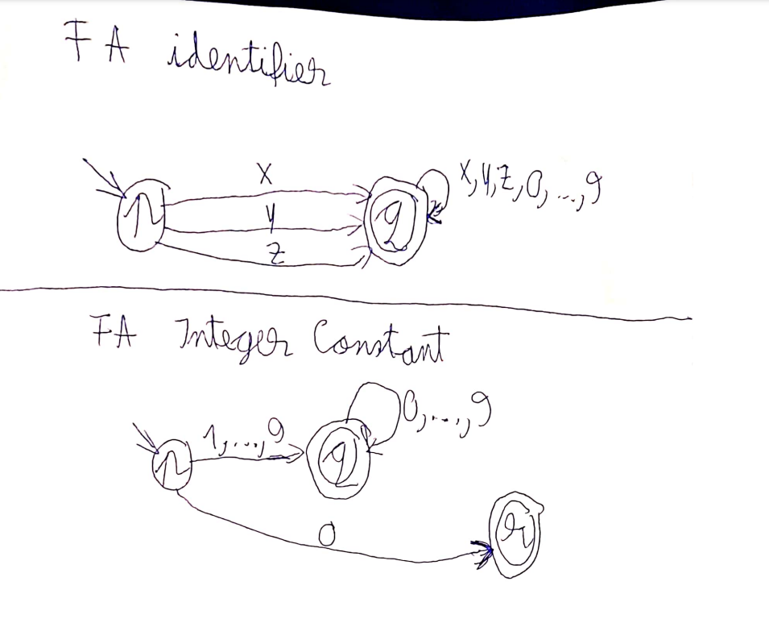

**Class diagram:**

