Github link: https://github.com/Tasadan-Filip/FilipT-lftc-labs
ST.out
1. Hash function
a. Hash function implementaiton:
{
int hashValue = 7;
for (int index = 0; index < stringToHash.length(); index++) {
hashValue = hashValue * 70 + stringToHash.charAt(index);
}

return hashValue % tableSize;
}

b. Hash function explanation:
The hash function multiplies the current computed hash value with 70 (number of different characters that we could have in the string) and it adds the ASCII value of the character. In order to retrieve the list's position where the new element should be added, the hash function's value will be the remainder of the computed hash value and the size of the symbol table (because the symbol table is represented as a list of lists)

2. Data structure used for Symbol table:
Collision resolution method:
The method used is "Separate chaining Hash Table" in which the hash table contains a list of lists, where each internal list contains string elements that should be kept in the table. Each element is hashed to the position of a internal list from the table's list and it gets added there if doesn't exist.

Class diagram:
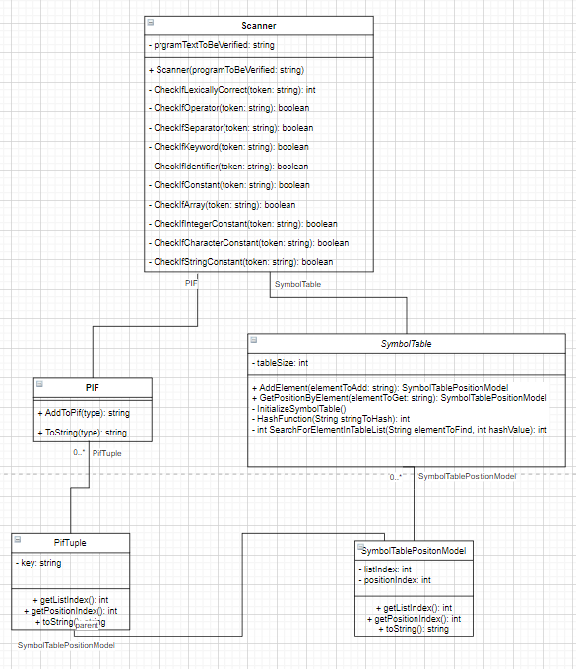

Regex explanations:
CheckIfOperator: (\+)|(-)|(\*)|(/)|(==)|(!=)|(<)|(>)|(<=)|(=)|(>=)|(%)
Since the operators are "+|-|=|>|<|==|!=|>=|<=|*|**|/|%" this regex checks one by one wheter the token is one of the above strings.
CheckIfSeparator: (\[)|(])|(\{)|(})|(;)|\(|\)
Since the separators are "[|]|{|}|(|):|.|space|tab" this regex checks one by one wheter the token is one of the above strings.
CheckIfKeyword: char|const|for|else|if|int|bool|read|write|var|while
Since the keywords are "char|const|for|else|if|int|bool|read|write|var|while" this regex checks one by one wheter the token is one of the above strings.
CheckIfIdentifier: [a-zA-Z]+[a-zA-Z0-9]*
Since each identifier must start with a letter (either capital or lowercase), this regex checks wheter the token starts with at least one letter (this is the meaning of +) and this sequence may be followed by any combination of letters and digits.
CheckIfArray: [a-zA-z]+[a-zA-Z0-9]*\\[[1-9]+[0-9]*]
Since each array must start with a letter (either capital or lowercase), this regex checks wheter the token starts with at least one letter (this is the meaning of +) and this sequence may be followed by any combination of letters and digits, followed by straight brackets [ ] in which there must be a positive non-zero integer number (this is why it checks if between brackets there is at least one digit from 1-9 followed by any number of digits including zero, but an integer number cannot start with 0)
CheckIfIntegerConstant: [0-9]|[1-9]+[0-9]*
This regex checks wheter the number contains a single digit or if it contains more digits it assures that the first digit is non-zero and it can be followed by any number of digits (including zero)
CheckIfCharacterConstant: '[a-zA-Z0-9]'
A character constant starts with ' and ends in ' and in between there can be one character which is either a letter (lowercase or uppercase) or a number
CheckIfStringConstant: "[a-zA-Z0-9]*"
A string constant starts with " and ends in " and in between there can be a variable length sequence of letters (lowercase or uppercase) or numbers

