

Become a Successful Seller in Daraz

**Introduction:**

First we look at how to sell a product on a daraz.pk. There are two selling methods on daraz.pk one is FBS/FBM fulfillment by seller/Merchant and the other is FBD fulfillment by Daraz.

* **FBD:** You keep your inventory in Daraz's warehouse and Daraz himself pick, pack, and ship the product.
* **FBM/FBS:** Seller receives the order, he himself pick, pack, and ships the product at Daraz service center.

**Registration as a Seller:**

First you have to go the daraz.pk and click on the sell on daraz button (figure1.1) then you see second page (figure1.2) click on start selling button and then will see these options (figure 1.3).

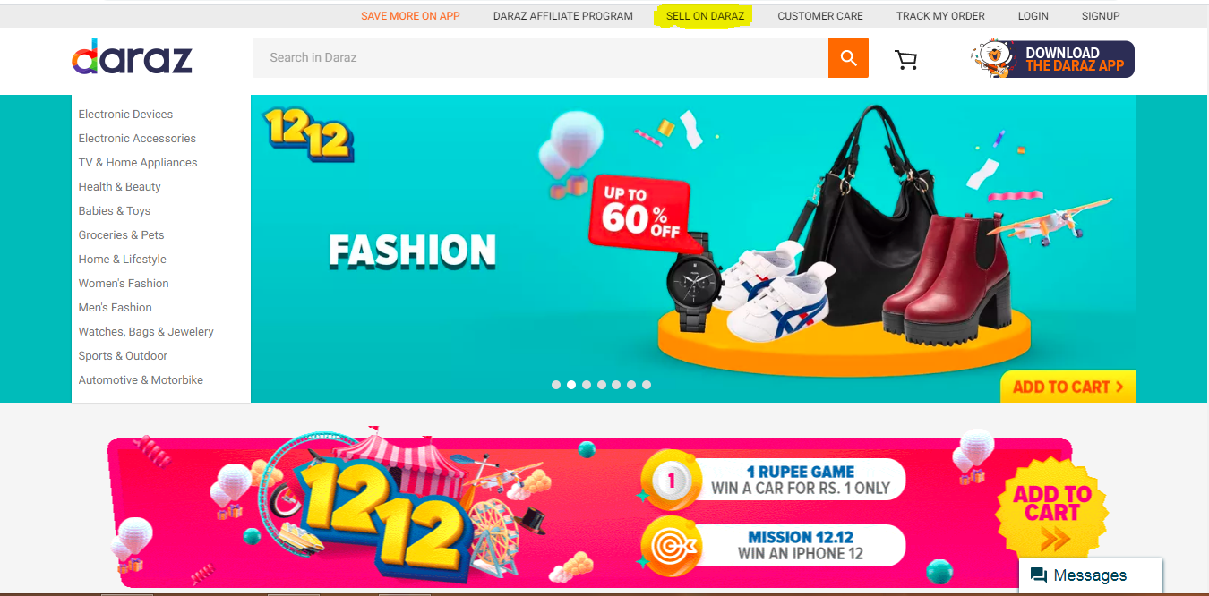

Figure 1.1

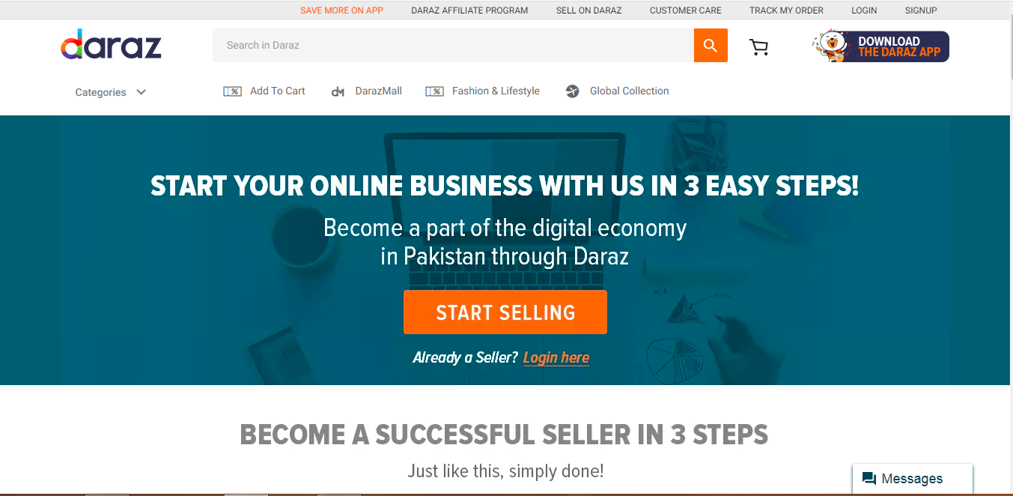

Figure 1.2

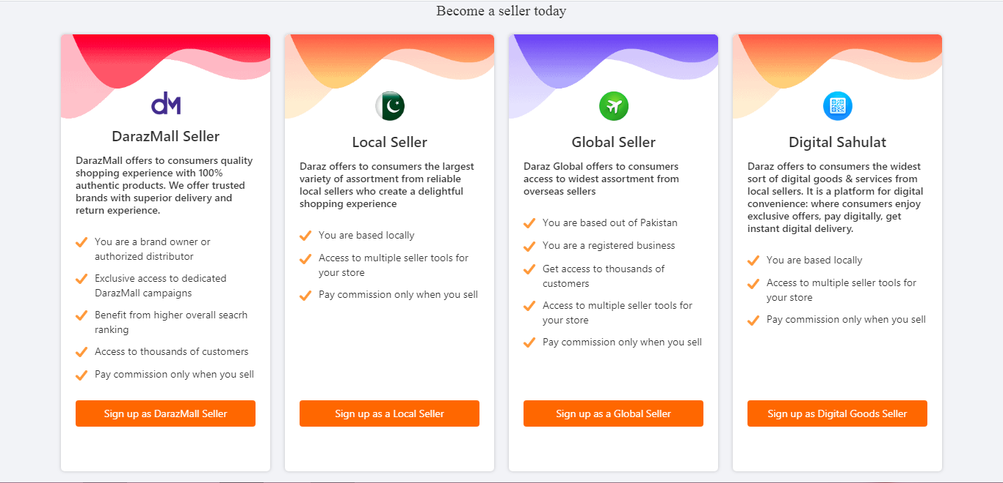

Figure 1.3

* **DarazMall Seller:** If you’re a licensed business or a registered company, you should create an account in the DarazMall Seller section.
* **Local Seller:** If you don’t have a licensed business, it’s always great to become a local seller.
* **Global Seller:** Those who have an established business outside Pakistan and want to spread their product in Pakistan, then they require a Global Seller account.
* **Digital Good Seller:** This section is for those who want to sell digital goods.

Once you choose your best suitable category, you will require the following details. (Figure 1.4)

* **Mobile number:** You must provide your own mobile number because your number will be used for communications. Keep the phone with you because you will be required to verify your number during registration.
* **Human test:** You will be asked to slide the arrows to prove yourself human. These kinds of tests help sites stop spamming on the sites. So that registration couldn’t be automated with software and robots.
* **Password:** Set a password for your account. Keep that confidential so that your account couldn’t be misused or hacked.
* **Email:** An email address makes communications more accessible. You can easily save the details of your transactions and selling’s in your email address. It does not depend on your mobile only because you can’t keep all the records on your phone.
* **Shop name:** Set a name whatever you want to be called on the site. It should be easy to remember and easy to pronounce. So that if someone refers to a friend for your shop, he should not face any hurdle during the search.

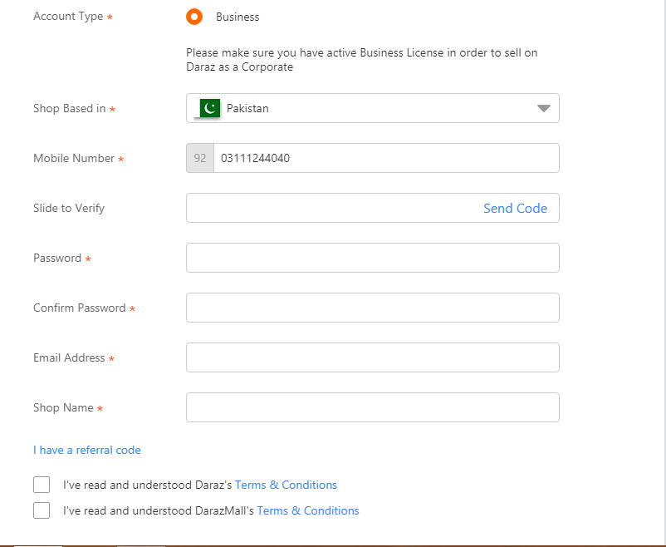

Figure 1.4

After Filling in all the information, you login to seller central. (Figure 1.5) and register yourself as a seller. Once you filled out all the information, make sure you purchase packaging material as per your product requirement. Keep in mind you can only order packaging material with your registered email ID.

**Daraz Cheat Fact:** Ordering packaging material speeds up your shop verification process and the sooner you order, the quicker your shop will be verified.

Figure 1.5

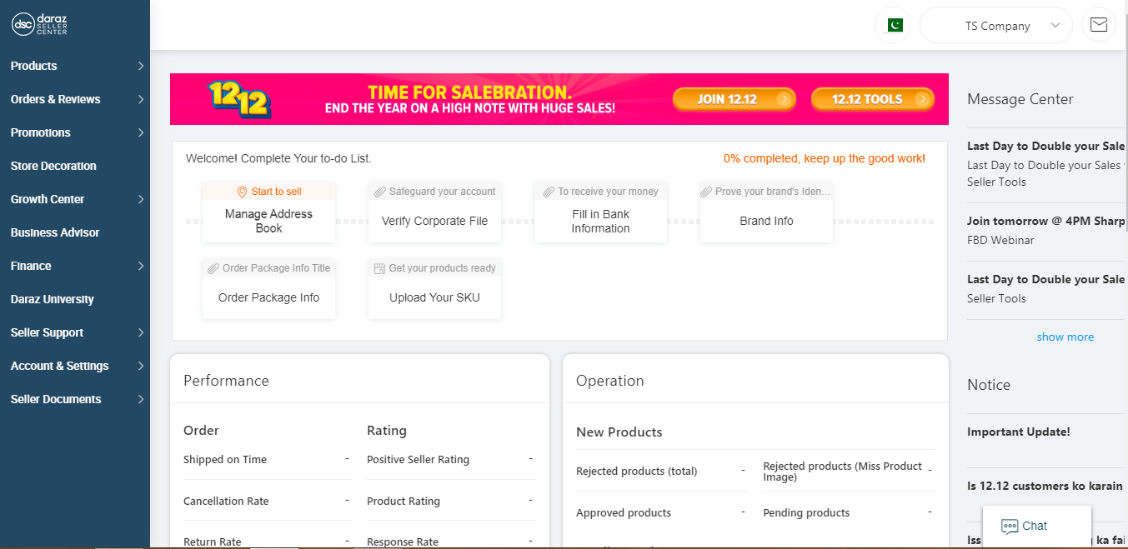

**Product Listing:**

In Seller central, click on the product button and then click on add product. You will see this screen (Figure 2.1)

Figure 2.1

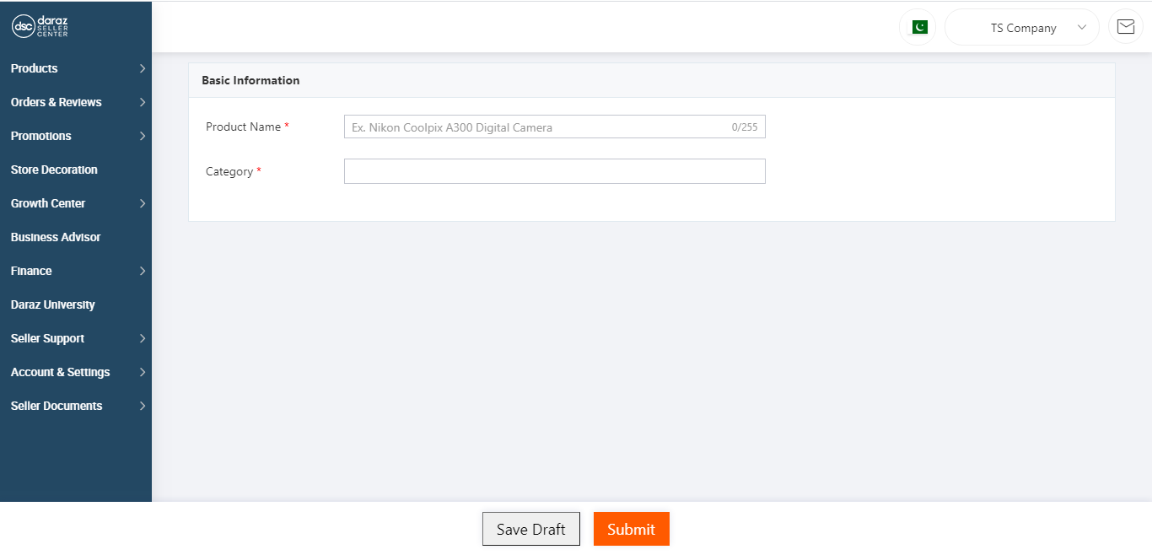

Now write down all the information of your product and click on submit button then your list is created. Below are snapshots of all the required information about product listing. (figure 2.2-2.6)

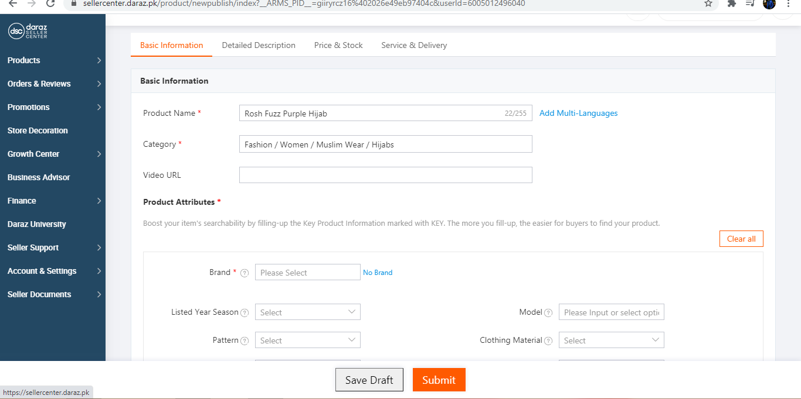

Figure 2.2

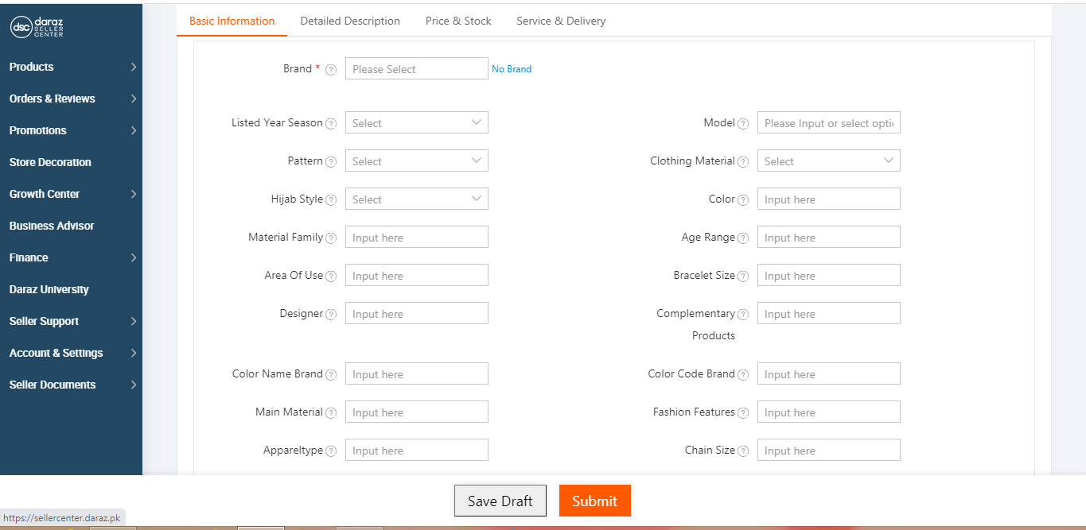

Figure 2.3

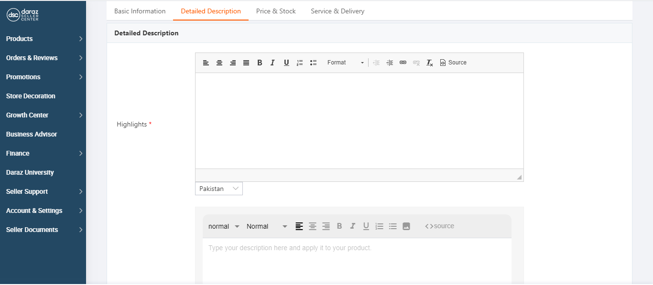

Figure 2.4

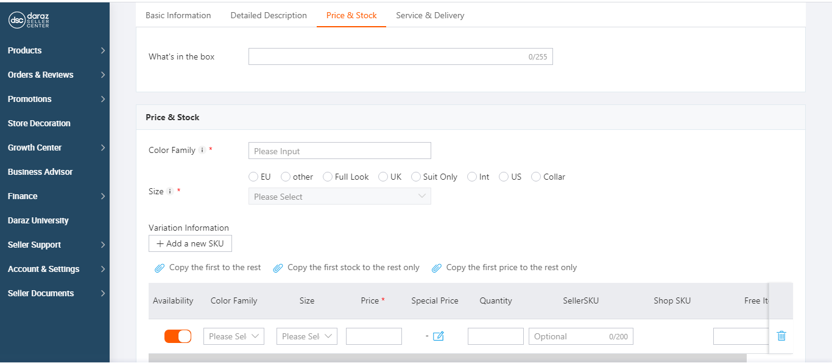

Figure 2.5

Figure 2.6

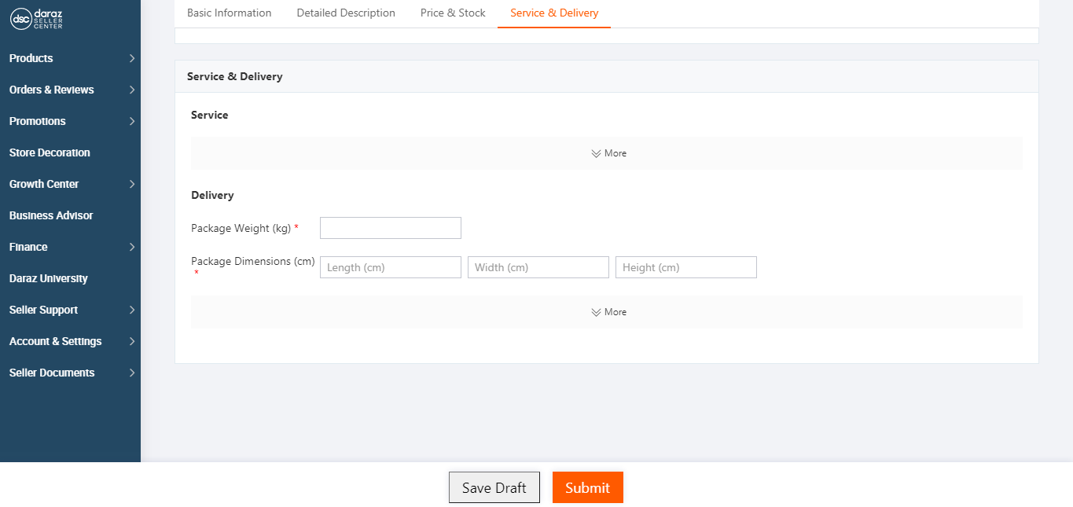

**Do’s & don’t for Product Listing:**

1. Images of your product must be accurate.
2. Description and highlights must be attractive and correctly depict the product.
3. Avoid Irrelevant Information.
4. Do not make any false claims.

**Image Guidelines:**

1. Be clear not blurred.
2. Have a white or grey background.
3. Have adequate lighting.
4. Show color/ material clearly.
5. Cover multiple angles of the product.

Now that your product is listed, as soon as account is activated your listing will be live. Now just work on your review, ranking, sales velocity and marketing and try to join every daraz campaign and maximize your sales.

**Strategies for Marketing:**

**Daraz Campaigns:** Daraz makes several campaigns a year, some small and some large. You have to be part of these campaigns to increase the sales of your product because daraz markets them himself and ranks the products that are part of it.

There are many types of campaigns.

1. **Mega Campaigns**

Mega campaigns offer customers exclusive discounts, unbelievable offers and are also heavily marketed by daraz, giving sellers a great opportunity to increase sales.

* 11,11
* Big Friday

1. **One Day campaigns**

One day campaigns are targeted towards a certain category group of example

* Thursday Baby Bash
* Workout Wednesday

1. **Weekly Campaigns**

Weekly campaigns are usually targeted towards a certain category group for example

* Mobile Week
* Super Electronics Week

1. **Occasion Based Campaigns**

These campaigns are scheduled around or related to a certain occasion or event examples

* Pakistan Day Sale
* Hari Bari Eid

1. **Vouchers & Bundles Campaigns**

These campaign are only exclusive to Vouchers or Bundles. All sellers who register and participate must create product bundles or vouchers for approval.

This attracts customer because not only are getting great offers, but a specified campaign makes them think they are saving even more.

1. **Flash Sales**

This means a sale with greatly reduced prices that only lasts for only a short period of time.

The quantity is limited, which often means the discount are higher or more significant compared to other sales or campaigns.

**Note:** Whenever you participate in any campaigns, you have to keep your inventory stock as high as possible because these campaigns have a lot of sales.

**Social Media Marketing:** In this strategy, the seller posts and market his product on social media sites like (Facebook, Instagram, Twitter, and Pinterest). This is a very useful strategy because here is the marketing of your product to your friends and their friends. And most importantly, this strategy is very useful in the early days.

**Proxy Marketing:** In this marketing strategy the seller convince his friends to buy his product and also gives him money for that. And in return he takes reviews and ratings from them. And after receiving the review, he also takes back the money from these people but provides a free product. This is a way to generate reviews, rating and sales velocity for new sellers.

**Summary**

This entire report explains how to register as a seller on daraz.pk. How to list a product after registration as a seller and how to marketing a product. And how you can make a successful business on daraz.

May Allah make every one successful!

Sheikh Taseen