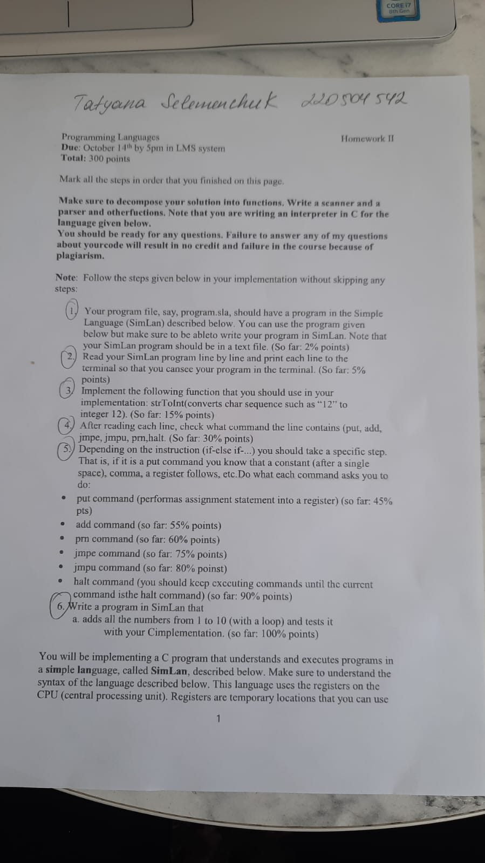

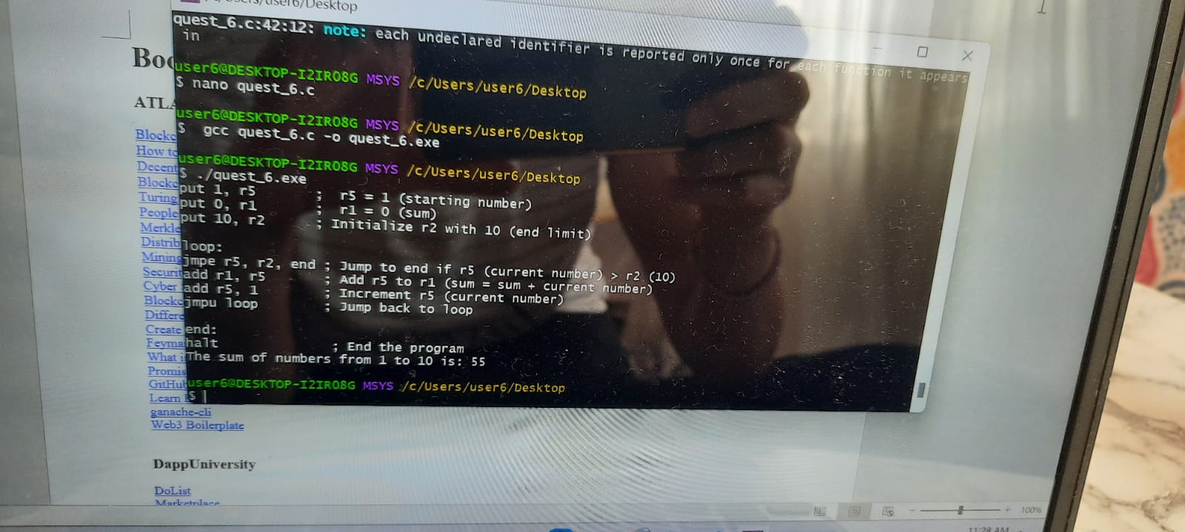

#include <stdio.h>

#include <stdlib.h>

#include <string.h>

#define MAX_LINE_LENGTH 100 // Function to execute the logic for adding numbers from 1 to 10

int add_numbers() {

int sum = 0; // Initialize sum

int current = 1; // Start with 1

int limit = 10; // Limit to 10 // Loop to add numbers from 1 to 10

while (current <= limit) {

sum += current; // Add current to sum

current++; // Increment current }

return sum; // Return the final sum

}

int main() { FILE *file = fopen("adds_num.sla", "r");

if (file == NULL) {

perror("Error opening file");

return EXIT_F;

}

char line[MAX_LINE_LENGTH];

// Read the file line by line (optional)

while (fgets(line, sizeof(line), file)) {

// Print the line (for debugging purposes)

printf("%s", line); } fclose(file); // Close the file /

/ Execute the addition logic

int sum_result = add_numbers();

printf("The sum of numbers from 1 to 10 is: %d\n", sum_result);

return EXIT_S;

}

Photos of other questions:

1

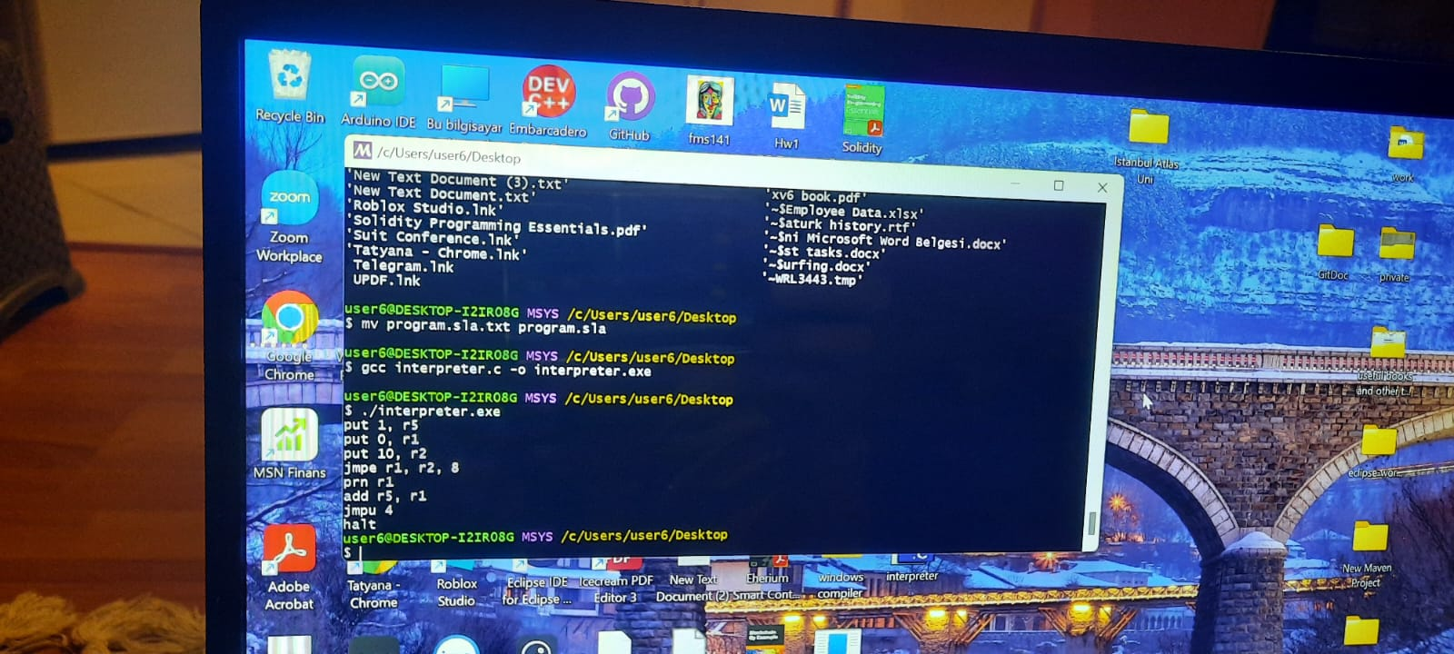

2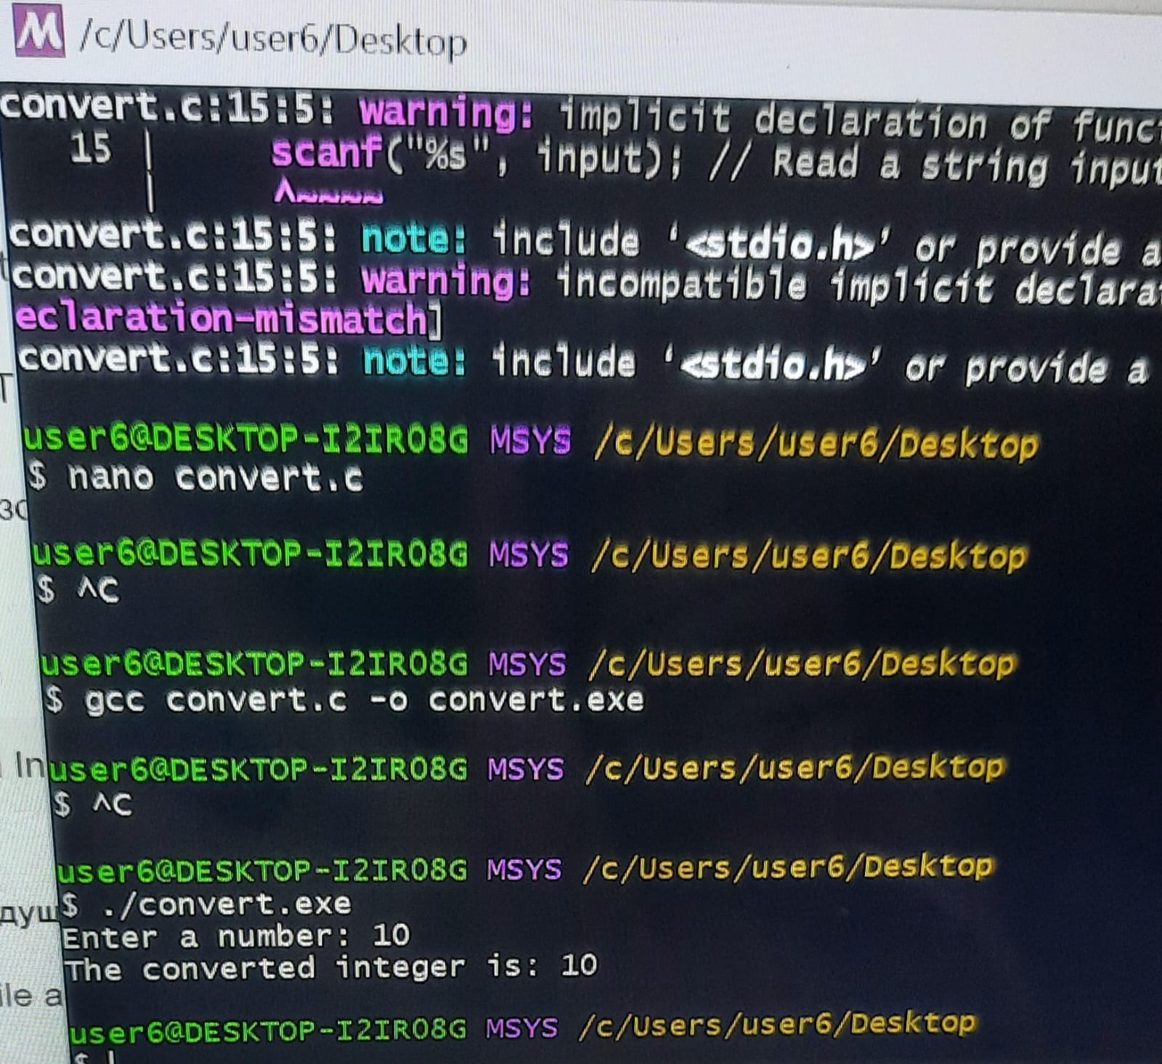

3.