**HW4 PROGLANG Tatyana Selemenchuk 220504542**

**(*All my handwritings you can find below)**

1. Takes three arguments where the first element replaces of the occurrences of the second argument in the list which is the last argument

(define (replace arg1 arg2 lst)

(cond

((null? lst) '()) ;; Base case: empty list returns empty

((equal? (car lst) arg2) ;; If head matches 'arg2'

(cons arg1 (replace arg1 arg2 (cdr lst))) ;;

)

(else

(cons (car lst) (replace arg1 arg2 (cdr lst)))))) ;;

> (replace 1 3 '(1 5 7 1 3)) ;

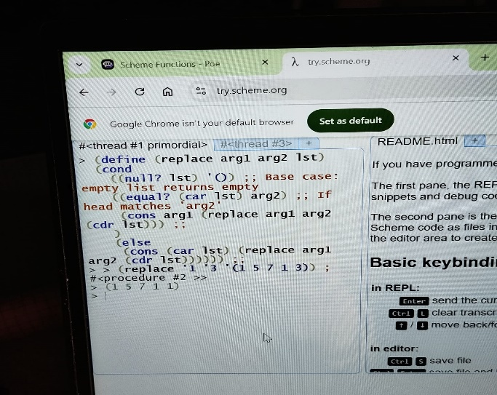**> (1 5 7 1 1)**

2. Takes three arguments where the first argument replaces the ith element (second

argument) in the list (the third argument)

(define (replace-i-th_elem arg1 i lst)

(cond ((null? lst) lst) ;; Base case: if the list is empty, return it

((= i 0) ;; If we've reached the index

(cons arg1 (cdr lst))) ;; Replace and return

(else

(cons (car lst) (replace-i-th_elem arg1 (- i 1) (cdr lst)))))) ;; Decrement index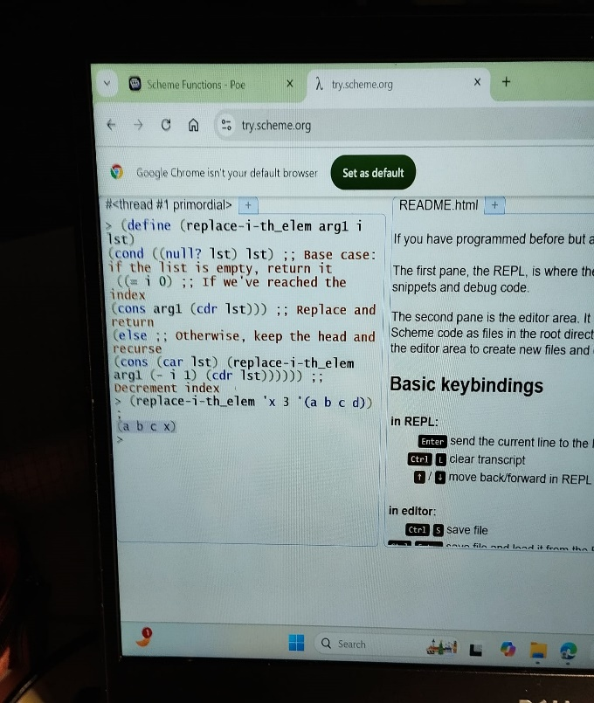

(replace-i-th_elem 'x 3 '(a b c d)) **; > (a b c x)**

3. takes two arguments where the number of occurrences of the first argument in the list

(second argument) is counted.

(define (count_occur elem lst)

(cond ((null? lst) 0) ;; Base case: if the list is empty, count is 0

((equal? (car lst) elem) ;; If head equals elem

(+ 1 (count_occur elem (cdr lst))))

(else (count_occur elem (cdr lst)))))

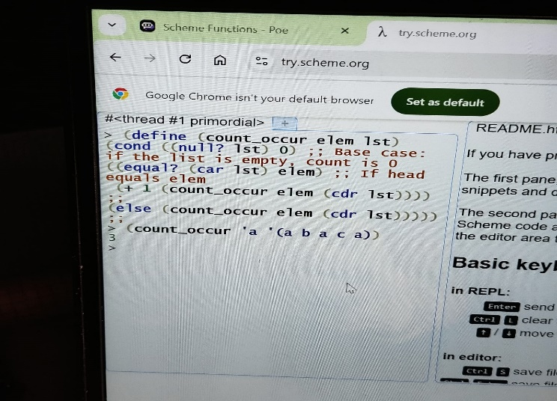

(count_occur 'a '(a b a c a**)) => 3**

4. takes two arguments where all the occurrences of the first argument in the list (second

argument) is removed.

(define (remove_occur elem lst)

(cond

((null? lst) '()) ;; Base case: if the list is empty, return empty

((equal? (car lst) elem) ;; If head equals elem

(remove_occur elem (cdr lst))) ;;

(else

(cons (car lst) (remove_occur elem(cdr lst)))))) ;;

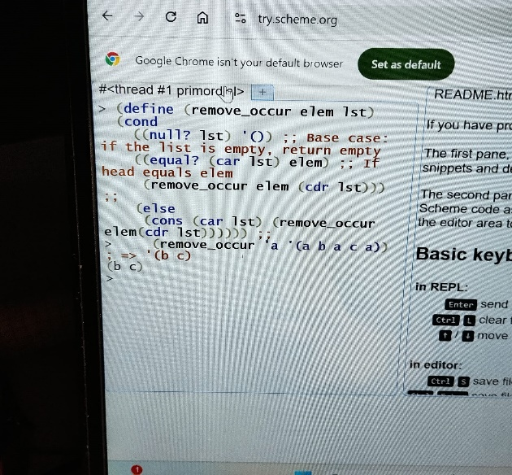

(remove_occur 'a '(a b a c a)) ; > **'(b c)**

5. takes two arguments where only the first occurrence (the first argument) in the list(second argument) is removed.

(define (remove-first elem lst)

(cond ((null? lst) '()) ;; Base case: if the list is empty, return empty

((equal? (car lst) elem) ;; If head equals elem

(cdr lst)) ;;

(else (cons (car lst) (remove-first elem (cdr lst))))))

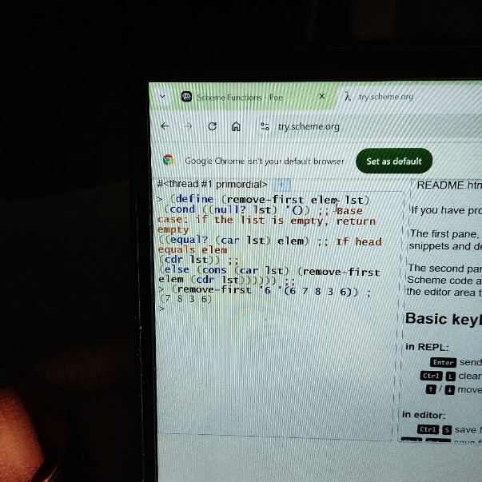

(remove-first '6 '(6 7 8 3 6)) **=> (7 8 3 6)**

6. takes two arguments where all the occurrences that are less than the first argument in

the list (second argument) is removed.

(define (remove-less-than num lst)

(cond ((null? lst) '()) ;; Base case: if the list is empty, return empty

((< (car lst) num) ;; If head is less than num

(remove-less-than num (cdr lst)))

(else (cons (car lst)

(remove-less-than num(cdr lst))))))

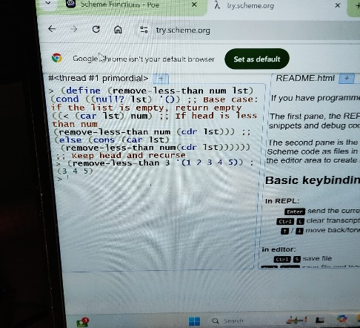

(remove-less-than 3 '(1 2 3 4 5)) **; > (3 4 5)**

7. takes two arguments and evaluates to true if the length of list A (first argument) is

less than the length of list B (second argument).

> (define (length-less? lstA lstB)

(cond

((null? lstA) #t) ;; If lstA is empty, return true (it is shorter)

((null? lstB) #f) ;; If lstB is empty, return false (lstA cannot be shorter)

(else (length-less? (cdr lstA) (cdr lstB)))))

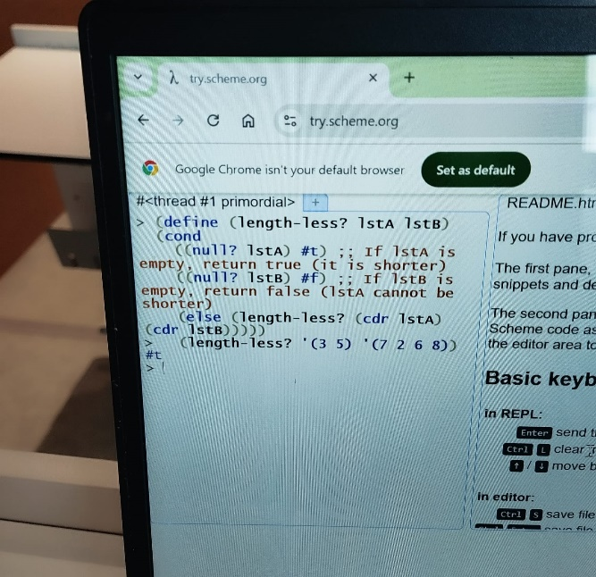

> (length-less? '(3 5) '(7 2 6 8))

**#t**

> (length-less? '(1 2 3) '(4 5))

**#f**

8. takes a list of pairs where each pair is a letter and a positive number (associated with

it) and evaluates to the letter whose associated number is the biggest.

> (define (max-letter pairs)

 (cond

   ((null? pairs) #f) ;; Return false if the list is empty

   ((null? (cdr pairs)) (car (car pairs))) ;; If there's only one pair, return its letter

   (else

    (let* ((max-from-cdr (max-letter (cdr pairs))) ;; Recursively find the max from the cdr

           (max-pair (car pairs))) ;; Get the first pair

      (if (> (cadr max-pair) (cadr (assoc max-from-cdr pairs))) ;; Compare the numbers

          (car max-pair) ;; If max from car is greater, return its letter

          max-from-cdr)))))

> (max-letter '((a 8) (b 10) (c 20) (d 35))) **=> d**

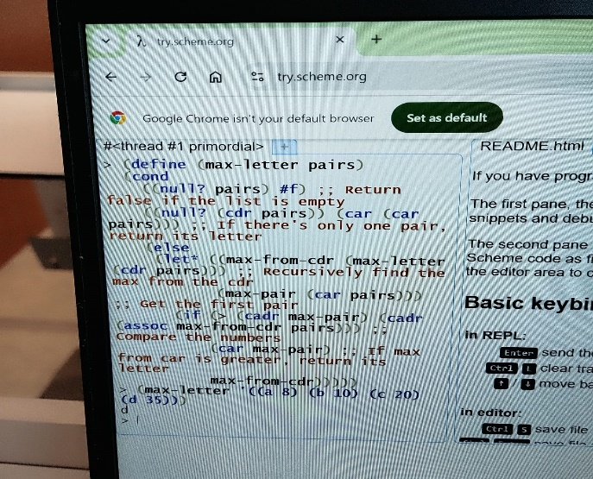

9. takes a list of integers and evaluates to the average of the list.

> (define (average lst)

(define (sum lst)

(if (null? lst)

0

(+ (car lst) (sum (cdr lst))))) ;; Recursive sum of the list

(define (charac lst)

(if (null? lst)

0

(+ 1 (charac (cdr lst))))) ;; Count of characters in the list

(let ((total-sum (sum lst)) ;; Assigned Total sum of the list

(total-charac (charac lst))) ;; Assigned Total-characterof the list

(/ total-sum total-charac))))

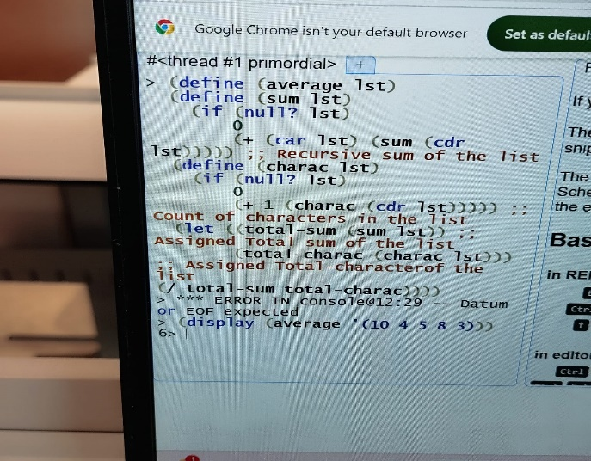>

(display (average '(10 4 5 8 3)))

**6>**

10. takes three arguments where the first argument inserted in the ith position (second

argument) in the list (the third argument).

(define (insert element i lst)

(cond

((= i 0) (cons element lst)) ;; If index is 0, insert at the front

((null? lst) ;; If the list is empty

'()) ;; Return an empty list

(else

(cons (car lst) ;; Keep the head of the list

(insert element

(- i 1) ;; Decrease index for the recursive call

(cdr lst)))))))

> (display (insert 11 1 '(7 4 9 3 8)))

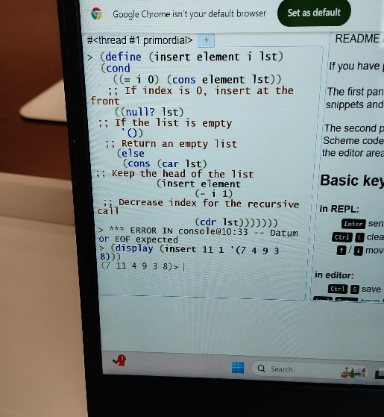**Out put (7 11 4 9 3 8)>** 