二、实验环境
PC机,Red Flag Linux6.0操作系统

- 实验内容
1、用C或其他语言分别实现采用首次适应算法和最佳适应算法的动态分区分配过程和回收过程

- 实验步骤及结果
程序设计-源程序
#include"stdio.h"
#include"stdlib.h"

typedef struct mem
{
int start;
int end;
struct mem *next;
}mem;
typedef struct work
{
int id;
int size;//memsize
int start;
struct work *next;
}work;
work* initwork(int id, int size)
{
work *head = (work *)malloc(sizeof(head)+15*sizeof(int));
head->id = id;
head->start = 1;
head->size = size;
head->next = NULL;
return head;

}
work* insertwork(int id, work *head, int start, int size)
{
work *pi, *pb;//pi is the insert one ##pb is the point
pi = (work*)malloc(sizeof(work));
pi->id = id;
pi->start = start;
pi->size = size;
pi->next = NULL;
if (head == NULL){ head = pi; head->next = NULL; }
pb = head;
while (pb->next != NULL){ pb = pb->next; }
pb->next = pi;
return head;
}
mem *initmem(int size)
{
mem *head = (mem*)malloc(sizeof(mem));
head->start = 1;
head->end = 640;
head->next = NULL;
return head;
}
mem *insertmem(mem *head, int start, int size)
{
mem *pi, *pb, *pf;
int pbsize;
pb = head;
pbsize = pb->end - pb->start + 1;
pi = (mem*)malloc(sizeof(mem));
pi->start = start;
pi->end = size + start - 1;
if (pb == NULL){ head = pi; pi->next = NULL; }
else
{
while (pi->start > pb->start&&pb->next != NULL){ pf = pb; pb = pb->next; }
if (pi->start < pb->start)
{
if (pb == head)
{

head = pi;//头节点
pi->next = pb;
}

else
{
pf->next = pi;//其他位置
pi->next = pb;

}

}
else
{
pb->next = pi;
pi->next = NULL;//在表末插入
}
}
//合并相邻的内存
pf = pb = head;
while (pb->next != NULL)
{
if (pf->end + 2>pb->start)
{
pf->end = pb->end;
pf->next = pb->next;
}
pf = pb;
pb = pb->next;
}
return head;
}
int getstart(int id, work*head)
{
work *pb;
pb = head;
while (pb != NULL)
{
if (pb->id == id)
{
return pb->start;
}

pb = pb->next;
}

return 0;
}
int alloc(mem *head, int size)
{
mem *pb,*pi;
pb = head;
int a;
int zhong=0;
while (pb != NULL)
{
if (zhong == 1 && size <= (pb->end - pb->start + 1))
{
if (pb->end - pb->start + 1 < pi->end - pi->start + 1)
{
pi = pb;
}
}
if (zhong==0 && size <= (pb->end - pb->start + 1) )
{
pi = pb;
zhong = 1;
}
pb = pb->next;
}
a = pi->start;
pi->start = pi->start + size;
return a;
}
work*free1(int id, work *head)
{
work *pb, *pf;
while (head == NULL){ printf("no this nod"); goto end; }
pb = head;
while (pb->id != id&&pb->next != NULL)
{

pf = pb;
pb = pb->next;
}
if (pb->id == id)
{
if (pb == head)head = pb->next;
else pf->next = pb->next;

}

end:
return head;
}
void printw(work *head)
{
work *pb;
pb = head;
while (pb != NULL)
{
printf("id start size---->\n");
printf("%d%7d%8d\n", pb->id, pb->start, pb->size);
pb = pb->next;
}
}
void printm(mem *head)
{
mem *pb;
pb = head;
while (pb != NULL)
{
printf("start end---->\n");
printf("%d%9d\n", pb->start, pb->end);
pb = pb->next;
}
}

void final_printf(mem *mhead, work *whead)
{
printf("JOB LISTS\n");
printw(whead);
printf("========================\n");
printf("FREE \n");
printm(mhead);
printf("\n");
}

int main()
{
int wrec;//接收返回的地址
int mrec;
mem *mhead;
mhead = initmem(640);
work *whead;

//1
whead = initwork(1, 130);
wrec = alloc(mhead, 130);
final_printf(mhead, whead);

//2
wrec = alloc(mhead, 60);
whead = insertwork(2, whead, wrec, 60);
final_printf(mhead, whead);

//3
wrec = alloc(mhead, 100);
whead = insertwork(3, whead, wrec, 100);
final_printf(mhead, whead);

//4
mrec = getstart(2, whead);
whead = free1(2, whead);
mhead = insertmem(mhead, mrec, 60);
final_printf(mhead, whead);

//5
wrec = alloc(mhead, 200);
whead = insertwork(4, whead, wrec, 200);
final_printf(mhead, whead);

//6
mrec = getstart(3, whead);
whead = free1(3, whead);
mhead = insertmem(mhead, mrec, 100);
final_printf(mhead, whead);

//7
mrec = getstart(1, whead);
whead = free1(1, whead);
mhead = insertmem(mhead, mrec, 130);
final_printf(mhead, whead);

//8
wrec = alloc(mhead, 140);
whead = insertwork(5, whead, wrec, 140);
final_printf(mhead, whead);

//9
wrec = alloc(mhead, 60);
whead = insertwork(6, whead, wrec, 60);
final_printf(mhead, whead);

//10
wrec = alloc(mhead, 50);
whead = insertwork(7, whead, wrec, 50);
final_printf(mhead, whead);

//11
mrec = getstart(6, whead);
whead = free1(6, whead);
mhead = insertmem(mhead, mrec, 60);
final_printf(mhead, whead);
return 0;
}

程序调试
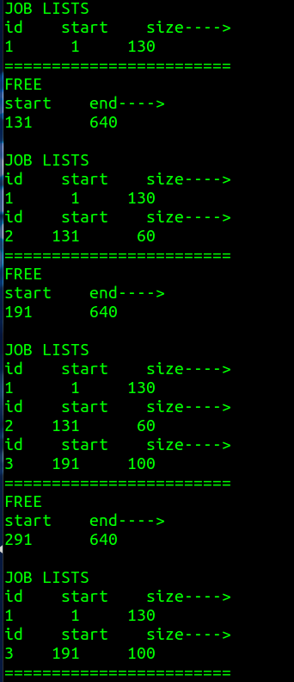
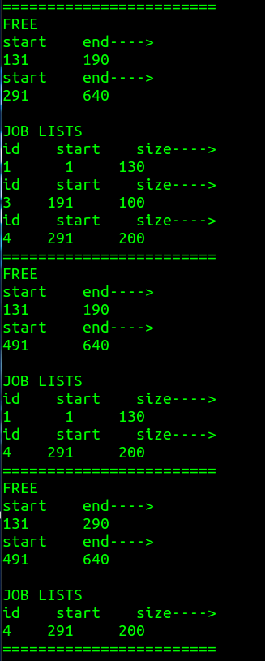

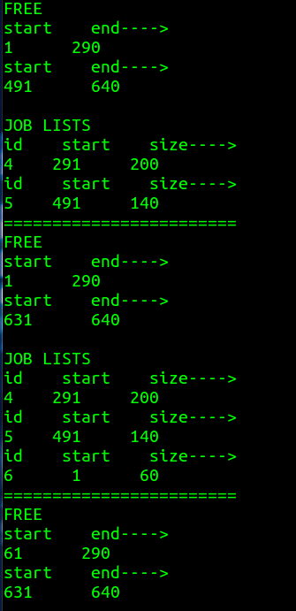
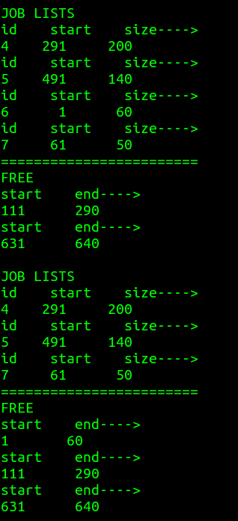
结果分析：
使用首次适应算法和最佳适应算法的显示结果正确，通过课堂小测进行了相应的分析。由于实验设置的最小size为15，一开始并没有考虑这个值的设置，后来加上后，并重新进行了结果分析，查阅了相关资料弄懂了其中的原理。

