

**Department : Computer Science & Engineering**

**Course Title Code : CSE 324**

**PROJECT NAME: Student Management System**

Student Management System is software which is helpful for school authorities. It is done through the automated computerized method.In the current system all the activities are done manually. It is very time consuming and costly.This Student Management System deals with the various information to the students.This system saves the time of the administrator.

In the Student Management System Project in python, will show a project that manages all the information of the students.

It includes managing data such as Students roll, name, email-id, contact number, date of birth, gender which stream they are in, etc.

In this Python project, will build a GUI-based Student Management System Project using the

Tkinter,

My-Sql,

Logging.root,

messagebox,

Logging.root and

Ttk modules of the Tkinter library.

It is an intermediate-level project, where you will learn how to use databases, and modules and make some great GUIs in Python and apply them in real life.

**Tools & Technology**: Student Management System

|  |  |
| --- | --- |
| Project Name | Student Management System |
| Abstract | This is a GUI-based program in python that includes basically.  make use of the Tkinter and SQLite database for the execution. |
| Language/Technologies Used | Python, Tkinter, tktcalender,datetime |
| IDE | Visual Studio code |
| Database | MySQL |
| Python version | python 3.10.5 |

* **Features** of Student Management System

The basic task to be performed on this Project are:

1. Add all the details

2. Update any parts from the details

3. Search the details of any student

4. Clear the details from the board

5. Delete the details of any student record from the database.

**These modules are used for the purposes:**

1. Tkinter – To create the GUI.

2. MySQL – To connect the program to the database and store information in it.

3. Logging.root – To get the user to enter database

4. PyMySQL – To contain a pure python MySQL client library for showing information in the program instance so that it can be set in.

5. Tkinter.messagebox – To show a display box, displaying some information or an error.

6. Tkinter.ttk – To create the tree where all the information will be displayed.

Creation of universal font variables:

Here I have created a universal font for all the variables in the entire program. Here have mentioned the Font, style, and size of the variables in the code.

ER DIAGRAM:

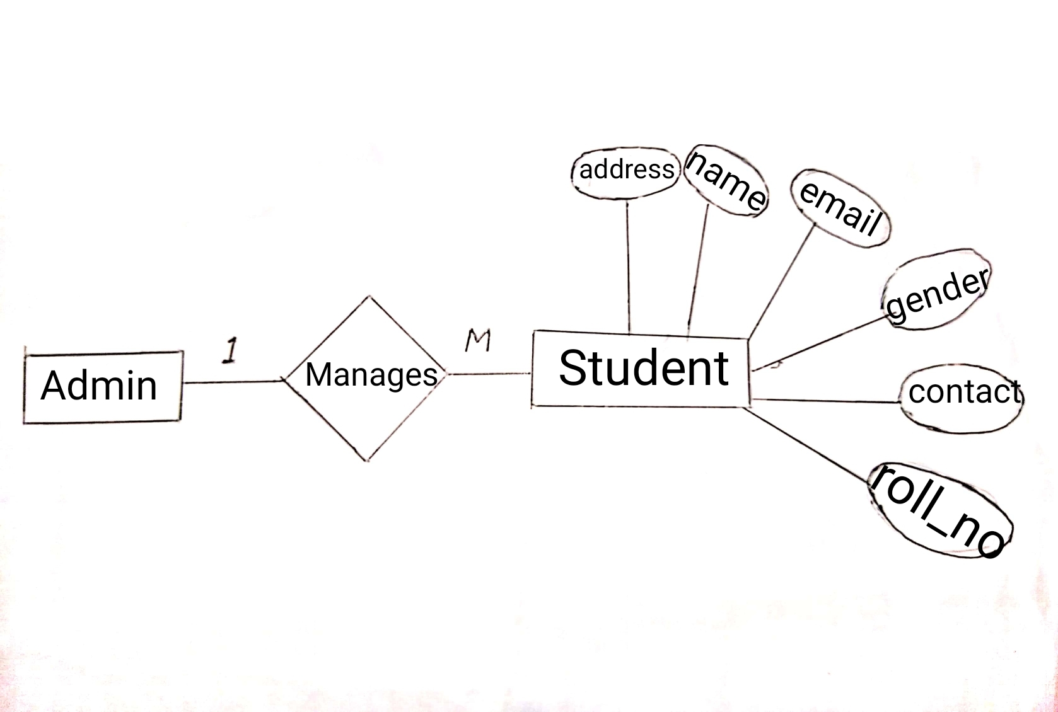

**Connection of database:**

The connect() function accepts connection credentials and returns an object of type SQLITE for database connection. The mysql.cursor() is used to communicate with the SQLite. connector.execute() will create the table in the database if it doesn’t exist.

Creation of GUI Window for Student Management system

**Algorithm:**

* Start
* Add student information
* Edit student information
* Delete student information
* Search student information by roll or name or contact
* Show all students information
* End

**References :**

* Google
* Youtube
* Python book
* Xampp expert Book
* The MySQL CookBook
* **OUTPUT :**

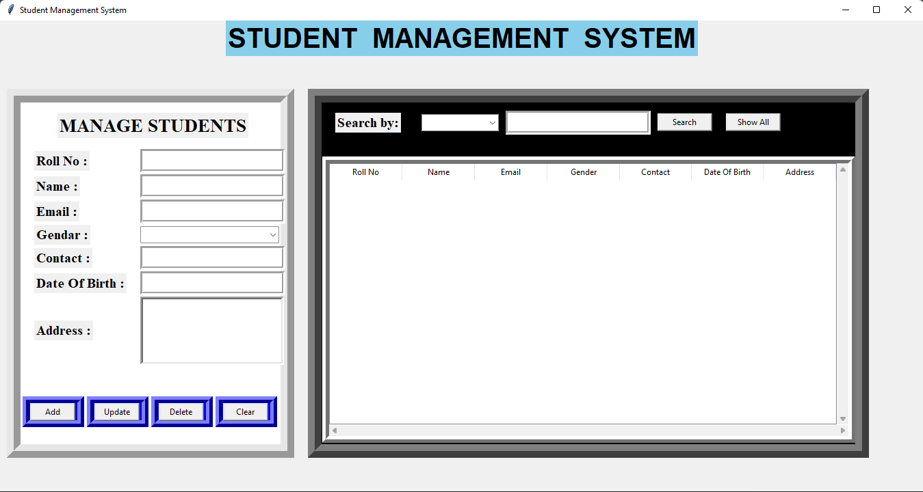

* Write student’s information and click “add” button

Then a record will be inserted.

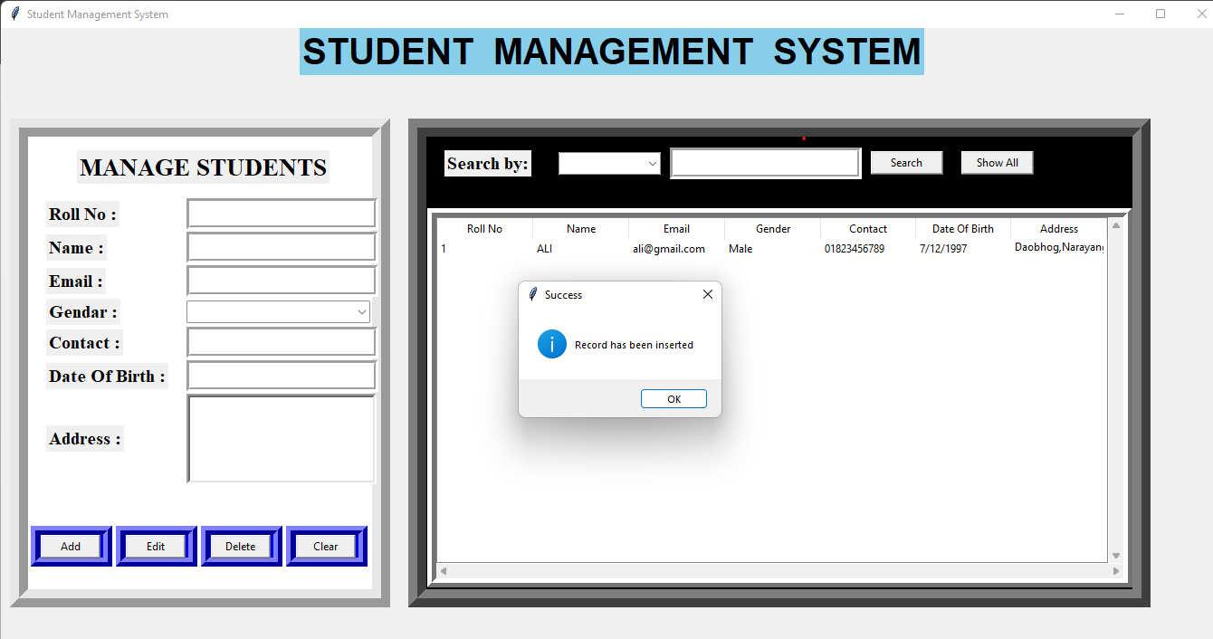

* After adding many students information

**Edit** (1st roll_no students name)

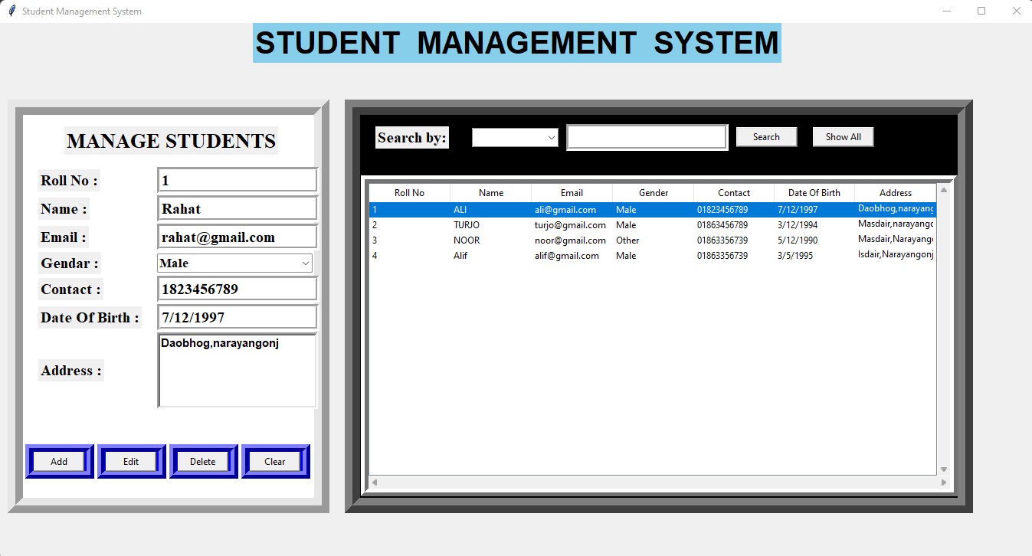

* **Name** has been edited “ali” to “rahat”

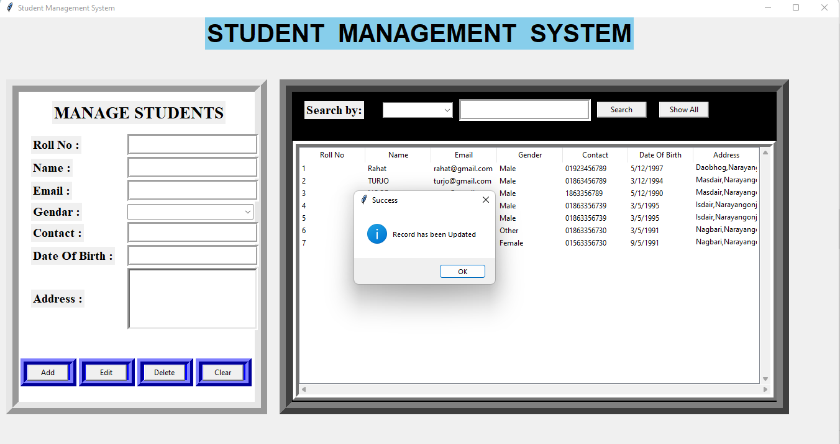

* For **delete** any students information click on the data then click “delete” button

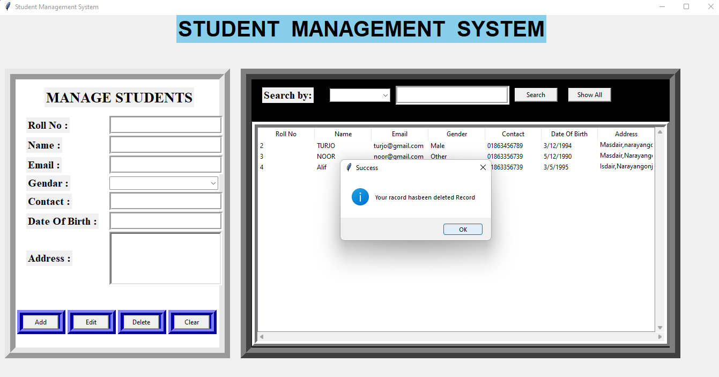

* for **Searching** any students information click searchfield and select(name||roll_no||contact) then click search

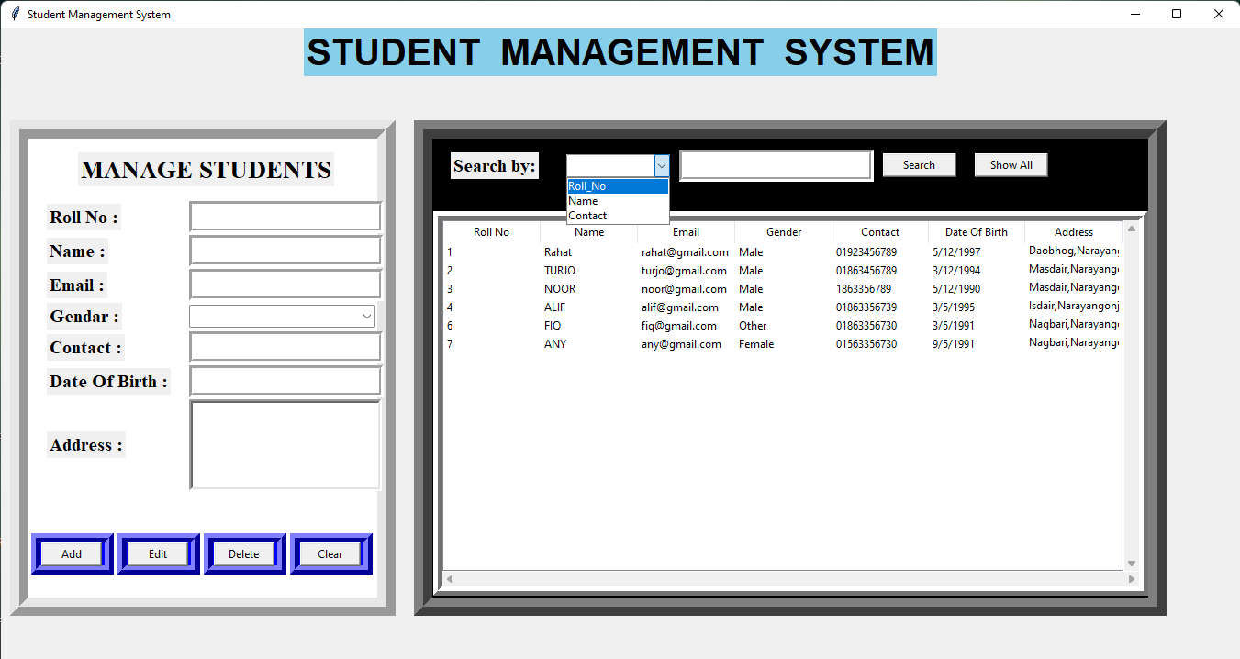

**Search by roll_no:**

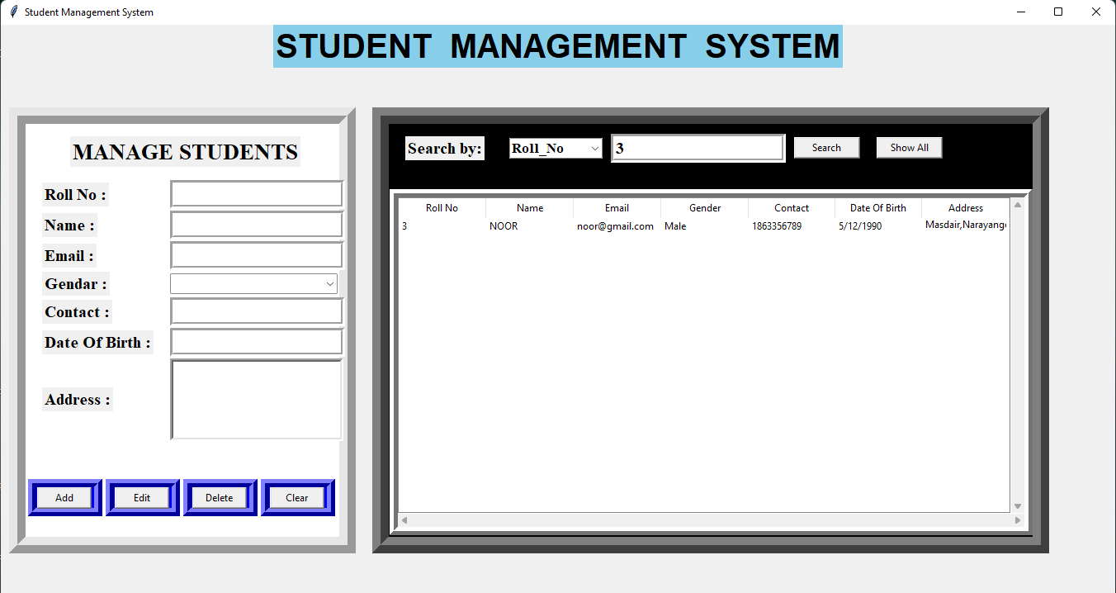

**Search by Name :**

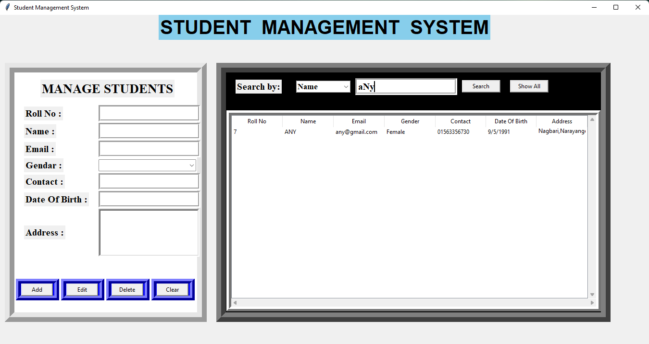

**Search by Contact:**

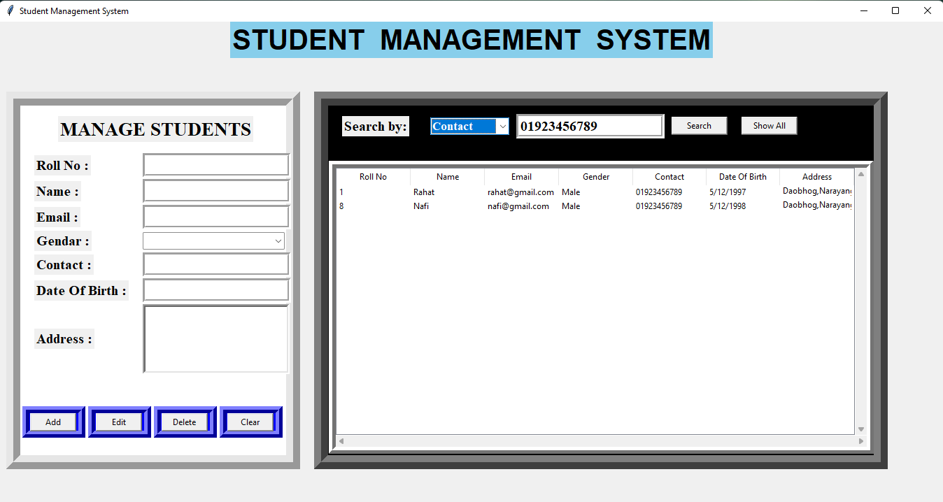

* For showing all students information click “show all” button

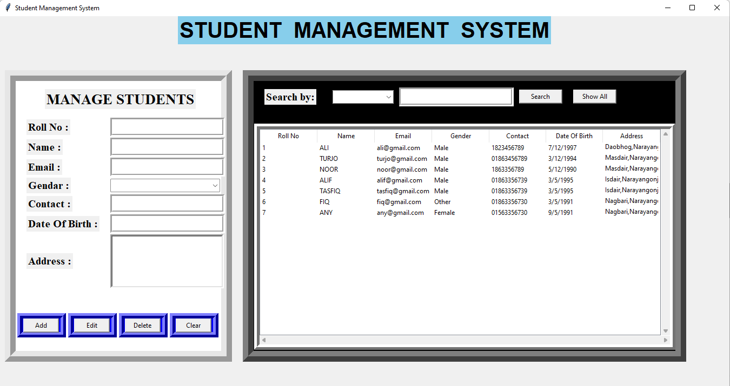

If we want to add any students information without (Roll_No || Name) then it doesn't take input

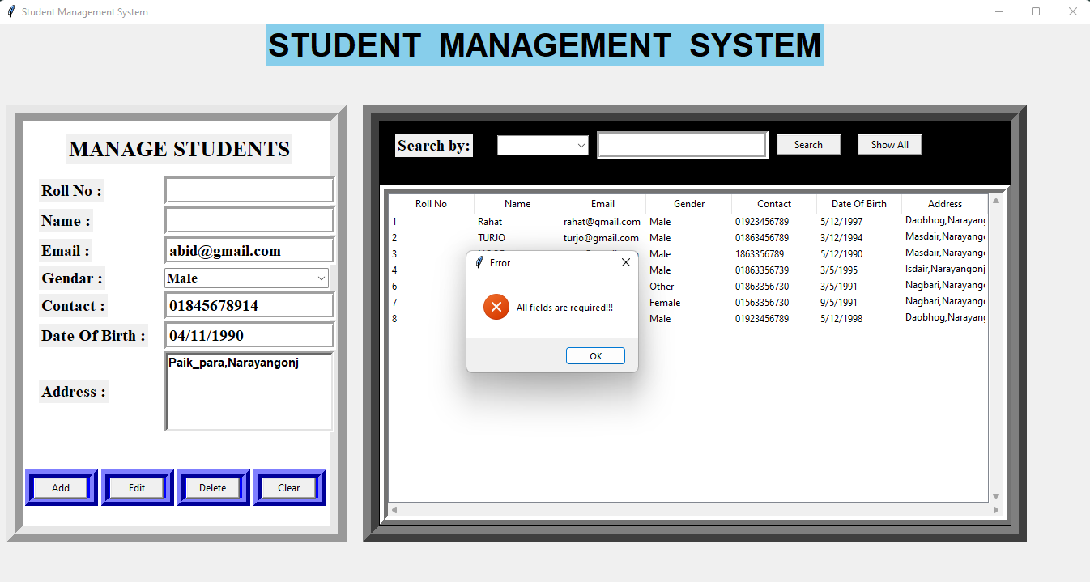

* + **Advantages**:

1. Helpful to perform paperless work and manage all data.

1. Provides easy,accurate,unambiguous and faster data access.
2. User friendly interface Fast access to database
3. Less error
4. More Storage Capacity
5. Search facility
6. Look and Feel Environment
7. Quick transaction

* **Conclusion** :

Student Management System is software which is helpful for school authorities. In the current system all the activities are done manually. It is very time consuming and costly.This Student Management System deals with the various activities related to the students.