Bycatch Paper

Natasha Besseling

2023-06-06

Table 1: Average yearly landed catch composition

| **Scientific Name** | **Landed mass (t)** | **Percentage** | **Cumulative Percentage** |
| --- | --- | --- | --- |
| Merluccius | 4967 | 62.71 | 62.72 |
| Trachurus capensis | 686 | 8.66 | 71.38 |
| Rajiformes | 518 | 6.54 | 77.92 |
| Pterogymnus laniarius | 441 | 5.56 | 83.49 |
| Austroglossus pectoralis | 313 | 3.96 | 87.45 |
| Callorhinchus capensis | 295 | 3.73 | 91.18 |
| Chelidonichthys | 186 | 2.35 | 93.53 |
| Loligo vulgaris reynaudii | 128 | 1.62 | 95.14 |
| Argyrosomus | 90 | 1.13 | 96.28 |
| Genypterus capensis | 69 | 0.87 | 97.15 |
| Lophius vomerinus | 50 | 0.63 | 97.78 |
| Galeorhinus galeus | 41 | 0.52 | 98.30 |
| Mustelus | 37 | 0.46 | 98.75 |

Cluster analysis of vessels

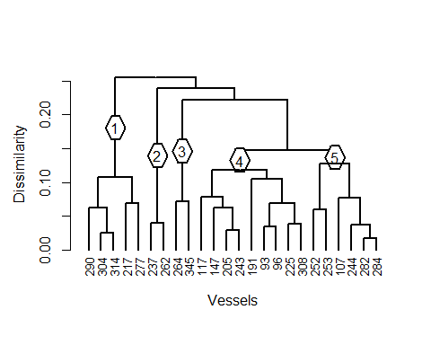

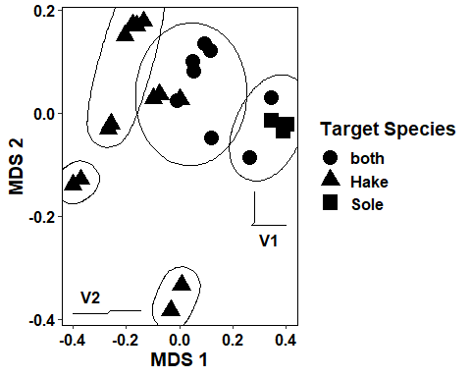

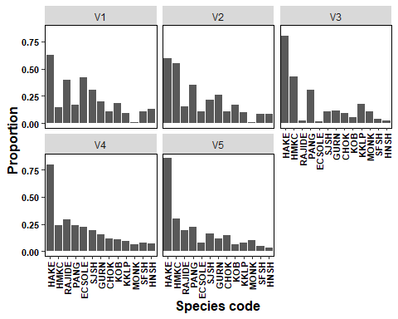

Simper analysis of vessels

| species_code | V4_V3 | V4_V2 | V4_V1 |
| --- | --- | --- | --- |
| HAKE | NA | 3.584 | 2.906 |
| HMKC | 3.829 | 5.776 | NA |
| RAJIDE | 5.514 | NA | NA |
| PANG | NA | 2.377 | NA |
| ECSOLE | NA | NA | NA |
| SJSH | NA | NA | 1.768 |
| GURN | NA | 2.023 | NA |
| CHOK | NA | NA | NA |
| KOB | NA | NA | NA |
| KKLP | 1.812 | NA | NA |
| MONK | NA | NA | NA |
| SFSH | NA | NA | NA |
| HNSH | NA | NA | 1.020 |

cluster analysis of year

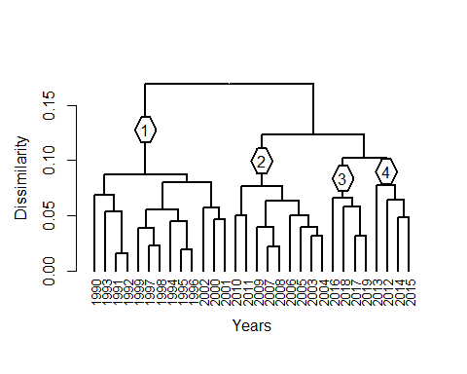

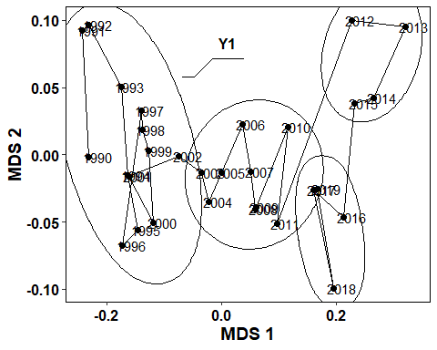

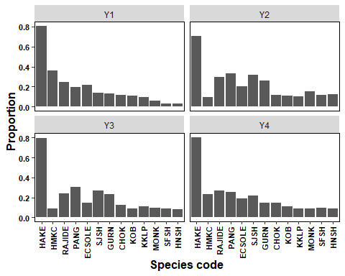 Simper analysis of year

| species_code | Y4_Y3 | Y2_Y3 | Y1_Y3 | Y1_Y2 | Y1_Y4 |
| --- | --- | --- | --- | --- | --- |
| HAKE | NA | 1.72 | NA | 1.89 | NA |
| HMKC | NA | NA | 5.27 | 4.99 | NA |
| RAJIDE | 0.80 | 1.18 | NA | 0.87 | NA |
| PANG | NA | NA | 2.19 | 2.59 | NA |
| ECSOLE | NA | NA | 1.30 | NA | NA |
| SJSH | NA | NA | 2.56 | 3.41 | NA |
| GURN | 1.60 | NA | 2.03 | 2.53 | NA |
| CHOK | NA | NA | NA | NA | 0.74 |
| KOB | NA | NA | NA | NA | NA |
| KKLP | 0.74 | NA | 0.71 | NA | NA |
| MONK | NA | NA | NA | 1.72 | NA |
| SFSH | NA | NA | 1.39 | 1.86 | 1.60 |
| HNSH | NA | NA | 1.42 | 2.05 | 1.42 |

Cluster analysis of months 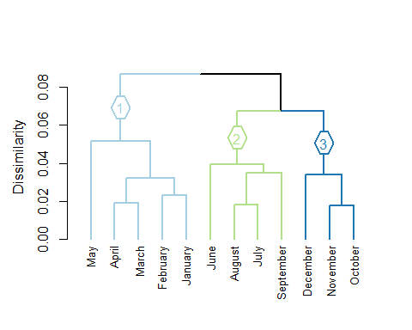

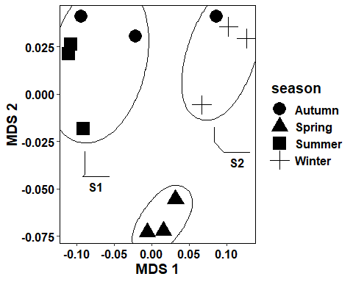

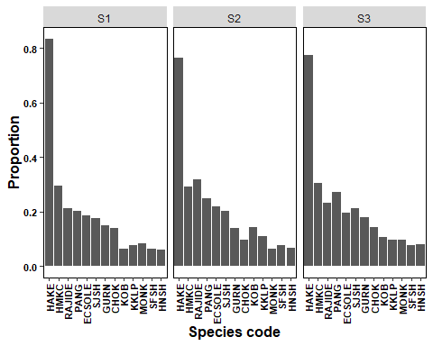 Simper analysis of months

| species_code | Y2_Y3 | Y1_Y3 | Y1_Y2 | Y1_Y4 |
| --- | --- | --- | --- | --- |
| NA | NA | NA | NA | NA |

cluster analysis of area

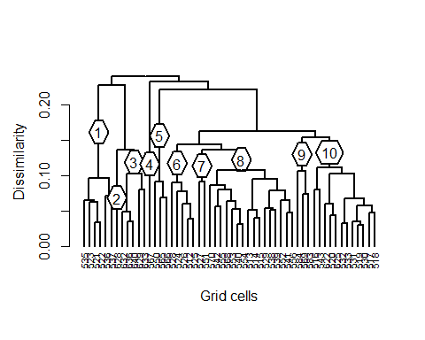

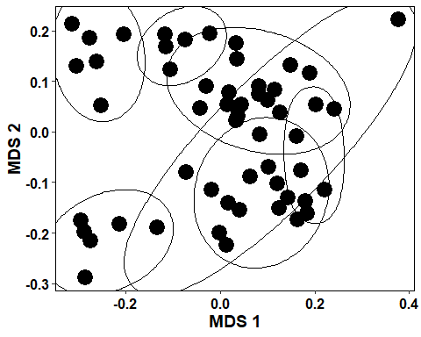

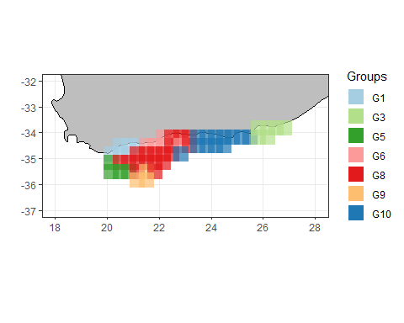

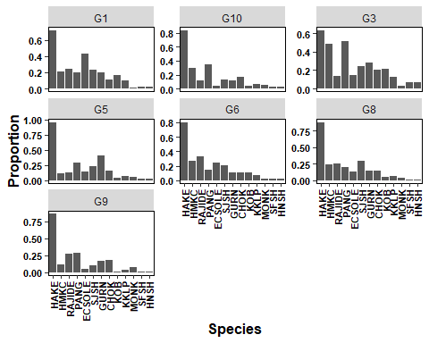

differences in vessel catches by area across the months 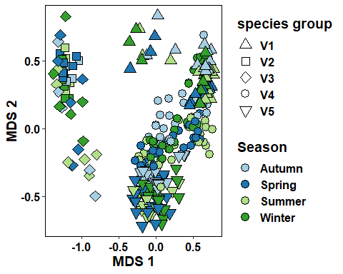

| ExplanatoryVariables | Df | SumOfSqs | R2 | F | Pr(>F) |
| --- | --- | --- | --- | --- | --- |
| vessel_number | 23 | 43.514437 | 0.83380420 | 68.489727 | 0.001 |
| docking_date_mm | 11 | 1.684631 | 0.03228015 | 5.544113 | 0.001 |
| Residual | 253 | 6.988768 | 0.13391565 | NA | NA |
| Total | 287 | 52.187836 | 1.00000000 | NA | NA |

Catch composition model per trip

| ExplanatoryVariables | Df | SumOfSqs | R2 | F | Pr(>F) |
| --- | --- | --- | --- | --- | --- |
| docking_date_yy | 29 | 3.057315 | 0.2930144 | 3.071743 | 0.001 |
| docking_date_mm | 11 | 1.055450 | 0.1011547 | 2.795680 | 0.001 |
| vessel_number | 23 | 3.472619 | 0.3328173 | 4.399182 | 0.001 |
| Residual | 83 | 2.848626 | 0.2730135 | NA | NA |
| Total | 146 | 10.434011 | 1.0000000 | NA | NA |

ANOVA’s of the variable’s dispersions

| Year | Df | Sum Sq | Mean Sq | F value | Pr(>F) |
| --- | --- | --- | --- | --- | --- |
| Groups | 29 | 0.3457590 | 0.011922723 | 1.909116 | 0.008407232 |
| Residuals | 117 | 0.7306829 | 0.006245153 | NA | NA |

| Vessel | Df | Sum Sq | Mean Sq | F value | Pr(>F) |
| --- | --- | --- | --- | --- | --- |
| Groups | 23 | 0.1917960 | 0.008338958 | 2.081164 | 0.005662204 |
| Residuals | 123 | 0.4928453 | 0.004006872 | NA | NA |

| Month | Df | Sum Sq | Mean Sq | F value | Pr(>F) |
| --- | --- | --- | --- | --- | --- |
| Groups | 11 | 0.04600345 | 0.004182132 | 0.5876899 | 0.8363225 |
| Residuals | 135 | 0.96068991 | 0.007116222 | NA | NA |

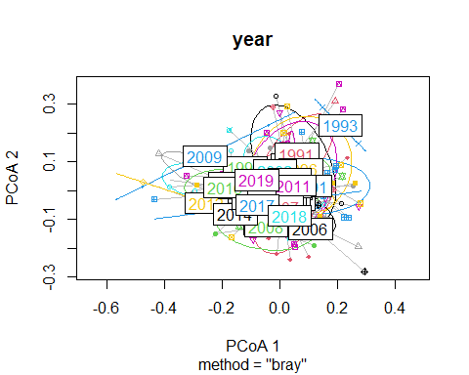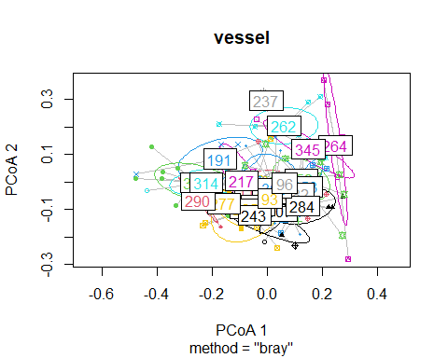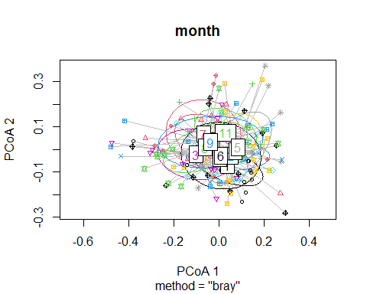

Catch composition model per trawl

| ExplanatoryVariables | Df | SumOfSqs | R2 | F | Pr(>F) |
| --- | --- | --- | --- | --- | --- |
| docking_date_yy | 1 | 0.1030569 | 0.08283364 | 3.4550026 | 0.020 |
| docking_date_mm | 11 | 0.2470408 | 0.19856309 | 0.7529176 | 0.755 |
| grid_code | 9 | 0.2182154 | 0.17539420 | 0.8128573 | 0.694 |
| vessel_number | 4 | 0.1687484 | 0.13563429 | 1.4143313 | 0.186 |
| Residual | 17 | 0.5070812 | 0.40757478 | NA | NA |
| Total | 42 | 1.2441428 | 1.00000000 | NA | NA |

ANOVA’s of the variable’s dispersions

| Year | Df | Sum Sq | Mean Sq | F value | Pr(>F) |
| --- | --- | --- | --- | --- | --- |
| Groups | 1 | 0.07305464 | 0.07305464 | 6.834689 | 0.01244941 |
| Residuals | 41 | 0.43824091 | 0.01068880 | NA | NA |

| Vessel | Df | Sum Sq | Mean Sq | F value | Pr(>F) |
| --- | --- | --- | --- | --- | --- |
| Groups | 4 | 0.2077655 | 0.051941384 | 7.507622 | 0.0001469102 |
| Residuals | 38 | 0.2629025 | 0.006918487 | NA | NA |

| Grid code | Df | Sum Sq | Mean Sq | F value | Pr(>F) |
| --- | --- | --- | --- | --- | --- |
| Groups | 9 | 0.1975942 | 0.021954911 | 4.022471 | 0.001506478 |
| Residuals | 33 | 0.1801162 | 0.005458066 | NA | NA |

