USER ROLE AND THEIR RIGHTS:

**Customer:**

1. View Items
2. Filter items based on Item Id, Name, or Type.
3. Place Order: Customers can select multiple items from various sellers when placing an order.
4. View Orders and their details.
5. Pay for the order.

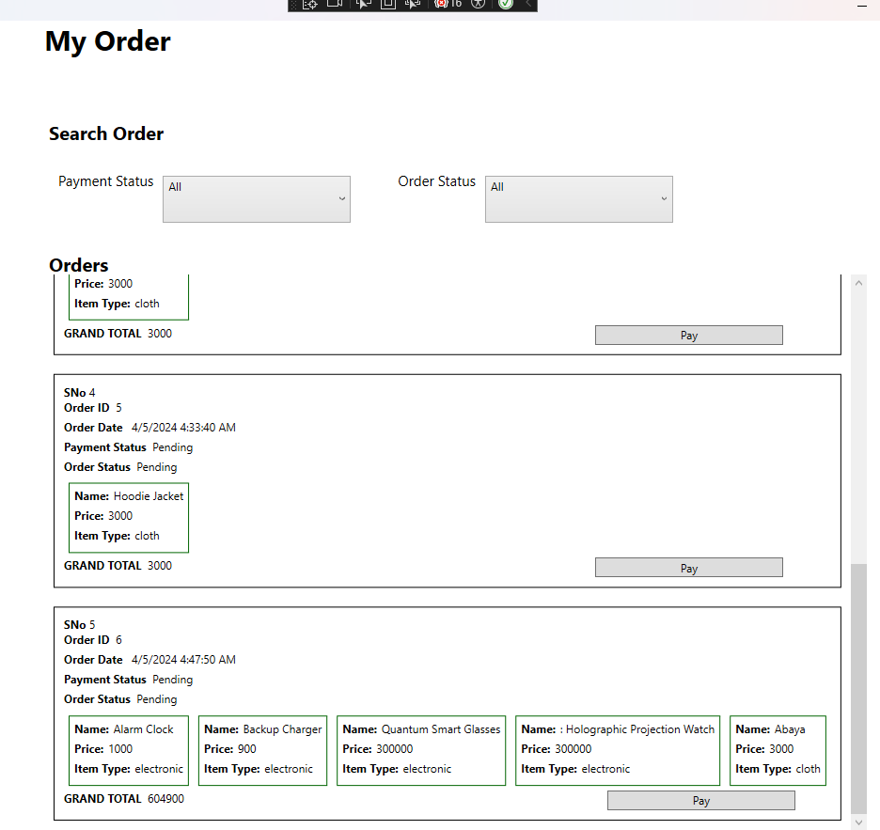

1. After completing all order processes, the customer will confirm receipt of their order.

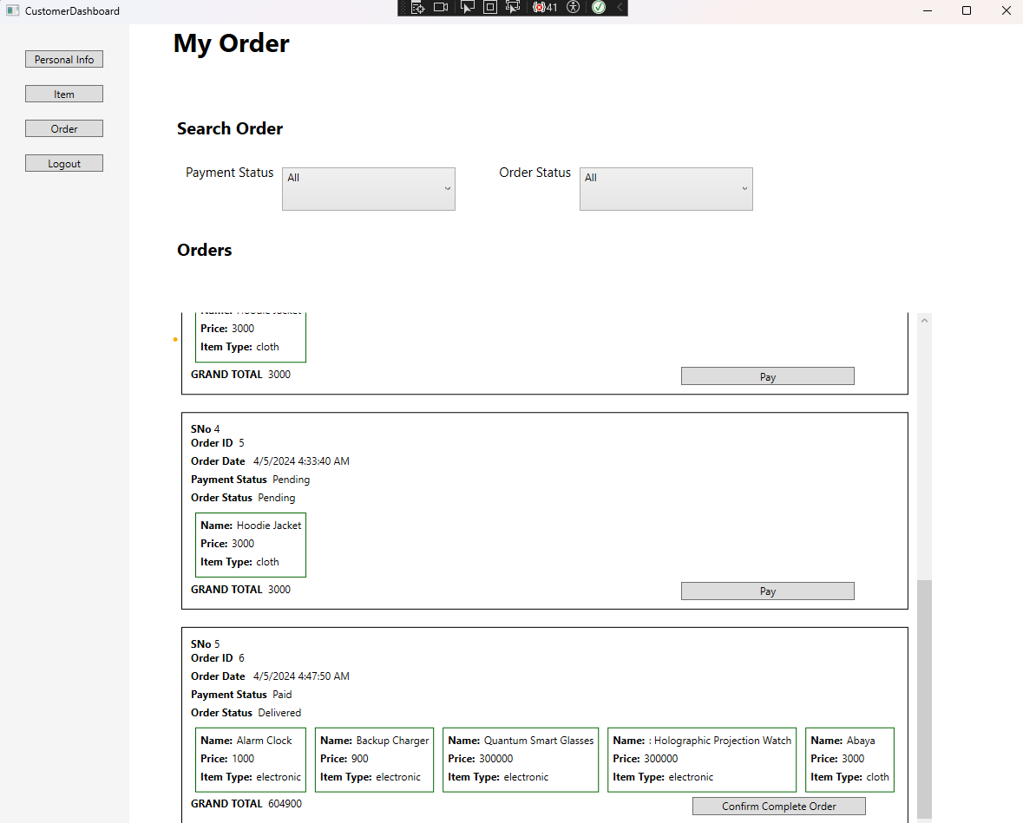

**Seller:**

1. View items in grid format.
2. Add new items.
3. Search for items.
4. Delete items.
5. View orders.
6. Sellers can ship their own generated items to the admin after customers complete the payment procedure.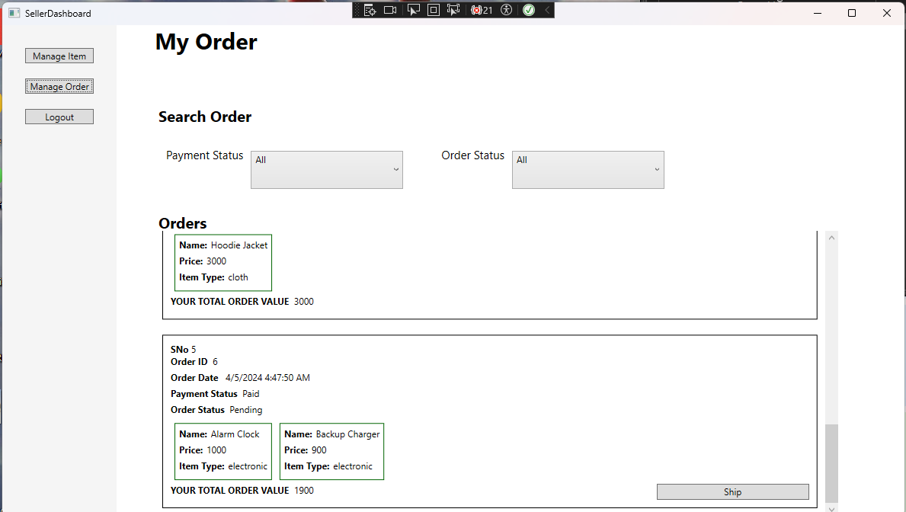

**Admin:**

After all seller shipped their item in an order then admin deliver item to customers.

