SRS Document:
Introduction:
A new application must be built which would provide all the necessary highlights to discuss individuals doubt and problems of academic related. Therefor,i am developing and discussion application for Gyalpozhing college of information technology lectures and students. The application with the features that enable: discuss(question answer) with your friends and tutors and upload the important and useful files.
Purpose:
AIM
 To build a well-designed, user friendly android application in order to provide a
platform to discuss the students doubts without any hesitation.

OBJECTIVES
 To improve students academic performance.
 To enhance students participation in learning system.
 To share information and perspectives, and connect students and teachers.

Scope:
Limited to students Teachers of Gyalpozhing college of information technoloyg.

System Scope:
- register/signup(email address,name,password).
- login(email address,password).
- upload(Questions,doubt).
- View and reply on discussion(Questions and answers).

User Scope:
- students and teachers of Gyalpozhing and Gyalpozhing college of information technology.

Requirements.
a. Functional Requirements.
Register
user should register by providing email,name,password and varify by getting OPT from email.
Log in
When first opening the application , the users will be provided with the “log in” interface of the system. The users are required to enter their Email address and the password.
Upload Questions/doubt
Here user can upload their doubts or questions so that they can receive multiple solutions.

View and reply to other doubts/questions.
This feature of application provide the students to view the doubts/questions of other members can also they can answer it or give feedback/solution to their doubts.

b. Non-Functional Requirements.
  - Performance Requirements
To enable the android application to perform in the most optimal and feasible way is that the user needs stable internet connection and minimal latency to the internet speed.
So the users are recommended to use the best internet speed they could which we recommend 4G connection and wifi.
  - Safety Requirements
The content will be always backed up in our servers so if they are going to switch to a new device, they can still access previous doubts/questions.
Besides from academic purpose nothing is allowed to discuss.
  - Security Requirements
In order for the users to be able to log in they should enter their email to gain their OTP.
Thus if the user wants to access the application or log in, they need to be register by using our college email. Thus security breaches are not possible at the most.
  - Software Quality Attributes
The application is easy to use as it has the interface of any other common discussion app thus it is easy to adapt.

c. Software Requirements.
Developer Requirements:
XML 1.0
XML stands for extensible Markup Language that enables users to define a representation of
data or data structure where values are assigned in each field in the structure.

Android studio 4.1.2
Android Studio is the official Integrated Development Environment (IDE) or a graphical user
interface tool for Android app development.

Android SDK
The Android SDK (software development kit) is a set of development tools used to develop
applications for Android platform. It includes tools such as libraries, Debugger, An emulator,
relevant documentation for the Android application program interfaces (APIs), Sample source
code, Tutorials for the Android OS. Usually, this tool comes with android studio.

Java JDK 12
Java Development Kit contains the software and tools that you need to compile, debug, and run
applets and applications that are written using the Java programming language

Web Services or cloud platforms requirement
Firebase
The Firebase Real Time Database is a cloud-hosted database. Data is stored as JSON and
synchronized in real time to every connected client. Firebase uses a non-relational DBMS called
NOSQL that does not require a fixed schema, avoids joins, and is easy to scale.
3. Hardware Requirements:
Developers
- Microsoft Windows 7/8/10 (32-bit or 64-bit)
- 4 GB RAM minimum, 8 GB RAM recommended (plus 1 GB for the Android Emulator)
- 2 GB of available disk space minimum, 4 GB recommended (500 MB for IDE plus 1.5 GB for Android SDK and emulator system image)
- 1280 x 800 minimum screen resolution.
Users
- An android smartphone
- Android version 5.0(Lollipop) and onwards
- Internet Connection while using application
- Minimum of 100mb storage space for installation.

Design
Usecase

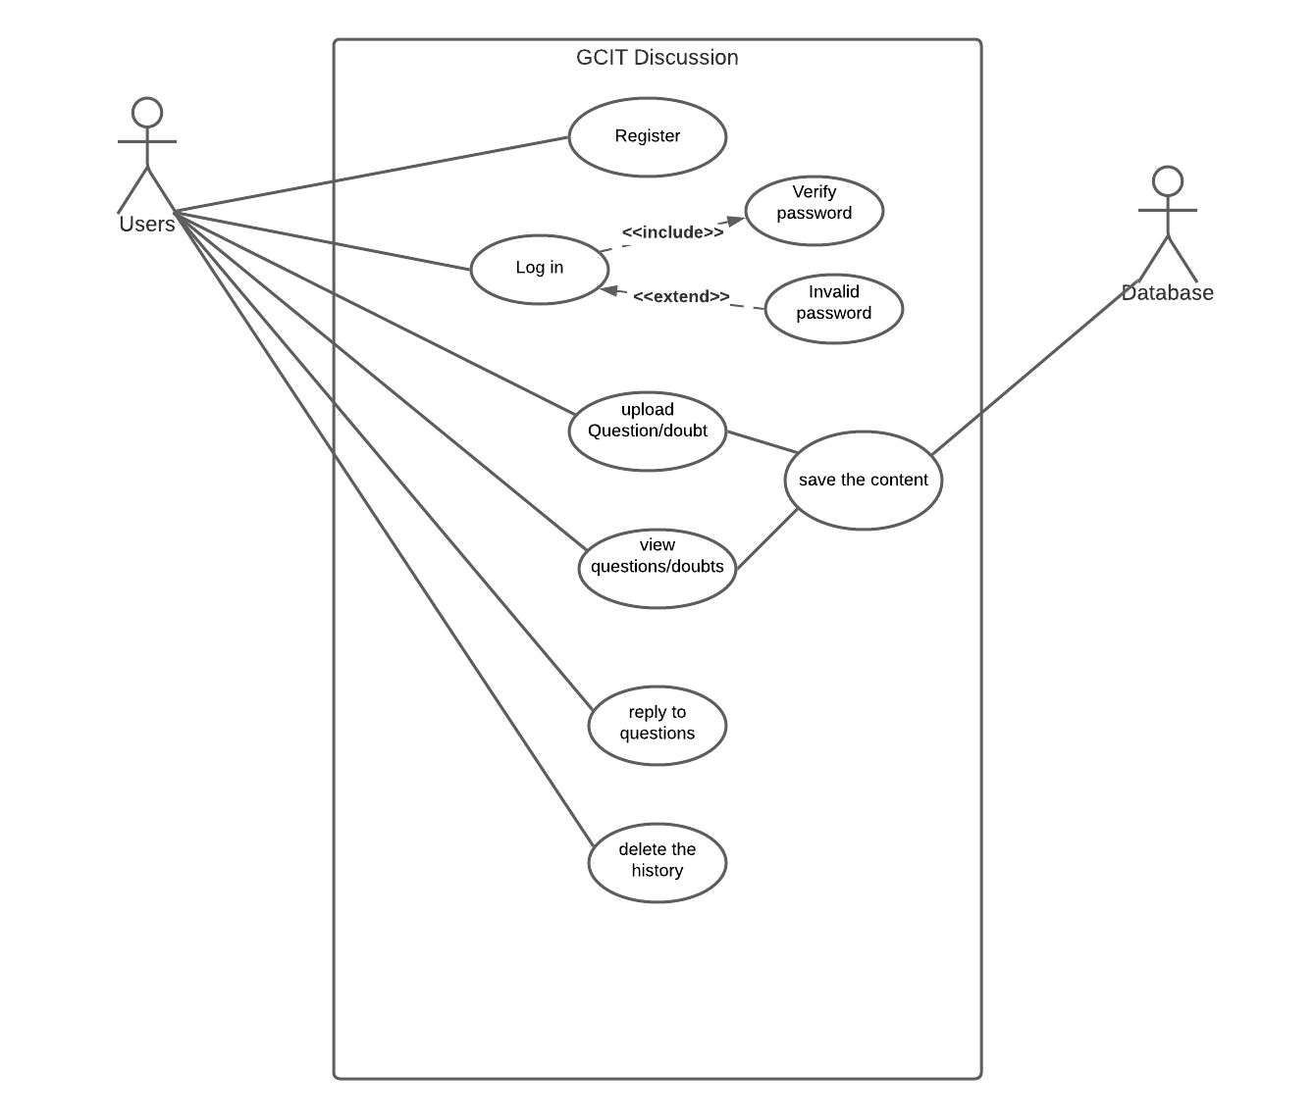

ERD:
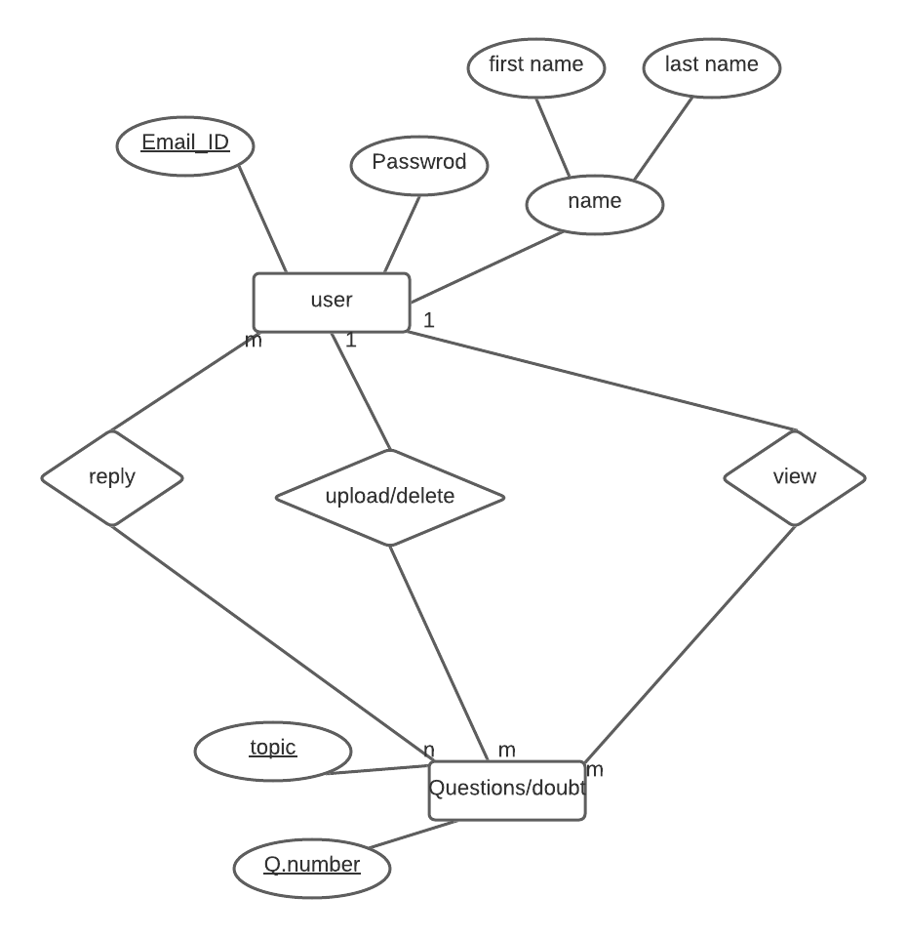

relational schema:

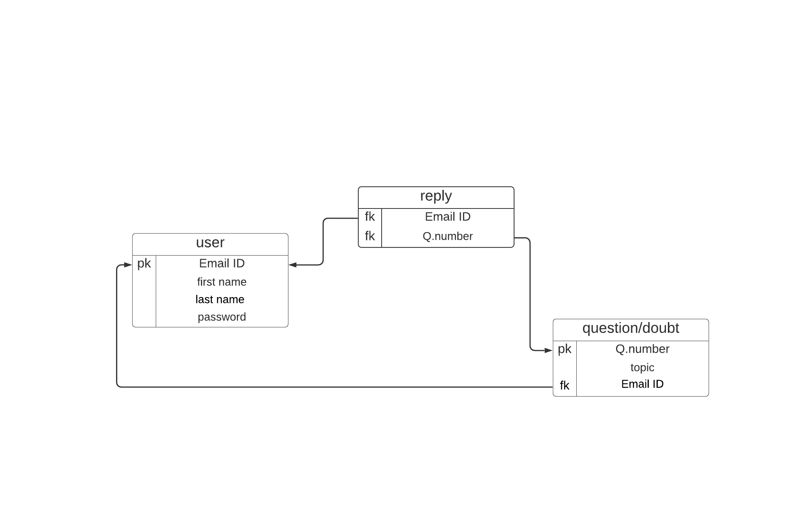

sequence:
