CTE412 Integrated Systems Technology
Practical 15 – Assessed Lab Report
Rolling, Recreate and Blue/Green Releases of the Campus Notice Board on Kubernetes – Measured, Not Assumed
Item | Detail
Student | Tashi Seldon
Student number (<sid>) | 02230153
Programme | BE in Information Technology, Year 3
Cluster / namespace | cte412-02230153 / nb-02230153
Repository | CTE412_Practical15_02230153 (URL submitted on the VLE)
Date of lab session | 13 October 2026

1. Objective
The Student Services Office releases new versions of the Campus Notice Board API, and every release so far has caused an unmeasured outage. The purpose of this practical was to replace belief with measurement. I deployed the API to a local three-node Kubernetes cluster, built a continuously running availability monitor that requests the Service twice a second, and then released new versions using three strategies: Recreate, RollingUpdate and blue/green. For each release I counted the failed requests and measured how long old and new versions were served side by side.
I also tested what Kubernetes does with a release that can never become healthy (a broken 1.2.0 image), how a rollback behaves, and whether a feature flag held in a ConfigMap can change behaviour without building a new image. All cluster changes were made declaratively from manifests in the repository; the only imperative change was the rollback in Task 6.3.

2. Environment
Component | Value (evidence)
Operating system | Windows host running Docker Desktop on the WSL2 backend (kernel 6.18.40.1-microsoft-standard-WSL2; t1-nodes-wide.txt). Commands run in PowerShell; shell scripts run with Git for Windows bash.
Docker | Docker Desktop, Linux engine, WSL2 backend; version: 29.8.2 (build 7fc2dff)
kind | kind.exe from C:\kind (version 0.33.0); node image kindest/node:v1.37.0, containerd 2.3.4 (t1-nodes-wide.txt)
kubectl | Client v1.36.1 (within one minor version of the cluster); Kustomize v5.8.1 (t9-versions.txt)
Cluster Kubernetes | Server v1.37.0; one control-plane and two worker nodes, all Ready (t1-nodes-wide.txt)
Application | Python 3.13 (standard-library http.server), built FROM python:3.13-alpine, runs as non-root UID 10001 on port 8080; image size 78.8 MB on disk / 19.5 MB content (t2-local-images.txt)
Monitor image | busybox:1.36 (wget and date), loaded into the cluster with kind load

Every image is Alpine-based or busybox, no Pod pulls a notice-board image from a registry (imagePullPolicy: Never; images loaded with kind load docker-image), and the student number appears in the cluster name, namespace, image tags and every /version response.

3. Results
Request counts and failures come from the monitor logs and the output of scripts/summarise.sh and scripts/window.sh. The monitor requested http://notice-board/version every 0.5 s from inside the cluster and was never restarted. Timestamps have one-second resolution, so windows are accurate to about ±1 s. The "peak Pods" column counts notice-board Pods (not the monitor).
Release | Requests observed | Failed requests | Mixed-version window (s) | Peak notice-board Pods
Recreate: 1.0.0 → 1.1.0 (t5-recreate.log) | 113 | 10 | 0 (versions never overlapped; 13 s outage 10:32:29–10:32:42Z) | 3 (0 Ready during the gap)
RollingUpdate: 1.0.0 → 1.1.0 (t5-rolling.log) | 142 | 0 | 37 (first 1.1.0 at 10:39:05Z, last 1.0.0 at 10:39:42Z) | 4 (3 + 1 surge)
Broken release 1.2.0-broken (t6-monitor.log, whole task) | 689 | 0 | 0 (broken Pod never became Ready, so 1.2.0-broken was never served) | 4 (3 old + 1 broken surge Pod)
Blue/green switch 1: blue → green (13:48:49Z) | 467 (one log for all three switches) | 0 | 0 (last 1.0.0 at 13:48:49, first 1.1.0 at 13:48:50) | 6 (3 blue + 3 green)
Blue/green switch 2: green → blue (13:49:10Z) | (same log) | 0 | 0 (first 1.0.0 at 13:49:11) | 6
Blue/green switch 3: blue → green (13:49:32Z) | (same log) | 0 | 0 (first 1.1.0 at 13:49:32) | 6
Flag change FEATURE_PINNED false → true (t8-monitor.log) | 2130 | 0 | 0 (version stayed 1.1.0 throughout) | 7 (3 blue + 3 green + 1 surge)

Other measurements. At rest (Task 4) the monitor recorded 112 requests, 0 failures, all 1.0.0 (t4-summary.txt). The return to 1.0.0 with Recreate (Task 5.2) added a further 8 FAIL lines in the 10:35 minute (checked with the monitor log grouped by minute), giving 18 failures across the two Recreate rollouts. The quota with both colours and the monitor running showed 7 of 15 Pods, 610m of 1 CPU requested and 1550m of 2 CPU limited (t7-quota-both-colours.txt).
Task 6 conditions. After the 60 s deadline Kubernetes reported Progressing = False with reason ProgressDeadlineExceeded, while Available = True with reason MinimumReplicasAvailable (t6-conditions.txt).

4. Analysis

A1. Ranking by failed requests and the mechanism behind each number
Ranking (fewest failures first): RollingUpdate, blue/green, broken release and feature-flag restart all tied at 0 failed requests; Recreate was last with 10 failed requests in the first rollout (t5-recreate-summary.txt) and 8 more in the return rollout.
- Recreate (10 failures). The strategy scales the old ReplicaSet to zero before any new Pod exists. In t5-recreate-window.txt the last 1.0.0 response is 10:32:28Z, the first FAIL is 10:32:29Z, the last FAIL is 10:32:42Z and the first 1.1.0 response is 10:32:43Z: a 13 s gap with no ready endpoints. It consists of old-Pod termination, container start, the 5 s warm-up during which /healthz returns 503, and the readiness probe period. A failed wget takes up to its 1 s timeout plus the 0.5 s sleep, so about 10 FAIL lines fit in 13 s. The mixed-version window is 0 s because the versions never overlap.
- RollingUpdate (0 failures). maxUnavailable: 0 forbids removing a ready Pod before its replacement is available. The Pod watch (t5-rolling-podwatch.txt) shows the first new Pod appear at 10:38:55 and start running at 10:38:56 as 0/1, while all three old Pods stayed 1/1 Running. The Service always had at least three ready endpoints.
- Blue/green (0 failures). Both colours were already Ready, so a switch only changes the Service selector. The EndpointSlice is repointed to Pods that are already serving; no Pod starts or stops. t7-switch-analysis.txt shows the first response from the new colour within one second of each switch and 0 failures in each 20 s window.
- Broken release (0 failures). The 1.2.0-broken Pod never passed its readiness probe, so it was never added to the Service endpoints. See A2.
- Flag restart (0 failures). The green Deployment was replaced with a RollingUpdate (maxUnavailable 0), so the mechanism is the same as the rolling release. The monitor logged 2130 requests, all 1.1.0 (t8-monitor-summary.txt).

A2. Why the broken release caused no failed requests, and what defaults would have done
The broken image still answers /version, but /healthz always returns 503, so the new Pod stayed 0/1. The Pod list taken 25 s after the apply (t6-pods-during-failure.txt) shows the three old 1.1.0 Pods Running 1/1 plus one new Pod at 0/1, so the old Pods kept serving. The fields responsible, and the predicted result if each had been left at its default:
Field in my manifest | My value | Prediction at the default value
readinessProbe (httpGet /healthz) | Gates traffic until /healthz is 200 | No probe: the Pod is Ready as soon as the container starts and receives traffic. Because /version works on the broken image, my monitor would still record 0 FAIL, but it would show 1.2.0-broken responses and the failure would be invisible to my instrument. With maxUnavailable 0 the rollout would also complete, because the Pod counts as available.
strategy.rollingUpdate.maxUnavailable | 0 | Default is 25 %. With 3 replicas this rounds down to 0, so the result would be the same here. At 1 or more, an old Pod could be removed while the new one is unready, lowering capacity to 2 Pods during the stall, though still with no failures.
strategy.rollingUpdate.maxSurge | 1 | Default 25 % rounds up to 1, so the same. With 0 and maxUnavailable 0 the rollout could not start.
minReadySeconds | 5 | Default 0: a Pod is available the moment it is Ready. No difference for the broken Pod, which is never Ready; it would only matter for a Pod that is Ready briefly and then flaps.
progressDeadlineSeconds | 60 | Default 600. The traffic outcome would be the same (0 failures), but Kubernetes would take 10 minutes instead of 60 s to report Progressing=False / ProgressDeadlineExceeded, so the failure signal would arrive about 9 minutes later.
livenessProbe (tcpSocket, not /healthz) | TCP check on the named port | If liveness used /healthz, the kubelet would restart the container during the 5 s warm-up and on the broken image, producing restart loops. A TCP check avoids this.

A3. RollingUpdate compared with blue/green
Axis | RollingUpdate (measured) | Blue/green (measured)
Mixed-version window | 37 s  Old and new versions are served together while Pods are replaced one at a time. | 0 s in all three switches (t7-switch-analysis.txt). Within one request interval the Service moves from all-blue to all-green. Traffic was never split between versions in the log.
Peak resource use against quota | Peak 4 notice-board Pods (3 + 1 surge). Quota fits comfortably: 4 × 100m = 400m CPU requests and 4 × 250m = 1000m limits, against 1 CPU and 2 CPU. | Peak 6 notice-board Pods plus the monitor = 7 Pods. Measured: requests.cpu 610m of 1, limits.cpu 1550m of 2, requests.memory 592Mi of 1Gi, limits.memory 1184Mi of 2Gi (t7-quota-both-colours.txt). The Task 3 Deployment had to be removed first so that both colours fit.
Time to roll back | Slow: each replacement Pod must start, pass the 5 s warm-up and readiness checks, and stay Ready for minReadySeconds (5 s), so a rollback takes tens of seconds (the Task 6 rollback needed several rollout-status polls). | Fast: switch the Service selector back and apply. Switch 2 (green → blue) at 13:49:10Z had its first 1.0.0 response at 13:49:11Z, about one second.

In short, blue/green buys a near-instant, clean cut-over and rollback at the price of double the Pods. RollingUpdate is cheaper but slower and has a period when two versions answer requests.

A4. A situation where Recreate is the correct choice
Recreate is correct when two versions must never run at the same time. A realistic case is a release that includes a non-backwards-compatible database schema migration, or a single-instance workload holding a ReadWriteOnce volume or an exclusive lock, where version 1.0.0 would break or corrupt data if it were still running while 1.1.0 migrates. The measured 13 s of downtime is acceptable if announced in a maintenance window, because correctness matters more than availability in that case. It is also appropriate when the cluster has no spare quota for a surge Pod or a second colour.

A5. What the feature flag allowed, and what it did not avoid
The flag let me change application behaviour (pinned notices listed first and "pinnedFirst": true) with the same 1.1.0 image: no new build, no new tag and no image load. The ConfigMap value changed to true, and after the flag was active production returned the pinned notices first (t8 evidence; also visible in t9-rebuild.txt).
It did not avoid a rollout. After applying the ConfigMap with FEATURE_PINNED: "true" and waiting 30 s, the three running green Pods still had FEATURE_PINNED=false and production still returned "pinnedFirst": false (t8-flag-observed.txt / E8.2). The variable is injected into the container environment at start-up, so a running process never sees a ConfigMap change. I had to change a Pod-template annotation (cte412/flags-revision: "2") in green.yaml, which forced a RollingUpdate that replaced every green Pod, with 0 failed requests. The flag therefore avoided an image build, but not a Pod restart, and the change still needed a declarative apply.

5. Reflection

An error I met
My first Recreate measurement was invalid. I ran kubectl apply for the "Recreate release" and the output said deployment.apps/notice-board unchanged. The summary then showed 49 requests, 0 failures and only 1.0.0 responses, and the rollout history listed only <none> change-causes (the script also failed with "scripts/window.sh: No such file or directory"). Together these showed that no release had happened. A Select-String of the manifest confirmed it still contained image 1.0.0, version "1.0.0" and no Recreate strategy or change-cause, so my edit had not been written to the file.
The reasoning: kubectl apply compares the manifest with the live object, so "unchanged" means the file I thought I had edited was identical to the cluster state. I deleted the invalid t5-recreate evidence, edited the manifest properly (strategy type Recreate, image 1.1.0, version label 1.1.0 and a change-cause), created scripts/window.sh, and repeated the test. The repeat gave 113 requests and 10 failures, and the rollout history then showed "Release 1.1.0 using Recreate strategy" as revision 3.

One thing that remains unclear
The rollout history shows revisions 1, 4, 6 and 7 rather than a continuous sequence, and the rollback created revision 7 with the change-cause of the earlier 1.1.0 rolling release. I understand that Kubernetes re-uses the number of a ReplicaSet when a rollback re-activates an old template, but I did not verify this in the documentation or the source. Also, because my timestamps have one-second resolution, I cannot tell whether the blue/green switches had a sub-second overlap.

6. References
[1] Kubernetes Documentation: Deployments (rolling update, Recreate, progressDeadlineSeconds, rollout history and rollback). https://kubernetes.io/docs/concepts/workloads/controllers/deployment/ (accessed 13 October 2026).
[2] Kubernetes Documentation: Configure Liveness, Readiness and Startup Probes. https://kubernetes.io/docs/tasks/configure-pod-container/configure-liveness-readiness-startup-probes/ (accessed 13 October 2026).
[3] Kubernetes Documentation: Resource Quotas and Limit Ranges. https://kubernetes.io/docs/concepts/policy/resource-quotas/ (accessed 13 October 2026).
[4] Kubernetes Documentation: ConfigMaps (environment variables are read at container start). https://kubernetes.io/docs/concepts/configuration/configmap/ (accessed 13 October 2026).
[5] Kubernetes Documentation: Service and EndpointSlices. https://kubernetes.io/docs/concepts/services-networking/service/ (accessed 13 October 2026).
[6] kind Documentation: Quick Start, Loading an Image Into Your Cluster, Extra Port Mappings. https://kind.sigs.k8s.io/docs/user/quick-start/ (accessed 13 October 2026).

Appendix – Key Evidence Screenshots
Selected screenshots from the session, each showing the student number 02230153. The full command output is saved as .txt in the evidence/ folder of the repository.
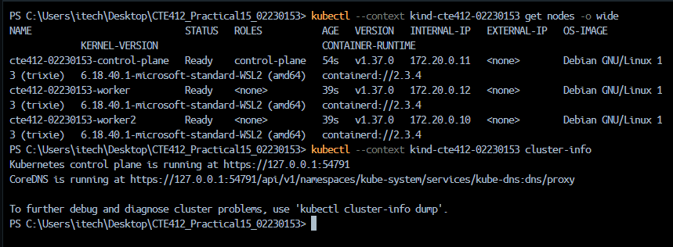
Figure 1 (E1.1): three Ready nodes in wide format, cluster cte412-02230153.
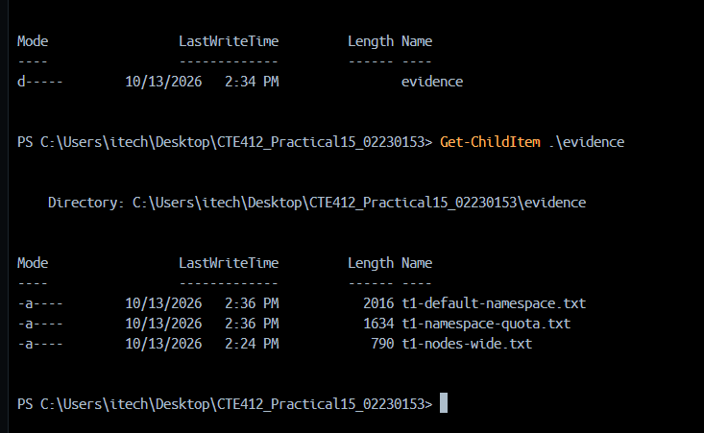
Figure 2 (E1.2/E1.3): Task 1 evidence files saved in evidence/.
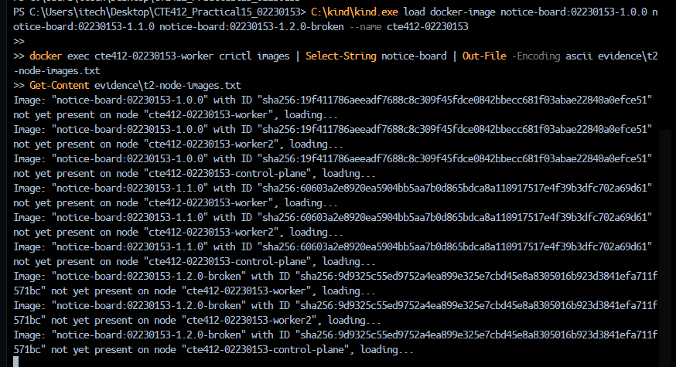
Figure 3 (E2.2): three release images loaded into the cluster nodes with kind load (no registry).
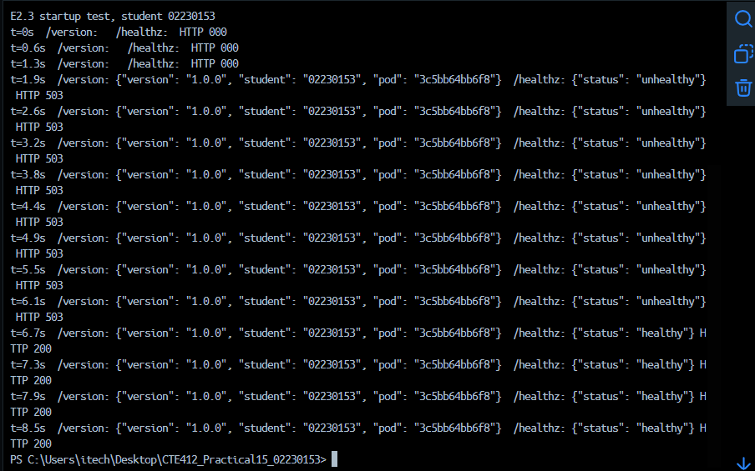
Figure 4 (E2.3): /version and /healthz from a local 1.0.0 container; 503 unhealthy for the first ~5 s, then 200 healthy.
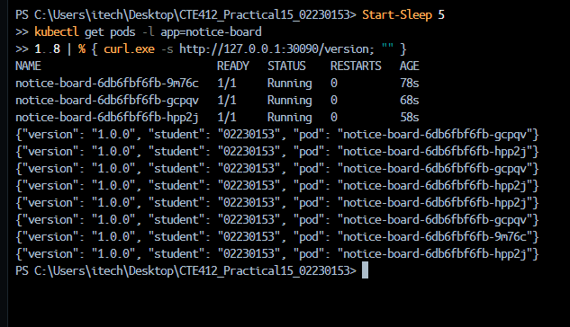
Figure 5 (E3.3): eight /version responses through port 30090, answered by several different Pods.
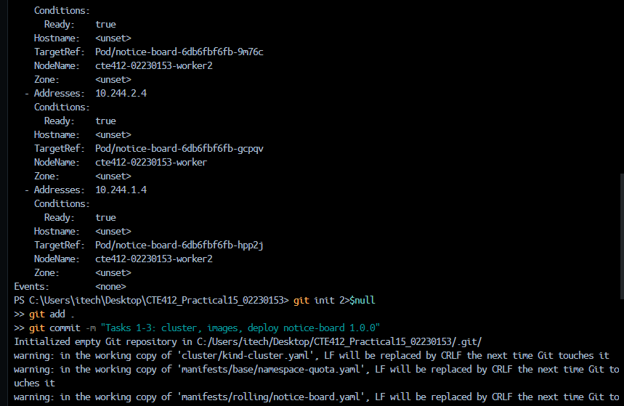
Figure 6 (E3.2): EndpointSlice of notice-board listing three addresses.
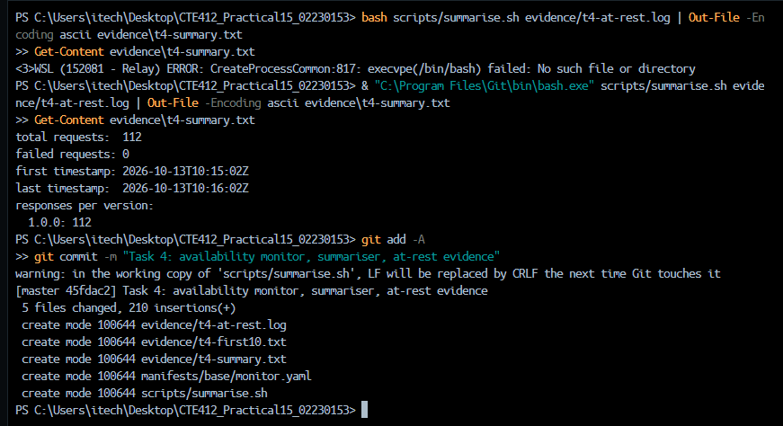
Figure 7 (E4.2): at-rest summary – 112 requests, 0 failed.
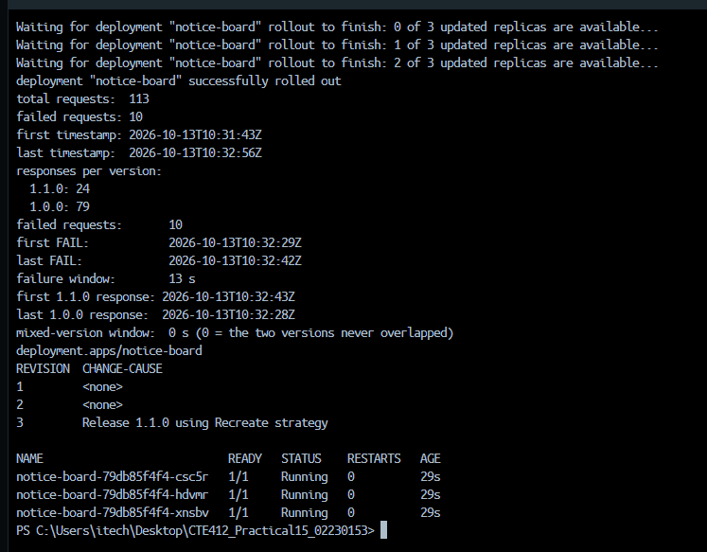
Figure 8 (E5.1): Recreate release – 113 requests, 10 failed, 13 s failure window, change-cause recorded.
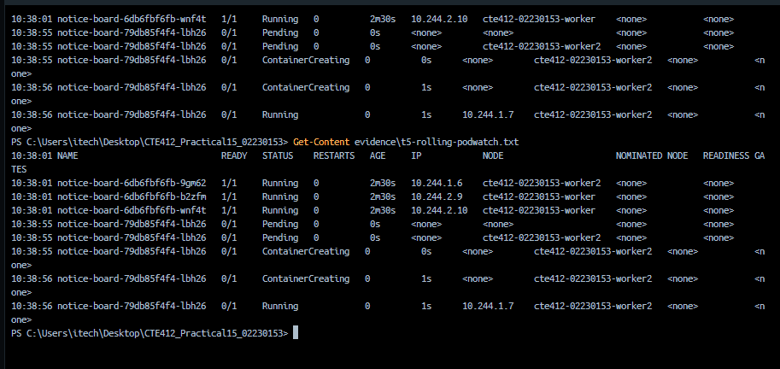
Figure 9 (E5.4): Pod watch during the RollingUpdate release (new Pod created while old Pods remain Running).
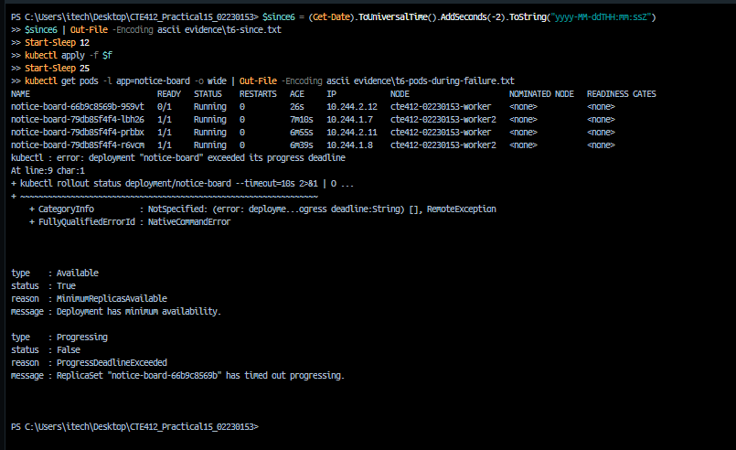
Figure 10 (E6.1/E6.2): broken release – old Pods still serving; Progressing=False, ProgressDeadlineExceeded.
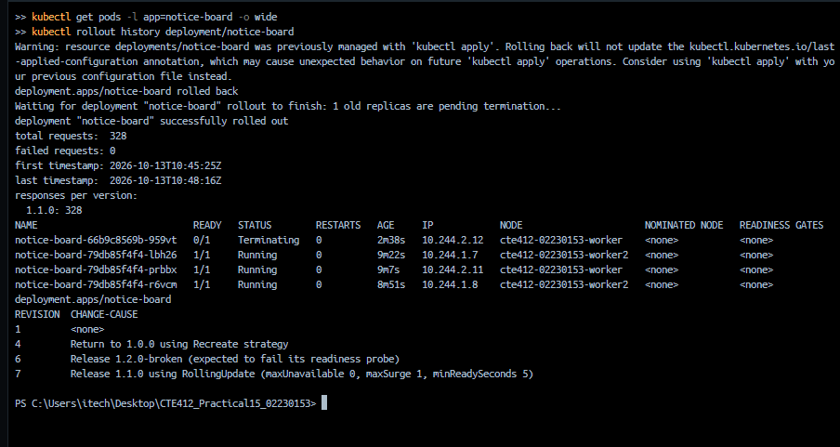
Figure 11 (E6.3): rollback and monitor summary with 0 failed requests.
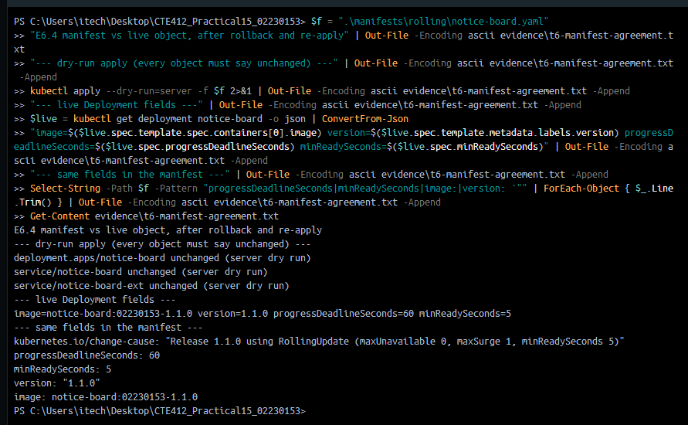
Figure 12 (E6.4): manifest and live Deployment agree after the rollback (dry-run apply: unchanged).
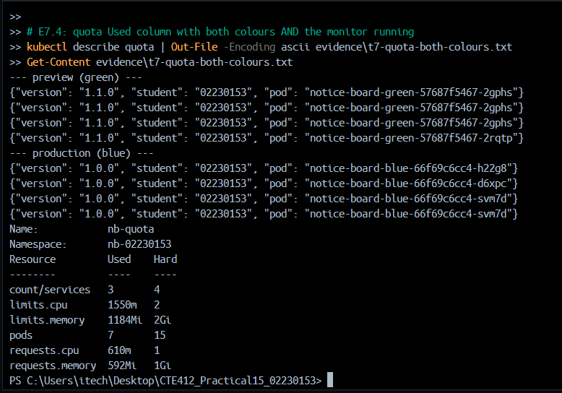
Figure 13 (E7.2/E7.4): preview returns 1.1.0 while production returns 1.0.0; quota Used column with both colours running.
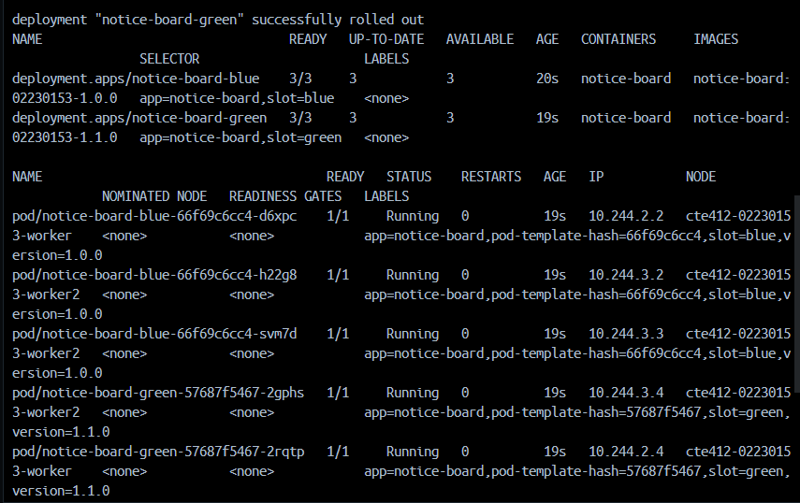
Figure 14 (E7.1): blue and green Pods with slot labels, and Services selecting slot=blue (production) and slot=green (preview).
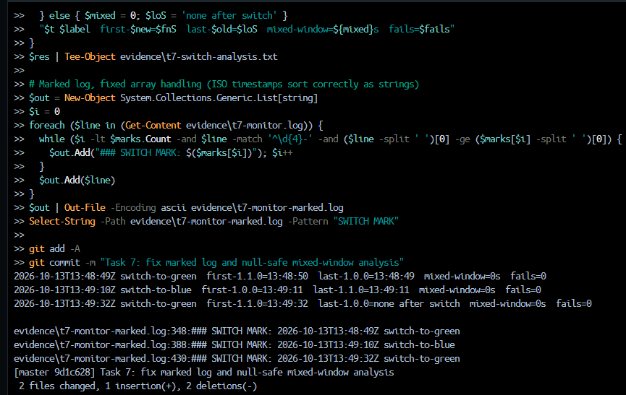
Figure 15 (E7.3): per-switch analysis and switch marks in the monitor log (0 failures, 0 s mixed window).
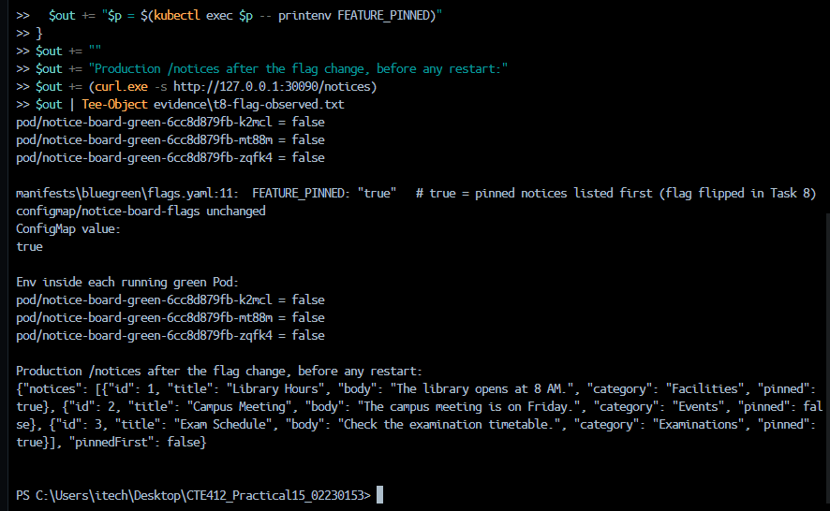
Figure 16 (E8.2): ConfigMap is true but running green Pods still report FEATURE_PINNED=false; production pinnedFirst is false.
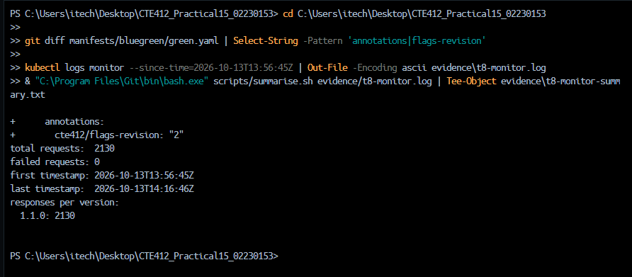
Figure 17 (E8.3): Task 8 monitor summary – 2130 requests, 0 failed.
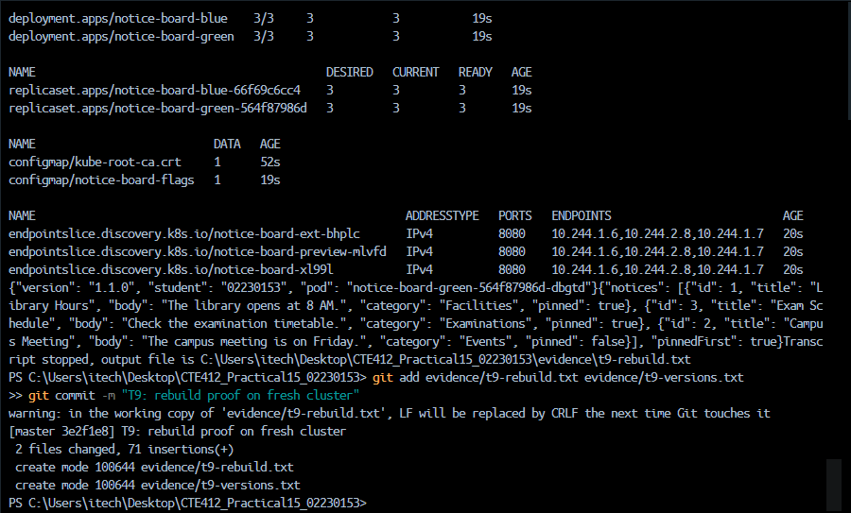
Figure 18 (E9.1): rebuild on a fresh cluster from the repository; pinnedFirst is true.
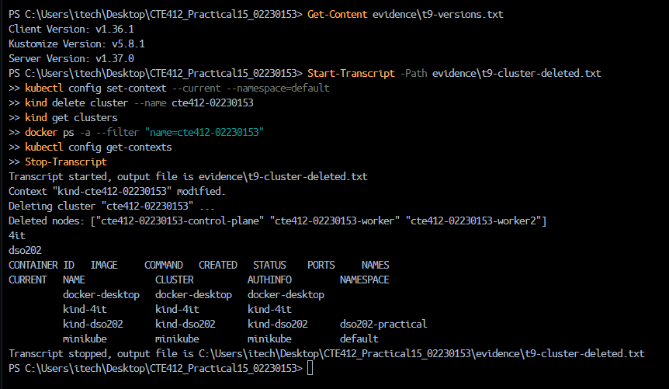
Figure 19 (E9.2): context reset to default and cluster cte412-02230153 deleted.
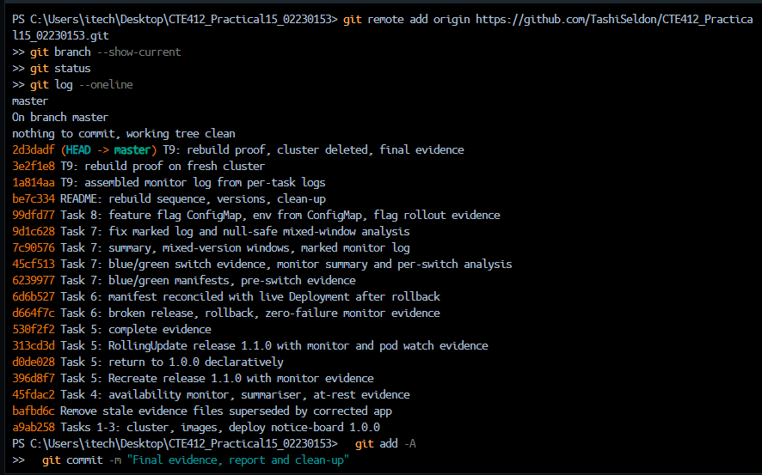
Figure 20 (repository): git history of the repository, 18 commits made during the lab session, one or more per task (git log --oneline).

