Deploying a Scalable User Management Application on Kubernetes
ITM403 Laboratory Report | Student number 02230153

Abstract
This report documents a Flask user-management API deployed on a local Minikube Kubernetes cluster. PostgreSQL provides persistent data storage through a StatefulSet and a 1 GiB PersistentVolumeClaim. The API is exposed through an NGINX Ingress and monitored with Kubernetes metrics. Horizontal Pod Autoscaling (HPA) is evaluated under generated HTTP load, while Vertical Pod Autoscaling (VPA) provides database recommendations in Off mode. Evidence covers CRUD operations, persistence after Pod replacement, host-based routing, autoscaling behaviour and troubleshooting findings.

1. System architecture
The client sends HTTP requests through the NGINX Ingress to the API Service and its Flask Pods. The API connects to PostgreSQL through a headless Service. A StatefulSet and persistent volume retain database files when the PostgreSQL Pod is replaced. HPA manages API replica count from CPU utilisation; VPA observes PostgreSQL resources and provides recommendations in Off mode.
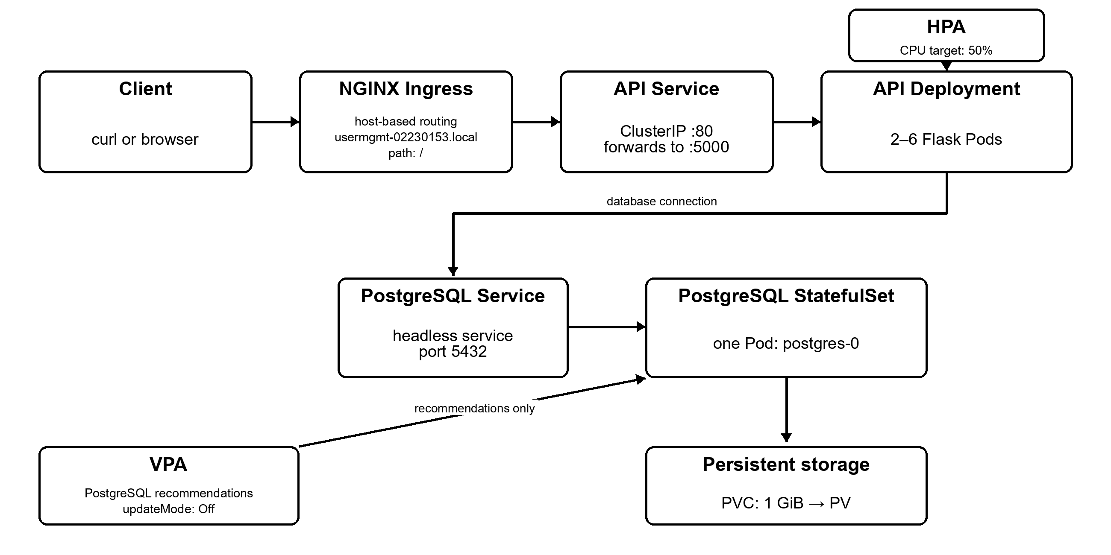
Figure 1. Architecture of the user-management system and its Kubernetes components.

2. Cluster and platform setup
A local Minikube v1.39.0 cluster was started with the Docker driver, two CPUs and 4 GiB of memory. Kubernetes v1.37.0 ran on the cluster. Namespace usermgmt-02230153 was created from k8s/00-namespace.yaml. The NGINX Ingress and Metrics Server add-ons were enabled, and VPA 1.8.0 components were installed from the Kubernetes autoscaler repository. The default standard StorageClass uses the Minikube hostpath provisioner; node metrics became available after Metrics Server recovered.
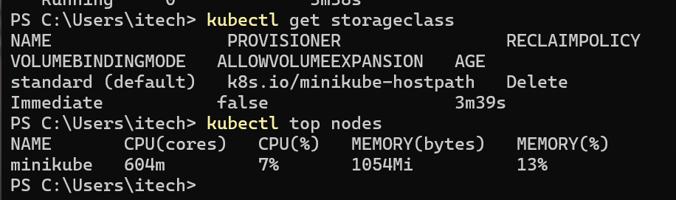
Figure 2. Ready Minikube node and system Pod status, including the Ingress controller.
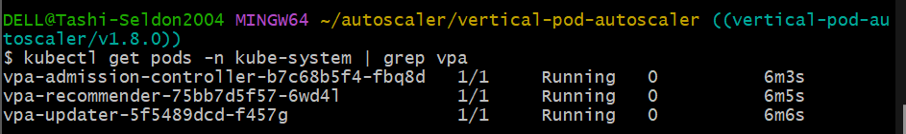
Figure 3. Default StorageClass and node resource metrics.
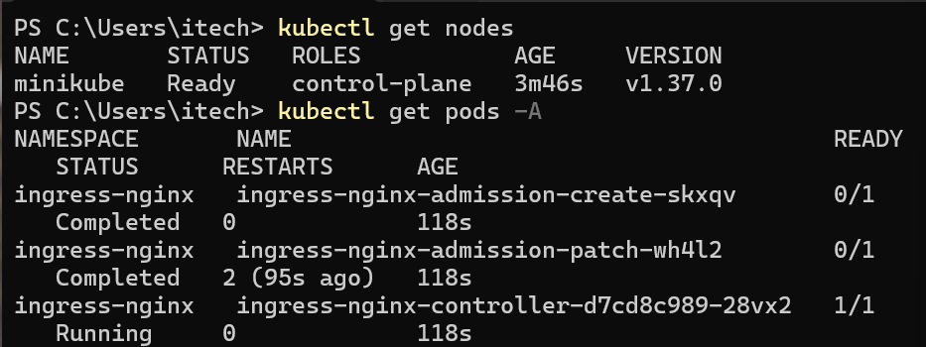
Figure 4. Vertical Pod Autoscaler components after installation.
Cluster readiness was confirmed through node and system-Pod listings. The Ingress controller, Metrics Server and all three VPA components were subsequently observed running.

3. Stateful PostgreSQL deployment and persistence
PostgreSQL was deployed as a one-replica StatefulSet. A headless Service provides a stable in-cluster identity, and a claim template requested 1 GiB from the default standard StorageClass. The volume claim became Bound, and postgres-0 reached Ready. Database credentials were supplied through a Kubernetes Secret. The PostgreSQL container requests 250m CPU and 256Mi memory, with limits of 1 CPU and 1Gi memory. StatefulSets associate stable storage with their Pods, while persistent volumes outlive an individual Pod.
The persistence test created a database row, deleted only postgres-0, waited for the replacement Pod to become Ready, and queried the record again. The record with ID 2 remained available after Pod recreation, and the same PVC remained Bound.
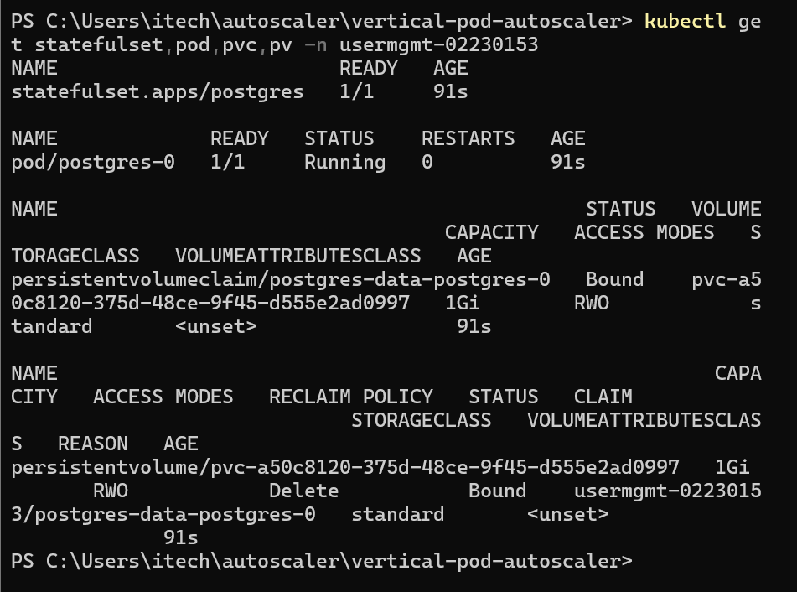
Figure 5. PostgreSQL StatefulSet, Pod and bound 1 GiB persistent storage.
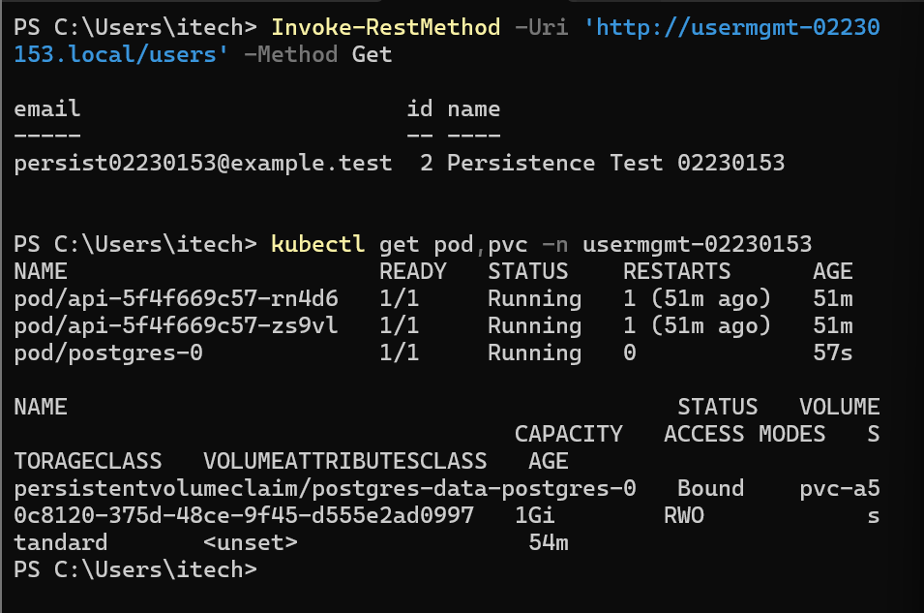
Figure 6a. Persistence-test record before PostgreSQL Pod replacement.
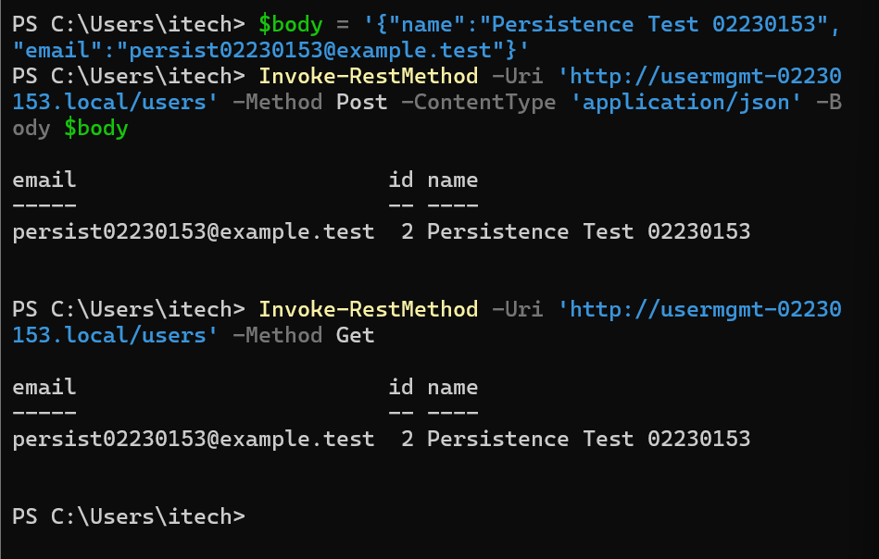
Figure 6b. Record and persistent claim after PostgreSQL Pod replacement.

4. API deployment and CRUD verification
The usermgmt-api:1.0 container image was built and loaded into Minikube. A Deployment ran two API replicas behind the api ClusterIP Service. The API used a ConfigMap for non-secret connection settings and the PostgreSQL Secret for credentials. Each API Pod requests 100m CPU and 128Mi memory, with limits of 500m CPU and 512Mi memory. Liveness and startup probes use /healthz. The /ready readiness endpoint opens a PostgreSQL connection and runs SELECT 1; it returned HTTP 200 during verification. Kubernetes Services provide a stable virtual endpoint for selected Pods.
The API supported create, list, retrieve-by-ID, update and delete operations. A POST created a user with ID 1; the subsequent GET returned that record, PUT changed the name and email, and DELETE removed it. A final GET returned HTTP 404 with user not found. An earlier malformed PowerShell curl body returned HTTP 400; the corrected Invoke-RestMethod request succeeded.
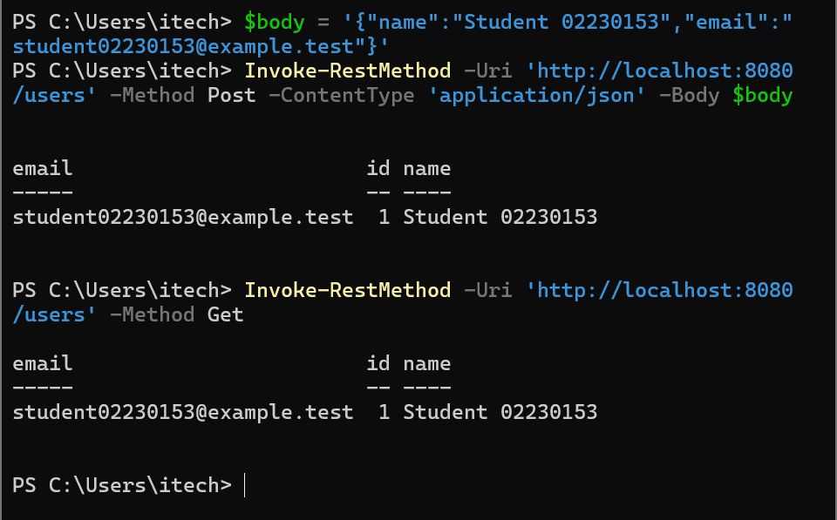
Figure 7. API Deployment, ReplicaSet, two ready API Pods and Services.
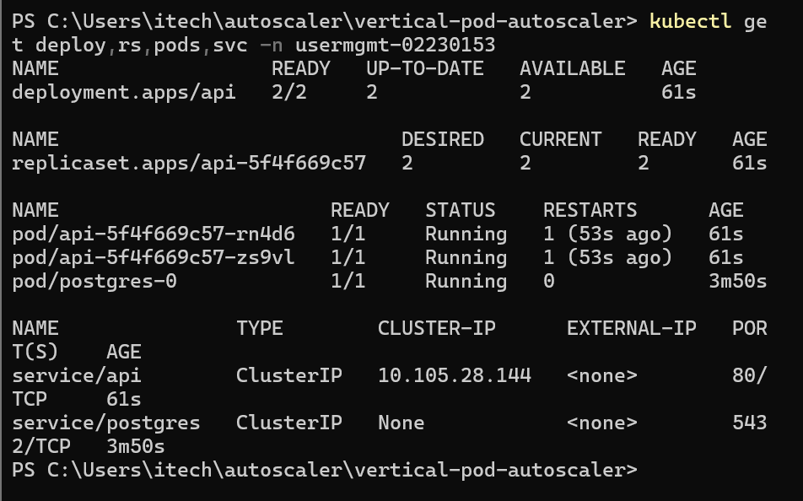
Figure 8a. Successful create and list requests.
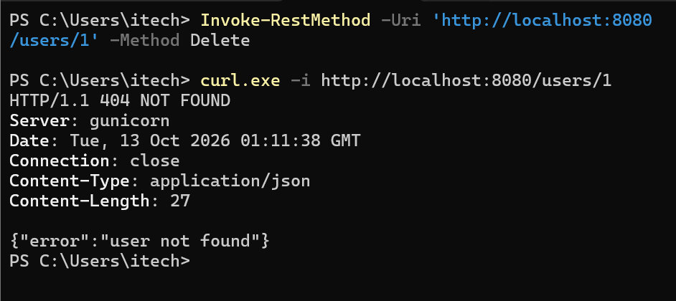
Figure 8b. Delete operation followed by a not-found response.

5. Ingress and host-based routing
The Ingress resource used class nginx, host usermgmt-02230153.local and path /. On Windows, the host mapped to 127.0.0.1 in the hosts file (Figure 14). A local port-forward exposed the Docker Desktop NodePort controller on port 80. The request path is client → Ingress controller → matching host/path rule → api Service → ready API Pod. The positive routing test returned HTTP 200 for http://usermgmt-02230153.local/users; a request with Host: other.local returned the NGINX HTTP 404 page.
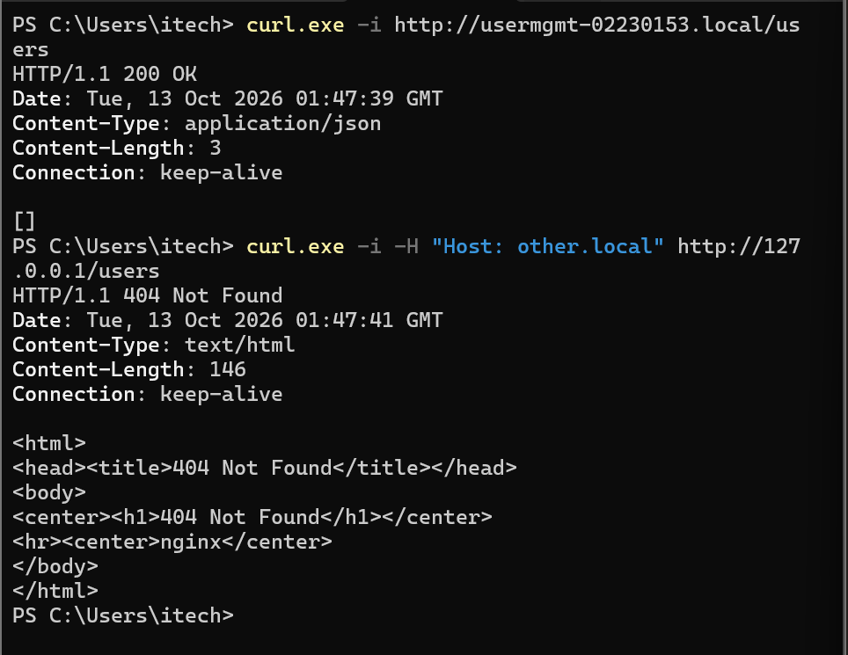
Figure 9. Ingress rule and resolved API backend endpoints.
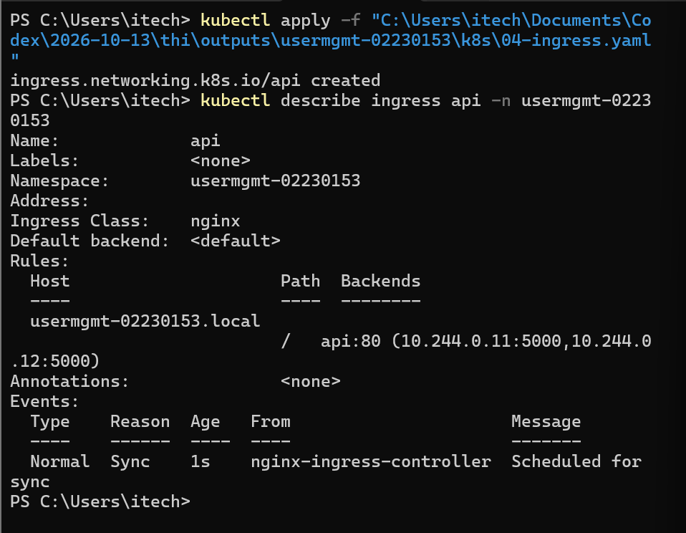
Figure 10. Successful request to the configured host and HTTP 404 for a non-matching host.

6. Autoscaling experiment and observations
Metrics Server supplied per-Pod measurements. The API HPA targeted 50% CPU utilisation, with two minimum and six maximum replicas. An initial three-minute test with 50 concurrent clients completed 11,168 requests: 8,284 returned HTTP 200 and 2,884 returned HTTP 503 (25.8%); mean response time was 0.807 seconds at 61.81 requests per second. A repeat test through the confirmed local Ingress port-forward completed 5,611 responses in 181.03 seconds: 5,596 returned HTTP 200 and 15 returned HTTP 503 (0.27%). Its mean response time was 1.61 seconds at 31.00 requests per second (Figure 11a).
During the repeat test, CPU rose from 4% to 197%, the HPA increased its desired count to six, and all six API Pods were Ready by 09:09 (Figure 11b). At the final captured sample, 09:12:47, CPU had fallen to 5% while six replicas remained, so scale-down to the minimum was not captured in that run. An earlier cooldown record showed the API returning to two replicas (Figure 11c).
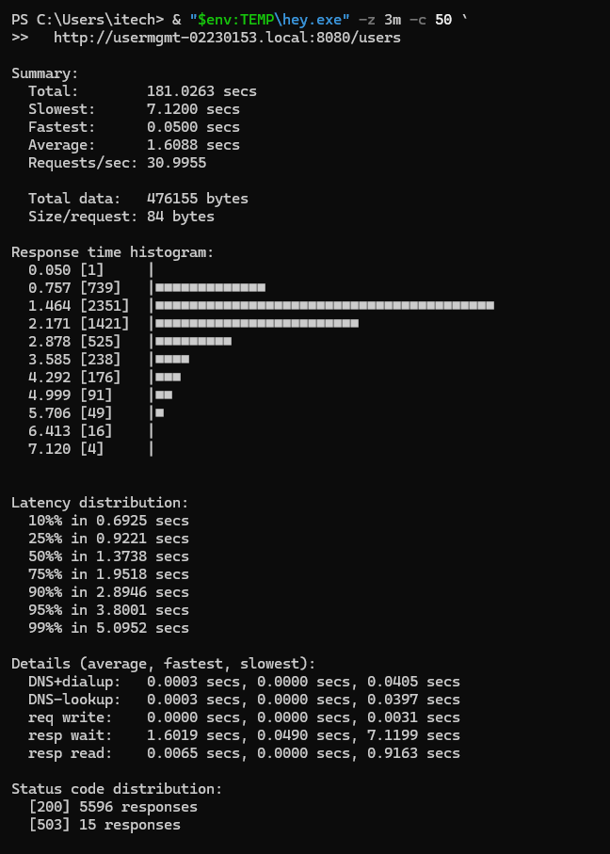
Figure 11a. Repeat three-minute hey load-test results through the Ingress port-forward.
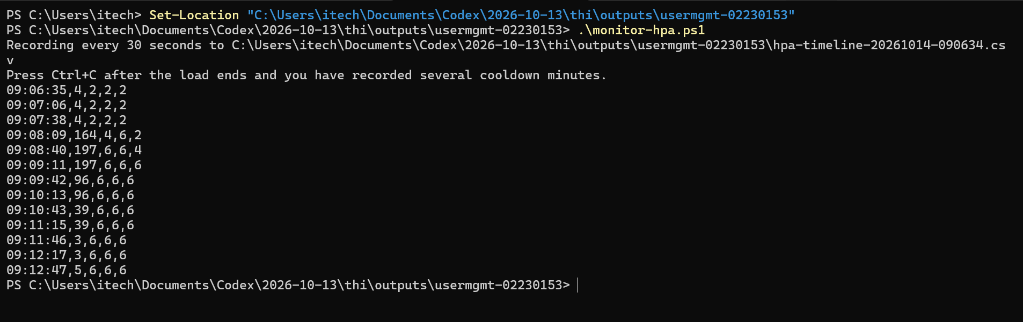
Figure 11b. HPA monitor samples during the repeat load run and post-load observation.
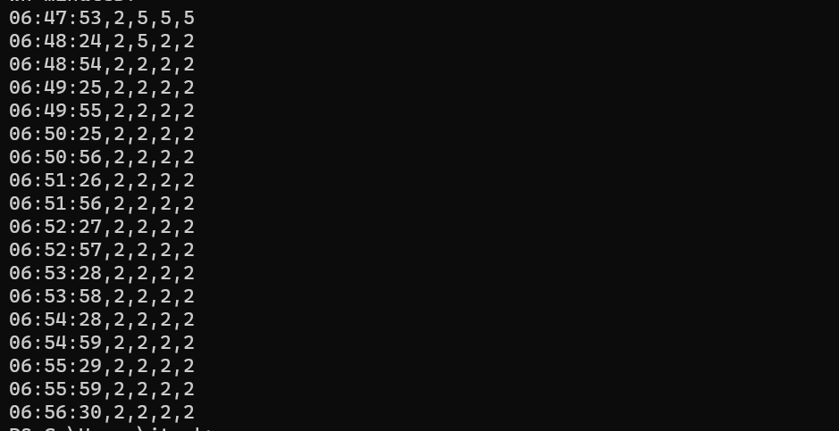
Figure 11c. Earlier HPA cooldown record showing a return to two API replicas.

7. Vertical Pod Autoscaler and troubleshooting
The HPA was assigned to the stateless API because additional replicas can share incoming requests. The VPA targeted PostgreSQL, where resource recommendations inform database sizing without changing a StatefulSet Pod automatically. updateMode: Off was selected to report recommendations while keeping current resource requests intact. The two autoscalers target separate workloads. If CPU-based HPA and an updating VPA controlled the same Deployment, changing CPU requests would change the utilisation denominator and could influence HPA replica decisions.
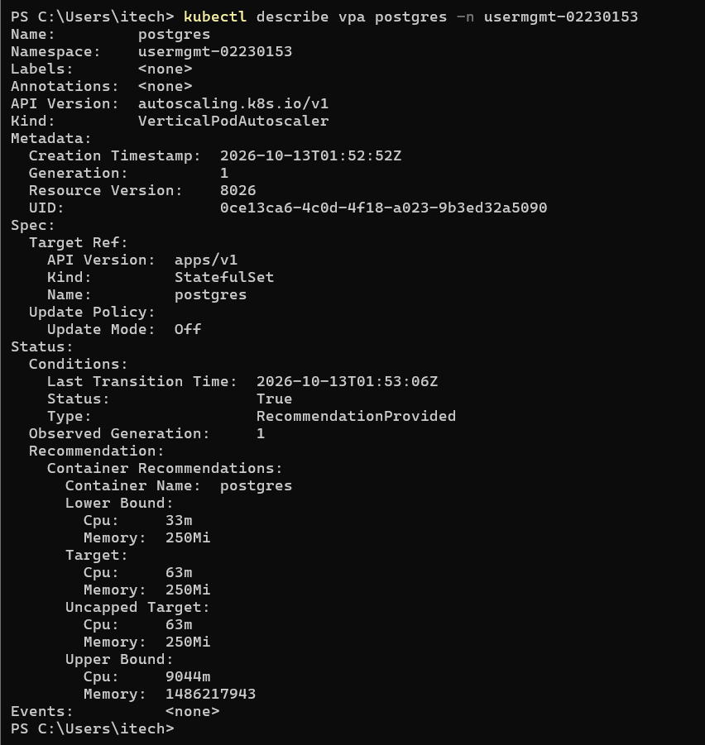
Figure 12. VPA recommendation for PostgreSQL in Off mode.

Troubleshooting record
Admission-controller TLS setup. The initial VPA installation failed to generate its CA certificate under Git Bash because path conversion changed the OpenSSL subject. The missing vpa-tls-certs Secret caused a FailedMount event. Running MSYS2_ARG_CONV_EXCL=/CN= ./hack/vpa-up.sh preserved the subject; the Secret was created and the admission controller subsequently reached 1/1 Running.
HTTP 503 responses. The initial three-minute load returned 2,884 HTTP 503 responses among 11,168 requests (25.8%). NGINX Ingress logs recorded connect() failed (111: Connection refused) while connecting to endpoint 10.244.0.11:5000; API log searches found no matching application errors. A repeat test after confirming the Ingress port-forward returned 15 HTTP 503 responses among 5,611 responses (0.27%). The lower error proportion is an observed difference between runs; available evidence does not establish its cause.

8. Conclusion
The deployment demonstrated the application path from container image to Kubernetes Service and host-based Ingress. CRUD operations succeeded, and PostgreSQL data remained available after Pod replacement. The HPA scaled the API during recorded load; one cooldown record returned to two replicas, while the latest run ended with six replicas and did not capture the later scale-down. The repeat 50-client load test returned 0.27% HTTP 503 responses, compared with 25.8% in an earlier run, but the reason for the difference remains unconfirmed. VPA generated PostgreSQL recommendations without applying them in Off mode.

Source repository
The source is maintained at https://github.com/TashiSeldon/kubernetes-user-management-02230153. The repository contains the Flask application, Dockerfile, numbered Kubernetes manifests, and deployment instructions in README.md. The database Secret is excluded from Git; the example manifest must be copied and populated locally. Assessor access depends on repository visibility or an explicit access grant.
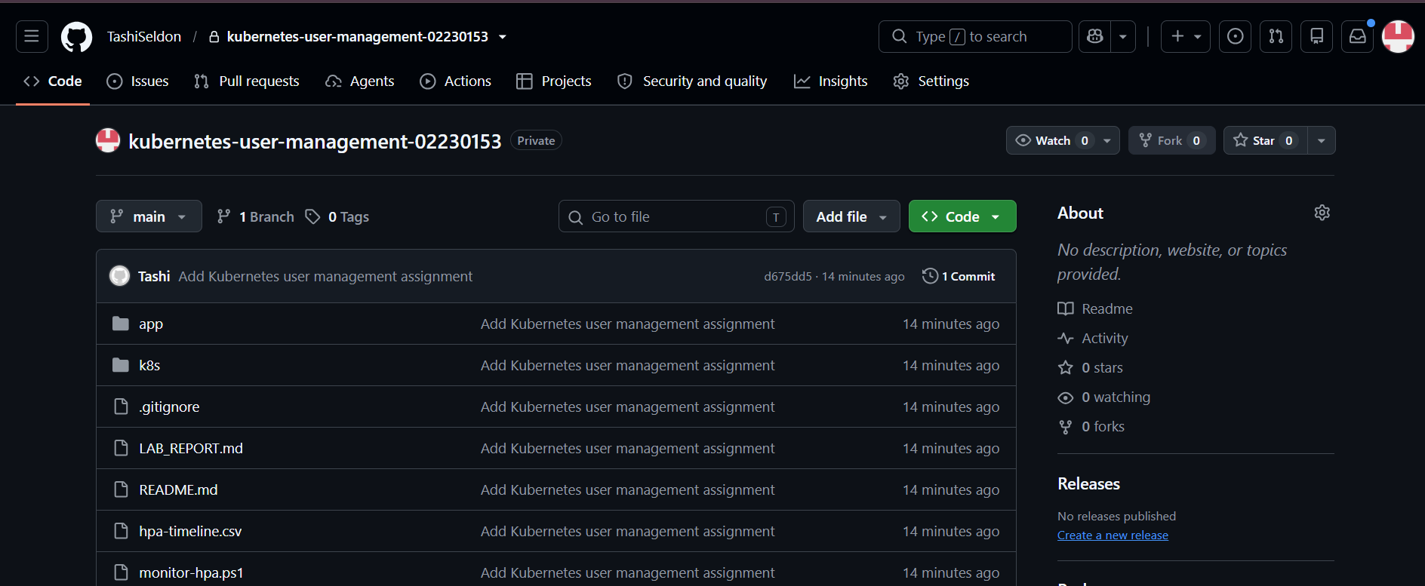
Figure 13. GitHub repository showing the application and Kubernetes manifest folders.
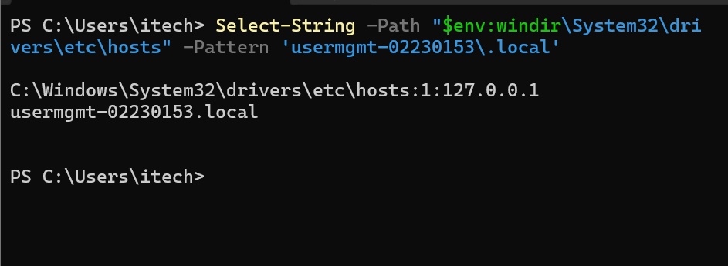
Figure 14. Windows hosts-file mapping for the student-specific Ingress host.

References
[1] Kubernetes. “StatefulSets.” Kubernetes Documentation. https://kubernetes.io/docs/concepts/workloads/controllers/statefulset/ (accessed 14 October 2026).
[2] Kubernetes. “Persistent Volumes.” Kubernetes Documentation. https://kubernetes.io/docs/concepts/storage/persistent-volumes/ (accessed 14 October 2026).
[3] Kubernetes. “Services” and “Ingress.” Kubernetes Documentation. https://kubernetes.io/docs/concepts/services-networking/service/ and https://kubernetes.io/docs/concepts/services-networking/ingress/ (accessed 14 October 2026).
[4] Kubernetes. “Minikube start.” Minikube Documentation. https://minikube.sigs.k8s.io/docs/commands/start/ (accessed 14 October 2026).
[5] Kubernetes Autoscaler Project. “Vertical Pod Autoscaler.” GitHub repository and documentation. https://github.com/kubernetes/autoscaler/tree/master/vertical-pod-autoscaler (accessed 14 October 2026).
[6] Kubernetes. “Horizontal Pod Autoscaling.” Kubernetes Documentation. https://kubernetes.io/docs/concepts/workloads/autoscaling/horizontal-pod-autoscale/ (accessed 14 October 2026).
[7] Kubernetes. “Vertical Pod Autoscaling.” Kubernetes Documentation. https://kubernetes.io/docs/concepts/workloads/autoscaling/vertical-pod-autoscale/ (accessed 14 October 2026).
[8] Kubernetes Autoscaler Project. “VPA Quickstart.” GitHub. https://github.com/kubernetes/autoscaler/blob/master/vertical-pod-autoscaler/docs/quickstart.md (accessed 14 October 2026).

