Lab 2
Runing the app on a real Android device
*For this lab, an actual Android phone was connected to Android Studio following the given instructions:
- Device Set up instructions:
*Enable Pair using QR code in the Developer options window of the phone.
  - Open the Settings app.
  - Select System.
  - Scroll to the bottom and select About phone.
  - Scroll to the bottom and tap Build number seven times.
  - Return to the previous screen, scroll to the bottom, and tap Developer options.
  - In the Developer options window, scroll down to find Pair using QR code.
- How to run the app on our device
- In Android Studio, select your app from the run/debug configurations drop-down menu in the toolbar.
- In the toolbar, select the device that you want to run your app on from the target device drop-down menu.
- Click Run

Screenshots of the successful connection of my Android phone with Android Studio
*Phone is paired with Android Studio scanning the “QR code”
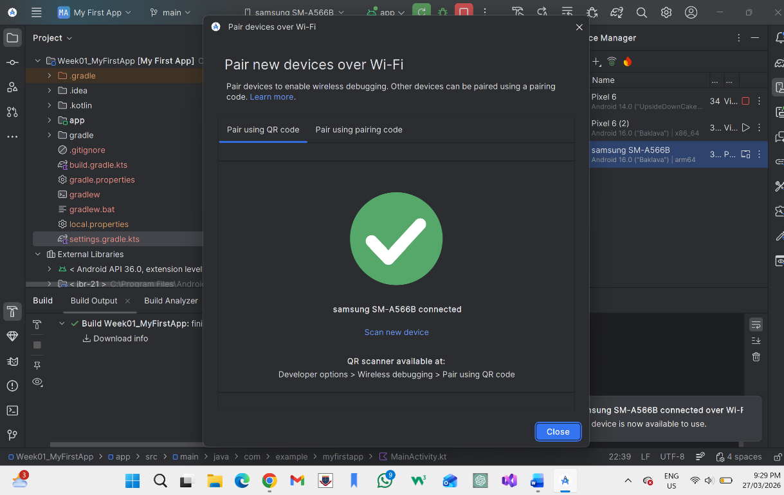

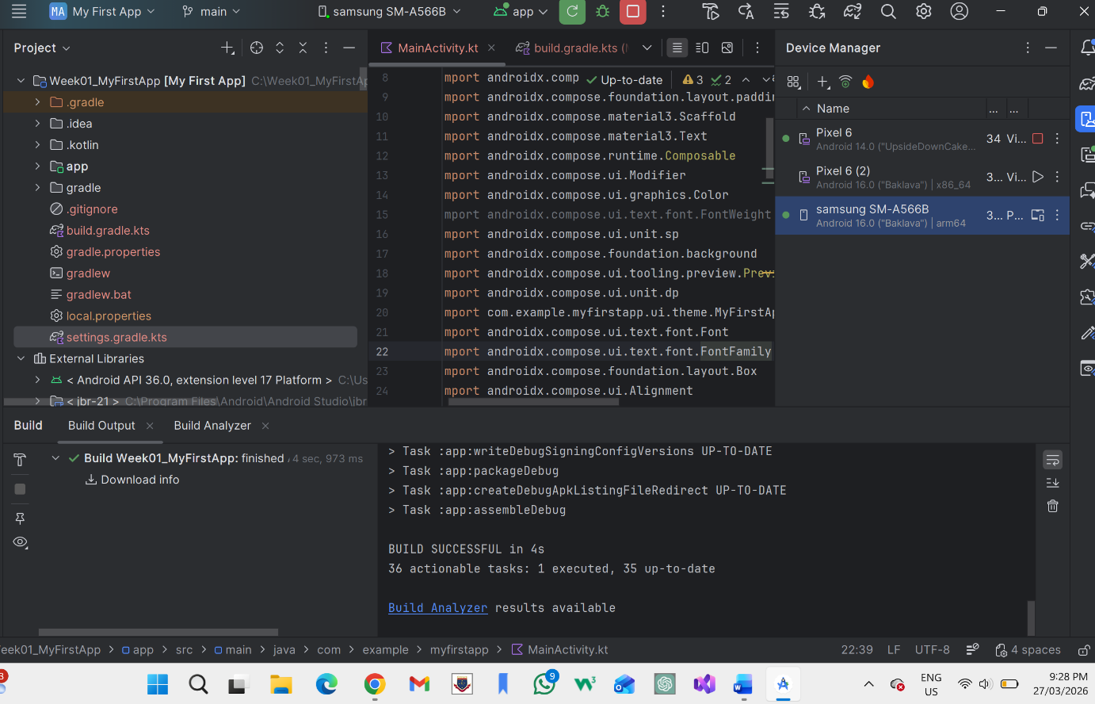
*Screenshot showing paired android phone on Android Studio

*Screenshot of the app shown on the Android phone after running the code on Android studio.

