1. Download the dataset. Make sure that you are able to visualize MRI scans and read \*.plq files with lesion coordinates and cropped views. The example is in the attached notebook.

🡪 Did a run down with provided and integrated the example code in my existing notebook. It’s working seamlessly.

1. Describe the attached picture. What is the region highlighted on MRI scan, and how is this scan connected to the MS disease?

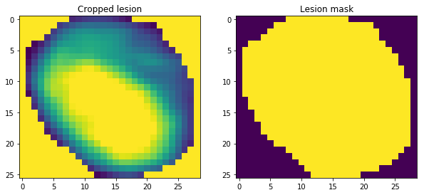

🡪 MS or multiple sclerosis is a disease in which the immune system eats away the protective covering of nerves called myelin (as shown in figure below).

MRI is an effective technique to measure MS because MRI uses magnetic fields and radio waves to measure the relative water content in tissues — both normal tissue and abnormal — in the body. Since the layer of myelin the protects the nerve cell is fatty, it repels water. In the areas where myelin has been damaged by MS, the fat is stripped away. With the fat gone, the area holds more water, which shows in MRI either as a bright spot or darkened areas depending on the type of scan that’s used.

1. What is the target variable in the dataset? What is the meaning of this score?

🡪 The target variable is EDSS score (Expanded Disability Status Scale) in a range from 0 to 10, providing a way of quantifying disability in MS and monitoring the changes over time in level of disability. Here we are specifically interested in EDSS score > 2 as a cut-off point because above this point neurological signs demonstrate the onset of accumulating disability.

1. Propose the hypothesis about the lesion features that, in your opinion, can be connected with the further progress of MS disease.

🡪 Shape Features – Maximum length of x and y coords, Area, perimeter, major and minor axis length, eccentricity, convex area and volume. These features tend to describe the shape and size of lesion. We can try different combinations of it for an instance, same maximum length of x and y coords can still provide a different area and/or volume. Overall an increment in these directly leads to number of demyelinated axons leads to an increased signal transmission impairment

🡪 Texture features [as proposed in paper] along their results

1. Median Value – intuitively shows the brightness of each ROI. MS Lesions are brighter than NWM.
2. Contrast - which is a measure of local variation between pixel intensities. MS regions have higher contrast values than NWM regions.
3. Inverse different moment (IDM) – This is related to lesions homogeneity. In NWM, IDM had higher values than in MS regions, implying that NWM were smoother and more homogeneous.
4. Entropy and Sum of average - MS lesions attained lower values than NWM ROIs, indicating that the degree of randomness of pixel intensities or textural roughness in MS regions was lower.

The loss of homogeneity in MS may be attributed to a number of processes such gliosis, inflammation, demyelination and changes in water content that may disrupt MR signal intensity uniformity

References:

1. <https://www.nationalmssociety.org/Symptoms-Diagnosis/Diagnosing-Tools/MRI>