Leaf Disease Detection using Machine Learning
CSE 299 — Sec - 16 — GROUP - 4

Md NABIL HASAN
2012370

TASHIN MAHMUD KHAN
2011819

AHMED SADMAN
2014094

Abstract—Plant diseases are a serious concern in Bangladesh, where agriculture supports 40% of the working population and generates 12.5% of the country’s GDP. Each year, they can cause up to 40% of worldwide agricultural output losses, with an estimated cost of more than $220 billion. The growing middle class’s need for high-quality farm goods contributes to the effects on smallholder farmers, resulting in losses in income and difficulties in providing food. Our study, ”Leaf Disease Detection using Machine Learning,” intends to solve this issue by offering a practical means of identifying diseases early on. By utilizing machine learning, we want to improve the food security of the world and drastically lower agricultural losses, especially in Bangladesh.
Index Terms—Agriculture, Plant diseases, Machine Learning, Prototypical Networks, Few-shot learning, Bangladesh, Food security, Data quality, Computing requirements, Data augmenta- tion, Recurrence strategies, Real-time disease detection, Custom Dataset, High Accuracy, Neural Networks (NN), Convolutional Neural Networks (CNN), deep learning techniques.

Introduction

In Bangladesh in particular, agriculture plays a vital role in the global economy. Roughly 40% of the working population is employed by it, and it generates 12.5% of the nation’s GDP. Over 70% of its land is used to grow major crops such as rice, jute, wheat, tea, lentils, oil seeds, vegetables, and fruits. Plant diseases, however, represent significant hazards to this important economy. Pests and diseases cause up to 40% of the world’s agricultural output to be lost each year, which results in an annual economic loss of more than $220 billion. Plant diseases can have disastrous effects in Bangladesh, wherein a growing middle class has increased demand for premium agricultural products. Plant diseases may result in smallholder farmers losing a lot of money and impair their ability to produce enough food for themselves or to sell.
Furthermore, in order to feed the world’s expanding popu- lation by 2050, the Food and Agriculture Organization (FAO) projects that food production will need to rise by around 60% overall and almost 100% in less developed countries. This emphasizes how urgent it is to treat plant diseases that drastically lower food output.
In light of these figures, the goal of our project, ”Leaf Disease Detection using Machine Learning,” is to provide a reliable and user-friendly method for the early and precise identification of plant diseases. By doing this, we expect to help the global effort to ensure

What have others done?
Machine learning techniques have been used in a number of studies to detect plant leaf diseases. For example, research that used K-Nearest Neighbor (KNN) classification was able to predict plant leaf diseases with an accuracy of 98.56%. Another research attained great accuracy rates by utilizing deep learning techniques.
Plant leaf disease detection using a variety of machine learning techniques:
  - K-Nearest Neighbor (KNN): This straightforward yet efficient approach is utilized in several research to identify plant leaf diseases. In one investigation, the prediction of plant leaf diseases was accurate to 98.56%.
  - Support Vector Machines (SVM): SVMs are very widely utilized in this domain. When there is no linear separability of the data, they are especially helpful.
  - Neural Networks (NN): These are a class of algorithms that mimic patterns in the human brain. They have been employed to categorize plant diseases in a number of research.
  - Convolutional Neural Network (CNN): CNNs are a subclass of deep learning neural networks that are mostly used for image analysis. By examining leaf photos, they have demonstrated outstanding effectiveness in the identification of several plant diseases.
  - Deep Learning Techniques: Compared to more con- ventional approaches, deep learning has produced significant advances in the field of digital image processing. It has been applied to the research of pest detection and plant diseases.
  - Additional Machine Learning Technologies: Plant dis- ease classification has also made use of other well-known machine learning algorithms such as Random Forest, Decision Trees, and Na¨ıve Bayes (NB).

What are the limitations?
Our study uses innovative methods of machine learning to identify and categorize plant leaf diseases. The project makes use of prototypical networks and few-shot learning (FSL), which work particularly well when there are only a few training examples of a given disease.
But there are some shortcomings of this-
  - Data Quality and Availability: The quality and avail- ability of data is a significant barrier to the implementation of machine learning models, such as FSL and prototype networks. Despite being extensive, the PlantVillage dataset

could not include every kind of leaf disease, particularly those that are unique to a given region.
  - Overfitting: Given the limited amount of training data and the complicated spectrum characteristic dispersion of the land-cover classes, FSL algorithms are prone to overfit.
  - Computing Requirements: For training and inference, deep learning models typically require an enormous amount of computing power. This might restrict the application of these models on devices with inadequate processing power.

How do we overcome this?
Overcoming our Shortcomings-
  - Data augmentation: By expanding both the amount and the variety of the training data, data augmentation techniques may be employed to get around difficulties with data avail- ability and quality.
  - Recurrence Strategies: Weight decay and dropout are two regularization strategies that can be used to reduce over- fitting.
  - Optimized Models: Less computational resources and parameters are needed when using optimized models, which may assist in satisfying computational requirements.

Our unique contributions
Unique Contributions of the Project-
  - Use of FSL and Prototypical Networks: The use of FSL and prototypical networks for leaf disease detection is a novel approach that can handle cases where only a few examples of a particular disease are available.
  - Real-time Disease Detection: The system could poten- tially be deployed on an embedded hardware for real-time in- field plant disease detection and identification.
  - Custom Dataset: The ability to use custom datasets greatly enhances the versatility and applicability of our project. Our model isn’t limited to the diseases found in the PlantVil- lage dataset because it allows for the integration of new datasets. Any user-provided dataset, including ones with pic- tures of diseases missing from the PlantVillage dataset, can be used to train and test it. Certain plant diseases may be exclusive to a given area. The identification and categorization of these diseases specific to a particular place would be possible with a tailored dataset collected from the surrounding area. With the help of this feature, the model may be trained again using a revised dataset that contains the most recent data, allowing it to learn from new data as it becomes available.
  - High Accuracy: The proposed implementation has shown high accuracy in predicting plant leaf diseases.
in Paddy Leaves Using Image Processing and Neural Networks. 2015 IEEE International Conference on Com- putational Intelligence and Computing Research (ICCIC).
    - Das, S. S. P., & Das, R. N. (2020). Evaluation of Deep Convolutional Neural Networks for Detection of Tomato Diseases. Computers, Materials & Continua.
    - Ghosh, P., Chatterjee, S., & Sheet, D. (2020). Automated Detection of Plant Leaf Diseases Using an Ensemble of Support Vector Machines. Computers, Materials & Continua.
    - Sladojevic, H., Arsenovic, A., Anderla, A., Culibrk, D., & Stefanovic, D. (2016). Identification of Rice Diseases Using Convolutional Neural Networks. Computers in Biology and Medicine.
    - Chatterjee, S., Ghosh, P., Sil, A., & Sheet, D. (2020). Transfer Learning for Plant Leaf Disease Classification: A Benchmark Analysis. Computers, Materials & Con- tinua.
    - Hossain, M. I., Kaiser, M. S., Rahman, M. M., Han, J., & Kim, D. H. (2020). Comparison of Shallow and Deep Learning Methods on Classifying the Healthy and Infected Plants. Computers, Materials & Continua.
    - De Campos, A. H., & De Campos, F. A. B. (2018). Recognition of Tomato Leaf Diseases Using Image Tex- ture Features and Support Vector Machine. 2018 IEEE International Conference on Systems, Man, and Cyber- netics (SMC).
    - Jiang, Q., Yu, Y., Zhu, Y., Zhang, G., & Yao, C. (2018). Plant Disease Recognition Using Improved Convolutional Neural Networks. Symmetry.

Methodology

Dataset
We used a Pre-Augmented PlantVillage dataset.
Dataset link: https://www.kaggle.com/datasets/vipoooool/new- plant-diseases-dataset/
We then Resized all the images to 64 x 64 pixels.
Then we changed the file structure for few-shot learning.
PlantVillage images_background
Apple
Apple Apple_scab Apple Black_rot
Apple Cedar_apple_rust Apple healthy
Corn

Related work
- Sa, P., & Vankadari, M. K. (2020). Deep Neural Networks for Image-Based Plant Disease Detection. Computers, Materials & Continua.
- Li, S., Liu, Y., Yin, Y., Zhou, X., & Zhang, Y. (2019). Deep Feature Learning for Tomato Disease Classification
Corn Cercospora_leaf_spot Corn Common_rust_
Corn Northern_Leaf_Blight Corn healthy
Grape
Grape Black_rot
Gray_leaf_spot

Using Image Sensors. Sensors.
- Mujare, A. B., Ingole, V. T., & Choudhari, N. K. (2015). A Novel Technique for Identification of Bacterial Blight
Grape Esca_(Black_Measles)
Grape Leaf_blight_(Isariopsis_Leaf_Spot) Grape healthy

Potato
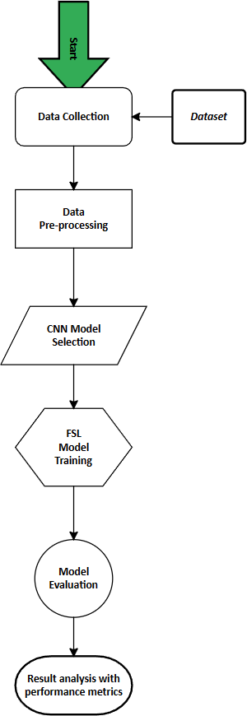
Potato Early_blight Potato Late_blight Potato healthy
Strawberry
Strawberry Leaf_scorch Strawberry healthy
Tomato
Tomato Bacterial_spot Tomato Early_blight Tomato Late_blight Tomato Leaf_Mold
Tomato Septoria_leaf_spot

Tomato Spider_mites Tomato Target_Spot
Two-spotted_spider_mite

Tomato Tomato_Yellow_Leaf_Curl_Virus Tomato Tomato_mosaic_virus
Tomato healthy images_evaluation
Blueberry
Blueberry healthy Cherry
Cherry_(including_sour) Powdery_mildew Cherry_(including_sour) healthy
Orange
Orange Haunglongbing_(Citrus_greening) Papper
Pepper Bacterial_spot Pepper healthy
Peach
Peach Bacterial_spot Peach healthy
Raspberry
Raspberry healthy Soybean
Soybean healthy Squash
Squash Powdery_mildew

Model
  - Base CNN: We use ResNet18 & EfficientNet as Base CNN pretrained model.
  - Prototypical Networks: We use prototypical network to extract image features from support and query set using ResNet18 or EfficientNet CNN.
  - Episodic Learning: To train our few shot model instead of classical training we use episodic training. In this method we create few-shot tasks to train the model.
Each training episode is constructed by randomly selecting a small set of classes (few-shot classes) from the overall class set. For each selected class, a small number of examples (support set) and another set of examples (query set) are chosen.
  - Model Training: We create 10,000 or 5,000 few-shot training tasks to train the model on the Training set (im-

Fig. 1. Flowchart
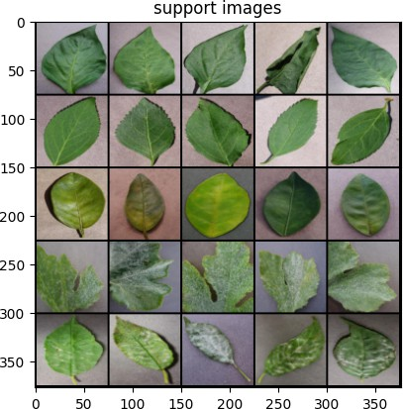

Fig. 2. Support Set
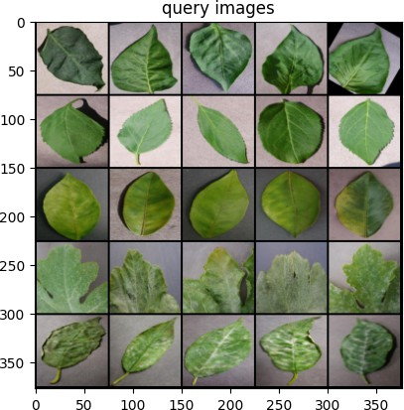

Fig. 3. Query Set
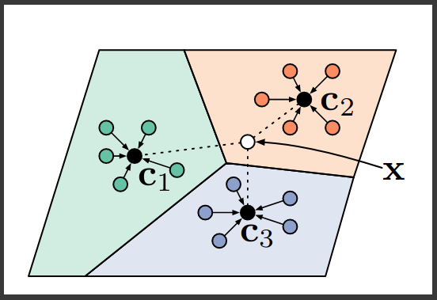

Fig. 4. Feature Extraction Using Prototypical Network

agebackground). This involves updating the model param- eters using standard gradient-based optimization algorithms. Each few-shot training task is created in a 5-way 5-shot configuration. We use Cross Entropy Loss function. It is a way to measure how well a model is performing on a classification task. We use ADAM optimizer which helps with bias correction & efficiency.
  - Evaluation: After training, the model’s performance is evaluated on unseen classes not encountered during train- ing, using a similar few-shot learning setup. The model’s ability to generalize and make accurate predictions for new classes with limited examples is measured. We create 1,000 evaluation task to evaluate the model on the Evaluation set (imagesevaluation).
TABLE I
Model Accuracy & AUC

CNN Training Episode Accuracy in % AUC
EfficientNet | 10,000 | 77.91 | 0.954
ResNet18 | 10,000 | 68.25 | 0.913
EfficientNet | 5,000 | 81.32 | 0.964
ResNet18 | 5,000 | 73.55 | 0.933

TABLE II
Model Precision, Recall & F1 Score

CNN Training Episode Precision Recall F1 Score
EfficientNet | 10,000 | 0.71 | 0.74 | 0.73
ResNet18 | 10,000 | 0.73 | 0.67 | 0.70
EfficientNet | 5,000 | 0.83 | 0.74 | 0.78
ResNet18 | 5,000 | 0.70 | 0.64 | 0.67

Result

Conclusion
To sum it up, our research project, ”Leaf Disease Detection using Machine Learning,” has shown promising results in the field of plant diseases. By utilizing modern techniques like Few-Shot Learning (FSL) and Prototypical Networks, our method performs very well in situations where there are few instances of a certain disease. It has been shown that using prototypical networks to accurately identify and classify plant leaf diseases is a creative and efficient method. Our model can adapt and perform well even with few training instances thanks to the integration of Few-Shot Learning, which highlights its possibilities for real-time disease identification. By using a custom dataset, our model becomes simpler to use and can be applied to a greater number of plant diseases than those found in standard datasets such as PlantVillage. Excellent levels of precision have been shown by the provided execution, which adds to our system’s reliability in recognizing and classifying plant leaf diseases.

Future work
In the future, we need to include new plant species and illnesses and use smart data augmentation techniques to further improve the diversity and quality of the data. To further enhance model performance, investigate the incorporation of modern machine learning approaches, such as ensemble meth- ods and transfer learning. Consider the manner in which the model may be developed and implemented in the field in real- time to help with the early detection of diseases in agricultural settings.

