

**SRI LANKA TECHNOLOGICAL CAMPUS**

**SCHOOL OF ENGINEERING**

**BACHELOR OF SCIENCE (HONOURS) IN ENGINEERING IN ELECTRONICS AND TELECOMMUNICATION**

**BATCH 07**

Group “MIND”

CDP07

Business Analysis

AA2028 – B.D.T.P De Silva

AA1609 – H.M.B.D.H Hanwella

**Table of Content**

Functional Requirements 2

Behavioral UML Diagrams 3

1. Use Case Diagram 3

2. Activity Diagram 4

Scoping 5

1. Project Scope: 5

2. Exclusions: 5

3. Project Deliverables: 5

4. Future Improvements: 6

Functional testing 7

1. Unit Testing 7

2. Integration Testing 8

References 9

# Functional Requirements

* User Login

This feature used by the user to login into system. They are required to enter user id and password before they are allowed to enter the system .The user id and password will be verified and if invalid id is there user is allowed to not enter the system.

Functional requirements

* User id is provided when they register
* The system must only allow user with valid id and password to enter the system
* The system performs authorization process which decides what user level can access to.
* The user must be able to logout after they finished using system.
* Register New User

This feature can be performed by all users to register new user to create account.

Functional requirements

* System must be able to verify information
* System must be able to delete information if information is wrong
* REGISTER NEW BOOK

This feature allows to add new books to the library.

Functional requirements

* System must be able to verify information
* System must be able to enter number of copies into table.
* System must be able to not allow two books having same book id.
* SEARCH BOOK

This feature is found in book maintenance part. We can search book based on book id, book name, and publication or by author name.

Functional requirements

* + System must be able to search the database based on select search type
  + System must be able to filter book based on keyword entered
  + System must be able to show the filtered book in table view

# Behavioral UML Diagrams

## Use Case Diagram

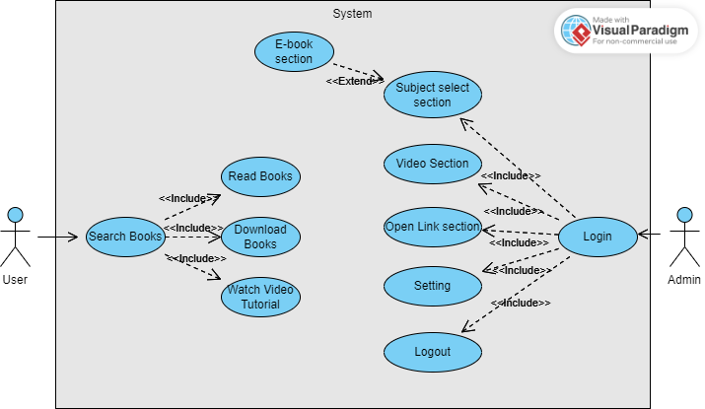

## Activity Diagram

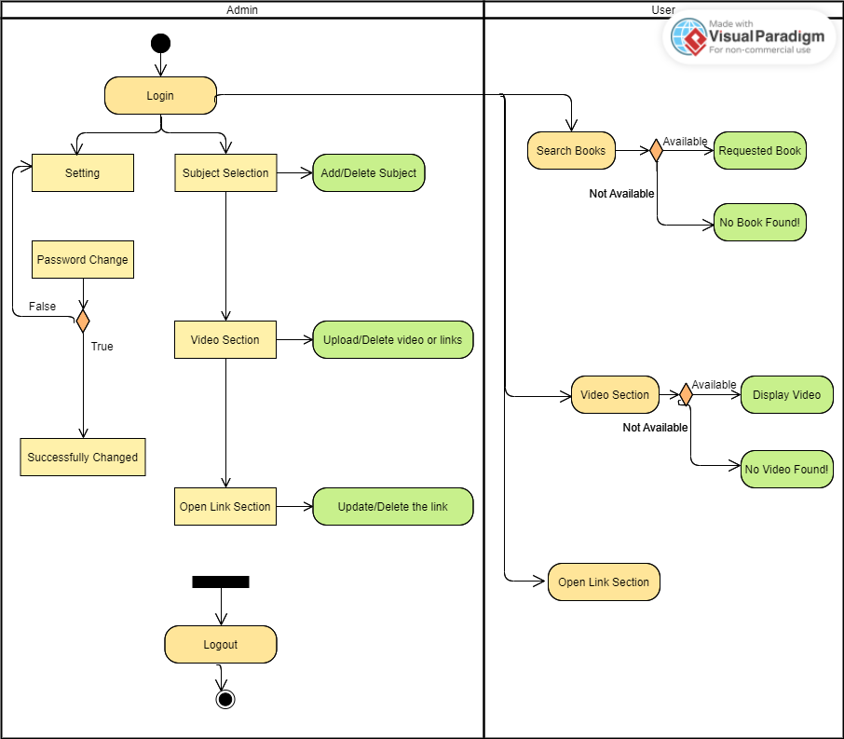

# Scoping

This scoping report's goal is to outline the project's boundaries and the work that will be done as part of it, as well as to point out areas that will be taken into consideration for future enhancements. This document acts as a manual to make sure the project scope is well stated.

## Project Scope:

The following essential elements are included in the project's scope for the E-library Management System:

* User maintenance: The implementation of capabilities for user registration, login, and profile maintenance.
* Book Management: Creation of tools for adding, looking up, and classifying books in the database.
* Book Borrowing and Return: Process design and implementation, including tracking of due dates for book borrowing and returns.
* Administrative Dashboard: Development of a dashboard for managing and monitoring systems.

## Exclusions:

A few features and functions are not included in this project's scope but may be added in the future. The following are not included in the project's current scope:

- Advanced Reporting: Features for thorough statistical analysis and reporting.

- Social Media Integration: User interaction through integration with social media networks.

- Mobile Application: The e-library system will get its own mobile application.

## Project Deliverables:

This project will have the following deliverables:

* A user-friendly and intuitive interface that is functional for interacting with the e-library system.
* Implementation of a well-designed database to store and manage user data, borrowing records, and book information.
* System Documentation: Extensive documentation describing system features, setup guidelines, and user manuals.

## Future Improvements:

Although they are not a part of the project's current scope, the following features can be taken into account:

* Advanced Search Capabilities: Including author, genre, and publishing date as advanced search filters.
* Book recommendation algorithm development: creating recommendations for books based on reader preferences and past reading habits.
* Mobile Application: Developing a mobile app to increase the system's usability and accessibility.

# Functional testing

The procedure of system testing has the objective of finding every flaw in our product. A series of test inputs were given to the software, and numerous observations were made. These observations were used to determine whether or not the program behaves as intended. Unit testing and integration testing were both performed on our project.

## Unit Testing

Once a module has been developed and approved, unit testing is started. A thorough test strategy spanning all of the features and facets of the module under development was designed in order to test a single module. Among them were the following:

* Testing the admin module
* Testing the admin login form: The system administrator logs in using this form. In order to ensure that the right behavior was displayed, the test plan included scenarios in which both the right and wrong login and password combinations were submitted.
* Student account addition: The test strategy included checking student information against academic records, entering student information into the main library database, and evaluating the ‘add’ and ‘delete’ button operations.
* Testing the student module

.

* Scenarios where the proper and improper library ID, username, and password combinations were input were included in the test plan for the student login form. Based on the input, it checked to see if the proper login page or error message was shown.
* Creating a testing account: This addresses situations in which a student incompletely filled out the form and the subsequent redirection to the complete form. Additionally, it involved checking the message that was waiting for confirmation before the administrator uploaded the data.
* Testing the teacher login module
* Include cases where the right and wrong username and password combinations were submitted when testing the teacher login form. Based on the input, it made sure that the appropriate login page or error message was presented.

## Integration Testing

Different project module integrations were tested during the integration testing process by supplying input. To verify the module interfaces and guarantee that no errors occurred when invoking another module, a thorough test plan was created. The test plan investigated the anticipated behavior of the integrated components and included various integration situations.

# References