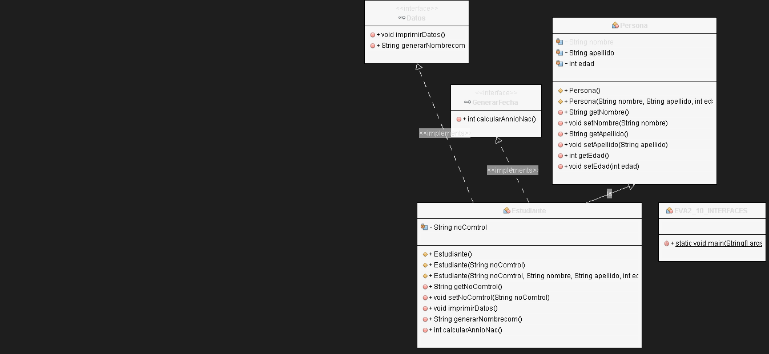EVA2_10_INTERFACES