Get a domain name

1. Prompts to get free/paid domain

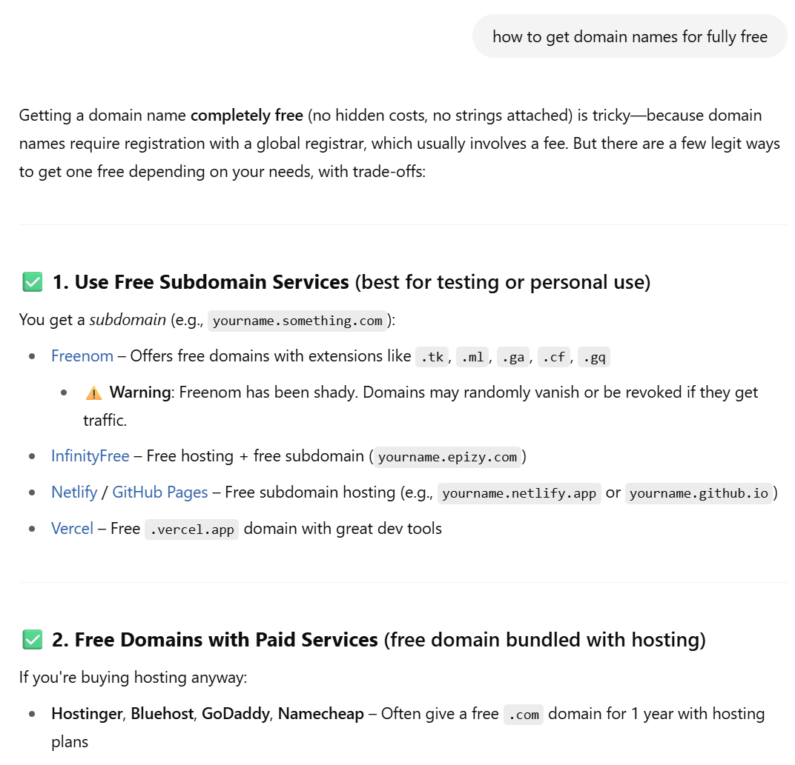

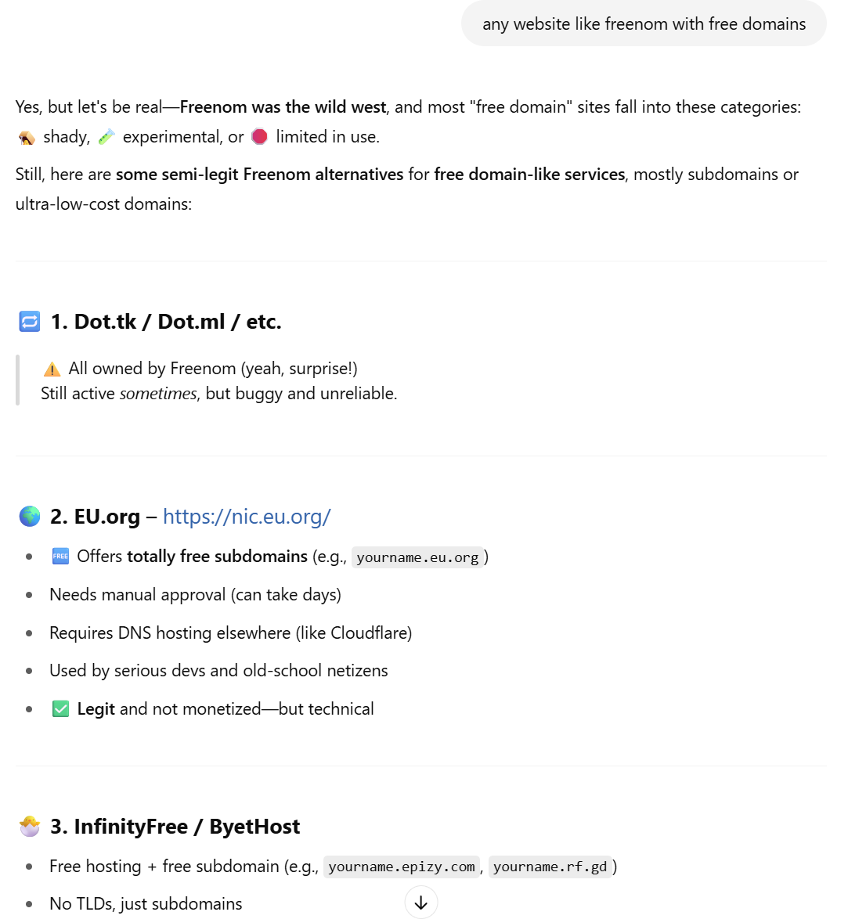

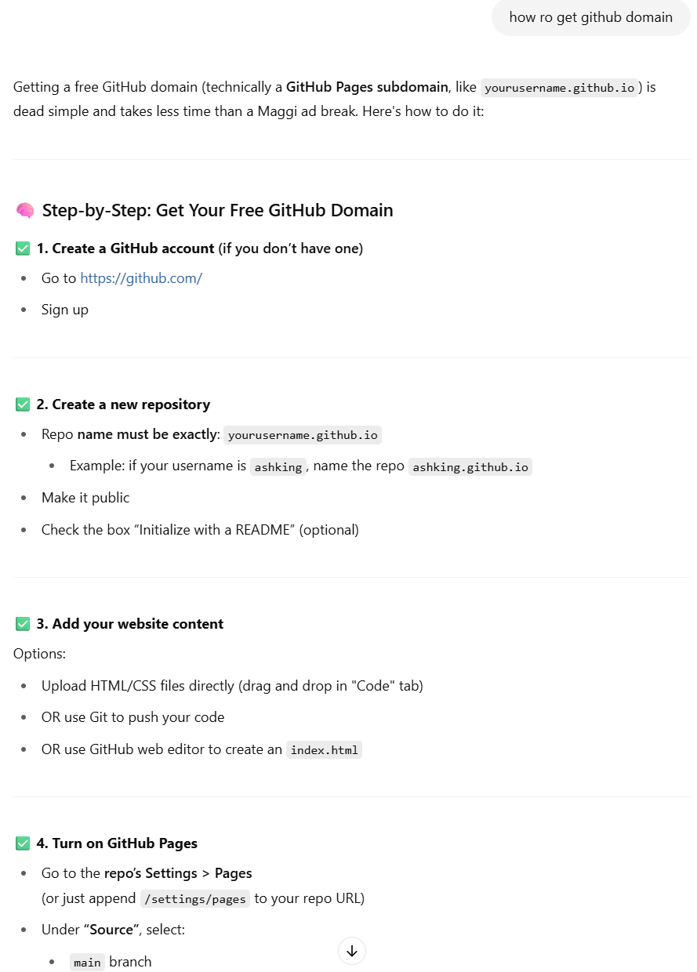

1. Paste the code in Notepad++
2. Save the file as index and related resources like photo and CA logo in the same folder

