Host your website

1. Prompts to host using subdomain

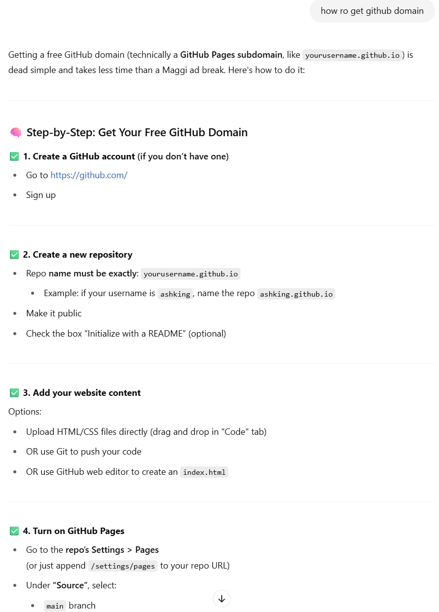

1. Prompt to host using domain

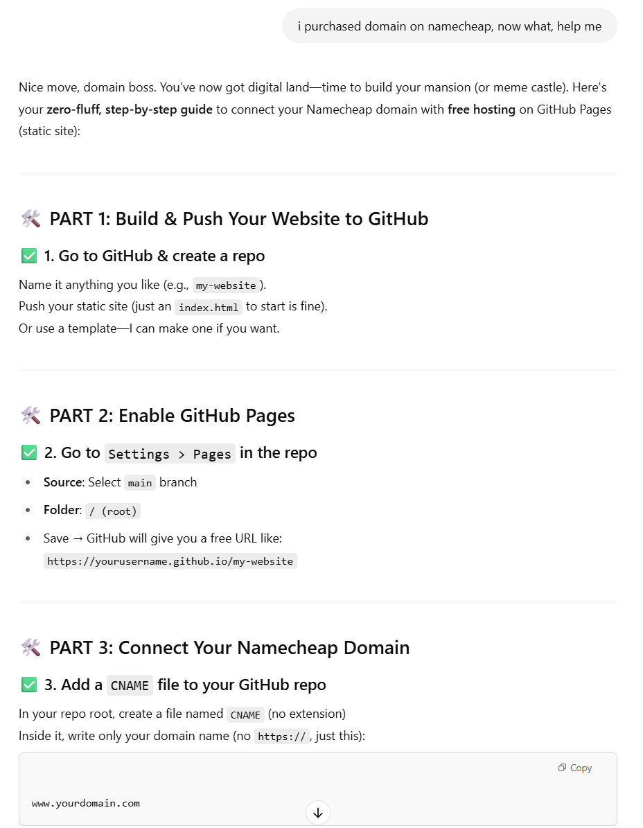

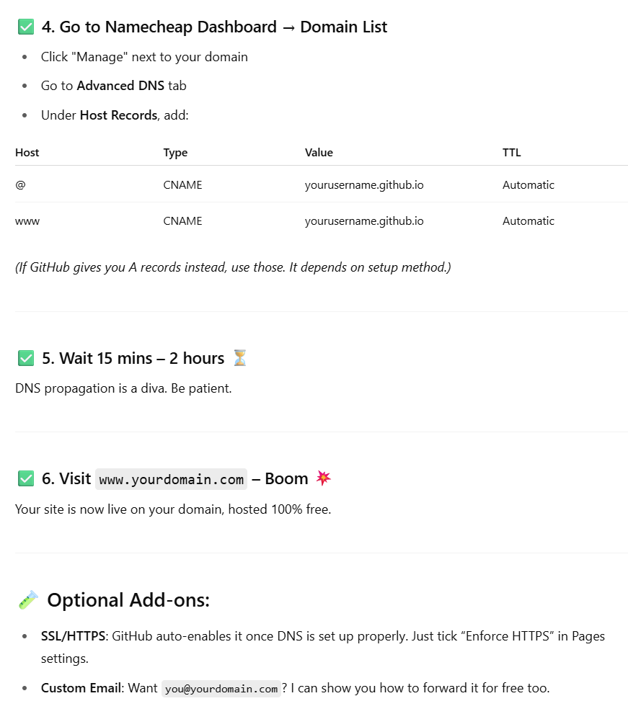

1. Open your website
2. Subdomain - <https://tashishping.github.io/>
3. Domain – <http://www.thanthry.com/>