Create industry specific custom RACM

1. Prompts
2. Prompt used to create RACM

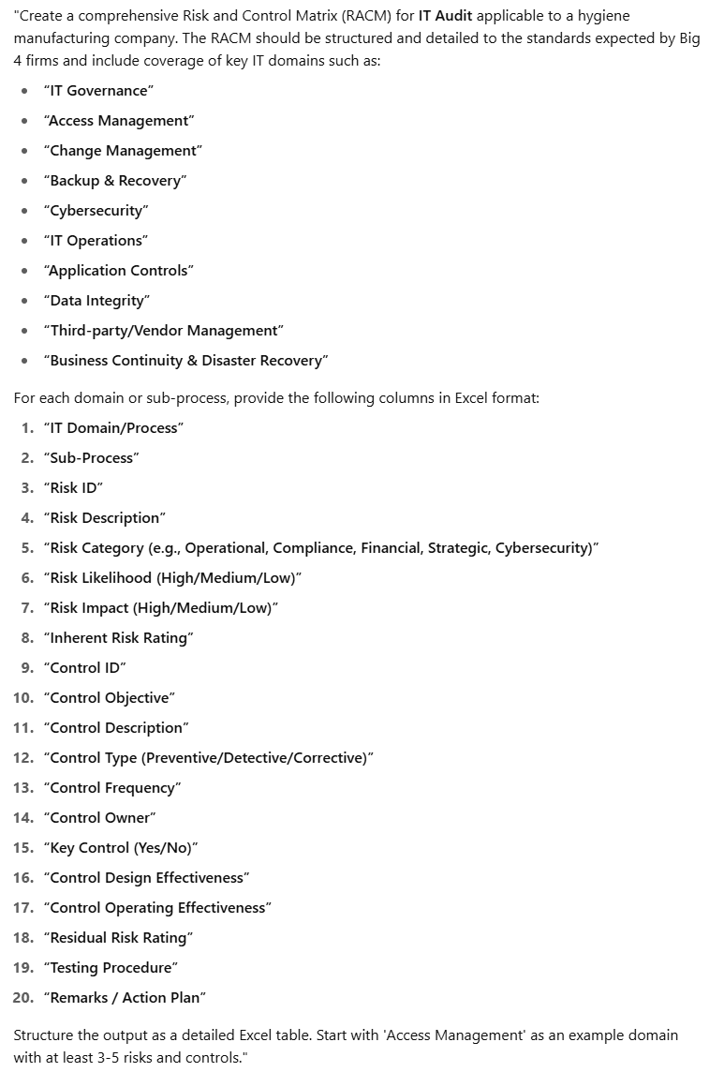

1. Prompt used to engineer the prompt



1. Obtain output in Excel file

