Smoke Rescue
Two robot dogs search a burning house, share one map, and walk back out.
OpenCV AI Competition 2026 · Technical report
In a burning house, the first crew inside can see about an arm's length ahead. Smoke Rescue sends two robot dogs in first. A mission runs in four steps:
1. Both robots enter through the front door. They have no floor plan.
2. Each robot maps the house with its own LiDAR and depth camera.
3. OpenCV 5 confirms each person and joins the two robots' maps into one.
4. When the search ends, both robots walk back out.
Result. On 39 real floor plans it had never seen, the two-robot team found 99 % of the people, against 92 % for one robot. It never reported a person who was not there.

In this report
1 Problem | 5 AWS deployment
2 Users | 6 Evaluation
3 Architecture | 7 Limitations
4 OpenCV 5 implementation | 8 Responsible use

Short on time? Read section 4 and section 6. Build and deploy steps are in the GitHub README: https://github.com/TashonBraganca/smoke-rescue.

1. Problem
Smoke takes away sight. Heat takes away time. Two searchers who cannot share what they saw search the same rooms twice. A robot team for this job must answer four questions with its own sensors:
- Where am I, and where is my partner?
- Which rooms have we searched?
- Is that shape a person?
- Can we both get back out?
We kept the limits of a real team. No robot gets a floor plan. The only shared reference is the launch pad at the front door. The radio is short-range and drops messages.

2. Users
- Fire incident commanders. Before a crew goes in, the commander sees one map with the searched rooms, the people found and the fire. The crew goes straight to a confirmed person.
- Robotics teams. Engineers test a multi-robot search policy on hundreds of real floor plans, scored against hidden ground truth, before they build hardware.

3. Architecture
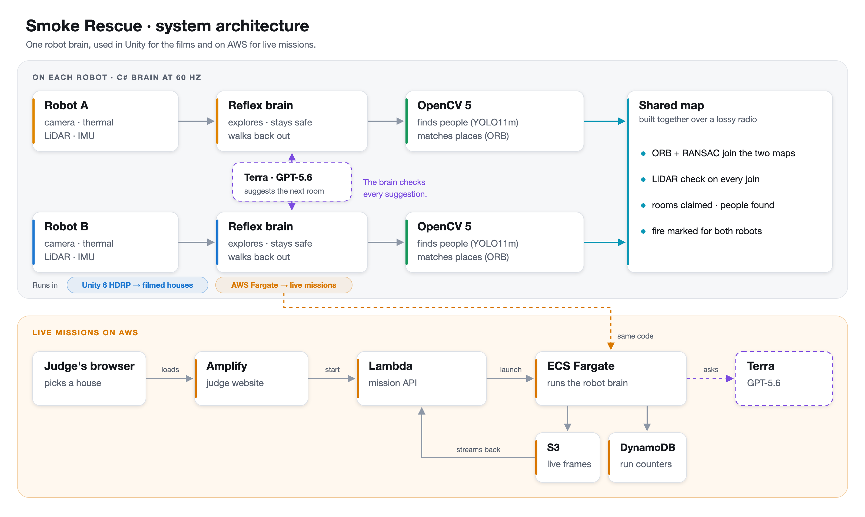
Figure 1. One robot brain, used in Unity for the films and on AWS for live missions.
Each robot runs the same brain, written in C# at 60 Hz. It keeps the robot safe with no language model in the loop. A mission follows five steps:
1. Enter. Walk straight in along the launch line, 1.5 m past the door.
2. Search. Build an occupancy grid from LiDAR and depth. Pick the next room from a room ledger. Claim doors so the two robots split the house.
3. Confirm people. Accept a person only from an OpenCV 5 detection within 4.5 m. Walk up to anything farther away or warm, and look again.
4. Avoid fire. Mark hot rooms. Keep 1.2 m from measured fire.
5. Walk out. At the deadline, return to the door by a planned route, or by the robot's own trail.
Shared map. Map layers, room claims, people found and ORB keyframes travel over the radio. Each robot places its partner's data with the measured link between the two maps.
Agent. Terra, a GPT-5.6 agent, reads each robot's report and suggests the next room. The brain checks every suggestion and can refuse it.

4. OpenCV 5 implementation
Only an OpenCV 5 detection confirms a person. Heat on the thermal camera is a reason to go and look, never a confirmation.
Task | OpenCV 5 method | Measured
Find people | cv2.dnn runs YOLO11m. The depth image gives the range. | Precision 0.99, recall 0.51 per view, range error 0.30 m (3,378 frames)
Find fire and body heat | Thermal thresholds, contours, morphology | Fire at 200 °C and above, people at 28 to 40 °C
Join two maps | ORB features with depth, Hamming kNN, RANSAC rigid fit | 0 false joins in about 30,000 wrong pairs
Build a 3D map | HashTSDF volume per robot | About 1 million surface points per robot
Agent tools | Laplacian variance, dark channel, contours | Visibility check in 8.6 ms

How two maps become one
The launch pads give both robots a rough shared frame. A small pad error still turns a whole map. In the one-door house, robot B started 2.39 degrees off its pad. Over 15 m, that moves its far walls by about 0.6 m.
1. Every 2 s, each robot sends an ORB keyframe with depth (7.6 KB) over the radio.
2. The partner matches it only against its own views near the expected place.
3. RANSAC needs 10 or more inliers, and the partner's LiDAR sweep must fit the map.
4. Two matching views, at least 1 m apart, set the link.
Result. The link measured robot B's tilt as 2.42 degrees against a true 2.39. Wall agreement between the maps rose from 72 % to 97 %.

5. AWS deployment
Judges start live missions on AWS. Each mission runs the same robot brain as the films.
Service | Role
AWS Amplify | Hosts the judge website
AWS Lambda | Mission API
Amazon ECS on Fargate (ARM64) | Runs one robot-brain task for each mission
Amazon S3 | Holds the live mission frames
Amazon DynamoDB | Counts running missions and agent calls
GPT-5.6 Terra (Azure OpenAI) | Room suggestions, called from the mission task

A live mission runs in four steps:
1. The judge picks a house and starts the mission.
2. The mission API starts a Fargate task with the robot brain.
3. The task streams robot positions, the shared map and the people found.
4. The website draws the house in 3D. Terra's suggestions appear in the team radio.

6. Evaluation
Every score comes from ground truth that no robot code can read.

6.1 Benchmark: 39 floor plans the brain never saw
Measure | Two robots | One robot | Difference
People found | 99.0 % | 92.3 % | +6.7 points (p = 0.002)
Rooms entered | 99.2 % | 93.9 % | +5.3 points (p = 0.002)
Time to confirm a person | 67.2 s | 94.5 s | 27.3 s sooner
False people reported | 0 | 0 | none
Every robot back outside | 60 % | 90 % | 30 points lower

HouseExpo floor plans, one mission per house and set-up, Wilcoxon tests on paired houses. Two robots find more people, sooner. Getting every robot back out is harder with two, and we report that plainly.

6.2 The three filmed missions
House | People found | False | Both robots out | Time
Three-bed ranch | 5 of 5 | 0 | Yes | 6:16
L-shaped ranch | 4 of 5 | 0 | Yes | 6:53
One-door house | 4 of 5 | 0 | Yes | 7:44

6.3 Agent evidence
Measure | Value
OpenCV 5 calls by the agents | 2,727
Orders backed by an OpenCV result | 990 of 1,571 (63 %)
Cited results that match a real call | 824 of 863
Orders the guardrails refused | 169

From 34 recorded agent runs. Orders without evidence, such as a turn or a team message, do not need it.

7. Limitations
- One look is not enough. A single view finds a visible person about half the time, so the robot comes close and looks again.
- Getting out is the weakest part. Every robot got back out in 60 % of two-robot benchmark missions. All three films end with both out, but three films are not a benchmark.
- Map links are sparse. Robots that never see the same place do not join their maps.

8. Responsible use
A wrong "nobody is in that room" can cost a life. We designed around that failure.
- Heat alone never counts. Only an OpenCV detection, checked up close, confirms a person.
- The agent advises. Terra cannot override the safety code. The brain checks every suggestion.
- Honest scoring. Robot code cannot read ground truth. No setting names a house.
- Not ready for a real fire. That needs hardware trials, a validated fire model and trained responders in the loop.
Build, pinned versions and deploy steps: https://github.com/TashonBraganca/smoke-rescue. Live website: https://main.dyhvyjxo1bz4g.amplifyapp.com.

