

VisionGuard: AI-Assisted Visibility Enhancement and Incident Retrieval for Smart CCTV Surveillance

Technical Report
SE - 801 - Software Project Lab III

Submitted By:
Shahid-E-Kaiser Md. Tashrif | BSSE-1448

Supervised By: Dr. Sumon Ahmed Associate Professor
Institute of Information Technology University of Dhaka

Submitted On: August 02, 2026



Letter of Transmittal
02 August 2026
BSSE 4th Year Exam Committee Institute of Information Technology University of Dhaka

Subject: Technical Report Submission, VisionGuard: AI-Assisted Visibility Enhancement and Incident Retrieval for smart CCTV surveillance

Sir,
I am submitting the technical report for our Software Project Lab 3, “VisionGuard: AI-Assisted Visibility Enhancement and Incident Retrieval for Smart CCTV Surveillance”. This report comprehensively covers the project's technical details, including design, implementation and testing phases. While I have tried to do my best, I welcome your feedback for improvement.
Thank you for your kind consideration.

Sincerely,
Shahid-E-Kaiser Md. Tashrif BSSE 1448
Institute of Information Technology University of Dhaka

02.08.2026

Supervisor’s Signature

Acknowledgement
I would like to thank my supervisor, Dr. Sumon Ahmed, for the guidance and feedback provided throughout the development of VisionGuard AI. Their input on scoping the hybrid dehazing architecture and on keeping the system CPU-friendly and explainable has directly shaped the design decisions documented in this report.

Abstract
VisionGuard AI is a lightweight, CPU-friendly CCTV surveillance platform that restores visibility in hazy or smoggy footage in real time. Rather than relying on an end-to-end deep learning model, it uses a hybrid approach: the Dark Channel Prior (DCP) produces a physics-based estimate of a scene's transmission map, and a small refinement CNN corrects that estimate before the clean image is reconstructed through the atmospheric scattering model. The system's central optimization is region-of-interest (ROI) processing, dehazing runs only on the portion of a frame flagged by motion detection, rather than on every pixel of every frame, which keeps the pipeline fast enough for real-time use on ordinary CPU hardware and suitable for edge deployment without a GPU.
Beyond the dehazing pipeline itself, VisionGuard AI supports live webcam and IP camera feeds as well as uploaded video files, automatically logs every enhanced event with its timestamp, snapshot, and region coordinates, and lets operators review that history through both a chronological timeline and a natural-language search interface backed by the Claude API. Access is restricted to admin-seeded operator accounts authenticated with JWTs, with no open self-registration. The target users are security guards and surveillance operators in settings such as campuses, warehouses, and parking lots, where hazy conditions can otherwise leave footage unusable exactly when it matters most.

Table of Contents
- Project Overview 6
  - Project Title 6
  - Problem Statement 6
  - Objectives 6
  - Scope 7
  - Deliverables 7
- Requirements Analysis 8
  - Functional Requirements 8
  - Non-functional Requirements 8
  - Stakeholders 9
- System Modeling 10
  - Use Case Diagram 10
  - Activity Diagram 16
    - User Management 17
    - Camera & Feed Management 18
    - Motion Detection & ROI Extraction 19
    - Hybrid Dehazing Pipeline 20
    - Event Logging 21
    - Timeline/Event Browser 21
    - NL Event Search 22
- Data & Information Modeling 23
- Preliminary Test Plan 26
  - Testing Objectives 26
  - Features to be Tested 26
- Timeline 28
7. Component-Level Design 29
8. Interface Design 39
9. Implementation 44
10. Testing 46
11. User Manual 51
12. Repository, Installer and Final Deliverables 54

Project Overview

Project Title
VisionGuard: AI-Assisted Visibility Enhancement and Incident Retrieval for Smart CCTV Surveillance

Problem Statement
CCTV footage from surveillance cameras degrades sharply in haze, smog, and fog, which is exactly when security teams need it most. Visibility loss during these conditions can hide intrusions, accidents, and other events a surveillance system exists to catch. Modern image dehazing research has moved toward end-to-end deep learning models that produce strong results, but those models are typically too heavy to run on the CPU-only hardware found in most guard rooms and edge installations, and running full-frame enhancement on every frame of a live feed is wasteful when most of a frame is static background with nothing happening in it. VisionGuard addresses this by combining a physics-based dehazing model (the Dark Channel Prior) with a lightweight CNN that only refines the prior's transmission estimate, and by restricting all of that computation to the small region of a frame where motion was actually detected — keeping the system real-time, explainable, and deployable without a GPU.

Objectives
- Recover clear visibility in hazy or smoggy CCTV footage without requiring specialized hardware.
- Keep the dehazing pipeline CPU-friendly and capable of real-time (30 FPS target) operation by only processing regions flagged by motion detection, not entire frames.
- Preserve a hybrid, explainable architecture — physics prior (DCP) plus a lightweight CNN refinement — rather than an opaque end-to-end deep learning model.
- Automatically log every enhanced event (timestamp, snapshot, event type, ROI coordinates) so operators have a retrievable record without manual effort.
- Let operators retrieve past events through both a chronological timeline and a natural-language search interface.
- Restrict system access to authenticated operator and administrator accounts, with no open self-registration.

Scope

In scope (MVP):
- Live webcam / IP camera feed ingestion, plus uploaded video file processing.
- Motion detection that skips dehazing entirely when no motion is present.
- ROI extraction from the motion mask, so only the suspicious region is processed.
- The hybrid DCP + Tiny CNN dehazing pipeline (dark channel, Top-K atmospheric light, coarse transmission, CNN refinement, radiance recovery, gamma correction, merge back into frame).
- Event logging with timestamp, snapshot image, event type, and ROI coordinates.
- A timeline / event browser for chronological review.
- Natural language event search (e.g. "any motion last night?") backed by the Claude API.
- JWT-based authentication with admin-seeded accounts (no open signup).

Out of scope (future work, not implemented):
- Object detection / intrusion classification.
- ONNX Runtime inference.
- FFmpeg integration.
- Multi-camera support.
- Temporal transmission smoothing across frames.

Deliverables
- A FastAPI backend implementing the motion-gated, ROI-based hybrid dehazing pipeline.
- A trained Tiny CNN transmission-refinement model with saved weights (backend/weights/tiny_cnn.pth).
- A PostgreSQL-backed event store with repository-layer access for cameras/video sources and events.
- A JWT authentication system with admin-seeded accounts and operator account management.
- A React + TypeScript dashboard for live feed viewing, event timeline browsing, and natural-language event search.
- A preliminary automated test suite covering the dark channel, transmission estimation, CNN inference, motion detection, and ROI extraction modules.

Requirements Analysis

Functional Requirements
- FR-1: The system will allow an operator to start a live feed from a webcam or IP camera, or upload a recorded video file for processing.
- FR-2: The system will allow an operator to stop an active feed at any time and view the latest processed frame while a feed is running.
- FR-3: The system will continuously monitor incoming frames for motion and skip the dehazing pipeline entirely when no motion is detected.
- FR-4: When motion is detected, the system will extract only the region of interest (ROI) containing that motion rather than processing the full frame.
- FR-5: The system will dehaze the extracted ROI using the Dark Channel Prior for an initial transmission estimate, refine that estimate with a Tiny CNN, and reconstruct the clean region via the atmospheric scattering model before merging it back into the original frame.
- FR-6: The system will automatically log every dehazing event with its timestamp, a snapshot image, the event type, and the ROI coordinates.
- FR-7: The system will allow an operator to browse logged events in chronological order on an Events page, showing each event's snapshot and details.
- FR-8: The system will allow an operator to enter a plain-English query (e.g. "any motion last night?") that is parsed into structured filters and used to retrieve matching logged events; if no time range can be determined, the system shall return all events rather than failing.
- FR-9: The system will require authentication (JWT) for every endpoint except login; an admin account is seeded on first startup, and only the admin can create operator accounts.

Non-functional Requirements
- Performance: The pipeline must sustain a target of 30 FPS on CPU-only hardware by dehazing only the motion ROI, not the full frame, and by skipping the pipeline entirely on static frames.
- Security: Passwords are hashed and never stored or logged in plaintext; tokens are signed and verified with JWT.
- Reliability: Every module raises meaningful, typed exceptions instead of silently swallowing errors, and model weights are loaded once at startup rather than per-request, so a missing or corrupt weights file fails fast and visibly.

- Scalability: Business logic is isolated in stateless service modules with dependency-injected pipeline/camera state (no global mutable state), so the system can be extended to additional camera sources without redesigning the core pipeline.
- Maintainability: The codebase follows a strict layered architecture (routers, controllers, services, repositories) with Pydantic schemas for every request/response and no ORM models leaking into the API layer, keeping responsibilities isolated and the system easy to extend.
- Usability: Operators interact with a single dashboard for live viewing, timeline browsing, and natural-language search, with all server state managed through React Query so the UI reflects backend state without manual refresh logic.

Stakeholders
- Operators: security guards, building surveillance operators, university campus surveillance staff, and warehouse/parking-lot monitoring teams who run live feeds, review events, and search the timeline day to day.
- Administrator: manages operator accounts (the only account-creation path in the system) and has full access to all operator-level functionality.

System Modeling
Scenario-based modeling is used here to depict how VisionGuard AI behaves under real usage scenarios. A use case diagram visually represents how the system interacts with its actors to achieve specific goals, showing the relationships between use cases (system functionalities) and the actors (users or systems) that trigger them. Following this convention, the use case diagrams for VisionGuard AI are broken into a Level 0 overview, a Level 1 module breakdown, and Level 2 diagrams for each individual module if needed.

  - Use Case Diagram

Level: 0
Use Case ID: 0
Name: VisionGuard AI: Detect, Enhance and Search
Primary Actor: Admin, Operator

Secondary Actor: None

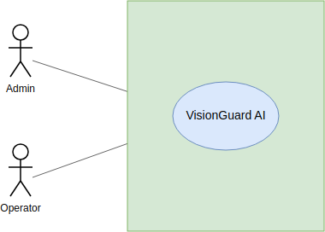

Fig 1: Use Case Level 0 (VisionGuard)

Level: 1
Use Case ID: 1
Name: VisionGuard AI: Detect, Enhance and Search
Primary Actor: Admin, Operator

Secondary Actor: None
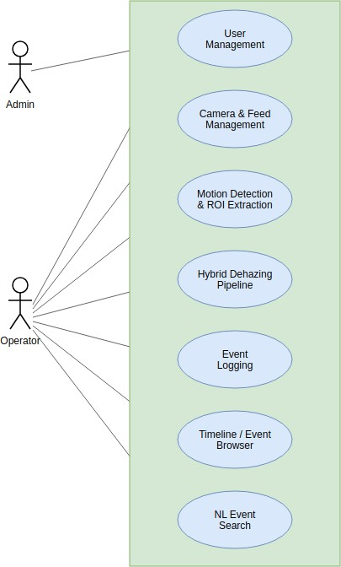

Fig 2: Use Case Level 1 (VisionGuard)
Level: 1.1

Use Case ID: 1.1
Name: User Management Primary Actor: Admin, Operator Secondary Actor: None

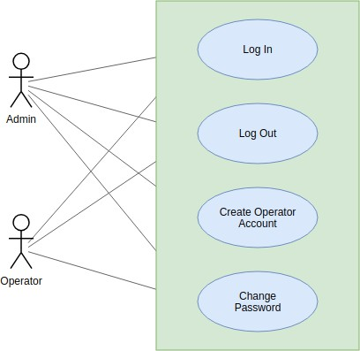

Fig 3: Use Case Level 1.1 (VisionGuard)
Level: 1.2

Use Case ID: 1.2
Name: Camera & Feed Management Primary Actor: Operator Secondary Actor: None
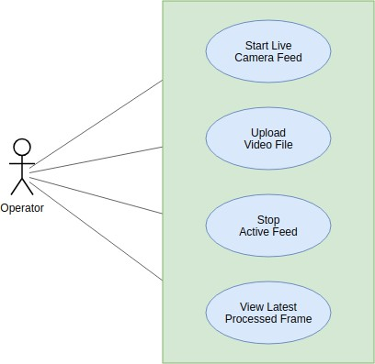

Fig 4: Use Case Level 1.2 (VisionGuard)

Level: 1.3

Use Case ID: 1.3
Name: Motion Detection & ROI Extraction Primary Actor: System (Capture Worker) Secondary Actor: None

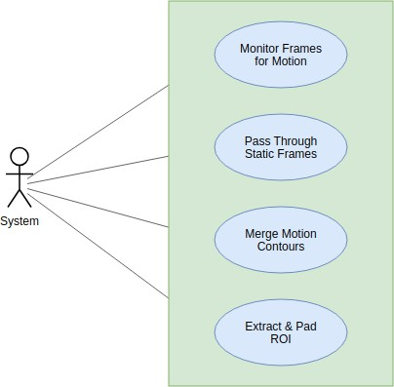

Fig 5: Use Case Level 1.3 (VisionGuard)

Level: 1.4

Use Case ID: 1.4
Name: Hybrid Dehazing Pipeline Primary Actor: System (Capture Worker) Secondary Actor: None

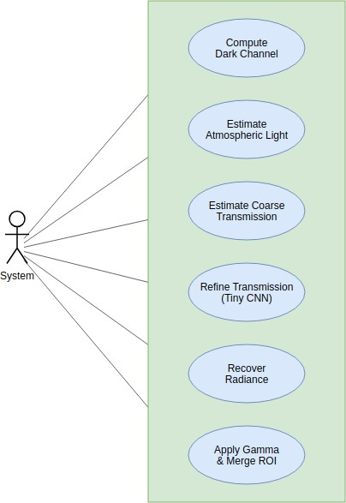

Fig 6: Use Case Level 1.4 (VisionGuard)

Level: 1.5

Use Case ID: 1.5
Name: Event Logging
Primary Actor: System (Capture Worker)

Secondary Actor: None

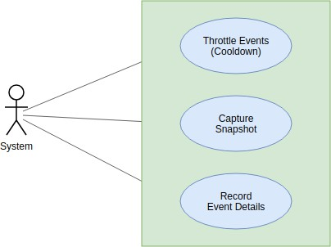

Fig 7: Use Case Level 1.5 (VisionGuard)
Level: 1.6

Use Case ID: 1.6
Name: Timeline / Event Browser Primary Actor: Operator Secondary Actor: None

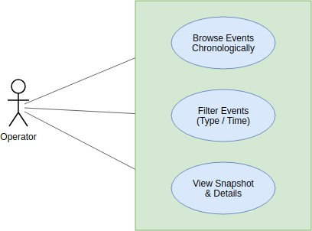

Fig 8: Use Case Level 1.6 (VisionGuard)

Level: 1.7

Use Case ID: 1.7
Name: NL Event Search Primary Actor: Operator Secondary Actor: LLM API
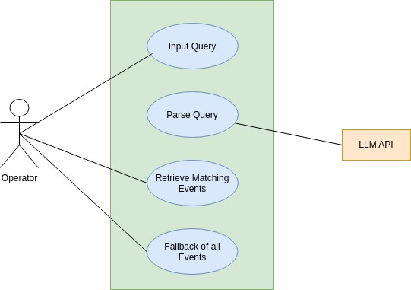
Fig 9: Use Case Level 1.7 (VisionGuard)

Activity Diagram
An activity diagram models the flow of control within a use case as a sequence of actions and decision points, capturing branching logic, loops, and parallel outcomes that a use case diagram alone cannot show. Following this convention, the activity diagrams for VisionGuard AI first trace the per-frame processing loop as a single end-to-end flow (Level 1), then break it down per module to mirror the use case breakdown in Section 3.1 (Levels 1.1–1.7).

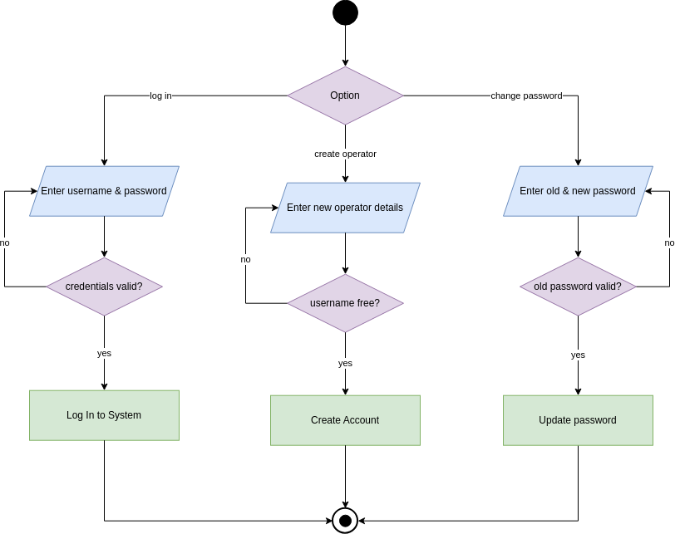

User Management

Fig 10: User Management

Camera & Feed Management

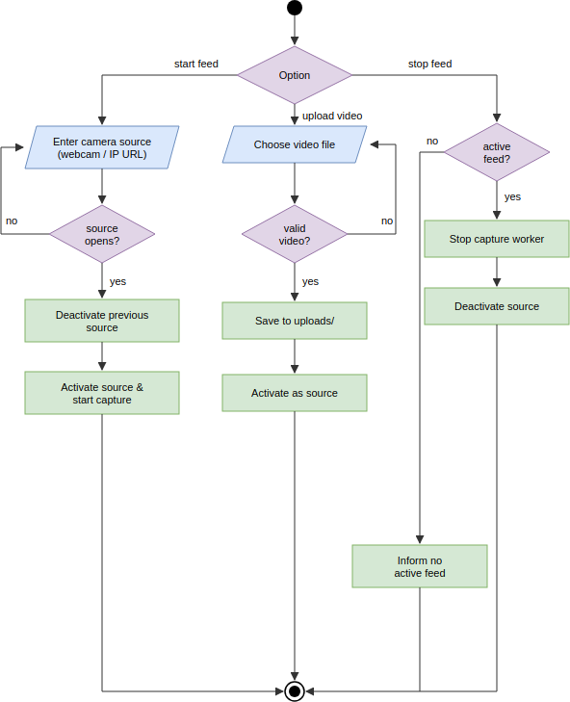
Fig 11: Camera and Feed Management

Motion Detection & ROI Extraction

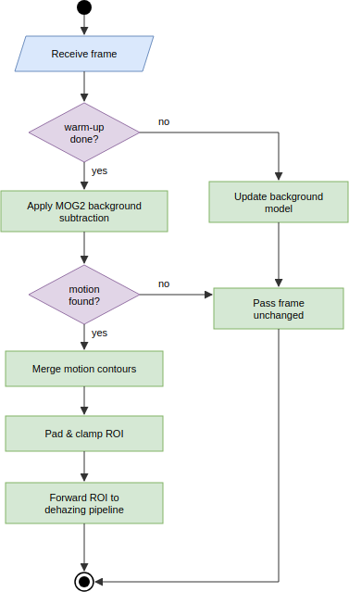

Fig 12: Motion Detection and ROI

Hybrid Dehazing Pipeline

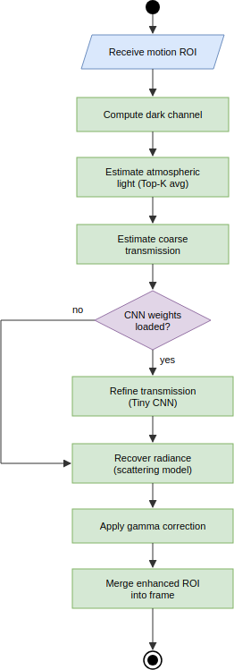

Fig 13: Hybrid Dehazing Pipeline

Event Logging
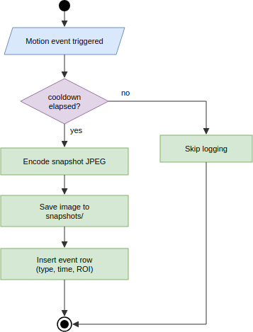

Fig 14: Event Logging

Timeline/Event Browser
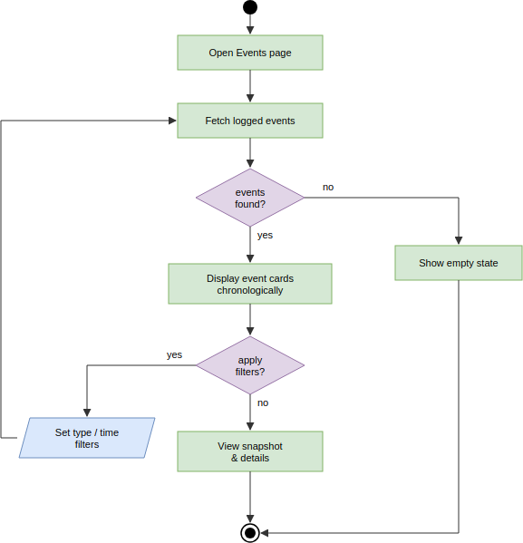

Fig 15: Event Browser

NL Event Search
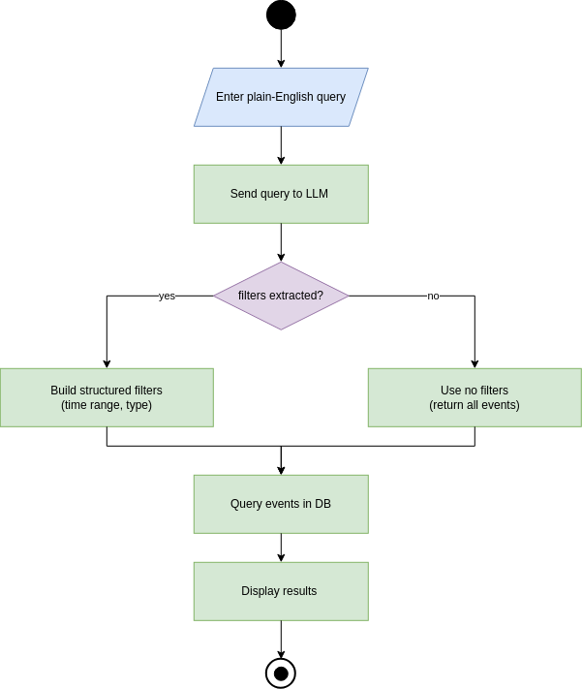

Fig 16: Event Search

Data & Information Modeling
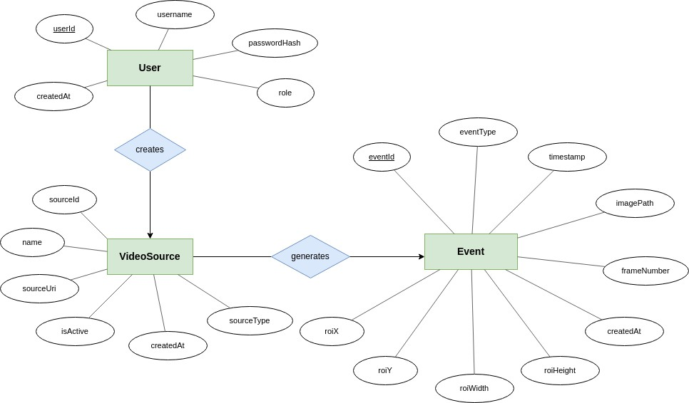
Fig 17: ER Diagram of VisionGuard

A User creates many VideoSource records (1:N); a VideoSource generates many Event records (1:N). The database schema, including primary and foreign keys, follows:

Table 1: User table for database schema

Attribute Name | Data Type | Key/Constraints
id | INTEGER | Primary Key, autoincrement
username | VARCHAR | Unique, not null
password_hash | VARCHAR | Not null (bcrypt hash, never plaintext)
role | VARCHAR | Not null ("admin" or "operator")
created_at | DATETIME | Not null, server default now

Table 2: VideoSource table for database schema

Attribute Name | Data Type | Key/Constraints
id | INTEGER | Primary Key, autoincrement
name | VARCHAR(255) | Not null
source_type | VARCHAR(20) | Not null (webcam / IP camera /  uploaded video)
source_uri | TEXT | Not null
is_active | BOOLEAN | Not null, default false
created_at | DATETIME | Not null, server default now
created_by | INTEGER | Foreign Key → User.id, nullable

Table 3: Event table for database schema

Attribute Name | Data Type | Key/Constraints
id | INTEGER | Primary Key, autoincrement
source_id | INTEGER | Foreign Key → VideoSource.id, not null
event_type | VARCHAR(30) | Not null
timestamp | DATETIME | Not null
image_path | TEXT | Not null
roi_x | INTEGER | Not null
roi_y | INTEGER | Not null
roi_width | INTEGER | Not null
roi_height | INTEGER | Not null
frame_number | INTEGER | Nullable
created_at | DATETIME | Not null, server default now

events are indexed on (source_id, timestamp) and (event_type, timestamp) to keep timeline browsing and natural-language search filters fast as the event log grows.

AI-Based Project Dataset Description
The Tiny CNN transmission-refinement model is trained on two complementary data sources rather than a single fixed dataset, since VisionGuard AI's neural component only needs to learn how to correct the Dark Channel Prior's errors, not to generate images from scratch.
- Dataset source:
- A synthetic haze generator that procedurally creates training samples: a random textured clean scene and a smooth, random ground-truth transmission field are combined through the atmospheric scattering model (I = J·t + A·(1−t)) to synthesize a hazy image. The network's input channels (grayscale ROI, dark channel, coarse transmission) are computed using the project's actual DCP implementation, so the

CNN learns to correct that specific estimator's real errors rather than an idealized one.
- The REVIDE real-world paired haze dataset (CVPR 2021), which records the same indoor scenes with and without machine-generated haze, giving pixel-aligned hazy/clear frame pairs for validating the model on real haze rather than only synthetic haze.
- Number of samples: 3,000 synthetic samples per training epoch by default (effectively unlimited and reproducible, generated deterministically per RNG seed/index), combined with 42 REVIDE training scene folders (1,697 hazy training images) and 6 REVIDE test scene folders (284 hazy test images) used for real-data validation.
- Features: each sample's input is a 3-channel stack — grayscale hazy ROI, dark channel, and coarse DCP transmission map — matching the Tiny CNN's documented input in this report's pipeline description.
- Labels: there is no classification label; the training target is a refined transmission map. For synthetic samples the ground-truth transmission field is known exactly; for REVIDE's real pairs (which have no true transmission map) the coarse DCP transmission is used as a physically-grounded anchor. The model is optimized primarily through a self-supervised image reconstruction loss — the L1 distance between the image recovered using the predicted transmission and the true clean image — with a small auxiliary L1 term against the known transmission on synthetic data.
- Data preprocessing: images are cropped to 96×96 training patches, the DCP is computed with a 15-pixel erosion window, and inputs/targets are normalized to [0, 1] float32 before being batched (batch size 16) for training with Adam (learning rate 1e-3, halved every 8 epochs) over 15 epochs by default, with the
best-validation-loss weights saved to backend/weights/tiny_cnn.pth.

Preliminary Test Plan

Testing Objectives
- Verify that all functional requirements listed in Section 2.1 behave as specified.
- Ensure the motion-gated, ROI-only dehazing pipeline remains stable under continuous frame processing.
- Validate that error and edge-case handling (missing CNN weights, invalid uploads, unparseable search queries) degrades gracefully instead of crashing.
- Evaluate whether the pipeline meets its real-time performance target on CPU-only hardware.

Features to be Tested

Table 4: High-level testing plan for VisionGuard AI

# | Title | Scenario | Steps | Expected Outcome
1 | Operator Login | Verify secure login flow. | 1. Enter valid username/password  . 2. Submit POST  /auth/login. | A signed JWT access token is issued and the frontend stores it  for subsequent requests.
2 | Admin-Only Account Creation | Restrict operator account creation to admins. | - Log in as an operator. 2. Attempt POST  /auth/users. | Request is rejected (403); no row is created in the User  table.
3 | Live Feed Start | Start a webcam/IP camera feed. | - Call POST  /start-camera  with a source URI.  - Check /frame. | The capture worker activates the source and /frame returns  a processed frame.
4 | Video Upload Validation | Upload a video file for processing. | - POST  /upload-video with an invalid (non-video) file. | The operator receives a clear validation error rather than a silently broken stream.
5 | Motion-Skip Behavior | Confirm dehazing is skipped when idle. | - Feed static frames with no motion. | The dehazing pipeline is never invoked; frames pass through unchanged, keeping CPU usage low.
6 | ROI Extraction Correctness | Confirm only the motion region is processed. | - Feed a frame with a single moving object. | The extracted ROI bounding box tightly (with padding) covers the motion contour, not the full frame.

# | Title | Scenario | Steps | Expected Outcome
7 | Dehazing Reconstruction Quality | Verify the hybrid pipeline improves visibility. | 1. Run a hazy ROI through the full pipeline (DCP → CNN → radiance recovery → gamma). | The recovered ROI has measurably higher contrast/lower haze than the  coarse-DCP-only output.
8 | CNN Weights Missing Fallback | Ensure pipeline degrades gracefully without trained weights. | 1. Start the pipeline with MODEL_PATH pointing to a missing file. | The pipeline falls back to the unrefined DCP  transmission instead of crashing.
9 | Event Logging & Cooldown | Verify events are throttled, not logged every frame. | 1. Trigger continuous motion for several seconds. | Exactly one event is logged per cooldown window, each with correct timestamp, image  path, and ROI coordinates.
10 | Timeline Browsing | Verify  chronological event retrieval. | 1. Log several  events. 2. Call GET  /events. | Events are returned  in chronological order with snapshot and metadata intact.
11 | NL Event Search  — Time Parsing | Verify natural language queries resolve to filters. | 1. Call GET  /events/search  ?q=any motion last night?. | Claude API returns a parsed time range; only events  within that range are returned.
12 | NL Event Search  — Fallback | Verify unparseable queries do not fail. | 1. Submit a vague query with no  extractable time/type. | The system returns all events rather  than raising an error.
13 | System Status  Check | Confirm health  endpoint reflects real pipeline state. | 1. Call GET  /system-status  while a feed is active. | Response reports  the camera feed and dehazing pipeline as running.
14 | Feed Stop Without Active Source | Guard against invalid stop requests. | 1. Call POST  /stop-camera  with no active feed. | The operator is informed no feed is active rather than the server raising  an unhandled error.
15 | Auth Enforcement on Protected Routes | Confirm  router-level auth guards all  non-login endpoints. | 1. Call GET  /events without an Authorization header. | Request is rejected (401) before reaching any controller or service logic.

Timeline

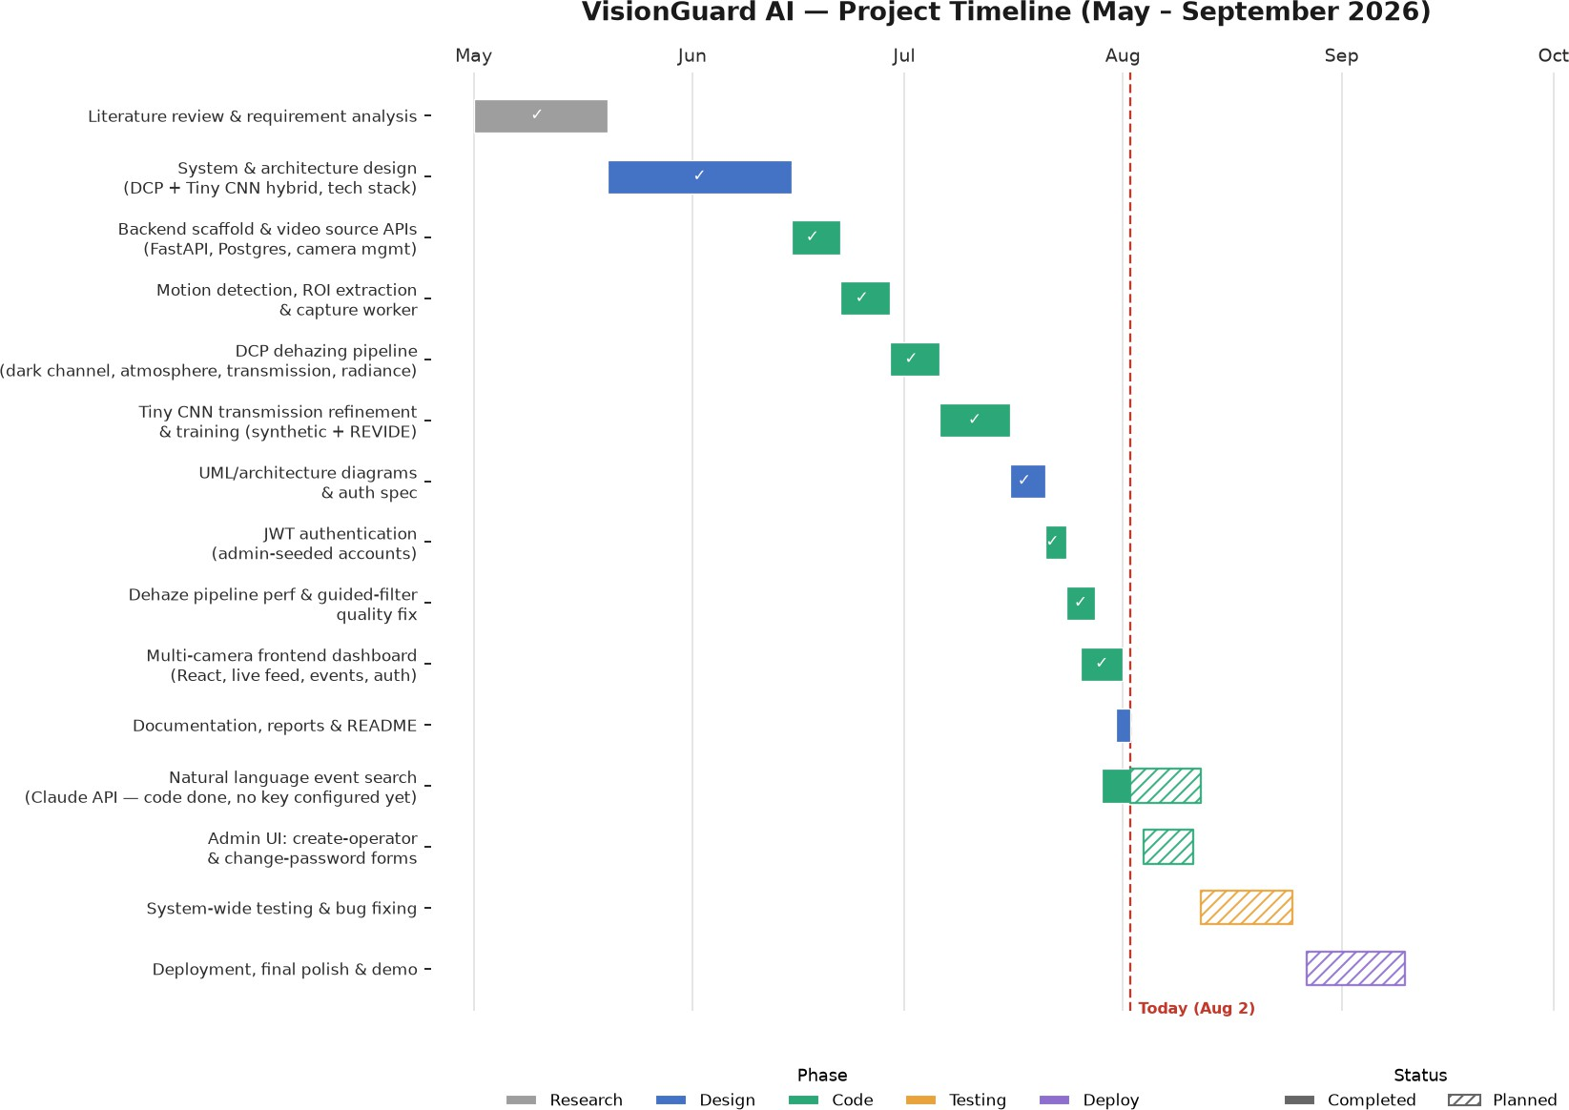
Fig 18: Gantt Chart of VisionGuard Progress Timeline

Component-Level Design
This chapter extends the models of Chapters 3 and 4 with the component-level design of the final system: design classes, persistent data sources, behavioural models, deployment, and the refactoring decisions taken. Features added after the technical report (multi-camera capture, detection zones, arming schedules, event video clips, analytics and account management) are included, so this chapter supersedes the earlier scope and data tables where they differ.

Architecture Overview
A React single-page application talks to a FastAPI backend over REST with a JWT bearer token. The backend has strict layers: routers (routes only), controllers (validation, error to HTTP status mapping), services (all business logic), repositories (all SQL) and PostgreSQL. Long-running video work runs in background capture threads owned by a CapturePool, never in request handlers. Authentication is enforced only by router-level dependencies.
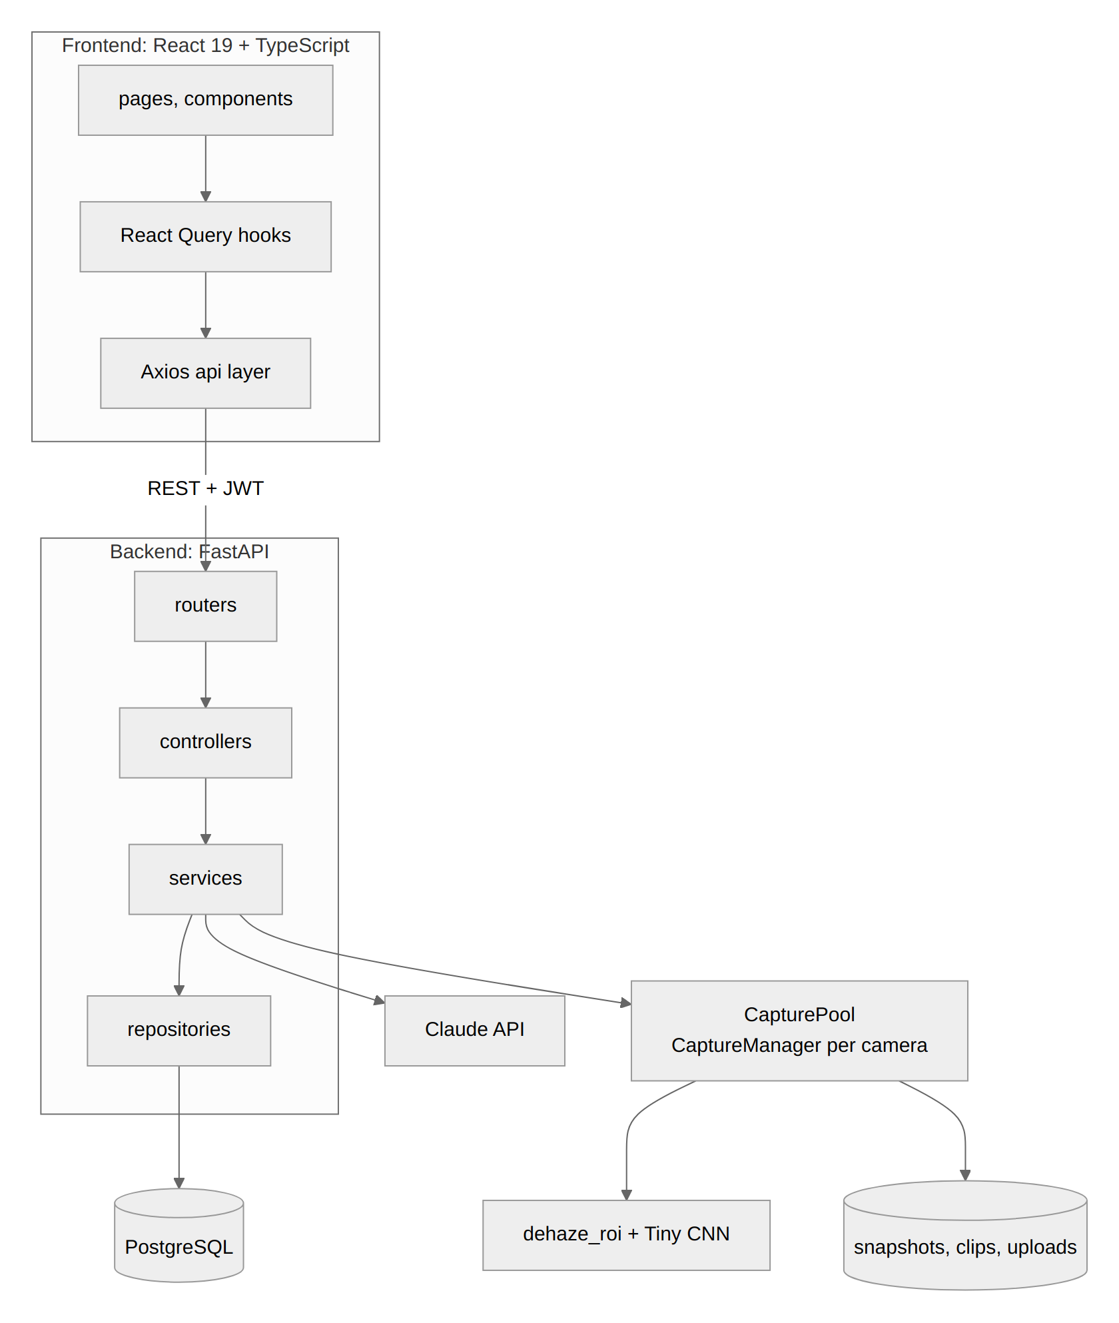
Fig 19: High-level architecture of VisionGuard

Design Classes
The classes below correspond to the problem domain (users, cameras, events, detection settings) and to the control objects that run the surveillance loop.
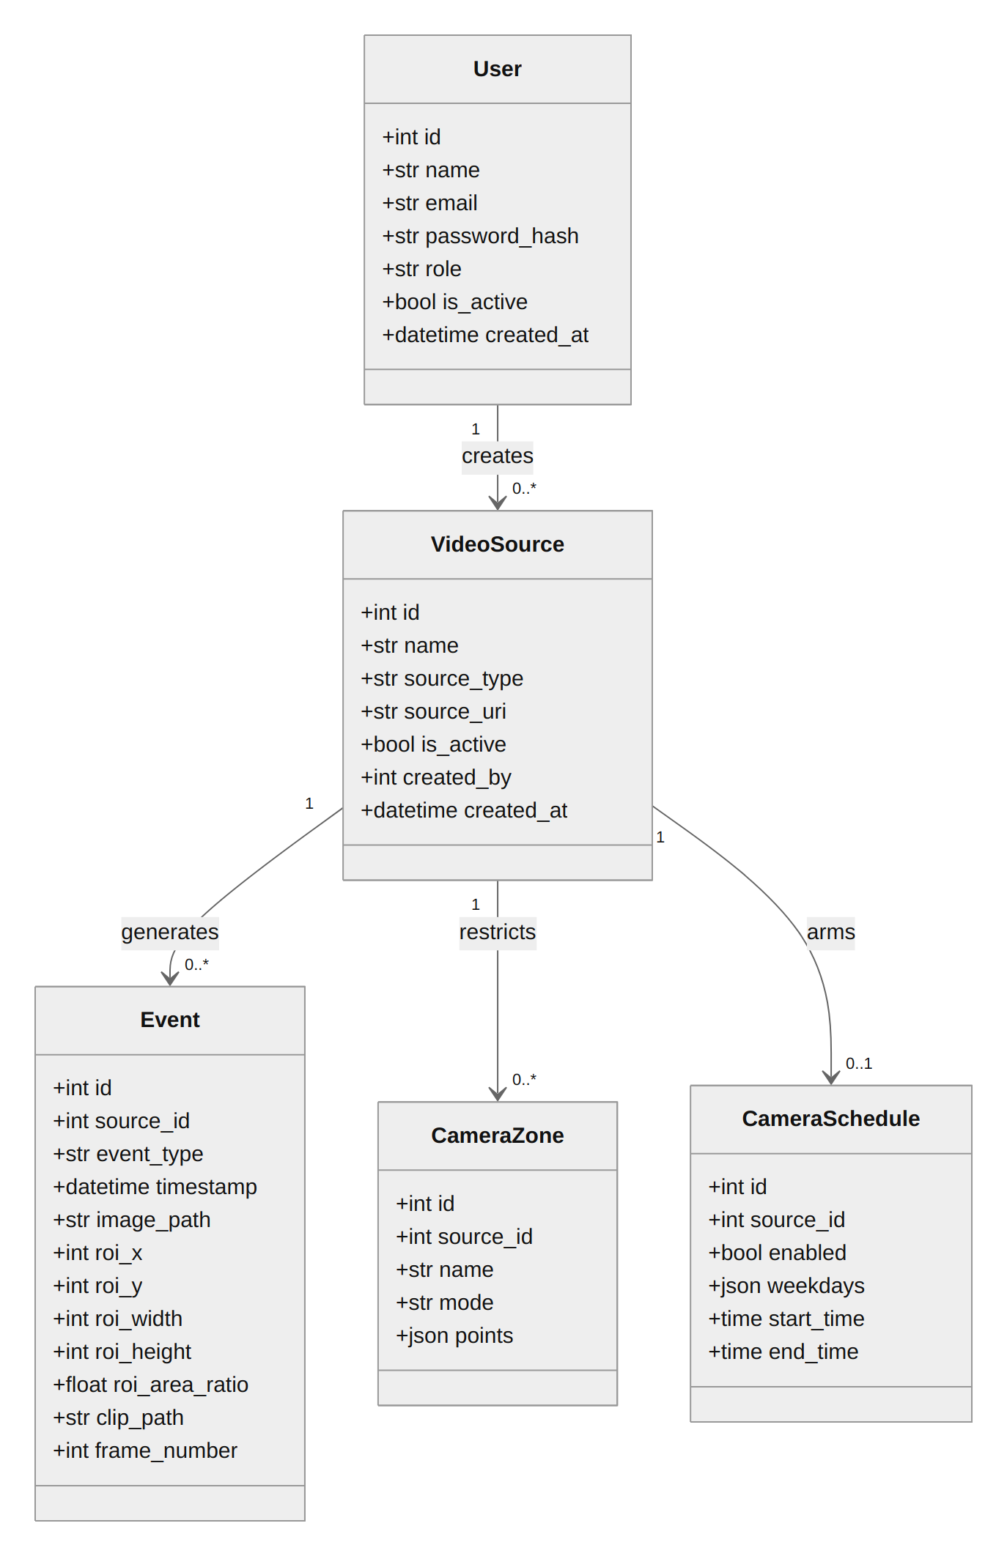  Fig 20: Entity (domain) classes | 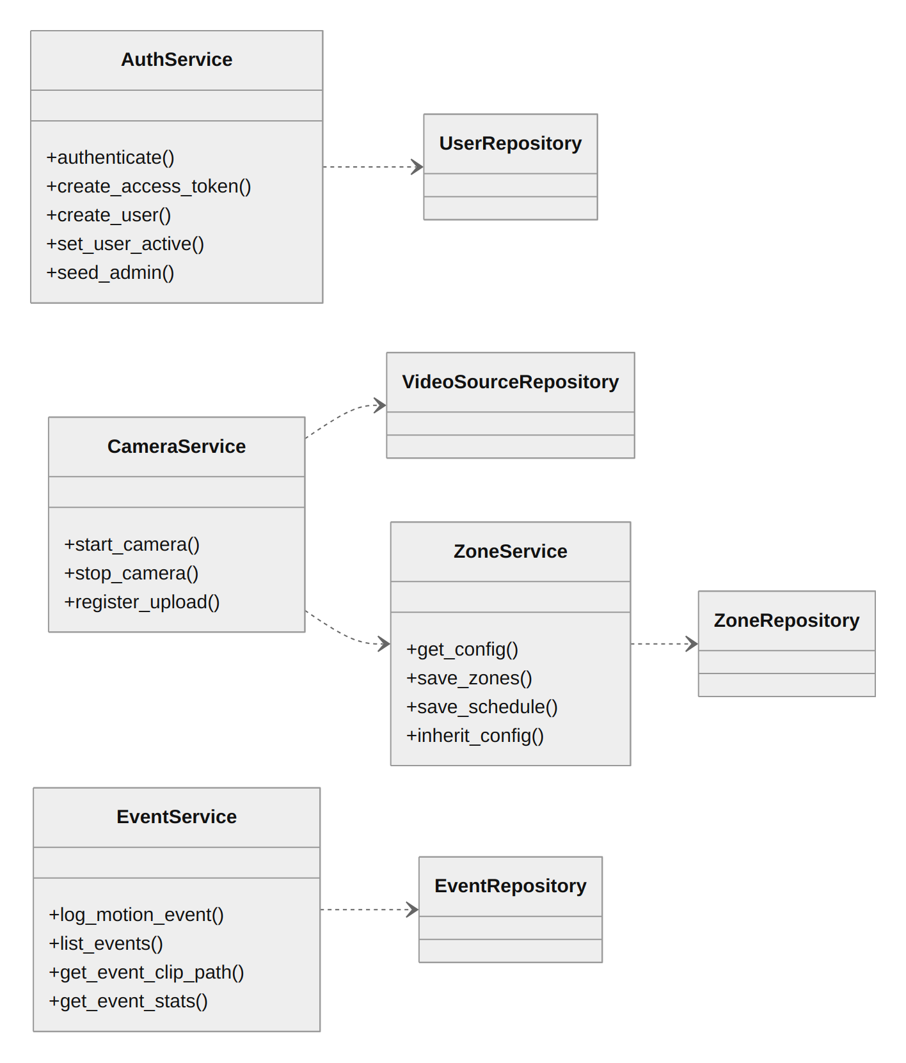  Fig 21: Service classes and repositories

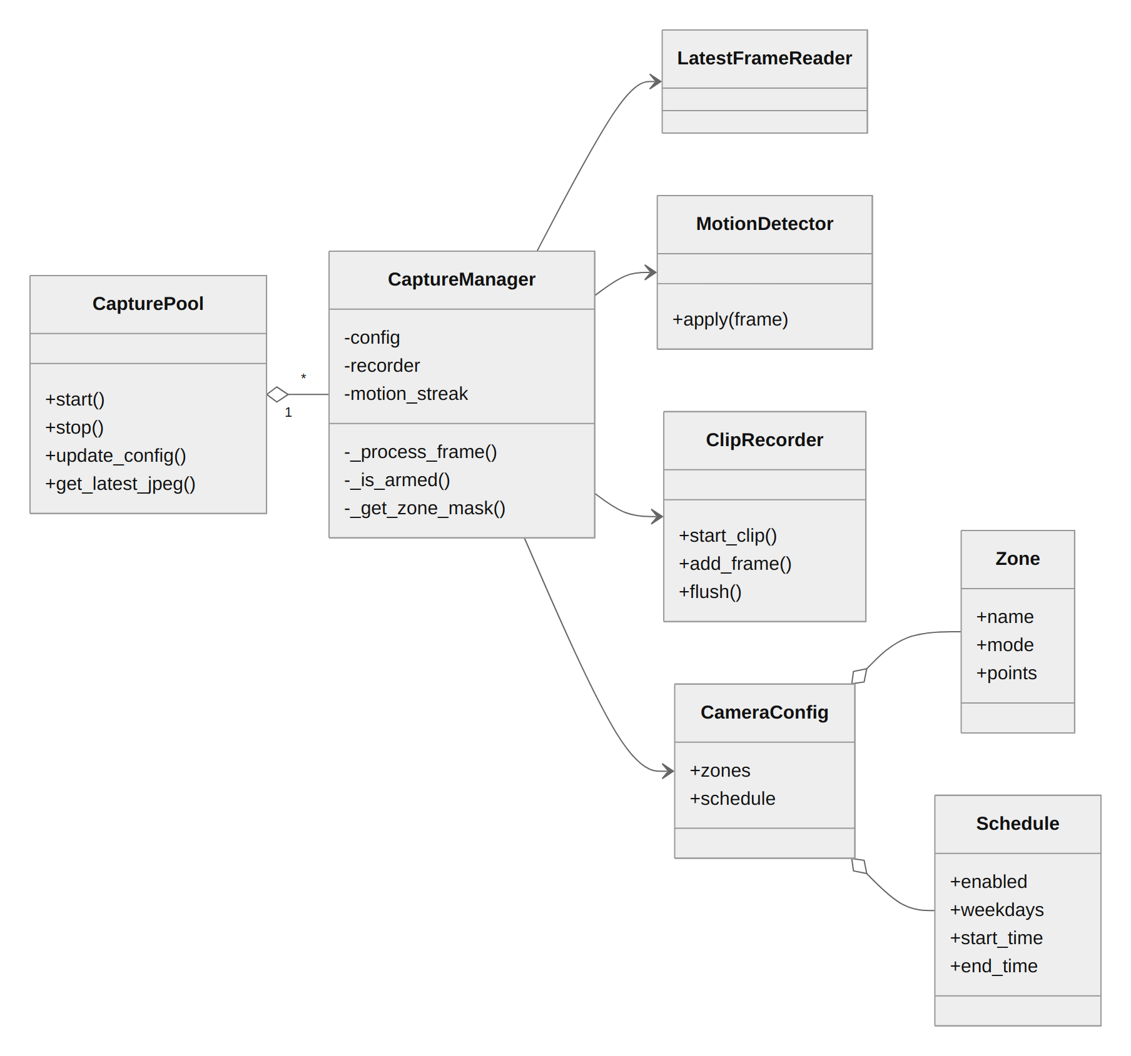
Fig 22: Runtime control classes of the capture subsystem

Table 5: Design classes and their responsibilities
Class | Responsibility | Collaborators
User | Account with role (admin or operator) and is_active flag; password stored only as a bcrypt hash | VideoSource
VideoSource | One camera, stream or uploaded file; is_active marks a running feed | User, Event, CameraZone, CameraSchedule
Event | One logged motion event: time, snapshot path, clip path, ROI box and ROI area ratio | VideoSource
CameraZone | Named include or exclude polygon in normalized (0..1) coordinates | VideoSource
CameraSchedule | Weekdays and a daily time window during which a camera is armed | VideoSource
CapturePool | Owns one CaptureManager per active source; start, stop, update config, latest preview JPEG. Injected with Depends, not a global | CaptureManager
CaptureManager | One capture thread: reads frames, applies schedule and zones, motion detection, ROI, dehazing, persistence and cooldown rules; feeds the clip recorder and event logging | MotionDetector, ClipRecorder, CameraConfig, TinyTransmissionCNN
LatestFrameReader | Keeps only the newest frame of a live source so latency stays near one frame | CaptureManager
MotionDetector | MOG2 background subtraction on a downscaled grayscale copy; returns a full-size binary mask | CaptureManager
ClipRecorder | Rolling pre-roll buffer; assembles pre and post-roll frames into a WebM clip | CaptureManager
CameraConfig | Immutable runtime copy of a camera's zones and schedule; replaced as a whole on save | CaptureManager, ZoneService
TinyTransmissionCNN | Refines the coarse transmission map; loaded once at startup; optional | pipeline.dehaze_roi
AuthService | Hashing, JWT issue and decode, self-lockout and last-admin rules, admin seeding | UserRepository
CameraService, ZoneService, EventService | Start, stop and upload sources; validate and store zones and schedules; log, serve, delete and aggregate events | Repositories, CapturePool
NlpSearch | Turns a plain-English query into ParsedFilters through Claude structured output; never raises | Claude API

Persistent Data Sources
Structured data is kept in PostgreSQL and binary evidence on the file system; the database stores only file paths. The updated entity-relationship diagram follows. It replaces the diagram of Chapter 4 by adding camera_zones and camera_schedules, the users email and is_active columns, and the events roi_area_ratio and clip_path columns.
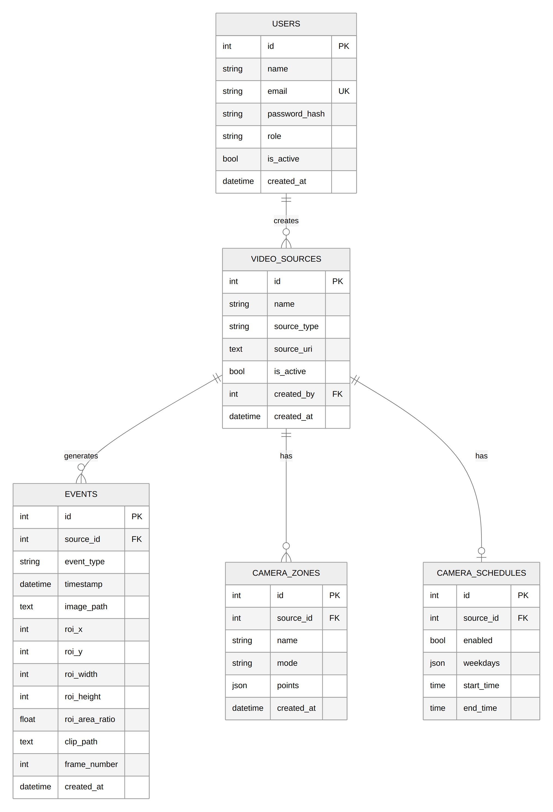
Fig 23: Updated ER diagram of VisionGuard

Table 6: Persistent data sources and the classes that use them
Data source | Technology | Holds | Classes and lifecycle
users | PostgreSQL table | Accounts, roles, active flag | User, UserRepository, AuthService. Created by the admin; deactivated, never deleted
video_sources | PostgreSQL table | Cameras and uploads | VideoSource, CameraService. One row per start; is_active cleared on stop, end of file or crash
events | PostgreSQL table | Event metadata and file paths | Event, EventRepository, EventService. Created by the capture thread; deleted by the admin
camera_zones, camera_schedules | PostgreSQL tables | Detection zones and schedules | ZoneRepository, ZoneService. Replaced on save; copied to a re-added source with the same URI
snapshots/ | JPEG files | Snapshot per event | EventService. Removed with the event
clips/ | WebM files | Video clip per event | ClipRecorder, EventService. Written as .part then renamed; removed with the event
uploads/ | Video files | Uploaded footage | CameraService. Kept after processing
backend/weights/tiny_cnn.pth | PyTorch state dict | CNN weights | load_tiny_cnn. Read once at startup; absent file means pure DCP
.env | Environment file | Settings and secrets | config.py (pydantic-settings). Not committed
Browser localStorage | Web storage | JWT token, theme | api/client.ts. Cleared on sign-out or a 401 response

- All database access goes through repository functions; there are no raw queries elsewhere.
- Event timestamps are stored as naive UTC; analytics converts them to SCHEDULE_TIMEZONE inside SQL before grouping.
- File paths use random UUID names and are checked with is_relative_to against the configured directory before being served.
- The clip path is reserved when the event row is created and the file appears a few seconds later, so the clip endpoint returns 404 until then and the interface retries.

Behavioural Representations

State models
Fig 24 shows the life cycle of a capture thread and Fig 25 follows one event and its clip. The snapshot and database row are produced on a separate executor thread so the capture thread never waits for disk or the database.
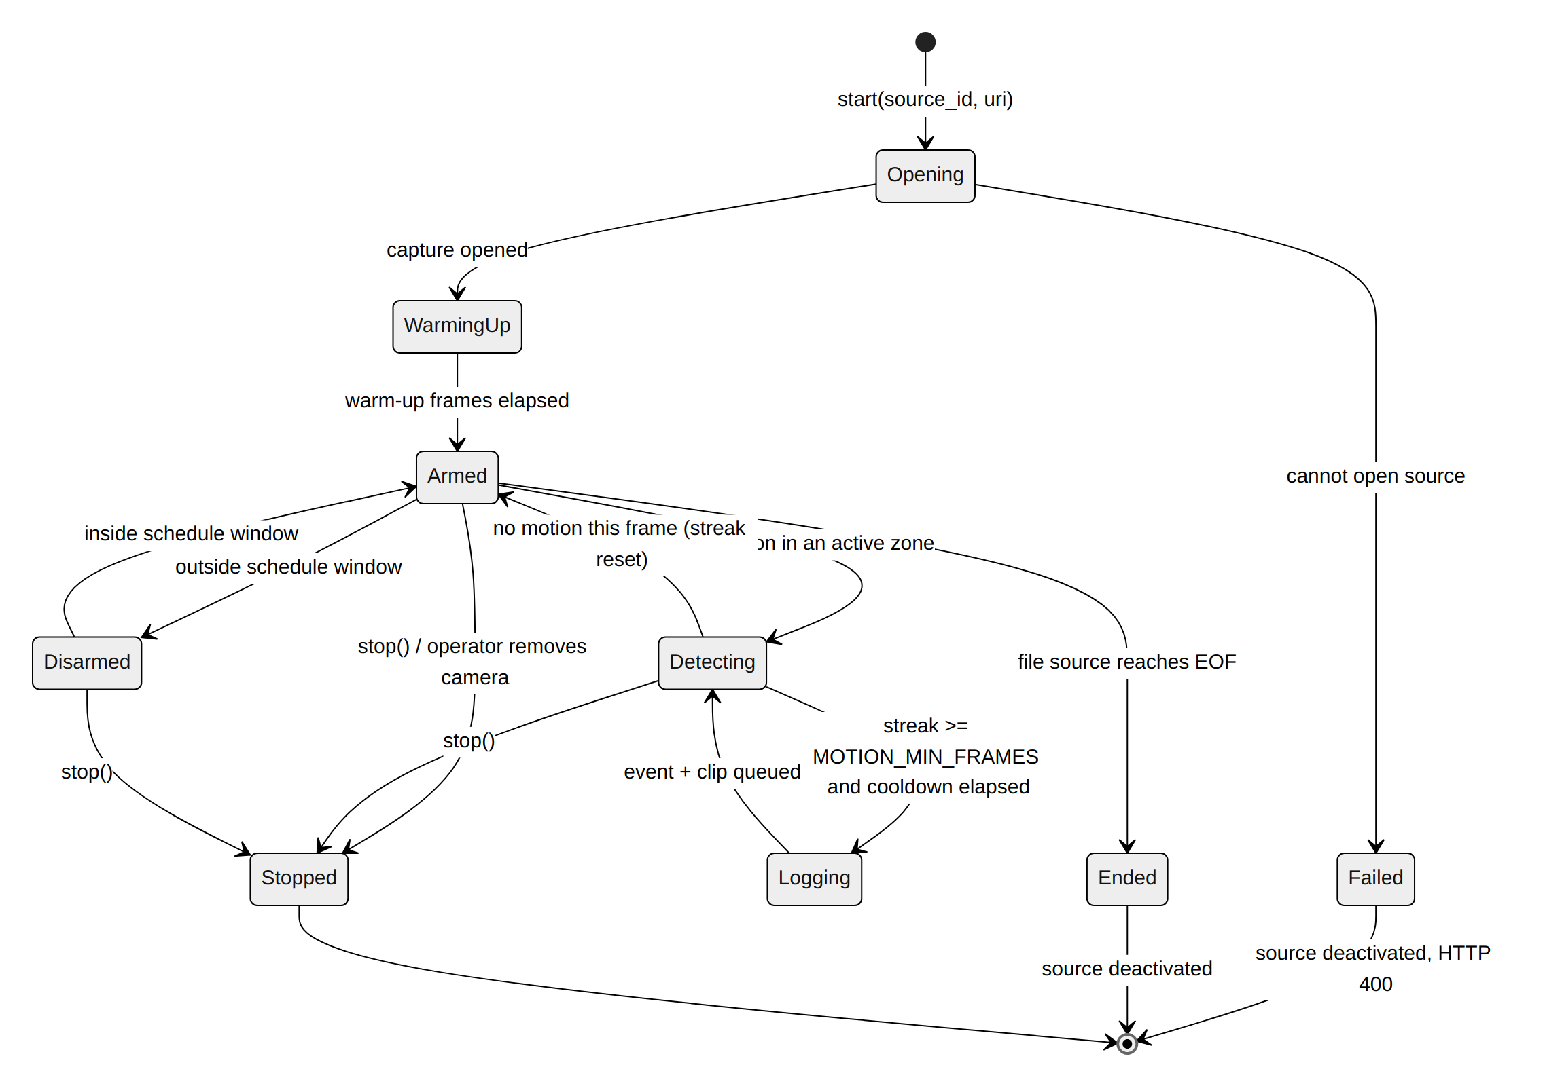
Fig 24: State diagram of a CaptureManager
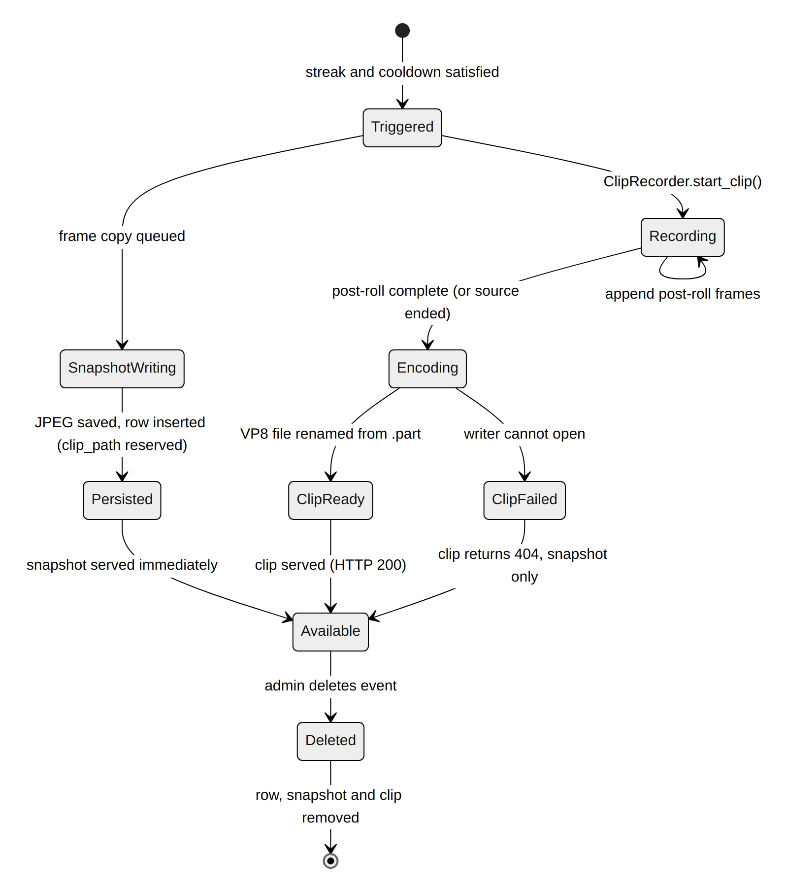
Fig 25: State diagram of an event and its clip

Sequence model
Fig 26 shows what happens to every frame, the performance-critical path of the system.
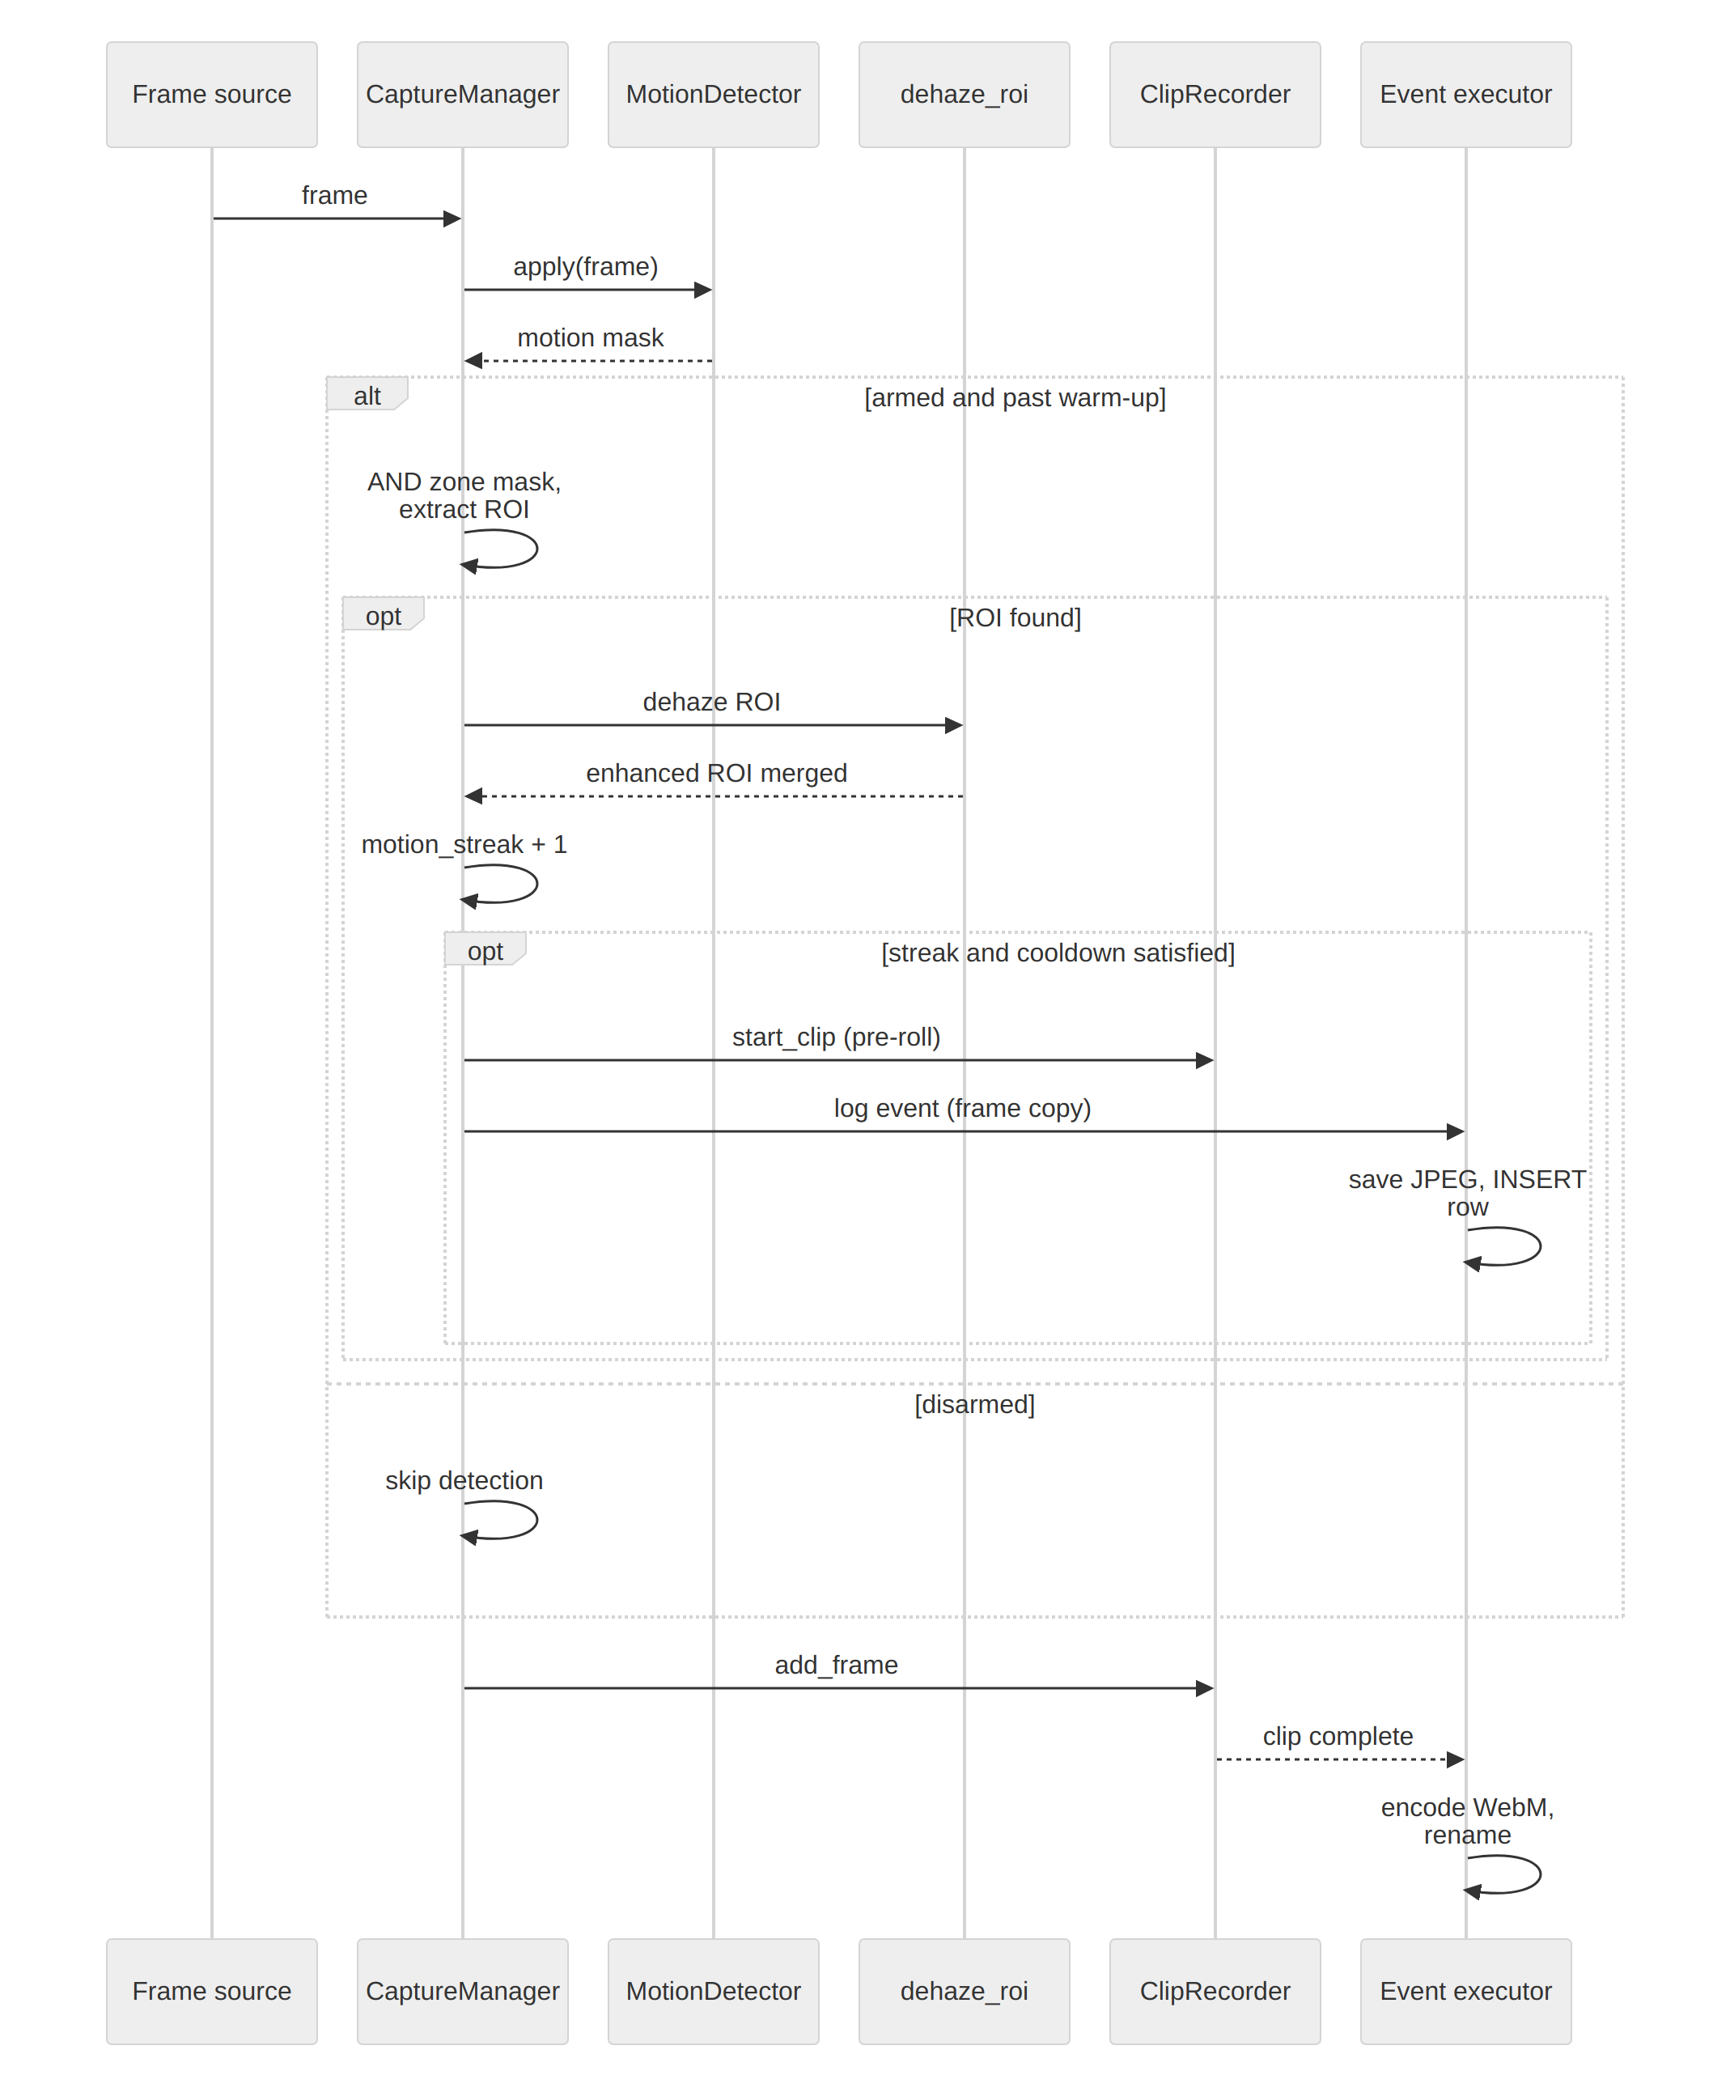
Fig 26: Sequence diagram: processing one frame

Component logic
Three small pure functions decide whether and where detection runs. Zone points are fractions of the frame, so a zone works at any camera resolution.
build_zone_mask(frame_shape, zones):
if no zones: return None
mask = zeros if any include zone else full-frame 255
for z in include zones: fillPoly(mask, z, 255)
for z in exclude zones: fillPoly(mask, z, 0)

is_armed(now, schedule):
if schedule is None or not enabled: return True
if start <= end: return weekday in days and start <= time < end
if time >= start: return weekday in days # overnight, evening part
return (weekday - 1) % 7 in days and time < end # overnight, morning part

per frame with an ROI: streak += 1
if streak >= MOTION_MIN_FRAMES and cooldown elapsed:
clip_path = recorder.start_clip(); executor.submit(log_event, frame, roi, clip_path)
per frame without an ROI: streak = 0

Deployment
Fig 27 shows the deployment. No GPU is needed, and all nodes can run on one machine (the configuration used for development and the demonstration) or be split across an application server and a database server.
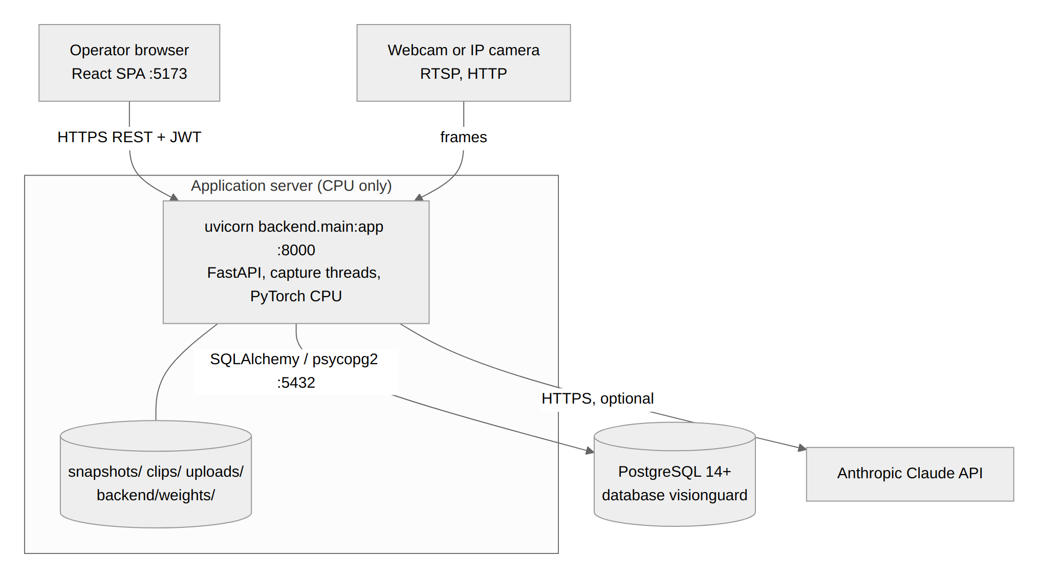
Fig 27: Deployment diagram

Table 7: Deployment nodes
Node | Software and port | Notes
Operator browser | Any current browser; React SPA (Vite dev server on 5173, or a static host) | Stores the JWT in localStorage
Application server | Python 3.11+, uvicorn, FastAPI, OpenCV, PyTorch CPU; port 8000 | Runs capture threads in-process; local disk for snapshots, clips and uploads
Database server | PostgreSQL 14+; port 5432 | Schema created and migrated at startup
Camera sources | Webcam index, RTSP or HTTP stream, uploaded file | Opened with cv2.VideoCapture
Claude API | Anthropic SDK over HTTPS | Optional; only parses search queries

Refactoring and Alternatives Considered
The component designs were revised several times. The table records the main alternatives and why the final design was chosen.

Table 8: Design decisions, alternatives and rationale
Concern | Alternative | Chosen design and why
Number of cameras | One global capture manager | CapturePool with one CaptureManager per source: starting a camera must not stop another, and global state is removed
Live capture lag | Read every frame in the loop | LatestFrameReader keeps only the newest frame; an unbounded backlog would make the feed minutes late
ROI size | Merge all motion into one box | Fall back to the largest contour above ROI_MAX_AREA_RATIO; scattered motion made the ROI approach the full frame
Transmission upsampling | Bilinear upsampling | Downscaled classical stages plus a guided-filter upsample (hand-written, no opencv-contrib): flat cost and no halos
CNN training loss | L1 on transmission only | Reconstruction loss through a differentiable radiance recovery; the transmission-only loss made the final image worse
Event rate | Log every motion frame | Minimum motion duration plus cooldown; a 6-frame flicker no longer creates an event
Meaning of an event | Label events "intruder" with heuristics | Label them "motion" and store the ROI area ratio; frame differencing cannot tell a person from a shadow
Zones and schedules storage | JSON columns on video_sources | Separate tables with a unique schedule per camera; settings are copied to a re-added source with the same URI
Clip codec | H.264, MPEG-4 | VP8 in WebM: H.264 cannot be encoded by this OpenCV build and MPEG-4 does not play in Chrome
Event persistence work | Write on the capture thread | Single-worker executor so disk and database latency never delay the next frame read
Evidence access | Public /snapshots mount | Authenticated snapshot and clip endpoints with a path-traversal guard
Search parsing | Regular expressions | LLM structured output with a no-filter fallback: free phrasing, and a failure widens the search instead of erroring

Interface Design

User Interface Analysis
Operators need to answer two questions quickly: "is something happening now?" and "what happened earlier?". The interface is organised around those tasks: Live Monitoring (a grid of camera tiles), Events and Timeline (events with an evidence inspector), Event Analytics, Profile, and an Admin Console shown to administrators only. Every action gives immediate feedback (a toast with the server's message, a spinner, or an empty-state sentence), and light and dark themes share the same design tokens.
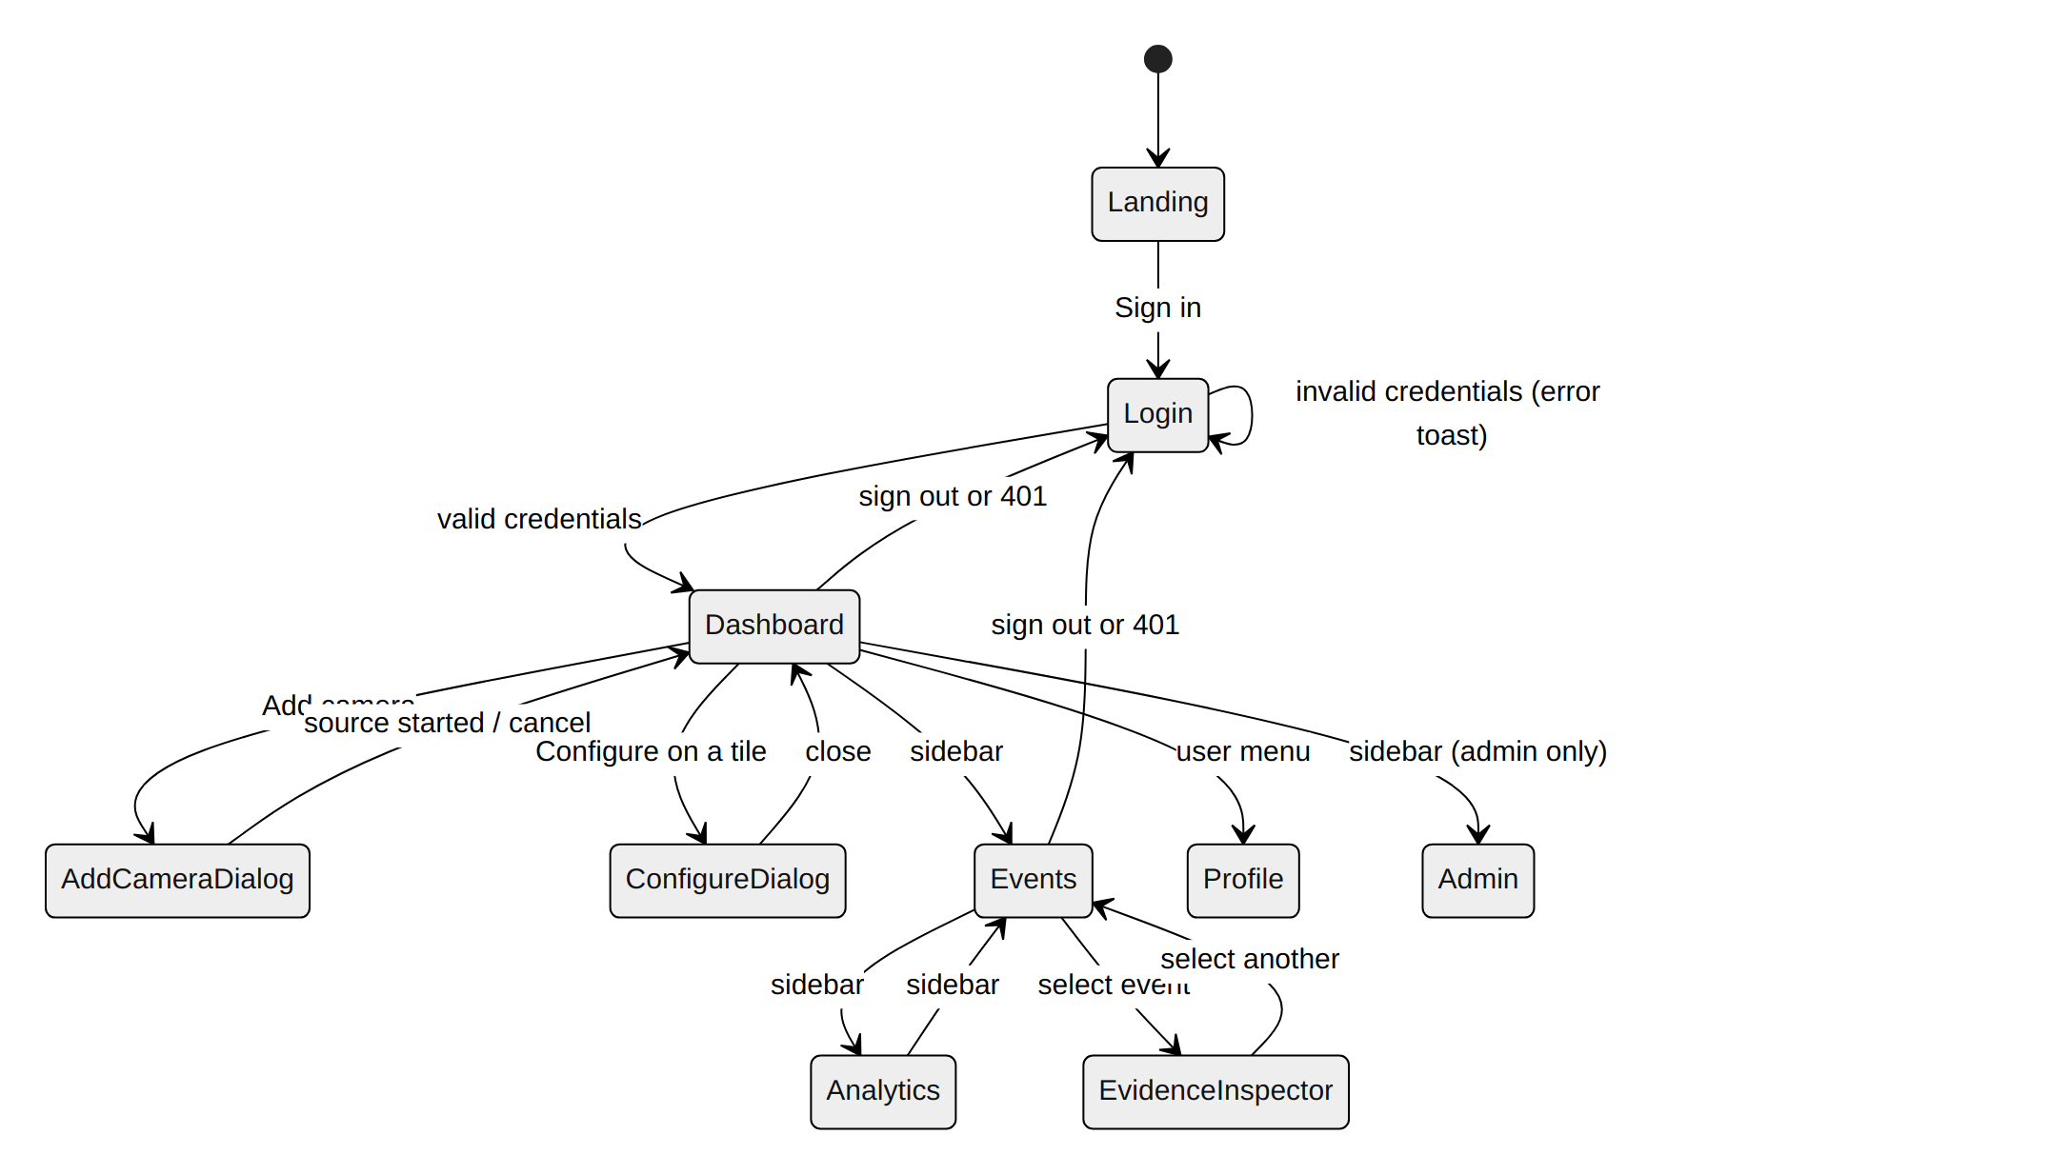
Fig 28: Interface state diagram (screen navigation)

Interface Objects and Operations

Table 9: Interface objects and their operations
Screen | Interface objects | Operations
Landing | Hero preview, Sign in button, how-it-works steps | Open the login page
Login | Email and password fields, Sign in button, error message | Enter credentials, submit
Dashboard | Camera chips, search box, Grid and Focus toggle, Add camera button, camera tiles, recent events strip | Filter cameras, switch layout, add a camera, open a recent event
Camera tile | Live frame, LIVE badge, zone count and Disarmed badges, Configure and Remove buttons | Configure detection, remove the source
Add camera dialog | Name and source fields, Add camera and Upload video buttons | Start a live source, upload a file
Zones tab | Live frame with polygon overlay, Exclude and Include toggle, Finish zone, zone list, Save zones | Click to add points, finish, rename, delete, save
Schedule tab | Use-a-schedule checkbox, weekday buttons, Armed-from and Until times, Save schedule | Choose days and window, save
Events | Search box with filter chips, day-grouped event cards with Clip badge, evidence inspector | Browse, search, select an event
Evidence inspector | Video clip and Snapshot toggle, player controls, detail list, Open full size | Play and seek, switch view, open image
Analytics | Time range and camera selectors, KPI cards, bar charts, heatmap | Change range or camera, hover for values
Profile | Identity card, Details and Security tabs, forms | Update name and email, change password
Admin Console | Create-operator form, user table, event table | Create operator, activate or deactivate, delete events

Events That Change the Interface State

Table 10: User actions and the resulting interface state
Event | Where | Handling and resulting state
Submit credentials | Login | POST /auth/login; token stored and Dashboard opens, or an error is shown and Login stays
API returns 401 | Any screen | Axios interceptor clears the token and Login opens
Add camera or upload | Add camera dialog | POST /start-camera or /upload-video; a new tile appears, or an error toast explains why the source cannot be opened
Click Configure | Camera tile | Dialog opens on the Zones tab with the saved config
Click on the frame | Zones tab | A point is appended to the draft polygon; Finish zone is enabled at 3 points
Save zones or schedule | Configure dialog | PUT request; success toast and tile badges update, or an error toast
Click Remove | Camera tile | POST /stop-camera/{id}; the tile disappears
Camera list poll (4 s) | Dashboard | GET /cameras; tiles match the server, even after a page refresh
Select event | Events | Clip is fetched (retried while the file is still being written); spinner, then video, or "Clip unavailable"
Toggle Snapshot | Evidence inspector | Snapshot with the ROI box is shown
Submit a search | Events | GET /events/search; filter chips and matching events
Change range or camera | Analytics | New query; charts redraw
Deactivate user | Admin Console | PATCH status; row shows Inactive, own row is protected

Interface States as They Appear to the User
Each figure is a real screenshot of the running application (1440 x 900), taken with live sources processing hazy footage. The analytics counts include test events and are not representative of a deployment.
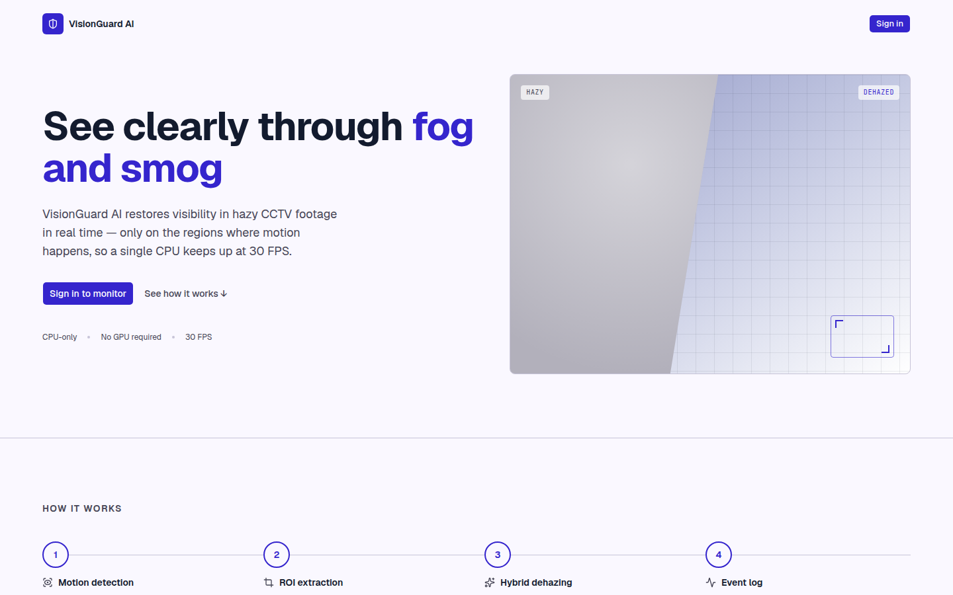  Fig 29: Landing page | 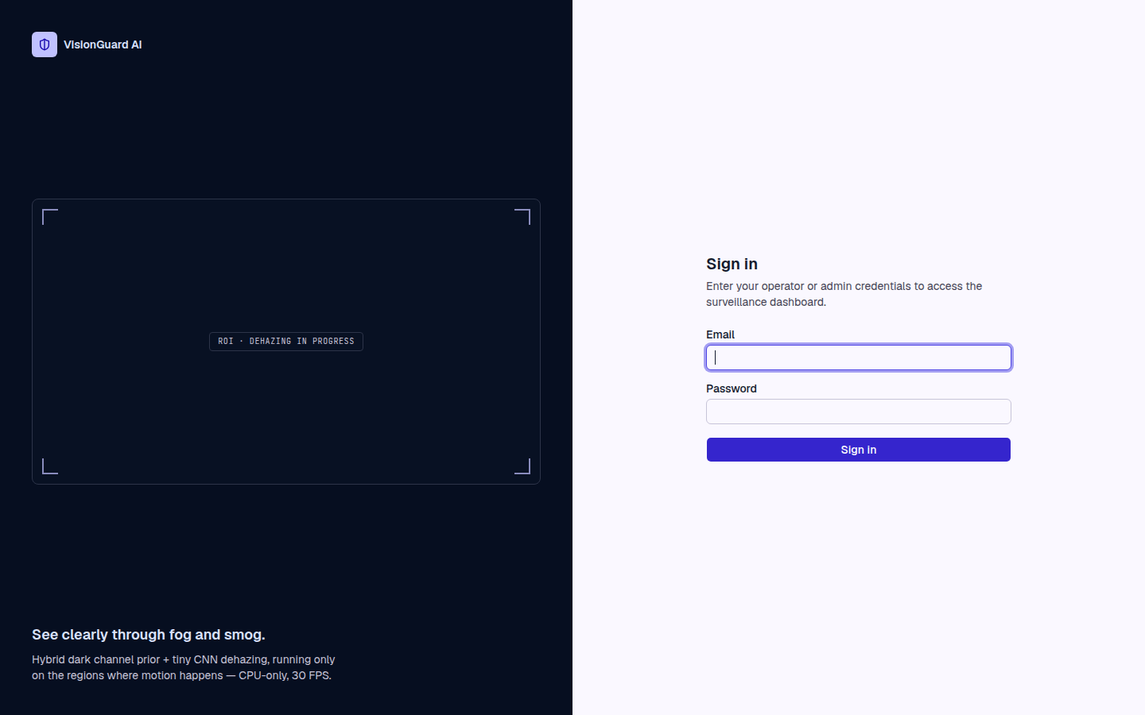  Fig 30: Sign-in page

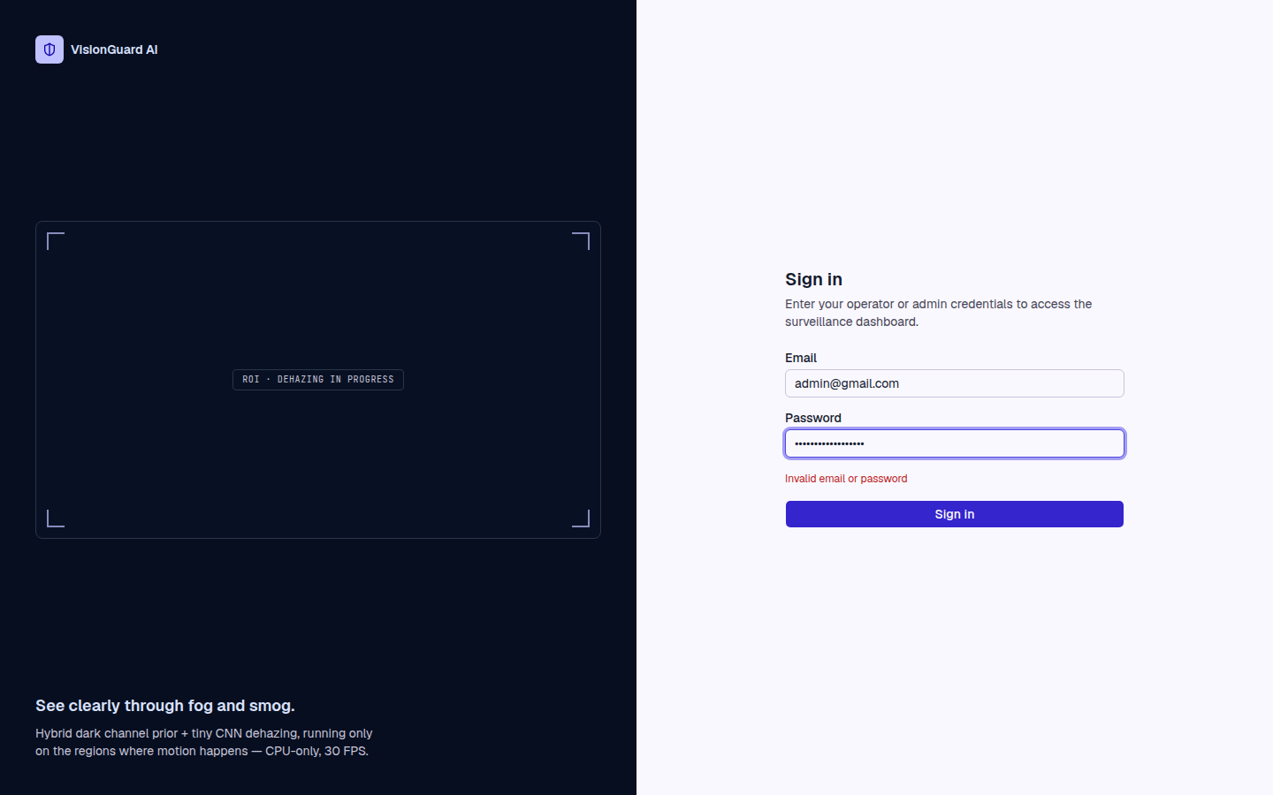  Fig 31: Sign-in error state | 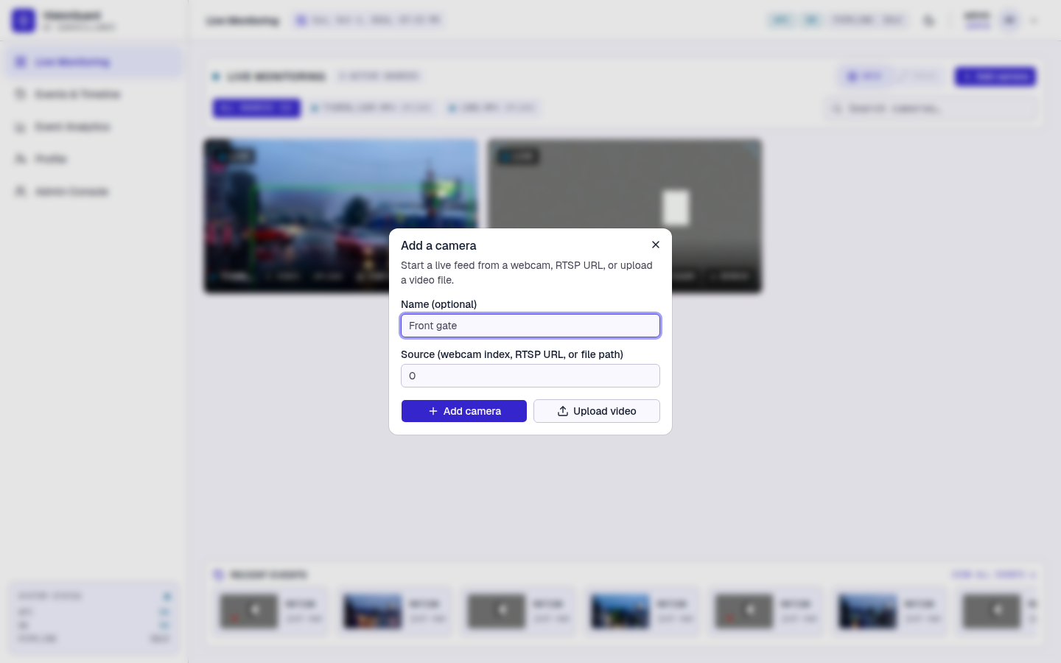  Fig 32: Add camera dialog

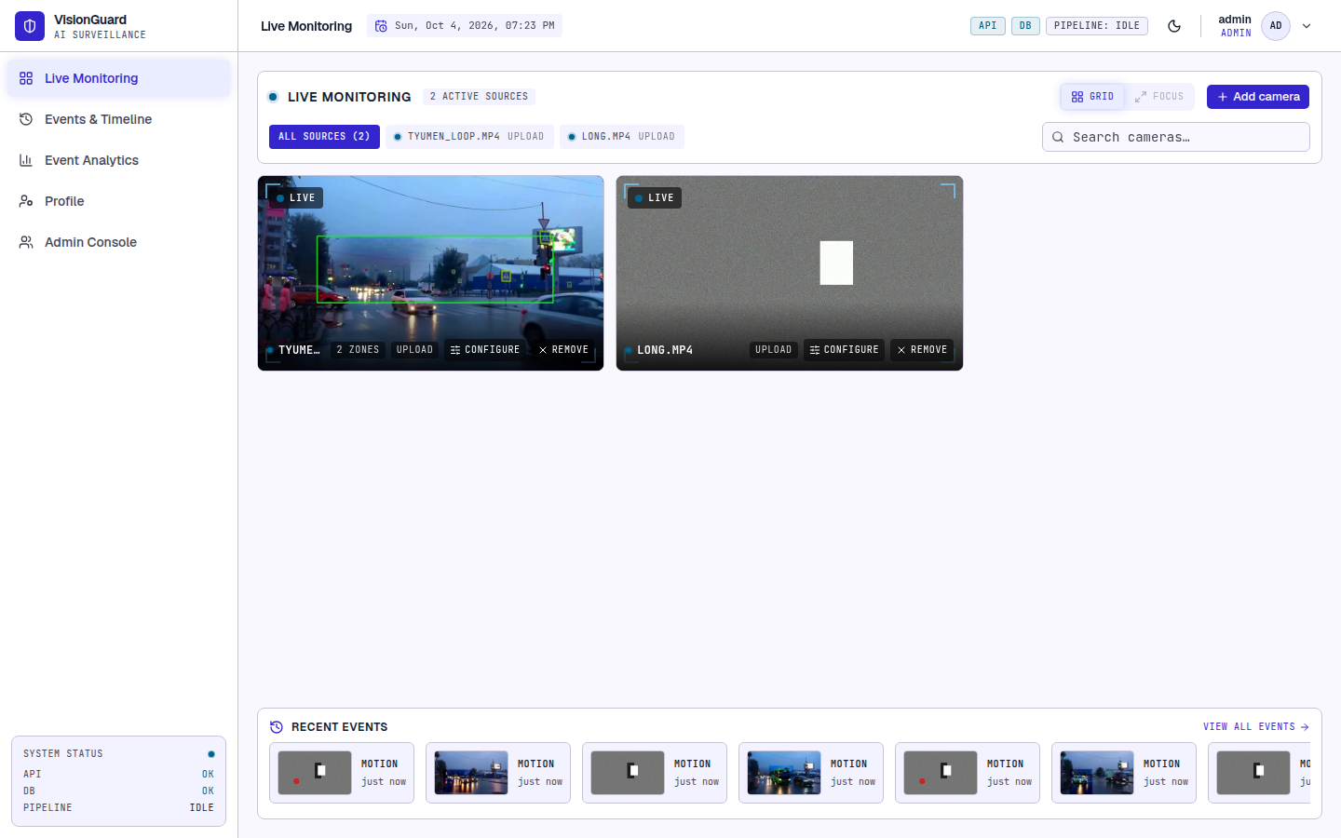
Fig 33: Live Monitoring with two active sources
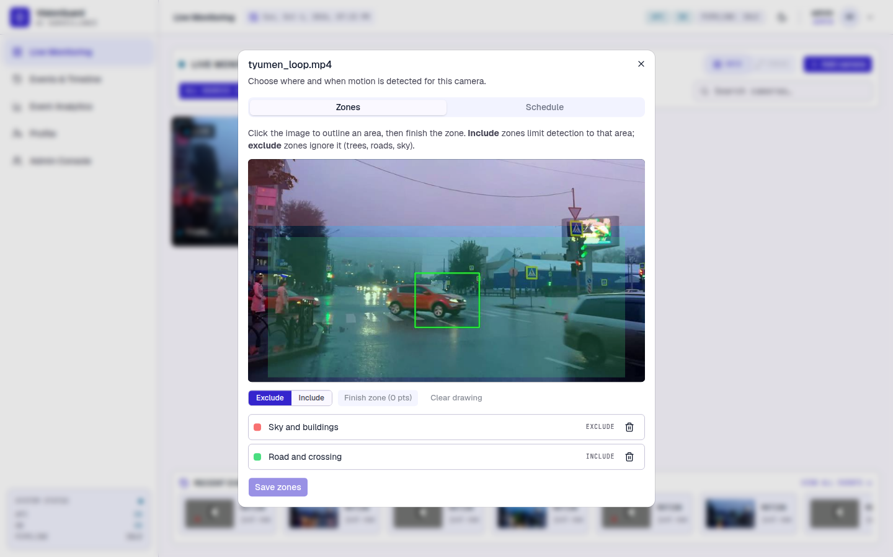  Fig 34: Zones tab (red = exclude, green = include) | 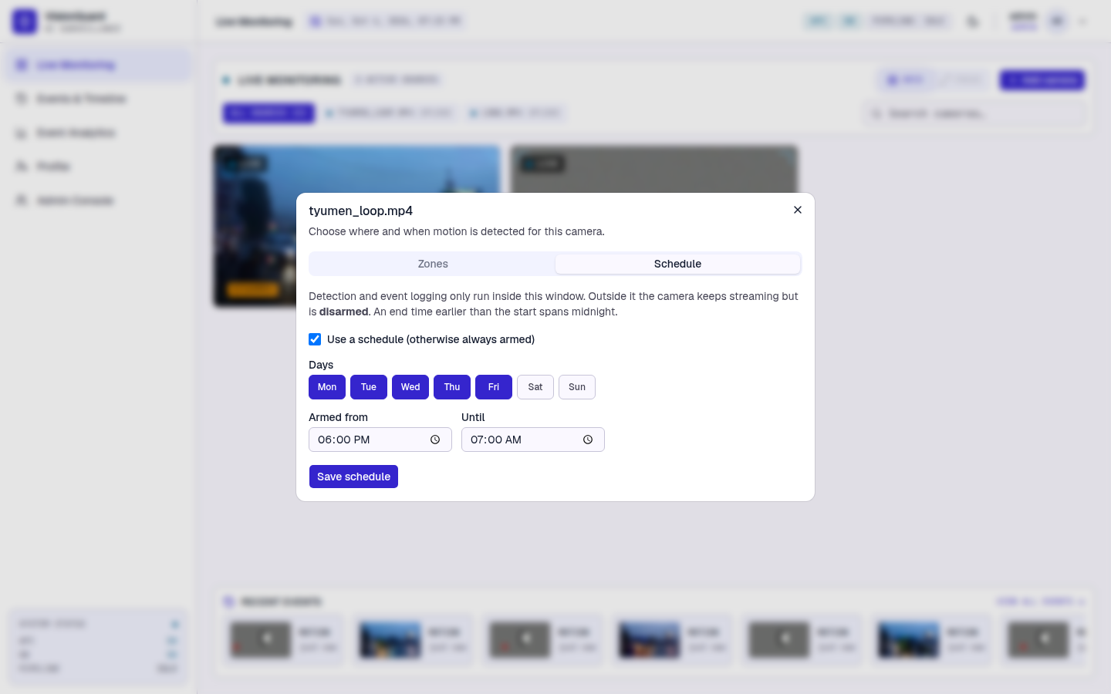  Fig 35: Schedule tab

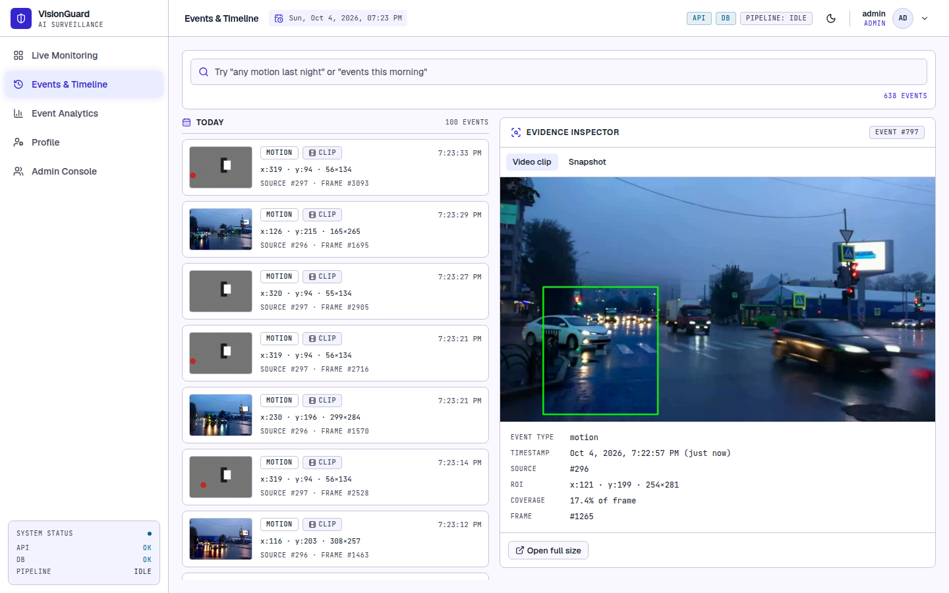  Fig 36: Events page with the video clip | 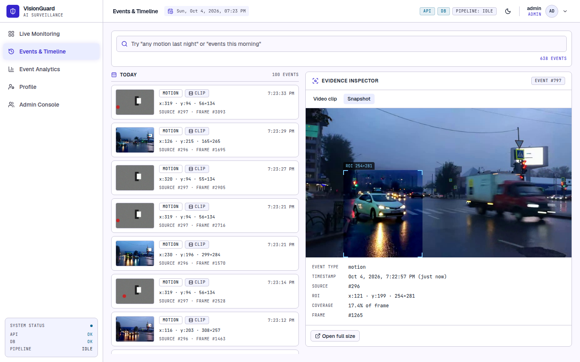  Fig 37: Evidence inspector, snapshot view

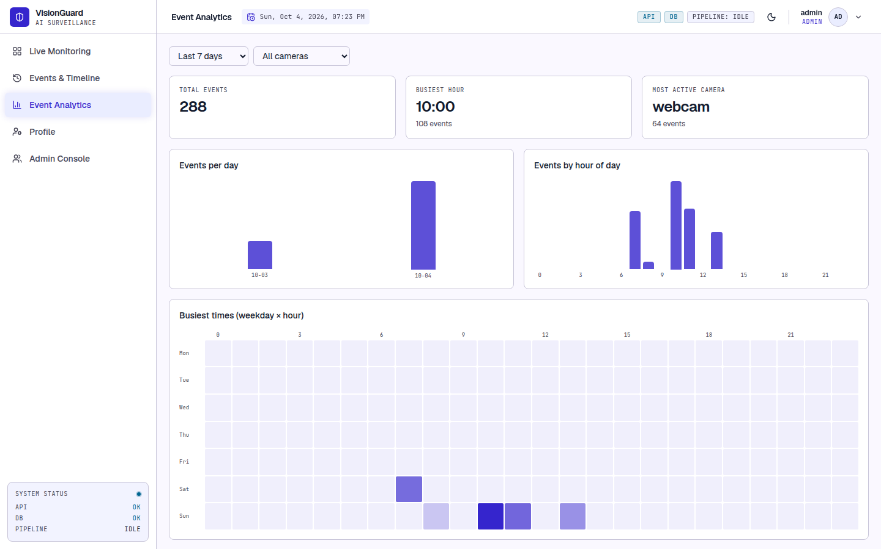  Fig 38: Event Analytics | 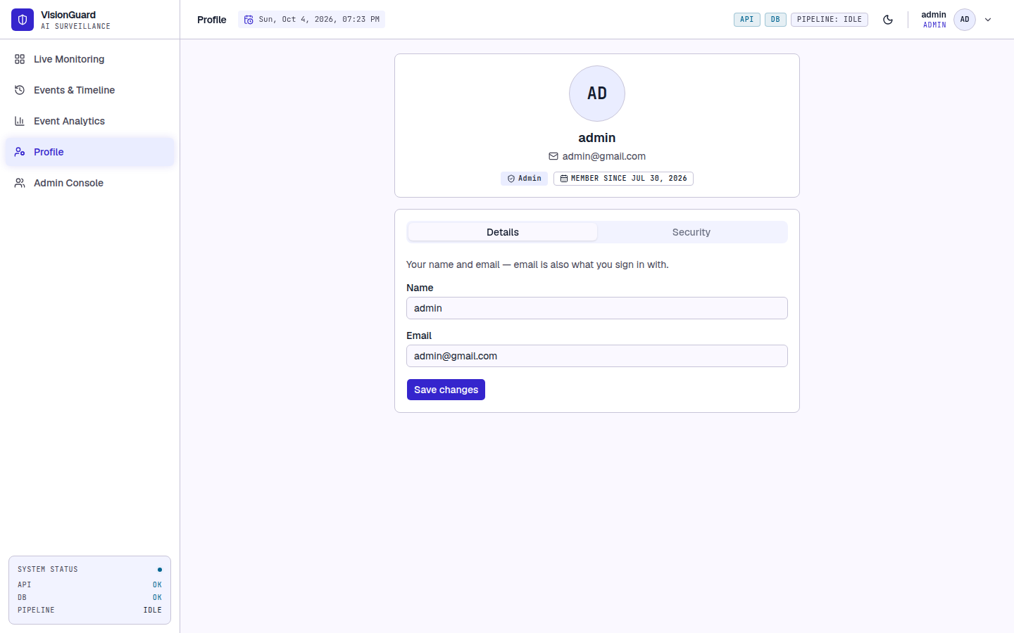  Fig 39: Profile page

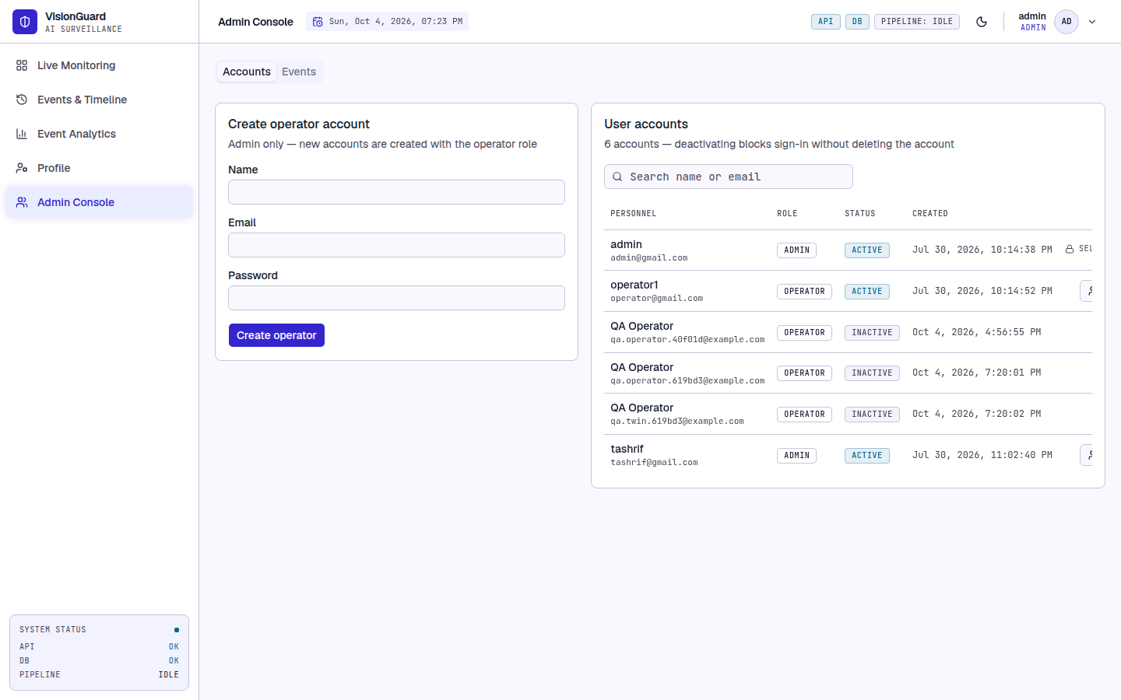
Fig 40: Admin Console

Implementation
The backend is Python 3.11+ with FastAPI, OpenCV, NumPy, PyTorch (CPU), SQLAlchemy with PostgreSQL, PyJWT and passlib (bcrypt), and the Anthropic SDK for search. The frontend is React 19 with TypeScript (strict), Vite, Tailwind CSS v4, shadcn-style Radix components, TanStack Query and Axios. The code base is about 3,050 lines of backend Python, 4,960 lines of frontend TypeScript, 380 lines of unit tests and 350 lines of training code.

Implementation Notes for the Added Features
- Capture: live sources use a one-slot LatestFrameReader thread; file sources are paced by monotonic deadlines and skip frames when far behind. Preview JPEGs are throttled to 12 fps and 960 px width. CPU threads for PyTorch and OpenCV are capped.
- Zones and schedules: stored in camera_zones and camera_schedules, converted to an immutable CameraConfig and swapped into the running CaptureManager, so changes apply on the next frame. The zone mask is cached per configuration and frame size.
- Persistence and size: an event needs MOTION_MIN_FRAMES (15) consecutive motion frames and EVENT_COOLDOWN_SECONDS (5 s); each event stores roi_area_ratio.
- Clips: frames are sampled at 10 fps, downscaled to 640 px and written as VP8 WebM (4 s before and 6 s after the event). Clips still recording when a file ends are flushed.
- Analytics: GET /events/stats runs four aggregate queries (per day, per camera, weekday by hour, ROI size buckets) with times converted to SCHEDULE_TIMEZONE in SQL.
- Security: bcrypt hashes, PyJWT tokens, router-level auth, authenticated snapshot and clip endpoints, Pydantic validation, no open registration. A legacy unique index on the user name was dropped so two accounts may share a display name.
- Frontend: all server state in React Query; media loaded as authenticated blobs with revoked object URLs; the zone editor is an SVG with a 0..1 view box so clicks map directly to normalized zone points; clip loading retries while the file is written; event times (stored as UTC) are parsed as UTC.

Performance
Per-frame cost of the dehazing step on the reference machine (Intel Core i5-1240P, CPU only, no GPU; real hazy street frame, mean of 40 runs). The budget for 30 FPS is 33 ms per frame.

Table 11: Dehazing cost per ROI size (milliseconds per frame)
ROI size | DCP only | DCP + Tiny CNN | Within 33 ms
160 x 120 | 2.0 | 9.5 | Yes
320 x 240 | 7.4 | 21.9 | Yes
640 x 360 | 19.0 | 26.1 | Yes
854 x 480 | 34.3 | 42.9 | No

Typical motion regions (a person or a vehicle) fall in the smaller rows. A very large ROI lowers that camera's processed frame rate but does not stop capture, because the live reader drops stale frames. Whole-system throughput with many cameras was not benchmarked.

Testing
This chapter extends the preliminary test plan of Chapter 5 with the testing strategy, pass and fail criteria, executed test cases with their outcomes, and risks and contingencies.

Testing Approach and Strategy
- Unit tests (pytest): pure image-processing and decision logic: dark channel, transmission, atmospheric light, CNN inference and loading, motion detector, ROI extraction, pipeline round trip, zone masks, schedule evaluation.
- API acceptance tests (tests/acceptance_api.py): a script that drives the public HTTP API of a live server with a real PostgreSQL database and synthetic videos, so every outcome is deterministic: a moving rectangle must create events, a static scene or a 6-frame blink must create none, and copies of the moving clip run with different zone or schedule settings.
- System walkthrough: manual use of the interface in a real browser while two sources processed hazy footage (Chapter 8 screenshots).

Item Pass and Fail Criteria
- A test case passes when the actual result equals the expected result in every stated part (status code, content type, count, state); otherwise it fails.
- The unit suite must pass completely before an acceptance run starts, and the acceptance run passes only when every case passes. A failing case must be fixed, or recorded as a known defect with a contingency, before release.
- Performance: for ROI sizes up to 640 x 360 the full pipeline stays within the 33 ms per-frame budget on the reference CPU.
- Suspension: if the server cannot start or the database is unreachable the run is suspended until the environment is repaired.
Test environment: Intel Core i5-1240P (16 logical CPUs), 7 GB RAM, Linux, no GPU; Python 3.12, uvicorn on port 8000, PostgreSQL on localhost, Vite on port 5173, Chrome 135 for the walkthrough. ANTHROPIC_API_KEY was empty, so only the search fallback was exercised.

Test Cases and Outcomes
All 40 unit tests passed (about two seconds). All 37 API acceptance cases passed. The unit tests are summarised by file, and every acceptance case is listed with its expected and actual outcome.

Table 12: Unit tests by file (40 tests, all passed)
File | Tests | Behaviours verified
test_dark_channel.py | 5 | Black and white images, minimum bound, saturated colours, patch spreading
test_transmission.py | 4 | High and low transmission, clipping to [0, 1], Top-K atmospheric light
test_cnn_inference.py | 7 | Output shape and range, geometry, large-ROI downscale, pure-DCP fallback, missing weights return None, weights round trip
test_motion_detector.py | 3 | Static scene, moving object, binary mask
test_roi.py | 7 | Empty mask, padding and clamping, minimum area, merging, largest-blob fallback
test_pipeline.py | 3 | Shape and dtype, scattering-model round trip, contrast increase
test_zones.py | 5 | No zones, include only, exclude only, exclude inside include, motion masking
test_schedule.py | 6 | Always armed, same-day window, weekday filter, overnight window and its morning part

Table 13: API acceptance test cases with expected and actual outcomes
ID and case | Expected outcome | Actual outcome | Result
TC-01 Admin login with valid credentials | 200 and a JWT access token | 200, token issued=True | Pass
TC-02 Login with a wrong password | 401, no token | 401 | Pass
TC-03 Protected route without a token | 401 before any controller logic | 401 | Pass
TC-04 Admin creates an operator account | 200/201 with role operator | 201, role=operator | Pass
TC-05 Two accounts may share a display name | 200/201 (email is the unique key, not the name) | 201 | Pass
TC-06 Operator cannot create accounts | 403, no account created | 403 | Pass
TC-07 Operator cannot delete events | 403 | 403 | Pass
TC-08 Change password with a wrong current password | Rejected (4xx), password unchanged | 401 | Pass
TC-09 Change password with the correct current password | 2xx, and the new password logs in | 200, relogin=200 | Pass
TC-10 Deactivated account cannot sign in | 401 on login after deactivation | deactivate=200, login=401 | Pass
TC-11 Admin cannot deactivate own account | Rejected (4xx) | 400 | Pass
TC-12 Start a camera with an unreachable source | 400 with a clear message, source not left active | 400: Cannot open video source: /nonexistent/video.mp4 | Pass
TC-13 Upload a non-video file | 400 validation error | 400 | Pass
TC-14 Stop a camera that is not active | 404, no unhandled error | 404 | Pass
TC-15 Upload a valid video and fetch a processed frame | Upload 200; /frame returns a JPEG | /frame=200 image/jpeg 28314 bytes | Pass
TC-16 Static scene: no motion, no events | 0 events | 0 events | Pass
TC-17 Motion shorter than MOTION_MIN_FRAMES is ignored | 0 events for a 6-frame blip repeated every 3 s | 0 events | Pass
TC-18 Moving object logs events with ROI geometry | >= 1 event; ROI width/height > 0 | 3 events; first ROI=60x134 | Pass
TC-19 Each event stores its ROI area ratio | roi_area_ratio in (0, 1) on every event | ratios=[0.0349, 0.0372, 0.0608] | Pass
TC-20 Event cooldown throttles logging | Gap between events >= 5 s (1 s tolerance) | min gap=6.0 s over 2 gaps | Pass
TC-21 Exclude zone over the motion suppresses events | 0 events | 0 events | Pass
TC-22 Include zone away from the motion suppresses events | 0 events | 0 events | Pass
TC-23 Include zone covering the motion keeps events | >= 1 event | 3 events | Pass
TC-24 Disarmed schedule logs nothing | armed=false in config, 0 events, PUT 200 | PUT=200, armed=False, 0 events | Pass
TC-25 Zone with a point outside 0..1 is rejected | 400 | 400 | Pass
TC-26 Zone with fewer than 3 points is rejected | 422 (schema validation) | 422 | Pass
TC-27 Schedule with identical start and end is rejected | 400 | 400 | Pass
TC-28 Re-adding a camera with the same URI keeps its zones | New source has the 'keep me' zone | zones=['keep me'] | Pass
TC-29 Snapshot endpoint returns the JPEG | 200 image/jpeg | 200 image/jpeg 104942 bytes | Pass
TC-30 Clip endpoint returns a playable WebM | 200 video/webm, non-empty, has_clip=true | 200 video/webm 1029258 bytes, has_clip=True | Pass
TC-31 Snapshot of an unknown event | 404 | 404 | Pass
TC-32 Timeline pagination and filtering | limit=1 returns 1 event; total unchanged | returned=1, total=3 | Pass
TC-33 Time filter in the future returns nothing | 0 events | 0 | Pass
TC-34 Analytics totals are internally consistent | total equals per-day, per-camera, heatmap and coverage sums | total=607 | Pass
TC-35 Natural-language search falls back when no API key is configured | 200, empty filters, all events returned | 200 filters={'from_ts': None, 'to_ts': None, 'event_type': None} total=607 | Pass
TC-36 System status reports a healthy database | 200 and database ok | 200 {'status': 'ok', 'database': 'ok', 'pipeline': 'idle'} | Pass
TC-37 Admin deletes an event and its files | 204; snapshot file removed | 204, existed=True, removed=True | Pass

Interface walkthrough: wrong credentials stay on the sign-in page with an error; two sources ran side by side, each with its own ROI box and Configure button; polygons were drawn and saved with the tile badge updating without a reload; a weeknight schedule showed the Disarmed badge outside its window; an event with a clip played with the ROI box, a brand-new event first showed "still being recorded"; the analytics page rendered with no console errors.
Performance results are in Table 11: 26.1 ms at 640 x 360 and 42.9 ms at 854 x 480 with the CNN. Seven synthetic sources ran at the same time during the acceptance run.

Not tested
- Natural-language time parsing with the real Claude API (no key was configured); only the fallback is verified.
- Physical webcams and RTSP cameras in the final run, many-camera load and long-duration tests, and browsers other than Chrome.
- mypy and black were not run because they are not installed in the final environment, and the frontend has no automated tests.

Risks and Contingencies

Table 14: Risks and contingencies
Risk | Contingency
Claude API unavailable or key missing | Search falls back to unfiltered results; the timeline stays fully usable
CNN weights missing or corrupt | load_tiny_cnn returns None and the pipeline runs pure DCP; a warning is logged
Processing slower than the camera frame rate | The live reader drops stale frames; ROI cap, downscaled stages and thread caps limit cost; thresholds are configurable
Many false events (foliage, shadows, lighting) | Exclude zones, schedules, MOTION_MIN_FRAMES, cooldown and the ROI area ratio
Disk fills with snapshots, clips and uploads | Directories are configurable; deleting an event removes its files; automatic retention is future work
Clip memory too high on small hardware | Lower CLIP_MAX_WIDTH, CLIP_FPS or CLIP_PRE_SECONDS
Camera becomes unreachable | The source is deactivated and leaves the dashboard; re-adding it restores its zones and schedule
Server crash with active sources | Stale active sources are deactivated at startup, so no ghost cameras appear
Database unavailable | /system/status reports the state; the API recovers when the database returns

User Manual

Installation
Requirements: Python 3.11+, Node.js 18+, PostgreSQL 14+, a current browser, and optionally an Anthropic API key for natural-language search. No GPU is needed.
- Get the code: git clone https://github.com/Tashrif-007/visionguard.git, then open the visionguard folder.
- Backend: python3 -m venv venv, source venv/bin/activate, pip install -r requirements.txt, createdb visionguard, cp .env.example .env.
- Edit .env: set the POSTGRES_* values, a long random JWT_SECRET_KEY, and ADMIN_EMAIL and ADMIN_PASSWORD (the first administrator). ANTHROPIC_API_KEY is optional.
- Start the API from the repository root: uvicorn backend.main:app --port 8000. Tables are created and the administrator is seeded on first start.
- Frontend: cd frontend, npm install, cp .env.example .env, npm run dev, then open http://localhost:5173.
- Check the installation: run pytest (all tests pass) and sign in with the administrator email and password.

Signing In, Monitoring and Adding Cameras
- Open the application, choose Sign in to monitor, and enter your email and password (Fig 30). Accounts are created by an administrator; there is no sign-up.
- Live Monitoring (Fig 33) shows one tile per active camera with a green box where motion was found; inside the box the haze has been removed.
- To add a camera press Add camera (Fig 32), type an optional name, enter a webcam index (0), a stream address (rtsp://...) or a file path, and press Add camera. Press Upload video to process a video file instead; its tile disappears when the video ends.
- Use the search box to find a tile, Grid or Focus to change the layout, and Remove to stop one source without affecting the others. A Disarmed badge means the camera is outside its schedule.

Detection Zones and Schedules
- Press Configure on a tile and stay on the Zones tab (Fig 34).
- Choose Exclude (ignore this area) or Include (watch only this area), click at least three corners on the picture, and press Finish zone. Repeat for more zones; rename or delete zones in the list.
- Press Save zones. The running camera uses them immediately. With any include zone only those areas are watched (minus exclude zones inside them); with only exclude zones everything is watched except those areas.
- For a schedule open the Schedule tab (Fig 35), tick Use a schedule, choose the weekdays, set Armed from and Until (an end earlier than the start runs past midnight), and press Save schedule. Outside the window the camera keeps streaming but detects and records nothing.

Reviewing Events, Search and Analytics
- Open Events and Timeline (Fig 36). Events are grouped by day, newest first; a Clip badge marks events that have video. Click an event to open the Evidence inspector: the Video clip tab plays a few seconds before and after the event with the motion box visible, and the Snapshot tab (Fig 37) shows the still frame. A clip that is still being recorded loads by itself.
- Type a plain-English question such as "any motion last night?" in the search box and press Enter; the interpreted time range appears as chips. If no time can be understood, all events are shown.
- Event Analytics (Fig 38) shows totals, the busiest hour, events per day, per hour and per camera, a weekday-by-hour heatmap and the size of the motion. Choose a time range and optionally one camera. Use the heatmap to choose schedules and zones.
- Events are recorded as motion. VisionGuard does not decide whether the motion is a person or vehicle; watch the video to decide.

Profile and Administration
- Profile (Fig 39): change your name and email (your sign-in name) on Details, and your password on Security (at least 8 characters).
- Administrators have the Admin Console (Fig 40): create operator accounts, deactivate or reactivate accounts (you cannot deactivate yourself or the last active administrator), and delete events together with their snapshot and clip.

Troubleshooting

Table 15: Common problems
Problem | Likely cause and what to do
"Cannot open video source" | Wrong address, camera offline, or the path does not exist on the server; check it in a media player
No events appear | Camera disarmed, motion outside include zones, or motion shorter than half a second; check the Disarmed badge, zones and schedule
Too many events | Foliage, shadows or lighting; add exclude zones or raise MOTION_MIN_FRAMES or MOTION_MIN_AREA
Clip says "unavailable" | The encoder could not create the file; check the server log; the snapshot is still available
Search returns every event | No time understood or no API key; rephrase with a time such as "yesterday" or set ANTHROPIC_API_KEY
Signed out unexpectedly | The token expired or the account was deactivated; sign in again or ask an administrator

Repository, Installer and Final Deliverables

Version Control
The source code is in a publicly accessible Git repository: https://github.com/Tashrif-007/visionguard. It has two long-lived branches, main (stable) and dev (integration). Work is done on feature branches (for example feature/authentication, feature/nlp-search, feature/frontend-dashboard) merged into dev with explicit merge commits, and commit messages use short type prefixes such as feat and docs. .env files, virtual environments, uploads, snapshots and clips are excluded through .gitignore.

Installer
Not applicable: VisionGuard is installed from source with the steps in Chapter 11. A container image that packages the backend, frontend and database is a reasonable future deliverable.

Coverage of the Final Report Requirements

Table 16: Where each required item is covered
Required item | Covered in
Design classes of the problem domain | Chapter 7, Design Classes
Persistent data sources and their classes | Chapter 4 and Chapter 7, Persistent Data Sources
Behavioural representations of classes and components | Chapter 7, Behavioural Representations
Deployment diagrams | Chapter 7, Deployment
Refactoring and alternatives | Chapter 7, Refactoring and Alternatives Considered
User interface objects and operations | Chapter 8, Interface Objects and Operations
Events that change the interface state | Chapter 8, Events That Change the Interface State
Each interface state as it looks to the user | Chapter 8, Interface States as They Appear to the User
Testing approach, pass and fail criteria, risks and contingencies | Chapter 10
Test cases with detailed outcomes | Chapter 10, Test Cases and Outcomes
Implementation details | Chapter 9
User manual, repository URL, installer | Chapter 11 and this chapter

