

VisionGuard: AI-Assisted Visibility Enhancement and Incident Retrieval for Smart CCTV Surveillance

Technical Report
SE - 801 - Software Project Lab III

Submitted By:
Shahid-E-Kaiser Md. Tashrif | BSSE-1448

Supervised By: Dr. Sumon Ahmed Associate Professor
Institute of Information Technology University of Dhaka

Submitted On: August 02, 2026



Letter of Transmittal
02 August 2026
BSSE 4th Year Exam Committee Institute of Information Technology University of Dhaka

Subject: Technical Report Submission, VisionGuard: AI-Assisted Visibility Enhancement and Incident Retrieval for smart CCTV surveillance

Sir,
I am submitting the technical report for our Software Project Lab 3, “VisionGuard: AI-Assisted Visibility Enhancement and Incident Retrieval for Smart CCTV Surveillance”. This report comprehensively covers the project's technical details, including design, implementation and testing phases. While I have tried to do my best, I welcome your feedback for improvement.
Thank you for your kind consideration.

Sincerely,
Shahid-E-Kaiser Md. Tashrif BSSE 1448
Institute of Information Technology University of Dhaka

02.08.2026

Supervisor’s Signature

Acknowledgement
I would like to thank my supervisor, Dr. Sumon Ahmed, for the guidance and feedback provided throughout the development of VisionGuard AI. Their input on scoping the hybrid dehazing architecture and on keeping the system CPU-friendly and explainable has directly shaped the design decisions documented in this report.

Abstract
VisionGuard AI is a lightweight, CPU-friendly CCTV surveillance platform that restores visibility in hazy or smoggy footage in real time. Rather than relying on an end-to-end deep learning model, it uses a hybrid approach: the Dark Channel Prior (DCP) produces a physics-based estimate of a scene's transmission map, and a small refinement CNN corrects that estimate before the clean image is reconstructed through the atmospheric scattering model. The system's central optimization is region-of-interest (ROI) processing, dehazing runs only on the portion of a frame flagged by motion detection, rather than on every pixel of every frame, which keeps the pipeline fast enough for real-time use on ordinary CPU hardware and suitable for edge deployment without a GPU.
Beyond the dehazing pipeline itself, VisionGuard AI supports live webcam and IP camera feeds as well as uploaded video files, automatically logs every enhanced event with its timestamp, snapshot, and region coordinates, and lets operators review that history through both a chronological timeline and a natural-language search interface backed by the Claude API. Access is restricted to admin-seeded operator accounts authenticated with JWTs, with no open self-registration. The target users are security guards and surveillance operators in settings such as campuses, warehouses, and parking lots, where hazy conditions can otherwise leave footage unusable exactly when it matters most.

Table of Contents
- Project Overview 6
  - Project Title 6
  - Problem Statement 6
  - Objectives 6
  - Scope 7
  - Deliverables 7
- Requirements Analysis 8
  - Functional Requirements 8
  - Non-functional Requirements 8
  - Stakeholders 9
- System Modeling 10
  - Use Case Diagram 10
  - Activity Diagram 16
    - User Management 17
    - Camera & Feed Management 18
    - Motion Detection & ROI Extraction 19
    - Hybrid Dehazing Pipeline 20
    - Event Logging 21
    - Timeline/Event Browser 21
    - NL Event Search 22
- Data & Information Modeling 23
- Preliminary Test Plan 26
  - Testing Objectives 26
  - Features to be Tested 26
- Timeline 28

Project Overview

Project Title
VisionGuard: AI-Assisted Visibility Enhancement and Incident Retrieval for Smart CCTV Surveillance

Problem Statement
CCTV footage from surveillance cameras degrades sharply in haze, smog, and fog, which is exactly when security teams need it most. Visibility loss during these conditions can hide intrusions, accidents, and other events a surveillance system exists to catch. Modern image dehazing research has moved toward end-to-end deep learning models that produce strong results, but those models are typically too heavy to run on the CPU-only hardware found in most guard rooms and edge installations, and running full-frame enhancement on every frame of a live feed is wasteful when most of a frame is static background with nothing happening in it. VisionGuard addresses this by combining a physics-based dehazing model (the Dark Channel Prior) with a lightweight CNN that only refines the prior's transmission estimate, and by restricting all of that computation to the small region of a frame where motion was actually detected — keeping the system real-time, explainable, and deployable without a GPU.

Objectives
- Recover clear visibility in hazy or smoggy CCTV footage without requiring specialized hardware.
- Keep the dehazing pipeline CPU-friendly and capable of real-time (30 FPS target) operation by only processing regions flagged by motion detection, not entire frames.
- Preserve a hybrid, explainable architecture — physics prior (DCP) plus a lightweight CNN refinement — rather than an opaque end-to-end deep learning model.
- Automatically log every enhanced event (timestamp, snapshot, event type, ROI coordinates) so operators have a retrievable record without manual effort.
- Let operators retrieve past events through both a chronological timeline and a natural-language search interface.
- Restrict system access to authenticated operator and administrator accounts, with no open self-registration.

Scope

In scope (MVP):
- Live webcam / IP camera feed ingestion, plus uploaded video file processing.
- Motion detection that skips dehazing entirely when no motion is present.
- ROI extraction from the motion mask, so only the suspicious region is processed.
- The hybrid DCP + Tiny CNN dehazing pipeline (dark channel, Top-K atmospheric light, coarse transmission, CNN refinement, radiance recovery, gamma correction, merge back into frame).
- Event logging with timestamp, snapshot image, event type, and ROI coordinates.
- A timeline / event browser for chronological review.
- Natural language event search (e.g. "any motion last night?") backed by the Claude API.
- JWT-based authentication with admin-seeded accounts (no open signup).

Out of scope (future work, not implemented):
- Object detection / intrusion classification.
- ONNX Runtime inference.
- FFmpeg integration.
- Multi-camera support.
- Temporal transmission smoothing across frames.

Deliverables
- A FastAPI backend implementing the motion-gated, ROI-based hybrid dehazing pipeline.
- A trained Tiny CNN transmission-refinement model with saved weights (backend/weights/tiny_cnn.pth).
- A PostgreSQL-backed event store with repository-layer access for cameras/video sources and events.
- A JWT authentication system with admin-seeded accounts and operator account management.
- A React + TypeScript dashboard for live feed viewing, event timeline browsing, and natural-language event search.
- A preliminary automated test suite covering the dark channel, transmission estimation, CNN inference, motion detection, and ROI extraction modules.

Requirements Analysis

Functional Requirements
- FR-1: The system will allow an operator to start a live feed from a webcam or IP camera, or upload a recorded video file for processing.
- FR-2: The system will allow an operator to stop an active feed at any time and view the latest processed frame while a feed is running.
- FR-3: The system will continuously monitor incoming frames for motion and skip the dehazing pipeline entirely when no motion is detected.
- FR-4: When motion is detected, the system will extract only the region of interest (ROI) containing that motion rather than processing the full frame.
- FR-5: The system will dehaze the extracted ROI using the Dark Channel Prior for an initial transmission estimate, refine that estimate with a Tiny CNN, and reconstruct the clean region via the atmospheric scattering model before merging it back into the original frame.
- FR-6: The system will automatically log every dehazing event with its timestamp, a snapshot image, the event type, and the ROI coordinates.
- FR-7: The system will allow an operator to browse logged events in chronological order on an Events page, showing each event's snapshot and details.
- FR-8: The system will allow an operator to enter a plain-English query (e.g. "any motion last night?") that is parsed into structured filters and used to retrieve matching logged events; if no time range can be determined, the system shall return all events rather than failing.
- FR-9: The system will require authentication (JWT) for every endpoint except login; an admin account is seeded on first startup, and only the admin can create operator accounts.

Non-functional Requirements
- Performance: The pipeline must sustain a target of 30 FPS on CPU-only hardware by dehazing only the motion ROI, not the full frame, and by skipping the pipeline entirely on static frames.
- Security: Passwords are hashed and never stored or logged in plaintext; tokens are signed and verified with JWT.
- Reliability: Every module raises meaningful, typed exceptions instead of silently swallowing errors, and model weights are loaded once at startup rather than per-request, so a missing or corrupt weights file fails fast and visibly.

- Scalability: Business logic is isolated in stateless service modules with dependency-injected pipeline/camera state (no global mutable state), so the system can be extended to additional camera sources without redesigning the core pipeline.
- Maintainability: The codebase follows a strict layered architecture (routers, controllers, services, repositories) with Pydantic schemas for every request/response and no ORM models leaking into the API layer, keeping responsibilities isolated and the system easy to extend.
- Usability: Operators interact with a single dashboard for live viewing, timeline browsing, and natural-language search, with all server state managed through React Query so the UI reflects backend state without manual refresh logic.

Stakeholders
- Operators: security guards, building surveillance operators, university campus surveillance staff, and warehouse/parking-lot monitoring teams who run live feeds, review events, and search the timeline day to day.
- Administrator: manages operator accounts (the only account-creation path in the system) and has full access to all operator-level functionality.

System Modeling
Scenario-based modeling is used here to depict how VisionGuard AI behaves under real usage scenarios. A use case diagram visually represents how the system interacts with its actors to achieve specific goals, showing the relationships between use cases (system functionalities) and the actors (users or systems) that trigger them. Following this convention, the use case diagrams for VisionGuard AI are broken into a Level 0 overview, a Level 1 module breakdown, and Level 2 diagrams for each individual module if needed.

  - Use Case Diagram

Level: 0
Use Case ID: 0
Name: VisionGuard AI: Detect, Enhance and Search
Primary Actor: Admin, Operator

Secondary Actor: None

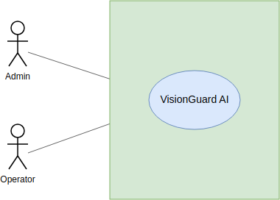

Fig 1: Use Case Level 0 (VisionGuard)

Level: 1
Use Case ID: 1
Name: VisionGuard AI: Detect, Enhance and Search
Primary Actor: Admin, Operator

Secondary Actor: None
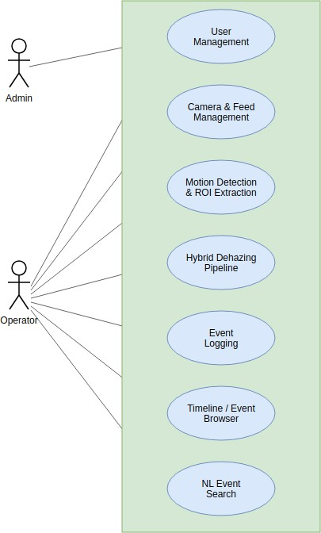

Fig 2: Use Case Level 1 (VisionGuard)
Level: 1.1

Use Case ID: 1.1
Name: User Management Primary Actor: Admin, Operator Secondary Actor: None

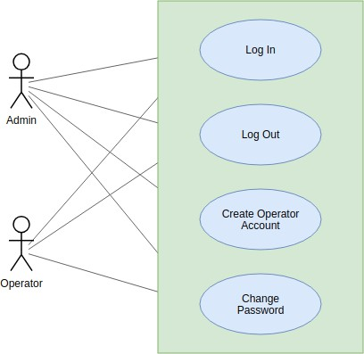

Fig 3: Use Case Level 1.1 (VisionGuard)
Level: 1.2

Use Case ID: 1.2
Name: Camera & Feed Management Primary Actor: Operator Secondary Actor: None
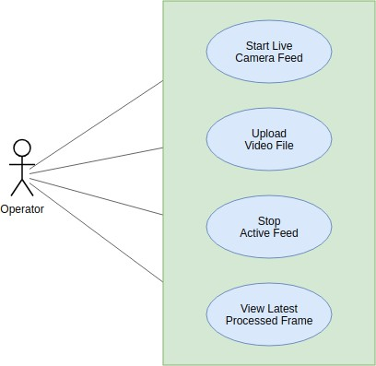

Fig 4: Use Case Level 1.2 (VisionGuard)

Level: 1.3

Use Case ID: 1.3
Name: Motion Detection & ROI Extraction Primary Actor: System (Capture Worker) Secondary Actor: None

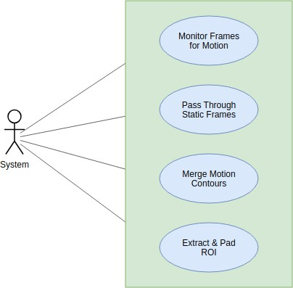

Fig 5: Use Case Level 1.3 (VisionGuard)

Level: 1.4

Use Case ID: 1.4
Name: Hybrid Dehazing Pipeline Primary Actor: System (Capture Worker) Secondary Actor: None

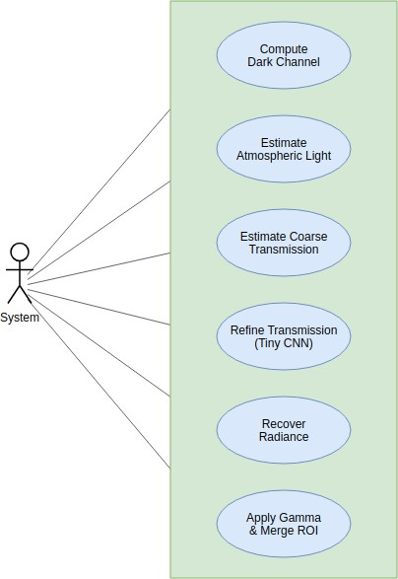

Fig 6: Use Case Level 1.4 (VisionGuard)

Level: 1.5

Use Case ID: 1.5
Name: Event Logging
Primary Actor: System (Capture Worker)

Secondary Actor: None

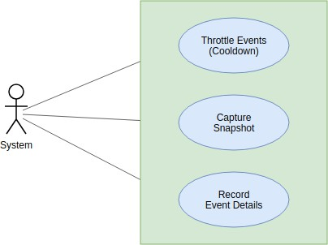

Fig 7: Use Case Level 1.5 (VisionGuard)
Level: 1.6

Use Case ID: 1.6
Name: Timeline / Event Browser Primary Actor: Operator Secondary Actor: None

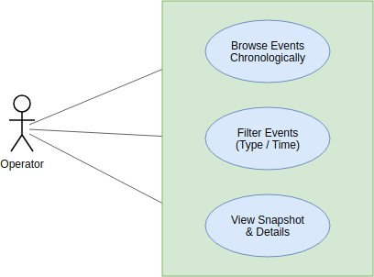

Fig 8: Use Case Level 1.6 (VisionGuard)

Level: 1.7

Use Case ID: 1.7
Name: NL Event Search Primary Actor: Operator Secondary Actor: LLM API
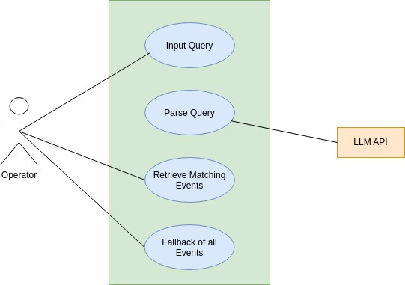
Fig 9: Use Case Level 1.7 (VisionGuard)

Activity Diagram
An activity diagram models the flow of control within a use case as a sequence of actions and decision points, capturing branching logic, loops, and parallel outcomes that a use case diagram alone cannot show. Following this convention, the activity diagrams for VisionGuard AI first trace the per-frame processing loop as a single end-to-end flow (Level 1), then break it down per module to mirror the use case breakdown in Section 3.1 (Levels 1.1–1.7).

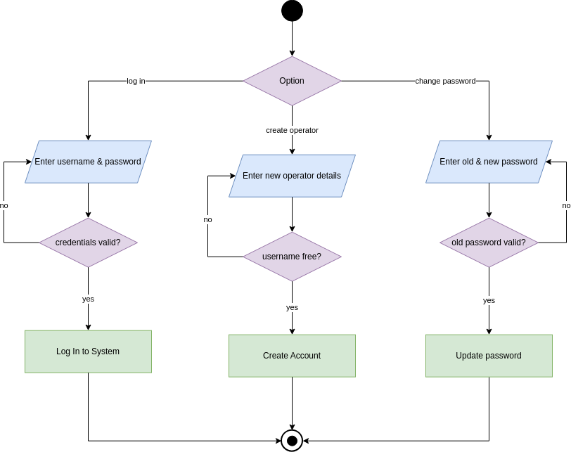

User Management

Fig 10: User Management

Camera & Feed Management

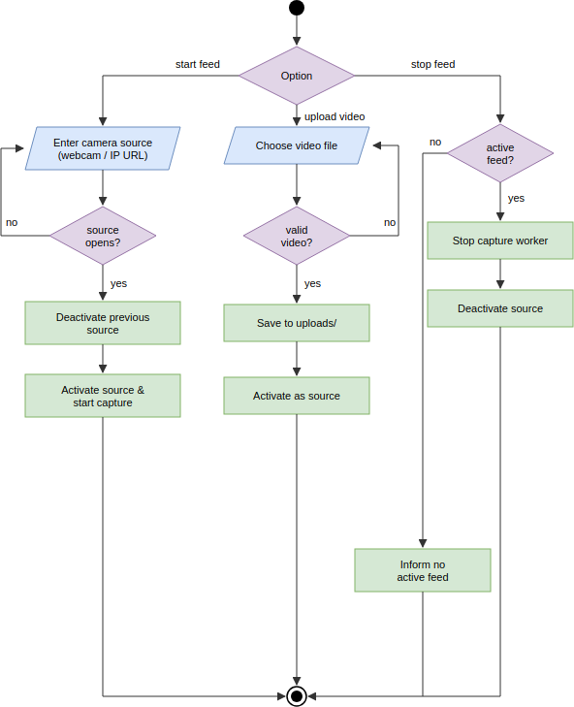
Fig 11: Camera and Feed Management

Motion Detection & ROI Extraction

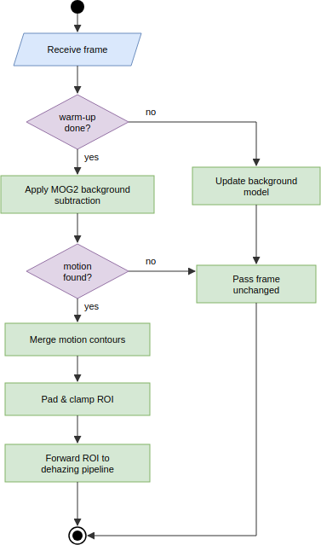

Fig 12: Motion Detection and ROI

Hybrid Dehazing Pipeline

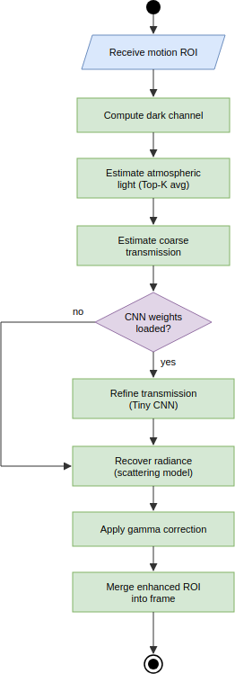

Fig 13: Hybrid Dehazing Pipeline

Event Logging
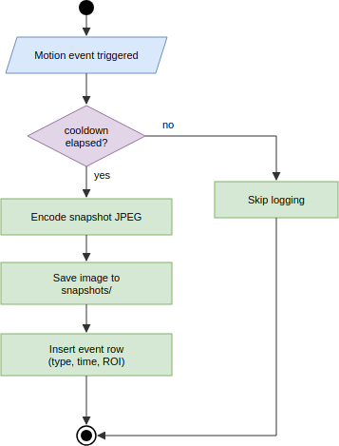

Fig 14: Event Logging

Timeline/Event Browser
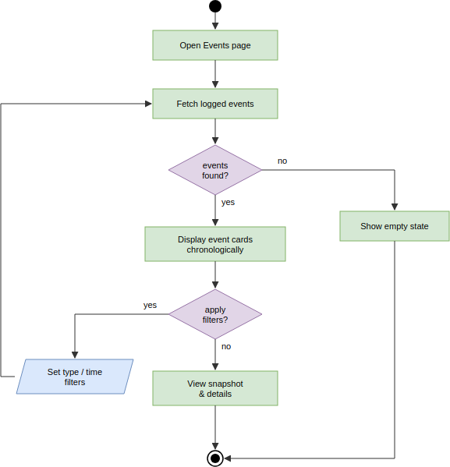

Fig 15: Event Browser

NL Event Search
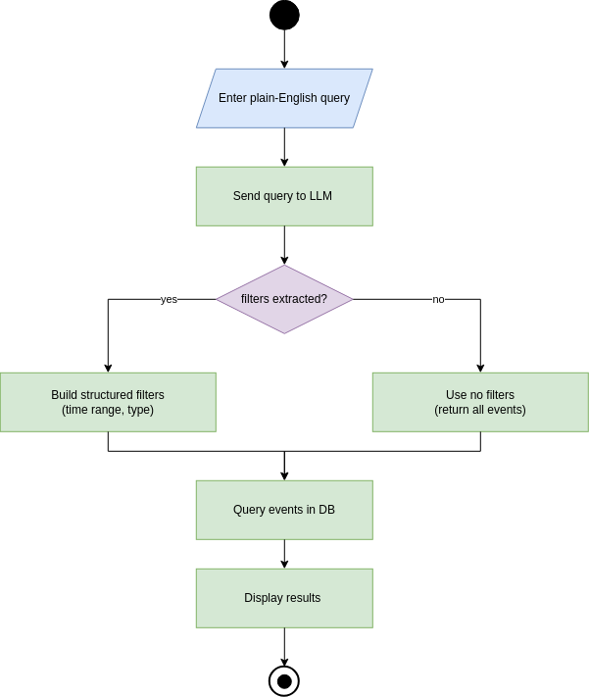

Fig 16: Event Search

Data & Information Modeling
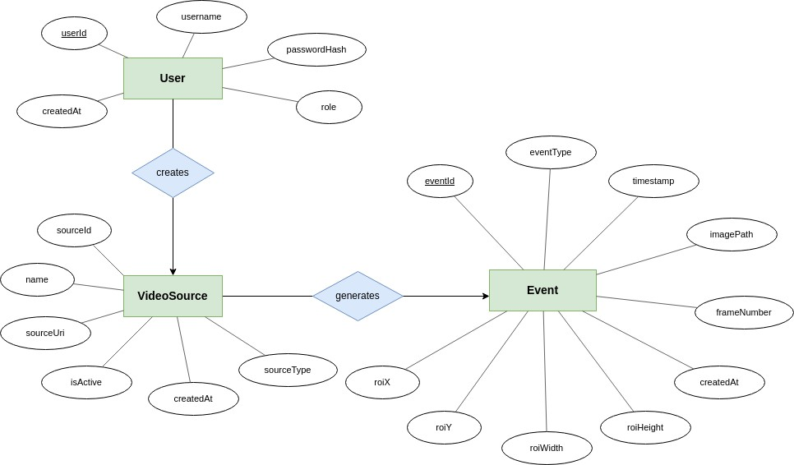
Fig 17: ER Diagram of VisionGuard

A User creates many VideoSource records (1:N); a VideoSource generates many Event records (1:N). The database schema, including primary and foreign keys, follows:

Table 1: User table for database schema

Attribute Name | Data Type | Key/Constraints
id | INTEGER | Primary Key, autoincrement
username | VARCHAR | Unique, not null
password_hash | VARCHAR | Not null (bcrypt hash, never plaintext)
role | VARCHAR | Not null ("admin" or "operator")
created_at | DATETIME | Not null, server default now

Table 2: VideoSource table for database schema

Attribute Name | Data Type | Key/Constraints
id | INTEGER | Primary Key, autoincrement
name | VARCHAR(255) | Not null
source_type | VARCHAR(20) | Not null (webcam / IP camera /  uploaded video)
source_uri | TEXT | Not null
is_active | BOOLEAN | Not null, default false
created_at | DATETIME | Not null, server default now
created_by | INTEGER | Foreign Key → User.id, nullable

Table 3: Event table for database schema

Attribute Name | Data Type | Key/Constraints
id | INTEGER | Primary Key, autoincrement
source_id | INTEGER | Foreign Key → VideoSource.id, not null
event_type | VARCHAR(30) | Not null
timestamp | DATETIME | Not null
image_path | TEXT | Not null
roi_x | INTEGER | Not null
roi_y | INTEGER | Not null
roi_width | INTEGER | Not null
roi_height | INTEGER | Not null
frame_number | INTEGER | Nullable
created_at | DATETIME | Not null, server default now

events are indexed on (source_id, timestamp) and (event_type, timestamp) to keep timeline browsing and natural-language search filters fast as the event log grows.

AI-Based Project Dataset Description
The Tiny CNN transmission-refinement model is trained on two complementary data sources rather than a single fixed dataset, since VisionGuard AI's neural component only needs to learn how to correct the Dark Channel Prior's errors, not to generate images from scratch.
- Dataset source:
- A synthetic haze generator that procedurally creates training samples: a random textured clean scene and a smooth, random ground-truth transmission field are combined through the atmospheric scattering model (I = J·t + A·(1−t)) to synthesize a hazy image. The network's input channels (grayscale ROI, dark channel, coarse transmission) are computed using the project's actual DCP implementation, so the

CNN learns to correct that specific estimator's real errors rather than an idealized one.
- The REVIDE real-world paired haze dataset (CVPR 2021), which records the same indoor scenes with and without machine-generated haze, giving pixel-aligned hazy/clear frame pairs for validating the model on real haze rather than only synthetic haze.
- Number of samples: 3,000 synthetic samples per training epoch by default (effectively unlimited and reproducible, generated deterministically per RNG seed/index), combined with 42 REVIDE training scene folders (1,697 hazy training images) and 6 REVIDE test scene folders (284 hazy test images) used for real-data validation.
- Features: each sample's input is a 3-channel stack — grayscale hazy ROI, dark channel, and coarse DCP transmission map — matching the Tiny CNN's documented input in this report's pipeline description.
- Labels: there is no classification label; the training target is a refined transmission map. For synthetic samples the ground-truth transmission field is known exactly; for REVIDE's real pairs (which have no true transmission map) the coarse DCP transmission is used as a physically-grounded anchor. The model is optimized primarily through a self-supervised image reconstruction loss — the L1 distance between the image recovered using the predicted transmission and the true clean image — with a small auxiliary L1 term against the known transmission on synthetic data.
- Data preprocessing: images are cropped to 96×96 training patches, the DCP is computed with a 15-pixel erosion window, and inputs/targets are normalized to [0, 1] float32 before being batched (batch size 16) for training with Adam (learning rate 1e-3, halved every 8 epochs) over 15 epochs by default, with the
best-validation-loss weights saved to backend/weights/tiny_cnn.pth.

Preliminary Test Plan

Testing Objectives
- Verify that all functional requirements listed in Section 2.1 behave as specified.
- Ensure the motion-gated, ROI-only dehazing pipeline remains stable under continuous frame processing.
- Validate that error and edge-case handling (missing CNN weights, invalid uploads, unparseable search queries) degrades gracefully instead of crashing.
- Evaluate whether the pipeline meets its real-time performance target on CPU-only hardware.

Features to be Tested

Table 4: High-level testing plan for VisionGuard AI

# | Title | Scenario | Steps | Expected Outcome
1 | Operator Login | Verify secure login flow. | 1. Enter valid username/password  . 2. Submit POST  /auth/login. | A signed JWT access token is issued and the frontend stores it  for subsequent requests.
2 | Admin-Only Account Creation | Restrict operator account creation to admins. | - Log in as an operator. 2. Attempt POST  /auth/users. | Request is rejected (403); no row is created in the User  table.
3 | Live Feed Start | Start a webcam/IP camera feed. | - Call POST  /start-camera  with a source URI.  - Check /frame. | The capture worker activates the source and /frame returns  a processed frame.
4 | Video Upload Validation | Upload a video file for processing. | - POST  /upload-video with an invalid (non-video) file. | The operator receives a clear validation error rather than a silently broken stream.
5 | Motion-Skip Behavior | Confirm dehazing is skipped when idle. | - Feed static frames with no motion. | The dehazing pipeline is never invoked; frames pass through unchanged, keeping CPU usage low.
6 | ROI Extraction Correctness | Confirm only the motion region is processed. | - Feed a frame with a single moving object. | The extracted ROI bounding box tightly (with padding) covers the motion contour, not the full frame.

# | Title | Scenario | Steps | Expected Outcome
7 | Dehazing Reconstruction Quality | Verify the hybrid pipeline improves visibility. | 1. Run a hazy ROI through the full pipeline (DCP → CNN → radiance recovery → gamma). | The recovered ROI has measurably higher contrast/lower haze than the  coarse-DCP-only output.
8 | CNN Weights Missing Fallback | Ensure pipeline degrades gracefully without trained weights. | 1. Start the pipeline with MODEL_PATH pointing to a missing file. | The pipeline falls back to the unrefined DCP  transmission instead of crashing.
9 | Event Logging & Cooldown | Verify events are throttled, not logged every frame. | 1. Trigger continuous motion for several seconds. | Exactly one event is logged per cooldown window, each with correct timestamp, image  path, and ROI coordinates.
10 | Timeline Browsing | Verify  chronological event retrieval. | 1. Log several  events. 2. Call GET  /events. | Events are returned  in chronological order with snapshot and metadata intact.
11 | NL Event Search  — Time Parsing | Verify natural language queries resolve to filters. | 1. Call GET  /events/search  ?q=any motion last night?. | Claude API returns a parsed time range; only events  within that range are returned.
12 | NL Event Search  — Fallback | Verify unparseable queries do not fail. | 1. Submit a vague query with no  extractable time/type. | The system returns all events rather  than raising an error.
13 | System Status  Check | Confirm health  endpoint reflects real pipeline state. | 1. Call GET  /system-status  while a feed is active. | Response reports  the camera feed and dehazing pipeline as running.
14 | Feed Stop Without Active Source | Guard against invalid stop requests. | 1. Call POST  /stop-camera  with no active feed. | The operator is informed no feed is active rather than the server raising  an unhandled error.
15 | Auth Enforcement on Protected Routes | Confirm  router-level auth guards all  non-login endpoints. | 1. Call GET  /events without an Authorization header. | Request is rejected (401) before reaching any controller or service logic.

Timeline

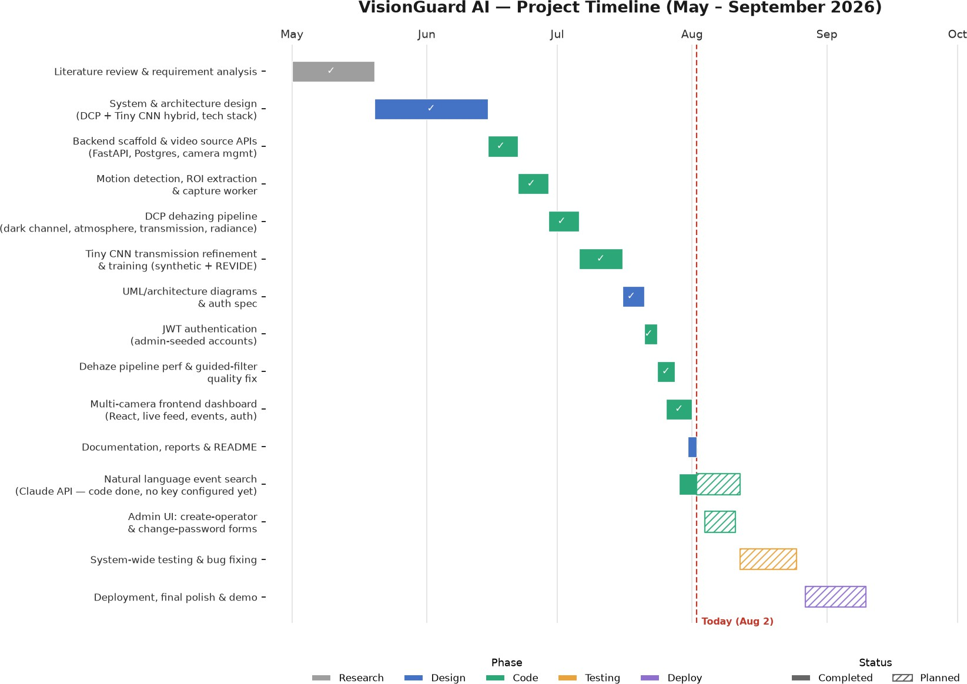
Fig 18: Gantt Chart of VisionGuard Progress Timeline

