**A PBL Report**

**of**

**Master of Computer Application (Cloud Computing)**

**in**

**“E-Commerce”**

**Submitted to**



**SAGE UNIVERSITY**

**BHOPAL (M.P.)**

|  |  |
| --- | --- |
| **Submitted by**  **Karishma Chilhate**  Enrollment No. 21MCA5CCM10003  **Tabasum Khan**  Enrollment No. 21MCA5CCM10011 | **Under the Supervision of** |

**SCHOOL OF COMPUTER APPLICATION**

**SAGE UNIVERSITY, BHOPAL**

**(2021-22)**



**SANJEEV AGRAWAL GLOBAL EDUCATIONAL UNIVERSITY, BHOPAL**

**SCHOOL OF COMPUTER APPLICATION**

**DECLARATION**

We **Karishma Chilhate, Tabasum Khan** student of “**Master of Computer Application (Cloud Computing)”,** session **2021-22,** hereby informed that the work presented in this project entitled **“E-Commerce ”** is the outcome of my/our own work, is a bonafide and correct to the best of my/our knowledge and work has been carried out taking care of ethics. The work presented does not infringe any patented work and has not been submitted to any other University or anywhere else.

|  |  |
| --- | --- |
| **Date: 22/09/22**  **Place: Bhopal** | **Student Name**  **Karishma Chilhate**  **(21MCA5CCM10003)**  **Tabasum Khan (21MCA5CCM10011)** |

|  |  |
| --- | --- |
| **Supervisor**  **Mr.. Bhavesh Shah (Guide)**  **SSOCA, Bhopal** | **HOS**  **Dr. Gourav Shrivastava**  **SSOCA, Bhopal** |



**SANJEEV AGRAWAL GLOBAL EDUCATIONAL UNIVERSITY, BHOPAL**

**SCHOOL OF COMPUTER APPLICATION**

**CERTIFICATE**

This is to certify that the work embodies in this project entitled **“E-Commerce”** being submitted by **Karishma Chilhate [Enrollment No.21MCA5CCM10003]**, **Tabasum Khan [Enrollment No. 21MCA5CCM10011],** in partial fulfillment of the requirement for the award of **“Master of Computer Application (Cloud Computing)’’** in **SAGE SCHOOL OF COMPUTER APPLICATION**, Bhopal, is an authentic record of my own work carried under the supervision and guidance of Mr. **Bhavesh Shah** and has not been submitted anywhere

I also declare that “A check for Plagiarism has been carried out on this project report and is found within the accepted limit and report of which is enclosed as annexure I”.

**Supervisor HOS**

**Prof. Bhavesh Shah (Guide) Dr. Gourav Shrivastava**

**SSOCA, Bhopal**



**SANJEEV AGRAWAL GLOBAL EDUCATIONAL UNIVERSITY, BHOPAL**

**SCHOOL OF COMPUTER APPLICATION**

**DECLARATION OF PLAGIARISM**

We hereby declare that the work embodies in this project entitled **“E-Commerce”** being submitted by, **Karishma Chilhate [Enrollment No. 21MCA5CCM10003],**  of **“Master Of Computer Application (Cloud Computing)** in **SAGE SCHOOL OF COMPUTER APPLICATION**, Bhopal, is an authentic record of our own work carried under the supervision and guidance of **Mr. Bhavesh Shah** and has not been submitted anywhere.

We also declare that “A check for Plagiarism has been carried out on this project report and is found within the accepted limit and report of which is enclosed as annexure I”.

|  |  |
| --- | --- |
| **Submitted by**  **Karishma Chilhate**  Enrollment No. 21MCA5CCM10003  **Tabasum Khan**  Enrollment No. 21MCA5CCM10011 | **Supervisor**  **Mr. Bhavesh Shah**  **(SAGE School of Computer Application, Bhopal)** |

**HOS/Dean Signature**

**SANJEEV AGRAWAL GLOBAL EDUCATIONAL UNIVERSITY, Bhopal**

**SCHOOL OF COMPUTER APPLICATION**

**CERTIFICATE OF APPROVAL**

The project entitled **“E-Commerce”** being submitted by **Karishma Chilhate [Enrollment No. 21MCA5CCM10003, Tabasum Khan [Enrollment No. 21MCA5CCM10011.]**  has been examined by us and is hereby approved for the partial fulfillment for the award of **“Master of Computer Application in ”** for which it has been submitted. It is understood that by this approval the undersigned do not necessary endorse or approve any statement made, opinion expressed or conclusion drawn therein but approved the project only for the purpose for which it has been submitted.

|  |  |
| --- | --- |
| **(Internal Examiner)**  **Mr. Bhavesh Shah (Guide)**  **(SSOAC,SAGE, Bhopal)** | **(External Examiner)** |

**SANNJEEV AGRAWAL GLOBAL EDUCATIONAL UNIVERSITY, Bhopal**

**SCHOOL OF COMPUTER APPLICATION**

**ACKNOWLEDGEMENT**

It is my proud privilege to present a project on **“E-Commerce”**. I take this opportunity to express deep sense of gratitude and would like to give thanks to my guide, **Mr. (Bhavesh Shah) SAGE SCHOOL OF COMPUTER APPLICATION**, Bhopal for his valuable guidance, inspiration and encouragement that has lead to successful completion of this work. I would like to express my heartfelt thanks towards **Dr. Gourav Shrivastava (HOS, SSOCA)**. I would like to express my heartfelt thanks to all the PBL Coordinators**,** for their valuable suggestions throughout the project work. I could not have accomplished, what I actually have, without their guidance.

I am also thankful to all faculty members and staff of SSOCA for their suggestion and support.

I would like to deeply thank my family and friends for all the support and encouragement they have rendered time to time.

Last but not the least, I dedicate my work to almighty God without whose wish and helping hands this work would not have taken the shape it has now and also to my family members whose support and encouragement had led me to complete this task.

|  |
| --- |
| **Karishma Chilhate**  Enrollment No. 21MCA5CCM10003  **Tabasum Khan**  Enrollment No. 21MCA5CCM10011 |

**INTRODUCTION**

A shop anywhere, is an e-commerce website which is beneficial for all buyers who are willing to purchase anything in a short duration of time. This website contain the home page, which will be displayed for everyone, but for purchasing further the customer have to create their account and after that he can access other features by searching and then he can buy that product. The module consist the payment gateway , which will be very beneficial for all customers wheather they can pay on delivery and those customers who have to pay the amount online can pay by their upi. An additional feature of this website is object detection where the customer who don’t known the product name can also keep the product in front of camera and can search for that specific product. This website will also allow user to edit their profile anytime. The easier we make it for customers to connect- with a contact form which will be available 24*7 , the easier it will be to solve their problems quickly. This data of this website will be stored in S3 service of AWS. Amazon Simple Storage Service (Amazon S3) is an object storage service offering industry-leading scalability, data availability, security, and performance.

**MODULES**

* Home – This module will contain all other modules through which the customer can go to any other module and also it will display the products with their price. So, that customer can view the product quality and go for further process
* Login – The module is for existing customer or who have created the account can login here.
* Create account – New customer’s first have to create their account in this
* Customer review – This will allow the customer’s to give their own review about the website
* Payment gateway – through this module customer’s can make payment of the product at the time of purchasing.
* Contact – The contact module will be available for 24*7 . so, that the customers can contact and ask the doubts anytime.

**FUNCTIONAL REQUIREMENT**

Order of product

Can view details of product

Payment gateway should work

**USE CASE DIAGRAM**

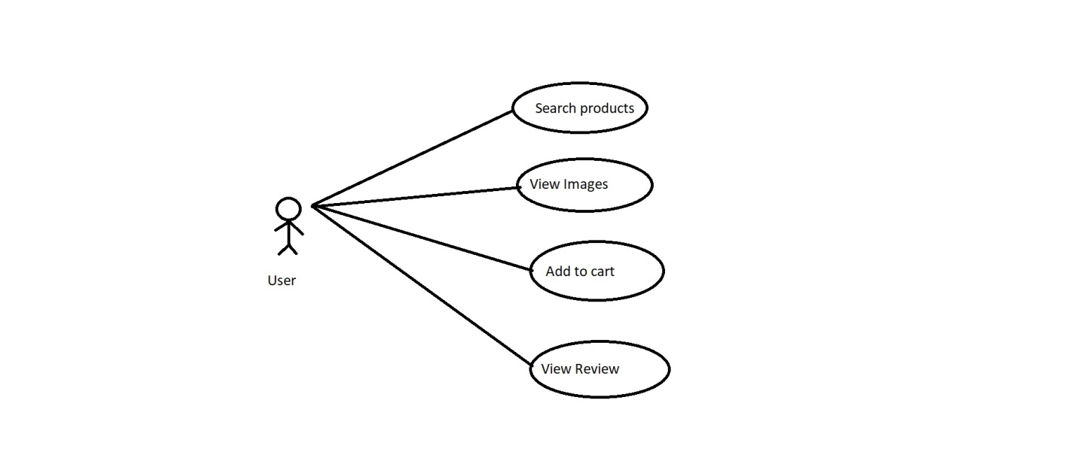

**ADVANTAGES of E-Commerce**

* Faster buying process
* Store product listing creation
* Faster response to buyer/market demand
* Several payment modes

**DISADVANTAGES of E-Commerce**

* **No one can buy during a site crash**
* **Customers can’t try before they buy**
* **E-commerce is highly competitive**