|  |  |  |
| --- | --- | --- |
| Name | Bob Chen |  |
| Job Section | P | Public Relations |
| Product | C | Cheese sandwich |
| Enter the number of servings | 4 |  |
| Which table are you at | 6 |  |
| Lookup price |  | 7 |
|  |  | Price times servings  4*7 = $28 |
|  | Discount (3 or more) 5% | 28-(28*0.05) = 28-1.40 = 26.6 |
|  | Tax | Tax at 8%  26.60 *0.08 = 2.128  Giving 26.6+2.128  =28.728  Rounded 28.73 |
|  |  | ----------------------------------------------  Name : Bob Chen  Table Number : 4  Meal : Cheese sandwich  Job Section : Astronaut  Product Cost :$7  Gross : 28  Discount : 1.40  Tax : 2.13  Total cost :$ 28.73  ---------------------------------------------- |

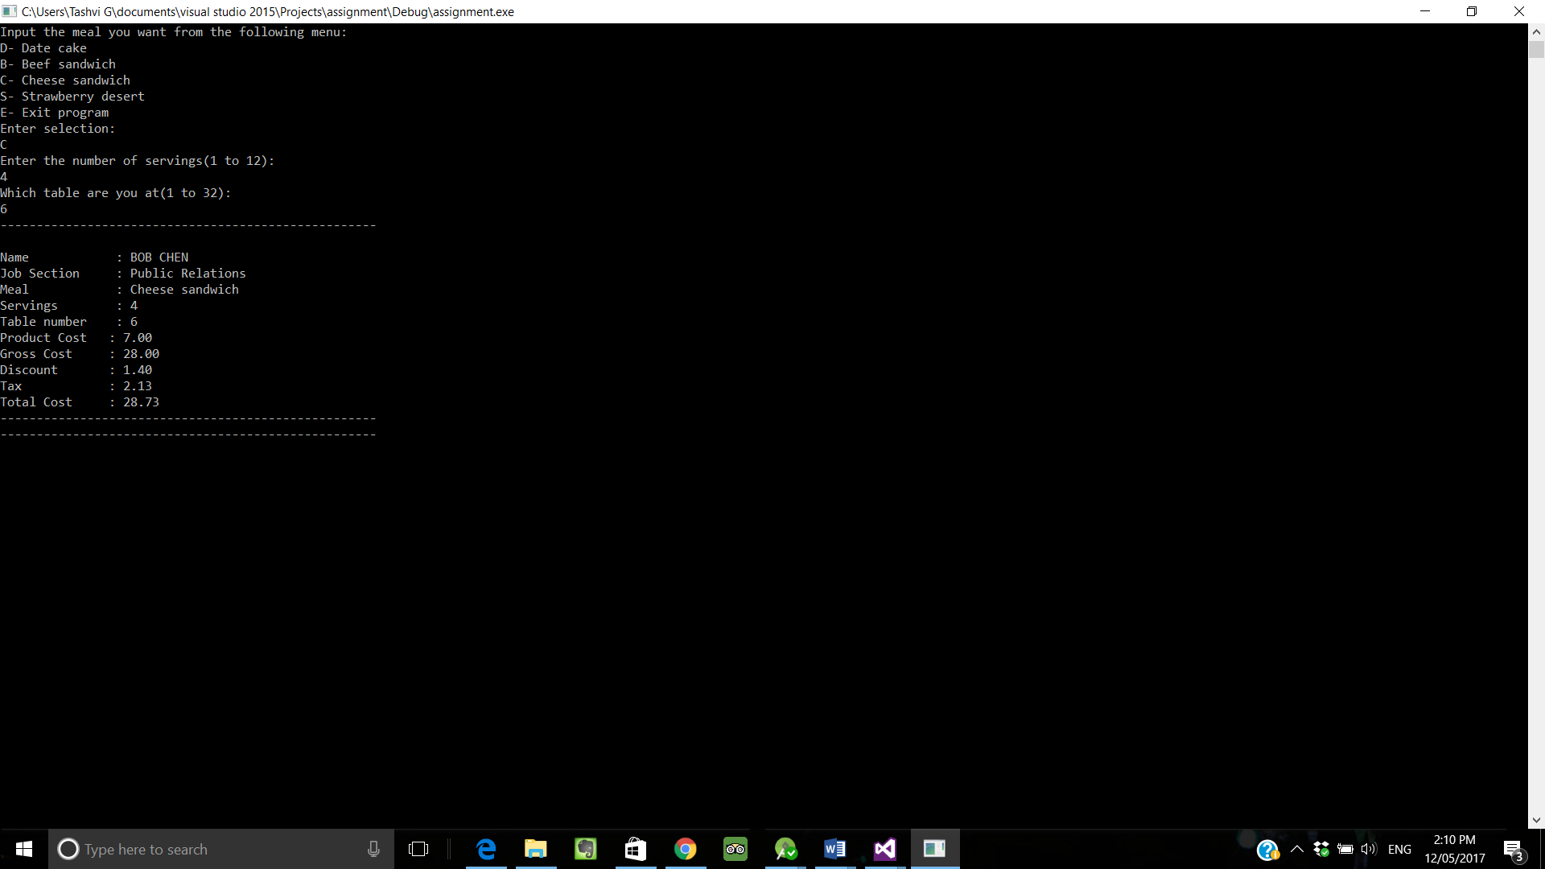

|  |  |  |
| --- | --- | --- |
| Name | Sally Ride |  |
| Job Section | A | Astronaut |
| Product | D | Date cake |
| Enter the number of servings | 1 |  |
| Which table are you at | 31 |  |
| Lookup price |  | 1 |
|  |  | Price times servings  1*1 = 1 |
|  | Discount (3 or more) 5% | 28-(28*0.05) = 28-1.40 = 26.6 |
|  | Tax | 0 |
|  |  | ----------------------------------------------  Name : Sally Ride  Table Number : 31  Meal : Date cake  Job Section : Astronaut  Product Cost :1 .00  Gross : 1.00  Discount : 1.00  Tax : 0.00  Total cost :1.00  ---------------------------------------------- |

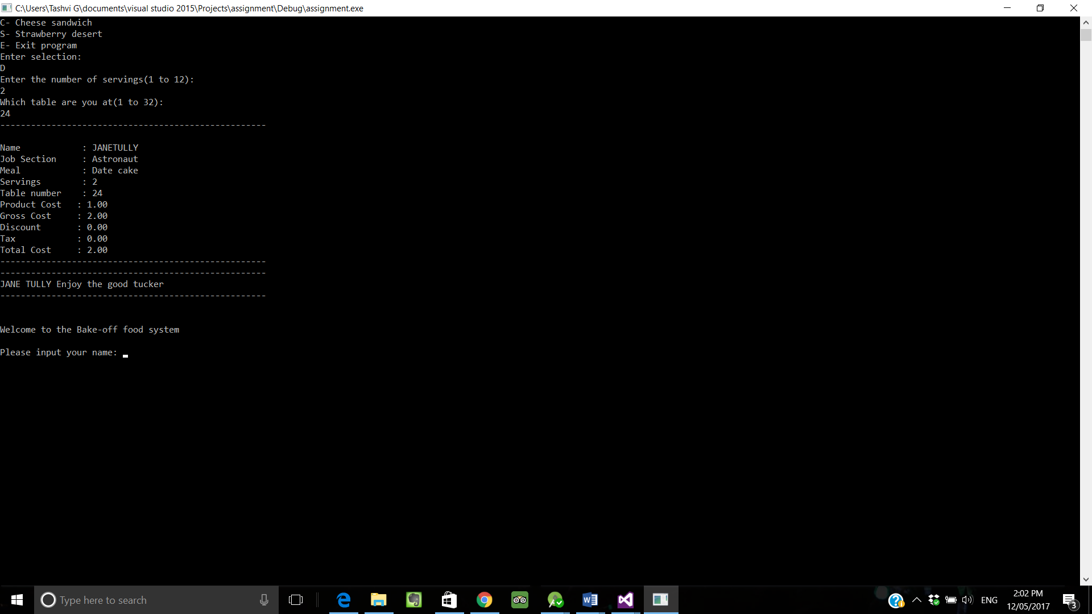

|  |  |  |
| --- | --- | --- |
| Name | Yuri Gagarin |  |
| Job Section | A | Astronaut |
| Product | B | Beef sandwich |
| Enter the number of servings | 4 |  |
| Which table are you at | 31 |  |
| Lookup price |  | 0 |
|  |  | Price times servings  0*4=0 |
|  | Discount (3 or more) 5% | 0 |
|  | Tax | 0 |
|  |  | ----------------------------------------------  Name : Yuri Gagarin  Table Number : 31  Meal : Beef sandwich  Job Section : Astronaut  Product Cost :$0.00  Gross : 0.00  Discount : 0.00  Tax : 0.00  Total cost :$ 0.00  ---------------------------------------------- |

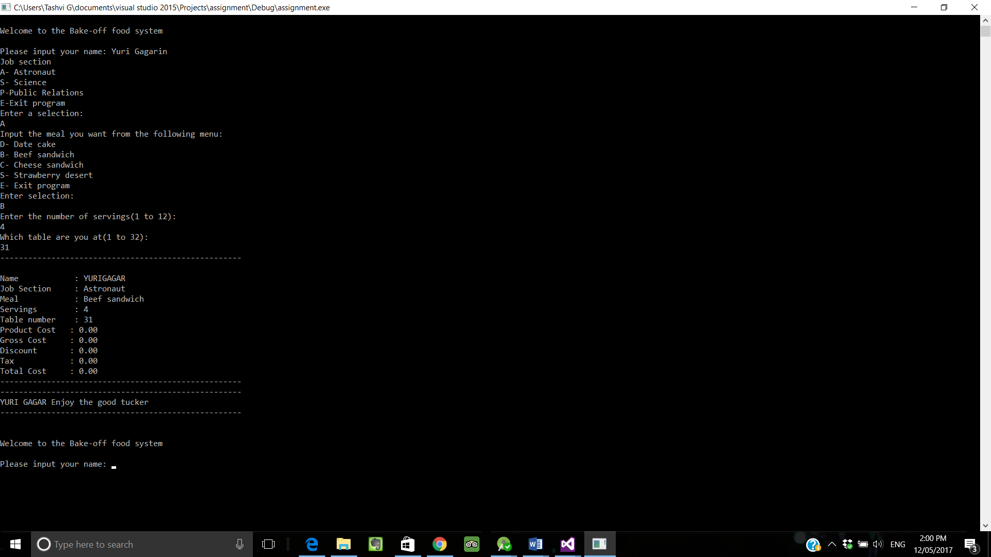

|  |  |  |
| --- | --- | --- |
| Name | Jane Tully |  |
| Job Section | A | astronaut |
| Product | S | Strawberry cake  That’s not in your diet  **enter meal again |



|  |  |  |
| --- | --- | --- |
| Name | Jane Tully |  |
| Job Section | A | Astronaut |
| Product | D | Date cake |
| Enter the number of servings | 2 |  |
| Which table are you at | 24 |  |
| Lookup price |  | 1 |
|  |  | Price times servings  1*2 = 2 |
|  | Discount (3 or more) 5% | 0 |
|  | Tax | 0 |
|  |  | ----------------------------------------------  Name : Jane Tully  Table Number : 24  Meal : Date cake  Job Section : Astronaut  Product Cost :2 .00  Gross : 2.00  Discount : 0.00  Tax : 0.00  Total cost :2.00  ---------------------------------------------- |



|  |  |  |
| --- | --- | --- |
| Name | Rubens May |  |
| Job Section | S | Science |
| Product | D | Date cake |
| Enter the number of servings | 12 |  |
| Which table are you at | 1 |  |
| Lookup price |  | 5 |
|  |  | Price times servings  12*5 = 60 |
|  | Discount (3 or more) 5% | 60*0.05=3 |
|  | Tax | 0 |
|  |  | ----------------------------------------------  Name : Rubens May  Table Number : 1  Meal : Date cake  Job Section : Science  Product Cost :5 .00  Gross : 60.00  Discount : 3.00  Tax : 0.00  Total cost :57.00  ---------------------------------------------- |

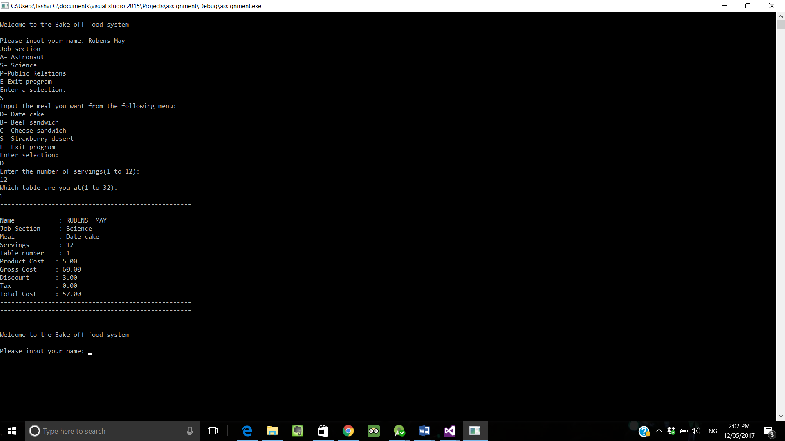

|  |  |  |
| --- | --- | --- |
| Name | Rob Cox |  |
| Job Section | S | Science |
| Product | C | Cheese Sandwich |
| Enter the number of servings | 3 |  |
| Which table are you at | 2 |  |
| Lookup price |  | 4.90 |
|  |  | Price times servings  4.90*3=14.7 |
|  | Discount (3 or more) 5% | 0.05*14.7=0.735 |
|  | Tax | 0 |
|  |  | ----------------------------------------------  Name : Rob Cox  Table Number : 2  Meal : Cheese sandwich  Job Section : Science  Product Cost :4.90  Gross : 14.7  Discount : 0.735  Tax : 0.00  Total cost :13.97  ---------------------------------------------- |

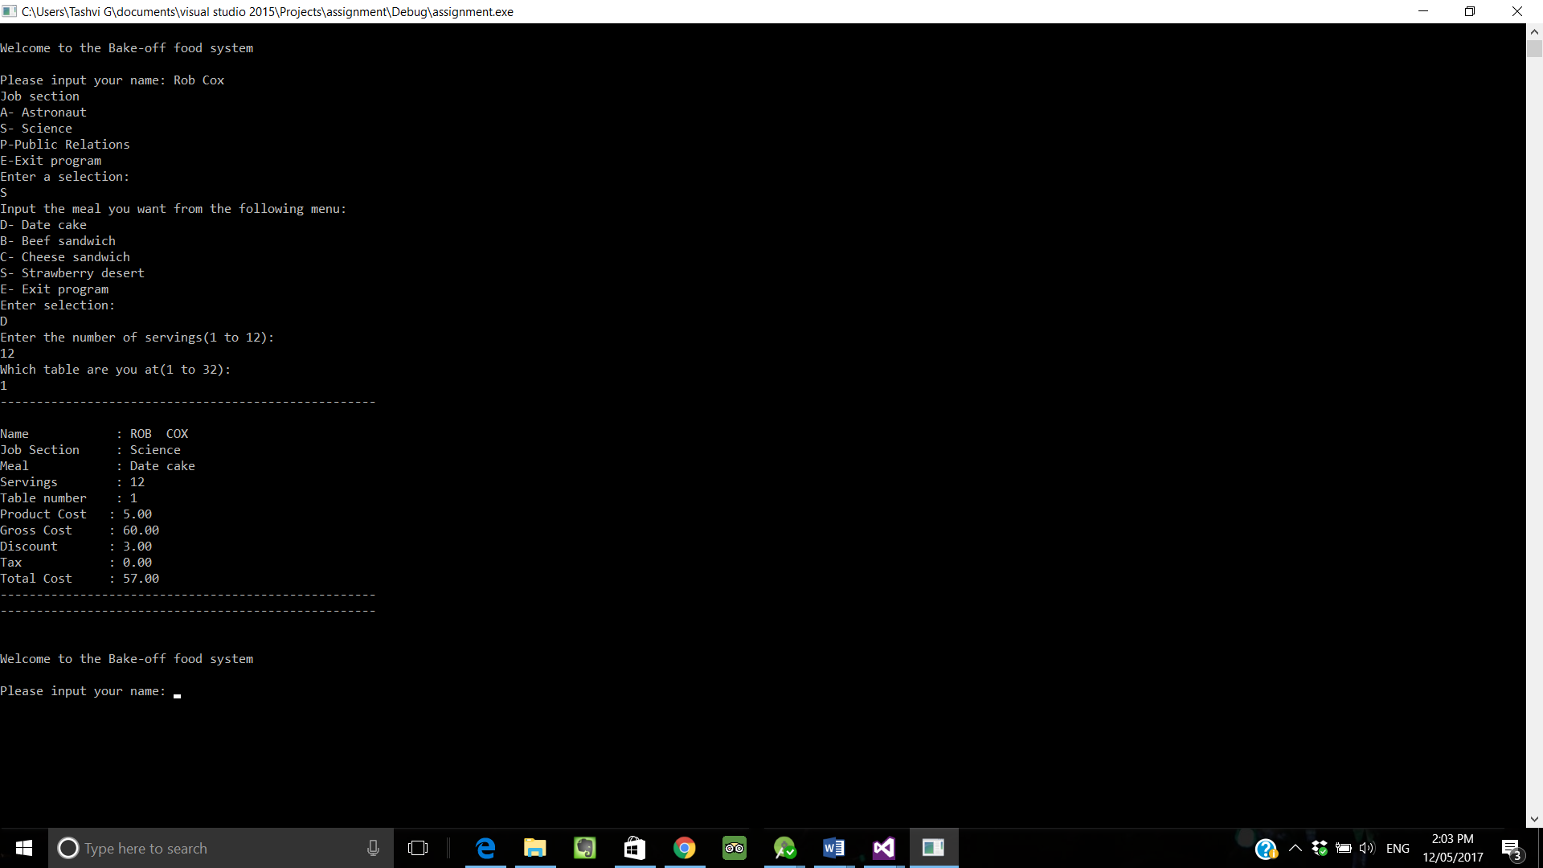

|  |  |  |
| --- | --- | --- |
| Name | Bob Chen |  |
| Job Section | P | Public Relations |
| Product | S | Strawberry cake |
| Enter the number of servings | 2 |  |
| Which table are you at | 6 |  |
| Lookup price |  | 7.50 |
|  |  | Price times servings  7.50*2=15 |
|  | Discount (3 or more) 5% | 0 |
|  | Tax | Tax at 8%  15 *0.08 = 1.2  Giving 1.2+15  =16.2 |
|  |  | ----------------------------------------------  Name : Bob Chen  Table Number : 6  Meal : Cheese sandwich  Job Section : Public Relations  Product Cost :$7.50  Gross : 15  Discount : 0  Tax : 1.2  Total cost :$ 16.2  ---------------------------------------------- |
|  |  |  |



|  |  |  |
| --- | --- | --- |
| Name | Jonathan Coulton |  |
| Job Section | P | Public Relations |
| Product | B | Beef Sandwich |
| Enter the number of servings | 13 | Error cannot order more than 12 |
|  |  |  |
|  |  |  |
|  |  |  |
|  |  |  |
|  |  |  |
|  |  |  |



|  |  |  |
| --- | --- | --- |
| Name | Jonathan Coulton |  |
| Job Section | P | Public Relations |
| Product | B | Beef Sandwich |
| Enter the number of servings | 1 |  |
| Which table are you at | 35 | Error Invalid amount |
|  |  |  |
|  |  |  |
|  |  |  |



ADDITIONAL TEST PLANS

|  |  |  |
| --- | --- | --- |
| Name | Tashvi Gooroochurn |  |
| Job Section | A | astronaut |
| Product | T | Error- must be one of the D,B,C,S |

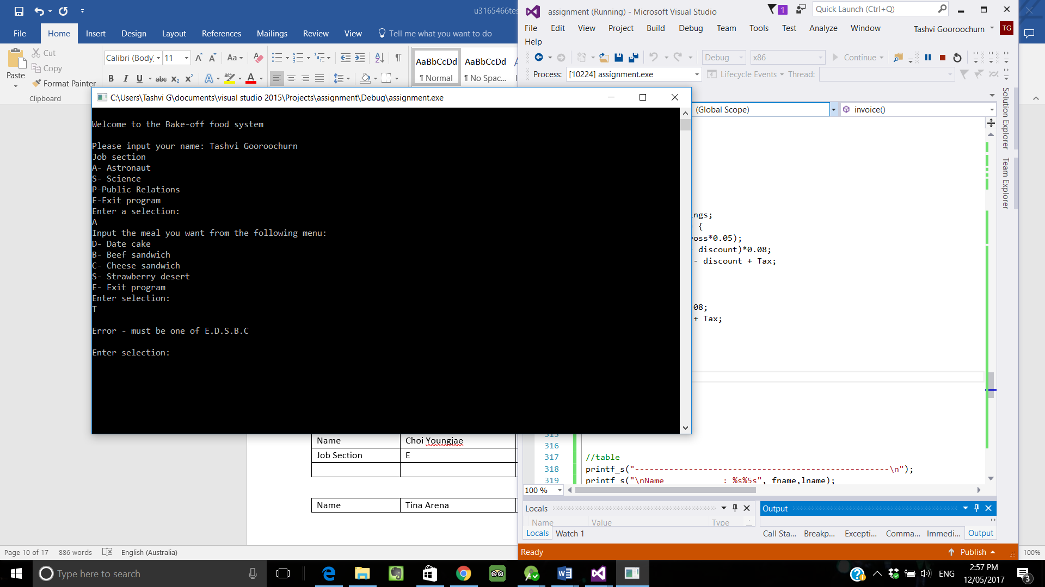

|  |  |  |
| --- | --- | --- |
| Name | Park Jinyoung |  |
| Job Section | J | Error- must be one of the E,A,S,P |

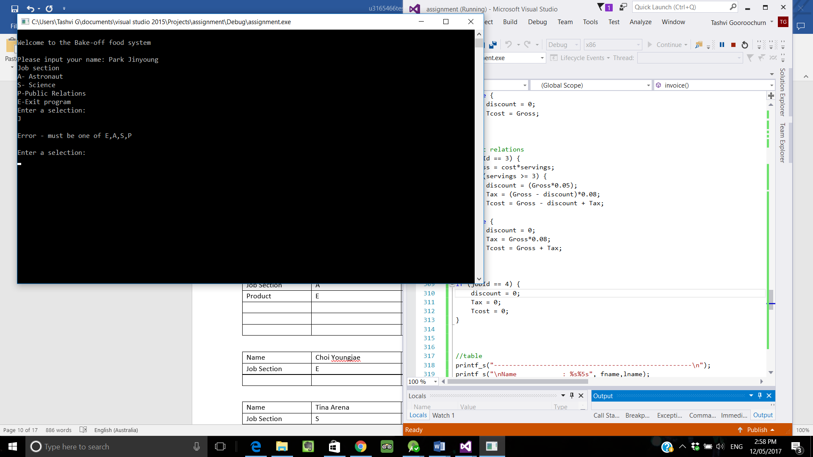

|  |  |  |
| --- | --- | --- |
| Name | Mark Tuan |  |
| Job Section | A | astronaut |
| Product | E | **Program exits** |
|  |  |  |
|  |  |  |
|  |  |  |

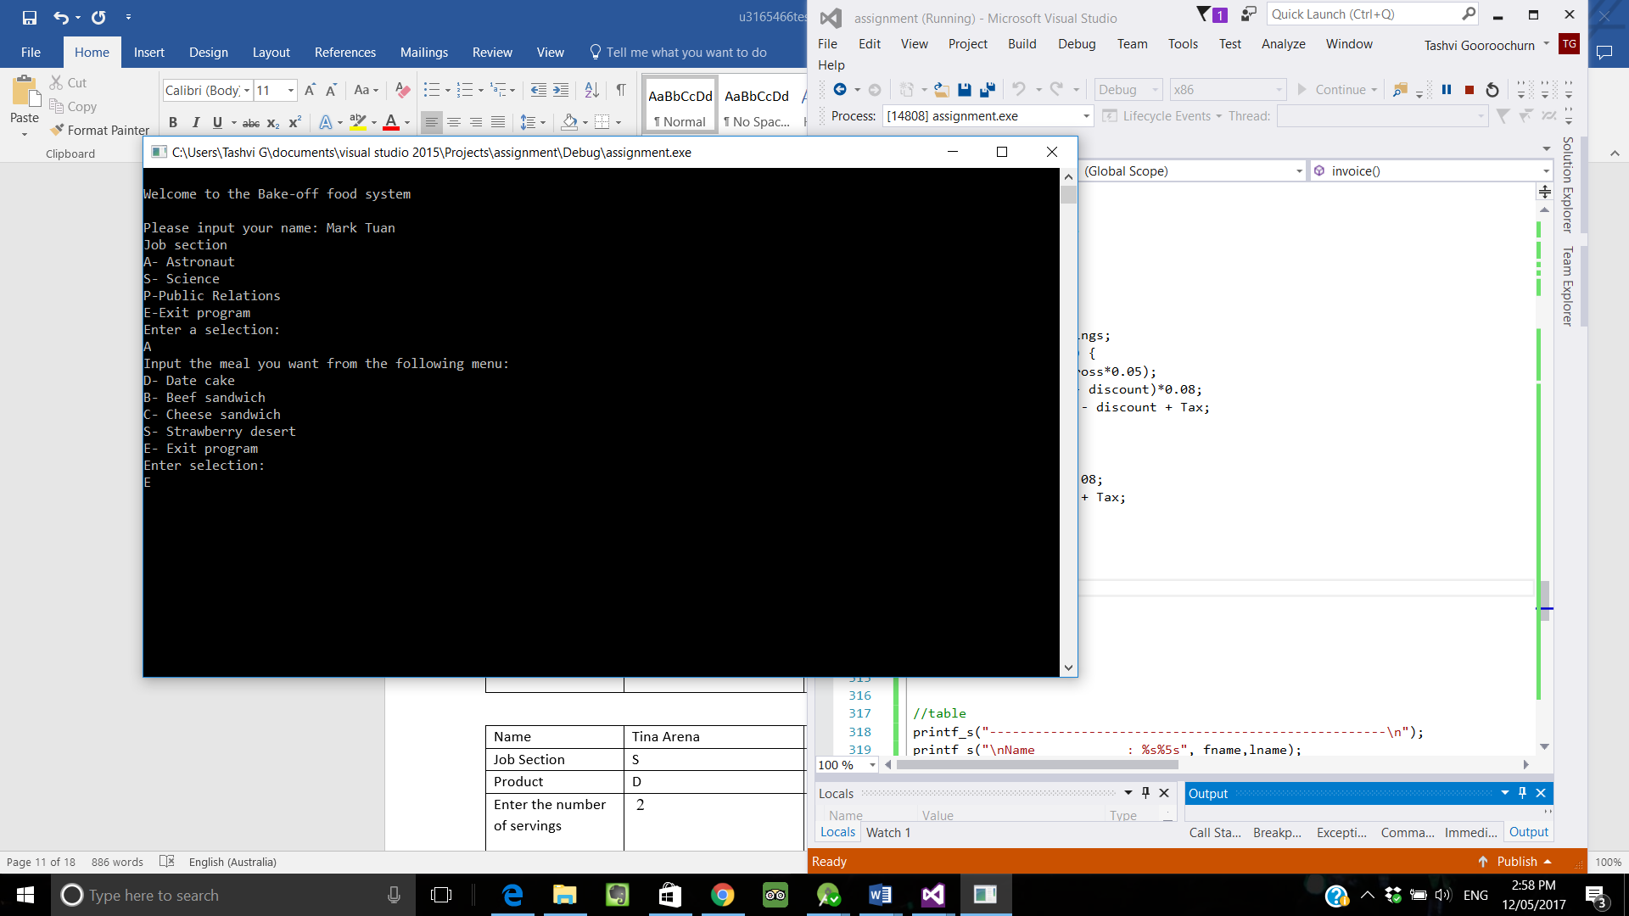

|  |  |  |
| --- | --- | --- |
| Name | Choi Youngjae |  |
| Job Section | E | **Program exits** |
|  |  |  |
|  |  |  |

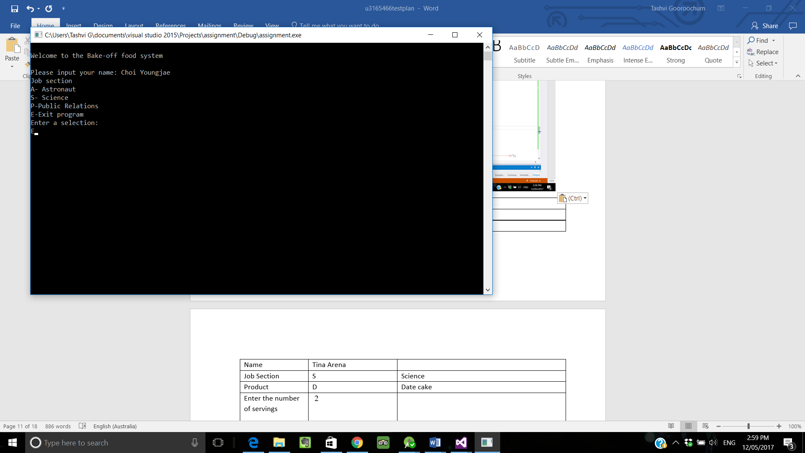

|  |  |  |
| --- | --- | --- |
| Name | Tina Arena |  |
| Job Section | S | Science |
| Product | D | Date cake |
| Enter the number of servings | 2 |  |
| Which table are you at | 17 |  |
| Lookup price |  | 5 |
|  |  | Price times servings  5*2 = $10 |
|  | Discount (3 or more) 5% | N/A |
|  | Tax | Science does not pay tax |
|  |  | ----------------------------------------------  Name : Tina Arena  Table Number : 17  Meal : Date cake  Job Section : Science  Product Cost :$5  Gross : 10  Discount : 0  Tax : 0.00  Total cost :$ 10.00  ---------------------------------------------- |

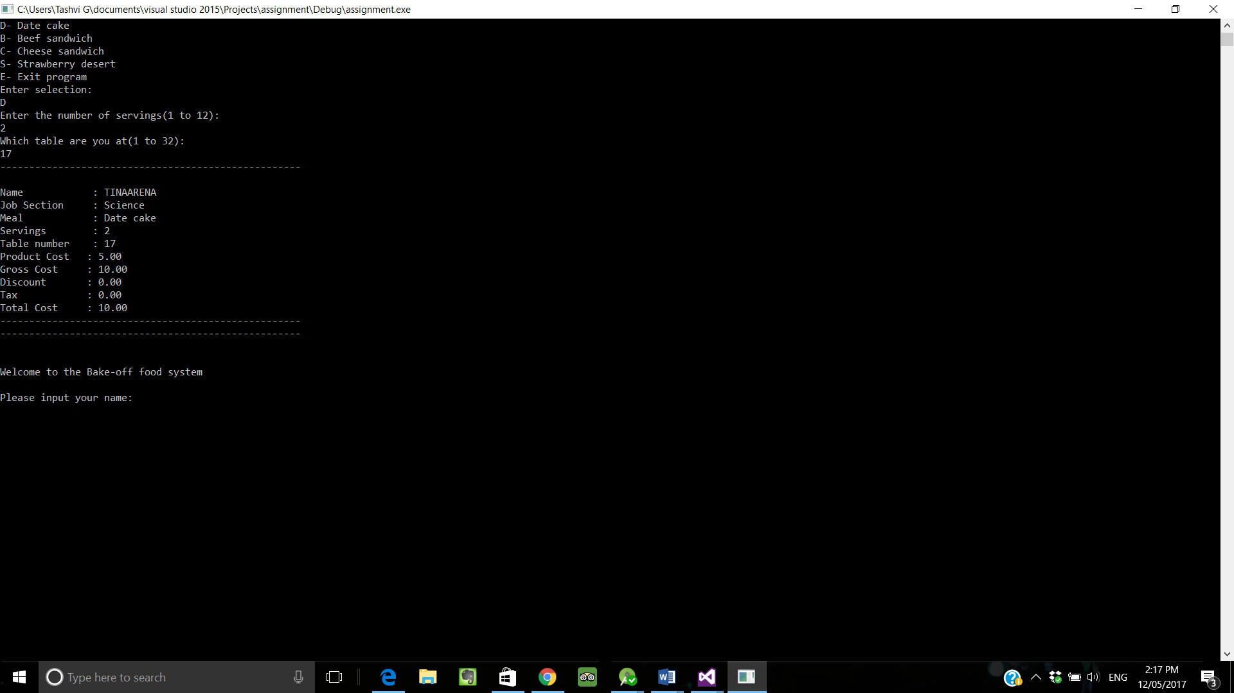

|  |  |  |
| --- | --- | --- |
| Name | Jane Tully |  |
| Job Section | A | astronaut |
| Product | S | Strawberry  That’s not in your diet  Ending Now |
| Product | 3 | Error must be one of E.D.S.B.C |
| Product | 24 | Error must be one of E.D.S.B.C |
|  |  |  |

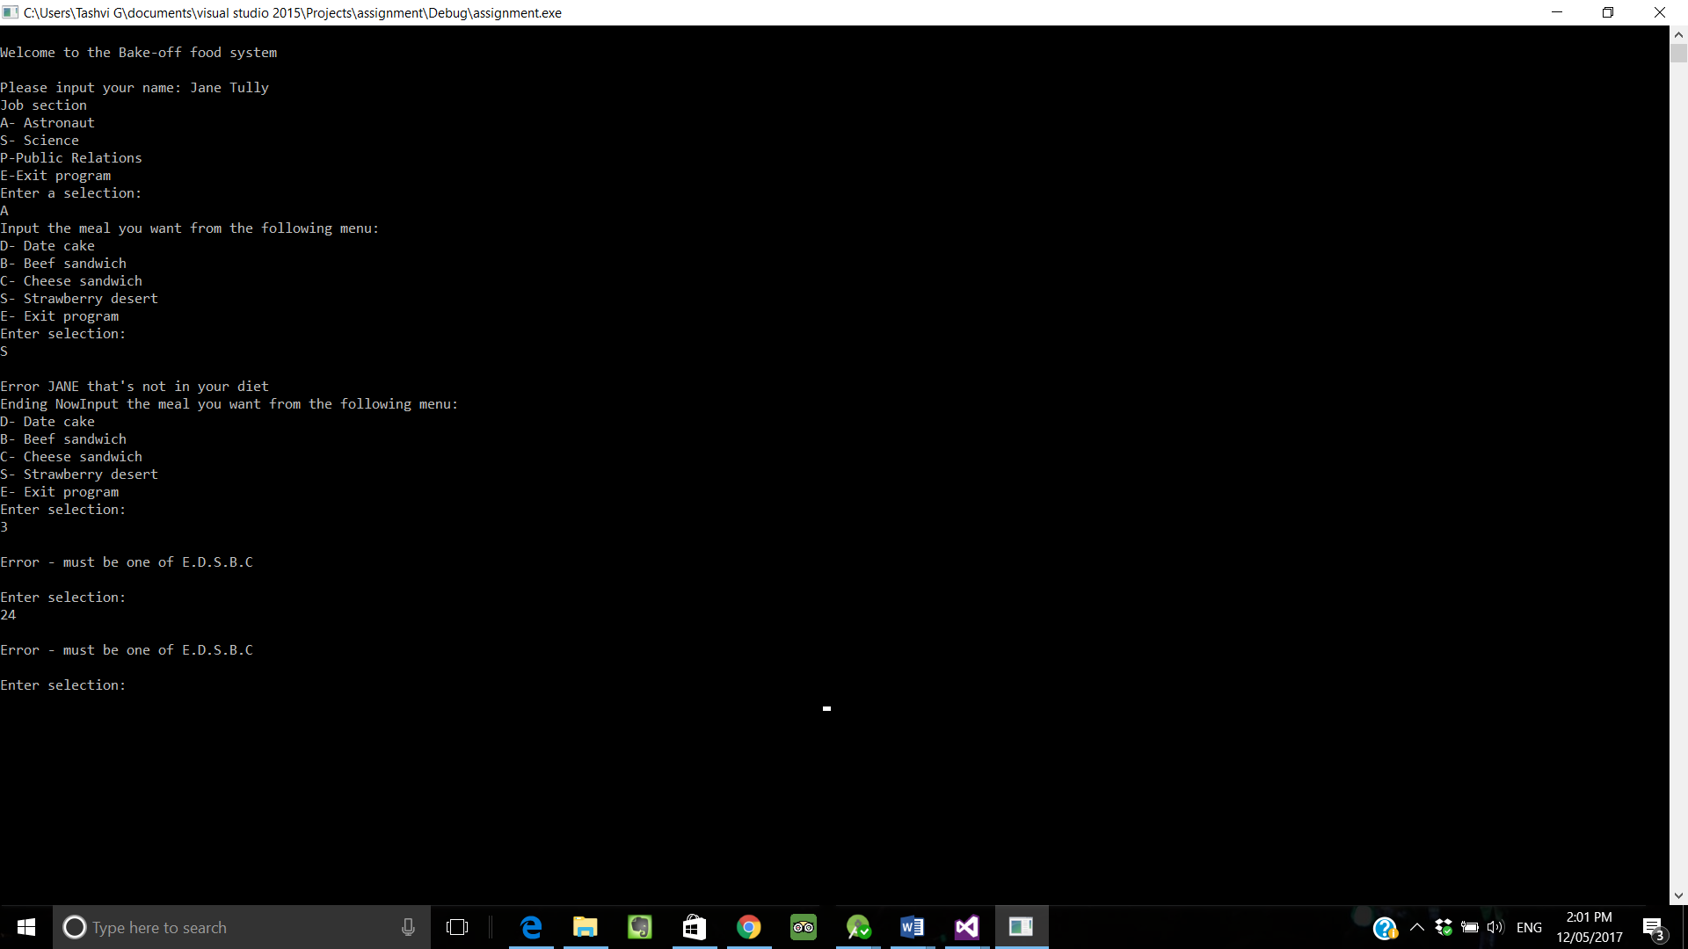

|  |  |  |
| --- | --- | --- |
| Name | Kim Y |  |
| Job Section | S | Science |
| Product | S | Strawberry Cake |
| Enter the number of servings | 7 |  |
| Which table are you at | 30 |  |
| Lookup price |  | 7.41 |
|  |  | Price times servings  51.87 |
|  | Discount (3 or more) 5% | 2.59 |
|  | Tax | 0 |
|  |  | ----------------------------------------------  Name : Kim Y  Table Number : 7  Meal : Strawberry cake  Job Section : Science  Product Cost :7.41  Gross : 51.87  Discount : 2.59  Tax : 0.00  Total cost :49.28  ---------------------------------------------- |

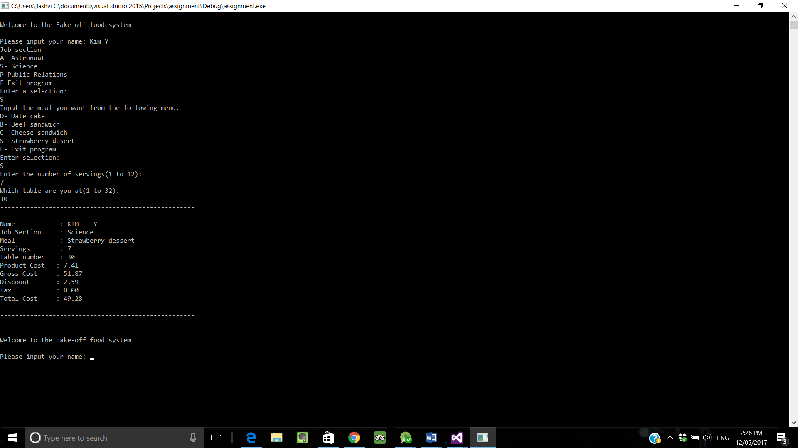

|  |  |  |
| --- | --- | --- |
| Name | Tashvi | Presses enter and it doesn’t proceed to the next enquiry |
|  |  |  |
|  |  |  |
|  |  |  |



|  |  |  |
| --- | --- | --- |
| Name | Wang J |  |
|  |  |  |
|  |  |  |
| Job section | A | Astronaut |
| Product | E | Program exits |
|  |  |  |
|  |  |  |
|  |  |  |

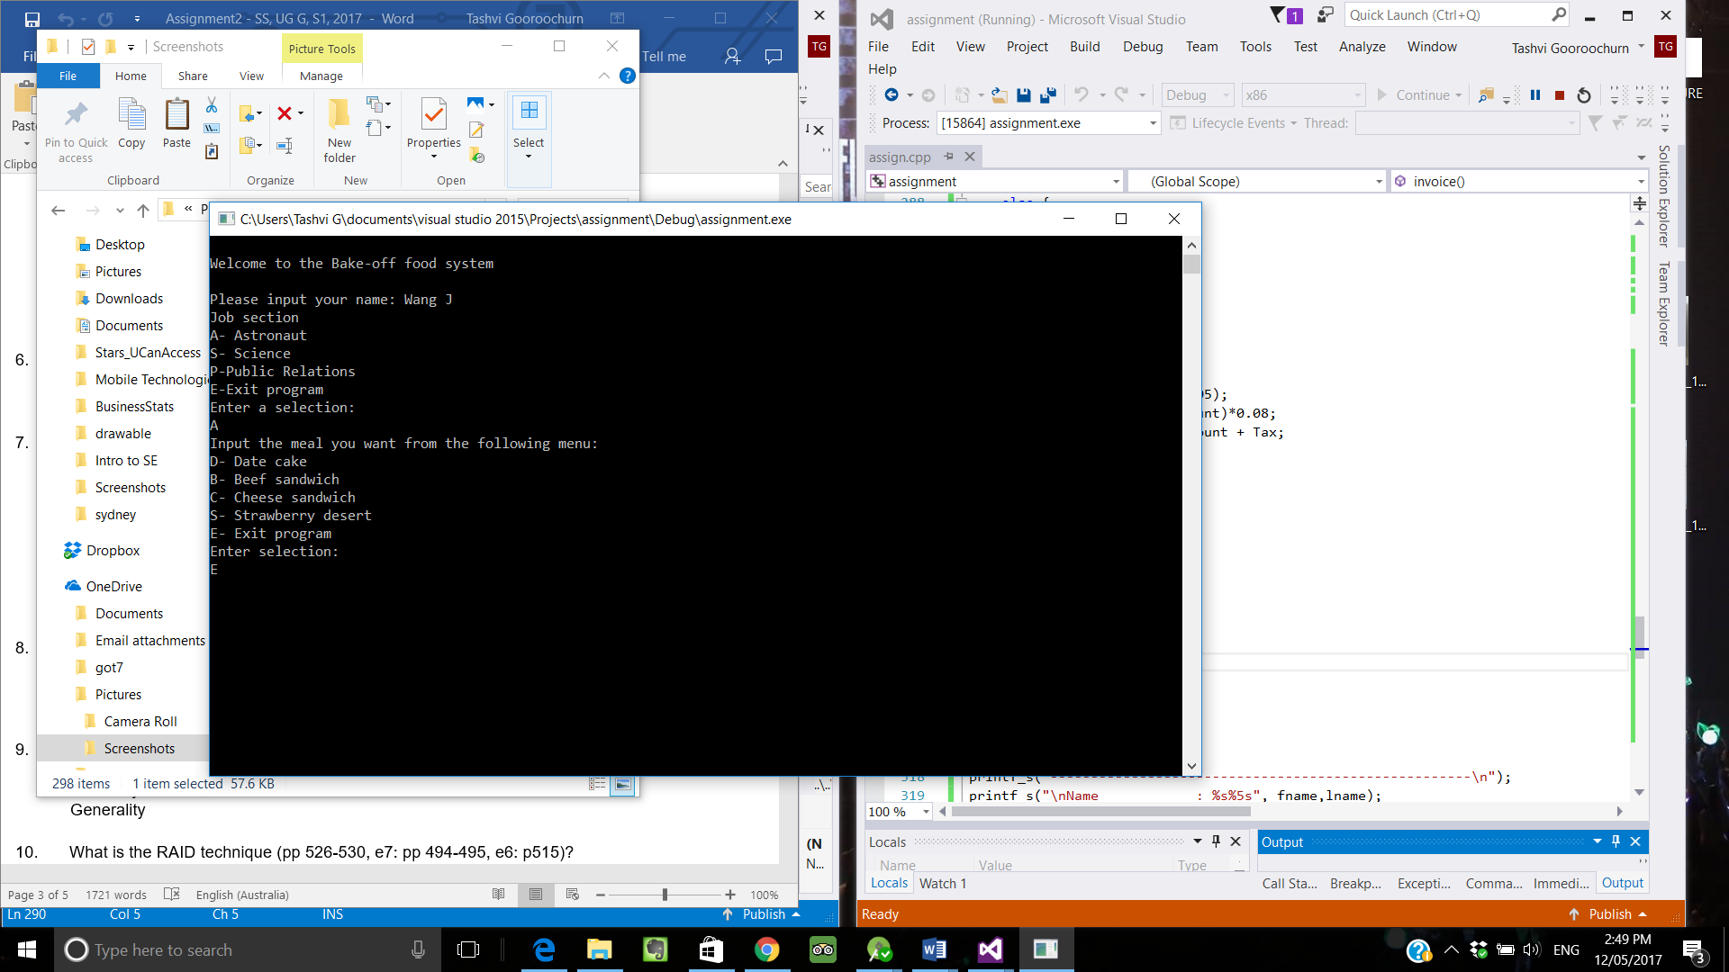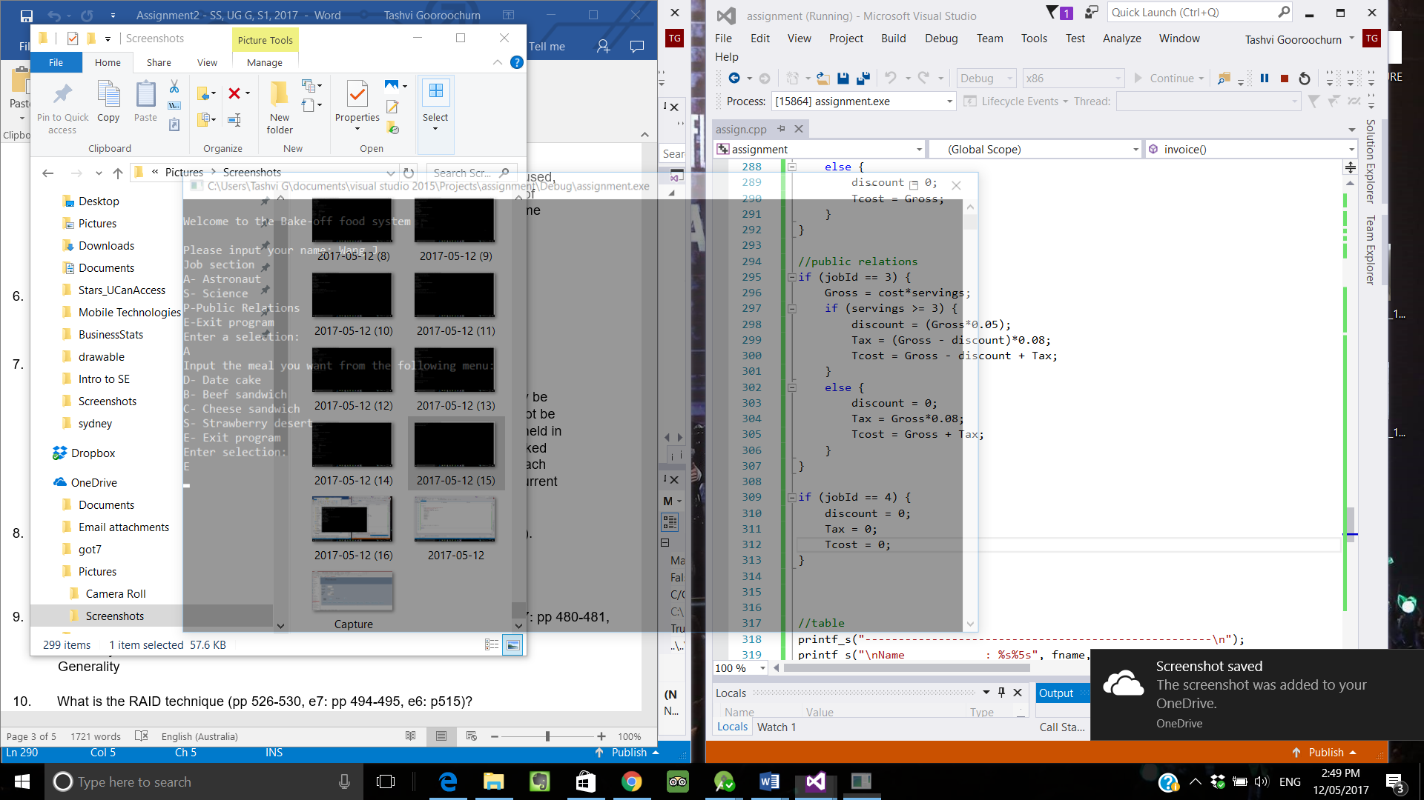

|  |  |  |
| --- | --- | --- |
| Name | Dab Bam |  |
|  |  |  |
|  |  |  |
| Job section | S | Science |
| Product | S | Strawberry |
| Enter the number of servings |  | 0  Program exits |
|  |  |  |
|  |  |  |
|  |  |  |
|  |  |  |

