Mid-Sem Lab Examination

Name: Tashyab Raj

Roll: 2101214

Date: 14.02.2024

**Ques**. Determine the cutoff frequency of dominant mode of a copper made rectangular waveguide with inner dimension A = 22.86mm (0.9 inch) and B = 10.16mm (0.4 inch) and 100 mm length from transmission coefficient characteristic. Consider 1mm as the thickness of wall.

Results:

Waveguide Dimension view:

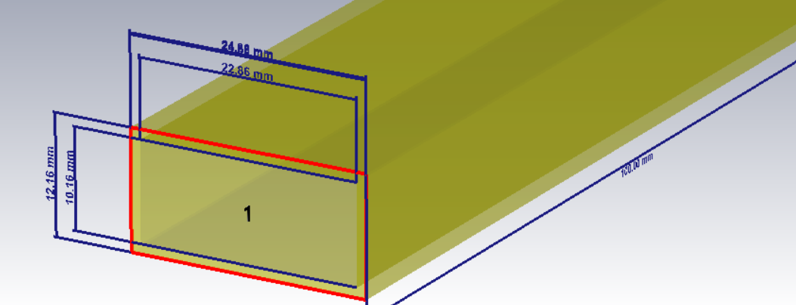

The dominant mode of a rectangular waveguide is the mode having the lowest cutoff frequency and with dimensions a = 2b the dominant mode is TE(10) mode.

Plotting the S-parameter for S2, 1 (input at port 1 and output at port 2)

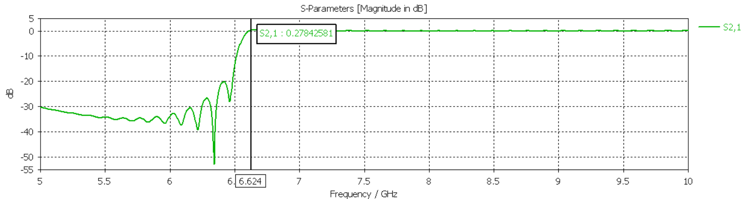

It can be seen that there is a rise and then uniform frequency of propagation at/after ~6.624 GHz which is the cutoff frequency of TE(10) mode.

E-field propagation:

Our result can be further clarified by showing the E-field propagation of the wave.

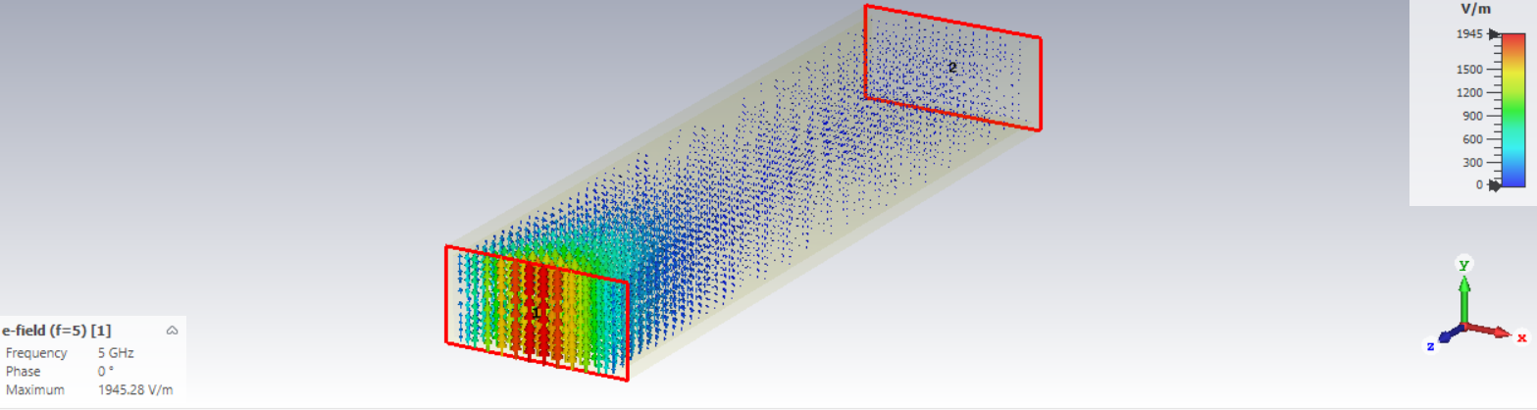

For frequency = 5GHz, the wave is non-propagating. As we know that the wave is non-propagating for f < fcutoff

Similarly, for frequency = 7.5GHz, the wave becomes propagating.

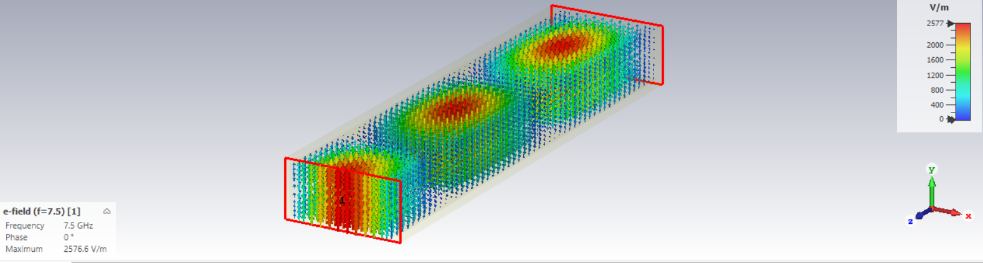

This indicates the cutoff frequency is between 5 and 7.5GHz.

Manual calculation for verification gives fcutoff = 6.56GHz.