Experiment-1

Name: Tashyab Raj

Roll: 2101214

Title: Study of rectangular waveguide

Objectives:

* Calculation of the cut-off frequency for the dominant TE10 mode.
* Study propagation delay.
* Study reflection and transmission characteristics.
* Study modal characteristic (ex: TE10, TE20, TE01, TE11/TM11 modes)

Platform: Dassasualt Systems's Computer Simulation Technology (CST)

Theory:

A rectangular waveguide is a hollow metallic enclosure with a rectangular cross section. The conducting walls of the waveguide confine the electromagnetic fields and thereby guide the electromagnetic wave. The rectangular waveguide is basically characterized by its dimensions i.e., length a and breadth b, as shown in Figure 12.1.

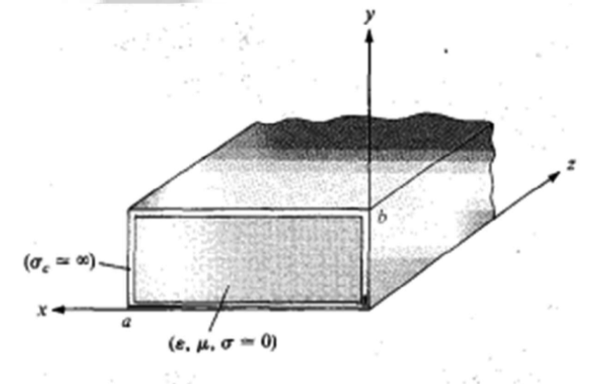

The hollow rectangular wave guide supports propagation of Transverse Electric (TE) and Transverse Magnetic (TM) modes but not TEM waves since only one conductor is present. The TM and TE modes of a rectangular waveguide have cut-off frequencies below which propagation is not possible. Each mode (each combination of m and n) has a cut-off frequency fc(mn) given by

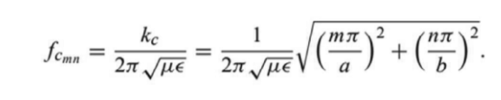

The mode with the lowest cutoff frequency is called the dominant mode; for a rectangular waveguide of a > b, the lowest cutoff frequency occurs for the TE(10) (m = 1, n = 0) mode:

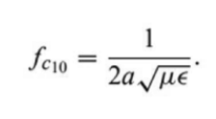

At a given operating frequency / only those modes having f> fc will propagate are called propagating modes and modes with f< fc will lead to an imaginary ẞ (or real a), meaning that all field components will decay exponentially away from the source of excitation. Such modes are referred to as cut-off modes, or evanescent modes (non-propagating modes). If more than one mode is propagating, the waveguide is said to be overmoded.

Procedure:

First construct a rectangular waveguide on CST platform considering the appropriate dimension according to the frequency of operation and material and then run the simulator.

Results:

The calculation of cut-off frequency using the above give formula gives:

1. fc10: 7.5Ghz
2. fc20: 15Ghz
3. fc01: 8.3Ghz
4. fc11: 15.8Ghz

The following results are given for a hollow rectangular waveguide of a = 22mm and b = 20 mm of 100mm long.

1. Study of propagation delay

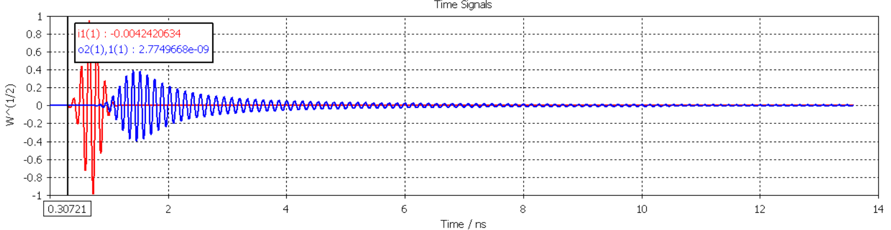

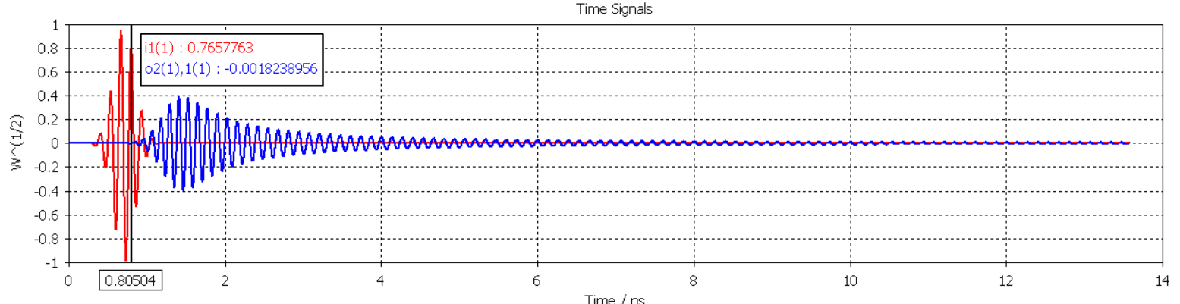

As seen above,

The propagation delay is given by 0.8 – 0.3 = 0.5 ns.

1. Study of reflection and transmission characteristic for dominant mode.

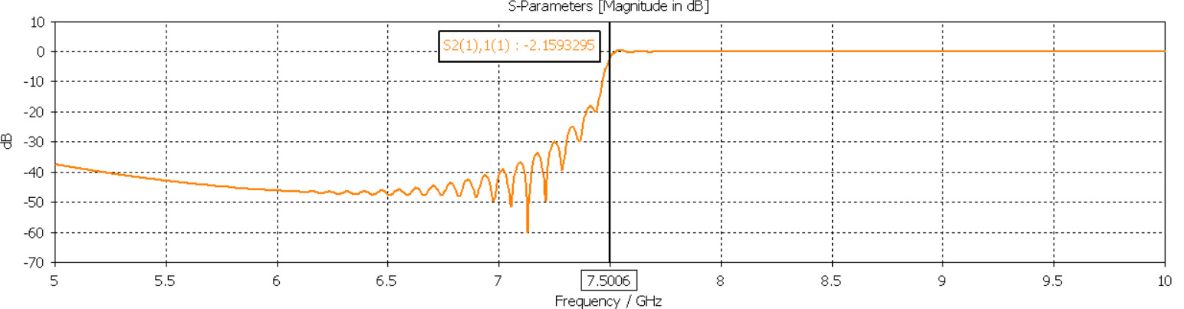

We can see the transmission after 7.5ns which is the cutoff frequency of mode 1.

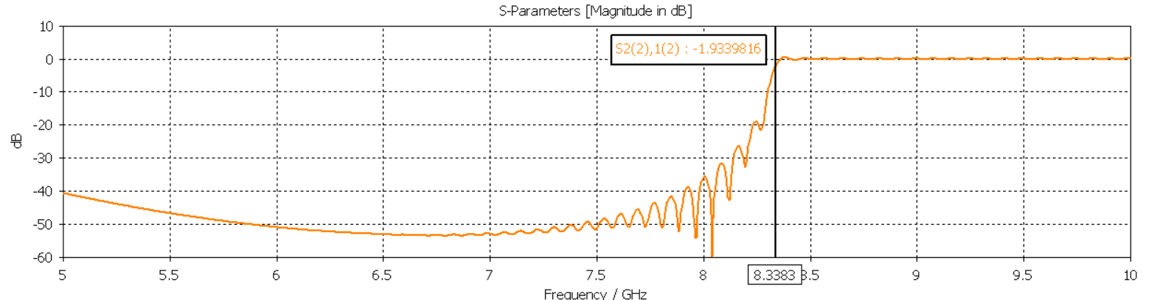

We can see the transmission after 8.3ns which is the cutoff frequency of mode 2.

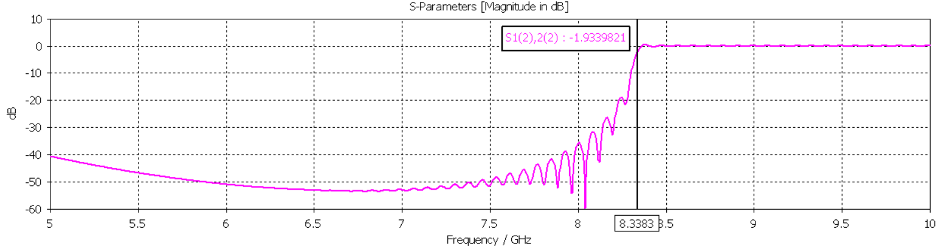

Also, the graph for 2 to 1 is same as 1 to 2 for the given mode.

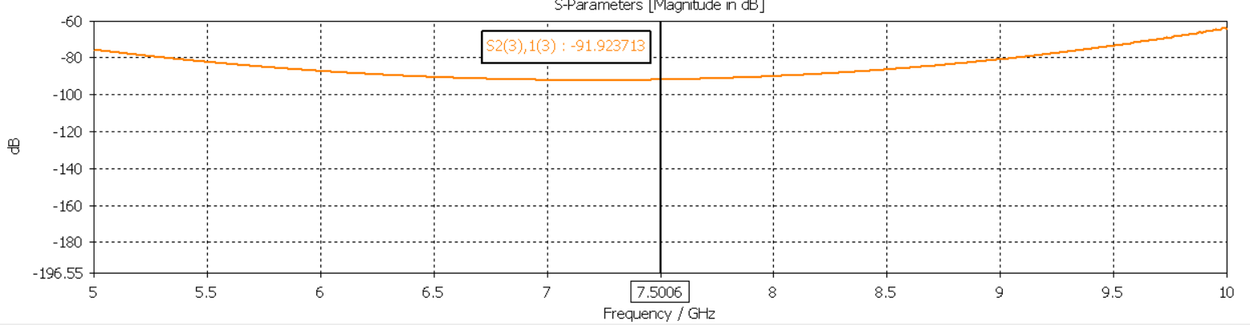

There is no transmission in the 3rd mode because of its high cut-off frequency.

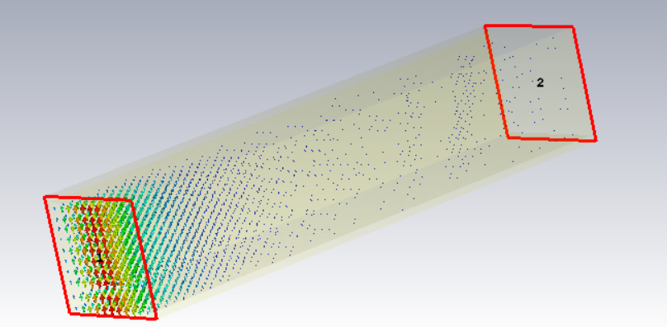

TE10 at 5GHz: Non-propagating mode.

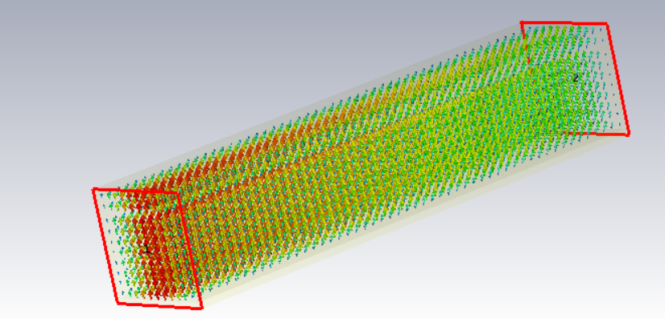

TE10 at 7.5GHz: Propagating mode.

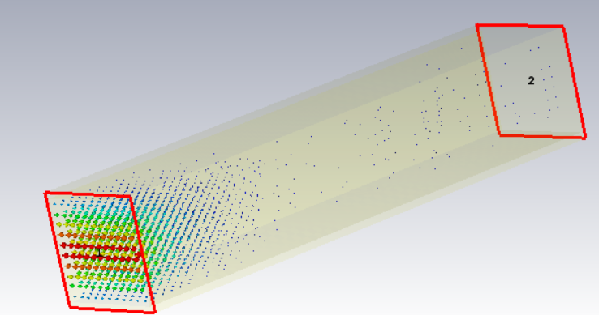

TE01 at 5GHz: Non-propagating mode.

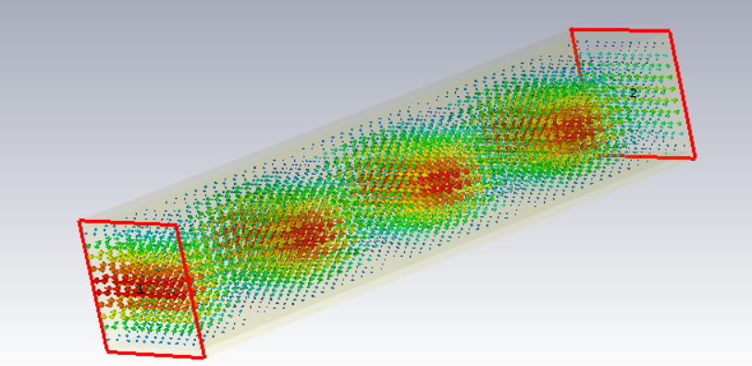

TE01 at 10GHz: Propagating mode.

Conclusion:

The study of rectangular waveguide using CST application provided valuable insights into its fundamental characteristics. The calculation of the cut-off frequency for the dominant TE10 mode allowed for a clear understanding of the operational limits of the waveguide. The analysis of propagation delay shed light on the time it takes for signals to traverse the waveguide, crucial information for signal integrity. The examination of reflection and transmission characteristics contributed to comprehending how the waveguide interacts with incoming and outgoing signals. Additionally, the exploration of modal characteristics, including TE10, TE20, TE01, and TE11 modes, enhanced our knowledge of the diverse modes supported by the waveguide. Overall, this experiment using CST application deepened our understanding of rectangular waveguides and their applications in communication systems.