Experiment-2

Name: Tashyab Raj

Roll: 2101214

Date: 31-01-2024

Title: Study of power divider (H-plane TEE)

Objectives:

* Study port signal.
* Study propagation delay.
* Study power flow.
* Study E-filed and H-field propagation.

Platform: Dassasualt Systems' Computer Simulation Technology (CST)

H-Plane Tee:

• Cutoff Frequency Band: 10 GHz to 15 GHz

• MWG (22mm \* 12mm \* 100mm)

• CWG (20mm\*10mm\*100mm)

• HW (30mm\*12mm\*22mm)

• Material: Copper (pure)

Procedure:

First construct a Tee-shaped waveguide on CST platform considering the appropriate dimension according to the frequency of operation and material and then run the simulator.

Results:

1. Fig (a). Port Signal

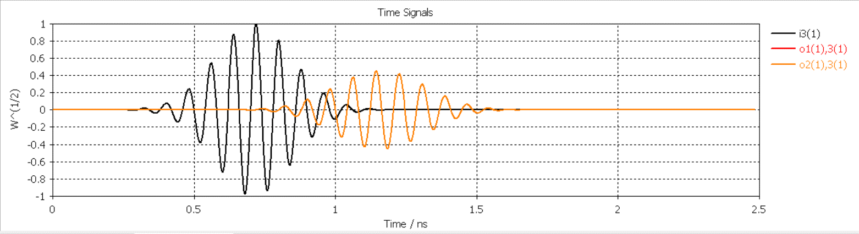

Observations:

* Output at port 1 and 2 are identical.
* The output power is halved at the two ports.

This shows that the voltage divider is working.

1. The propagation delay can be calculated by:

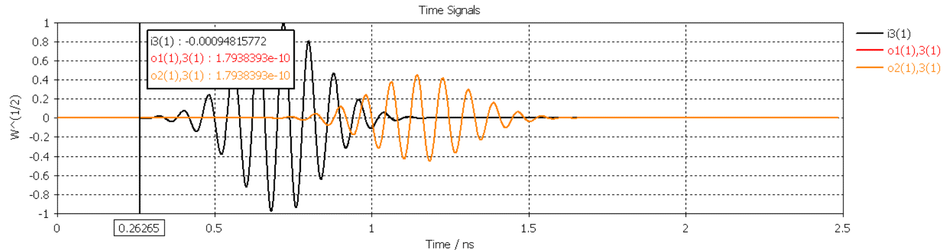

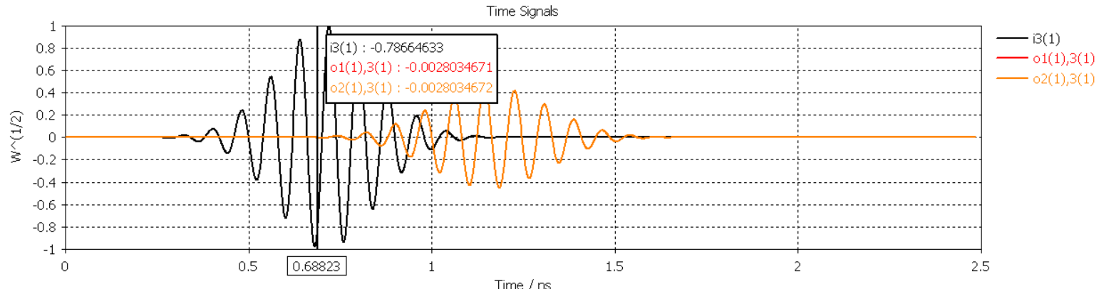

T(delay) = 0.68823 – 0.26265 = 0.42568 ns

1. Power Flow

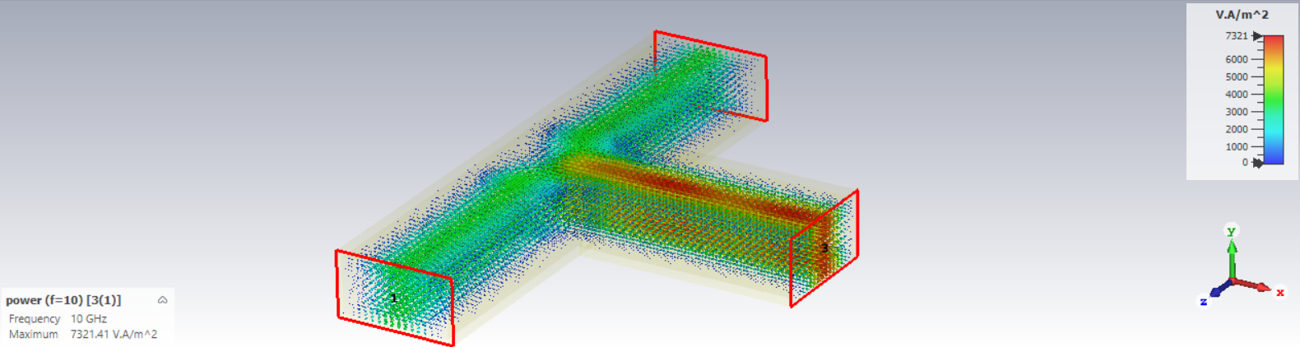

Fig (b). Power Flow at f = 10 GHz from port 3

We can see that the power is equally divide to the ports 1 and 2 from port 3.

1. E-field propagation

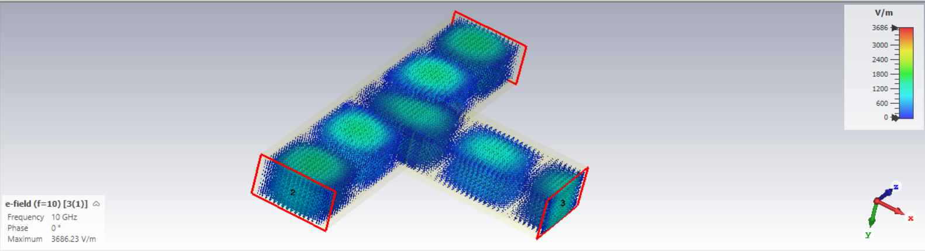

Fig(c) Electric field at f = 10 GHz [3(1)]

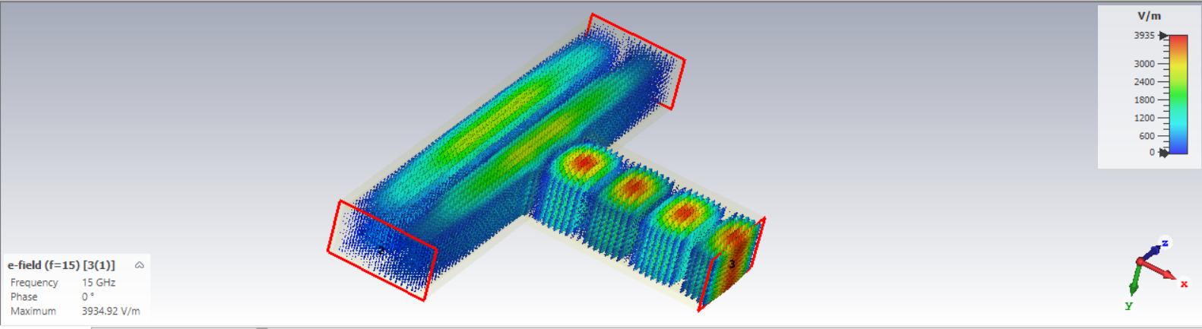

Fig(d) Electric field at f = 15 GHz [3(1)]

1. H-field propagation

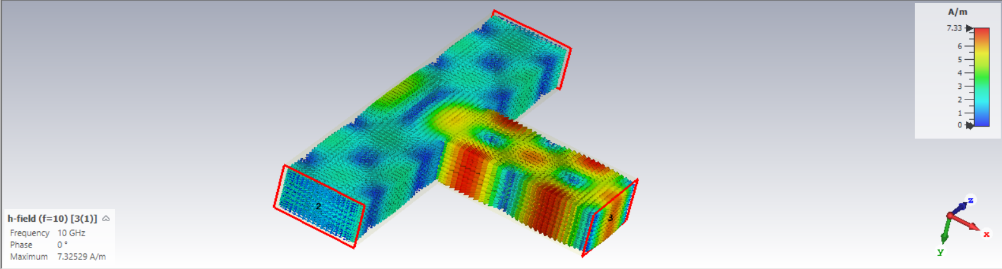

Fig(f) Magnetic field at f = 10 GHz [3(1)]

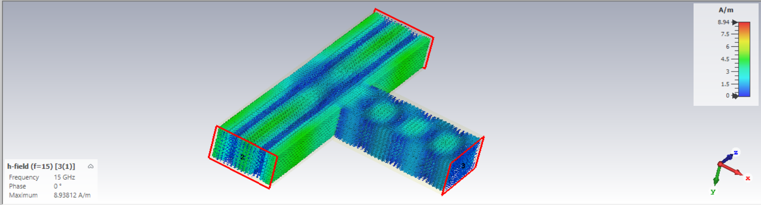

Fig(g) Electric field at f = 15 GHz [3(1)]

Conclusion

In summary, the study of the H-plane TEE power divider has provided insightful observations regarding its operation. The analysis revealed that the output power is halved at the two ports, illustrating the equal distribution of power within the system. This phenomenon aligns with the fundamental concept of a voltage divider, where the input voltage is divided equally between the two output ports. Such behaviour is essential for maintaining signal integrity and balance in practical applications of power dividers. Overall, the study contributes to a deeper understanding of power divider mechanisms and lays the groundwork for further exploration and optimization in RF and microwave engineering.

Examining the power flow characteristics of the H-plane TEE power divider revealed crucial insights into energy distribution within the system. The analysis demonstrated the balanced division of power among the output ports, highlighting the device's ability to efficiently route signals while minimizing loss.

Additionally, the investigation into the E-plane provided valuable observations regarding electromagnetic wave propagation and interaction within the divider structure.

Overall, the study of power flow and E-plane behaviour enhances our comprehension of the H-plane TEE power divider's functionality and applicability in various engineering contexts.