Experiment – 6

Name: Tashyab Raj

Roll: 2101214

Date: 12.03.2024

Aim: The aim of this project is to design a system that measures the voltage output of a potentiometer using a PSoC microcontroller and displays the voltage value on an LCD screen.

Theory:

In this project, we utilize a PSoC microcontroller along with an Analog-to-Digital Converter (ADC) to measure the voltage output of a potentiometer. The potentiometer is used to generate an analog voltage signal, which is then converted into a digital value by the ADC. The ADC converts the analog voltage signal into a 10-bit digital value, which represents the voltage level proportional to the potentiometer position.

The PSoC microcontroller reads the digital value from the ADC and calculates the corresponding voltage value using a simple formula: voltage = (pot_data 5.0) / 255.0. This formula scales the digital value to obtain the voltage in the range of 0 to 5 volts.

The voltage value obtained is then displayed on an LCD screen connected to the PSoC microcontroller. The LCD screen is initialized and configured to display the voltage value in real-time. The voltage value is updated periodically, allowing the user to observe changes in the potentiometer position reflected as changes in voltage.

Flowchart:

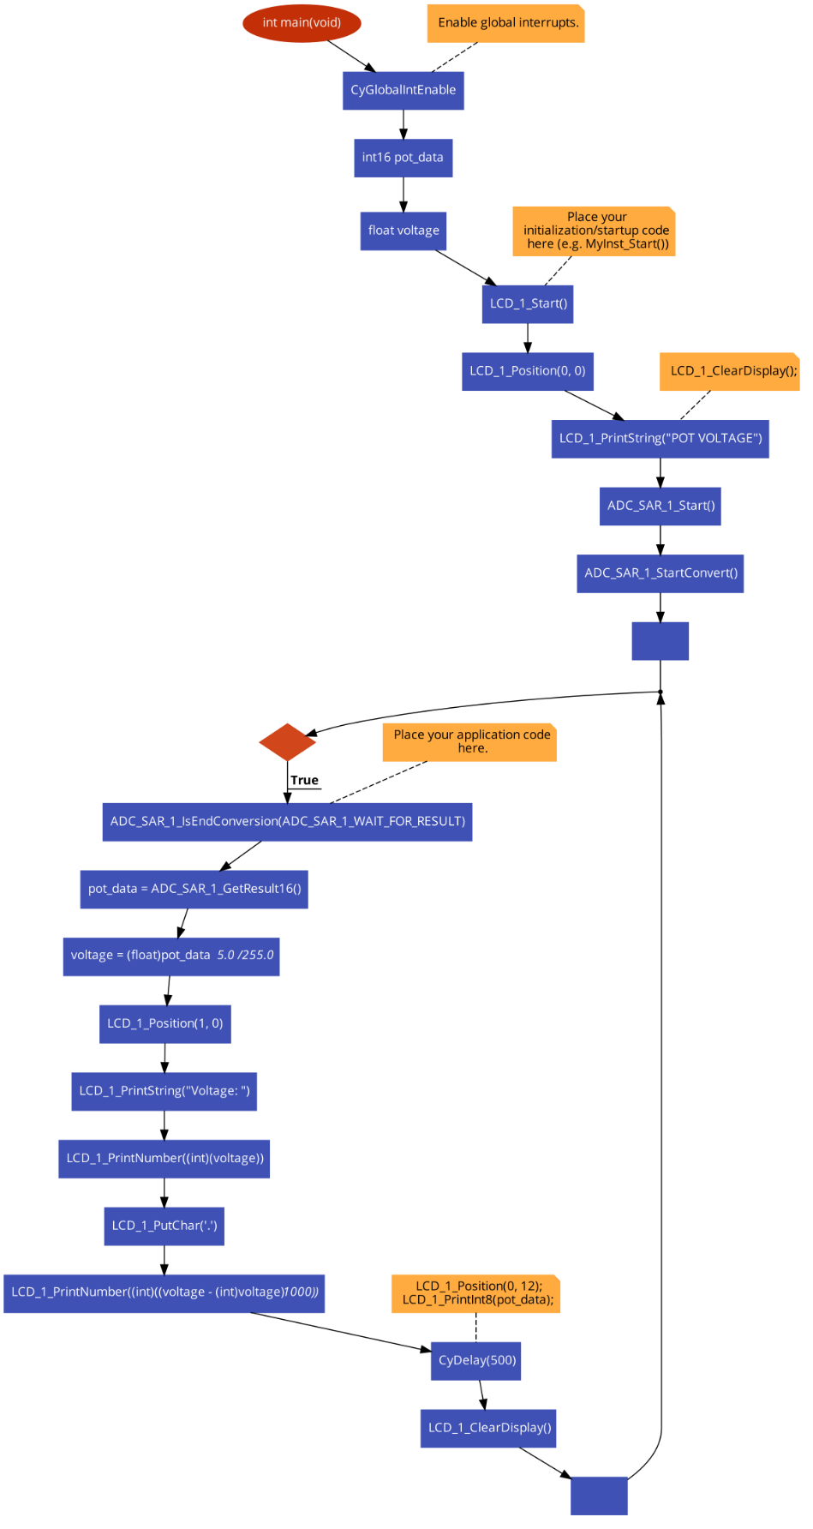

Result:

1. Maximum Voltage

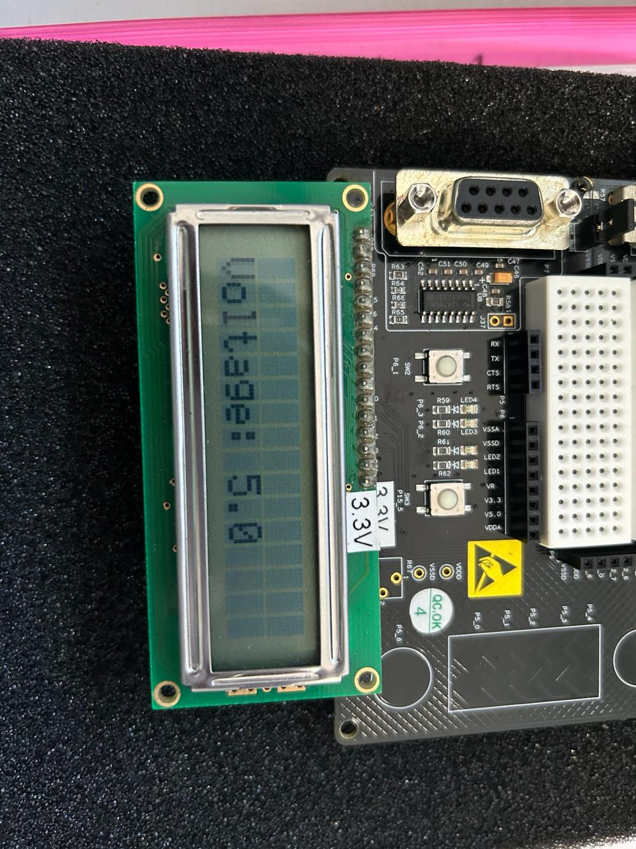

1. Minimum Voltage

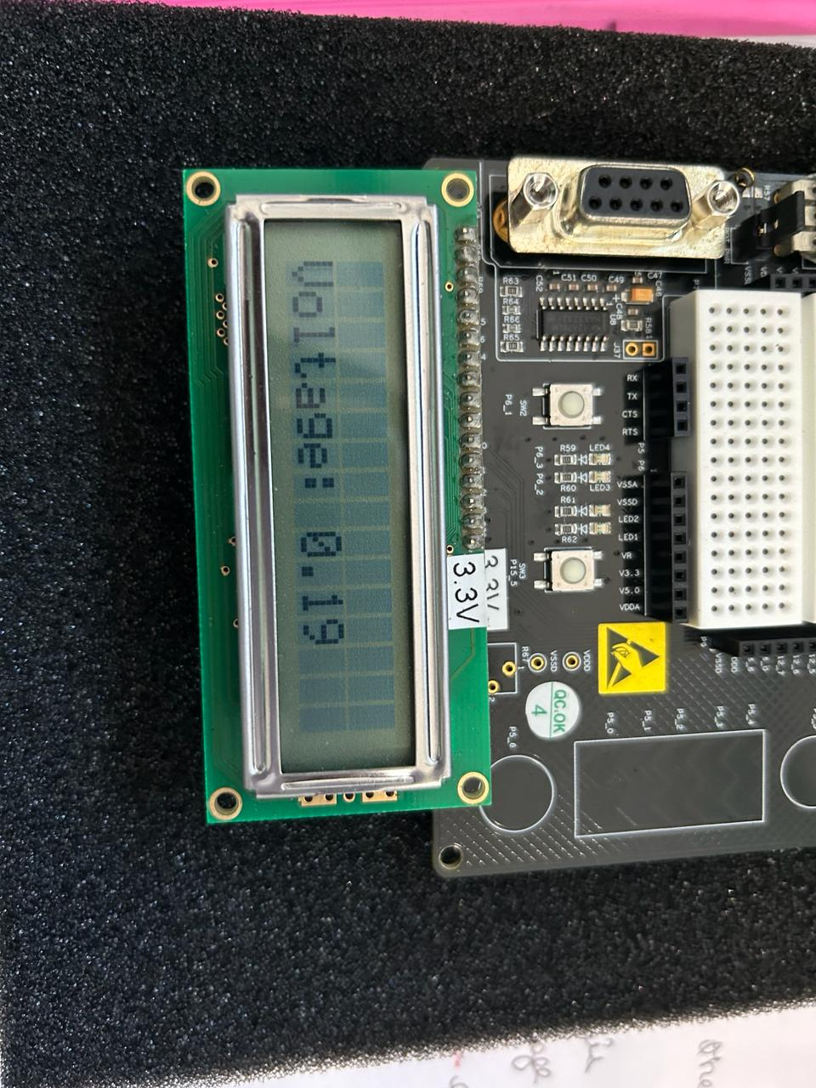

Conclusion:

In conclusion, this project demonstrates the implementation of a voltage measurement system using a PSoC microcontroller. By interfacing with a potentiometer and an ADC, the system accurately measures the voltage output and displays it on an LCD screen. This project serves as a practical example of analog-to-digital conversion and real-time display of sensor data using PSoC microcontrollers, showcasing their versatility and effectiveness in embedded systems applications.