Experiment – 7

Name: Tashyab Raj

Roll: 2101214

Date: 18.03.2024

Aim:

The aim of this project is to design a system that monitors the voltage output from a potentiometer and controls an LED based on the measured voltage level (Threshold Voltage). Additionally, it displays the measured voltage on an LCD screen.

Theory:

We utilize a PSoC microcontroller along with an Analog-to-Digital Converter (ADC) to measure the voltage output of a potentiometer. The potentiometer is used to generate an analog voltage signal, which is then converted into a digital value by the ADC. The ADC converts the analog voltage signal into a 10-bit digital value, which represents the voltage level proportional to the potentiometer position.

The code initializes the necessary components, including an LCD display and an ADC (Analog-to-Digital Converter), to read the voltage output from a potentiometer. It then enters a loop where it continuously reads the ADC value, calculates the corresponding voltage, and displays it on the LCD screen.

Furthermore, the code checks if the measured voltage is above a certain threshold (in this case, 2.5 volts). If the voltage exceeds this threshold, it turns on an LED connected to Pin_2; otherwise, it turns off the LED. It also updates the LCD screen to indicate whether the LED is on or off.

Flowchart:

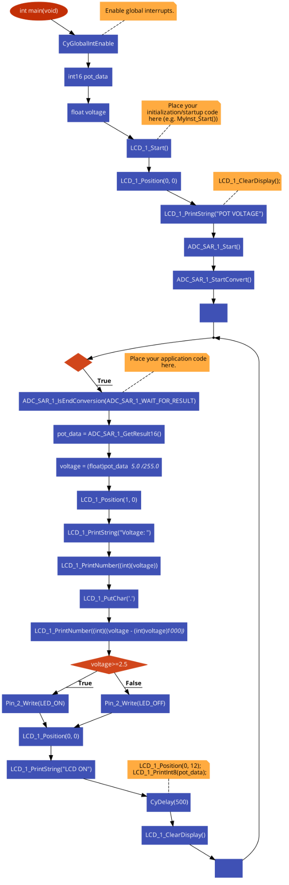

Result:

1. LED ON

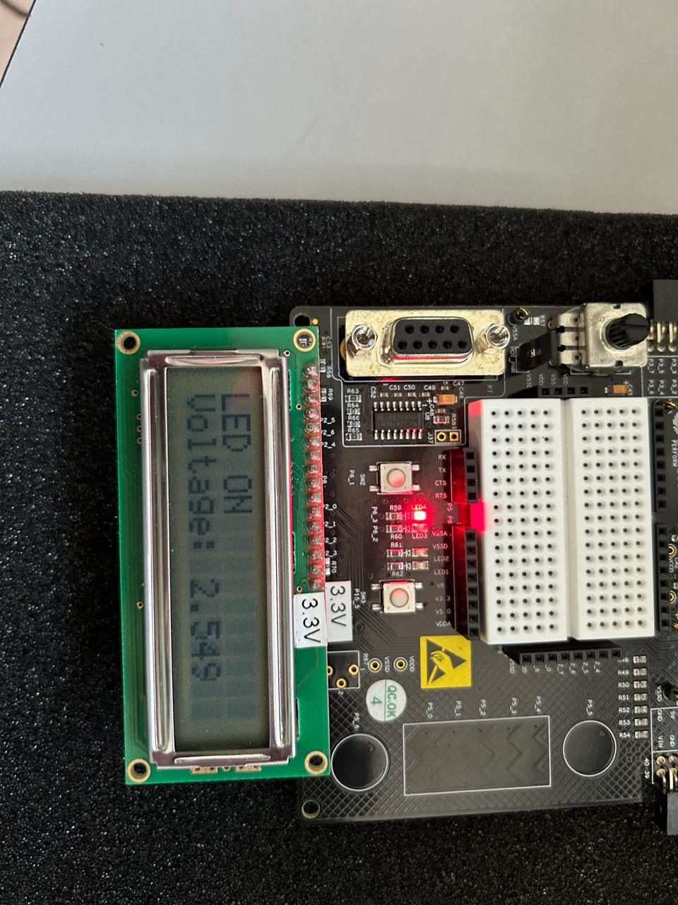

1. LED OFF

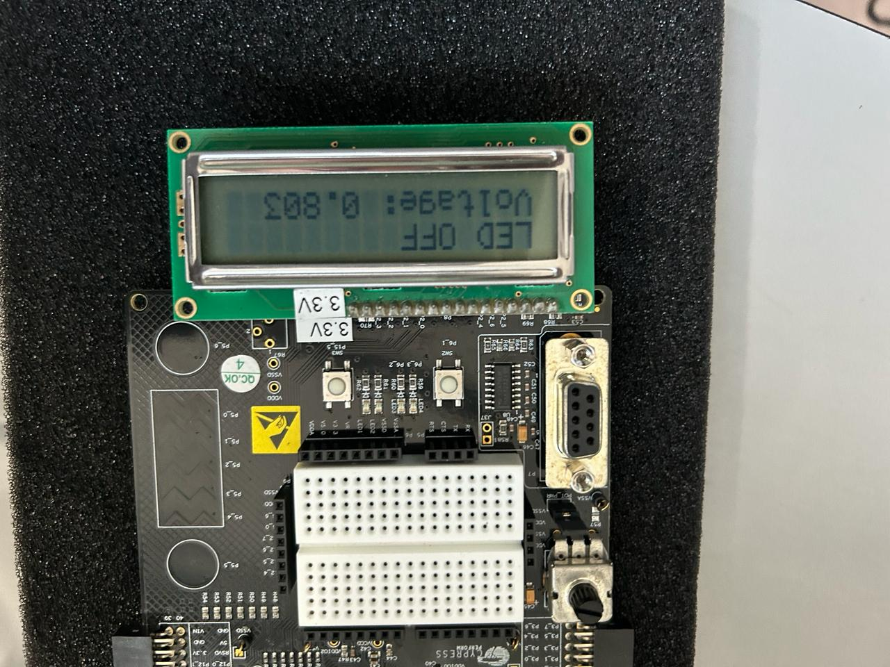

Conclusion:

The project successfully demonstrates the integration of input/output devices with a PSoC device. By monitoring the voltage output from a potentiometer and controlling an LED based on the measured voltage level, it showcases practical applications of analog-to-digital conversion and digital control. The addition of an LCD screen enhances user interaction by providing real-time feedback on the measured voltage and the status of the LED. Overall, this project serves as a foundational example of embedded systems development and demonstrates the versatility of PSoC devices in controlling and interfacing with external components.